SMART PARKING
DETECTION SYSTEM
Technical report and presentation-ready project summary
Prepared 12 October 2026
IMPORTANT EVIDENCE NOTE
The reported high test metrics apply to parking-slot detection only. The current system does not have manually labeled vehicle-violation ground truth, so red/green overlays are qualitative predictions—not verified accuracy results.
Prepared from the project repository, trained-model metrics, configured thresholds, and the three latest attached-image inference runs.

Contents and how to use this report
- 1. Executive summary
- 2. Project background, problem, and objectives
- 3. Data and labels
- 4. System design and inference workflow
- 5. Training and model performance
- 6. Parking classification logic and thresholds
- 7. Latest attached-image results
- 8. Visual examples: input and prediction pairs
- 9. What can safely be claimed in a presentation
- 10. Limitations, risks, and improvement plan
- 11. Ready-to-copy PowerPoint outline and speaker notes
- 12. Technical appendix and file inventory
Recommended PPT use: Use the first and third image pairs as illustrative outputs only after visually checking every red box. Use the second pair only on a limitations slide. Never call any of these three-image results “99% accurate”; that number is not a violation-classification score.

1. Executive summary
This project combines a YOLOv8 parking-slot detector, a pretrained vehicle detector, and geometric overlap rules to estimate free spaces and possible parking violations from still images. It is a prototype decision-support system: it can draw slot and vehicle boxes and classify some vehicle/slot relationships, but it is not a validated enforcement system.
- The trained YOLOv8s slot model distinguishes space-empty and space-occupied. Its reported held-out test metrics are mAP@0.50 = 0.9795, mAP@0.50:0.95 = 0.9770, precision = 0.9984, and recall = 0.9797. These are slot-detection metrics only.
- The vehicle detector used for the latest images is COCO-pretrained YOLOv8n. The project does not have custom per-vehicle or violation labels for this detector in the parking dataset.
- Wrong parking is inferred from the detected vehicle box relative to predicted slot boxes. A large vehicle crossing into another bay can be marked red; uncertain or borderline cases are intentionally withheld from red/blue labels.
- Across the three latest attached images, the pipeline detected 57 vehicle boxes and 210 slot boxes, emitted 6 red predictions, omitted 6 confidently correct vehicles, and left 45 vehicle detections uncertain. These counts describe model output, not ground-truth correctness.
- One latest input had only 7 slot predictions for 21 detected vehicles. Its output is not suitable evidence of successful slot detection and should appear only as a failure/limitation example.

2. Project background, problem, and objectives

Problem statement
Parking-lot images contain multiple adjacent spaces, parked cars, empty bays, perspective distortion, painted dividers, landscaping, and drive lanes. A useful system must (a) locate spaces, (b) detect vehicles, and (c) decide whether a vehicle occupies one bay, obstructs a bay, or is too ambiguous to classify. Errors in any stage affect the final overlay.

Project objectives
- Detect candidate parking-space regions and estimate which are free or occupied.
- Detect visible cars with a general-purpose object detector.
- Use geometric overlap and adjacent-slot intrusion to flag possible incorrectly parked vehicles.
- Keep ambiguous cases as uncertain rather than forcing a correct/wrong decision.
- Produce annotated images that can support human inspection and a prototype presentation.

Scope and non-goals
The current scope is single-image inference on user-provided parking-lot scenes. The current system does not identify a vehicle owner, read license plates, determine legal rules, track vehicles over time, or establish a violation with camera-calibrated ground truth. A red box is an algorithmic flag for review, not a legal or definitive verdict.

3. Data and labels
The repository documents a PKLot-derived Roboflow export called Parking_dataset_2. Its label set is limited to parking-space states:
Dataset fact | Documented value
Total images | 12,416 JPG images at 640 x 640
Train / validation / test | 8,691 / 2,483 / 1,242
Class 0 | space-empty (free parking-space box)
Class 1 | space-occupied (occupied-space box)
Vehicle-instance labels | Not present in this export
Incorrect-parking labels | Not present in this export
Slot geometry | Axis-aligned boxes; original rotated-space geometry is approximated

Meaning: “occupied slot” is not a label for “correct parking,” and an occupied-space box is not a precise outline of a car. The dataset can train slot occupancy, but it cannot directly train or validate the parking-violation classifier.

4. System design and inference workflow
Stage | Component | Output / role
1. Space detection | Custom YOLOv8s slot checkpoint | Bounding boxes classified as space-empty or space-occupied.
2. Vehicle detection | COCO-pretrained YOLOv8n | General vehicle boxes; small, distant, occluded, or unusual-angle cars can be missed.
3. Geometry | Vehicle-box/slot-box intersections | Computes overlap ratios, best slot assignment, outside estimate, and adjacent-slot intrusion.
4. Decision and drawing | Threshold-based classifier and renderer | RED possible wrong parking, GREEN free-slot box; correctly parked and uncertain vehicle boxes are omitted in these output images.

Geometry terms
Quantity | Definition | Interpretation
R_vehicle | Area(vehicle box intersect slot) / Area(vehicle box) | Fraction of the detected vehicle rectangle covered by one slot box.
R_slot | Area(vehicle box intersect slot) / Area(slot box) | Fraction of a detected slot box overlapped by the vehicle box.
R_outside | 1 - R_vehicle | Estimated portion of the vehicle rectangle outside one slot box.
IoU | Intersection / union of vehicle and slot boxes | General overlap score; useful for matching, not a violation label by itself.

All quantities operate on axis-aligned rectangular boxes. They approximate visible geometry and do not recover true tires, vehicle footprint, painted lines, or legal bay boundaries.

5. Training and model performance

Slot model training configuration
Parameter | Recorded value
Model | YOLOv8s pretrained initialization
Task | Object detection
Epochs | 50
Image size | 640
Batch | 16
Seed | 42
Target labels | space-empty and space-occupied
Checkpoint | weights/slot_det_best.pt

Reported held-out test metrics
Metric | Value | Correct interpretation
mAP@0.50 | 0.9795 | Slot classes only
mAP@0.50:0.95 | 0.9770 | Slot box localization across IoU thresholds
Precision | 0.9984 | Slot predictions only
Recall | 0.9797 | Slot labels only
Per-class mAP@0.50:0.95 | 0.9821 / 0.9719 | Class order follows dataset YAML; verify names there before assigning labels

Do not overstate: These values do not measure vehicle detection accuracy, empty-space accuracy on the recent attachments, or wrong-parking precision/recall. No labeled violation test set is available in the documented dataset.

6. Parking classification logic and current thresholds
The current configured classifier is conservative for single-slot outside cases and uses a separate straddle path for cars that appear too large for one space and intrude into an adjacent predicted space. Borderline cases remain uncertain.
Setting | Current value | Purpose / trade-off
wrong_parking_min_outside_ratio | 0.70 | Single-slot case needs at least 70% estimated vehicle-box area outside the assigned slot; conservative, may miss true violations.
minimum_second_slot_intrusion_ratio | 0.20 | Minimum portion intruding beyond primary-slot tolerance used for adjacent-slot straddle path.
minimum_vehicle_slot_size_ratio_for_straddle | 1.50 | Avoids flagging a near-slot-sized car merely because two predicted boxes split its overlap.
boundary_crossing_tolerance | 0.05 | Ignores a thin 5% short-side vehicle-box boundary band.
slot_assign_min | 0.30 | Minimum vehicle overlap fraction to assign a primary slot.
vehicle_imgsz / slot_imgsz | 1280 / 640 | Inference input sizes for vehicle and slot detectors.
vehicle_conf_min / uncertain_conf_max | 0.25 / 0.40 | Separates weak/uncertain detections from confident classification.
tiled_inference | false | Latest three-image run used full-frame inference; tiling was disabled.

Thresholds are engineering choices and require calibration on manually labeled images from the intended camera. A lower threshold can increase red detections while also increasing false alarms; it cannot create missing ground-truth knowledge.

7. Latest attached-image run: measured outputs
Run ID 20261012_192541; local CPU inference; three user-provided images. The run’s own JSON summary is included with the outputs. “Incorrect” below means a red prediction emitted by the heuristic classifier, not a verified violation.
Image | Vehicles | Slots | Free-slot boxes | Red predictions | Correct omitted | Uncertain omitted | Latency
1 | 20 | 103 | 72 | 3 | 4 | 13 | 3.53 s
2 | 21 | 7 | 6 | 0 | 0 | 21 | 1.59 s
3 | 16 | 100 | 76 | 3 | 2 | 11 | 3.22 s
TOTAL | 57 | 210 | 154 | 6 | 6 | 45 | 8.33 s total

How to read these counts
- The 57 vehicle detections are not a count of all true cars; detector misses and false detections are possible.
- The 6 red predictions are not confirmed true violations; each requires visual review or a labeled ground-truth annotation.
- The 45 uncertain detections indicate that the pipeline did not confidently assign a final correct/wrong status. They are not “correctly parked.”
- Image 2’s 7 slot predictions indicate a serious slot-detection failure on that scene. Zero red predictions is not evidence that the cars are correctly parked.
- The 154 free-slot boxes are model outputs. Their correctness has not been measured against manually labeled ground truth for these attachments.

8. Image evidence: complete input/output pairs
The following section includes all three source images and their corresponding latest model outputs. Pairs 1 and 3 are candidate visuals for a prototype/demo slide only, not quantitatively validated success evidence. Pair 2 is deliberately labeled as a limitation example.

Example 1 - mixed parking rows
20 vehicles detected; 103 slot predictions; 3 red predictions; 13 uncertain. Treat as a qualitative example only; red labels are heuristic and need human checking.
ORIGINAL INPUT  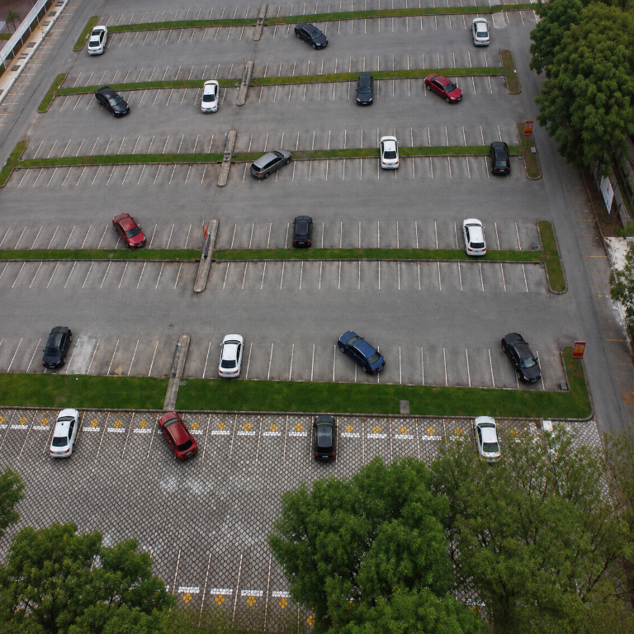  Pasted Image.png | MODEL OUTPUT  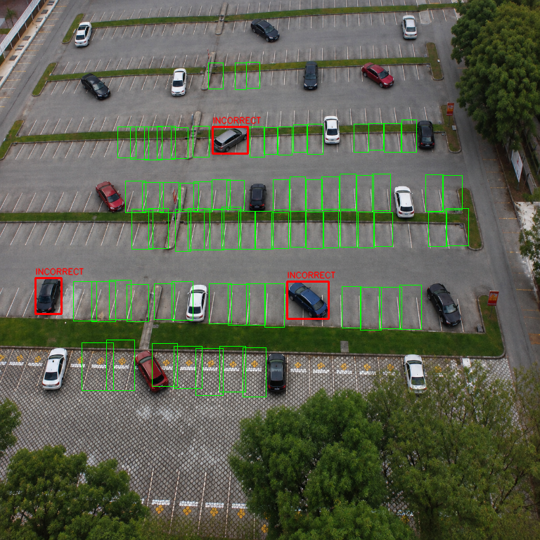  latest_20261012_192541_01_Pasted_Image.png
PPT recommendation: Not validated ground truth. If shown, describe as a sample model overlay and state that red boxes need human review.

Example 2 - low slot-detection coverage (limitation)
21 vehicles detected; only 7 slot predictions; all 21 vehicle decisions uncertain; 0 red. Do NOT use as a success example. It demonstrates a failure/limitation and requires detector/domain improvement.
ORIGINAL INPUT  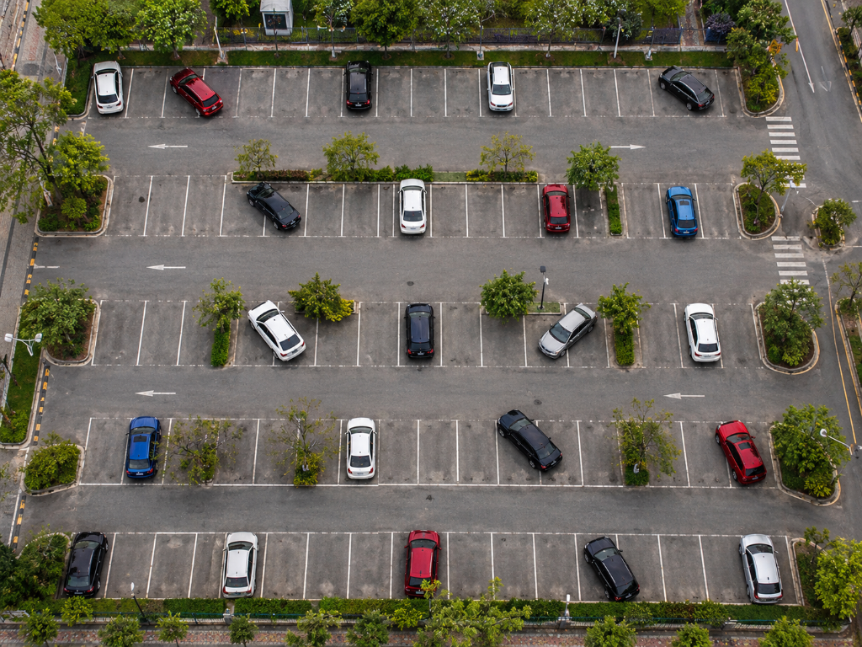  Pasted Image 2.png | MODEL OUTPUT  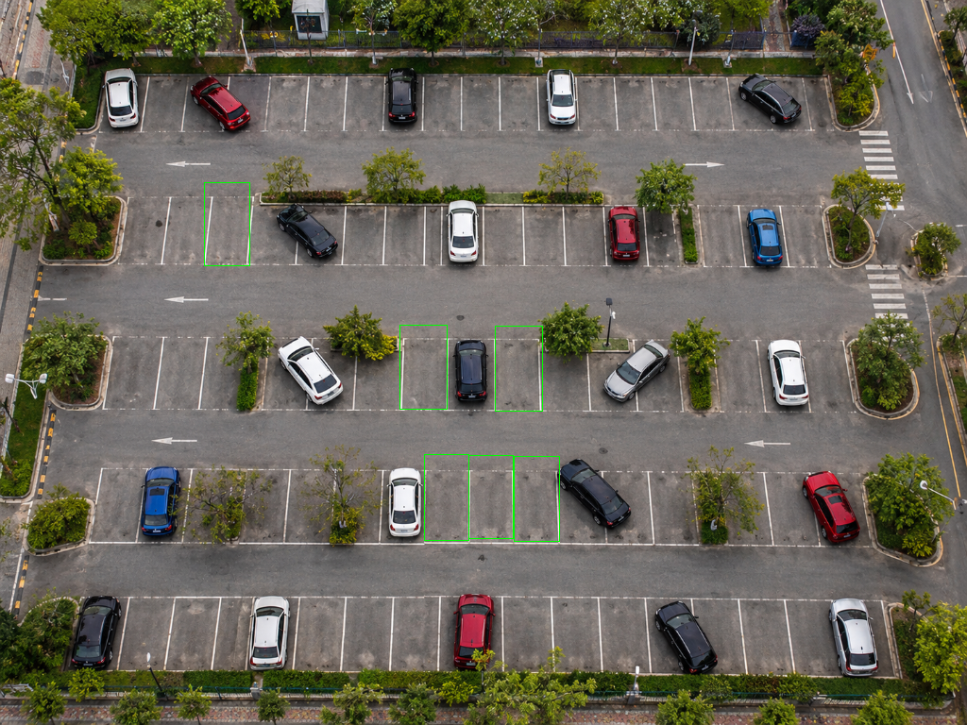  latest_20261012_192541_02_Pasted_Image_2.png
PPT recommendation: Use only for a limitations slide: the model produced very few slot boxes and every vehicle decision was uncertain.

Example 3 - second mixed-lot view
16 vehicles detected; 100 slot predictions; 3 red predictions; 11 uncertain. Qualitative example only; visually inspect all red boxes before presentation.
ORIGINAL INPUT  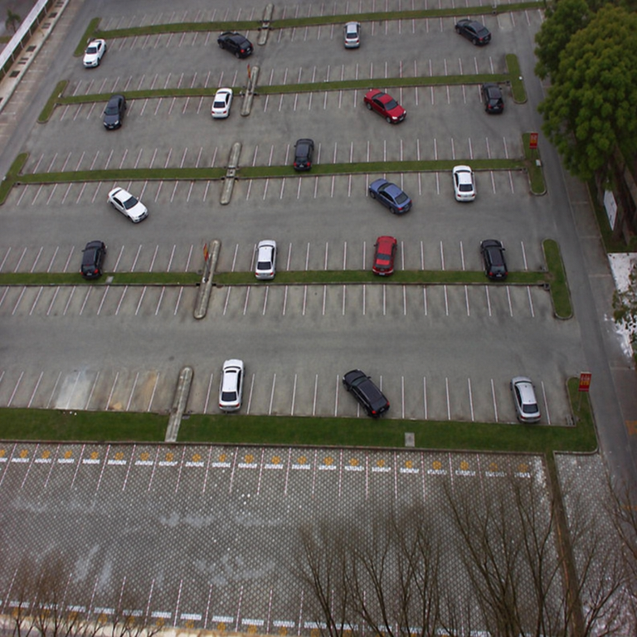  Pasted Image 3.png | MODEL OUTPUT  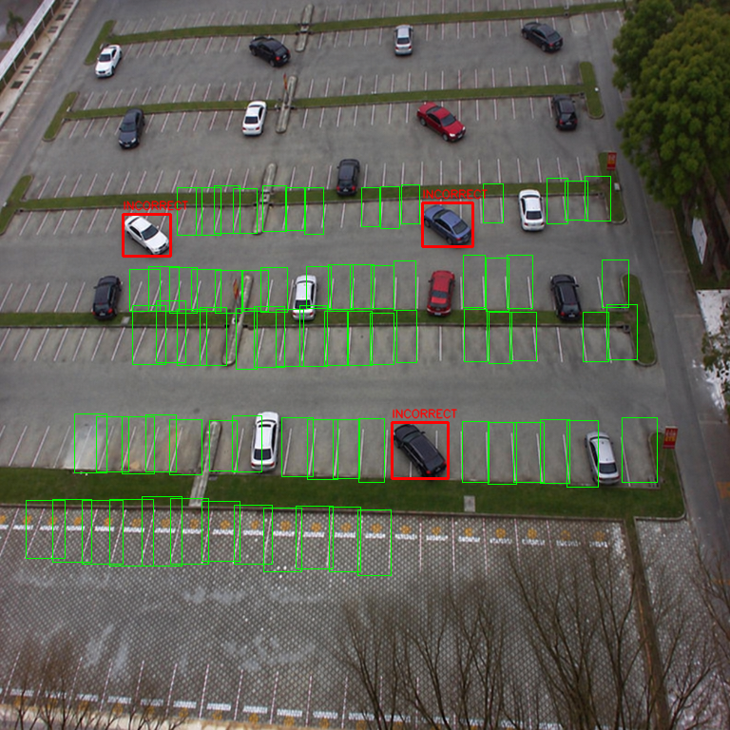  latest_20261012_192541_03_Pasted_Image_3.png
PPT recommendation: Not validated ground truth. If shown, describe as a sample model overlay and state that red boxes need human review.

9. What can safely be claimed in a presentation

Accurate, defensible statements
- “We built a prototype that combines a YOLOv8 slot detector, a pretrained vehicle detector, and a geometric rule-based classifier.”
- “On the documented PKLot-derived test split, the slot detector achieved mAP@0.50 of 0.9795 and mAP@0.50:0.95 of 0.9770.”
- “The dataset contains empty/occupied parking-space labels, but no individual vehicle footprints or wrong-parking labels.”
- “On three illustrative attached images, the pipeline returned 57 vehicle detections, 210 slot predictions, and 6 red flags; these attachment-run counts are not accuracy measurements.”
- “The system uses an uncertain state to avoid forcing a decision when slot matching or geometry is ambiguous.”

Claims to avoid
- “The system detects parking violations with 99% accuracy.” (Not measured.)
- “All red cars are illegally parked.” (No ground-truth validation.)
- “Every green box is a confirmed empty space.” (No attachment-level evaluation.)
- “There are only 6 violations in the images.” (Red output is not a complete or verified count.)
- “No red boxes means no violations.” (Image 2 demonstrates why this inference is invalid.)

Recommended figure caption
“Illustrative inference output: green boxes denote predicted available slots and red boxes denote geometry-based possible parking violations. These overlays are prototype predictions and have not been validated as violation classifications against manually labeled ground truth.”

10. Limitations, risks, and improvement plan
Limitation | Observed / root cause | Recommended next step
No violation ground truth | Training export labels slot state only. | Create a camera-specific labeled set: vehicle boxes, slot polygons, and violation/valid/uncertain labels.
General vehicle detector | COCO YOLOv8n is not fine-tuned for small aerial parking cars. | Label and fine-tune vehicle detector on representative camera views; report AP/recall on held-out scenes.
Slot-domain failure | One recent scene had 7 slot detections despite 21 vehicle detections. | Investigate crop/scale/perspective; fine-tune using similar scenes and test multiple camera conditions.
Axis-aligned geometry | Rotated/perspective bays and loose car rectangles distort overlap ratios. | Use calibrated camera perspective and polygon/quadrilateral slot boundaries.
Threshold trade-off | Conservative red cutoff reduces false alarms but misses violations. | Choose thresholds on a manually labeled validation set; publish confusion matrix and precision/recall.
Single still frame | No temporal evidence; occlusion and partial detections are unresolved. | Add tracking and temporal smoothing only after measuring per-frame and per-track performance.
Possible false red / missed red | Red is a rules-based geometric result, not a learned violation class. | Human-review workflow; save uncertain detections and audit false positives/negatives.

Minimum evaluation plan before claiming violation accuracy
- Collect diverse images from the exact target camera and day/night/weather conditions.
- Have at least two reviewers label each vehicle as valid, violation, or uncertain; define boundary/straddling rules before annotation.
- Split by camera/time/location—not just random neighboring frames—to reduce leakage.
- Report vehicle detection precision/recall/AP separately from slot detection.
- For violation classification report TP, FP, FN, TN, precision, recall, F1, and a confusion matrix; include confidence intervals and per-scene breakdown.
- Set a false-alarm target with the intended user; choose thresholds on validation only and reserve a final test set.
- Audit failure cases, especially missed small vehicles, occlusion, misaligned slot boxes, and false red labels.

11. Ready-to-copy PowerPoint outline and speaker notes

Slide 1 - Title
Slide text: Smart Parking Detection System
Speaker note: Show one original parking-lot photo. Subtitle: YOLOv8 slot detection plus vehicle/slot geometry.

Slide 2 - Problem and goal
Slide text: Many spaces and vehicles make manual availability/violation review slow. Goal: automate candidate slot availability and flag possible violations for review.
Speaker note: Avoid promising autonomous enforcement.

Slide 3 - Data
Slide text: 12,416 images; 8,691 train / 2,483 validation / 1,242 test; labels are empty/occupied spaces only.
Speaker note: State explicitly that vehicle and wrong-parking labels are absent.

Slide 4 - System pipeline
Slide text: Slot detector -> vehicle detector -> geometric overlap -> RED / GREEN / uncertain output.
Speaker note: Use a simple 4-box diagram; define red as possible violation.

Slide 5 - Slot-model result
Slide text: Show mAP@0.50 0.9795 and mAP@0.50:0.95 0.9770 for slot detection.
Speaker note: Put “slot detector only; not violation accuracy” directly beside metrics.

Slide 6 - Example output 1
Slide text: Use image pair 1 only as an illustrative output after checking each red box.
Speaker note: Caption it as an unvalidated model overlay.

Slide 7 - Example output 3
Slide text: Use image pair 3 as a second qualitative example, with the same caveat.
Speaker note: Do not count red labels as verified violations.

Slide 8 - Failure case
Slide text: Show pair 2: 7 slots detected, 21 vehicles uncertain, zero red predictions.
Speaker note: Explain that zero red does not mean zero violations.

Slide 9 - Limitations and improvement
Slide text: No violation labels; small aerial vehicles; box geometry/perspective; threshold trade-off.
Speaker note: Present camera-specific annotation and validation as next steps.

Slide 10 - Conclusion
Slide text: The prototype demonstrates a workable pipeline and strong slot-detector benchmark; violation decisions still need labeled validation.
Speaker note: End with measured evidence and the planned evaluation.

12. Technical appendix and artifact inventory
Artifact | Location / description
Latest annotated image 1 | myfold/attached_image/latest_20261012_192541_01_Pasted_Image.png
Latest annotated image 2 (failure example) | myfold/attached_image/latest_20261012_192541_02_Pasted_Image_2.png
Latest annotated image 3 | myfold/attached_image/latest_20261012_192541_03_Pasted_Image_3.png
Run summary | myfold/attached_image/latest_20261012_192541_summary.json
Slot checkpoint | weights/slot_det_best.pt
Vehicle checkpoint | weights/yolov8n.pt
Threshold configuration | configs/thresholds.yaml
Slot model metrics | new_model/slot_metrics.json
Training arguments | new_model/args.yaml

Reproducibility notes
- The three latest images were processed locally using the active project weights and current configs/thresholds.yaml.
- The run used CPU inference; configured inference sizes were 1280 for vehicles and 640 for slots, with tiled inference disabled.
- The summary records per-image counts and latency; no ground-truth labels were supplied for these three attachments.
- Keep source images and annotated predictions side-by-side in the PPT so viewers can distinguish input from model output.

Final conclusion
The project is a promising prototype for parking-space monitoring. Its slot model has strong reported test metrics on the space-label task, and the geometric pipeline can produce useful candidate alerts. However, the current evidence does not establish reliable wrong-parking accuracy. The next essential milestone is a manually labeled, camera-specific vehicle/violation dataset followed by a held-out evaluation that reports false alarms and missed violations separately.

