SMART PARKING
DETECTION SYSTEM
Full project report, visual results, formulas, and code walkthrough
Prepared 12 October 2026 | Inference batch: 20261012_223506
CRITICAL EVALUATION NOTE
The high reported test metrics measure parking-slot detection, not correct/incorrect parking decisions. The dataset has no manually labeled violation class. Red overlays are possible-violation alerts from geometry and require human verification.
Includes all eight latest input/output image pairs and teacher-ready technical explanations.

1. Executive summary
This project is a computer-vision prototype for parking-lot monitoring. A YOLOv8 model predicts parking-space boxes and labels them empty or occupied. A separate pretrained model predicts vehicle boxes. A geometry-based rule then compares vehicles with parking spaces to identify candidate free spaces and possible parking violations.
- Latest batch: 8 attached images processed with slot_det_best.pt and yolov8n.pt on CPU.
- Combined output: 116 vehicle detections, 817 slot predictions, 581 free-slot predictions, 17 red possible-violation predictions, 31 vehicles labeled confidently correct (and omitted from red/green-only render), and 68 uncertain detections.
- These are prediction counts, not accuracy measurements. The uploaded scenes do not include ground-truth vehicle or violation annotations.
- The slot detector has strong reported test metrics on the parking-space task. Wrong-parking precision, recall, F1, and accuracy remain unavailable without labeled violations.
- All 8 input images and all 8 corresponding annotated outputs are included later in this report. Images 5 and 6 are selected as visually plausible red-alert examples, not certified correct classifications.

2. Project problem, aims, and scope

Problem
A parking scene has many adjacent spaces and vehicles, often viewed obliquely from a high camera. Determining open spaces and spotting a vehicle that crosses bay boundaries is difficult to automate because cars may be small, slot markings may be faint, and the perspective changes across the image.

Aims
- Detect parking spaces and classify the dataset labels space-empty / space-occupied.
- Detect visible vehicles using a general-purpose vehicle model.
- Estimate vehicle-to-space overlap and flag likely multi-space intrusions.
- Keep ambiguous cases uncertain instead of forcing a correct/wrong decision.
- Render visual overlays that a human operator can inspect.

Scope / exclusions
This is a still-image prototype, not a deployed enforcement system. It does not identify drivers, read license plates, determine local parking law, or prove a violation. It does not use temporal tracking in the attached-image batch.

3. Dataset, labels, and what they mean
The project uses a PKLot-derived Roboflow export documented as 12,416 640x640 images: 8,691 train, 2,483 validation, and 1,242 test. The two trained classes are parking-space categories:
Class id | Class name | Ground-truth meaning
0 | space-empty | An annotated parking-space region labeled empty.
1 | space-occupied | An annotated parking-space region labeled occupied.

- The labels are for parking spaces, not separate car silhouettes.
- There is no wrong-parking/violation class in this export.
- Occupied space does not mean “incorrectly parked”; it means only that the space annotation is occupied.
- The annotations are axis-aligned boxes; real parking bays may be rotated or perspective-distorted.

4. Model architecture and inference flow
Stage | Model / method | What it produces
1. Parking-space detection | YOLOv8s checkpoint: weights/slot_det_best.pt | space-empty and space-occupied bounding boxes.
2. Vehicle detection | COCO-pretrained YOLOv8n: weights/yolov8n.pt | Candidate vehicle bounding boxes; not custom-trained on these submitted camera images.
3. Geometry | Shapely polygon/rectangle intersections | Inside, outside, slot-coverage, and adjacent-slot intrusion ratios.
4. Rule classification | Threshold-based classifier | WRONG_PARKING, CORRECT_PARKING, or UNCERTAIN.
5. Output rendering | OpenCV rectangles and labels | Green = predicted usable free slot; red = possible incorrect parking; correct/uncertain cars omitted.

End-to-end sequence
- Read image and run the slot detector.
- Read image and run the vehicle detector.
- For each vehicle, calculate overlap with every predicted slot and choose the largest eligible vehicle-inside ratio as its primary slot.
- Check whether the car appears much larger than a slot and intrudes into a second slot beyond a tolerance band.
- If no straddle is found, check whether a sufficiently large share of the car box lies outside the assigned space.
- Emit a red flag only when a configured rule passes; otherwise classify as correct only for a strong single-space fit, or leave uncertain.
- Draw green boxes for free-space predictions and red boxes for possible violations.

5. Geometry formulas used by the classifier
Let B be the detected vehicle bounding box, S a parking-slot bounding box/polygon, A(X) the area of region X, and ∩ the geometric intersection.
Name | Formula | Plain-English meaning
Vehicle inside ratio, R_vehicle | A(B ∩ S) / A(B) | Fraction of the detected vehicle rectangle lying inside one slot.
Slot coverage ratio, R_slot | A(B ∩ S) / A(S) | Fraction of the slot rectangle covered by the vehicle box.
Outside ratio, R_outside | 1 - R_vehicle | Estimated fraction of vehicle box outside that one slot.
Intersection over Union, IoU | A(B ∩ S) / A(B ∪ S) | Overlap relative to combined vehicle + slot box area.
Second-slot intrusion, R_intrude | A(B ∩ (S2 minus buffered S1)) / A(B) | Vehicle fraction inside adjacent slot S2 after excluding primary slot S1 plus tolerance buffer.

Decision rules in the current configuration
- Primary slot assignment: R_vehicle >= 0.30 (slot_assign_min).
- Single-slot red rule: confident vehicle and R_outside >= 0.70 (wrong_parking_min_outside_ratio).
- Straddle red rule: car is at least 1.50x the assigned slot size in one dimension and R_intrude >= 0.20; a separate stricter fallback may apply for strongly elongated boxes.
- Correct/blue internal status (not drawn in the latest outputs): strong fit thresholds or at least 0.50 inside one unambiguous slot.
- No strong assignment, low confidence, competing slots, or borderline overlap -> UNCERTAIN.
Important caveat: These are ratios of model-predicted rectangles, not true vehicle footprints or legal boundaries. A geometric rule can be wrong when either detector box is inaccurate.

6. Important code excerpts for explaining the project
The snippets below are short, teacher-readable excerpts matching the project logic. They illustrate the equations and rules without requiring a presentation audience to read the entire source repository.

6.1 Compute vehicle/slot overlap ratios
# For vehicle region B and slot region S:
R_vehicle = area(intersection(B, S)) / area(B)
R_slot = area(intersection(B, S)) / area(S)
R_outside = 1.0 - R_vehicle

# Source implementation concept (src/geometry.py):
intersection = vehicle_polygon.intersection(slot_polygon).area
r_vehicle = intersection / vehicle_polygon.area
r_slot = intersection / slot_polygon.area
r_outside = 1.0 - r_vehicle

In the code, degenerate zero-area boxes are guarded so the division is not performed when the relevant area is zero.

6.2 Choose primary slot
metrics = [compute_overlap_metrics(vehicle, slot) for slot in slots]
metrics.sort(key=lambda item: item.r_vehicle, reverse=True)
primary = metrics[0] if metrics and metrics[0].r_vehicle >= slot_assign_min else None

The slot that contains the largest fraction of the vehicle box is the primary candidate, provided it passes the minimum assignment threshold.

6.3 Adjacent-slot intrusion and red classification
tolerance = min(vehicle_width, vehicle_height) * boundary_tolerance_ratio
intrusion = vehicle_intrusion_ratio_beyond_tolerance(
vehicle, adjacent_slot, primary_slot, tolerance
)

if car_is_large_relative_to_slot and intrusion >= 0.20:
status = "WRONG_PARKING" # possible straddle alert
elif confident and primary.r_outside >= 0.70:
status = "WRONG_PARKING" # most of vehicle box outside one slot
elif strong_single_slot_fit and not_competing_slot:
status = "CORRECT_PARKING"
else:
status = "UNCERTAIN"

Simplification note: The production implementation also checks vehicle confidence, slot-size ratio, competing slot overlap, and elongated-box fallback. The excerpt is explanatory pseudocode, not a complete drop-in implementation.

6.4 Main application call flow
slot_detector, vehicle_detector = load_models(
slot_weights="weights/slot_det_best.pt",
vehicle_weights="weights/yolov8n.pt",
device="cpu",
...
)
frame_result, annotated, latency_ms = process_image(
image, slot_detector, vehicle_detector, thresholds
)
# frame_result contains vehicle and slot classifications
# annotated image is drawn and saved as a PNG

7. Training and reported evaluation metrics

Training setup
Parameter | Recorded configuration
Model / task | YOLOv8s / object detection
Epochs | 50
Image size | 640
Batch size | 16
Seed | 42
Classes | space-empty, space-occupied
Checkpoint | weights/slot_det_best.pt

Held-out slot-test metrics (Kaggle run)
Metric | Value | Meaning
Precision | 99.84% | Among predicted slot boxes, share matching a labeled slot under evaluation criteria.
Recall | 97.97% | Among labeled slots, share found by the detector.
mAP@0.50 | 97.95% | Mean average precision at IoU 0.50 for slot classes.
mAP@0.50:0.95 | 97.70% | Average mAP across IoU thresholds 0.50 through 0.95, as recorded in the Kaggle metrics file.

Source: new_model/slot_metrics.json. These numbers apply only to the slot detector on its recorded test split; they are not vehicle or violation metrics.

Separate local 100-image evaluation (do not merge with above)
Class / metric | Precision | Recall | mAP@0.50 | mAP@0.50:0.95
space-empty | 93.1% | 97.3% | 98.2% | 66.0%
space-occupied | 96.7% | 94.0% | 98.7% | 59.9%
All slot classes | 94.9% | 95.6% | 98.4% | 62.9%

Source: outputs/evaluation/eval_log.txt and outputs/evaluation/slot_metrics.json. This is a separate local evaluation of 100 images using a different split/metric record. Keep it distinct from the 1,242-image Kaggle test result.

Metrics that cannot currently be claimed
- Wrong-parking precision: unavailable.
- Wrong-parking recall: unavailable.
- Wrong-parking F1 / accuracy / confusion matrix: unavailable.
- Custom camera-scene vehicle detector precision/recall: not established by the supplied parking-slot labels.
To compute violation metrics, each test vehicle must have a verified ground-truth label (for example, valid / violation / uncertain) and be matched consistently to model predictions.

8. Results from latest eight attached images
Batch ID 20261012_223506. All images were processed using the current slot and vehicle weights, CPU inference, thresholds in configs/thresholds.yaml, vehicle image size 1280, slot image size 640, and tiled_inference=false.
# | Size | Veh. | Slots | Free* | Red* | Correct* | Uncertain | Latency
1 | 768x768 | 16 | 100 | 76 | 3 | 2 | 11 | 2.36s
2 | 768x768 | 20 | 103 | 72 | 3 | 4 | 13 | 2.05s
3 | 768x768 | 6 | 104 | 90 | 2 | 1 | 3 | 1.20s
4 | 768x768 | 8 | 104 | 88 | 2 | 1 | 5 | 1.37s
5 | 768x768 | 2 | 106 | 99 | 1 | 0 | 1 | 0.90s
6 | 768x768 | 2 | 100 | 89 | 1 | 0 | 1 | 0.86s
7 | 768x768 | 54 | 100 | 38 | 5 | 19 | 30 | 4.30s
8 | 640x640 | 8 | 100 | 29 | 0 | 4 | 4 | 1.26s
TOTAL | 8 imgs | 116 | 817 | 581 | 17 | 31 | 68 | 14.29s

*Every quantity marked with an asterisk in this table is a model prediction/output count, not a verified truth count. “Correct omitted” means the classifier assigned CORRECT_PARKING and the vehicle box was not drawn in the red/green-only overlay.

Aggregate interpretation
- The system emitted 17 red possible-violation alerts across 116 detected vehicles.
- 68 vehicle detections stayed uncertain; they must not be counted as correct or as wrong.
- 581 predicted free slots were drawn across the eight images; without annotated slot truth for these images, free-slot precision/recall on this batch cannot be calculated.
- A count of zero red predictions on an image would not prove there are no violations; the classifier can miss violations or leave vehicles uncertain.

9. Representative images and all eight input/output pairs
The next eight pages contain every original input next to its corresponding model output. The overlays show green predicted-free slots and red possible incorrect-parking flags. In this dataset, no car-level ground-truth violation labels exist, so examples that appear visually plausible are not guaranteed correct classifications.

Image pair 1 - Latest inference example
16 vehicle detections | 100 slot predictions | 76 free-slot predictions | 3 red alerts | 11 uncertain
Qualitative model output only; not a labeled validation example.
INPUT IMAGE  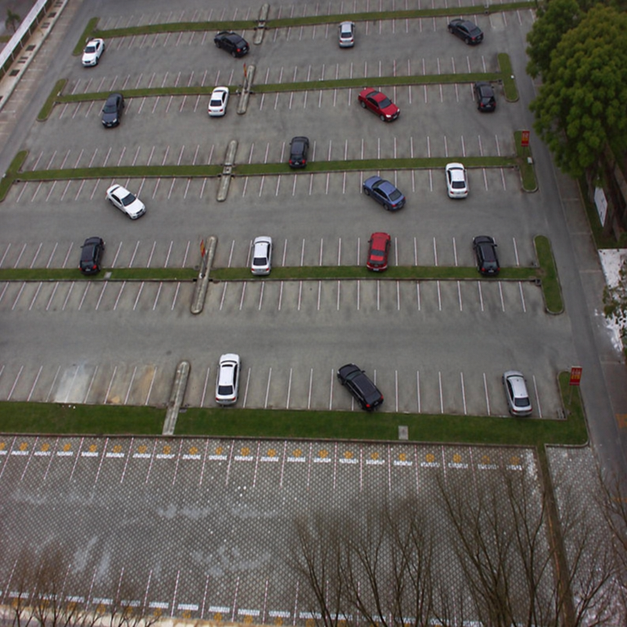  Pasted Image.png | MODEL OUTPUT  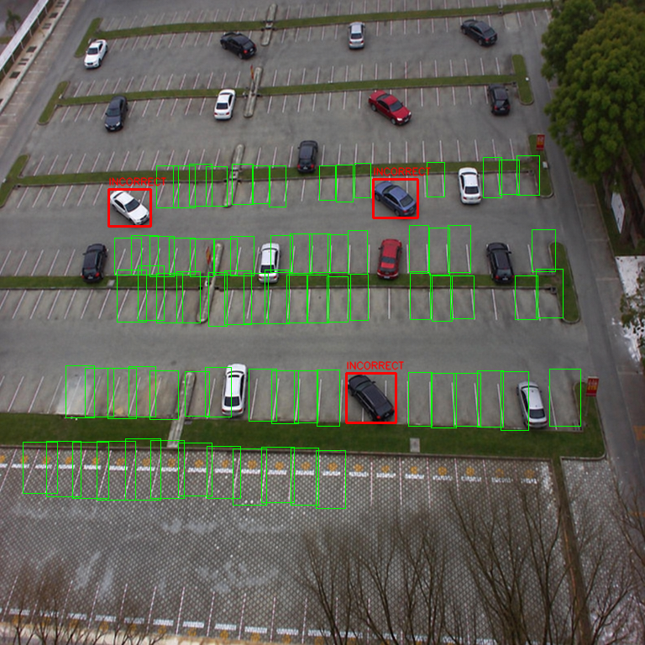  latest_20261012_223506_01_Pasted_Image_1.png
Teacher explanation: The left panel is the original scene. The right panel overlays predicted empty-space boxes in green and possible violation boxes in red. Uncertain vehicle boxes are intentionally not drawn in this simplified output.

Image pair 2 - Latest inference example
20 vehicle detections | 103 slot predictions | 72 free-slot predictions | 3 red alerts | 13 uncertain
Qualitative model output only; not a labeled validation example.
INPUT IMAGE  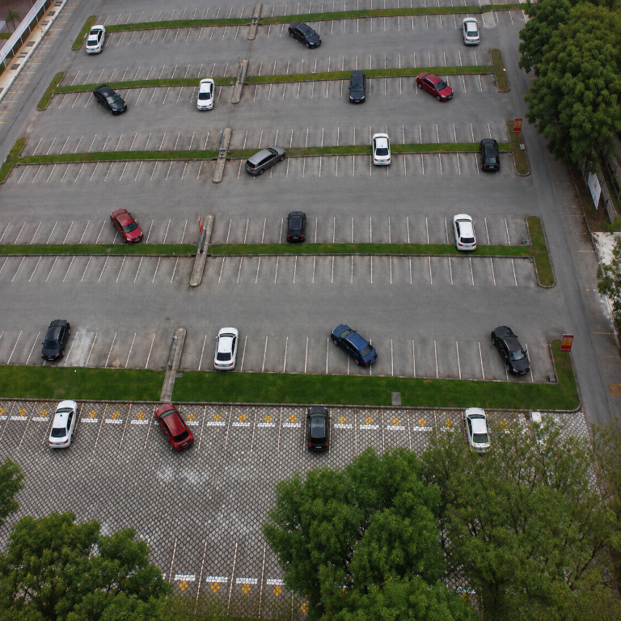  Pasted Image 2.png | MODEL OUTPUT  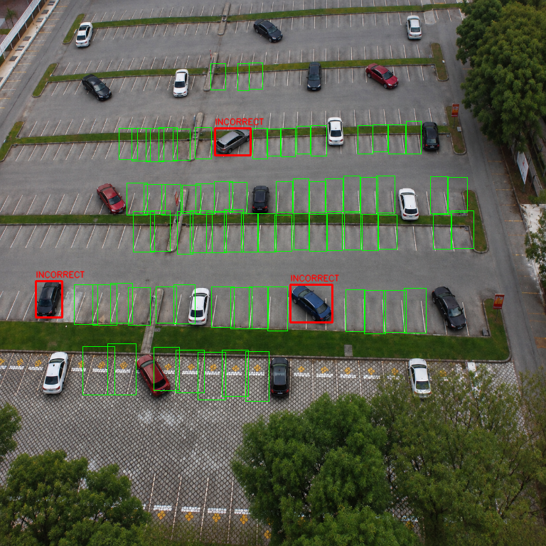  latest_20261012_223506_02_Pasted_Image_2.png
Teacher explanation: The left panel is the original scene. The right panel overlays predicted empty-space boxes in green and possible violation boxes in red. Uncertain vehicle boxes are intentionally not drawn in this simplified output.

Image pair 3 - Latest inference example
6 vehicle detections | 104 slot predictions | 90 free-slot predictions | 2 red alerts | 3 uncertain
Qualitative model output only; not a labeled validation example.
INPUT IMAGE  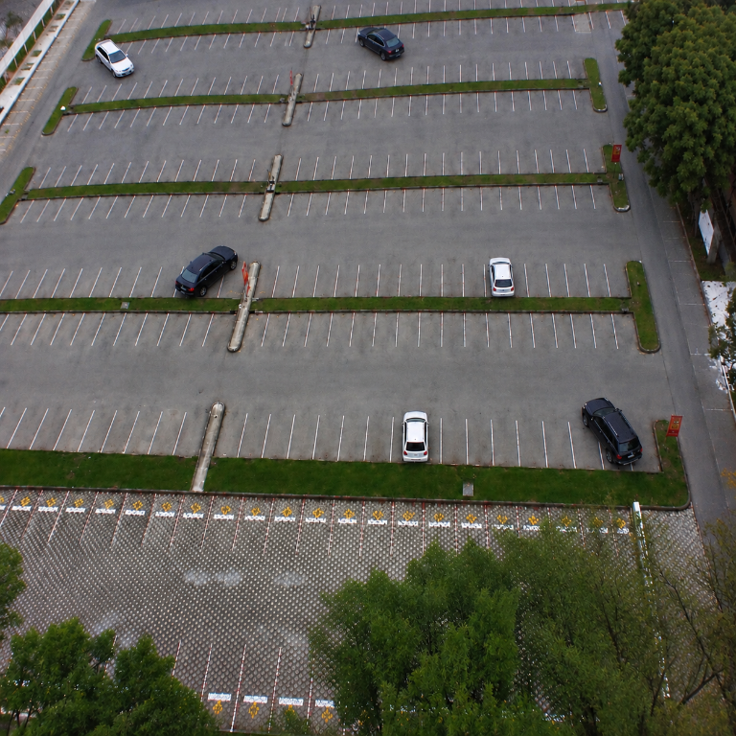  Pasted Image 3.png | MODEL OUTPUT  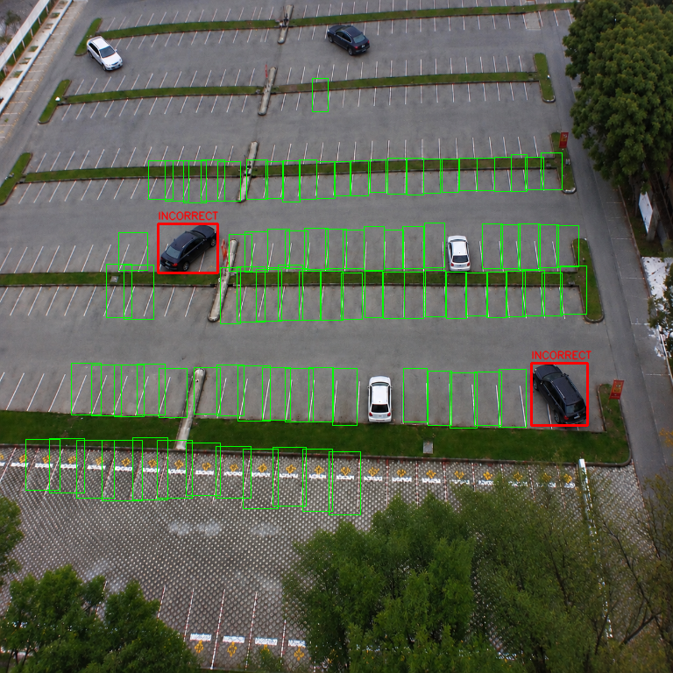  latest_20261012_223506_03_Pasted_Image_3.png
Teacher explanation: The left panel is the original scene. The right panel overlays predicted empty-space boxes in green and possible violation boxes in red. Uncertain vehicle boxes are intentionally not drawn in this simplified output.

Image pair 4 - Latest inference example
8 vehicle detections | 104 slot predictions | 88 free-slot predictions | 2 red alerts | 5 uncertain
Qualitative model output only; not a labeled validation example.
INPUT IMAGE  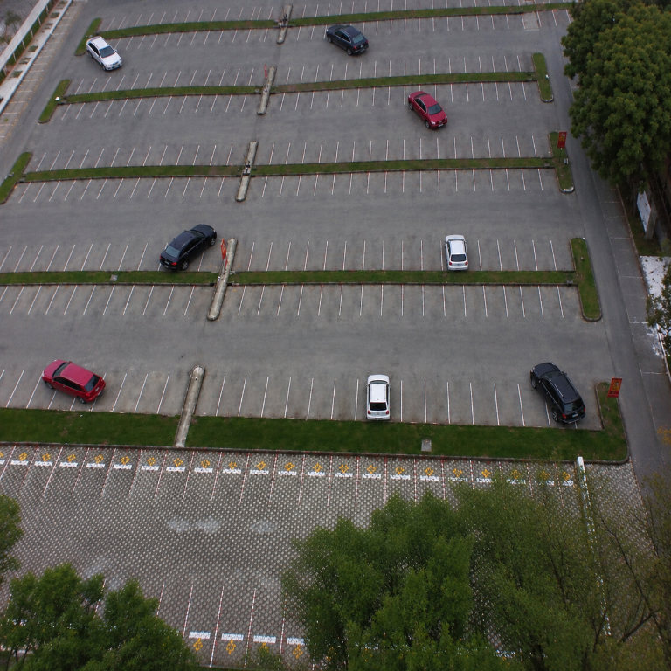  Pasted Image 4.png | MODEL OUTPUT  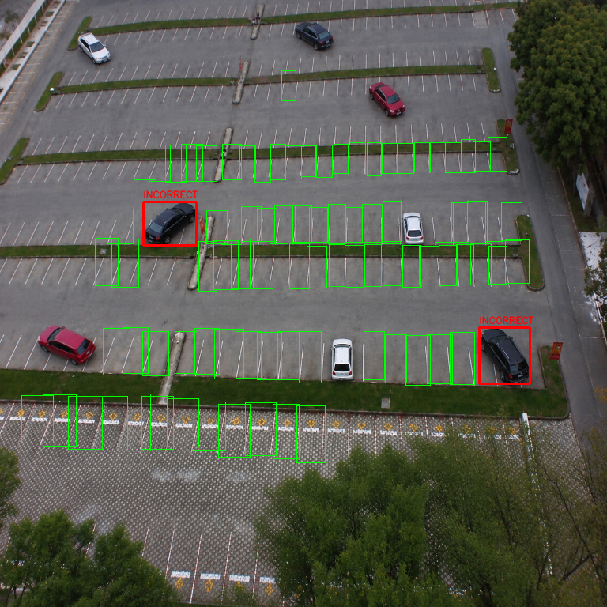  latest_20261012_223506_04_Pasted_Image_4.png
Teacher explanation: The left panel is the original scene. The right panel overlays predicted empty-space boxes in green and possible violation boxes in red. Uncertain vehicle boxes are intentionally not drawn in this simplified output.

Image pair 5 - Latest inference example
2 vehicle detections | 106 slot predictions | 99 free-slot predictions | 1 red alerts | 1 uncertain
Selected as a visually plausible example of the geometry-based alert on a vehicle near bay boundaries. Do not label “verified correct” without human annotation against the exact parking rules.
INPUT IMAGE  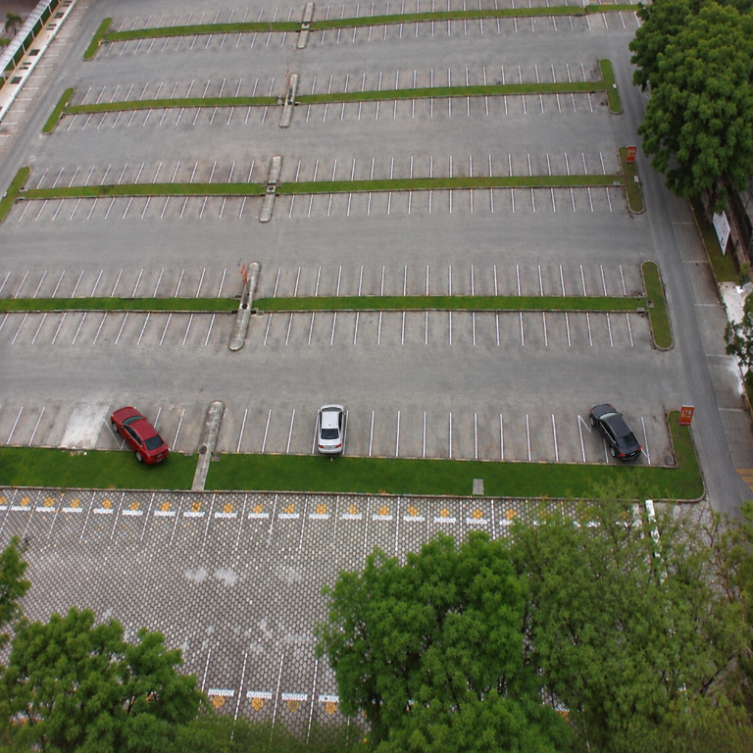  Pasted Image 5.png | MODEL OUTPUT  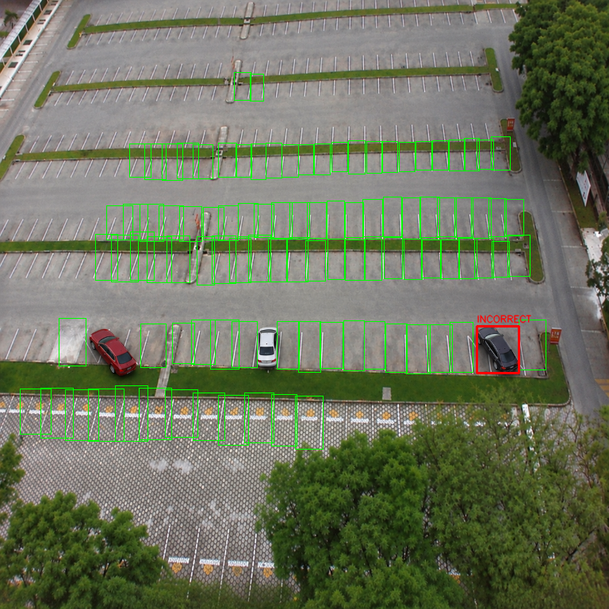  latest_20261012_223506_05_Pasted_Image_5.png
Teacher explanation: The left panel is the original scene. The right panel overlays predicted empty-space boxes in green and possible violation boxes in red. Uncertain vehicle boxes are intentionally not drawn in this simplified output.

Image pair 6 - Latest inference example
2 vehicle detections | 100 slot predictions | 89 free-slot predictions | 1 red alerts | 1 uncertain
Selected as a visually plausible example of the geometry-based alert on a vehicle near bay boundaries. Do not label “verified correct” without human annotation against the exact parking rules.
INPUT IMAGE  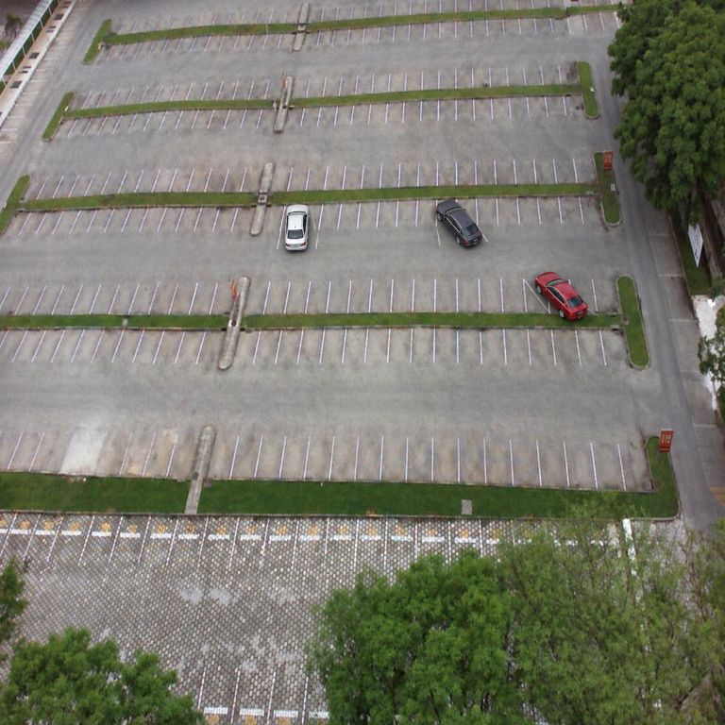  Pasted Image 6.png | MODEL OUTPUT  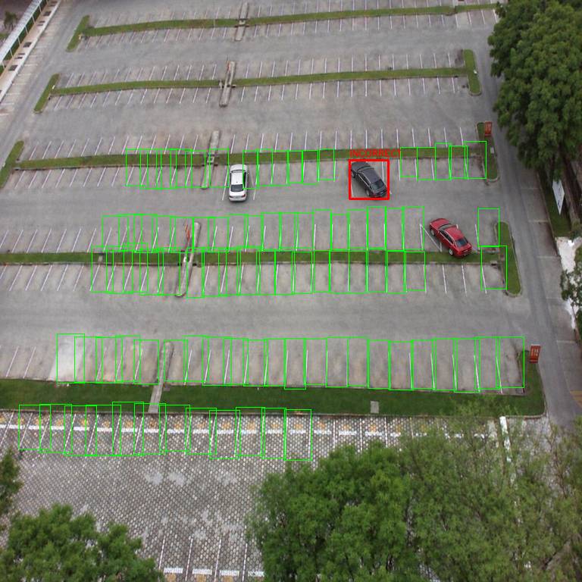  latest_20261012_223506_06_Pasted_Image_6.png
Teacher explanation: The left panel is the original scene. The right panel overlays predicted empty-space boxes in green and possible violation boxes in red. Uncertain vehicle boxes are intentionally not drawn in this simplified output.

Image pair 7 - Latest inference example
54 vehicle detections | 100 slot predictions | 38 free-slot predictions | 5 red alerts | 30 uncertain
Dense-scene stress example. Many detections remain uncertain; red overlays should be manually reviewed.
INPUT IMAGE  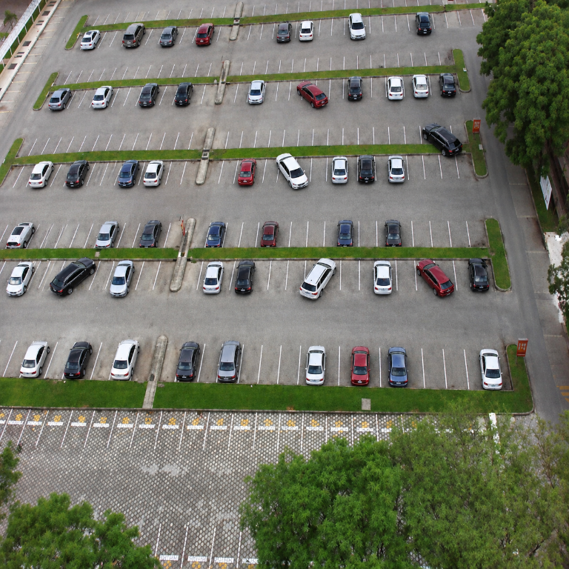  Pasted Image 7.png | MODEL OUTPUT  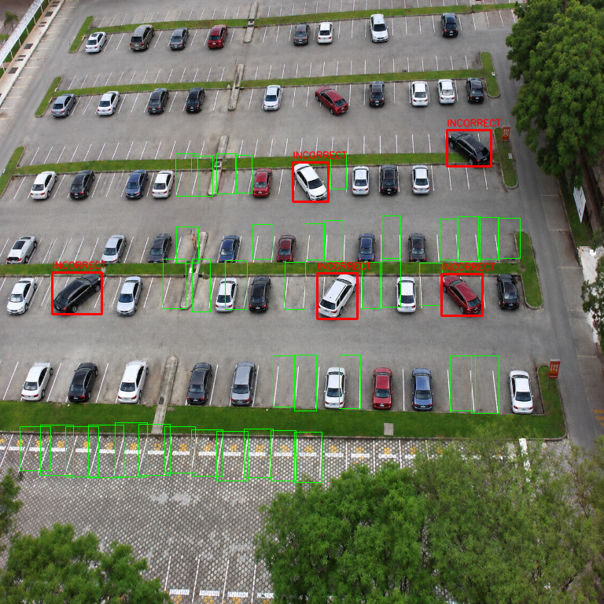  latest_20261012_223506_07_Pasted_Image_7.png
Teacher explanation: The left panel is the original scene. The right panel overlays predicted empty-space boxes in green and possible violation boxes in red. Uncertain vehicle boxes are intentionally not drawn in this simplified output.

Image pair 8 - Latest inference example
8 vehicle detections | 100 slot predictions | 29 free-slot predictions | 0 red alerts | 4 uncertain
Qualitative model output only; not a labeled validation example.
INPUT IMAGE  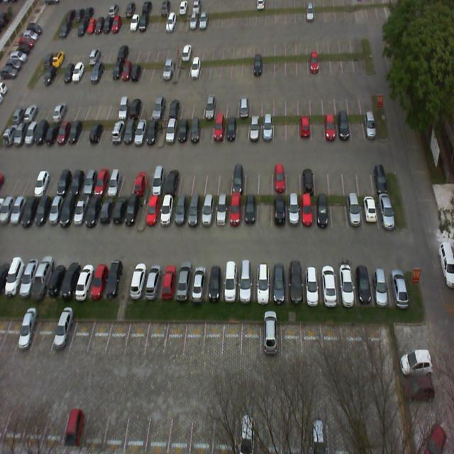  Pasted Image 8.jpe | MODEL OUTPUT  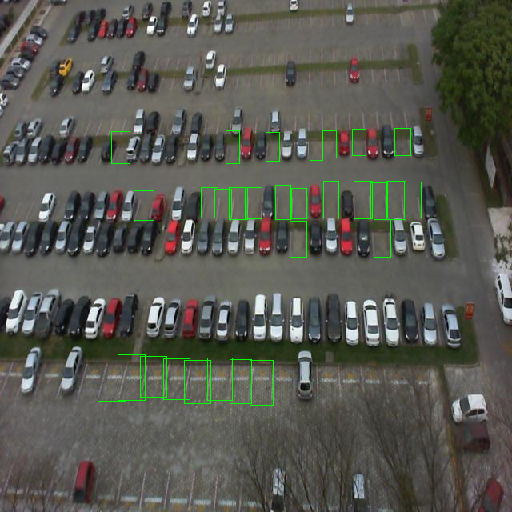  latest_20261012_223506_08_Pasted_Image_8.png
Teacher explanation: The left panel is the original scene. The right panel overlays predicted empty-space boxes in green and possible violation boxes in red. Uncertain vehicle boxes are intentionally not drawn in this simplified output.

10. Strengths, limits, and risks
Strength | Limitation / risk
Trained space detector distinguishes empty and occupied slots. | High slot metrics do not transfer to vehicle/violation accuracy.
Geometry provides an explainable rule for a red alert. | A box is not a true car footprint; perspective and slot-box error can cause false reds or misses.
Uncertain state prevents some forced classifications. | The 68 uncertain detections in the latest batch reduce coverage; omitted from red-only visualization.
Image output is easy to inspect. | Visual examples without truth labels cannot prove precision, recall, or accuracy.
Thresholds are configurable. | Changing thresholds trades missed alerts against false alarms; requires camera-specific calibration.

Recommended development plan
- Collect and annotate representative target-camera scenes with vehicle boxes, exact slot polygons, and valid/violation/uncertain labels.
- Create train/validation/test splits by scene, camera, date, or lot to prevent near-duplicate leakage.
- Fine-tune a vehicle detector using true vehicle-instance labels from the target camera, especially small aerial vehicles.
- Use calibrated perspective-aware slot polygons rather than one-size axis-aligned rectangles.
- Tune thresholds only on labeled validation data.
- On the held-out set report per-class precision, recall, F1, AP, confusion matrix, false alarms per image, and missed violations.
- Have a human verify alerts before any enforcement use.

11. Teacher-ready presentation outline and short script

Slide 1 - Project title
Slide content: Smart Parking Detection System
Speaker script: “This is a prototype that combines parking-space detection, vehicle detection, and geometric rules to flag possible parking violations.”

Slide 2 - Problem
Slide content: Parking-lot occupancy and boundary violations are difficult to review manually.
Speaker script: “The system aims to identify candidate free spaces and possible bay intrusions from a camera image.”

Slide 3 - Data
Slide content: 12,416 images; 8,691 train / 2,483 validation / 1,242 test; space-empty and space-occupied labels.
Speaker script: “The training data labels spaces, not individual vehicles or violations.”

Slide 4 - Architecture
Slide content: Slot detector -> vehicle detector -> overlap geometry -> decision -> overlay.
Speaker script: “The first model predicts spaces, a pretrained detector predicts vehicles, and rules compare their boxes.”

Slide 5 - Formula
Slide content: R_vehicle = intersection area / vehicle area; R_outside = 1 - R_vehicle.
Speaker script: “If a confident car lies mostly outside its assigned slot, or significantly intrudes into an adjacent bay, it may receive a red candidate alert.”

Slide 6 - Slot-model results
Slide content: Kaggle full test: P 99.84%, R 97.97%, mAP50 97.95%, mAP50-95 97.70%.
Speaker script: “These are space-detection metrics only, not violation-classification results.”

Slide 7 - Qualitative images
Slide content: Show a selected input/output pair, preferably image pair 5 or 6, with caveat.
Speaker script: “This example shows the model output; red boxes need human verification because the dataset has no violation labels.”

Slide 8 - Batch summary
Slide content: 8 images: 116 vehicle detections; 17 red flags; 68 uncertain.
Speaker script: “These are raw prediction counts; they cannot be interpreted as precision or recall.”

Slide 9 - Limitations
Slide content: No labeled violation test set; perspective/box mismatch; vehicle detector not specialized for these aerial images.
Speaker script: “The next step is to collect annotated target-camera data and evaluate false positives and missed violations.”

Slide 10 - Conclusion
Slide content: Working prototype, strong slot benchmark, violation classifier still requires validation.
Speaker script: “The system can help a person review parking scenes, but it is not yet an independently validated enforcement tool.”

12. Teacher questions and concise answers
Question | Short answer
What does the model detect? | The trained custom model detects empty and occupied parking spaces. A pretrained COCO model detects vehicles.
How does it call something wrongly parked? | It compares the vehicle box with predicted slot boxes using inside/outside overlap and adjacent-slot intrusion thresholds.
What does 99.84% precision mean? | For the recorded full test run, it is slot-box precision under the detector’s matching criteria. It is not the precision of red violation alerts.
How many wrong-parking labels were used to train? | None in the documented PKLot export. Wrong parking is a hand-coded geometry heuristic, not a learned class.
Can we report wrong-parking accuracy now? | No. We need manually labeled violations and a held-out evaluation before computing precision, recall, F1, or accuracy.
Why are some cars uncertain or not detected? | The vehicle model is general-purpose; small objects, occlusion, perspective, weak slot detections, and ambiguous overlaps can reduce confidence.
Is the output ready for automated enforcement? | No. Treat red boxes as review candidates; human verification and validated camera-specific metrics are required.

13. Reproducibility and artifact paths
Artifact | Project path
Full 8-image summary | myfold/attached_images/latest_20261012_223506_summary.json
Eight annotated outputs | myfold/attached_images/latest_20261012_223506_01_Pasted_Image_1.png through ..._08_Pasted_Image_8.png
Slot model metrics | new_model/slot_metrics.json
Separate local class metrics | outputs/evaluation/eval_log.txt and outputs/evaluation/slot_metrics.json
Thresholds | configs/thresholds.yaml
Classifier implementation | src/parking_classifier.py
Geometry implementation | src/geometry.py
Inference implementation | src/inference.py
Training configuration | new_model/args.yaml

Inference run configuration: local Python environment, CPU, current weights, thresholds loaded from configs/thresholds.yaml, vehicle image size 1280, slot image size 640, tiled inference disabled. The run summary records per-image counts and latency.

14. Final conclusion
The system demonstrates an end-to-end prototype and the trained parking-space detector has strong recorded benchmark metrics. The attached-image run also demonstrates explainable geometry-based candidate alerts. However, the project has not established wrong-parking precision or recall because the available annotations contain no verified violations. The scientifically accurate conclusion is that this system flags possible violations for human review; a labeled camera-specific evaluation is required before making accuracy claims or using it for enforcement.

