INTERNSHIP REPORT
A report submitted in partial fulfillment of the requirements for the Award of
Degree of
BACHELOR OF TECHNOLOGY
In
COMPUTER SCIENCE AND ENGINEERING
By
P. YUGENDRA
Regd. No.: 239Y1A05C2
Under Supervision of
BHARAT CARE LIFE LINE FOUNDATION
in association with ZERO P4 POVERTY
Project Title: Customer Churn Prediction Using Machine Learning
(Duration: 45-Day Internship, Summer 2026)

DEPARTMENT OF COMPUTER SCIENCE AND ENGINEERING
K.S.R.M. COLLEGE OF ENGINEERING
(An Autonomous Institution)
Approved by AICTE, New Delhi & Affiliated to JNTUA, Ananthapuramu
Accredited by NAAC with A+ Grade & B.Tech (EEE, ECE, CSE, CE and ME) Programs by NBA
KADAPA, ANDHRA PRADESH
2026 – 2027

DEPARTMENT OF COMPUTER SCIENCE AND ENGINEERING
K.S.R.M. COLLEGE OF ENGINEERING
(An Autonomous Institution)
KADAPA
CERTIFICATE
This is to certify that the Internship Report entitled "Customer Churn Prediction Using Machine Learning" submitted by P. Yugendra (Regd. No.: 239Y1A05C2) is a record of work carried out during the 45-Day Data Science Internship conducted under the AVISHKARANA ANDHRA SUMMER INTERNSHIP by BHARAT CARE LIFE LINE FOUNDATION, in association with ZERO P4 Poverty, from the summer of 2026, and submitted during the 2026 – 2027 academic year, in partial fulfillment of the requirements for the award of the degree of BACHELOR OF TECHNOLOGY in COMPUTER SCIENCE AND ENGINEERING at K.S.R.M. COLLEGE OF ENGINEERING, KADAPA.
The internship was completed under the guidance of A. Vamsi Reddy, Coordinator, Bharat Care Life Line Foundation. The certificate of achievement was issued on 15 August 2026.

Internship Coordinator | External Examiners | Head of the Department
A. Vamsi Reddy |  | Dr. P. V. Kishore
Coordinator, Bharat Care Life Line Foundation |  | Associate Professor & HoD, CSE

CERTIFICATION
The following certificate of achievement was issued to the candidate by BHARAT CARE LIFE LINE FOUNDATION on 15 August 2026 for the successful completion of the 45-Day Internship in Data Science under the Avishkarana Andhra Summer Internship programme.

Certificate of Achievement – 45-Day Internship in Data Science
The certificate is reproduced here as documentary evidence of the internship. The original document is available for verification.

K.S.R.M. COLLEGE OF ENGINEERING
(An Autonomous Institution Affiliated to JNTUA, Ananthapuramu)
Kadapa, Andhra Pradesh, India – 516 005
VISION
To emerge as a centre of excellence in technical education and research, nurturing psychologically strong, socially responsible and globally competent professionals for sustainable development.
MISSION
M1: To provide multidisciplinary education through enriched curricula, emerging technologies and effective pedagogical practices.
M2: To foster research, innovation and entrepreneurship through industry–academia linkage.
M3: To instill leadership skills and ethical values among professionals through community engagement, contributing to the development of society and the nation.
DEPARTMENT OF COMPUTER SCIENCE AND ENGINEERING
Vision
To emerge as a centre of excellence in Computer Science and allied fields, producing technically competent professionals imbued with ethical values who drive sustainable digital transformation.
Mission
M1: To empower learners through student-centred teaching, cutting-edge technologies, and a curriculum aligned with industry needs.
M2: To nurture a culture of research, innovation, and entrepreneurship, and to strengthen industry–academia partnerships that address real-world and societal challenges.
M3: To produce technically competent graduates with strong ethical values, a sense of social responsibility, and leadership capabilities, who continue to learn and contribute to sustainable digital transformation.

ACKNOWLEDGEMENT
First and foremost, I would like to express my sincere gratitude to BHARAT CARE LIFE LINE FOUNDATION and the AVISHKARANA ANDHRA SUMMER INTERNSHIP for providing me with the opportunity to undertake a 45-day internship in Data Science and to gain practical experience through the project titled "Customer Churn Prediction Using Machine Learning."
I am thankful to the ZERO P4 Poverty initiative for supporting the programme and for creating an environment in which students can apply classroom knowledge to real social and business problems.
I am deeply grateful to A. Vamsi Reddy, Coordinator, Bharat Care Life Line Foundation, for his constant guidance, patient reviews and constructive feedback throughout the internship. His suggestions shaped both the analytical work and the final report.
I am extremely thankful to our beloved Managing Director and Vice Chairman, Dr. K. Chandra Obul Reddy Garu, for his encouragement and support.
I am highly indebted to our Principal, Dr. T. Nageswara Prasad, for providing the necessary facilities and support to accomplish this internship.
I would like to express my sincere thanks to Dr. P. V. Kishore, Associate Professor and Head of the Department of CSE, for his constant encouragement and support throughout my academic work.
I am also grateful to Dr. V. Lokeswara Reddy, Professor and Internship Coordinator, Department of CSE, for his valuable guidance in obtaining and completing this internship.
I extend my sincere thanks to all the faculty members of the Department of Computer Science and Engineering, my friends and my family for their encouragement and help throughout the internship.
Finally, I would like to thank everyone who directly or indirectly contributed to the successful completion of this internship.
Name: P. Yugendra
Regd. No.: 239Y1A05C2

ABSTRACT
Customer churn is the loss of customers who stop using a company's product or service. In subscription-based industries such as telecommunications, churn directly reduces recurring revenue and increases the cost of replacing lost customers. Retention teams, however, cannot contact every customer. They need a ranked list of who is most likely to leave, an explanation of why, and a practical way to test retention options.
This project develops a complete machine learning system for customer churn prediction using the publicly available IBM Telco Customer Churn dataset, which contains 7,043 customers and 21 attributes covering demographics, subscribed services, contract details, billing and tenure. The data is cleaned, explored and enriched with three engineered features: the number of active services, average monthly spend and a new-customer flag. Three classification models—Logistic Regression, Random Forest and Histogram Gradient Boosting—are compared using stratified five-fold cross-validation.
Logistic Regression achieves the best cross-validated ROC-AUC (0.847) and is selected as the final model. On a held-out test set of 1,409 customers, it reaches a ROC-AUC of 0.846, a recall of 79.4%, a precision of 50.6% and an F1 score of 0.618. In practical terms, the model catches 297 of the 374 customers who actually churn. The results also show that contract type and tenure are the strongest signals: month-to-month customers churn at 42.7%, compared with 2.8% on two-year contracts.
The selected model is deployed in an interactive Streamlit application. The application shows a customer's churn probability, explains the factors behind the score, and re-scores the customer under alternative contract, payment and service scenarios. The project demonstrates a reproducible end-to-end data science workflow—from data preparation and model selection to evaluation, interpretation and deployment—and provides a practical decision-support tool for retention planning.
Keywords: customer churn; telecommunications; machine learning; logistic regression; ROC-AUC; recall; Streamlit; retention analytics.

Programmes and Opportunities
The Avishkarana Andhra Summer Internship is a structured summer programme that connects undergraduate students with industry and social-sector organisations for mentored, project-based learning. It gives students an opportunity to work on real problems, apply technical skills in a professional setting and understand how organisations use data to make decisions.
The 45-day Data Science internship was hosted by Bharat Care Life Line Foundation in association with ZERO P4 Poverty. The programme combined independent project work with periodic reviews, giving the intern experience in data preparation, analysis, machine learning and communication of results.
Organization Information
Bharat Care Life Line Foundation is a social-purpose organisation that works on community welfare, skills development and livelihood initiatives. Through its collaboration with ZERO P4 Poverty, it supports programmes that use education, technology and enterprise to reduce poverty and expand opportunity.
As part of the Avishkarana Andhra Summer Internship, the foundation provided the internship framework, mentorship and project review. The Data Science project described in this report was completed within that framework.
Internship at a Glance
Item | Details
Programme | Avishkarana Andhra Summer Internship
Host organisation | Bharat Care Life Line Foundation
In association with | ZERO P4 Poverty
Domain | Data Science
Duration | 45 days (Summer 2026)
Project | Customer Churn Prediction Using Machine Learning
Coordinator | A. Vamsi Reddy
Certificate issued | 15 August 2026
Table F.1: Internship details

Benefits to the Institution and the Host Organisation
The project offers practical value to both the host organisation and the institution. For the host organisation, it demonstrates how routinely collected customer data can be converted into a ranked retention list, an explanation of risk drivers and a simple what-if tool for planning retention offers. The same workflow can be adapted to other programmes that need to identify participants or beneficiaries at risk of disengagement.
For the institution, the report documents a complete applied data science workflow that can serve as a reference for future internships and student projects. It shows how statistical reasoning, software engineering and communication are combined in a real deliverable rather than an isolated classroom exercise.
Learning Objectives
- To gain practical experience in Python programming and data analysis.
- To clean, validate and prepare a real-world dataset for machine learning.
- To perform exploratory data analysis and communicate the findings clearly.
- To engineer interpretable features from raw customer and account data.
- To train, compare and validate classification models using scikit-learn.
- To evaluate imbalanced classification models with appropriate metrics.
- To interpret model behaviour and connect it to business decisions.
- To deploy a trained model in an interactive Streamlit application.
- To document the work professionally and present it to a review panel.
Expected Outcomes
At the end of the internship, the candidate is expected to demonstrate a reproducible machine learning pipeline, a validated model with honest performance estimates, a working demonstration application, and a written report that explains the design choices, results and limitations of the work.

INDEX
S. No. | CONTENTS | PAGE
1. | Introduction | 10
2. | History | 15
3. | Definition | 18
4. | System Architecture | 22
5. | Applications | 26
6. | Technologies Used | 30
7. | Advantages and Disadvantages | 33
8. | Requirements | 37
9. | Methodology and Source Code | 40
10. | Results and Output Screenshots | 48
11. | Conclusion | 61
12. | Bibliography and References | 64
Note: page numbers refer to the printed page numbers at the bottom of each page. The index is updated after the final pagination of the report.

1. INTRODUCTION
Telecommunications is one of the most competitive subscription industries in the world. Customers can compare tariffs in minutes, switch providers without visiting a store, and bundle or unbundle services as their needs change. In this environment, acquiring a new customer is considerably more expensive than retaining an existing one, and a single percentage point of avoidable churn can translate into a large amount of recurring revenue. Retention is therefore no longer only a customer-service concern; it is a core commercial capability that depends on the ability to anticipate which customers are about to leave and to act before they do.
This report documents the design, implementation and evaluation of a Customer Churn Prediction system completed during a 45-day Data Science internship under the AVISHKARANA ANDHRA SUMMER INTERNSHIP, hosted by BHARAT CARE LIFE LINE FOUNDATION in association with ZERO P4 Poverty. The system uses the publicly available IBM Telco Customer Churn dataset, compares three classification algorithms, selects the most suitable model on cross-validated performance, and exposes the result through an interactive Streamlit application that a retention team can use without writing code.

1.1 Background and Motivation
Every subscription business maintains a record of its relationship with each customer: how long the customer has been with the company, which services are active, how much is paid each month, which contract has been signed and how the bill is settled. Individually these fields are operational data. Collectively they describe behaviour, and behaviour carries signal. A customer on a month-to-month contract who pays by electronic check, has been with the company for three months and has never contacted technical support is not a random customer; that combination is statistically much more likely to end in cancellation than a two-year customer with automatic payment and a long tenure.
Traditional reporting answers the question what happened. A churn dashboard that shows last month's cancellations is useful for accounting, but it cannot prevent the next cancellation. Predictive analytics changes the question from what happened to what is likely to happen, and then to what should we do about it. A supervised machine learning model learns the relationship between customer attributes and the observed churn outcome, and applies that relationship to current customers. The output is a probability, not a verdict. Customers can then be ranked, and retention resources can be concentrated on the segment where the expected benefit is highest.
The motivation for this project is practical. Retention teams usually have limited capacity: a call centre can contact only a few hundred customers per week, and every retention offer has a cost. A model that identifies the highest-risk customers with reasonable precision allows the team to spend that capacity where it matters. An explanation of why each customer is at risk allows the team to choose an appropriate intervention - a contract upgrade, a service review, a payment-method change or a goodwill credit - instead of applying the same discount to everyone.

1.2 Problem Statement
The host organisation and its partners work with communities and enterprises that depend on sustained participation. In a commercial subscription setting, the problem can be stated precisely: given a customer's demographic, account, service and billing attributes at a point in time, estimate the probability that the customer will cancel the service in the near future, and present that estimate in a form that supports a retention decision.
The project addresses four specific sub-problems:
1. Data preparation. The raw dataset contains a numeric field stored as text, missing values and an imbalanced target. The data must be cleaned and transformed without leaking information from the test set.
2. Model selection. Several algorithms can model a binary outcome. The project must compare them under a fair protocol and choose a model that performs well on customers it has never seen.
3. Evaluation. Accuracy is misleading when only about one in four customers churns. The evaluation must focus on ranking quality (ROC-AUC) and on the proportion of churners that are actually caught (recall), while reporting precision and F1 as trade-off indicators.
4. Deployment and explanation. A model that exists only in a notebook has limited value. The result must be packaged into an application that accepts customer details, returns a risk score, explains the main contributing factors and allows a what-if analysis of retention scenarios.

1.3 Objectives
The objectives of the internship project are as follows:
- To understand the business meaning of customer churn and the cost structure that makes retention economically important.
- To perform a structured data-quality audit and clean the Telco Customer Churn dataset reproducibly.
- To explore the data visually and quantify the relationship between contract, tenure, charges, services and churn.
- To engineer a small number of interpretable features that capture service breadth, spending behaviour and customer maturity.
- To build a leakage-free preprocessing and modelling pipeline using scikit-learn.
- To train and compare Logistic Regression, Random Forest and Gradient Boosting with stratified cross-validation.
- To evaluate the selected model on a held-out test set using accuracy, precision, recall, F1, ROC-AUC and PR-AUC.
- To interpret the model using permutation importance and connect the results to retention practice.
- To deploy the model in an interactive Streamlit application with a risk score, factor explanation and what-if simulator.
- To document the work in a professional internship report and present it to an academic and industry audience.

1.4 Scope and Delimitations
The scope of the project is a single-tabular, binary classification problem using historical customer records. The model predicts whether a customer will churn, not when the customer will churn. It does not use text, call transcripts, network telemetry, social media activity or competitor pricing, because those sources are not part of the public dataset. The model is intended as a decision-support tool; it does not automate cancellations, pricing or contract decisions.
The dataset is a cross-sectional snapshot rather than a longitudinal event log. As a result, the model cannot capture the effect of a retention campaign that has already been run, nor can it account for seasonality. These limitations are discussed in Chapter 11. The project nevertheless covers the complete applied workflow - data audit, exploration, feature engineering, model selection, evaluation, interpretation and deployment - which is the educational and professional objective of the internship.

1.5 Dataset Overview
The IBM Telco Customer Churn dataset contains 7,043 customers and 21 columns. Each row represents one customer at the time the snapshot was taken. The target column, Churn, records whether the customer left. The dataset is imbalanced: 1,869 customers (26.5%) churned, while 5,174 (73.5%) stayed. The columns can be grouped as shown in Table 1.1.
Group | Attributes | Type | Example
Identity | customerID | Text | 7590-VHVEG
Demographics | gender, SeniorCitizen, Partner, Dependents | Categorical / binary | Female, 0, Yes, No
Account | tenure, Contract, PaperlessBilling, PaymentMethod | Numeric / categorical | 1 month, Month-to-month, Yes, Electronic check
Services | PhoneService, MultipleLines, InternetService, OnlineSecurity, OnlineBackup, DeviceProtection, TechSupport, StreamingTV, StreamingMovies | Categorical | Yes, No, Fiber optic
Billing | MonthlyCharges, TotalCharges | Numeric | 29.85, 29.85
Target | Churn | Binary | Yes / No
Table 1.1: Structure of the Telco Customer Churn dataset
The dataset is widely used in churn research and teaching because it combines demographic, contractual and behavioural variables in a realistic proportions. It is small enough to train on a laptop, yet rich enough to demonstrate a complete machine learning workflow. Chapter 9 describes the audit and preparation of the data in detail.

1.6 Contributions of the Project
The project makes the following practical contributions:
1. A reproducible data-cleaning and feature-engineering pipeline that can be re-run from the raw CSV with a single command.
2. An honest model comparison using stratified five-fold cross-validation and a held-out test set that is never used for model selection.
3. A selected model with a documented operating threshold and an explicit discussion of the precision-recall trade-off.
4. A permutation-importance analysis that identifies the variables a retention team should monitor.
5. A deployed Streamlit application with a live risk score, a factor explanation, a what-if simulator, a model-performance view and a data-insights view.
6. A written record of the methodology, results and limitations suitable for academic review and for handover to a future intern.

1.7 Organisation of the Report
The remainder of the report is organised as follows. Chapter 2 traces the history of churn analysis and the technologies used. Chapter 3 defines churn and the machine learning concepts that the project relies on. Chapter 4 presents the system architecture. Chapter 5 discusses applications of the solution. Chapter 6 describes the technologies used. Chapter 7 lists advantages and disadvantages. Chapter 8 states the hardware, software and data requirements. Chapter 9 explains the methodology and includes selected source code. Chapter 10 presents the results and output screenshots. Chapter 11 concludes the report and outlines future work. Chapter 12 lists the references consulted.

2. HISTORY
Churn analysis did not begin with machine learning. It emerged from the commercial pressures of deregulated telecommunications markets, matured through the data-mining wave of the 1990s, and was transformed by the open-source scientific computing stack in the 2010s. Understanding this history explains why churn models look the way they do today and why certain metrics, particularly recall and ROC-AUC, have become standard in retention analytics.

2.1 The Emergence of Customer Retention in Telecommunications
For much of the twentieth century, telephone service was delivered by state-owned or regulated monopolies. Customers had little choice, and churn was a minor operational issue. The deregulation of telecommunications in the United States in the 1980s, followed by similar reforms in Europe and Asia, created competitive markets with multiple long-distance and mobile carriers. Switching became possible, tariffs became visible, and acquisition costs rose sharply. Carriers responded by building customer databases and by tracking cancellation rates as a key performance indicator.
Early retention practice was largely reactive and rule-based. A customer who had not renewed a contract was contacted; a customer who complained repeatedly was escalated. As billing systems became computerised in the 1980s and 1990s, carriers accumulated detailed records of usage, payment and service calls. This data made it possible to move from intuition to statistical segmentation, and the first churn scorecards were built using logistic regression on a small number of account variables.

2.2 From Descriptive Reporting to Predictive Modelling
The 1990s saw the emergence of data mining as a discipline. Decision trees, neural networks and logistic regression were applied to customer databases in banking, insurance and telecommunications. The landmark work of Berry and Linoff on data mining techniques, and the development of the CRISP-DM process model in 1996, gave practitioners a shared vocabulary for business understanding, data preparation, modelling, evaluation and deployment. Churn prediction became a standard case study in both academic research and commercial analytics.
A second wave arrived with ensemble methods. Random Forests, introduced by Leo Breiman in 2001, combined many decision trees to reduce variance and improved predictive accuracy on tabular data. Gradient boosting machines, developed by Jerome Friedman in the same period, built trees sequentially to correct previous errors and became the dominant approach in many competitions. These methods are now available in mature open-source libraries such as scikit-learn, XGBoost and LightGBM, which brought high-quality modelling to ordinary analysts.
Despite the sophistication of modern algorithms, logistic regression remains a strong baseline for churn. It is fast, stable, interpretable and often competitive when the relationship between features and the log-odds of churn is approximately linear. This project treats it as a serious candidate rather than a token baseline, and the results in Chapter 10 show why.

2.3 The Rise of the Open-Source Data Science Stack
Python was created by Guido van Rossum in 1991 as a general-purpose language emphasising readability. Its adoption for scientific computing accelerated after NumPy (2006) and pandas (2008) provided efficient arrays and data frames. scikit-learn, released in 2007 by David Cournapeau and later maintained by a broad community, unified model selection, preprocessing and evaluation under a consistent API. Matplotlib and Seaborn made publication-quality visualisation accessible, while Jupyter notebooks changed the way analysts explored data.
The most recent shift is deployment. Streamlit, launched in 2019, allows a Python script to become an interactive web application without front-end code. This lowered the barrier between analysis and use: a model can be demonstrated to a business audience in the same language in which it was built. The project described in this report sits at the end of this evolution - a scikit-learn pipeline, visualised with Matplotlib and delivered through Streamlit.

2.4 History of the Telco Customer Churn Dataset
The dataset used in this project was published by IBM as a sample dataset for analytics education. It represents a fictional telecommunications company with 7,043 customers in California and contains demographic information, subscribed services, contract details, billing information and a churn label. Because it is synthetic but realistic, it has become one of the most widely used benchmarks for binary classification with mixed numerical and categorical features.
The dataset's popularity has both benefits and risks. The benefit is comparability: many published analyses provide context for the results obtained here. The risk is overfitting to a well-known benchmark. For that reason, this project emphasises methodological discipline - a fixed train/test split, cross-validation on the training set only, and a clear separation between model selection and final evaluation - rather than chasing a leaderboard score.

2.5 The Internship Context
The project was carried out during a 45-day Data Science internship under the AVISHKARANA ANDHRA SUMMER INTERNSHIP, hosted by BHARAT CARE LIFE LINE FOUNDATION in association with ZERO P4 Poverty. The programme's structure - an independent project with periodic reviews - mirrors professional analytics work: the intern defines the problem, prepares the data, builds and validates the model, and communicates the result to a non-technical audience. The certificate of achievement was issued on 15 August 2026 and is reproduced in the front matter of this report.
The choice of a churn project was deliberate. Churn is a problem that connects statistics, software engineering and business communication. It requires the analyst to reason about class imbalance and evaluation metrics, to write clean and reproducible code, and to explain a probability in language that a retention manager can act on. These are precisely the competencies that the internship aimed to develop.

3. DEFINITION
This chapter defines the central concepts used throughout the report. It begins with the business definition of churn, distinguishes its different forms, and then translates the business problem into a machine learning formulation. The evaluation metrics are defined mathematically so that the results in Chapter 10 can be read without ambiguity.

3.1 Customer Churn
Customer churn, also called customer attrition, is the loss of a customer who stops using a company's product or service. In a contractual setting, churn is observed when a subscription is cancelled or not renewed. In a non-contractual setting, such as retail banking or e-commerce, churn is inferred from a prolonged absence of activity. The Telco dataset is contractual: the Churn column explicitly records whether the customer left the company.
Churn is usually expressed as a rate over a defined period. The overall churn rate in the dataset is 26.5%, calculated as the number of customers who left divided by the total number of customers. This aggregate figure conceals large differences between segments: the churn rate is 42.7% for month-to-month customers but only 2.8% for customers on two-year contracts. Segment-level rates are therefore more useful for management than a single company-wide number.

3.2 Types of Churn
Retention analysts distinguish several forms of churn:
- Voluntary churn. The customer actively cancels or does not renew. This is the form recorded in the Telco dataset and the form that retention campaigns can influence.
- Involuntary churn. The customer is lost because of payment failure, fraud or credit action rather than a deliberate decision. It is often addressed through billing recovery rather than predictive modelling.
- Partial churn. The customer remains but reduces usage or drops some services. It is an early warning signal and often precedes full churn.
- Silent churn. The customer remains formally subscribed but stops engaging. In non-contractual businesses this is the dominant form and requires an activity-based definition.
- Seasonal churn. Cancellations concentrated in a particular period, such as the end of an academic year or a promotional cycle. It should be separated from structural churn.
The project models voluntary churn at the customer level. This is the most actionable definition for a telecom operator because the customer's decision is preceded by observable account and service characteristics.

3.3 Key Terms
Term | Definition
Churn | Loss of a customer who stops using the product or service.
Churn rate | Number of customers lost in a period divided by the customers at risk at the start of the period.
Feature | An input variable used by the model, such as tenure or contract type.
Target | The outcome the model learns to predict; here, the binary churn label.
Class imbalance | A situation in which one outcome is much more frequent than the other.
Training set | The portion of data used to fit the model parameters.
Validation set | Data used to compare models and tune settings without touching the test set.
Test set | A held-out portion used once to estimate final performance.
Pipeline | A sequence of preprocessing and modelling steps applied as one object.
Probability | A number between 0 and 1 expressing the model's estimated likelihood of churn.
Threshold | The probability cut-off above which a customer is classified as a churner.
ROC-AUC | The probability that the model ranks a random churner above a random non-churner.
Recall | The proportion of actual churners that the model identifies.
Precision | The proportion of customers flagged as churners who actually churn.
Permutation importance | The drop in model performance when a feature's values are randomly shuffled.
Table 3.1: Glossary of terms used in the report

3.4 Churn as a Binary Classification Problem
Let each customer be represented by a feature vector x containing account, service and billing attributes, and let y be a binary label with y = 1 for churn and y = 0 for retention. A classifier estimates the conditional probability P(y = 1 | x). The model is trained on a labelled sample and then applied to new customers. A decision rule converts the probability into a class label: if the estimated probability exceeds a threshold t, the customer is classified as a predicted churner.
The choice of threshold is a business decision, not a statistical one. A low threshold flags more customers, catching more true churners at the cost of contacting more customers who would have stayed. A high threshold conserves retention capacity but misses customers who are about to leave. This project uses the conventional 0.50 threshold for the reported results and discusses the trade-off explicitly in Chapter 10. The application also reports the raw probability, so a manager can apply a different threshold if the economics of the campaign justify it.
The features are a mixture of numeric variables (tenure, monthly charges, total charges) and categorical variables (contract, payment method, internet service). Categorical variables cannot be used directly by most algorithms and must be encoded. Numeric variables have different scales and must be standardised for logistic regression. These transformations are learned from the training data and applied unchanged to the test data, which prevents information leakage.

3.5 Evaluation Metrics
A binary classifier produces four outcomes: true positives (TP), customers who churned and were correctly flagged; true negatives (TN), customers who stayed and were correctly left alone; false positives (FP), customers who stayed but were flagged; and false negatives (FN), customers who churned but were missed. The metrics used in this report are defined in Table 3.2.
Metric | Formula | Interpretation
Accuracy | (TP + TN) / (TP + TN + FP + FN) | Overall proportion of correct predictions; misleading under class imbalance.
Precision | TP / (TP + FP) | Of the customers flagged, the proportion who actually churn.
Recall | TP / (TP + FN) | Of the customers who churn, the proportion that is caught.
F1 score | 2 × (Precision × Recall) / (Precision + Recall) | Harmonic mean of precision and recall.
ROC-AUC | Area under the true-positive vs false-positive curve | Probability of ranking a churner above a non-churner.
PR-AUC | Area under the precision-recall curve | Summary of precision-recall performance; sensitive to imbalance.
Table 3.2: Evaluation metrics and their interpretation
Accuracy is included for completeness but is not used to select the model. A trivial classifier that predicts no churn for every customer would achieve 73.5% accuracy while catching zero churners. The project therefore selects on cross-validated ROC-AUC, which measures ranking quality independent of the threshold, and reports recall and precision at the chosen operating point.
ROC-AUC has a precise interpretation: it is the probability that a randomly chosen churner receives a higher risk score than a randomly chosen non-churner. A value of 0.5 corresponds to random ranking and 1.0 to perfect ranking. The selected model achieves 0.846, which means that in roughly 85 of every 100 randomly formed churner/non-churner pairs, the churner is ranked higher. This is a strong result for tabular customer data.

3.6 Business Interpretation of a Probability
A churn probability is not a certainty about an individual. It is an estimate of the frequency with which customers with similar characteristics leave. If the model assigns a probability of 0.72 to a customer, the correct interpretation is that among customers with a similar profile, approximately 72% churned in the historical data. The retention team can use that estimate to prioritise, but it should not treat the score as a guarantee.
This distinction matters for communication. Saying this customer will leave is overconfident and can damage trust when the customer stays. Saying this customer has a high estimated risk and here are the factors driving it is accurate, actionable and consistent with the model's actual output. The Streamlit application is designed around this interpretation: it presents a risk band, a probability and a list of contributing factors rather than a binary verdict.

4. SYSTEM ARCHITECTURE
The system is organised as a sequence of well-defined stages that transform raw customer records into an actionable risk score. The architecture separates offline model development from online inference, keeps preprocessing inside the saved pipeline, and exposes the model through a thin presentation layer. This separation makes the system reproducible, testable and easy to extend.

4.1 Architectural Overview
Figure 4.1 shows the end-to-end architecture. Raw data enters the system once and is cleaned and enriched before being split into training and test partitions. The training partition is used for cross-validation and model selection; the test partition is held back until the final evaluation. The selected pipeline, together with its metadata and evaluation artifacts, is persisted to disk. The Streamlit application loads the persisted pipeline and serves predictions to the user.
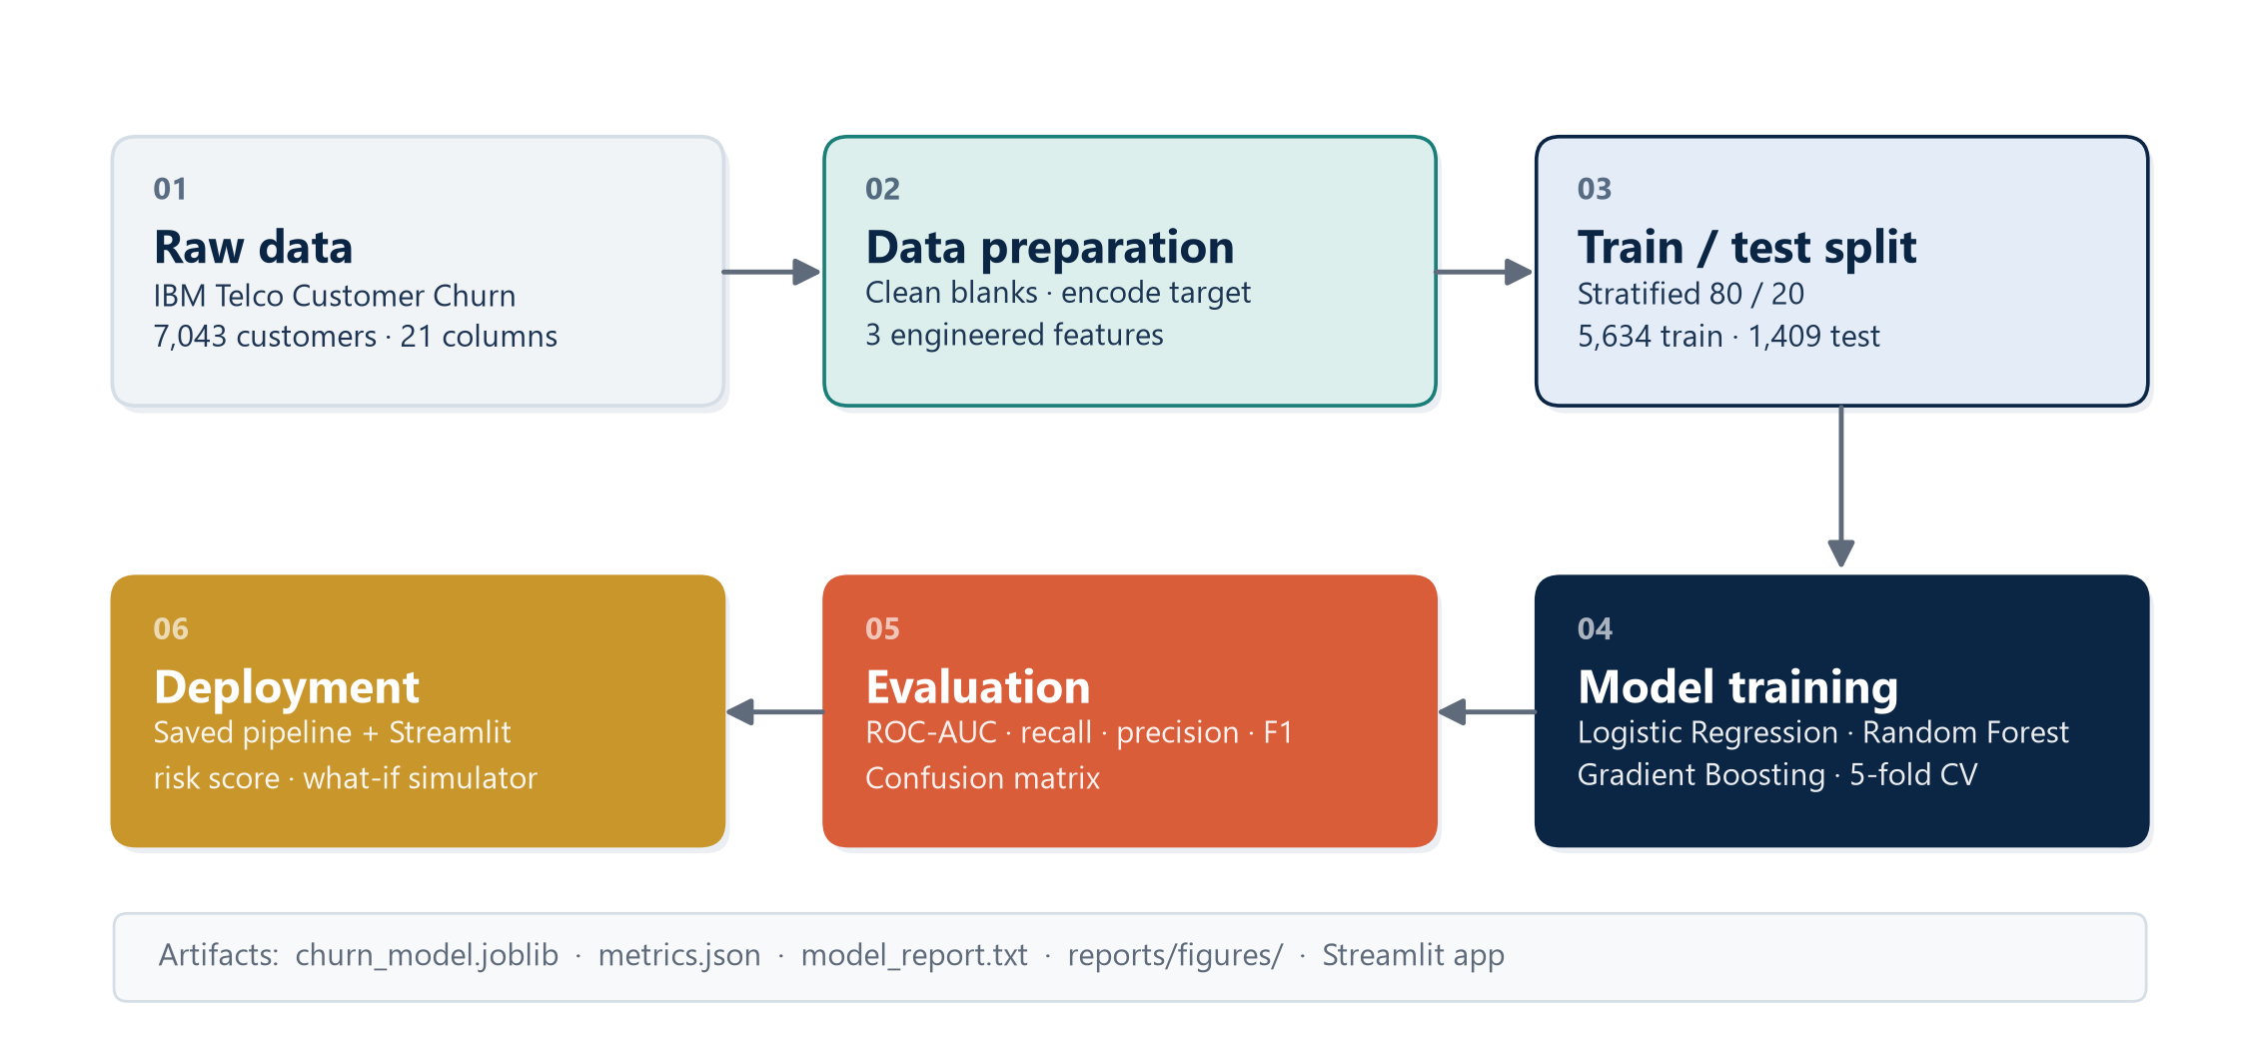
Figure 4.1: End-to-end system architecture
The architecture is deliberately batch-oriented on the training side and request-oriented on the serving side. Training is an offline, reproducible job that can be re-run when new data arrives. Serving is a stateless function of the customer record and the saved pipeline, which makes the application easy to host and reason about.

4.2 Architectural Principles
Five principles guided the design:
1. Single source of truth. All preprocessing is defined inside the scikit-learn pipeline. The same transformations are used during training, evaluation and inference, eliminating training-serving skew.
2. No leakage. The test set is created once with a fixed random seed and is never used for feature selection, hyperparameter tuning or threshold selection.
3. Reproducibility. Random seeds, package versions, input data and output artifacts are recorded so that the experiment can be reconstructed.
4. Separation of concerns. Data preparation, modelling, evaluation and presentation are implemented in separate modules with clear responsibilities.
5. Explainability by design. The system stores feature names and permutation importance so that predictions can be explained to a non-technical audience.

4.3 System Components
Component | Responsibility | Implementation
Data layer | Stores the raw CSV and the cleaned modelling table. | data/Telco-Customer-Churn.csv
Preparation module | Loads, validates, cleans and enriches the data. | src/train.py
Preprocessing pipeline | Imputes, scales and one-hot encodes features. | scikit-learn ColumnTransformer
Model layer | Trains and compares three classifiers; selects the best. | LogisticRegression, RandomForestClassifier, HistGradientBoostingClassifier
Evaluation layer | Computes metrics, curves and permutation importance. | scikit-learn metrics and inspection
Artifact layer | Persists the pipeline, metrics and human-readable report. | joblib, JSON, text
Presentation layer | Provides risk scoring, explanations and what-if analysis. | Streamlit application (app.py)
Documentation layer | Records methodology, results and operating instructions. | Markdown, DOCX and PDF reports
Table 4.1: System components and responsibilities

4.4 End-to-End Workflow
The workflow consists of eight stages:
1. Acquisition. The raw CSV is read into a pandas DataFrame. The schema is checked and the target is mapped from Yes/No to 1/0.
2. Cleaning. TotalCharges is converted from text to numeric. Eleven blank values, all belonging to customers with zero tenure, are imputed from MonthlyCharges. The identifier column is dropped.
3. Feature engineering. Three features are added: the number of active services, the average monthly spend and a new-customer indicator.
4. Splitting. The data is divided into 80% training and 20% test partitions using stratified sampling with a fixed random seed.
5. Preprocessing. Numeric features are median-imputed and standardised; categorical features are most-frequent-imputed and one-hot encoded with unknown-category tolerance.
6. Training and selection. Three models are evaluated with stratified five-fold cross-validation on the training partition. The model with the highest mean cross-validated ROC-AUC is selected.
7. Evaluation. The selected model is fitted on the full training partition and evaluated once on the test partition. Confusion matrix, classification report, ROC curve, PR curve and permutation importance are computed.
8. Packaging and deployment. The fitted pipeline and metadata are saved with joblib. The Streamlit application loads them and serves the interactive interface.

4.5 Data Flow and Transformations
Table 4.2 summarises how the data changes as it moves through the pipeline. The number of columns increases from 21 to 23 after feature engineering, and then expands substantially after one-hot encoding. The exact encoded width depends on the categories observed in the training data, which is why the encoder is fitted inside the pipeline rather than on the full dataset.
Stage | Rows | Columns | Transformation
Raw CSV | 7,043 | 21 | As downloaded; TotalCharges stored as text.
Cleaned | 7,043 | 20 | Target encoded; identifier dropped; TotalCharges numeric.
Feature-engineered | 7,043 | 23 | NumServices, AvgMonthlySpend and IsNewCustomer added.
Training partition | 5,634 | 22 features | Stratified 80% split; target separated.
Test partition | 1,409 | 22 features | Held out until final evaluation.
Encoded matrix | 5,634 | ≈ 45 | Numeric scaled; categorical variables one-hot encoded.
Table 4.2: Data transformations through the pipeline

4.6 Deployment Architecture
The deployed application is a single-process Streamlit server. On start-up it loads models/churn_model.joblib, which contains the fitted pipeline, the ordered feature list and the model name. It also loads reports/metrics.json for the performance view. When the user changes an input in the sidebar, Streamlit re-executes the script, builds a one-row DataFrame with the engineered features, calls predict_proba and renders the result.
This architecture is appropriate for demonstration and internal review. It requires no database, no authentication layer and no separate API server. For production use, the same pipeline could be wrapped in a REST endpoint and placed behind an authenticated gateway; the model artifact would not need to change. Chapter 11 discusses this path.

4.7 Design Decisions and Trade-offs
Several design decisions shaped the system:
- Pipeline over ad-hoc preprocessing. Wrapping all transformations in a ColumnTransformer and Pipeline costs a little extra code but guarantees that inference uses exactly the same transformations as training.
- Logistic Regression as a serious candidate. The model is often treated as a baseline, but it offers interpretability, fast training and stable probabilities. It won the cross-validated comparison and was therefore selected on evidence rather than assumption.
- Fixed 0.50 threshold for reporting. Reporting at a standard threshold makes the results comparable with other studies. The application exposes the probability so that a different operating point can be chosen for a specific campaign.
- Permutation importance over coefficients. Coefficients are informative for logistic regression but depend on the encoding and scale. Permutation importance measures the actual drop in ROC-AUC when a feature is disrupted, which is easier to communicate.
- Streamlit over a custom web application. Streamlit delivers an interactive experience in a single Python file, which is appropriate for an internship timeline and keeps the focus on the model rather than on front-end engineering.

5. APPLICATIONS
A churn model is valuable only when its output changes a decision. This chapter describes the practical applications of the system, moving from the retention workflow where it originated to adjacent uses in service design, financial planning and social programmes. It also states where the model should not be used, because the boundary between a useful decision aid and an inappropriate automation is an important part of professional practice.

5.1 Retention Prioritisation
The primary application is the ranking of customers by churn risk. A retention team typically has capacity to contact a few hundred customers per week. Sorting the customer base by predicted probability produces a work queue in which the expected number of true churners is much higher than in a random sample. At the selected operating point, the model catches about 79% of churners while flagging roughly 587 customers; a team that works through that list spends its effort where the risk is concentrated.
Ranking is more useful than a binary flag because it supports triage. The highest-risk customers can receive a personal call, the next tier an automated offer, and the lowest-risk customers no intervention at all. The risk bands used in the application (low below 30%, medium between 30% and 60%, high above 60%) provide a simple triage scheme that can be adjusted to the team's capacity.

5.2 Campaign Targeting and Offer Design
The factor explanation in the application helps match the intervention to the reason for risk. A customer who is flagged because of a month-to-month contract may respond to a discounted annual plan. A customer who is flagged because of high monthly charges may respond to a service review or a loyalty credit. A customer who is flagged because of fiber-optic service and no technical support may need a service-quality conversation rather than a price discount.
This is the difference between a churn score and a retention strategy. The score answers who; the explanation suggests why; the what-if simulator answers what would change the score. A retention manager can test a proposed intervention - for example, moving a customer from electronic check to automatic card payment, or from month-to-month to a one-year contract - and see the estimated effect before making the offer.

5.3 Customer Segmentation and Lifetime Value
Churn probabilities can be combined with customer value to prioritise by expected loss rather than by risk alone. A high-risk customer with a low monthly charge is less valuable to retain than a medium-risk customer with a high charge and a long expected lifetime. Although the current application does not compute customer lifetime value, the probability it produces is the essential input to that calculation: expected value at risk is approximately the churn probability multiplied by the present value of future margin.
The same scores support segmentation. Customers can be grouped into risk tiers and cross-tabulated with contract type, tenure band or service mix. This produces a retention heat map that shows where risk is concentrated and whether the pattern is structural (for example, a product that consistently disappoints) or transient (for example, a billing problem affecting a cohort).

5.4 Service Quality and Product Feedback
Churn is a lagging indicator of customer experience. A model that identifies high-risk customers before they leave provides an early warning system for service problems. If a disproportionate number of high-risk customers share a particular internet service, payment method or support configuration, the operations team has a signal to investigate. In the Telco data, fiber-optic customers churn at 41.9% and electronic-check customers at 45.3%; these are not causal findings, but they are legitimate prompts for further investigation.
The model can also be used to evaluate the effect of service changes. If a new technical-support programme is introduced, the churn rate of the treated cohort can be compared with the model's expectation. This is not a substitute for a controlled experiment, but it provides a useful operational check.

5.5 Financial Planning and Forecasting
Aggregate churn probabilities can feed revenue forecasts. If the retention team knows that a certain number of high-risk customers are likely to leave, the finance team can model revenue under different retention scenarios. The probability distribution is more informative than a binary count because it allows a range of outcomes to be estimated rather than a single point forecast.
The same logic applies to capacity planning. The number of predicted churners sets the workload for the retention call centre; the expected success rate of each offer sets the number of retained customers; and the retained revenue sets the return on the campaign. A model with a well-calibrated probability is therefore a planning asset, not only a targeting tool.

5.6 Application in Social and Development Programmes
The host organisation, BHARAT CARE LIFE LINE FOUNDATION, works with communities and partners on welfare, skills and livelihood initiatives. The same analytical pattern - identifying participants who are at risk of disengaging and intervening early - applies to social programmes. A skills programme can use attendance and engagement data to identify learners at risk of dropping out; a livelihood programme can use participation data to identify households that may need additional support. The features and the label change, but the workflow does not.
This transferability is one of the reasons the project is relevant to the internship programme. It demonstrates that data science is not confined to commercial optimisation; the same methods can support social outcomes when they are applied with care, transparency and respect for the people represented in the data.

5.7 Where the Model Should Not Be Used
The model should not be used to deny service, set individual prices or make automated decisions without human review. It is a probabilistic estimate trained on historical data, and historical data can encode unfair patterns. If a feature such as gender or senior-citizen status is correlated with churn, using the model to allocate offers could produce discriminatory outcomes. The application is therefore framed as a decision-support tool for a human retention team, not as an autonomous decision system.
The model should also not be used outside the population on which it was trained. A model fitted to residential telecom customers may not transfer to enterprise accounts, prepaid mobile users or a different market. Before any operational use, the model should be validated on a recent, representative sample of the target population, and its performance should be monitored after deployment.

6. TECHNOLOGIES USED
The project uses a compact, well-established open-source stack. Every technology was chosen for a specific role: data manipulation, modelling, visualisation, persistence or presentation. The versions listed in this chapter are the versions used to produce the results in Chapter 10.

6.1 Python
Python is the primary implementation language. It provides readable syntax, a mature scientific ecosystem and excellent support for rapid experimentation. The project is organised into modules: src/train.py for data preparation, training and evaluation; src/make_deck_assets.py for presentation figures; app.py for the Streamlit application; and the report-generation modules under src/. All scripts are executed from the project root so that relative paths resolve consistently.
Python's dynamic typing and interactive tools make it well suited to exploratory work, while its packaging and testing ecosystem make it suitable for reproducible delivery. The project uses type hints and docstrings in the core modules to keep the code understandable.

6.2 pandas and NumPy
pandas provides the DataFrame abstraction used throughout the project. It handles CSV loading, column selection, grouping, aggregation, missing-value treatment and feature construction. NumPy supplies the underlying numerical arrays and is used for probability thresholds and array operations. The combination makes it possible to express data transformations concisely without writing manual loops.
pandas is also used in the application to construct a one-row DataFrame from the sidebar inputs. This ensures that the inference path receives the same column names and order as the training data, which is a common source of production errors.

6.3 scikit-learn
scikit-learn is the modelling backbone. It supplies the classifiers (LogisticRegression, RandomForestClassifier, HistGradientBoostingClassifier), the preprocessing transformers (SimpleImputer, StandardScaler, OneHotEncoder), the composition tools (ColumnTransformer, Pipeline), the model-selection utilities (StratifiedKFold, cross_val_score, train_test_split) and the evaluation metrics (roc_auc_score, precision_score, recall_score, f1_score, average_precision_score, confusion_matrix, classification_report).
The pipeline abstraction is particularly important. It binds preprocessing and modelling into a single object that can be fitted, evaluated and serialised as a unit. This eliminates the risk of applying a different encoding at inference time and makes cross-validation honest, because the transformers are re-fitted inside each fold.

6.4 Matplotlib and Seaborn
Matplotlib is the low-level plotting library used for the architecture diagram and for charts that require precise control over layout. Seaborn is used for statistical plots such as distribution plots and heat maps. The presentation figures in this report were generated with a consistent palette and typography so that the report and the slide deck share a visual language.
Charts are saved as high-resolution PNG files rather than embedded as interactive objects. This keeps the report portable and ensures that the figures render identically on any machine.

6.5 Streamlit
Streamlit converts a Python script into an interactive web application. The application uses a sidebar for customer inputs, tabs for prediction, model performance, data insights and methodology, and custom HTML/CSS for the risk card and gauge. Streamlit's reactive execution model means that every input change triggers a re-run of the script and an updated prediction, with no explicit event handlers.
The application is intentionally thin. It does not retrain the model or recompute metrics; it loads the artifacts produced by the training script. This separation keeps the demo fast and ensures that the displayed performance numbers correspond exactly to the saved model.

6.6 joblib and JSON Artifacts
joblib serialises the fitted pipeline, including the preprocessing steps and the classifier, into models/churn_model.joblib. The artifact also stores the ordered feature list and the model name. JSON files store the evaluation metrics and the EDA insights, which are read by the application and by the report generator. Plain text is used for the human-readable model report.
The use of simple, inspectable formats is deliberate. A JSON metrics file can be diffed in version control, read by any language and understood without the original code. A joblib artifact is Python-specific, but it preserves the exact fitted state of the pipeline, which is essential for reproducible inference.

6.7 Development and Documentation Tools
Development was carried out in Visual Studio Code with the Python extension, which provides debugging, linting and integrated terminals. PowerShell was used to run the training script and the Streamlit server. Microsoft Word and python-docx were used to produce this report, and python-pptx was used to produce the accompanying presentation. The project is version-controlled in a local folder structure; a Git repository can be initialised without changing the code.

6.8 Technology Stack Summary
Technology | Version | Role in the Project
Python | 3.11+ | Implementation language for all modules.
pandas | 3.1.1 | Data loading, cleaning, aggregation and feature engineering.
NumPy | 2.5.4 | Numerical arrays and vectorised operations.
scikit-learn | 1.9.1 | Preprocessing, models, cross-validation and metrics.
Matplotlib | 3.11.2 | Charts and the architecture diagram.
Seaborn | 0.13.2 | Statistical visualisations.
Streamlit | 1.66.1 | Interactive web application.
joblib | 1.6.0 | Model persistence.
python-docx | 1.2.0 | Programmatic report generation.
python-pptx | 1.0.2 | Programmatic slide generation.
Table 6.1: Technology stack and versions
The stack is intentionally conservative. Every library is widely used, well documented and available under a permissive open-source licence. This reduces the risk of maintenance problems and makes the project easy for another student or developer to continue.

7. ADVANTAGES AND DISADVANTAGES
No model is universally appropriate. A churn prediction system offers clear advantages over unaided retention work, but it also introduces costs, assumptions and risks. This chapter presents both sides honestly and describes how the project mitigates the main limitations.

7.1 Advantages
The system improves retention work in several concrete ways. The advantages below are stated in terms of what the organisation can do that it could not do before, rather than in terms of abstract model quality.
7.1.1 Prioritisation under Limited Capacity
The most immediate benefit is a ranked work queue. Retention teams cannot contact every customer, and contacting at random wastes effort on customers who would have stayed anyway. At the selected operating point the model flags 587 customers and correctly identifies 297 of the 374 churners in the test set. A random sample of the same size would be expected to contain only about 156 churners. The model therefore roughly doubles the yield of a fixed outreach budget.
7.1.2 Early Warning
Churn is observed only after the customer has left. A predictive model moves the observation point forward, giving the retention team time to intervene. This is especially important for customers on month-to-month contracts, whose departure can be abrupt. The model can be re-scored monthly, creating a rolling early-warning system.
7.1.3 Explainability
The application does not only return a score. It lists the factors that push the customer's risk up or down, and the report quantifies the global importance of each feature. This makes the output usable in a conversation with a customer or a manager, and it supports the choice of intervention. An unexplainable score is difficult to trust and difficult to act on.
7.1.4 Consistency and Reproducibility
A manual retention process depends on the judgement and memory of individual agents. Two agents may treat similar customers differently. A model applies the same logic to every customer and produces an auditable record. The pipeline, random seeds and package versions are recorded, so the result can be reproduced and reviewed.
7.1.5 Low Operating Cost
The stack is open source, the dataset is small and the model trains in seconds on a laptop. Inference is a single predict_proba call. There is no GPU requirement, no managed service and no licence fee. This makes the approach accessible to small organisations and to students, which is consistent with the inclusive ethos of the internship programme.
7.1.6 Extensibility
The pipeline is modular. New features can be added to the transformer, new models can be compared in the same cross-validation loop, and the presentation layer can be replaced without retraining. The same pattern can be applied to dropout prediction, loan default, equipment failure or any other binary outcome with tabular features.

7.2 Disadvantages
The limitations fall into three groups: data limitations, modelling limitations and deployment limitations. Recognising them is part of using the model responsibly.
7.2.1 Historical and Observational Data
The model learns associations present in historical data; it does not establish causation. A feature such as fiber-optic internet may be associated with churn because of price, service quality, competition or a combination of factors that the dataset does not record. Acting on an association as if it were a cause can lead to ineffective or even harmful interventions.
7.2.2 Class Imbalance and Metric Trade-offs
Only 26.5% of customers churn. The model therefore produces more false positives than a balanced problem would: at the 0.50 threshold, 290 customers are flagged who would have stayed. This is a deliberate trade-off in favour of recall, but it has a cost in outreach effort and in the risk of annoying customers who were not at risk. A different campaign economics would justify a different threshold.
7.2.3 Limited Context
The dataset contains account and service attributes but not the full context of the customer relationship: call transcripts, complaints, network outages, competitor offers and life events are absent. The model can therefore miss sudden changes that are not reflected in the recorded features. It should be complemented by qualitative feedback from front-line staff.
7.2.4 Temporal Validity
The data is a snapshot. Customer behaviour, pricing and competition change over time, and a model trained on one period may lose accuracy in another. The project does not include a temporal validation split because the dataset does not provide reliable timestamps. In production, the model should be retrained and monitored regularly.
7.2.5 Fairness and Privacy
The dataset includes gender, age and family status. A model trained on these attributes can reproduce historical inequalities. The project does not perform a formal fairness audit, and the application is intended for decision support rather than automated action. Any operational deployment should include a fairness review, data-minimisation review and compliance check.
7.2.6 Operational Dependence
A model is only useful if its output is integrated into a workflow. If the retention team does not trust the score, cannot access it at the point of contact, or is not given the authority to act on it, the system becomes a dashboard that nobody uses. Deployment is therefore as much an organisational challenge as a technical one.

7.3 Mitigation Strategies
Risk | Mitigation in the Project
Overfitting to the test set | The test partition is created once and used only for the final evaluation; model selection uses cross-validation on the training partition.
Training-serving skew | All preprocessing is stored inside the serialised pipeline and reused at inference.
Misleading accuracy | Selection is based on ROC-AUC; recall, precision, F1 and PR-AUC are reported alongside accuracy.
Unclear model behaviour | Permutation importance and per-customer factor explanations are provided.
Class imbalance | Stratified splitting and cross-validation preserve the churn proportion in every fold.
Data quality problems | Missing values and text-encoded numbers are handled explicitly and documented.
Automation bias | The application presents a probability and risk band, not an automatic decision.
Model drift | The pipeline is reproducible and can be retrained; monitoring is proposed in Chapter 11.
Table 7.1: Risks and mitigation strategies

7.4 When to Use This Approach
The approach is appropriate when historical labelled outcomes exist, when the features are available at prediction time, and when the cost of false positives is lower than the cost of missing a genuine churner. It is less appropriate when the population is small, when the outcome is driven by sudden external shocks, or when the organisation cannot act on the output. In those cases, a simpler segmentation or a qualitative review may be more useful than a sophisticated model.

8. REQUIREMENTS
This chapter specifies the resources needed to reproduce, run and evaluate the project. The requirements are deliberately modest: the system runs on a standard student laptop and uses only open-source software. The figures below are the configurations used during development and are stated as minimums where appropriate.

8.1 Hardware Requirements
Component | Minimum | Recommended
Processor | Intel Core i3 (8th generation) or equivalent | Intel Core i5 / Ryzen 5 or better
Memory | 8 GB RAM | 16 GB RAM
Storage | 2 GB free disk space | 5 GB free solid-state storage
Display | 1366 × 768 | 1920 × 1080
Network | Not required for local use | Required only to install packages or share the app
GPU | Not required | Not required
Table 8.1: Hardware requirements
The model is small enough to train on a CPU in a few seconds. Memory usage is dominated by the Python interpreter and the plotting libraries rather than by the dataset, which contains fewer than 10,000 rows.

8.2 Software Requirements
Software | Version | Purpose
Windows / Linux / macOS | Windows 10 or 11 (tested) | Operating system
Python | 3.11 or later | Runtime for all project code
pip | Latest | Package installation
Visual Studio Code | Latest | Code editing and debugging
PowerShell | 5.1 or later | Command execution
Web browser | Chrome, Edge or Firefox | Streamlit interface
Microsoft Word | 2016 or later | Review of the generated report
PDF reader | Any | Review of the exported report
Table 8.2: Software requirements

8.3 Python Package Requirements
Package | Version | Use
pandas | 3.1.1 | Tabular data manipulation
numpy | 2.5.4 | Numerical operations
scikit-learn | 1.9.1 | Preprocessing, models and metrics
matplotlib | 3.11.2 | Plotting
seaborn | 0.13.2 | Statistical plots
streamlit | 1.66.1 | Interactive application
joblib | 1.6.0 | Model serialisation
python-docx | 1.2.0 | Report generation
python-pptx | 1.0.2 | Presentation generation
Pillow | Latest | Image processing
Table 8.3: Python package requirements
The versions are pinned in requirements.txt so that a fresh environment can be recreated with pip install -r requirements.txt. Minor version differences are usually harmless, but the pinned versions are the ones used for the reported results.

8.4 Data Requirements
The system expects a CSV file with the following characteristics:
- One row per customer and a unique identifier column named customerID.
- A binary target column named Churn containing Yes or No.
- Twenty predictor columns covering demographics, account, services and billing.
- Numeric columns tenure, MonthlyCharges and TotalCharges; TotalCharges may contain blanks and is converted during cleaning.
- Categorical columns stored as text, with missing values allowed.
The file is stored at data/Telco-Customer-Churn.csv. The training script validates the presence of the target and identifier columns and fails early with a clear error if either is missing.

8.5 Functional Requirements
ID | Requirement | Acceptance Criterion
FR-01 | Load and validate the raw dataset. | The script reads the CSV and confirms 7,043 rows and the required columns.
FR-02 | Clean missing and malformed values. | TotalCharges is numeric and contains no missing values after cleaning.
FR-03 | Engineer the three additional features. | NumServices, AvgMonthlySpend and IsNewCustomer exist for every row.
FR-04 | Create a stratified train/test split. | 5,634 training rows and 1,409 test rows with matching churn proportions.
FR-05 | Train and compare three classifiers. | Cross-validated ROC-AUC is recorded for every model.
FR-06 | Select and evaluate the best model. | The selected model is evaluated once on the test set and all metrics are saved.
FR-07 | Explain model behaviour. | Permutation importance is computed and stored for the top features.
FR-08 | Provide an interactive prediction interface. | The Streamlit app accepts customer inputs and returns a probability and risk band.
FR-09 | Support what-if analysis. | Changing contract, payment or service settings updates the estimated risk.
FR-10 | Persist artifacts for reuse. | The pipeline, metrics and model report are saved to disk.
Table 8.4: Functional requirements

8.6 Non-Functional Requirements
Attribute | Requirement
Usability | A non-technical user can obtain a risk score without reading documentation.
Performance | Training completes in under one minute; a prediction is returned in under one second.
Reliability | The same input and the same saved model always produce the same output.
Reproducibility | A fixed random seed and pinned package versions reproduce the reported metrics.
Maintainability | Data preparation, modelling, evaluation and presentation are separate modules.
Portability | The application runs on Windows, Linux and macOS with the same Python dependencies.
Explainability | Every prediction is accompanied by the factors that influenced it.
Privacy | The demo uses a public dataset and does not process personal data.
Table 8.5: Non-functional requirements

8.7 Installation and Execution
The project is executed from the project root with the following commands:
Code 8.1: Installation and execution commands
# 1. Create and activate a virtual environment (recommended)
python -m venv .venv
.venv\Scripts\activate

# 2. Install the pinned dependencies
pip install -r requirements.txt

# 3. Reproduce the training, evaluation and figures
python src/train.py

# 4. Launch the interactive application
streamlit run app.py
The application opens at http://localhost:8501. If the port is in use, an alternative port can be supplied with --server.port. The training script is idempotent: running it again overwrites the saved model and charts with artifacts computed from the same fixed seed.

9. METHODOLOGY AND SOURCE CODE
This chapter describes how the system was built. The methodology follows the CRISP-DM process model - business understanding, data understanding, data preparation, modelling, evaluation and deployment - adapted to the constraints of a 45-day internship. Each stage is explained, the important design choices are justified, and selected source code is reproduced so that the implementation can be reviewed without opening the repository.

9.1 Research Design
The project is an applied, quantitative study. It uses a publicly available observational dataset, a supervised learning design and a held-out evaluation. The unit of analysis is the customer; the outcome is the binary churn label; the predictors are the account, service, demographic and billing attributes. The study is cross-sectional: each customer is observed once, and the model estimates the probability associated with that profile.
CRISP-DM Phase | Activity in This Project | Output
Business understanding | Define churn, retention value and the decision the model should support. | Problem statement and objectives
Data understanding | Audit schema, missing values, distributions and class balance. | Data-quality report and EDA charts
Data preparation | Clean, engineer features, split and build the preprocessing pipeline. | Modelling table and pipeline
Modelling | Train three classifiers and compare them with cross-validation. | Cross-validated scores
Evaluation | Evaluate the selected model on the test set; interpret importance. | Metrics, curves and importance
Deployment | Package the pipeline and build the Streamlit interface. | Saved model and live application
Table 9.1: Mapping of the project to CRISP-DM

9.2 Data Acquisition
The dataset was downloaded as a single CSV file and stored in the data directory. The file contains 7,043 rows and 21 columns. The first column, customerID, is a unique identifier; the last column, Churn, is the target. The remaining 19 columns are predictors. No external data was merged, which keeps the study self-contained and reproducible.
The data was loaded with pandas.read_csv. Column names were checked against the expected schema, and the target was mapped from the strings Yes and No to the integers 1 and 0. This mapping is explicit rather than implicit, so the positive class is unambiguously the churn class.

9.3 Data Quality Audit and Cleaning
A structured audit was performed before any modelling. The audit checked row counts, duplicate identifiers, data types, missing values, category consistency and the distribution of the target. The findings are summarised in Table 9.2.
Issue | Finding | Treatment
TotalCharges type | Stored as text rather than numeric. | Converted with pd.to_numeric(errors='coerce').
Missing TotalCharges | 11 blank values, all with tenure = 0. | Filled with the customer's MonthlyCharges.
Identifier | customerID is unique and random. | Dropped before modelling.
Target encoding | Churn stored as Yes/No. | Mapped to 1/0.
Class balance | 1,869 churners (26.5%) and 5,174 stayers (73.5%). | Stratified split and stratified cross-validation.
Category consistency | No unexpected categories or trailing spaces. | No action required.
Duplicates | No duplicate customer identifiers. | No action required.
Table 9.2: Data-quality findings and treatments
The eleven missing TotalCharges values are not random. They belong to customers with zero tenure, who have not yet received a bill. Imputing them with the median would be wrong because it would assign a lifetime spend to a customer who has just joined. Filling them with the monthly charge is a sensible approximation of the first bill and preserves the customer in the dataset.
Code 9.1: Data loading and cleaning
def load_and_clean(path: Path) -> pd.DataFrame:
df = pd.read_csv(path)

# TotalCharges is text with 11 blanks for tenure = 0 customers.
df["TotalCharges"] = pd.to_numeric(df["TotalCharges"], errors="coerce")
df["TotalCharges"] = df["TotalCharges"].fillna(df["MonthlyCharges"])

# Encode the target explicitly: churn = 1, stay = 0.
df["Churn"] = df["Churn"].map({"Yes": 1, "No": 0})

# The identifier has no predictive value.
df = df.drop(columns=["customerID"])
return df

9.4 Exploratory Data Analysis
Exploratory analysis was used to understand the data before modelling, not to select features on the test set. The analysis examined the target distribution, the relationship between churn and contract type, the tenure distribution, the relationship between churn and charges, and the churn rate across service and payment categories. The main findings are summarised below; the corresponding figures appear in Chapter 10.
The target is imbalanced: 73.5% of customers stayed and 26.5% churned. Contract type is the strongest single segmentation variable, with churn rates of 42.7%, 11.3% and 2.8% for month-to-month, one-year and two-year contracts respectively. Churners have a mean tenure of 18.0 months compared with 37.6 months for stayers, and a mean monthly charge of $74.44 compared with $61.27. Fiber-optic customers churn at 41.9%, compared with 19.0% for DSL and 7.4% for customers with no internet service. Electronic-check customers churn at 45.3%, the highest of any payment method.
These patterns are descriptive. They motivate the feature set and the later interpretation, but they are not causal claims. The modelling stage determines how much unique information each variable contributes once the others are taken into account.
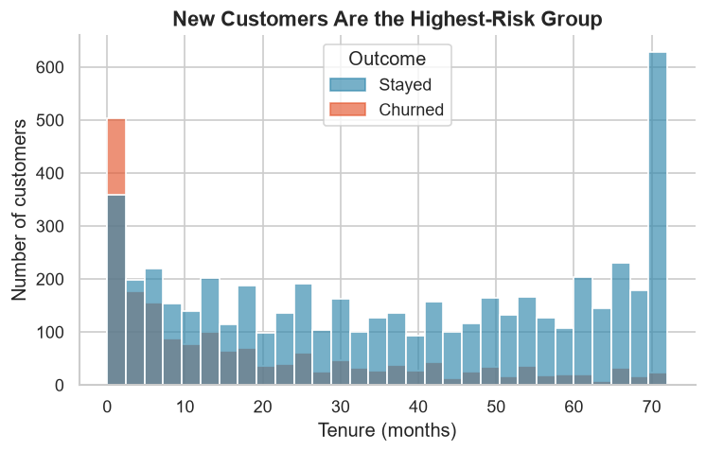
Figure 9.1: Tenure distribution by churn outcome
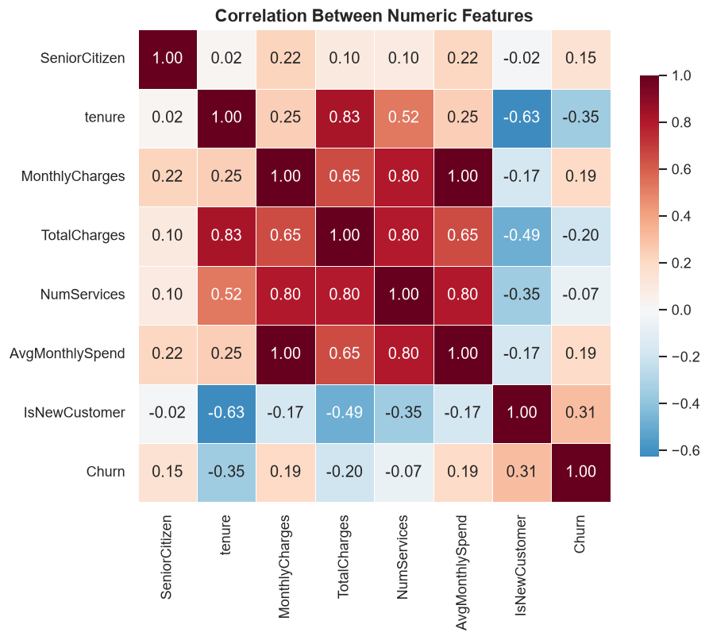
Figure 9.2: Correlation between numeric features and churn

9.5 Feature Engineering
Three features were added to the raw data. They were chosen because they are interpretable, computable at prediction time and motivated by the exploratory analysis. The first is the number of active services, which captures the breadth of the customer's relationship with the company. The second is the average monthly spend, which normalises total charges by tenure and distinguishes customers who pay a high rate from those whose total is high only because they have stayed for a long time. The third is a new-customer indicator for tenure of six months or less, which captures the high-risk early period observed in the tenure distribution.
Feature | Definition | Rationale
NumServices | Count of the eight service columns equal to Yes. | Customers with a broader service relationship may be more embedded, or may be paying for services they do not value.
AvgMonthlySpend | TotalCharges divided by tenure (minimum 1). | Separates high spenders from long-tenured customers whose total is large only because of time.
IsNewCustomer | 1 if tenure ≤ 6 months, otherwise 0. | The early months are the highest-risk period in the tenure distribution.
Table 9.3: Engineered features
Code 9.2: Feature engineering
service_cols = [
"PhoneService", "MultipleLines", "OnlineSecurity", "OnlineBackup",
"DeviceProtection", "TechSupport", "StreamingTV", "StreamingMovies",
]
df["NumServices"] = (df[service_cols] == "Yes").sum(axis=1)
df["AvgMonthlySpend"] = df["TotalCharges"] / df["tenure"].clip(lower=1)
df["IsNewCustomer"] = (df["tenure"] <= 6).astype(int)

9.6 Preprocessing Pipeline
The preprocessing pipeline is a ColumnTransformer with two branches. Numeric features are median-imputed and standardised. Categorical features are most-frequent-imputed and one-hot encoded. The encoder uses handle_unknown='ignore' so that a category not seen during training does not cause an error at inference; it is simply encoded as all zeros for that feature group.
The pipeline is fitted inside each cross-validation fold, which means that imputation and scaling parameters are learned only from the training portion of that fold. This is the correct way to prevent leakage. Fitting the scaler on the full dataset before splitting would allow information from the test set to influence the training process and would produce optimistic performance estimates.
Code 9.3: Preprocessing pipeline
numeric_pipeline = Pipeline([
("imputer", SimpleImputer(strategy="median")),
("scaler", StandardScaler()),
])

categorical_pipeline = Pipeline([
("imputer", SimpleImputer(strategy="most_frequent")),
("onehot", OneHotEncoder(handle_unknown="ignore")),
])

preprocessor = ColumnTransformer([
("num", numeric_pipeline, NUMERIC_FEATURES),
("cat", categorical_pipeline, CATEGORICAL_FEATURES),
])

9.7 Model Selection and Training
Three classifiers were compared: Logistic Regression, Random Forest and Histogram Gradient Boosting. The three represent different inductive biases. Logistic Regression assumes a linear relationship in the log-odds and produces a smooth, well-calibrated probability. Random Forest averages many decorrelated decision trees and captures non-linear interactions. Gradient Boosting builds trees sequentially, each one correcting the errors of its predecessor, and often achieves high accuracy on tabular data.
Model | Key Settings | Rationale
Logistic Regression | max_iter=2000, default L2 penalty, lbfgs solver | Interpretable linear baseline; stable probabilities.
Random Forest | 300 trees, max_depth=None, min_samples_leaf=2, n_jobs=-1 | Captures non-linearities and interactions; robust to outliers.
Histogram Gradient Boosting | learning_rate=0.08, max_iter=250, max_leaf_nodes=31 | Strong tabular learner; handles mixed feature scales.
Table 9.4: Model configurations
The comparison uses stratified five-fold cross-validation on the training partition. In each fold, four parts are used to fit the pipeline and one part is used to score it. The reported score is the mean ROC-AUC across the five folds, and the standard deviation is retained as a measure of stability. The test partition is not touched during this process.
Code 9.4: Stratified cross-validation
cv = StratifiedKFold(n_splits=5, shuffle=True, random_state=42)

for name, estimator in MODELS.items():
pipeline = Pipeline([
("preprocessor", build_preprocessor()),
("classifier", estimator),
])
scores = cross_val_score(
pipeline, X_train, y_train,
cv=cv, scoring="roc_auc", n_jobs=-1,
)
print(f"{name}: {scores.mean():.4f} +/- {scores.std():.4f}")

9.8 Evaluation Protocol
The model with the highest mean cross-validated ROC-AUC is selected. It is then fitted on the entire training partition and evaluated once on the test partition. The evaluation reports accuracy, precision, recall, F1, ROC-AUC and PR-AUC, together with the confusion matrix and the classification report. ROC and precision-recall curves are plotted, and permutation importance is computed on the test set to quantify the contribution of each feature.
Permutation importance is calculated by shuffling one feature at a time and measuring the resulting drop in ROC-AUC. The procedure is repeated several times per feature to obtain a mean and standard deviation. Unlike a coefficient, the measure reflects the model's actual reliance on the feature in the context of all other features, which makes it more suitable for communicating importance to a business audience.
Code 9.5: Final evaluation
probs = best_model.predict_proba(X_test)[:, 1]
preds = (probs >= 0.5).astype(int)

print(classification_report(
y_test, preds, target_names=["Stayed", "Churned"],
))
print("ROC-AUC:", roc_auc_score(y_test, probs))
print("PR-AUC :", average_precision_score(y_test, probs))

9.9 Threshold Selection
The reported results use a probability threshold of 0.50. This is a conventional choice that makes the results comparable with other studies, but it is not necessarily the optimal operating point for a retention campaign. If a contact costs $5 and a retained customer is worth $500, the optimal threshold is much lower than 0.50 because a false negative is far more expensive than a false positive. The application therefore exposes the probability and the risk band, allowing the retention team to apply its own cost assumptions.
The threshold should be chosen on a validation set, not on the test set. In this project, the test set is reserved for the final report; a production deployment would use a separate validation partition or a time-based holdout to tune the operating point.

9.10 Application Implementation
The Streamlit application loads the saved pipeline and feature list at start-up. The sidebar collects the customer's demographic, account, service and billing details. The application constructs a one-row DataFrame, computes the engineered features, calls predict_proba and renders a risk card, a gauge and a list of contributing factors. The factor logic compares the customer's values with known risk patterns from the training data, such as a month-to-month contract or electronic-check payment, and labels each factor as risk-increasing or risk-reducing.
The what-if simulator reuses the same inference function with modified contract, payment or service values. It displays the original probability, the new probability and the difference, which makes the effect of a proposed intervention concrete. The model-performance and data-insights tabs read the saved metrics and charts, so the application remains consistent with the report.
Code 9.6: Inference in the Streamlit application
customer = build_customer(
gender, senior, partner, dependents, phone_service, multiple_lines,
internet_service, online_security, online_backup, device_protection,
tech_support, streaming_tv, streaming_movies, contract,
paperless_billing, payment_method, tenure, monthly_charges,
)
probability = float(model.predict_proba(customer)[0, 1])
band, colour, background = risk_band(probability)

9.11 Reproducibility and Code Quality
The project fixes the random seed at 42 for the train/test split, the cross-validation folds and the Random Forest. Package versions are pinned in requirements.txt. The training script writes the model, metrics, EDA insights and figures to known paths, so the application and the report generator can consume them without manual steps. Functions are small and named after the operation they perform, and the main modules include docstrings that explain their purpose.
A limitation is that the project does not include an automated test suite or a continuous-integration pipeline. For an internship project of this scope, manual verification and a reproducible script were considered sufficient. A production version would add unit tests for the cleaning and feature-engineering functions, an integration test for the pipeline and a smoke test for the application.

10. RESULTS AND OUTPUT SCREENSHOTS
This chapter presents the results of the study. It begins with the exploratory findings, then reports the model comparison, the final test-set performance, the confusion matrix, the ranking curves and the feature importance. It concludes with screenshots of the deployed application and a discussion of the errors the model makes.

10.1 Experimental Setup
The cleaned dataset contains 7,043 customers and 22 predictors after feature engineering. A stratified 80/20 split produced 5,634 training customers and 1,409 test customers. The test set contains 374 churners and 1,035 stayers, which matches the overall churn rate of 26.5%. All models were trained on the same training partition and evaluated on the same test partition with the same preprocessing pipeline.

10.2 Exploratory Findings
Figure 10.1 shows the class distribution. The imbalance is substantial: a model that always predicts stay would be 73.5% accurate while never identifying a churner. This is why the evaluation focuses on ROC-AUC and recall rather than accuracy.
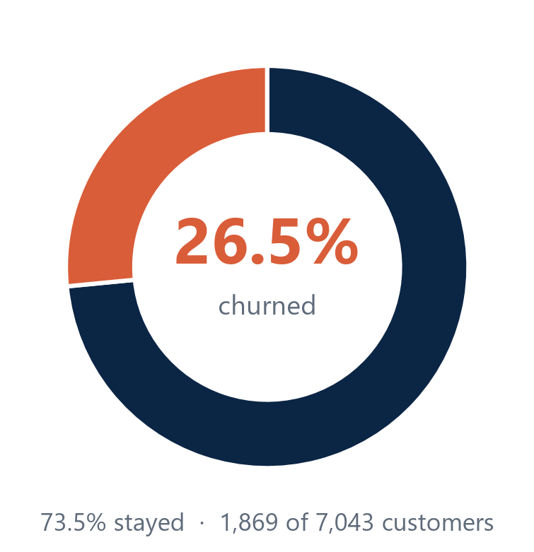
Figure 10.1: Class distribution in the dataset
Figure 10.2 shows churn by contract type. The gradient is steep: 42.7% of month-to-month customers churn, compared with 11.3% of one-year customers and 2.8% of two-year customers. Contract type is therefore a powerful segmentation variable and a plausible target for retention offers, although the observational data cannot prove that upgrading a contract causes a customer to stay.
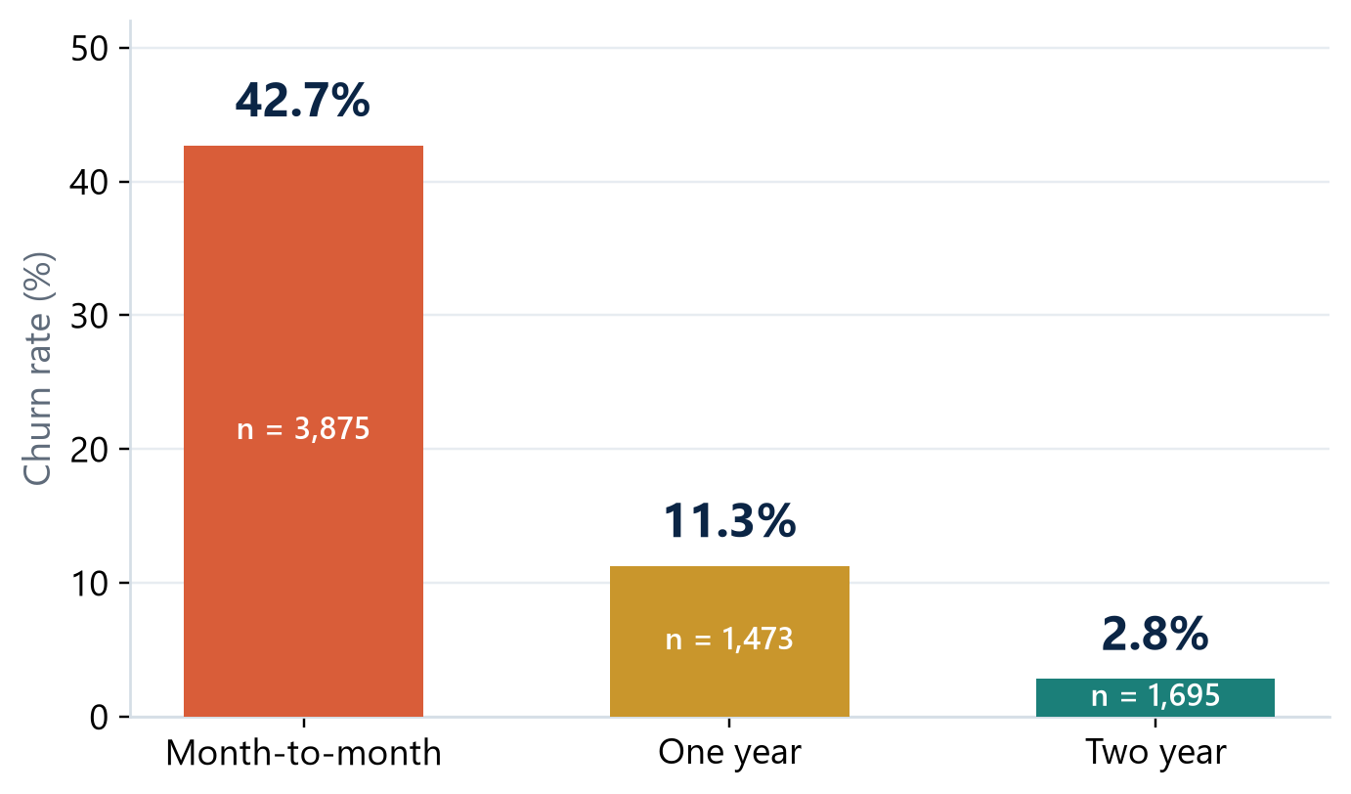
Figure 10.2: Churn rate by contract type
Figure 10.3 shows the tenure distribution. Churners are concentrated at low tenure, with a mean of 18.0 months, while stayers have a mean of 37.6 months. The shape suggests that the first year is the critical retention window and that interventions should be concentrated early in the customer lifecycle.
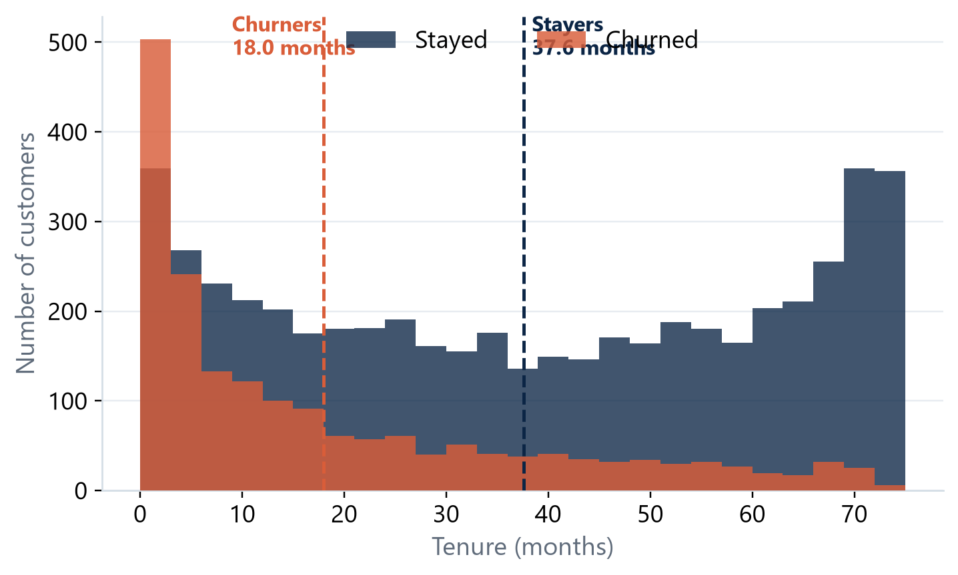
Figure 10.3: Tenure distribution for churned and retained customers
Figure 10.4 summarises four behavioural drivers. Fiber-optic customers churn at 41.9%, compared with 19.0% for DSL and 7.4% for customers without internet service. Electronic-check customers churn at 45.3%, compared with 15.2% for automatic credit card and 16.7% for automatic bank transfer. Customers without technical support or online security also show higher churn. These patterns are consistent with the hypothesis that customers who feel unsupported or who have a more transactional payment relationship are more likely to leave.
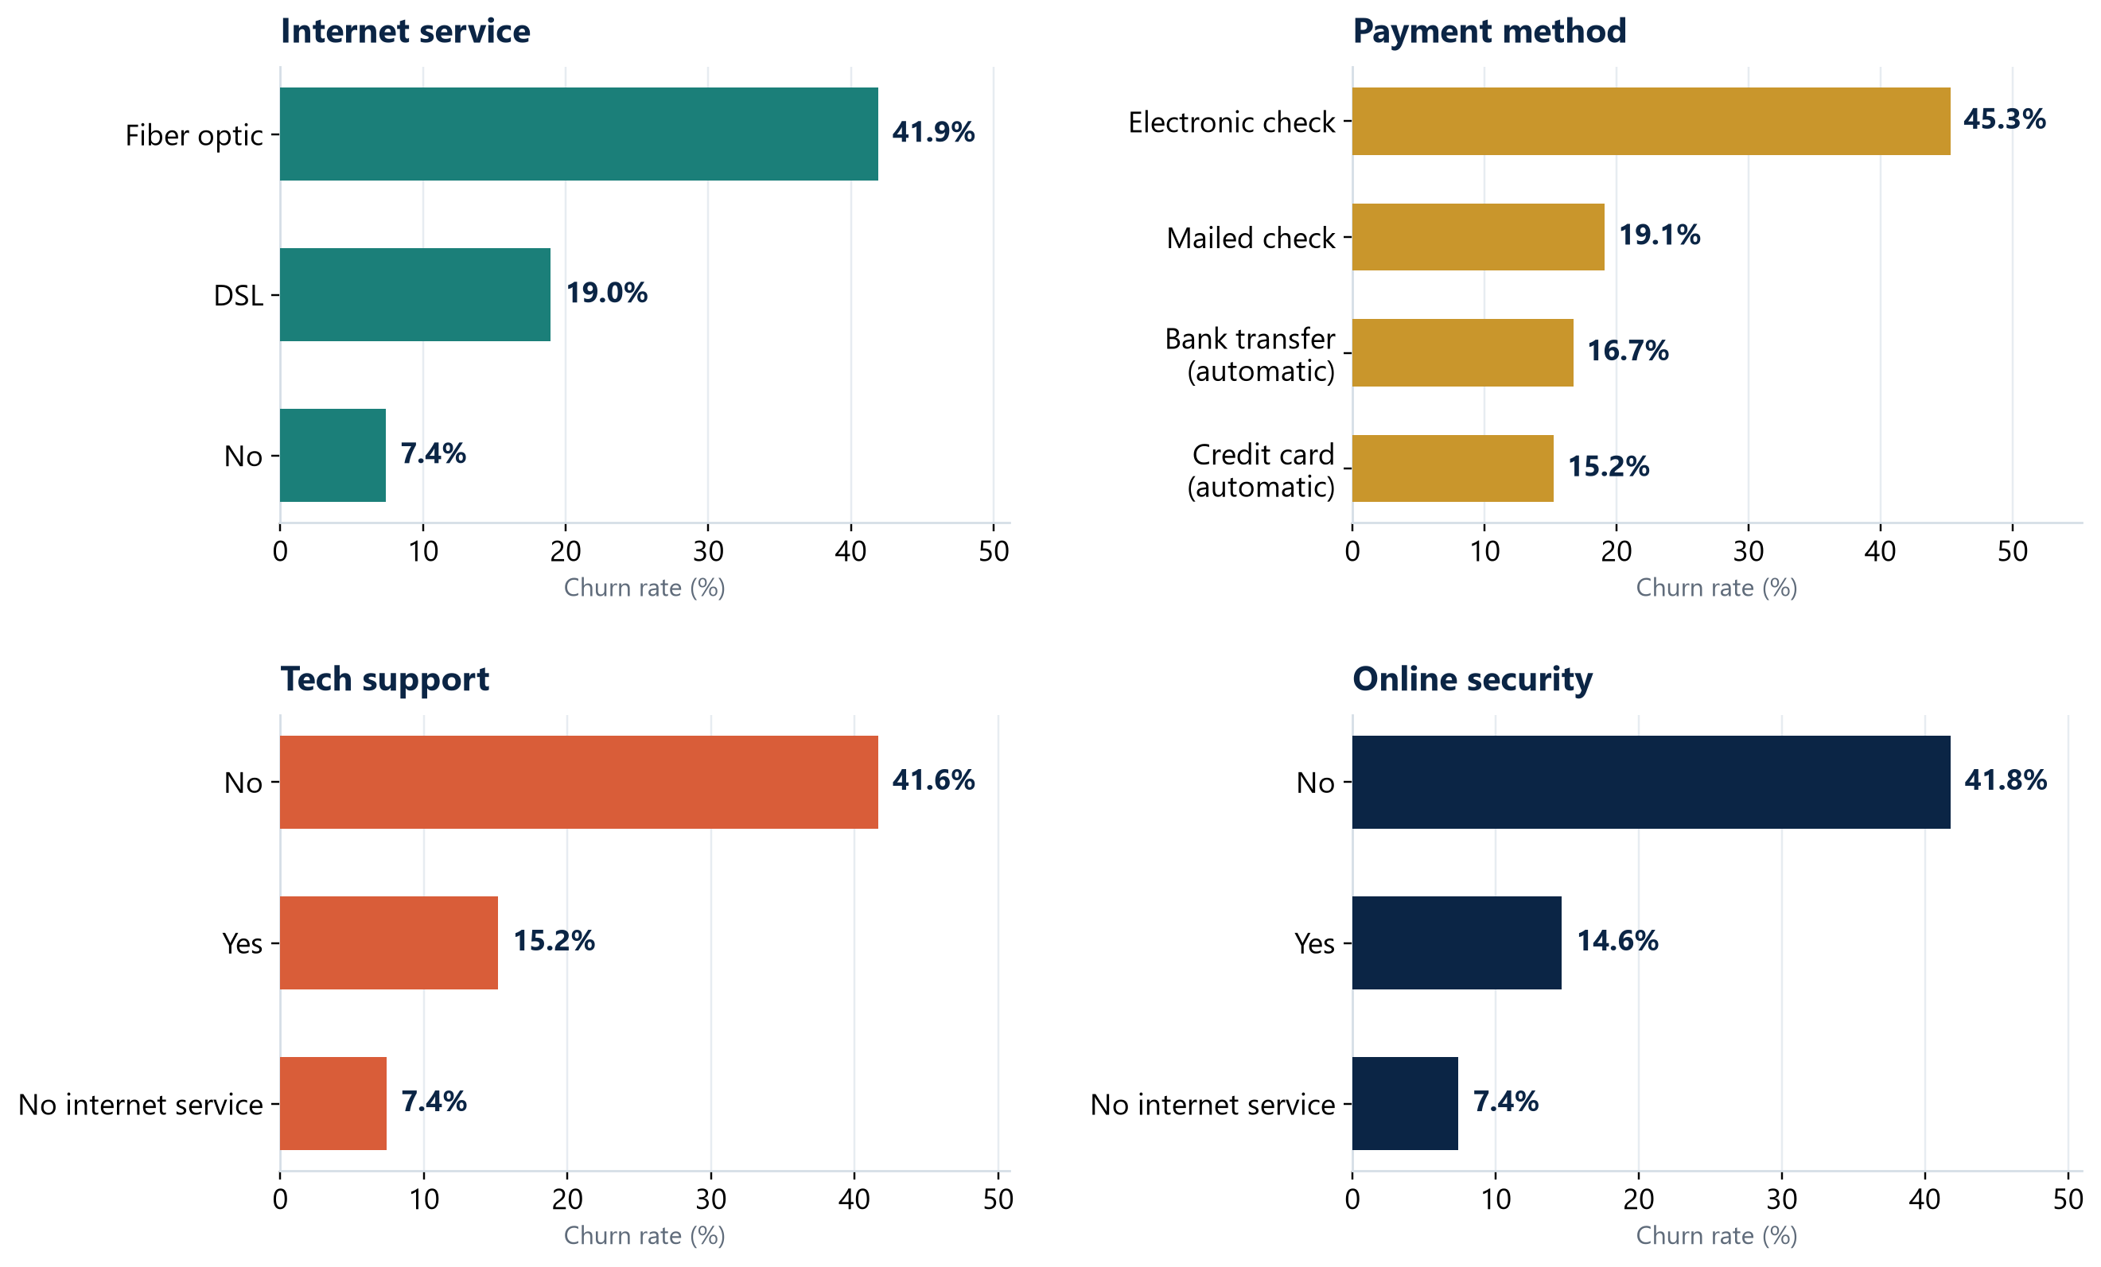
Figure 10.4: Churn rate across internet service, payment method, technical support and online security

10.3 Model Comparison
Table 10.1 reports the cross-validated ROC-AUC and the test-set metrics for the three models. Logistic Regression achieved the highest mean cross-validated ROC-AUC (0.8474) and was selected. Random Forest was extremely close (0.8457), while Gradient Boosting was lower (0.8267). The difference between the top two models is small relative to their fold-to-fold variation, but the selection rule was fixed in advance, so the result is not a post-hoc choice.
Model | CV ROC-AUC | Test ROC-AUC | Accuracy | Precision | Recall | F1
Logistic Regression | 0.8474 ± 0.0110 | 0.8458 | 0.7395 | 0.5060 | 0.7941 | 0.6181
Random Forest | 0.8457 ± 0.0093 | 0.8406 | 0.7679 | 0.5464 | 0.7406 | 0.6288
Gradient Boosting | 0.8267 ± 0.0059 | 0.8255 | 0.7807 | 0.6045 | 0.5027 | 0.5489
Table 10.1: Cross-validation and test-set performance
The table reveals an important trade-off. Gradient Boosting has the highest accuracy (0.7807) and precision (0.6045) but the lowest recall (0.5027): it identifies only about half of the churners. Logistic Regression has the highest recall (0.7941) and the highest ROC-AUC on both cross-validation and the test set. For a retention use case, where missing a churner is usually more costly than contacting a customer who would have stayed, the higher recall is the more valuable property.
Random Forest is a close second on ROC-AUC and has a slightly higher F1 (0.6288) because its precision is better balanced against recall. If the retention team were strictly limited in capacity and could tolerate missing more churners, Random Forest would be a reasonable alternative. The selection of Logistic Regression is therefore justified by the stated objective - ranking quality and recall - rather than by a claim that it dominates on every metric.
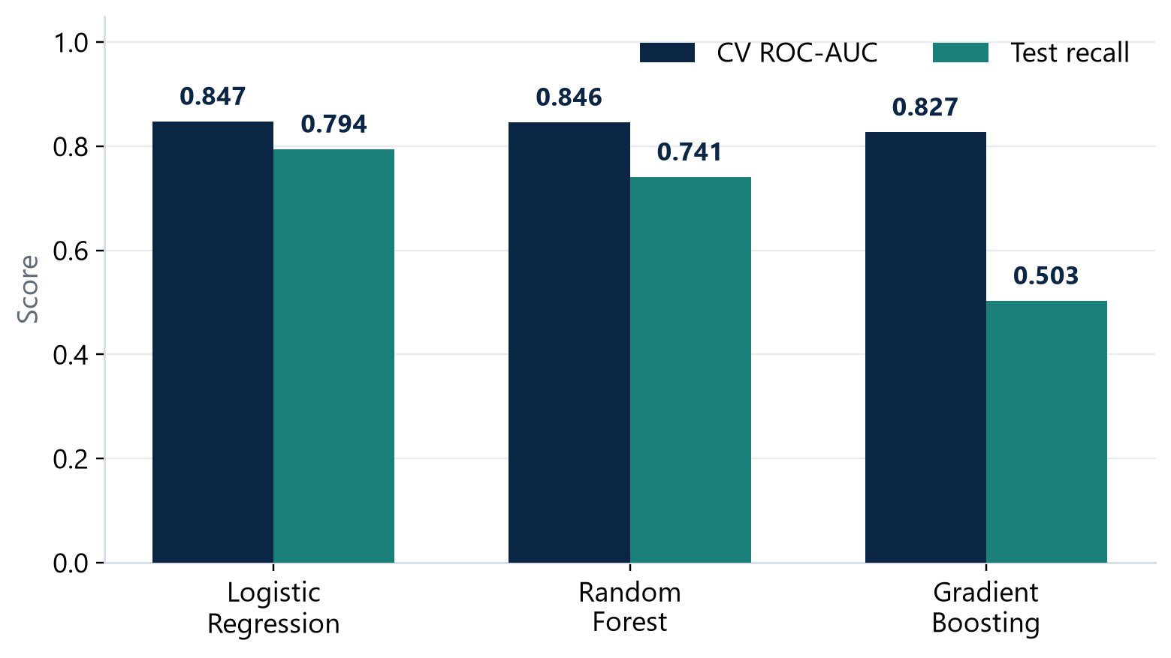
Figure 10.5: Cross-validated ROC-AUC and test recall by model

10.4 Final Model Performance
On the held-out test set, the selected Logistic Regression model achieved a ROC-AUC of 0.846, a recall of 79.4%, a precision of 50.6%, an F1 of 0.618 and an accuracy of 74.0%. The PR-AUC is 0.653. In practical terms, the model correctly identified 297 of the 374 customers who churned and flagged 290 customers who stayed. The full classification report is reproduced in Table 10.2.
Class | Precision | Recall | F1 | Support
Stayed | 0.91 | 0.72 | 0.80 | 1,035
Churned | 0.51 | 0.79 | 0.62 | 374
Accuracy |  |  | 0.740 | 1,409
Macro average | 0.71 | 0.76 | 0.71 | 1,409
Weighted average | 0.80 | 0.74 | 0.75 | 1,409
Table 10.2: Classification report for the selected model
The asymmetry between the classes is visible in the table. The model is good at recognising stayers (precision 0.91) and good at catching churners (recall 0.79), but the precision on churners is only 0.51. This is the expected consequence of a 0.50 threshold on an imbalanced problem: to catch four out of five churners, the model must accept that about half of the customers it flags would have stayed.

10.5 Confusion Matrix and Error Analysis
The confusion matrix in Figure 10.6 makes the error structure explicit. Of 1,035 stayers, 745 were correctly left alone and 290 were flagged. Of 374 churners, 297 were correctly flagged and 77 were missed. The false negatives are the most expensive errors for a retention team because they represent lost customers who received no intervention.
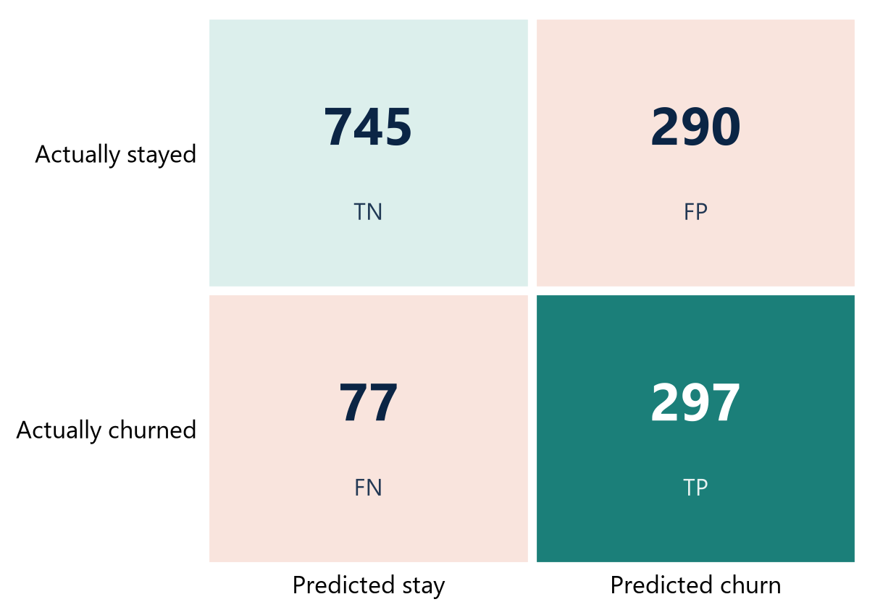
Figure 10.6: Confusion matrix on the held-out test set
The 77 missed churners are likely to be customers whose profile resembles that of stayers: long tenure, a two-year contract or a service bundle that historically correlates with retention. Their departure may be driven by factors that the dataset does not capture, such as a competitor offer, a house move or a change in household circumstances. This is a fundamental limit of a model trained on account attributes alone.
The 290 false positives are customers who were flagged but stayed. In a retention campaign they would receive an unnecessary contact or offer. This is not wasted in the same sense as a missed churner - a well-designed check-in can strengthen the relationship - but it consumes capacity and should be managed. A higher threshold would reduce false positives at the cost of more false negatives; the right balance depends on campaign economics.

10.6 Ranking Quality
Figure 10.7 shows the ROC curve. The curve rises steeply at low false-positive rates, which is the region that matters when a retention team can contact only a small fraction of the customer base. The area under the curve is 0.846, well above the random-ranking diagonal of 0.500. The PR-AUC of 0.653 is also substantially above the base churn rate of 0.265, which confirms that the model concentrates true churners near the top of the ranking.
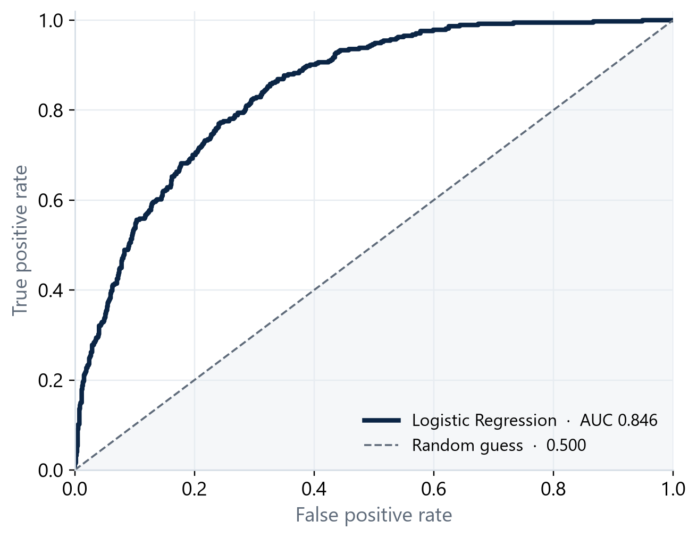
Figure 10.7: ROC curve for the selected model
The practical interpretation is a lift of approximately 1.9. If the team contacts the 587 flagged customers, it reaches 297 true churners. A random sample of 587 customers would contain about 156 churners. The model therefore nearly doubles the number of at-risk customers reached for the same outreach cost.

10.7 Feature Importance
Figure 10.8 reports permutation importance on the test set. Tenure is the most important feature, followed by contract type, internet service, monthly charges and the new-customer indicator. The ordering is consistent with the exploratory analysis and with the business intuition that the length and type of the relationship matter more than demographic attributes.
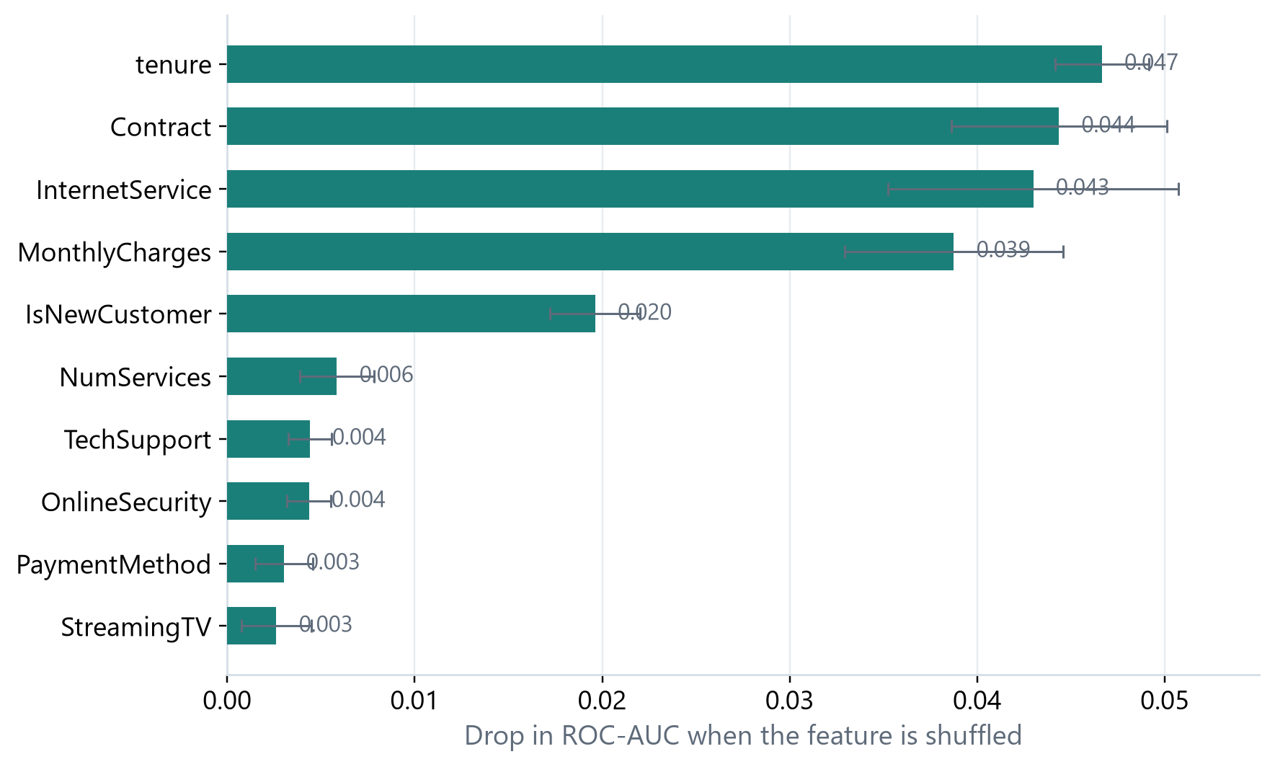
Figure 10.8: Permutation importance of the top ten features
The engineered features add modest but real value. IsNewCustomer is the fifth most important feature, which confirms that the early lifecycle is a distinct risk period rather than a simple linear effect of tenure. NumServices is sixth, suggesting that service breadth carries information beyond the individual service flags. AvgMonthlySpend does not appear in the top ten, which suggests that MonthlyCharges and TotalCharges already capture most of the spending signal.
Permutation importance measures reliance, not causation. A feature can be important because it is a proxy for an unobserved cause. Contract type, for example, may partly reflect self-selection: customers who expect to stay are more likely to sign a long contract. The model is therefore best used to prioritise and to generate hypotheses, not to prescribe interventions without further evidence.

10.8 Application Screenshots
The model is deployed as a Streamlit application. Figure 10.9 shows the main prediction view. The sidebar contains the customer inputs, the main panel shows the risk band, the probability gauge and the recommended actions, and the factor chips explain which attributes push the risk up or down.
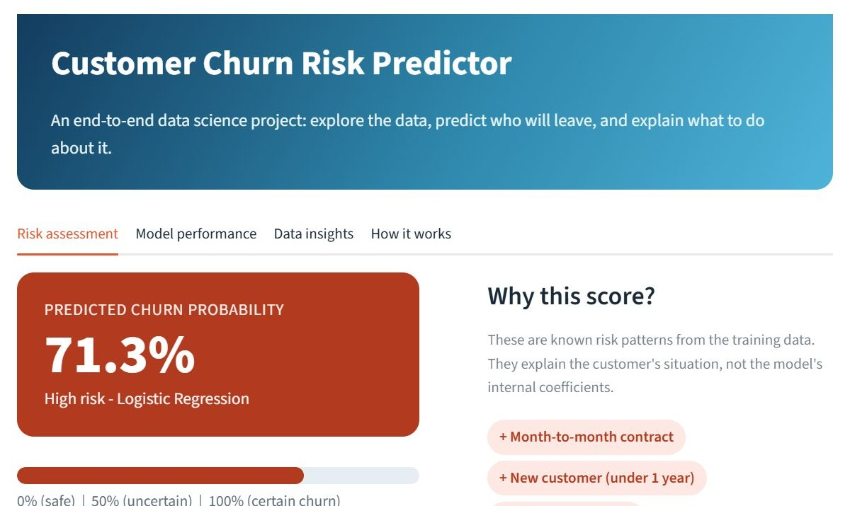
Figure 10.9: Risk assessment view of the Streamlit application
Figure 10.10 shows the what-if simulator. The user selects an alternative contract, payment method or service configuration and the application re-scores the customer. In this example, the estimated risk falls when the customer is moved to a longer contract or an automatic payment method, which illustrates how the model can support a retention conversation.
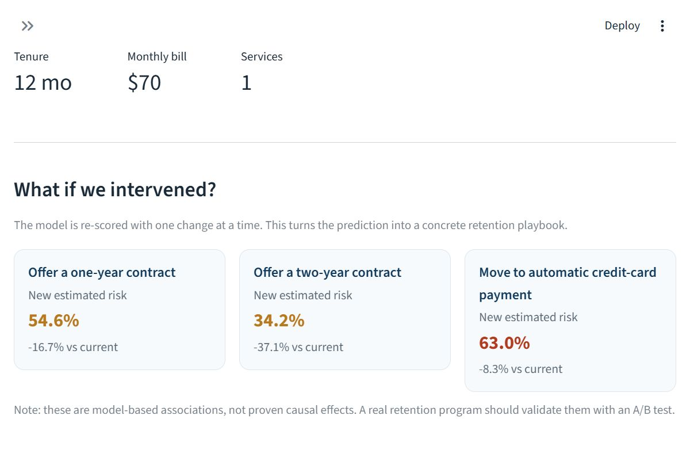
Figure 10.10: What-if retention simulator
Figure 10.11 shows the model-performance tab. It presents the headline metrics, the confusion matrix and the feature importance in a single view so that a reviewer can assess the model without leaving the application. Figure 10.12 shows the data-insights tab, which summarises the exploratory findings that motivated the feature set.
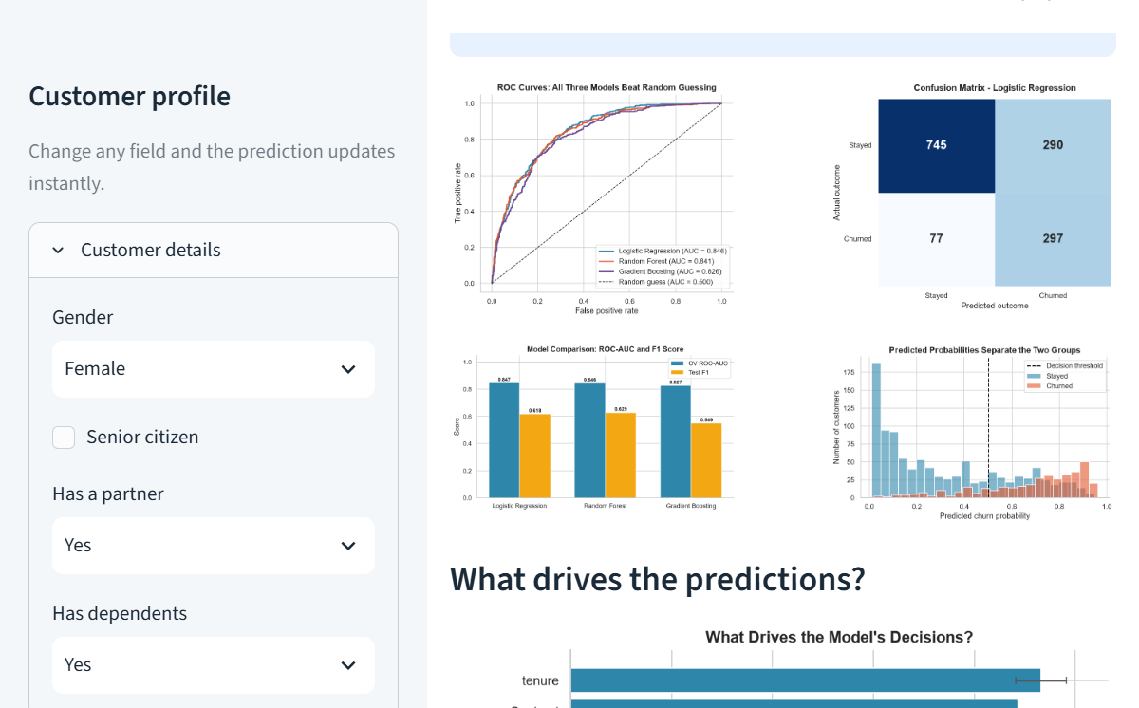
Figure 10.11: Model performance view
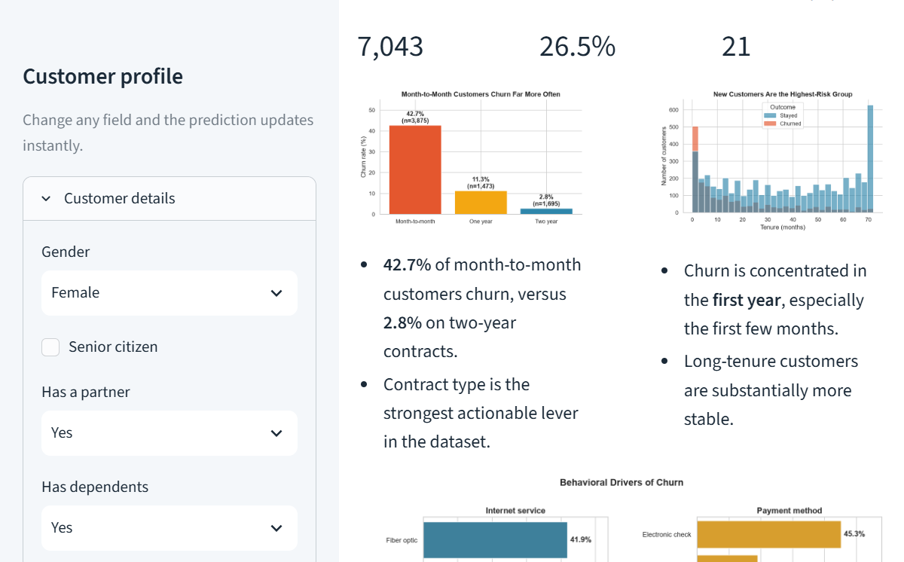
Figure 10.12: Data insights view

10.9 Comparison with a Baseline
A majority-class baseline predicts stay for every customer. It achieves 73.5% accuracy, zero recall, zero precision on churners and an undefined F1. The selected model has almost the same accuracy (74.0%) but a recall of 79.4% and an F1 of 0.618. The comparison shows why accuracy alone is an inadequate summary: the baseline looks respectable while providing no retention value at all.
Strategy | Accuracy | Recall (churn) | Precision (churn) | F1 (churn)
Predict everyone stays | 0.735 | 0.000 | 0.000 | 0.000
Logistic Regression (0.50) | 0.740 | 0.794 | 0.506 | 0.618
Random Forest (0.50) | 0.768 | 0.741 | 0.546 | 0.629
Gradient Boosting (0.50) | 0.781 | 0.503 | 0.605 | 0.549
Table 10.3: Comparison with baseline strategies

10.10 Discussion
The results support three conclusions. First, churn in this dataset is predictable to a useful degree: a compact linear model achieves a ROC-AUC of 0.846 and catches about four out of five churners. Second, the strongest signals are relational rather than demographic: tenure, contract type, internet service and monthly charges dominate the importance ranking. Third, the choice of model involves a genuine trade-off between recall and precision, and the right choice depends on the cost of each type of error.
The results also show the limits of a single snapshot. The model cannot explain why a particular customer leaves, and it cannot predict the effect of an intervention. It is a prioritisation tool that should be combined with human judgement, A/B testing and continuous monitoring. Within those limits, it provides a substantial improvement over random outreach and a transparent basis for a retention strategy.

11. CONCLUSION
This report has described the design, implementation and evaluation of a customer churn prediction system built during a 45-day Data Science internship. The project began with a business problem - identifying customers at risk of leaving - and ended with a deployed application that returns a risk score, explains the factors behind it and allows a what-if analysis of retention scenarios.

11.1 Summary of the Work
The IBM Telco Customer Churn dataset was cleaned, explored and enriched with three interpretable features. A leakage-free preprocessing pipeline was built with scikit-learn, and three classifiers were compared using stratified five-fold cross-validation. Logistic Regression achieved the highest cross-validated ROC-AUC (0.847) and was selected. On the held-out test set it achieved a ROC-AUC of 0.846, a recall of 79.4%, a precision of 50.6% and an F1 of 0.618, correctly identifying 297 of 374 churners. The model was deployed in a Streamlit application and documented in this report.

11.2 Key Findings
1. Contract type is the strongest segmentation variable. Month-to-month customers churn at 42.7%, compared with 11.3% for one-year and 2.8% for two-year contracts.
2. Tenure is the most important model feature. Churners have a mean tenure of 18.0 months, compared with 37.6 months for stayers, and the new-customer indicator adds independent information.
3. Service and payment behaviour matter. Fiber-optic customers and electronic-check customers show substantially higher churn than their alternatives.
4. Accuracy is the wrong headline metric. A majority-class baseline is 73.5% accurate but catches no churners; the selected model has similar accuracy and a recall of 79.4%.
5. A simple model can be competitive. Logistic Regression outperformed two tree-based ensembles on the selection metric while remaining interpretable and fast.
6. Deployment changes the conversation. The interactive application makes the model usable by a non-technical audience and turns a probability into a retention workflow.

11.3 Limitations
The study has several limitations. The dataset is a single cross-sectional snapshot, so the model cannot capture temporal drift or the effect of past interventions. The features are limited to account, service and billing attributes; call transcripts, network quality and competitor activity are absent. The model is evaluated at a single threshold and does not include a formal cost-benefit optimisation or probability calibration analysis. Fairness was considered qualitatively but not tested with group-level metrics. Finally, the application is a local demonstration rather than a production service with authentication, monitoring and audit logging.

11.4 Future Work
Several extensions would strengthen the system:
- Temporal validation. Train on earlier cohorts and test on later ones to estimate how performance decays over time and to support a retraining schedule.
- Probability calibration. Apply isotonic or Platt calibration and report reliability diagrams so that predicted probabilities can be used directly in financial planning.
- Cost-sensitive thresholding. Replace the fixed 0.50 threshold with an operating point derived from the cost of contact and the value of a retained customer.
- Local explanations. Add SHAP values to explain individual predictions more precisely than the current rule-based factor chips.
- Fairness audit. Evaluate performance and selection rates across gender and age groups, and document any disparities.
- Production deployment. Wrap the pipeline in a REST API, add authentication, logging, input validation and drift monitoring, and integrate the score into the retention team's workflow.
- Causal evaluation. Run a controlled experiment on a subset of flagged customers to measure the actual effect of each retention offer rather than relying on association.

11.5 Concluding Remarks
The internship provided an opportunity to work through the complete lifecycle of a data science project: understanding a business problem, preparing messy data, selecting and validating a model, interpreting the results and delivering a usable application. The technical result - a model with a ROC-AUC of 0.846 and a recall of 79.4% - is encouraging, but the more important outcome is the workflow behind it. The project demonstrates that a small, well-documented, reproducible pipeline can turn routine customer data into a decision-support tool with measurable value.
The work was carried out under the AVISHKARANA ANDHRA SUMMER INTERNSHIP at BHARAT CARE LIFE LINE FOUNDATION, in association with ZERO P4 Poverty. The experience reinforced the importance of clear communication, honest evaluation and responsible use of data - lessons that will carry forward into professional practice.

12. BIBLIOGRAPHY AND REFERENCES
The following sources were consulted during the project. References are listed in the order in which they are first relevant to the report, using a consistent author-title-year style.
[1] IBM. (2019). Telco Customer Churn [Data set]. IBM Cognos Analytics. https://www.ibm.com/analytics (accessed July 2026).
[2] Chapman, P., Clinton, J., Kerber, R., Khabaza, T., Reinartz, T., Shearer, C., & Wirth, R. (2000). CRISP-DM 1.0: Step-by-step data mining guide. SPSS Inc.
[3] Berry, M. J. A., & Linoff, G. S. (2004). Data mining techniques: For marketing, sales, and customer relationship management (2nd ed.). Wiley.
[4] Breiman, L. (2001). Random forests. Machine Learning, 45(1), 5–32. https://doi.org/10.1023/A:1010933404324
[5] Friedman, J. H. (2001). Greedy function approximation: A gradient boosting machine. Annals of Statistics, 29(5), 1189–1232. https://doi.org/10.1214/aos/1013203451
[6] Pedregosa, F., Varoquaux, G., Gramfort, A., Michel, V., Thirion, B., Grisel, O., et al. (2011). Scikit-learn: Machine learning in Python. Journal of Machine Learning Research, 12, 2825–2830.
[7] McKinney, W. (2010). Data structures for statistical computing in Python. In Proceedings of the 9th Python in Science Conference (pp. 56–61).
[8] Harris, C. R., Millman, K. J., van der Walt, S. J., Gommers, R., Virtanen, P., Cournapeau, D., et al. (2020). Array programming with NumPy. Nature, 585, 357–362. https://doi.org/10.1038/s41586-020-2649-2
[9] Hunter, J. D. (2007). Matplotlib: A 2D graphics environment. Computing in Science & Engineering, 9(3), 90–95.
[10] Waskom, M. L. (2021). Seaborn: Statistical data visualization. Journal of Open Source Software, 6(60), 3021. https://doi.org/10.21105/joss.03021
[11] Streamlit. (2026). Streamlit documentation. https://docs.streamlit.io (accessed July 2026).
[12] Neslin, S. A., Gupta, S., Kamakura, W., Lu, J., & Mason, C. H. (2006). Defection detection: Measuring and understanding the predictive accuracy of customer churn models. Journal of Marketing Research, 43(2), 204–211.
[13] Verbeke, W., Dejaeger, K., Martens, D., Hur, J., & Baesens, B. (2012). New insights into churn prediction in the telecommunication sector: A profit driven data mining approach. European Journal of Operational Research, 218(1), 211–229.
[14] Provost, F., & Fawcett, T. (2013). Data science for business. O'Reilly Media.
[15] Hastie, T., Tibshirani, R., & Friedman, J. (2009). The elements of statistical learning (2nd ed.). Springer.
[16] James, G., Witten, D., Hastie, T., & Tibshirani, R. (2013). An introduction to statistical learning. Springer.
[17] Géron, A. (2022). Hands-on machine learning with Scikit-Learn, Keras & TensorFlow (3rd ed.). O'Reilly Media.
[18] Sculley, D., Holt, G., Golovin, D., Davydov, E., Phillips, T., Ebner, D., et al. (2015). Hidden technical debt in machine learning systems. In Advances in Neural Information Processing Systems (Vol. 28).
[19] Ribeiro, M. T., Singh, S., & Guestrin, C. (2016). "Why should I trust you?": Explaining the predictions of any classifier. In Proceedings of the 22nd ACM SIGKDD International Conference on Knowledge Discovery and Data Mining (pp. 1135–1144).
[20] Lundberg, S. M., & Lee, S.-I. (2017). A unified approach to interpreting model predictions. In Advances in Neural Information Processing Systems (Vol. 30).
[21] Microsoft. (2026). python-docx documentation. https://python-docx.readthedocs.io (accessed July 2026).
[22] Microsoft. (2026). Field codes in Word. https://support.microsoft.com (accessed July 2026).

