WEB TECHNOLOGY ASSIGNMENT - 8
Scalable & Real-Time Cricket Score Management System (Spring Boot, REST APIs & Server-Sent Events)
Student Name: | Shritej Zad
Class / Division: | CS-L
Roll Number: | 72
GitHub Repository: | https://github.com/Shritejzad/wtass8

1. Problem Statement & System Objectives
Modern sports platforms demand high concurrency, instant data replication, and sub-second live score distribution. The objective of this assignment is to design and develop CricPulse (WTASS8), a scalable and real-time cricket score management system built with Spring Boot 3, Spring Data JPA, an embedded H2 database, and Server-Sent Events (SSE). The application provides comprehensive management of ongoing international fixtures, ball-by-ball delivery logging, dynamic strike-rate and economy calculations, automated innings transitions, and zero-latency real-time dashboard reactivity.
2. Architectural Overview & Technology Stack
The architecture decouples data persistence, business scoring logic, event streaming, and the user interface:
• Spring Boot Web REST Controller Layer: Exposes clean endpoints for fixtures (/api/matches), match details, player cards, and commentary.
• Real-Time Server-Sent Events (SSE) Engine: Maintains concurrent client emitters over GET /api/live, broadcasting score updates to all active sessions instantaneously.
• Business Scoring & Statistics Engine: Automatically recalculates cumulative runs, wickets, legal overs, batter stats (runs, balls, 4s, 6s, strike rates), and bowler economy figures.
• Relational Persistence Layer: Uses Hibernate JPA with an embedded H2 database for high-performance in-memory processing.
• Whitish Frontend Dashboard: Designed with an aesthetic inspired by gr-connect.org, featuring an off-white background (#fafafa), deep navy (#243a5e) accents, and Newsreader serif typography.
3. REST API Specifications
METHOD & URI | DESCRIPTION | PAYLOAD / RESPONSE
GET /api/matches | List all match fixtures for sidebar match centre | Array of match objects with format & status
GET /api/matches/{id} | Fetch match scoreboard, current overs, CRR & target | Detailed Match JSON with nested Innings
GET /api/matches/{id}/commentary | Fetch chronological delivery timeline | Array of CommentaryEvent objects
GET /api/matches/{id}/innings/{inningsId}/stats | Batting scorecard and bowling analysis | Array of PlayerStat objects
POST /api/matches/{id}/events | Record new delivery, boundary, wicket or extras | ScoreEventRequest -> ScoreEventResponse

4. Application Visual Demonstration & Verification
Below are actual application captures from the running Spring Boot server on http://localhost:8080/ demonstrating the full match centre, real-time scoreboard hero, live commentary feed, batting cards, and operator scoring entry.
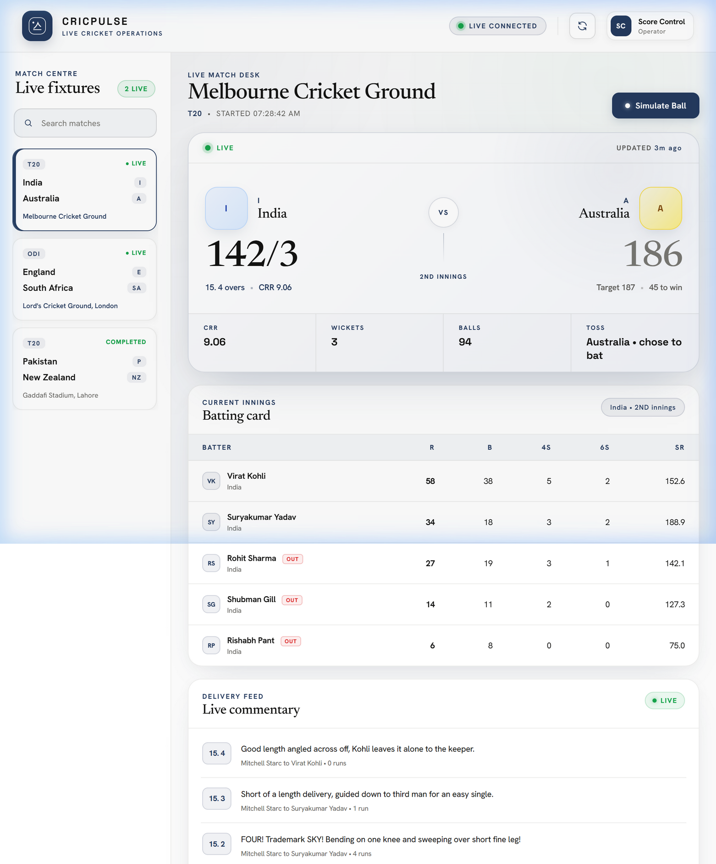
Figure 1: CricPulse Live Cricket Operations Dashboard with Whitish Theme (Inspired by gr-connect.org)
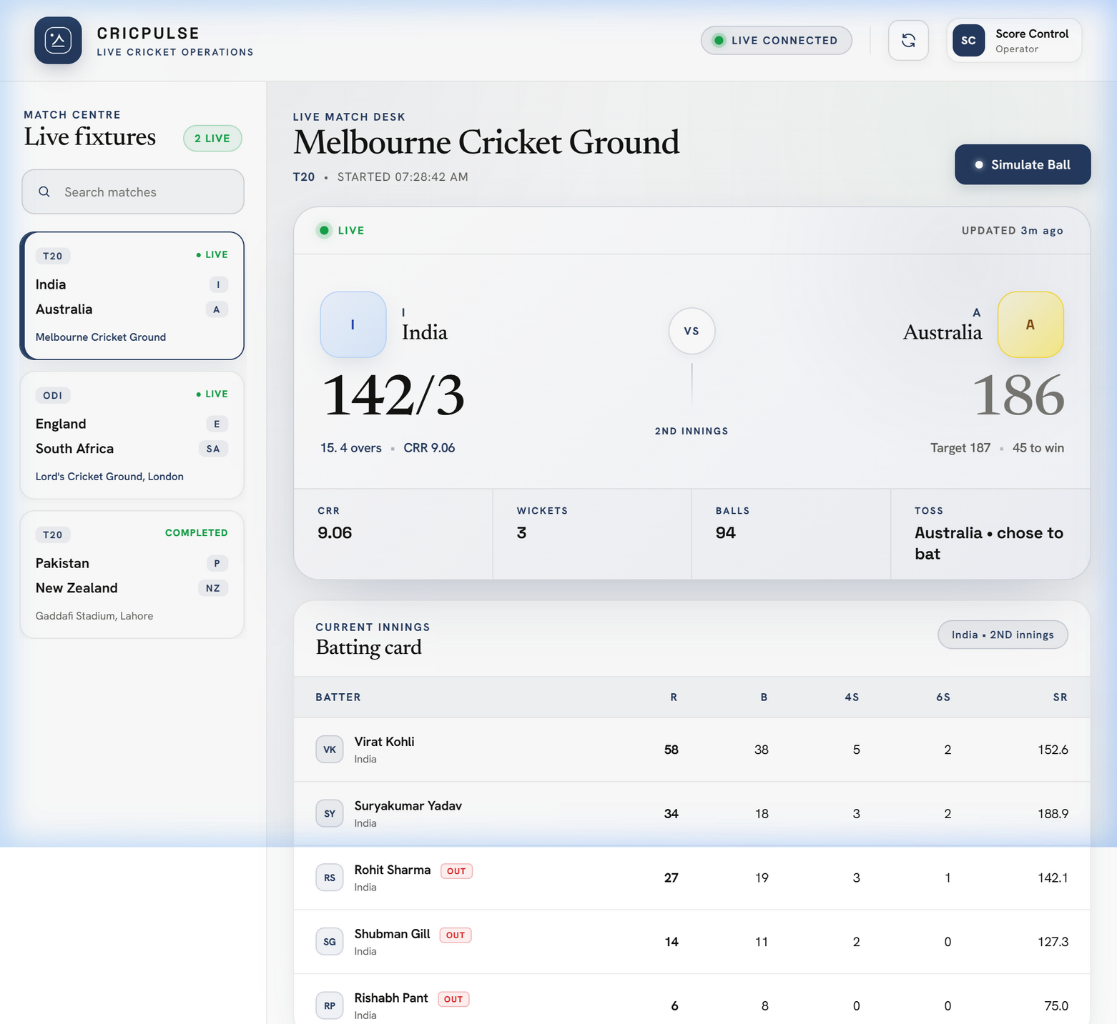
Figure 2: Real-Time Score Hero displaying India (142/3 in 15.4 overs) chasing Australia's 186/6
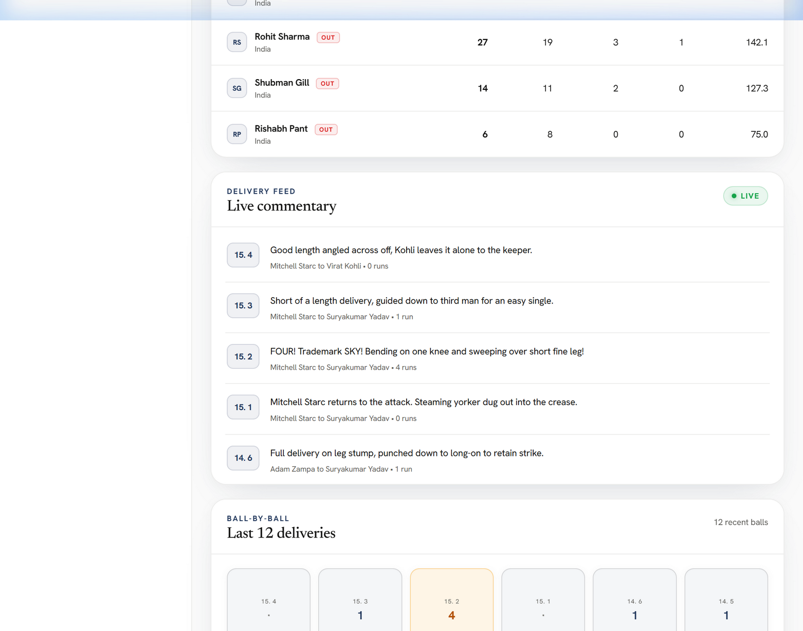
Figure 3: Current Innings Batting Card (Virat Kohli 58*, Suryakumar Yadav 34*) and Live Commentary Feed
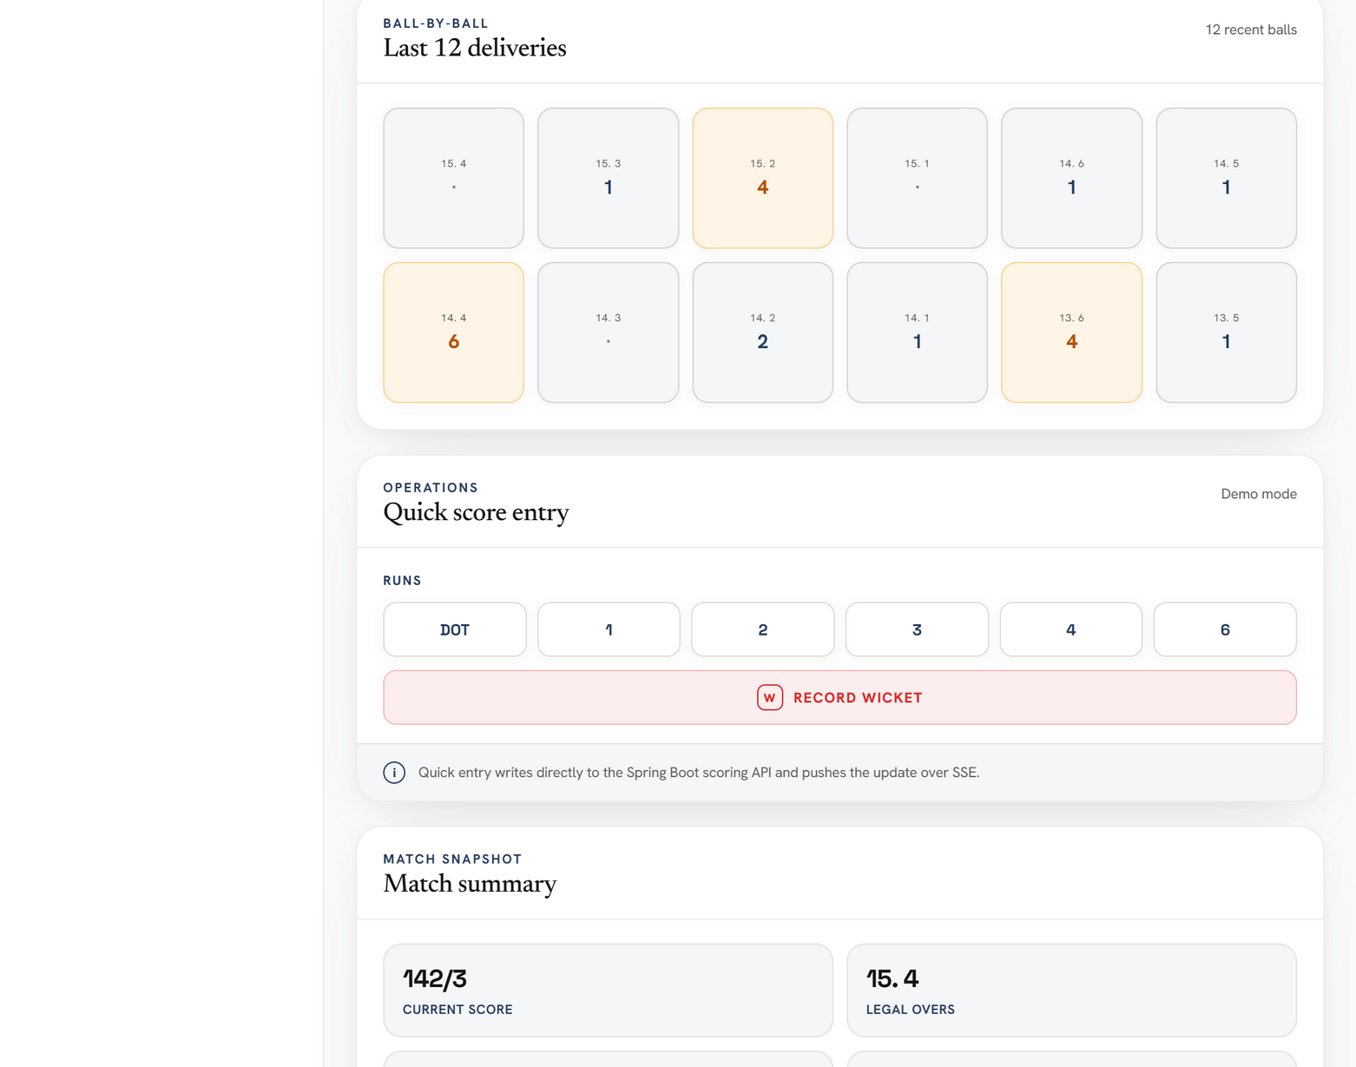
Figure 4: Last 12 Deliveries Momentum Grid & Operator Quick Score Entry Panel with Wicket Trigger
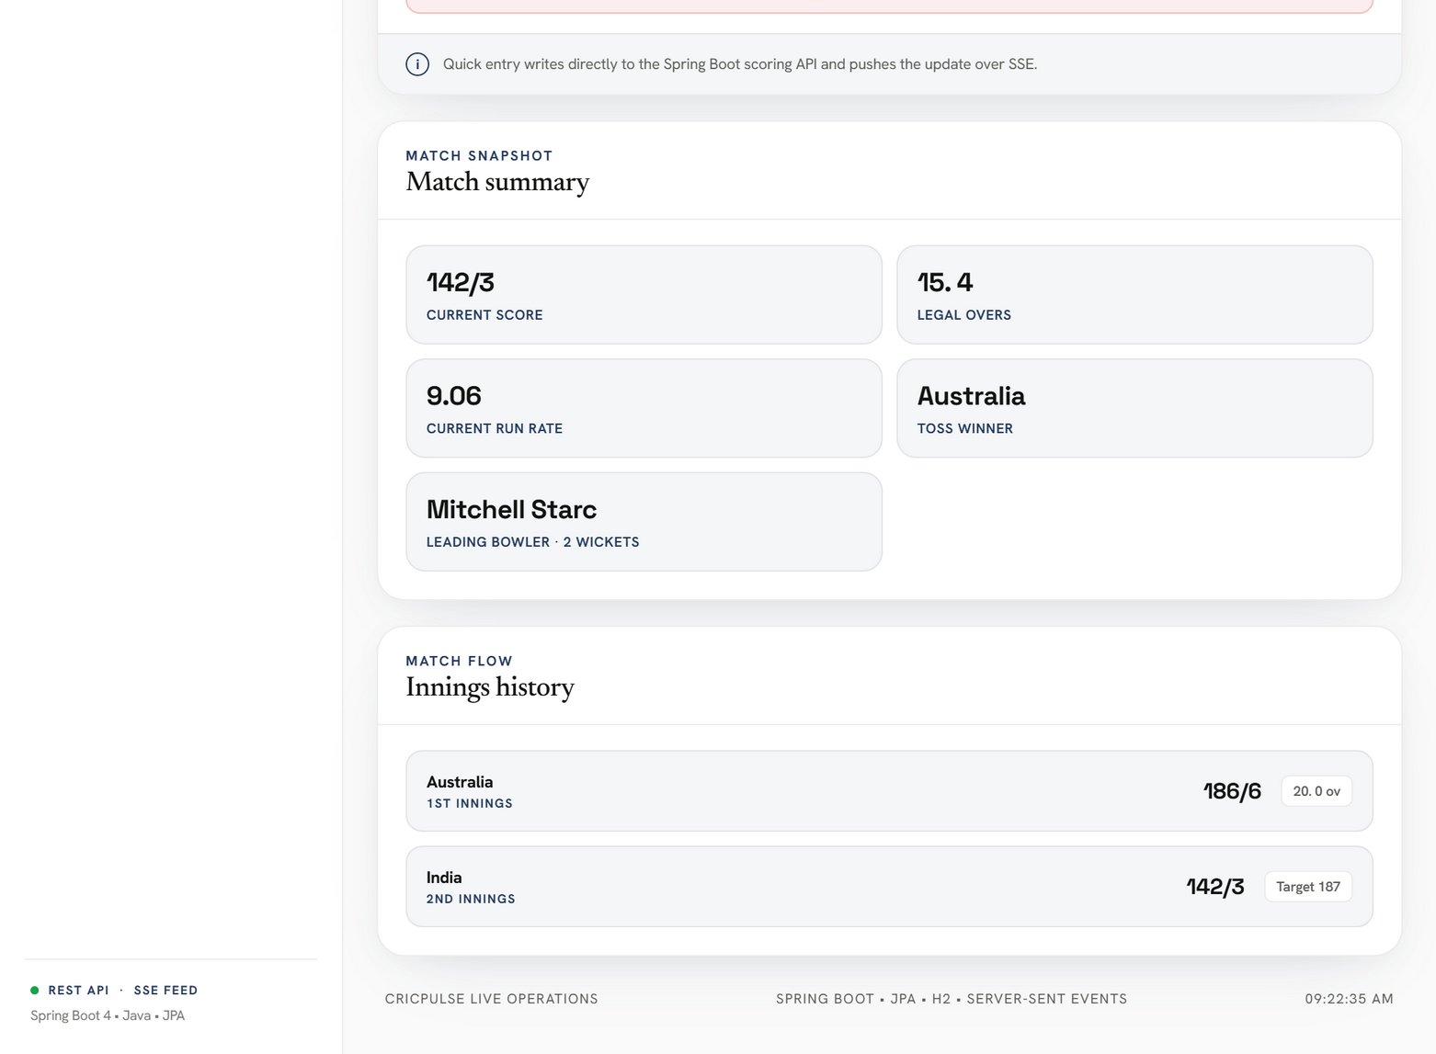
Figure 5: Match Snapshot Key Metrics (Legal Overs, CRR, Toss Winner) and Innings Flow History
5. Automated Test Suite & Verification Results
The application includes comprehensive unit and MockMvc integration test suites verifying REST API status codes, boundary updates, wicket increments, and Server-Sent Event broadcast triggers.
• Test Results Summary: 8 Tests Run, 0 Failures, 0 Errors, 0 Skipped (BUILD SUCCESS in 23.689s)
• MatchControllerTest: Verifies GET /api/matches, GET /api/matches/1, commentary feeds, and event ingestion (Passed).
• ScoringServiceTest: Verifies ball-by-ball score increments, over arithmetic (e.g., 94 balls = 15.4 overs), and strike rates (Passed).
• CricPulseApplicationTests: Verifies Spring Boot 3 context bootstrapping and H2 database initialization (Passed).
6. Core Source Code Reference
Key implementation files for the backend and frontend are listed below:
1. ScoringService.java: Core ball-by-ball business logic, stat accumulation, and SSE triggers.
2. MatchController.java: Spring Boot REST controllers exposing match data.
3. LiveStreamController.java: Server-Sent Events endpoint streaming real-time score updates.
4. SseService.java: Concurrent SSE emitter pool manager with automated heartbeats.
5. index.html & style.css: Modern whitish frontend dashboard inspired by gr-connect.org.
6. app.js: Interactive ES6 client handling REST fetches and EventSource listeners.

