ITUE301: Advance Web Development Framework 24CS019
Student ID : | 24CS019 | Student Name: | Yug Dholiya
Email : | 24cs019@charusat.edu.in | Semester : | 5th
Degree : | B.Tech | Program : | CSE-CSPIT
Subject code & Name : | ITUE301: Advance Web Development Framework | Practical : | 1 | Academic Year | : | 2026-27
Task - 1
Aim
To set up a React development environment using Vite and develop a simple student portfolio application using reusable functional components, demonstrating component-based architecture and data passing through props.
Code
GitHub Link Repository Link: https://github.com/YugDholiya/24cs019-awdf-practical1
Output
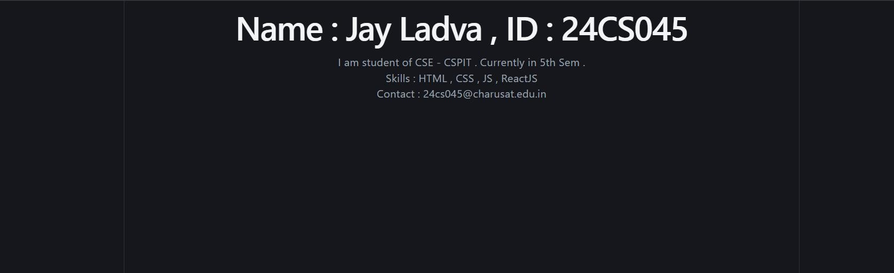
++
Department of Computer Science and Engineering, CSPIT Page 1

