Name :- Yug Kapuriya
CIN : FIT/DEC25/CS5458

Top OWASP - 2025
A01 | Broken Access Control | ✅
A02 | Security Misconfiguration | ✅
A03 | Software Supply Chain Failures | ✅
A04 | Cryptographic Failures | ✅
A05 | Injection | ✅
A06 | Insecure Design | ✅
A07 | Authentication Failures | ✅

A01 :- Broken Access Control (Product Tampering)
Description :-
Product Tampering is a Broken Access Control vulnerability where an attacker can modify product information (like price, description, or availability) without proper authorization.
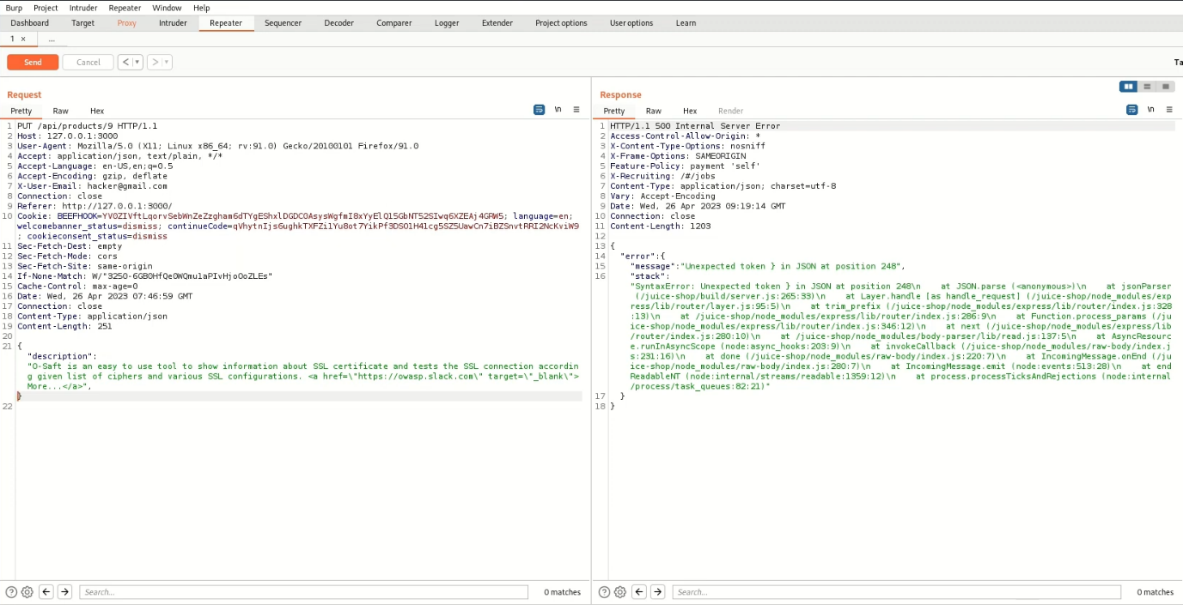
Impact Level: HIGH to CRITICAL
Recommended Action:
- Priority: P0 - CRITICAL
- Timeline: Fix within 24-48 hours
- Action: Hotfix required
- Testing: Full regression before deploy
- Comms:Notify security team immediately

A02 :- Security Misconfiguration (Deprecated Interface)
URL :- http://localhost:3000/#/complain

Description:-
a deprecated B2B interface that was not properly shut down. Xml file is not allowed by Browser but still Uploaded. This is called as Security misconfiguration.
Payload = Hacked.xml

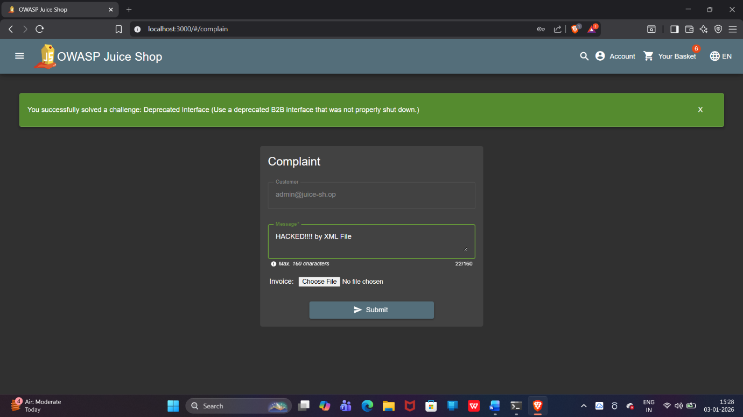

Impact Level: HIGH to CRITICAL
Remediation Steps :-
- Disable deprecated endpoint (NOW)
- Add authentication requirement
- Implement IP whitelisting
- Enable comprehensive logging
- Alert security team

A03 :- Software Supply Chain Failures (jsonwebtoken Authentication Bypass)
Description:-
OWASP Juice Shop uses jsonwebtoken version 0.4.0 (released 2014), which is 8 major versions outdated. This allows attackers to forge JWT tokens with no signature verification, achieving complete authentication bypass and admin access in under 5 minutes with zero technical skills.

Many more version is also outdated are following.
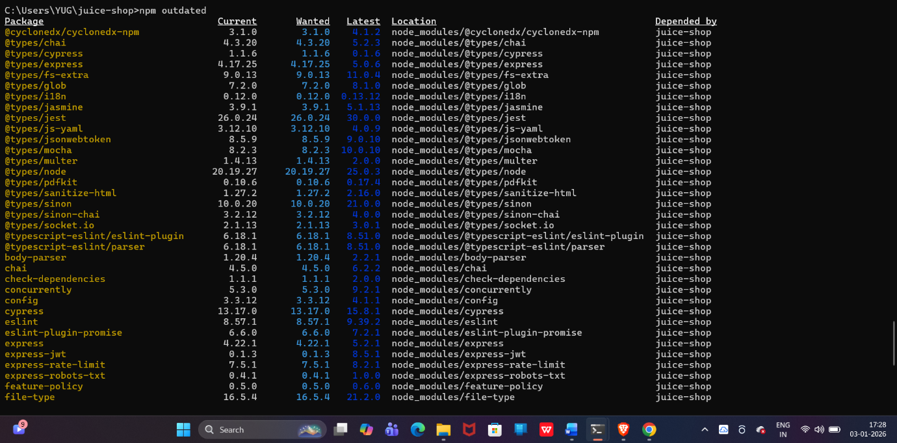
Impact Level: HIGH to CRITICAL
📊 TECHNICAL DETAILS
Field | Value
Package Name | jsonwebtoken
Current Version | 0.4.0 (10 years old)
Fixed Version | 9.0.3+
Versions Behind | 8 major versions
CVE | CVE-2022-23529
CVSS Score | 9.8 (CRITICAL)
CWE | CWE-347 (Improper Verification of Cryptographic Signature)

Business Impact:
- Complete authentication bypass
- Full admin access to all data
- Ability to modify/delete any records
- PII/payment data exposure
- GDPR/PCI-DSS violations
- Estimated cost: $4.45M+ (average data breach)
📚 REFERENCES
- CVE-2022-23529: https://nvd.nist.gov/vuln/detail/CVE-2022-23529
- GitHub Advisory: https://github.com/advisories/GHSA-8cf7-32gw-wr33
- OWASP A06:2021: https://owasp.org/Top10/A06_2021-Vulnerable_and_Outdated_Components/

Recommendations:
- Update all critical packages: express-jwt, sanitize-html, socket.io, helmet
- Run npm audit fix to automatically patch remaining vulnerabilities
- Enable GitHub Dependabot for automated security updates
- Add npm audit to CI/CD pipeline to catch future vulnerabilities
- Document all changes in a security update log
- Run full test suite to ensure no breaking changes

A04 :- Cryptographic Failures (Weird Crypto)
URL :- http://localhost:3000/#/contact
Description :-
I found an encoded string in /ftp/, recognized it as MD5+ROT13, decoded the ROT13 first, then cracked the MD5 hash online to reveal the password. This exposed weak cryptography practices.
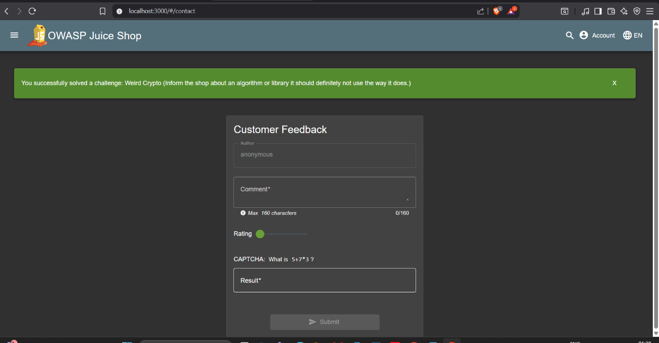
Impact Level: HIGH
Recommendations:
- Replace MD5 with bcrypt/Argon2
- Remove ROT13 encoding
- Add unique salts
- Force password reset

A05 :- Injection (SQl Injection in Login Form)

URL:- http://localhost:3000/#/search
Description :-
First we have to use SQL injection at email and password will anything. Try more then 4 or 5 injection to by pass the login page as Admin. and end of the process we can Bypass the login form.

Payload = ‘’ OR TRUE--
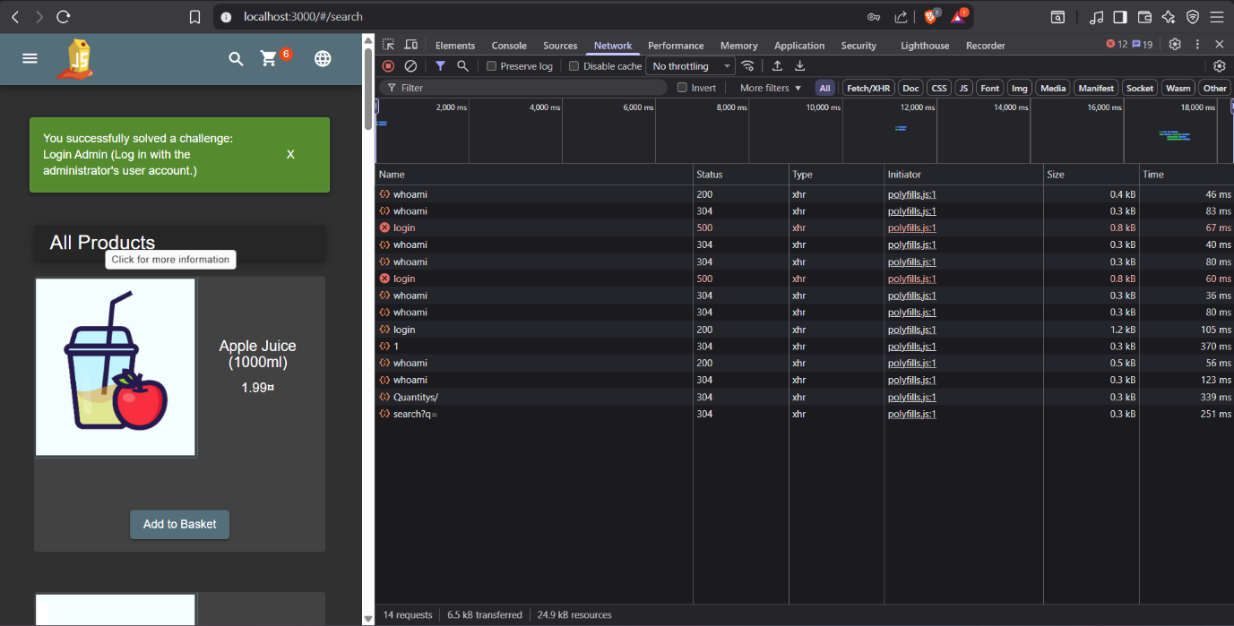

Impact Level = High Data breach / Account takeover
Remediation Steps :-
- Use prepared statements
- Input validation
- ORM frameworks

A06 :- Insecure Design
Description:-
The application allows manipulation of product prices by trusting client-side input. This represents an Insecure Design vulnerability (OWASP A04:2021) caused by improper trust boundaries and missing server-side business logic validation. I can change or manipulate the req. and change the amount.
Screenshot of Req. manipulate.
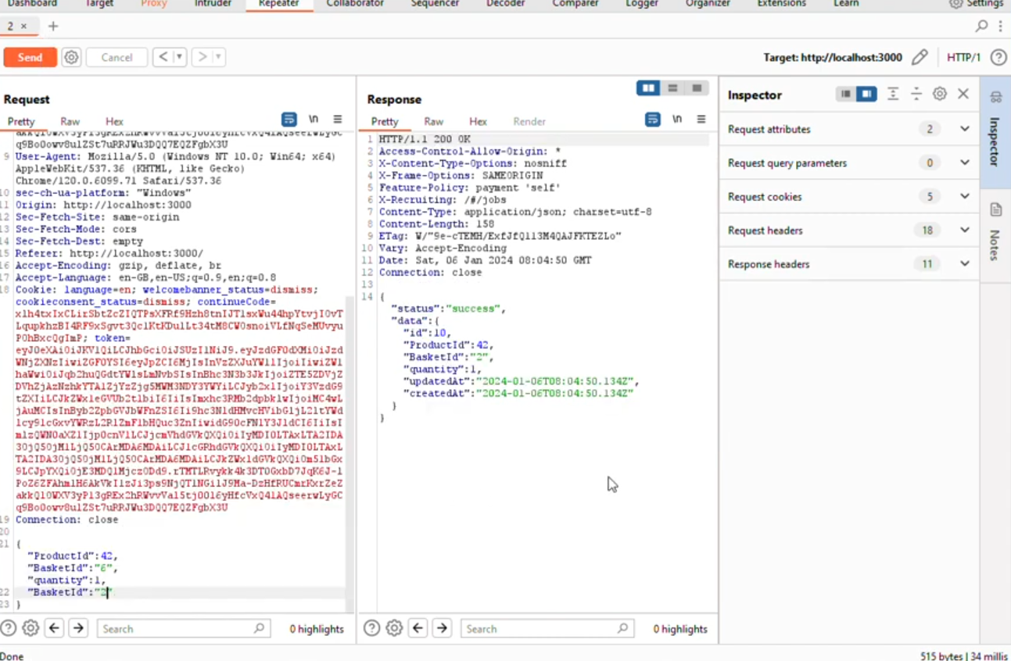
Impact Level: HIGH
Remediation Steps :-
- Perform all price calculations on the server and never trust client-side values
- Accept only product ID and quantity from the client
- Recalculate totals on the backend before checkout
- Validate business rules (price, quantity, discounts) server-side
- Enable logging and monitoring for abnormal price changes

A07 :- Authentication Failure (Broken Authentication)
Description :-
The application allows login as a privileged user without requiring valid credentials or exploiting injection flaws. This indicates a Broken Authentication vulnerability (OWASP A02:2021) caused by improper authentication logic and insufficient identity verification.
Screenshot of How I got the Password.
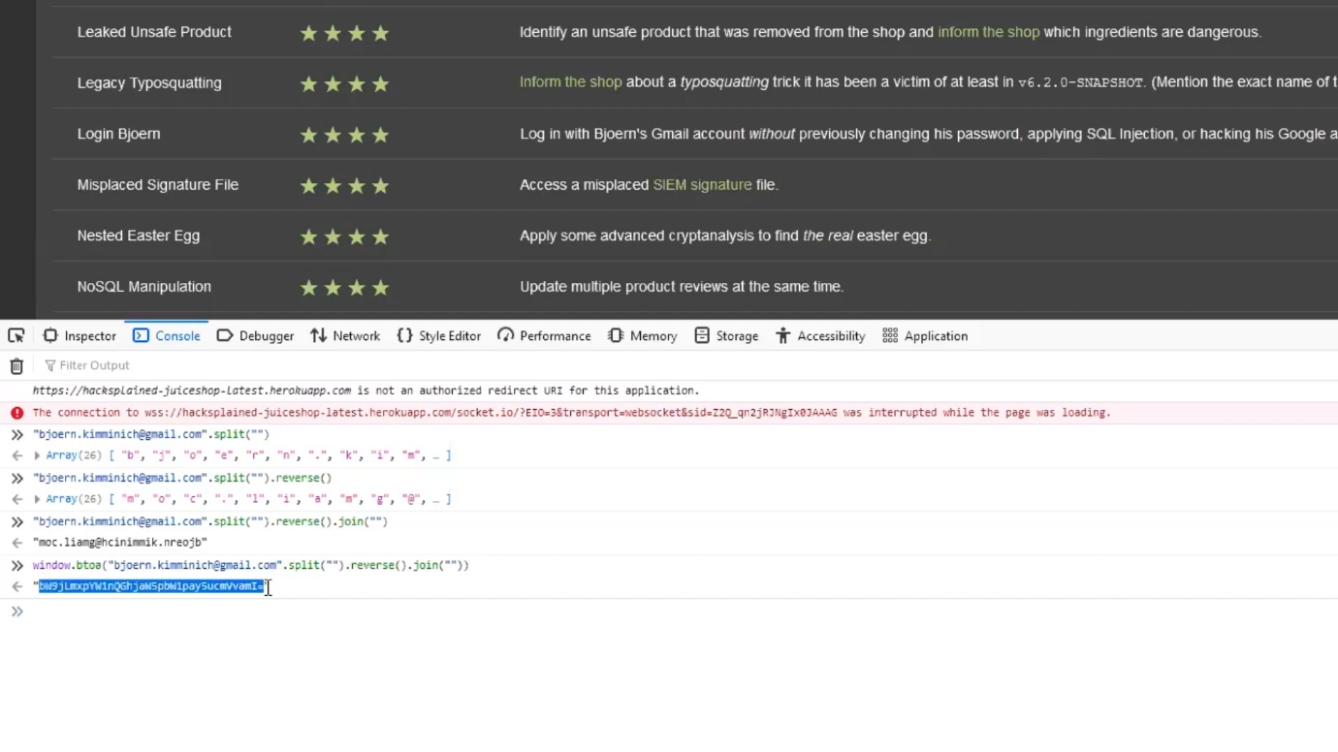
Impact Level: HIGH
Recommendations:-
- Enforce strict credential validation for all login attempts
- Implement rate limiting and account lockout mechanisms
- Secure session management (invalidate tokens on logout)
- Use strong password policies and hashing
- Enable logging and monitoring for suspicious login activity

