**Smart Home System For Saving Electricity**

**Project Report**

**Internet of Things**

**BTech ICT (Sem VII)**

Yug Patel (1741017)

Aditya Bajaj (1741028)

Shivansh Nautiyal (1741037)

Nisarg Gandhi (1741099)

**Under the guidance of**

**Instructor Name**

**Anurag Lakhlani**

School of Engineering and Applied Science

Ahmedabad University

Ahmedabad - 380009

**CHAPTER_1**

**INTRODUCTION**

1.1 OVERVIEW

The project deals with an interesting manner of how energy can be saved by just turning instruments of room off when not in used.

1.2 MOTIVATION

In India most of the people forgets to switch off fans and lights when they leave the room which cause a big loss of energy. Currently India Faces a huge Problem of Electricity Shortage And there are many Villages in India which still Doesn’t have electricity. So, saving Electricity is a huge task and very important for a developing Country like India.

1.3 OBJECTIVE

* Our main objective is to control lights, fans and A/C’s on the basis of human presence.
* We will be using IR sensors to count humans inside the room.
* As the person moves inside the lights will be controlled in that way.
* And as the temperature changes fans and A/C’s will be operating accordingly.
* Also, we have 4x4 Keypad for Entering the Password. And Servo Motor for Opening the Door.

**CHAPTER 2**

MARKET SURVEY

|  |  |  |  |  |  |  |
| --- | --- | --- | --- | --- | --- | --- |
| **Sr No.** | **System** | **Communication**  **Interface** | **Controller** | **User**  **Interface** | **Applications** | **Benefits** |

|  |  |  |  |  |  |  |
| --- | --- | --- | --- | --- | --- | --- |
| 1. | Philips Hue Bridge | Zig bee  wireless Network | Home  gateway and Router | Smart device | Monitoring  and Controlling Home Appliances | Effectively  Manages and Controls Home Appliances and Other devices |

|  |  |  |  |  |  |  |
| --- | --- | --- | --- | --- | --- | --- |
| 2. | LIFX Lighting Systems | Wi-Fi Module | Works on Wi-Fi System. | Led Lights | Switching  LED | Smart,  Economic and  Efficient |

|  |  |  |  |  |  |  |
| --- | --- | --- | --- | --- | --- | --- |
| 3. | Comfy Lights | Wi-Fi Network | Build in Sensors (Motion Sensor, LED, Wi-Fi, Light Sensor). | Android Phone | Comfy Light simulates Human presence at home realistically through light, so deterring intruders. | Convenience, safety, and Power-saving |

**CHAPTER 3**

BLOCK DIAGRAM

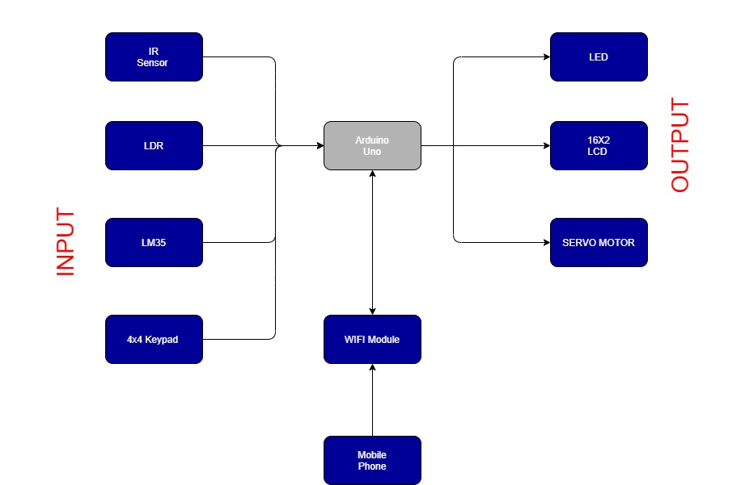

* First, Person will Enter the Password in 4X4 KeyPad. If the password is Correct the door (Servo Motor) will open (Rotate 90 Degree).
* After That when person will pass through the Door, IR Sensor will detect it and display the Count of No of Persons In the Room on 16X2 LCD.
* The Room will be divided in 2 Parts, Left & Right and there will be an IR Sensor in each part which will detect presence of person in each part.
* In Each part there will be a LM35 and a LDR to check the temperature and light intensity.
* Fan and A/c’s will be Controlled and turned ON and OFF on the bases of temperature readings provided by LM35.
* Lights will be Controlled and turned ON and OFF on the bases of Natural Light Intensity readings provided by LDR.
* All this data will be available to the user on his mobile phone. This data will be transferred using internet by ESP8266WiFi Module.
* Input for the System will be password on the 4X4 KeyPad, The Human Presence detected IR Sensors, Natural Light Intensity detected by LDR, Temperature Readings Taken by LM35.
* Output for the System will be Counts of No of Humans & Current Temperature on 16X2 LCD, Fans, AC’s and Lights as LED’s and Servo Motor as door.

**CHAPTER 4**

SYSTEM ARCHITECTURE

CIRCUIT DIAGRAM

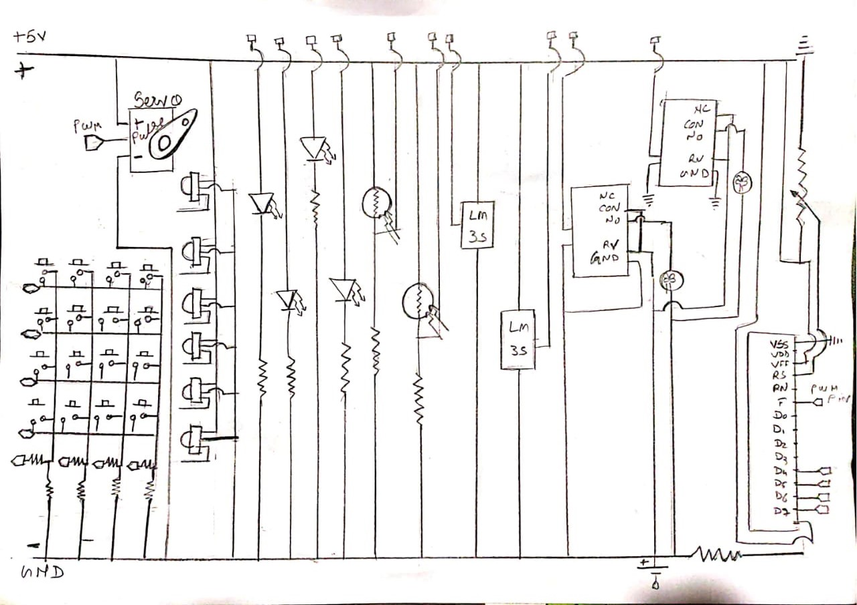

**HARDWARE AND SOFTWARE REQUIREMENTS**

* **Hardware Components**

1. ARDUINO MEGA

2. 16x2 CHARACTER LCD

3. IR SENSOR

4. LDR

5. LM35 TEMPERATURE SENSOR

6. 12V FAN

7. SERVO MOTOR

8. 4x4 KEYPAD

9. RELAY DRIVER

10. RESISTORS

11. LEDS

12. JUMPER WIRES

13. BREAD BOARD

* **Software Requirements**

1. Embedded C programming
2. ARDUINO
3. TinkerCad

* There Are Several Inputs and Several Outputs in the System
* Inputs: IR Sensors, LM35, LDR, 4X4 KeyPad.
* Outputs: 16X2 Lcd, Led, Servo Motor.
* Selection Criteria:

1. LM35: Minimum and Maximum Input Voltage is 35V and -2V respectively. Typically, 5V. Can measure temperature ranging from -55°C to 150°C. Output voltage is directly proportional (Linear) to temperature (i.e.) there will be a rise of 10mV (0.01V) for every 1°C rise in temperature. ±0.5°C Accuracy. Drain current is less than 60uA. Low cost temperature sensor. Small and hence suitable for remote application. Available in TO-92, TO-220, TO-CAN and SOIC package.
2. LDR: Can be used to sense Light. Easy to use on Breadboard or Perf Board. Easy to use with Microcontrollers or even with normal Digital/Analog IC. Small, cheap and easily available. Available in PG5, PG5-MP, PG12, PG12-MP, PG20 and PG20-MP series.
3. IR Sensor: IR sensors read moving objects. Contact-based temperature sensors do not work well on moving objects. Infrared temperature sensors are ideally suited for measuring the temperatures of tires, brakes and similar devices. IR sensors don’t wear. No contact means no friction. Infrared sensors experience no wear and tear, and consequently have longer operating lives. IR sensors can provide more detail. An IR sensor can provide greater detail during a measurement than contact devices, simply by pointing it at different spots on the object being read. IR sensors can be used to detect motion by measuring fluctuations in temperature in the field of view.
4. 4X4 KeyPad: Maximum Voltage across EACH SEGMENT or BUTTON: 24V. Maximum Current through EACH SEGMENT or BUTTON: 30mA. Maximum operating temperature: 0°C to + 50°C. Ultra-thin design. Adhesive backing. Easy interface. Long life.
5. 16X2 LCD: Operating Voltage is 4.7V to 5.3V. Current consumption is 1mA without backlight. Alphanumeric LCD display module, meaning can display alphabets and numbers. Consists of two rows and each row can print 16 characters. Each character is built by a 5×8-pixel box. Can work on both 8-bit and 4-bit mode. It can also display any custom generated characters. Available in Green and Blue Backlight
6. Servo Motor: The servo motor is specialized for high-response, high-precision positioning. As a motor capable of accurate rotation angle and speed control, it can be used for a variety of equipment.