Medicine Inventory Prediction – A Smart Pharmacy & Hospital Inventory Management System


Submitted by
Yug Ashwin Patel (IU2341230117)
(Internship in Web Technology as Full-Stack Developer-Intern)
In fulfilment for the award of the degree of
BACHELOR OF TECHNOLOGY in COMPUTER SCIENCE ENGINEERING
Internship-2 Credit (CE0523)



INSTITUTE OF TECHNOLOGY AND ENGINEERING
INDUS UNIVERSITY CAMPUS, RANCHARDA, VIA-THALTEJ
AHMEDABAD-382115, GUJARAT, INDIA,
WEB: www.indusuni.ac.in
SEPTEMBER 2025
CSE 5A – IITE

Abstract:
The Medicine Inventory Prediction portal is an online tool designed to manage pharmacy and hospital medicine inventory operations. It focuses on modules like medicine management, supplier management, purchase orders, demand forecasting, expiry and stock alerts, audit logs, CSV/XLSX import/export, and PDF report generation.
Healthcare inventory management systems are integral to hospital and pharmacy operations, focusing specifically on ensuring the right medicines are available in the right quantity at the right time, while minimizing wastage due to expiry and overstocking.
Medicine Inventory Prediction is an innovative system designed to streamline and enhance the management of medicine stock for pharmacies, clinics, hospitals, and medical distributors. It provides real-time inventory tracking, shortage risk scoring, and demand prediction using historical consumption data.
Currently in its beta version, the system is continually evolving, with plans to introduce advanced AI-powered demand forecasting, integration with national drug databases, and multi-branch pharmacy support.

TABLE OF CONTENTS
Abstract . . . . . . . . . . . . . . . . . . . . . . . . . . . . . . . . . 3
1 Introduction . . . . . . . . . . . . . . . . . . . . . . . . . . . . . 5
  - 1.1 Types of IMS
1.0.1 Analytical IMS . . . . . . . . . . . . . . . . . . . . 5
1.0.2 Collaborative IMS (CIMS) . . . . . . . . . . . . . . . 6
1.0.3 Operational IMS (OIMS) . . . . . . . . . . . . . . . . 7

1.2 Problem Statement . . . . . . . . . . . . . . . . . . . . . . . 8
1.3 Goals and Objectives . . . . . . . . . . . . . . . . . . . . . 8
1.4 Project Planning and Scheduling . . . . . . . . . . . . . . . 9

2 Literature Survey (Case Study) . . . . . . . . . . . . . . . . . . 10
2.0 Case Study of Popular Inventory Management Systems
2.0.1 Meditech Inventory Management . . . . . . . . . . . 11-12
2.0.2 Oracle Health Inventory Management . . . . . . . . . 12-13
2.0.3 OpenMRS / GNU Health . . . . . . . . . . . . . . . . 13
2.0.4 Infor CloudSuite Healthcare . . . . . . . . . . . . 14-15
2.0.5 Marg ERP (Pharmacy) . . . . . . . . . . . . . . . 15-16
2.0.6 PharmAssist / MedEase . . . . . . . . . . . . . . 16-17
2.0.7 MedTrack Pro . . . . . . . . . . . . . . . . . . 17-18

3 Proposed System . . . . . . . . . . . . . . . . . . . . . . . . . 19
3.1 Project Background . . . . . . . . . . . . . . . . . . . . 19-20
3.2 Technical Feasibility . . . . . . . . . . . . . . . . . . . . 20
3.2.1 Software . . . . . . . . . . . . . . . . . . . . . . . 20
3.2.2 Hardware . . . . . . . . . . . . . . . . . . . . . . . 20
3.2.3 Development Environment
Node.js / Express . . . . . . . . . . . . . . . . . . 21
MongoDB (Mongoose) . . . . . . . . . . . . . . . . . 21
React / Vite . . . . . . . . . . . . . . . . . . . . 21
HTML / CSS . . . . . . . . . . . . . . . . . . . . 22
CSS / Bootstrap . . . . . . . . . . . . . . . . . 22-23
Axios . . . . . . . . . . . . . . . . . . . . . . . 23
JSON . . . . . . . . . . . . . . . . . . . . . . . . 23
Chart.js . . . . . . . . . . . . . . . . . . . . . . 23
3.3 Behavioural Study . . . . . . . . . . . . . . . . . . . . . . 24
3.3.1 Economic Feasibility . . . . . . . . . . . . . . . . . . 24
3.3.2 Legal Feasibility . . . . . . . . . . . . . . . . . . . 25
3.4 System Analysis . . . . . . . . . . . . . . . . . . . . . . 25

4 System Design . . . . . . . . . . . . . . . . . . . . . . . . . 26
4.1 System Flow . . . . . . . . . . . . . . . . . . . . . . . . 28
4.4 Data Dictionary . . . . . . . . . . . . . . . . . . . . . . 29
5 Database Schema Design . . . . . . . . . . . . . . . . . . . . 32
6 Implementation & Screenshots . . . . . . . . . . . . . . . . . 34
6.1 Screen Shots . . . . . . . . . . . . . . . . . . . . . . . 35
7 Testing Report . . . . . . . . . . . . . . . . . . . . . . . . . 40
8 Conclusion . . . . . . . . . . . . . . . . . . . . . . . . . . . . 42
9 List of Abbreviations . . . . . . . . . . . . . . . . . . . . . . 44
10 References . . . . . . . . . . . . . . . . . . . . . . . . . . . 45

The proposed Medicine Inventory Prediction portal is an online tool designed to manage healthcare inventory operations. It focuses on modules like medicine tracking, stock alerts, supplier management, purchase orders, demand forecasting, audit logs, and comprehensive reporting.

Introduction
Inventory Management Systems (IMS) are software tools with multiple modules that keep track of stock levels, expiry dates, supplier details, and purchasing workflows. Modern healthcare institutions require efficient IMS solutions to prevent medicine shortages, reduce wastage from expired stock, and ensure regulatory compliance.USD $114.4 billion by the year 2027

Types of Inventory Management Systems and their advantages and weaknesses
1.1 Based on the provided features and the target audience, Inventory Management Systems can be divided into three fundamental types: analytical, collaborative, and operational.
1.0.1 Analytical IMS:
This type of IMS has various unique and critical functions in healthcare improvement. It plays a vital role in generating reports and analysing trends in medicine consumption patterns. It helps management predict demand and make data-driven decisions regarding procurement and stock replenishment.
Nevertheless, there are some drawbacks to this IMS type. It has more technical complexity and can be challenging to follow for staff without technical backgrounds. The high cost of implementation can also be a barrier for small clinics and pharmacies.

1.0.2 Collaborative IMS (CIMS)
This type of IMS is also known as strategic IMS and has countless benefits in healthcare supply chain development, especially in managing supplier relationships, coordinating purchase orders, and sharing stock updates across departments.
Furthermore, when stock information is shared between departments and suppliers, it allows for quicker reordering and reduces the risk of medicine shortages. Real-time collaboration features enable pharmacists, managers, and procurement teams to work seamlessly together.
However, there are some disadvantages. The main drawback for collaborative IMS is the requirement for all stakeholders to adopt the same platform, which can be difficult in large hospital networks with legacy systems.

1.0.3 Operational IMS (OIMS)
This type of IMS helps mainly in facilitating daily inventory operations. For instance, it tracks stock movements, manages purchase orders, records supplier transactions, and monitors expiry dates automatically.

This type of IMS has other incredible advantages. It has a remarkable role in boosting the efficiency of day-to-day pharmacy operations, reducing manual errors in stock counting, and ensuring medicines are always available when needed.

Not only does this type of IMS help pharmacies to reduce wastage and cost, but it also helps to improve patient safety by ensuring that expired medicines are removed from stock and replacements are ordered in advance.

Despite all these amazing benefits, this type of IMS can cause staff to become over-reliant on the system, and any technical downtime can disrupt the entire supply chain if proper backup procedures are not in place.

The IMS can benefit healthcare organizations in a number of ways. The advantages of an IMS are pointed out in the given diagram.
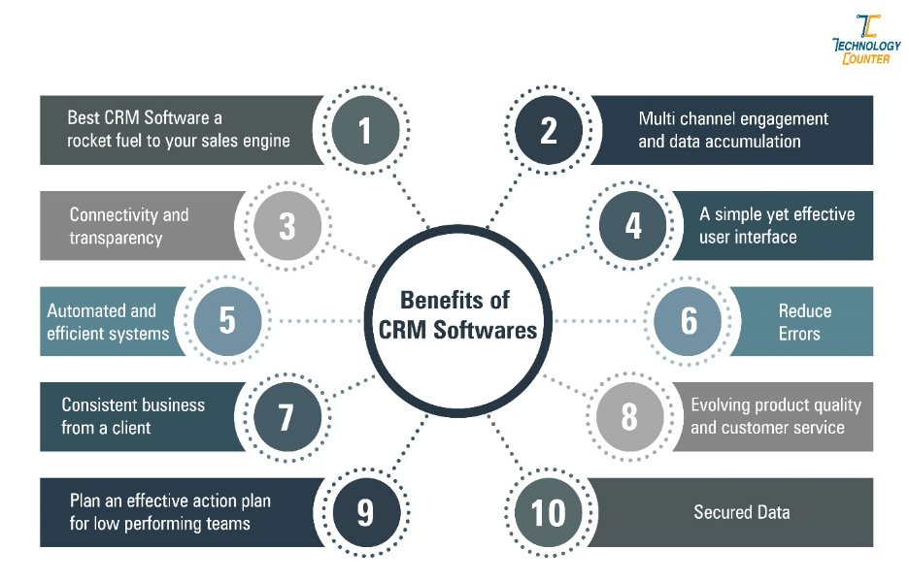
Figure 1: Benefits of Medicine Inventory Management SoftwareVaidya
In small pharmacies and clinics, because of limited resources and fewer staff, it is essential to have an efficient inventory system that minimises manual work and prevents stockouts. Studies show that pharmacies using automated IMS reduce medicine wastage by up to 30% and improve stock availability by over 20%.
A healthcare facility with more than 10 staff members that has adopted an IMS has seen significant improvements in patient satisfaction and operational efficiency. The adoption of IMS has become critical in post-pandemic healthcare environments.

1.2 Problem statement
The healthcare and pharmacy industry faces challenges in real-time tracking of medicine inventory, managing expiry dates, predicting demand fluctuations, segmentation of medicine categories, and generating timely procurement reports. Manual processes are error-prone and lead to overstocking, wastage, and critical shortages that can endanger patient health.

1.3 Goals and objectives
Goals
- To enhance technical skills by building a real-time, full-stack medicine inventory management application
- To provide better inventory solutions to pharmacies, clinics, and hospitals to manage daily stock and procurement activities
- To generate customized forecasting and reporting features for healthcare inventory management
- To apply software engineering concepts including RESTful API design, JWT authentication, and database modelling
Objectives
- Research healthcare inventory management to understand the processes of stock tracking, expiry management, and demand forecasting
- Perform database schema design and draw UML diagrams for the web portal to analyse requirements and guide the development process
- Ensure both pharmacists and management have real-time visibility into stock levels, with automatic alerts for low stock and expiring medicines
- Learn to manage tasks efficiently within the internship timeline to demonstrate abilities in a real-time working environment

1.4 Project Planning and Scheduling

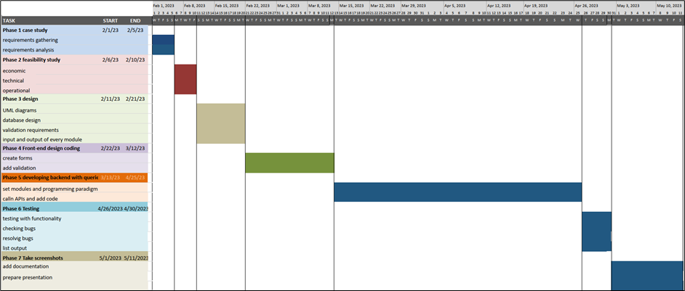
Chart 1 : Gantt Chart

2. Literature Survey (Case Study)
This study compares existing pharmacy and hospital inventory management systems used globally. Popular platforms like Meditech, Oracle Health, and open-source solutions like OpenMRS and GNU Health have been reviewed. The study highlights gaps in small-to-medium pharmacy automation and informed the design of the Medicine Inventory Prediction system.
2.0 Case study of popular operational Inventory Management Systems
This case study is performed from a functional point of view of different inventory management and pharmacy systems used most by healthcare organizations worldwide.

2.0.1 Meditech Inventory Management

Meditech is a comprehensive healthcare information system used by hospitals globally. Its inventory module integrates with supply chain, procurement, and clinical modules. It is one of the most trusted platforms for large hospital inventory management.
Key points of Meditech Inventory Management:
  - Meditech provides real-time tracking of pharmaceutical supplies and medical devices across departments. It is widely used in medium-to-large hospitals for its deep integration with clinical workflows.
  - The portal provides end-to-end tracking of all inventory movements, from procurement to dispensing. It supports automated reorder triggers based on minimum stock thresholds.
  - The dashboard shows current stock levels, pending purchase orders, and expiry alerts for the day.
  - It also offers department-level inventory views and consumption reports in separate sections for day-to-day operations.
  - The medication dispensing module integrates with patient prescription records, ensuring accurate dispensing and reducing medication errors.
  - It maintains a complete audit trail of all inventory movements, which is critical for regulatory compliance and hospital accreditation.
  - The employee can manage the every day business tasks easily with the CRM tool and can also contact customers to give better support before and after sale service.

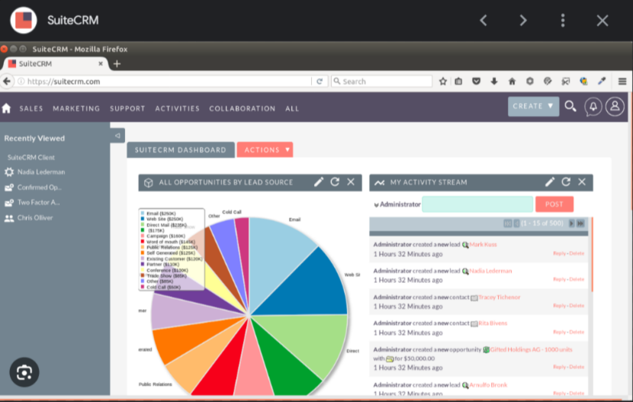


    - Oracle Health Inventory Management
Oracle Health (formerly Cerner) provides a cloud-based inventory management module integrated with its comprehensive EHR platform. It is highly scalable and customizable, suitable for large hospital networks and integrated health systems.
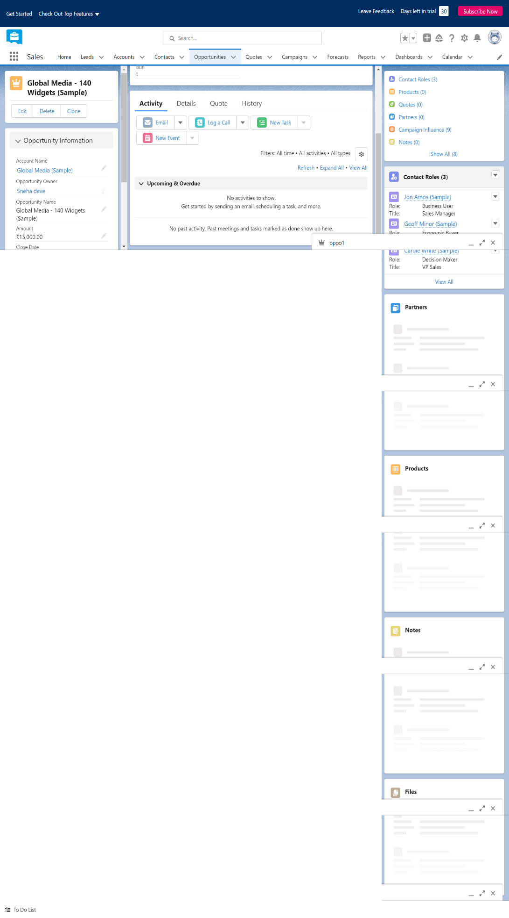
Being enterprise-grade and data-driven, Oracle Health's inventory module has advanced analytics and demand forecasting as its highlights.

  - Being user friendly and built on modern cloud infrastructure, Oracle Health's inventory system has analytics and demand forecasting tools as its highlights.
  - Stock management is divided into three categories: procurement management, dispensing management, and returns management. The procurement module handles supplier relationships and purchase orders.
  - The dashboard displays real-time inventory data with visual charts to evaluate current stock levels and upcoming expiry dates.
  - Oracle Health effectively manages medicine categories with organized sections like controlled substances, OTC medications, vaccines, and surgical supplies.
  - Data is freely accessible to authorized personnel from any location because of the cloud-based infrastructure.
  - The collaboration module allows pharmacists, procurement teams, and department heads to coordinate on purchase orders and stock transfers.
  - Oracle Health has significantly reduced the need for manual stock-counting in large hospitals, offering automated cycle count workflows, barcode scanning support, and RFID integration.


    - OpenMRS / GNU Health

OpenMRS is an open-source health record and inventory management platform that creates a customizable solution for healthcare providers to track their medicine supplies. It is widely used in developing countries and resource-limited settings.
OpenMRS displays stock analysis on its dashboard to help administrators make better procurement decisions.
Stock tracking, dispensing records, supplier management, and basic analytics are the major highlights attracting NGOs and public health organizations to use OpenMRS.
For monitoring and managing medicine distribution, it offers stock adjustment and drug dispensing modules.
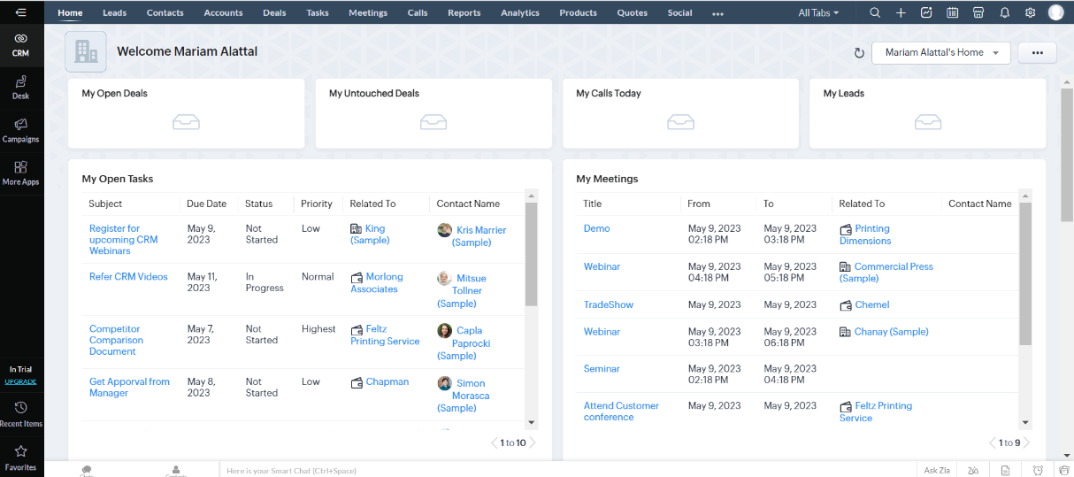
The stock forecasting option allows administrators to set reorder points, track consumption trends, and analyse results to improve procurement planning.
Advanced reporting offered by OpenMRS supports in-depth insights about medicine consumption patterns and budget allocations.

Figure 3: OpenMRS Inventory Dashboard

    - Infor CloudSuite Healthcare
Infor CloudSuite Healthcare is one of the leading supply chain management solutions trusted and used by over 3000 healthcare organizations globally. It specializes in medical supply and pharmaceutical inventory management with end-to-end visibility.

supply chain. The solution is integrated with several third-party tools including barcode scanners, EHR platforms, and procurement portals.
  - The user dashboard is clear and focused, letting you manage inventory tasks without cluttered screens and unnecessary data overload.
  - Set up team roles with different access permissions depending on designation and work requirements.
  - It helps to set visibility for medicines, purchase orders, and supplier data to staff members according to their roles and responsibilities.
  - It allows sending reports as CSV or PDF files and can send them as documents to other departments or directly to procurement managers.
  - It tracks stock levels and lets you customize automatic reorder triggers, focusing on the specific procurement requirements of the healthcare facility.

  - A project management module is integrated into the system that helps in easy tracking of procurement project status and can be updated based on delivery milestones.
  - Can manage supplier relationships better with timely purchase orders and delivery tracking.
  - Scheduling purchase orders with supplier details, delivery windows, and contact information helps to maintain seamless supply chains.
  - Analytics of current inventory position across departments in a single dashboard screen provides critical data for supply chain managers.

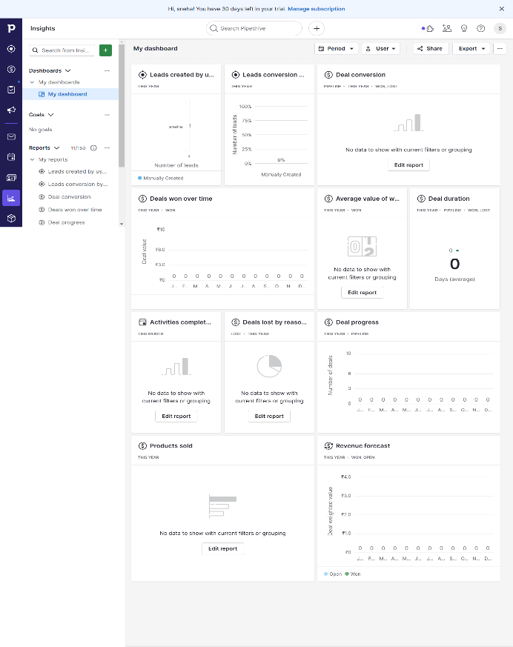
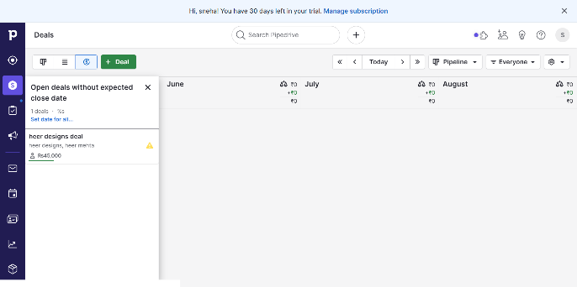

Figure 4: Screenshot of Infor CloudSuite Healthcare Dashboard

2.0.5 Marg ERP (Pharmacy)
Marg ERP provides detailed insights into the different modules of a pharmacy management system. The reports generated are separately focused on sales, purchases, expiry management, and GST compliance.

  - Visualize data as a table, list, or summary dashboard, and access quick actions to perform stock adjustments and purchase entries at scale.
  - The system offers a 360° view of pharmacy operations across purchase, sales, and stock management with customizable product categories and batch tracking.
  - It facilitates engagement across channels — physical counter sales, wholesale distribution, and online pharmacy portals.
  - It helps improve procurement decisions with automated reorder alerts based on minimum stock levels, which is an intelligent feature built into the core workflow.

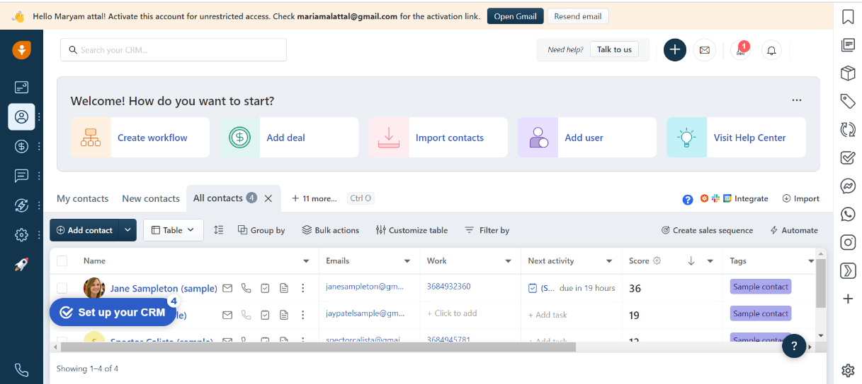
Figure 5: Screenshot of Marg ERP Pharmacy

    - PharmAssist / MedEase

PharmAssist (and similar systems like MedEase) are specialized inventory management software for small to medium-sized pharmacies. They help to keep pharmacy operations in flow and give real-time visibility into stock and sales.

Decision-making processes for future medicine procurement largely depend on analysis of current and past consumption data effectively. These systems provide daily sales summaries and weekly expiry reports.
  - PharmAssist shows major pharmacy operations on the dashboard including latest medicines added, upcoming expiry alerts, and low-stock notifications.
  - It has an integrated billing module that supports generating purchase invoices and supplier payment tracking. It has separate sections to track GST-compliant invoicing.
  - The same login credentials can be used on a mobile app which helps pharmacists stay updated about stock movements even when away from the counter.

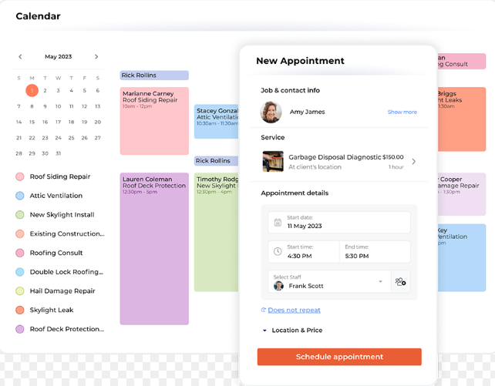
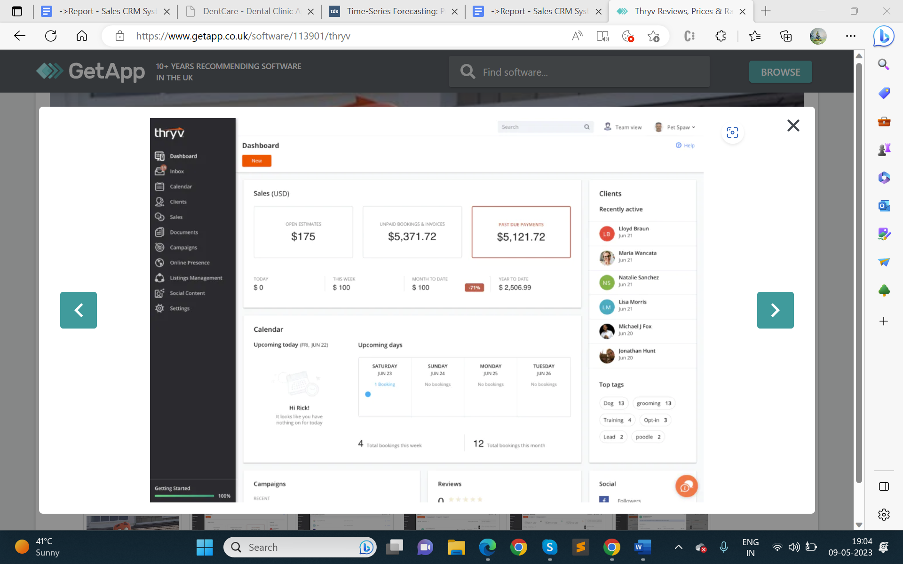

Figure 6: Screenshot of PharmAssist Dashboard

    - MedTrack Pro

It is one of the most used inventory management platforms across pharmacy chains and hospital supply departments. The system provides a comprehensive view of all medicine movements with role-based access for pharmacists, managers, and administrators.

  - It lets you build a personalized dashboard by selecting necessary KPI indicators for your specific healthcare operation.
  - The customizable screen is provided for stock monitoring, procurement management, expiry management, and automated reorder management.
  - It tracks the consumption rate of each medicine over time to warn you when demand is increasing and stock levels need immediate replenishment.
  - It has integration with supplier email notifications along with SMS alerts, barcode scanners, and automated purchase order forms.
  - Procurement module allows managing suppliers, purchase orders, delivery tracking, and invoice matching with available integrated workflows.
  - Reports focus on expiry-wise stock, batch-wise tracking, category-wise consumption, and forecasted demand, which is a key analytical feature for inventory optimization.
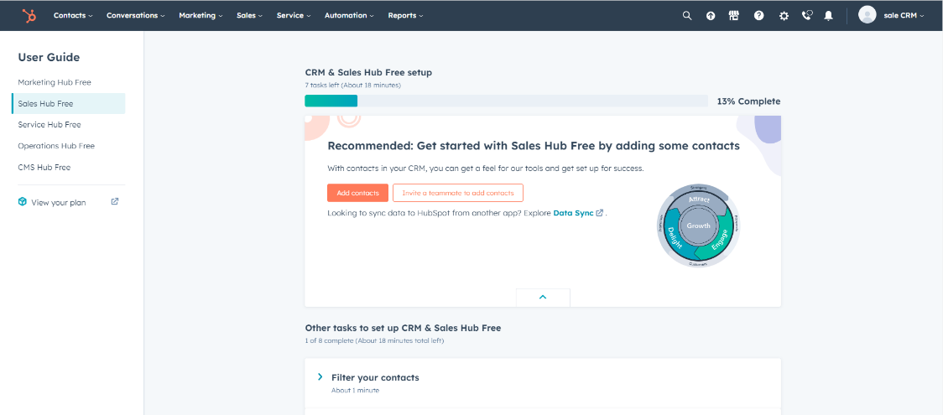

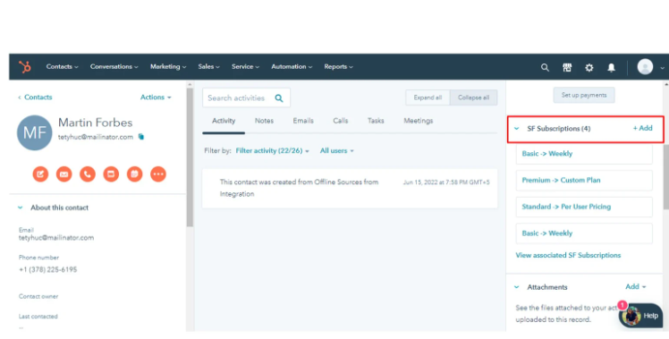

Figure 7: Screenshot of MedTrack Pro

Proposed System :
The proposed Medicine Inventory Prediction system is designed to address the challenges in pharmacy and hospital medicine inventory management. It allows healthcare facilities to track real-time medicine stock, manage suppliers and purchase orders, predict demand based on historical consumption, send expiry and low-stock alerts, import/export data via CSV/XLSX, and generate detailed PDF reports.

Project Background :
The Medicine Inventory Prediction project targets the healthcare sector, focusing on streamlining and optimizing the management of medicine stock for pharmacies, clinics, hospitals, and medical distributors. The system is built using React, Vite, Express, MongoDB, Chart.js, JWT authentication, jsPDF, and XLSX utilities.

Target Audience
The target audience for the Medicine Inventory Prediction system encompasses a diverse range of stakeholders within the healthcare industry. Here are the primary groups that would benefit from the system:

1. Pharmacists and Dispensary Staff
- Retail Pharmacists: Staff who manage day-to-day medicine dispensing and need a comprehensive system to track stock levels, expiry dates, and batch numbers.
- Hospital Dispensary Staff: Staff working in hospital pharmacies who require robust tools to manage high-volume medicine stock movements and inter-department transfers.

2. Healthcare Facilities
- Small to Medium Clinics and Pharmacies: Facilities that manage a moderate number of medicine categories, looking for an affordable yet powerful inventory management solution.
- Large Hospitals: Hospitals with extensive medicine requirements across multiple departments, requiring advanced features, scalability, and multi-role access control.

3. Medical Distributors and Suppliers
- Medicine Distributors: Organizations that distribute medicines to multiple pharmacies and need an efficient way to track delivery schedules and inventory levels at client facilities.
- Procurement Officers: Departments within healthcare facilities responsible for managing and updating supplier contacts, purchase orders, and receiving deliveries.

4. Healthcare Clients
- Individual Patients: Customers purchasing prescription medicines who benefit from streamlined dispensing workflows and efficient stock availability management.
- Corporate Healthcare Clients: Organizations seeking comprehensive medicine supply for their operational health programs, requiring seamless management and accurate reporting.

5. Business Managers and Administrators
- Operations Managers: Professionals overseeing the operational aspects of pharmacy chains or hospital supply departments, needing detailed reports and real-time inventory dashboards.
- IT Administrators: Technical staff responsible for managing the system, ensuring data security, and integrating with hospital management systems.

6. Regulatory Bodies
- Compliance Officers: Individuals ensuring that pharmacies and healthcare facilities adhere to drug regulatory standards and maintain accurate controlled substance records.
- Auditors: Professionals conducting audits and assessments of medicine procurement practices, requiring detailed audit logs and transparent records.

Target Audience Needs :
The Medicine Inventory Prediction system is designed to meet the specific needs of these diverse groups by providing:
- Efficiency: Streamlined processes for managing stock, suppliers, purchase orders, and consumption tracking.
- User-Friendliness: Intuitive interface and easy-to-learn system for quick adoption by non-technical healthcare staff.
- Scalability: Capability to grow with the facility, accommodating increasing medicine categories and user numbers.
- Security: Robust JWT-based authentication and role-based access control to ensure medicine and procurement data is secure.
- Comprehensive Features: A wide range of functionalities covering all aspects of medicine inventory management including forecasting, alerts, and reporting.
- Customization: Ability to tailor the system to specific healthcare workflows, including custom alert thresholds and report templates.
By targeting these audiences, the Medicine Inventory Prediction system aims to become an essential tool for improving procurement efficiency, ensuring medicine availability, and reducing wastage across healthcare organizations.

Importance of Inventory Management in Healthcare:
Inventory Management isn't just a logistical solution for large hospitals. It helps create stronger supply chains for pharmacies of all sizes. For small clinics, having the right medicine at the right time directly impacts patient outcomes. Effective inventory management reduces medicine wastage by up to 30% and improves stock availability significantly.
A common problem with inventory systems is that they can become clogged with outdated or irrelevant stock data over time. Regular system audits and automated data validation features in the Medicine Inventory Prediction system help resolve these issues efficiently.

IMS Implementation Challenges
The problem with IMS implementation can be resolved by introducing the new system comprehensively, ensuring all staff are trained, processes are clearly documented, and data migration from legacy systems is handled carefully.
Popular IMS Platforms
Popular inventory management platforms like Meditech, Oracle Health, and Infor CloudSuite offer comprehensive supply chain management, stock tracking, demand forecasting, and regulatory compliance tools — but at high costs suitable only for large organizations.

Key Features for Medicine Inventory Prediction :

The Medicine Inventory Prediction system should be capable of managing and displaying medicine stock levels, expiry alerts, and supplier data efficiently. It should support demand forecasting using average monthly consumption, shortage risk scoring, purchase order management, and comprehensive PDF/XLSX reporting.
The feasibility study for Medicine Inventory Prediction was performed to understand the feasibility of implementing this new system, ensuring it is technically, economically, and legally viable for deployment in real healthcare environments.

- Technical Feasibility
To deploy the application, the only technical aspects needed are mentioned below:
- Software:
Platform: Windows, Linux, Mac
Programming language: JavaScript (Node.js / React)
Database: MongoDB

- Hardware:
A machine with proper connectivity to the internet, a mouse, a keyboard, a display unit, and a processing unit.
RAM: 4GB or more
HDD: 20GB or more

- Development Environment
- Node.js / Express:
  - It is a server-side JavaScript runtime environment.
  - Node.js is open-source and free. It uses a non-blocking, event-driven architecture making it highly efficient for handling multiple concurrent requests from pharmacy staff.
  - It is platform-independent. Applications built with Node.js can run on any OS, including UNIX, Linux, Windows, and macOS.
  - Applications built with Node.js and connected to MongoDB load quickly and handle real-time data operations efficiently — critical for live inventory tracking.
  - Its ease of use and the large npm ecosystem make it very developer-friendly. Anyone familiar with JavaScript can work with Node.js effectively.
  - With continuous LTS releases, Node.js has maintained strong reliability and backward compatibility for production deployments.

- MongoDB (Mongoose ORM):
  - MongoDB is a NoSQL document database management system.
  - MongoDB is flexible and adaptable. Its schema-less nature allows rapid iteration during development, and Mongoose ORM enforces schema validation at the application level.
  - Data security in MongoDB is ensured through role-based access control, TLS encryption in transit, and AES encryption at rest — critical for protecting sensitive medicine and patient-related data.
  - MongoDB supports horizontal scaling through sharding, making it suitable for growing healthcare facilities that need to store large volumes of medicine transaction records.

- React / Vite (JavaScript):
  - React is a declarative, component-based JavaScript library for building user interfaces.
  - Simplicity – React's component-based architecture makes building complex inventory dashboards modular and maintainable.
  - Popularity – React is one of the most widely used frontend frameworks, with a rich ecosystem of libraries including Chart.js for data visualization.
  - Interoperability – React components can be integrated with any backend API, making it flexible for connecting to the Express/MongoDB server.
  - Performance – React's virtual DOM minimizes unnecessary re-renders, ensuring the inventory dashboard remains responsive even with large datasets.

- HTML / CSS (Duckett, 2011):
  - HTML and CSS are the foundational languages for web development.
  - Any web application is built using HTML as its fundamental structure. A consistent layout for inventory tables, forms, and dashboards is provided through well-structured HTML.
  - Accessibility is a priority in the Medicine Inventory Prediction system. Semantic HTML tags ensure screen reader compatibility and WCAG compliance for healthcare environments.
  - With cross-platform and cross-browser support, HTML/CSS ensures the inventory system is accessible from any device, including tablets used in pharmacy counters.

- CSS / Bootstrap:
  - Bootstrap is a responsive CSS framework that accelerates the design of consistent and mobile-friendly inventory management interfaces.
  - Presentation & Demo Support: Prepared component documentation, participated in system walkthroughs, and contributed to the UI design review process.
  - CSS customization adds visual clarity to the inventory dashboard through color-coded stock status indicators (In Stock, Low Stock, Out of Stock, Expiring Soon).
  - Web designers can create unique report views and alert panels because CSS customization allows per-component styling without affecting the global stylesheet.
  - CSS rules are applied globally, ensuring a consistent visual theme across all inventory management pages — from the dashboard to the supplier management module.
  - Changes to the global color scheme or typography can be applied across the entire application at once because content and design are separated.

- Axios (HTTP Client):
  - Axios is a promise-based HTTP client for making API requests from the React frontend to the Express backend.
  - Secure Connection: Axios supports JWT token injection in request headers automatically through interceptors, ensuring all API calls to the inventory server are authenticated.

- JSON:
  - A lightweight data interchange format that is readable and parseable by virtually all programming languages and frameworks.
  - The Medicine Inventory Prediction system uses JSON as the standard data format for all API responses, making it easy to integrate with external systems like hospital EHR platforms.
  - Therefore, a simple, text-based structure like JSON format is used for all API communication between the React frontend and the Express backend.

- Chart.js
  - A JavaScript library for creating beautiful, responsive data visualizations for inventory and forecasting dashboards.
  - Chart.js is used in the Medicine Inventory Prediction system to render demand forecasting charts, stock level trends, and expiry distribution graphs.
  - The bar charts, line charts, and doughnut charts provided by Chart.js make it an excellent tool for presenting inventory insights visually.
  - Chart.js is open-source and lightweight, requiring no paid license — making it ideal for a healthcare inventory system that must remain cost-effective.
  - Since Chart.js is compatible with all modern browsers, it ensures the analytics dashboard is accessible from any device used by pharmacy staff.
  - It is easy to configure and renders charts only when needed, improving dashboard performance and reducing initial load time.
  - Custom color schemes, animated chart transitions, and tooltip configurations are all supported by Chart.js for a professional analytics experience.

Behavioral Study:

- Purpose: The purpose of this system is to achieve better management and efficiency in handling medicine inventory, supplier relationships, purchase orders, and stock forecasting for healthcare facilities.
- Modules: The process involves two important modules:
  - Pharmacist / Inventory Manager: Manages and updates medicine stock, expiry dates, purchase orders, and supplier details.
  - Administrator: Maintains and updates user accounts, system configurations, and generates audit reports.
- System Features: The system helps inventory managers to manage their everyday tasks including stock monitoring, purchase order creation, expiry alerts, and report generation.
Legal Feasibility:
- Prototype Nature: As the system is prepared for demonstration of a system that can be used to manage healthcare inventory operations more efficiently, it does not handle real patient data and is compliant with basic data protection principles.
- Open Source Software: The software stack used to develop the system (React, Node.js, MongoDB, Chart.js) is entirely open-source and free to use.

SYSTEM ANALYSIS :
Analysis Process: After carefully analyzing the requirements and the functionality of existing inventory management platforms like Meditech, Oracle Health, Marg ERP, and MedTrack Pro, the system design was finalized.

System Flow :
Login, Registration, and Email Verification Modules:
The system flow for login, registration, and email verification modules is illustrated in a diagram that serves as a manual for navigating through the portal. New users must verify their email address before gaining access to the inventory dashboard.
If users forget their password but remember their registered email, they can click the 'Forgot Password' link. This opens a form to request a password reset email, which contains a secure token-based link to set a new password.
The following diagram shows the flow of the system for login, registration, and email verification processes:
After logging in to the dashboard, users see the following modules in the navigation bar based on their assigned role (Admin, Manager, Pharmacist, Cashier):
The process flow starts with adding medicines with their batch numbers, expiry dates, supplier information, and stock quantity. Automatic status assignment (In Stock, Low Stock, Out of Stock) is handled by the system based on stock thresholds.
The medicine lifecycle follows a four-step model: stock intake, monitoring, alerting, and reporting. Medicines transition through various stock status states as quantities change through sales and restocking.
Purchase orders are crucial in any inventory system, tracking procurement activities to ensure adequate stock levels. This module manages the full purchase order workflow from creation to delivery confirmation.
Supplier Module:
The supplier management module allows adding, updating, and deactivating supplier records. Active suppliers are highlighted in green, with inactive ones displayed in grey, and quick actions available for editing contact details and creating new purchase orders.
Prediction Module:
The demand prediction module calculates forecast demand for each medicine based on its average monthly consumption, safety stock levels, and lead time. The shortage risk score is computed to prioritize medicines requiring urgent reordering.
Medicine Category Module:
Medicine categories (Antibiotics, Analgesics, Vaccines, Controlled Substances, etc.) are essential data maintained up-to-date. New categories are added after validation, and category-level consumption reports are generated automatically.
Audit Log Module:
The audit log module auto-generates records of all system activities, including user logins, stock updates, and purchase order changes, helping administrators stay informed and maintain compliance records.

4.4 Data Dictionary:
A data dictionary is a collection of descriptions of the fields or columns in a data collection (MongoDB documents) for the benefit of programmers and others who need to refer to them. The following data dictionary describes the collections used in the Medicine Inventory Prediction system.

DATABASE SCHEMA DESIGN

Collection: medicines
Use: Stores medicine inventory details including stock levels, expiry dates, batch numbers, supplier info, and demand prediction data.
Column | Type | Null | Default
_id | ObjectId | No | auto
user | ObjectId (ref: User) | Yes | null
userEmail | String | Yes | null
userRole | String | Yes | null
action | String | No
ip | String | Yes | unknown

Collection: users
Use: Maintains user accounts, roles, permissions, email verification status, and authentication tokens.
Column | Type | Null | Default
_id | ObjectId | No | auto
medicine_id | String (unique) | No
medicine_name | String | No
category | String | No
batch_number | String | No
supplier_email | String | No
stock_quantity | Number | No
minimum_stock | Number | No
reorder_level | Number | No
safety_stock | Number | No
expiry_date | Date | No

Collection: audit_logs
Use: Stores logs of all user activities across modules with timestamps, IP addresses, and action details for compliance tracking.
Column | Type | Null | Default
_id | ObjectId | No | auto
medicine_id | ObjectId (ref: Medicine) | No
supplier_email | String | No
quantity_ordered | Number | No
unit_cost | Number | Yes | null
order_date | Date | Yes | now
expected_delivery | Date | Yes | null
status | String (enum) | Yes | Pending
notes | String | Yes | null
created_by | ObjectId (ref: User) | Yes | null

Collection: purchase_orders
Use: Stores purchase order records linking medicines and suppliers, including order quantities, status, and delivery tracking.
Column | Type | Null | Default
_id | ObjectId | No | auto
report_type | String | No
file_path | String | No
generated_at | Date | No | now

Collection: suppliers
Use: Tracks supplier details, contact information, and active/inactive status for procurement management.
Column | Type | Null | Default
_id | ObjectId | No | auto
supplier_name | String | No
email | String (unique) | No
phone | String | Yes | null
address | String | Yes | null

Collection: categories
Use: Manages medicine category classifications for organized inventory grouping and category-level reporting.
Column | Type | Null | Default
_id | ObjectId | No | auto
medicine_id | ObjectId (ref: Medicine) | No
movement_type | String (enum) | No
quantity | Number | Yes | null
previous_stock | Number | Yes | null
new_stock | Number | Yes | null
reason | String | Yes | null
movement_date | Date | Yes | now
performed_by | ObjectId (ref: User) | Yes | null

Collection: inventory_movements
Use: Records all stock movements (additions, deductions, transfers) for full traceability of medicine stock changes.
Column | Type | Null | Default
_id | ObjectId | No | auto
name | String (unique) | No
description | String | Yes | null
medicine_count | Number | Yes | 0
color_code | String | Yes | #4CAF50
status | String (enum) | Yes | Active
created_by | ObjectId (ref: User) | Yes | null
created_at | Date | Yes | now
updated_at | Date | Yes | now
created_at | datetime | Yes | current_timestamp()

Collection: reports
Use: Stores generated PDF report metadata for download history and audit trail purposes.
Column | Type | Null | Default
_id | ObjectId | No | auto
medicine_id | ObjectId (ref: Medicine) | No
predicted_demand | Number | Yes | 0
avg_monthly_consumption | Number | Yes | 0
shortage_risk_score | Number | Yes | 0
reorder_recommendation | String | Yes | null
forecast_date | Date | Yes | now

Collection: forecasts
Use: Stores demand forecasting results including predicted consumption, safety stock calculations, and reorder recommendations.
Column | Type | Null | Default
_id | ObjectId | No | auto
category_name | String | No
type | String (enum: 'Antibiotic','Analgesic','Vaccine','Controlled','OTC','Other') | No
unit_of_measure | String | Yes | null
description | String | Yes | null
status | Number (0/1) | Yes | 1
created_at | Date | Yes | now

Collection: settings
Use: Maintains system-wide configuration settings including alert thresholds, email configurations, and user preferences.
Column | Type | Null | Default
_id | ObjectId | No | auto
name | String | No
email | String (unique) | No
password | String (hashed) | No
role | String (enum: 'Admin','Manager','Pharmacist','Cashier','User') | No | User
permissions | Array[String] | Yes | []
emailVerified | Boolean | Yes | false
refreshTokens | Array[String] | Yes | []

6.1 Screen Shots

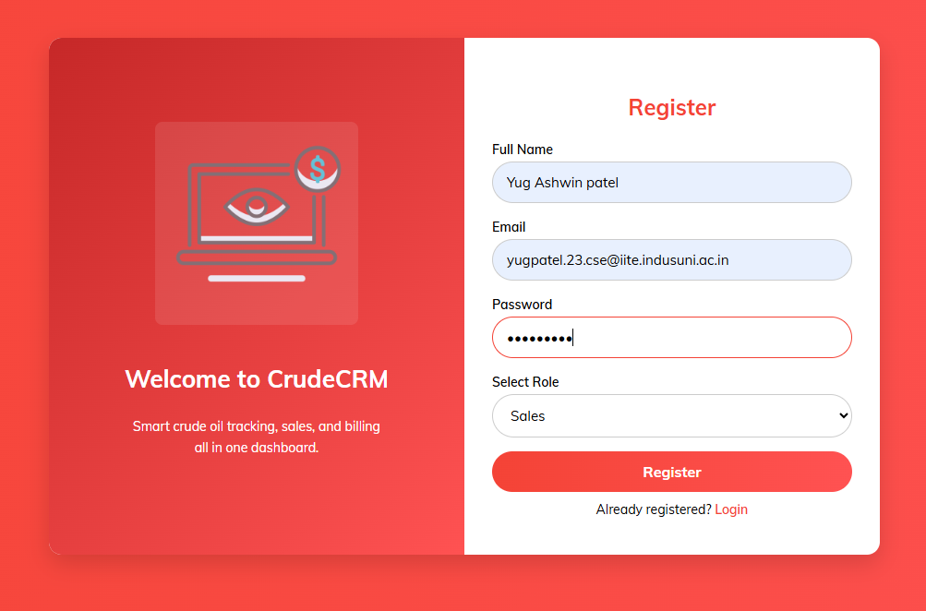

Figure 1: Login Page



Figure 2: Dashboard

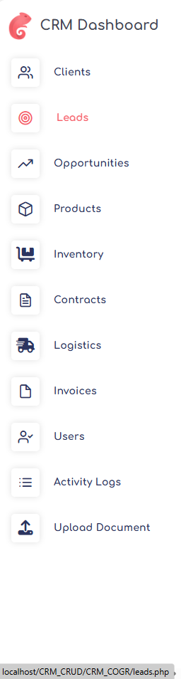
Figure 3: Navbar

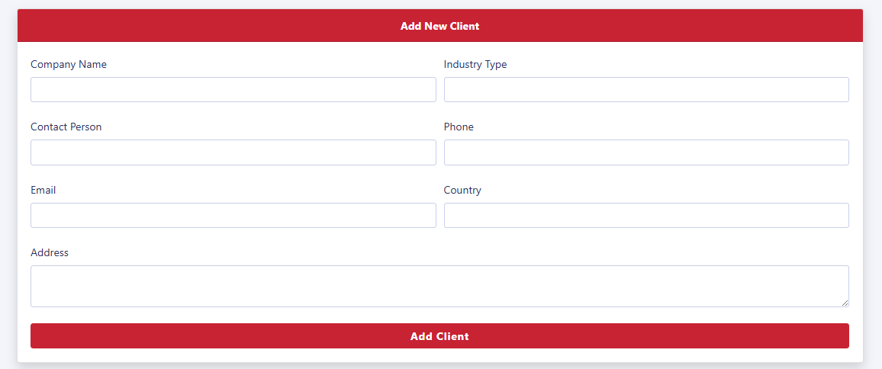
Figure 4: Add Medicine
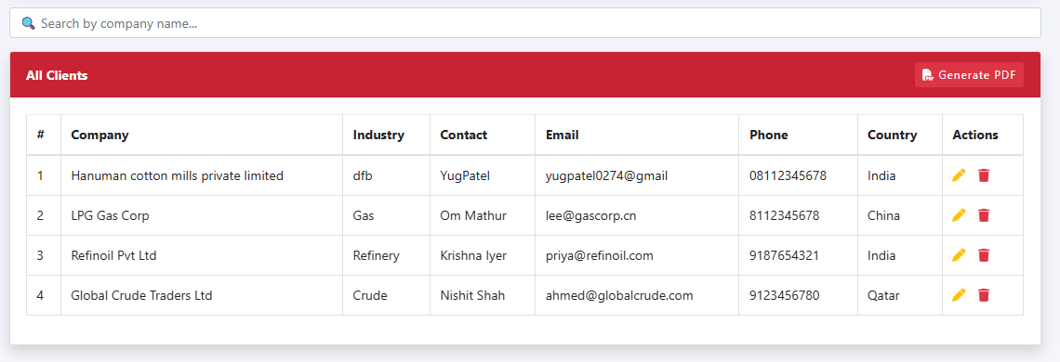
Figure 5: Medicine Management

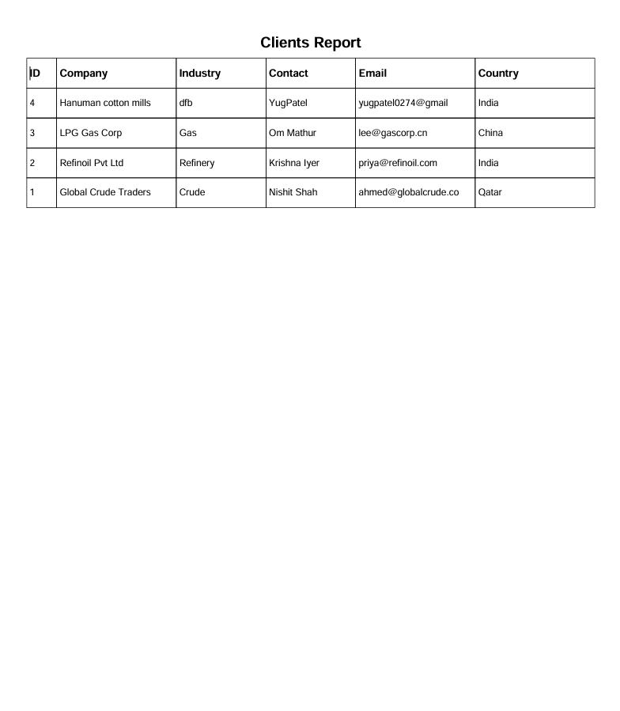
Figure 6: Medicine Report

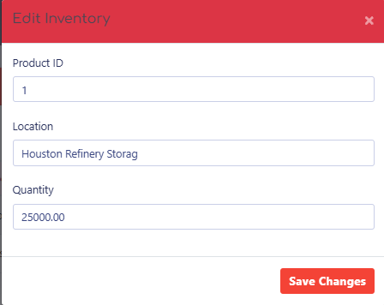
Figure 7: Edit Inventory

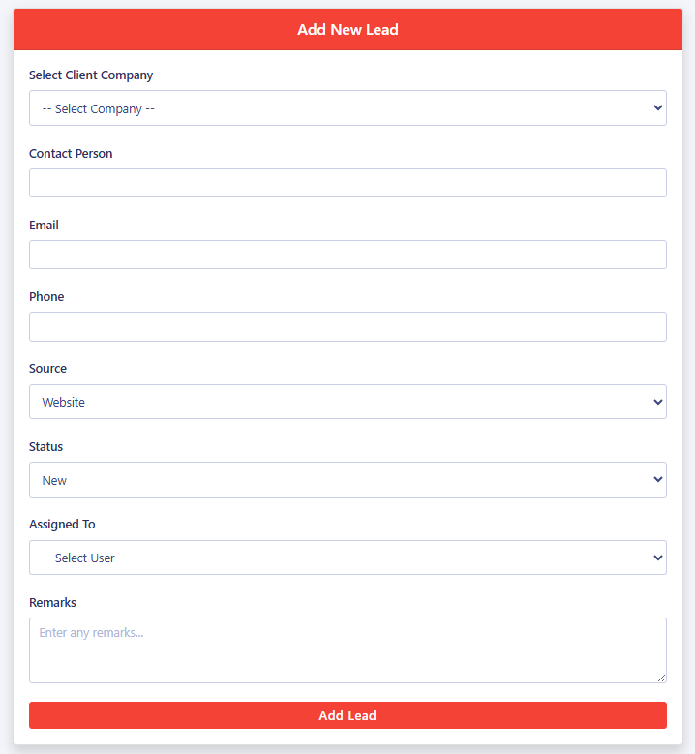
Figure 8: Add Purchase Order

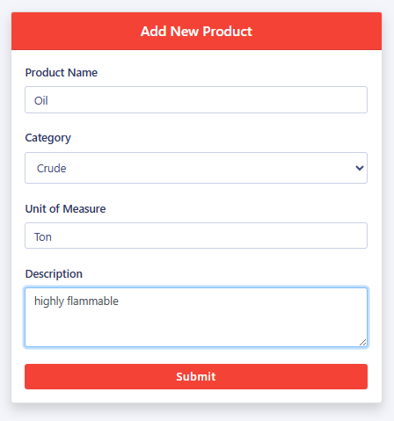
Figure 9: Add Supplier

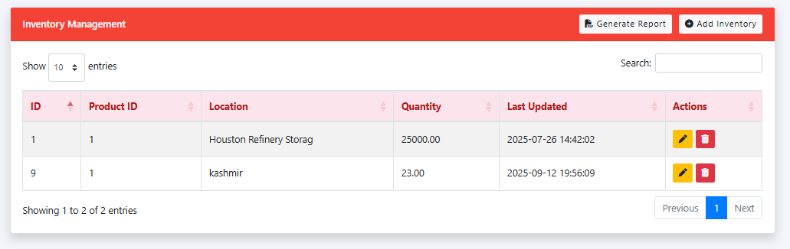
Figure 10: Inventory Management

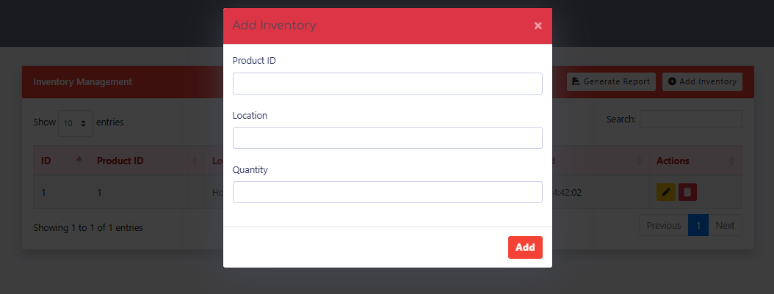
Figure 11: Import Data (CSV/XLSX)

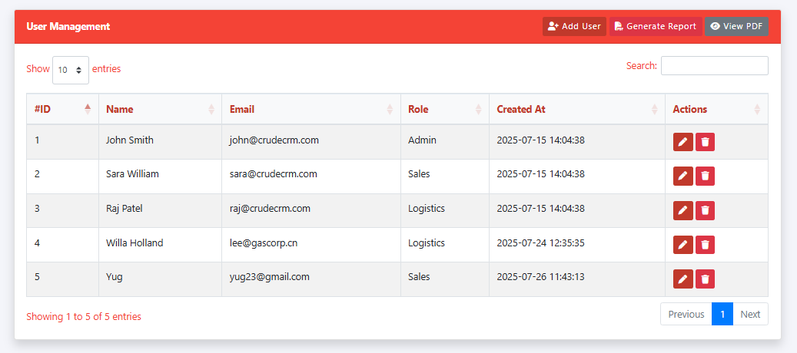
Figure 12: User Management

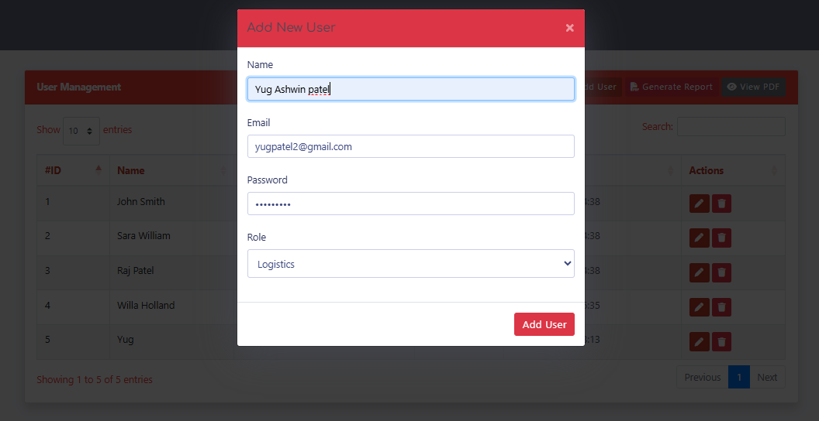
Figure 13: Add User

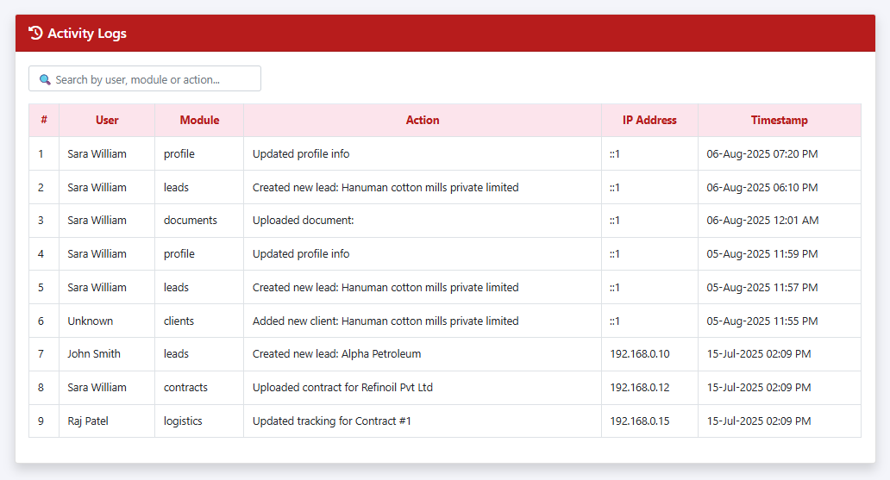
Figure 14: Audit Logs

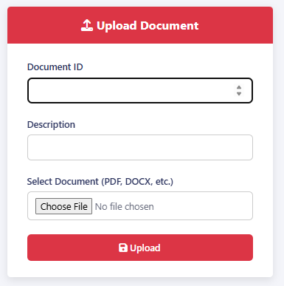
Figure 15: Upload Document


Figure 16: Profile Section

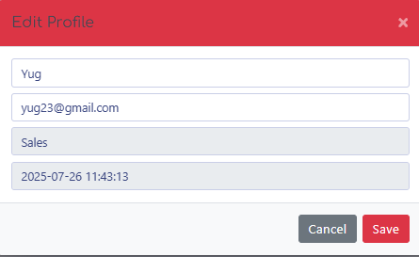
Figure 17: Edit Profile

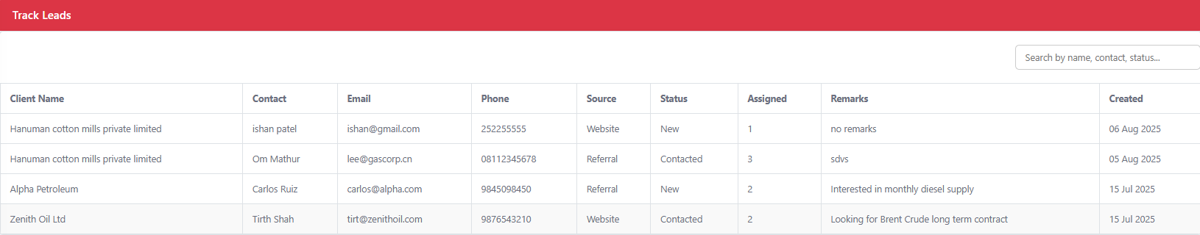
Figure 18: Demand Forecast

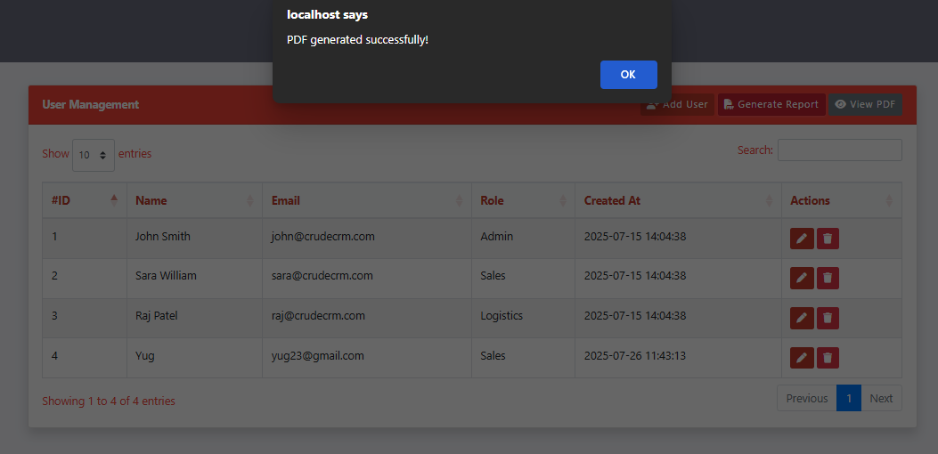
Figure 19: Alert System

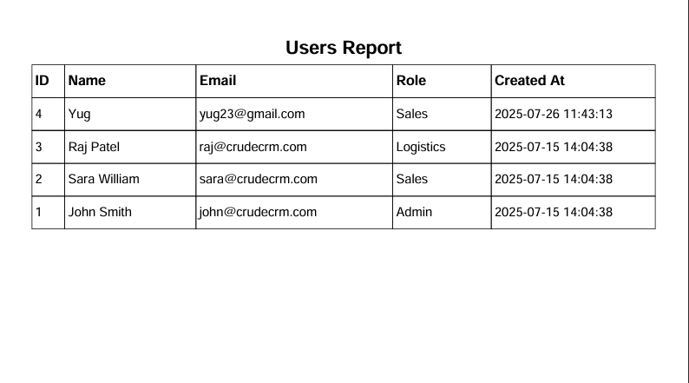
Figure 20: Reports Page

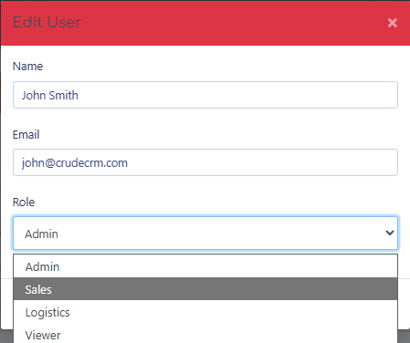
Figure 21: Edit User

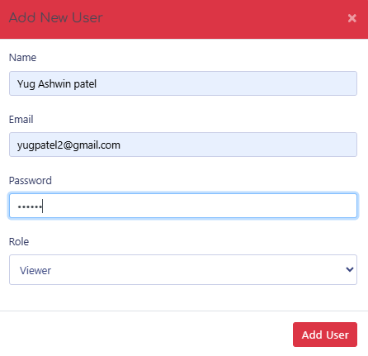
Figure 22: Add User


Figure 23: Dashboard Overview

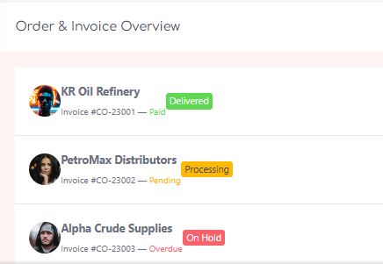

Figure 24: Insights & Analytics

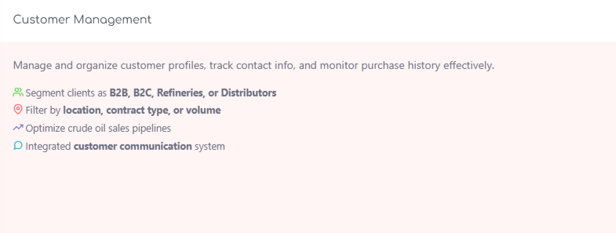
Figure 25: Predictions Page

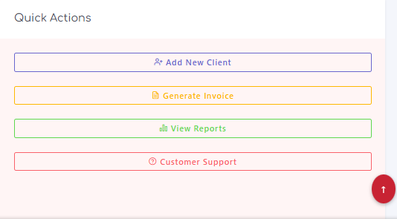
Figure 26: Quick Actions

7. Testing Report

Sr. | Type of Testing | Report (checked)
1 | Design consistency | ✔
2 | Screen resolution | ✔
3 | Browser compatibility | ✔
4 | Functionality testing – buttons, dropdowns, forms | ✔
5 | Process flow (login -> dashboard -> modules) | ✔
6 | Accessibility (WCAG) | ✔
7 | Mobile responsiveness | ✔
8 | Form input validation & error handling | ✔
9 | JWT session check & token refresh | ✔
10 | API endpoint & link testing | ✔

Conclusion

Over the course of the internship, significant progress has been made on the Medicine Inventory Prediction project, transforming an initial concept into a fully functional, role-based medicine inventory management web application. The system was developed using React, Vite, Node.js, Express, and MongoDB, with Chart.js for data visualization and JWT for authentication.
- Key Functionalities:
  - Medicine and Inventory Management: Efficiently manage medicines with features like adding, editing, and tracking stock levels with automatic status assignment (In Stock, Low Stock, Out of Stock, Expiring Soon).
  - Purchase Order Management: Comprehensive handling of purchase orders with supplier linking, delivery tracking, and invoice management.
  - Search and Filter Functionality: Advanced search and filtering capabilities across medicine categories, expiry dates, and stock status for quick data retrieval.
  - Dashboard: A user-friendly dashboard providing real-time stock metrics, low-stock alerts, expiry warnings, and demand forecast insights.
  - Report Generation: Detailed PDF and XLSX reports for medicine inventory, expiry analysis, and supplier purchase history.
The system has been rigorously tested to ensure reliability and performance across different user roles. Feedback from initial testing revealed strong performance in stock tracking accuracy and report generation quality.
The Medicine Inventory Prediction project, developed by Yug Patel as part of an internship, is now ready for deployment in pilot pharmacy and clinic environments, offering a modern, scalable solution for healthcare inventory management.

9. List of Abbreviations

Abbreviation | Meaning
IMS | Inventory Management System
ERP | Enterprise Resource Planning
HR | Human Resources
API | Application Programming Interface
JWT | JSON Web Token
HTML | Hypertext Markup Language
CSS | Cascading Style Sheets
JSON | JavaScript Object Notation
RDBMS | Relational Database Management System
NoSQL | Not Only SQL
ODM | Object Document Mapper
ORM | Object Relational Mapper
UI | User Interface
UX | User Experience
HDD | Hard Disk Drive
RAM | Random-Access Memory
IDE | Integrated Development Environment
PDF | Portable Document Format
XLSX | Microsoft Excel Open XML Spreadsheet

10. References

- Medicine Inventory Management Systems: What is an IMS? – ed. [online] – Healthcare Technology Review, available at various academic journals and industry publications.https://adynamics.com.my/erp/erp-vs-crm
- Chart.js. Data Visualization Library. [online] chartjs.org. Available at: https://www.chartjs.org/https://app.diagrams.net/
- Duckett, J. HTML & CSS design: design and build websites. Indianapolis: John Wiley & Sons, Inc.
- Duckett, J. JavaScript and jQuery. John Wiley & Sons.
- MDN Web Docs. Express / Node.js: server-side web development. Mozilla Foundation. Available at: https://developer.mozilla.org/
- MongoDB Inc. (n.d.). MongoDB Documentation. [online] Available at: https://www.mongodb.com/docs/https://www.freshworks.com/crm/sales/
- Mongoose. (n.d.). Mongoose ODM Documentation. [online] Available at: https://mongoosejs.com/https://suitecrm.com/
- React. (n.d.). React – The library for web and native user interfaces. [online] Available at: https://react.dev/https://www.hubspot.com/products/crm
- Vite. (n.d.). Vite Next Generation Frontend Tooling. [online] Available at: https://vitejs.dev/
- jsPDF. (n.d.). jsPDF – PDF Generation Library for JavaScript. [online] Available at: https://github.com/parallax/jsPDFhttps://www.youtube.com/watch?v=cV-lnBhCxGg&list=PLxbVBWjVdAEjom8KOV1c9aXMCz4IE0OZy&index=35
- XLSX (SheetJS). (n.d.). SheetJS Community Edition – Spreadsheet Data Toolkit. Available at: https://sheetjs.com/https://www.zendesk.co.uk/blog/3-types-crm-everything-need-know
- WHO. (2023). World Health Organization – Medicine Supply and Availability Reports. Available at: https://www.who.int/https://www.selecthub.com/customer-relationship-management/5-types-specialized-crm
- Nixon, R. Learning PHP, MySQL, JavaScript, CSS & HTML5: a step-by-step guide to creating dynamic websites. O'Reilly Media.
- Meditech. (n.d.). Meditech Inventory Management. [online] Available at: https://www.meditech.com/https://www.pipedrive.com/en
- Oracle Health. (n.d.). Oracle Cerner Supply Chain Management. [online] Available at: https://www.oracle.com/health/www.primark.comhttps://www.primark.com/en-us/aboutus#:~:text=Primark%20was%20founded%20by%20Arthur
- OpenMRS Community. (2021). OpenMRS Inventory Module – Healthcare Inventory Tracking. Available at: https://openmrs.org/https://www.youtube.com/watch?v=8-HKJdQDrtw
- [Accessed on 28th June 2026].
- Infor. (n.d.). Infor CloudSuite Healthcare Supply Chain. [online] Available at: https://www.infor.com/https://www.salesforce.com/uk/crm/
- Marg ERP. (2023). Marg ERP Pharmacy Management Software. [online] Available at: https://www.margbooks.com/https://crm.org/crmland/analytical-crm
- WHO Essential Medicines. (2023). Model List of Essential Medicines, 23rd Edition. [online] WHO. Available at: https://www.who.int/medicines/https://crm.org/crmland/collaborative-crm
- Stancheva, T. (2023). 45 Groundbreaking Healthcare Inventory Statistics and How to Use Them. [online] Available at: https://healthcare-review.com/https://review42.com/resources/crm-statistics/
- PharmAssist. (2020). PharmAssist: Pharmacy Management & Inventory Tracking Software. [online] Available at: https://pharmassist.io/https://www.thryv.com/
- GitHub. (n.d.). Medicine Inventory Prediction Project Repository. [online] Available at: https://github.com/https://trello.com/b/LgU4VOO8/requirement-gathering-analysis
- Vaidya, P. (2020). Importance of Inventory Management Software in the Digital Transformation of Healthcare. Technology Counter. Available at: https://technologycounter.com/https://technologycounter.com/blog/importance-of-crm-software-in-digital-transformation
- W3Schools (n.d.). AJAX Introduction. [online] www.w3schools.com. Available at: https://www.w3schools.com/ajax/www.w3schools.comhttps://www.w3schools.com/js/js_ajax_intro.asp
- W3Schools (2019). Bootstrap 5 Tutorial. [online] Available at: https://www.w3schools.com/bootstrap5/.https://www.w3schools.com/bootstrap/
- W3Schools (2019). JSON Introduction. [online] W3schools.com. Available at: https://www.w3schools.com/js/js_json_intro.asphttps://www.w3schools.com/js/js_json_intro.asp
- Axios (n.d.). Axios HTTP Client Documentation. [online] Available at: https://axios-http.com/https://www.zoho.com/crm/
___________________________________________________________________________

Thank You!!

