1. Home screen with pre-defined question along with user can enter own question.  
     
   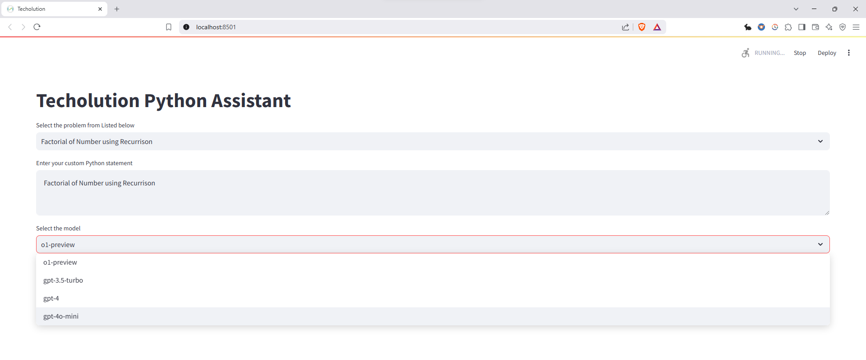
2. Provided wide variety of option from OpenAI:

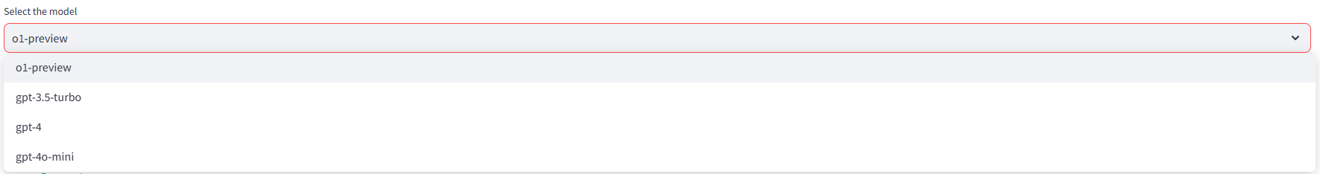

1. Answer Generation:

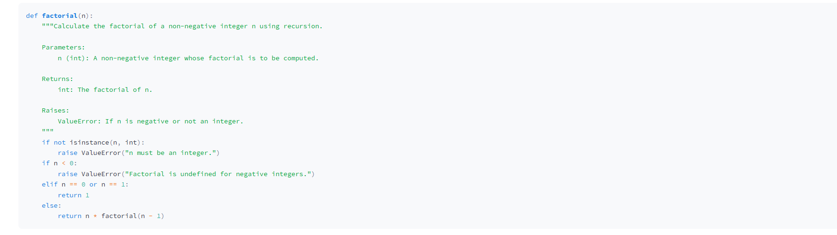

1. Explanation of Code:

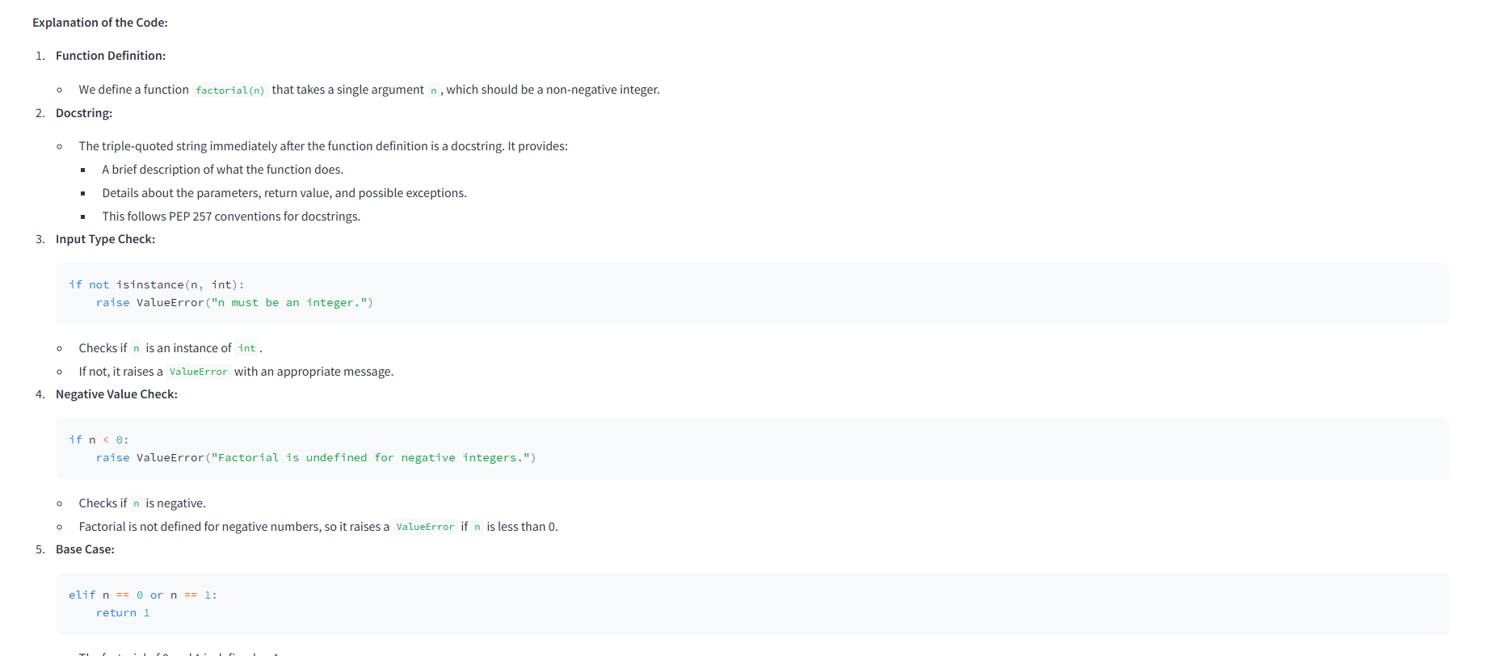

1. Alternative approach:

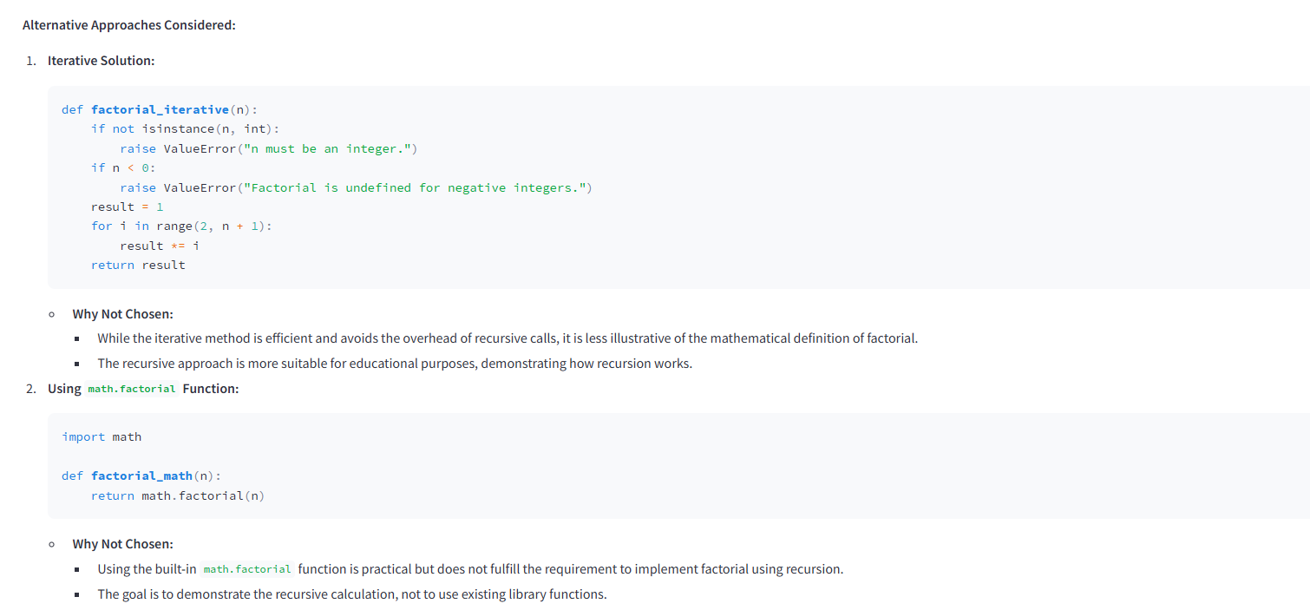

1. Best Practice with conclusion

