 

Front - End Development

Submitted by: Incognito Group Submitted to:

Group Members: Mohammad Kiani

Nishant Thokar

Nabin Dulal

Bishal Pulami Magar

Bibash Ghimire

Yugal Khatri

TABLE OF CONTENTS

1. Purpose of the website - Page 3
2. Target audience - Page 3
3. Number of pages - Page 3
4. Graphics used - Page 3
5. Color scheme - Page 4
6. Font style - Page 4
7. Features displayed - Page 4
8. Site Map - Page 5

Purpose of the website

The purpose of our restaurant website is to promote our restaurant name and brand while at the same time, targeting the people who want to have a taste of Nepali cuisine. Our website aims to provide detailed information about our restaurant menu, including all the food and drink options, their prices along with the description.

Moreover, information about our restaurant location, operating hours and contact information are also provided by our website. Finally, through our website, customers can book tables, make online reservations and even contact us for further information for a smooth visit at the restaurant.

Target Audience

Our website aims to target everyone, from local residents to tourists and visitors who are always on the lookout for casual dinner options or food enthusiasts who are always on the verge of trying new dishes and dining experiences. Furthermore, people wanting a venue to organize events and parties can also benefit from our website.

Number of Pages

Our website consists of 4 pages:

1. Home Page: A simple overview of the restaurant, featuring our restaurant and a brief introduction.
2. Menu Page: A detailed description of the food and drinks available, along with their images and prices.
3. About Us Page: Information about our restaurant story and goals featuring our valuable team members.
4. Contact Us Page: Contact information and a contact form along with a map showing our restaurant location.

Graphics Used

Our website features high-quality images of the food and drinks available at our restaurant to provide customers with a visual preview of the menu. Our home page also showcases some interior shot of the restaurant as its background. Similarly, custom icons and logos for navigation and contact forms for further information are also featured on our website. Finally, our website also showcases the images of our valuable team members.

Color Scheme

Our website just like other professional ones uses neutral color (white background with black texts) to create a clean and sophisticated look. While the color scheme is very minimal, it fits right for the professional purpose the website is trying to portray.

Likewise, use of light coral for the navigation enables the action buttons to stand out and add up for user interaction.

Font Styles

The website uses font family of the sans serif font for both the headings and body text. This portrays the website as elegant and sophisticated. But mostly, it provides the users with easy readability and aligns with the restaurant brand.

Features Displayed

The website has following features:

* Responsive Design: Our website is fully responsive and functional for all devices, including desktops, tablets, and smartphones.
* Contact Form: A user-friendly contact form that allows visitors to book reservation and even message us directly for more information.
* Google Maps: A map is embedded on the Contact Us page to provide directions for the people about the restaurant’s location.

Site map

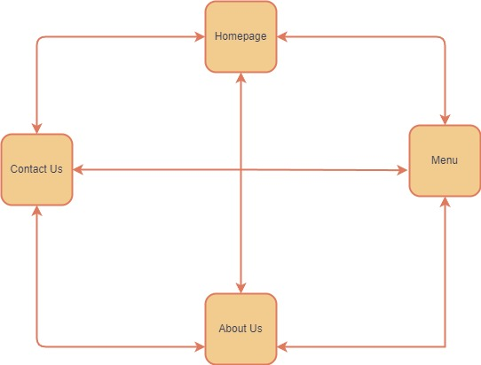

Our website follows webbed website structure. In our website, users can navigate from one webpage to any other webpages within the website.