1. Enquiry pop up like manpower group (right side up) and add one popup for latest job ….. https://www.manpowergroup.co.in/
2. In -- Enquiry for – Jobs and placements, Education and skill training, certification course, Career Guidance, Admission support, Corporate Training, Franchise & Partnership, Business & Requitement Collaboration, Manpower Support for Business
3. Remove partners button from header
5. DREAM | DISCOVER | DELIVER
India's Youth Deserves Better Opportunities
Sudhosan Skill Solutions bridges the gap between education and employment through industry-aligned training, career guidance, and direct placement opportunities — empowering students and professionals across emerging cities in India.
Sudhosan Skill Solutions connects students, job seekers, and professionals with industry-aligned training, direct placement support, and college admission guidance — building careers that last, across emerging cities in India.
6. Find a job (Explore Jobs) …….. Explore Courses …………..Get Admission
7.
100+
Candidates Placed
10+
Partner Companies
5+
Colleges Connected
100+
Students Trained
5+
Cities Served
100%
Placement Support
10+
Job-Ready Courses
( numbers are moving like increases from one …)
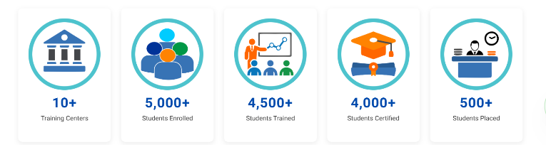
8.
What We Offer
Our Services & Solutions
One Stop platform. Every opportunity. Your next step starts here.
For Job Seekers
Job Placement Assistance
Resume Building Support
Interview Preparation
Skill Training Programs
Career Readiness Coaching
Digital Literacy Training
For Students
Admission Guidance
Education Planning
Personalized Career Counselling
Skill Development Courses
Campus Placement Support
Digital Learning Access
Education & Skill Training
For Businesses
Staffing & Recruitment Support
Corporate Training Programs
Workforce & Manpower Development
Data & Information Services
Digital Platform Solutions
CSR Training Programs
Partnerships
College & University Tie-Ups & Placement Support
Industry Partnerships
Franchise Opportunities
Govt. Scheme Integration
CSR & NGO Collaboration
Referral & Commission Model
remove - Digital Platforms, Corporate Training, Career Guidance

9.
Find Your Dream Job
Discover opportunities through Sudhosan Skill Solutions — connecting talent with employers across India through training, career guidance, and placement support. --- remove
Your skills deserve the right stage — we find it for you
10.
We Place Candidates In
Our trusted hiring and institutional partners
(all company logos are small and in one line and moving like Testimonials)
11. Testimonials
Write --- Why are we the most trusted brand?
"Here's what our students, candidates, and partners say about us." – sub line
Add photos of candidate and some small icon
12.
Meet Our Leadership
The experts behind thousands of successful careers --- remove
write - The Minds Behind the Mission United by one vision — building India's most impactful career platform.
remove – core team ….. (Education & Technology)….. (Strategy & Operations)

13. remove Latest Insights from home page
About Page
1. Education, skill development, and career placement for Tier 2 & 3 cities. Bridging learning and jobs with industry-ready training and direct employer connections.—remove
Making quality education and real careers accessible to every Indian — no matter where they live.
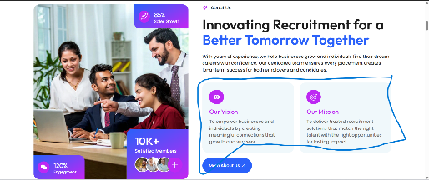
About - Who We Are
Sudhosan Skill Solutions Private Limited is an emerging education, skill development, and employment solutions company incorporated in November 2025, headquartered in Sheohar, Bihar. We were built with one clear purpose — to make quality skill training, career guidance, and real job opportunities accessible to every young Indian, regardless of where they come from.
We operate across six integrated verticals — skill training, employment placement, career counselling, information services, digital platforms, and institutional partnerships — serving students, job seekers, working professionals, and businesses across Tier 2 and Tier 3 cities in India.
We are a Startup India recognized company, registered under the Companies Act, 2013 with the Ministry of Corporate Affairs, Govt. of India.
------------------------------------------------------------------------------------------------------------------------------------------
Why We Started
India produces millions of graduates every year. Yet a large number of them struggle to find jobs — not because they lack intelligence or potential, but because they lack the right skills, guidance, and connections that urban candidates take for granted.
In Tier 2 and Tier 3 cities like Sheohar, Sitamarhi, and across rural Bihar — talented youth face an invisible wall between education and employment. No structured placement support. No career counselling. No affordable, job-oriented training. Just degrees that don't open doors.
Sudhosan Skill Solutions was born to break that wall.
Our Vision
"To build a skilled, informed, and employable India by providing accessible, innovative, and high-quality educational and career solutions”
Our Mission
Our mission is to make quality skill training, career guidance, and real job opportunities accessible to every young Indian — especially those in Tier 2 and Tier 3 cities who are overlooked by mainstream education and employment systems. We deliver affordable, industry-aligned courses, direct placement support, and personalised career counselling to help students and professionals move confidently from learning to earning.
3. Remove Our Impact
4. remove Testimonials

Services Page
Employment, Placement & Staffing

Education & Skill Training
Career Guidance & Advisory
Corporate Training and Workforce Development
Business & Partnership Consulting
And write in proper way in services
Courses Page
Improve Courses button .. popup is good but tap button on courses- all courses show in proper way then tap on courses all details are show
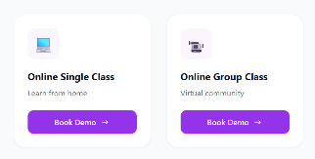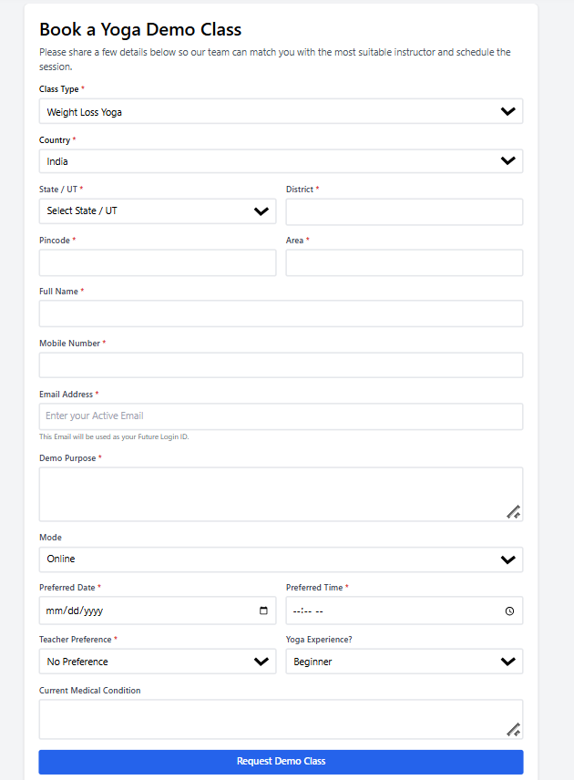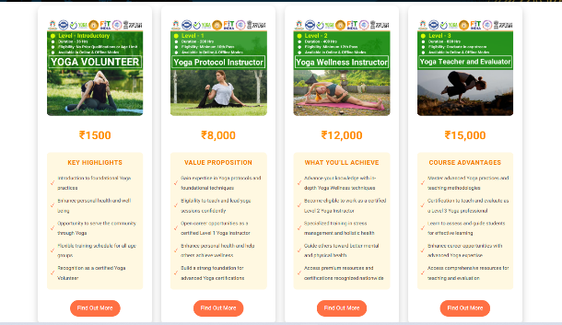

Jobs page
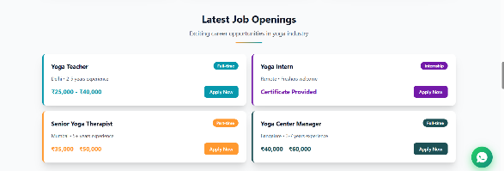
Blogs page
Sudhosan Insights
Discover career guidance, skill development insights, job market trends, and opportunities to build a successful future.
DREAM | DISCOVER | DELIVER
Stay Updated with Career Insights
Get the latest articles, career tips, and job market insights from Sudhosan Skill Solutions.
This is on bottom page also ---- Subscribe
Contact page
remove Upload Resume

Talk to Recruiter …
Form open --- ------
name
Email Address
Phone Number
Upload Resume
WhatsApp popup on home page
IN Bottom
1. Registered with Ministry of Corporate Affairs (MCA) Under Section 8 of the Company Act 2013.
Registration No.: U85499BR2025PTC080237, Registered. with MSME (Udyam Registration) and Startup India Recognized — DPIIT, Govt. of India
2. Sudhosan Skill Solutions
DREAM | DISCOVER | DELIVER
Sudhosan Skill Solutions Pvt. Ltd. bridges the gap between education and employment through industry-aligned training, career guidance, and direct placement support across India.
3. quick link--- all good add courses button
4. Bottom box is big ------- small
5. Add WhatsApp channel link in bottom with Facebook, insta link
6. Massage box for admin panel ….. deliver the massage on email and WhatsApp

