**NETWORKING**

**Date: 2020/01/08**

**Step to connect the computers**

1. Create folder.
2. Open properties
3. Click on share and then advance sharing.
4. Click on share folder and click on permission and select all.
5. Network setting and sharing option.
6. On all and save

**Commands**

Ipconfig- Show ip address

Ipconfigall- Show the Mac address

Ping ipaddres – connect the laptops

**Date: 2019/01/09**

**Commands**

Arp –a=show ip

Netstat =?

Netsh wlan show profile= to see connected networks

netsh wlan show profile name=BatBall key=clear- to see all connected password

tracert- to trace any company

**Date: 2019/01/10**

**Lazesoft- Recovery Software**

**Rufus**

**TO SHARE PRINTER**

* Go to cmd and check the ip of our pc
* Go to control panel and go to device printer
* 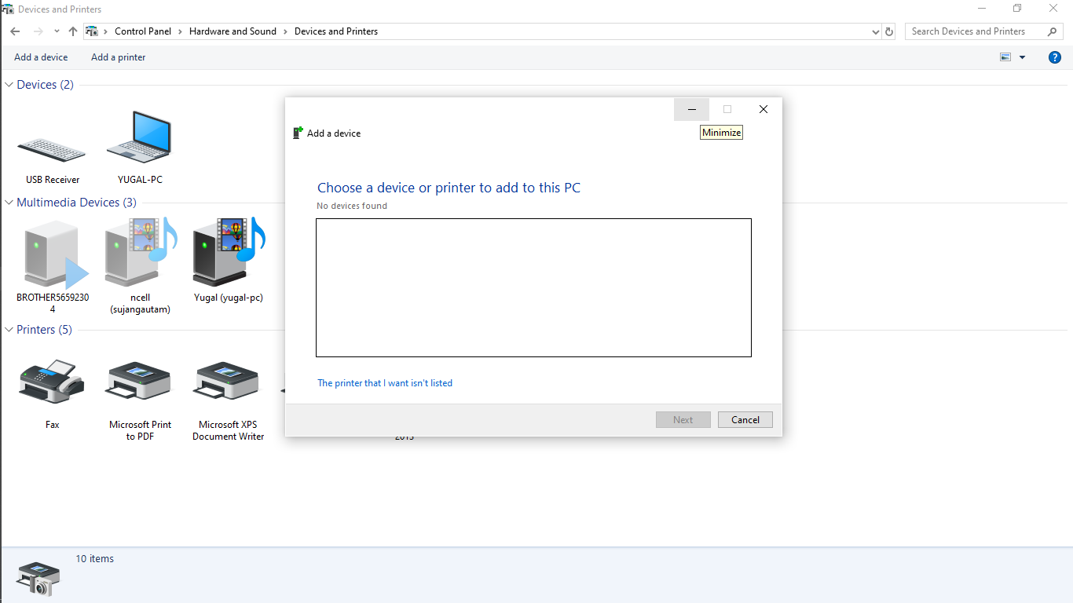Printer properties and click share