**AIR QUALITY MONITORING**



**TOPICS:**

• Describe the project's objectives, IoT device setup, platform development, and code implementation.

• Include diagrams, schematics, and screenshots of the IoT devices and data-sharing platform.

• Explain the project in detail.

IOT_PHASE 5

**TEAM MEMBERS**

**1)B VIGNESH**

**2)R SHOBAN BABU**

**3)K SANJIV KANTH**

**4)M VIMAL BABU**

**5)M YUGANDHAR**

**Here are some common objectives of air quality monitoring projects:**

**Assessment of Air Quality:**

The primary goal is to assess the current state of air quality in a particular region. This involves measuring various pollutants, such as particulate matter (PM), nitrogen oxides (NOx), sulfur dioxide (SO2), carbon monoxide (CO), volatile organic compounds (VOCs), and ozone (O3).

**Health and Environmental Protection:**

One of the key objectives is to protect public health and the environment by identifying pollutants that exceed established air quality standards. Monitoring helps in understanding the risks associated with air pollution and taking necessary actions to mitigate those risks.

**Compliance with Regulations:**

Many air quality monitoring projects are conducted to ensure compliance with local, national, and international air quality regulations and standards. This involves keeping track of pollutant levels and reporting data to regulatory authorities.

**Source Identification:**

Identifying the sources of air pollution is essential for targeted pollution control measures. Air quality monitoring helps in pinpointing industrial, transportation, or other sources responsible for elevated pollutant levels.

**Data for Policy Making:**

Air quality data collected through monitoring projects provide policymakers with essential information to create and implement effective air quality management policies and regulations.

**Public Awareness:**

Another objective is to increase public awareness about the quality of the air they breathe and the associated health risks. Sharing real-time air quality information with the public allows individuals to take precautions when pollution levels are high.

**Forecasting and Early Warning Systems:**

Air quality monitoring data can be used to develop forecasting models and early warning systems. These systems provide advance notice of deteriorating air quality, especially during events like wildfires, dust storms, or industrial accidents.

**Research and Scientific Understanding:**

Air quality monitoring projects often contribute to scientific research by providing valuable data for studying the effects of air pollution on ecosystems, climate change, and human health.

**Monitoring Long-Term Trends:**

In addition to short-term assessments, these projects aim to monitor long-term trends in air quality to assess the effectiveness of pollution control measures and track improvements or deteriorations over time.

**International Cooperation:**

Air quality can be influenced by sources across national borders. International cooperation is essential to address cross-boundary pollution and protect the air quality of neighboring regions.

**Development of Mitigation Strategies:**

The data collected can be used to develop and implement pollution control and mitigation strategies to reduce pollutant levels and improve air quality.

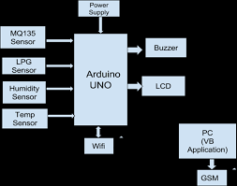

**Setting up an IoT (Internet of Things) device for air quality monitoring:**

**Define Your Objectives:**

Determine the specific parameters you want to monitor, such as particulate matter (PM2.5, PM10), carbon dioxide (CO2), temperature, humidity, or volatile organic compounds (VOCs).

**Select Hardware:**

Choose the appropriate sensors for your application. For air quality monitoring, consider sensors like the SDS011 for PM levels, MH-Z19 for CO2, DHT22 for temperature and humidity, and additional sensors as needed.

You may need a microcontroller or single-board computer (e.g., Raspberry Pi or Arduino) to interface with the sensors and transmit data.

**Assemble the Hardware:**

Connect the selected sensors to your microcontroller or single-board computer as per the manufacturer's instructions.

Make sure to provide adequate power to the sensors and the controller.

**Write Code:**

Program your microcontroller or single-board computer to read data from the sensors.

Use libraries or SDKs provided by the sensor manufacturers, or develop custom code as needed.

Ensure your code collects data at regular intervals and prepares it for transmission.

**Set Up Connectivity:**

To make your device IoT-enabled, you'll need a method to transmit the data. Options include Wi-Fi, Ethernet, or cellular connections.

Configure network settings and ensure your device can access the internet.

**Data Storage and Processing:**

You can use cloud platforms like AWS, Azure, or Google Cloud to store and process data.

Create a database to store the sensor readings. Implement data processing logic to clean, analyze, and visualize the data.

**Data Visualization:**

Create a dashboard to visualize air quality data. Tools like Grafana, Tableau, or custom web applications can help you with this.

Ensure your dashboard is accessible from any device with internet access.

**Security:**

Implement security measures to protect your IoT device and the data it collects. Use encryption, authentication, and authorization mechanisms.

Regularly update the firmware and software to address security vulnerabilities.

**Power Management:**

If your IoT device is battery-powered, optimize power consumption to extend the device's operational lifespan.

Implement sleep modes and low-power strategies.

**Calibration and Maintenance:**

Periodically calibrate your sensors to ensure accuracy.

Perform routine maintenance, such as cleaning sensors and checking for physical damage.

**Data Analysis and Alerts:**

Set up thresholds for air quality parameters and configure alerts to notify you when values go out of range.

**Compliance:**

Ensure that your device and data collection comply with local regulations and privacy laws.

**Deployment:**

Install your IoT device in the desired location. Ensure it's protected from the elements and positioned for accurate data collection.

**Monitoring:**

Regularly monitor your IoT device to ensure it's functioning correctly. Use remote monitoring tools to check device status and receive alerts.

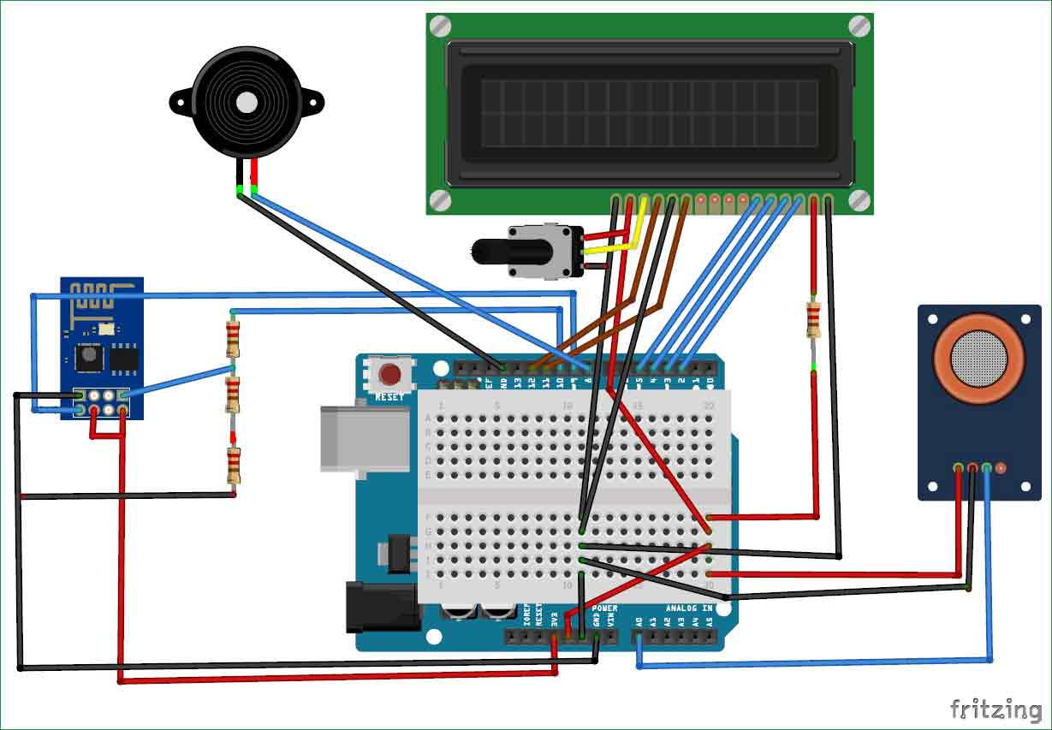



**Developing a platform for air quality monitoring :**

**Define your Objectives:**

Determine the purpose and scope of your air quality monitoring platform. Are you building this for personal use, a community project, or a commercial application?

**Select Hardware Components:**

Choose appropriate sensors: Select sensors for measuring key air quality parameters such as particulate matter (PM2.5 and PM10), gases (e.g., CO, CO2, NO2), temperature, humidity, and pressure.

Microcontroller: Use a microcontroller (e.g., Arduino, Raspberry Pi) to interface with the sensors and process the data.

Power supply: Ensure you have a stable power supply for continuous operation.

**Assemble the Hardware:**

Connect the sensors to the microcontroller following the manufacturer's instructions.

Ensure proper calibration and sensor maintenance for accurate measurements.

**Software Development:**

Develop or configure software to read data from the sensors and store it. You can use programming languages like Python or C/C++.

Implement data logging to record readings over time.

Set up communication protocols for data transmission, such as Wi-Fi, Bluetooth, or cellular connectivity.

Create algorithms for real-time data processing and analysis.

Implement error handling and alerting mechanisms for sensor malfunctions or unusual data patterns.

**Data Storage and Management:**

Choose a database system (e.g., MySQL, PostgreSQL, MongoDB) to store historical air quality data.

Set up cloud storage or local server to archive data.

Implement data retention policies to manage the storage of historical data.

**Data Visualization:**

Create a user interface to display real-time and historical air quality data. You can develop a web or mobile application.

Use libraries like D3.js, Plotly, or Matplotlib for data visualization.

Include charts, maps, and dashboards to make the data user-friendly.

**User Interaction and Control:**

Allow users to interact with the platform, set alerts, and access historical data.

Implement user authentication and access control to protect sensitive information.

**Remote Access:**

Ensure that users can access the platform remotely via web or mobile applications.

Consider integrating APIs or MQTT protocols for remote monitoring.

**Alerting and Notifications:**

Implement notification mechanisms (e.g., email, SMS, push notifications) to alert users when air quality levels exceed predefined thresholds.

**Maintenance and Calibration:**

Regularly maintain and calibrate sensors to ensure data accuracy.

Update software to address security vulnerabilities and improve performance.

**Compliance and Regulations:**

Ensure that your platform complies with local air quality regulations and standards.

**Testing and Validation:**

Thoroughly test the entire platform to ensure its accuracy and reliability in different environmental conditions.

**Documentation and Support:**

Provide comprehensive documentation for users and offer customer support as needed.

**Deployment:**

Deploy the platform in the desired locations for air quality monitoring.

**Data Sharing:**

Consider opening the data for public access through APIs or data-sharing platforms to benefit the community and researchers.

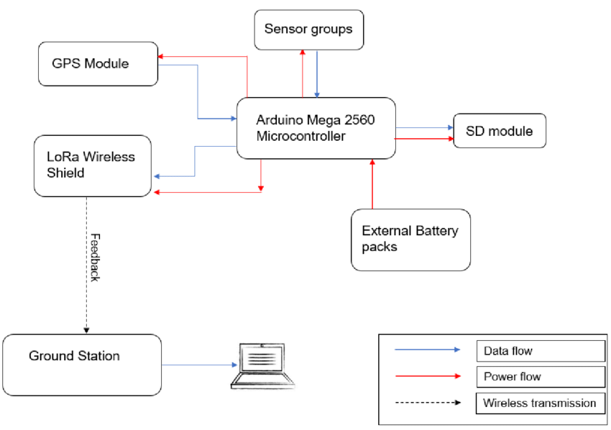

**Code implement for air quality monitoring system:**

**Requirements:**

- Raspberry Pi (or similar single-board computer)

- Air quality sensors (e.g., gas sensors, particulate matter sensors)

- Internet connectivity

- Python programming knowledge

- Appropriate libraries and dependencies for sensors

**Set up your Raspberry Pi:**

Install Raspbian or your preferred operating system on your Raspberry Pi.

Ensure that your Raspberry Pi is connected to the internet.

**Connect your sensors:**

Connect your air quality sensors to the Raspberry Pi. Refer to the sensor's datasheet and documentation for wiring instructions.

**Install necessary libraries:**

Use Python to interface with the sensors. Install the required libraries for your sensors. For example, you might need libraries like `Adafruit_DHT`, `smbus2`, or others, depending on the sensors you are using.

**Write Python code:**

Create a Python script to read data from your sensors and process it. Here's a simplified example using the Raspberry Pi and a few common sensors:

**Python:**

import time

import smbus2

from datetime import datetime

# Initialize I2C bus

bus = smbus2.SMBus(1)

def read_sensor_data():

# Read data from sensors and return the values

co_value = bus.read_word_data(0x48, 0x00) # Replace with your CO sensor's I2C address

no2_value = bus.read_word_data(0x49, 0x00) # Replace with your NO2 sensor's I2C address

pm25_value = 25.0 # Replace with your PM2.5 sensor data retrieval

return {

"timestamp": datetime.now(),

"CO": co_value,

"NO2": no2_value,

"PM2.5": pm25_value

}

while True:

air_quality_data = read_sensor_data()

# You can process and store the data as needed, e.g., send it to a database, display it, or log it to a file.

print(air_quality_data)

time.sleep(60) # Adjust the interval as needed

**Data storage and visualization:**

You can store the collected air quality data in a database (e.g., SQLite, MySQL, or cloud-based databases like AWS DynamoDB).

To visualize the data, you can use various tools and frameworks like Matplotlib, Grafana, or web-based dashboards.

**Alerting:**

Implement alerting mechanisms based on predefined air quality thresholds.

**Remote access:**

Consider setting up remote access to your Raspberry Pi using SSH or a VPN for monitoring and maintenance.

**Power source and enclosure:**

Ensure your Raspberry Pi and sensors have a stable power source and are appropriately enclosed if placed outdoors.

**Maintenance and calibration:**

Periodically calibrate and maintain your sensors to ensure accurate readings.

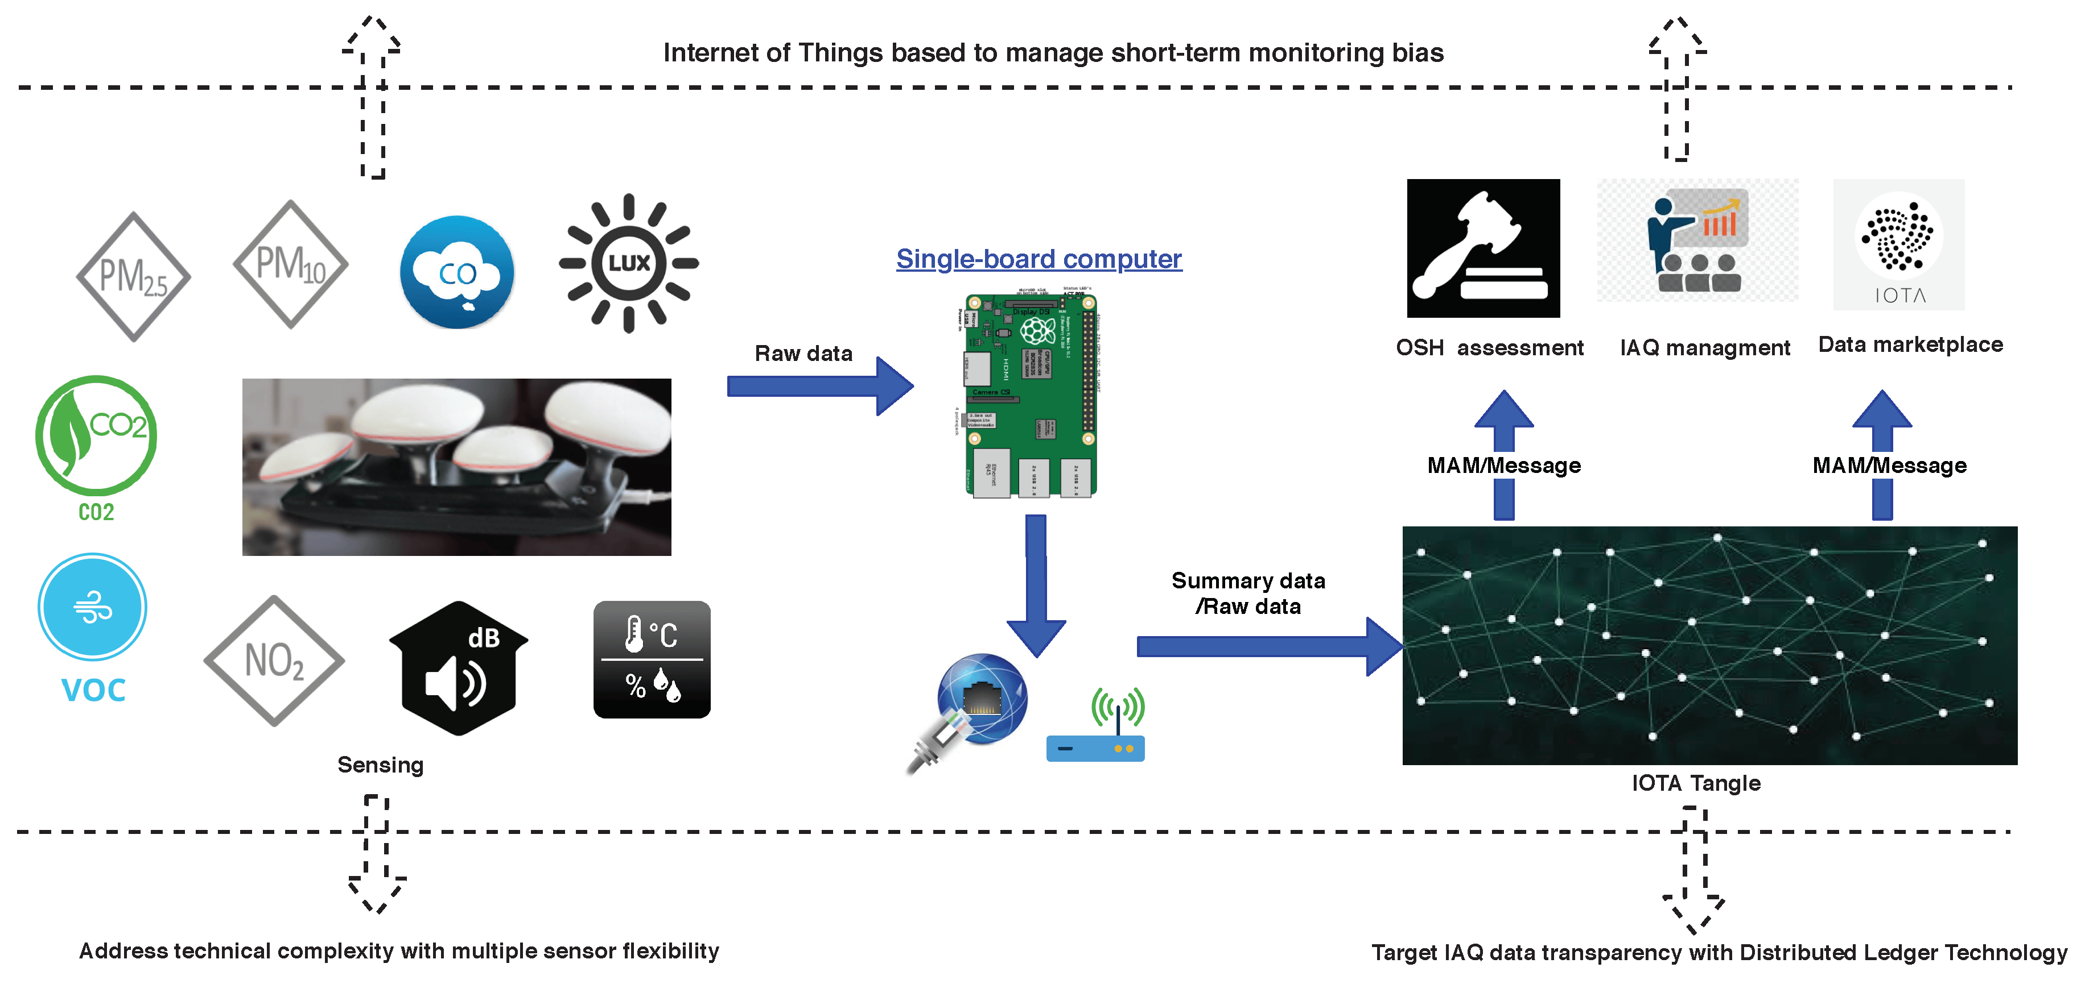

**Detailed explanation of air quality monitoring:**

**Purpose of Air Quality Monitoring:**

**Public Health:** The primary goal is to protect human health by assessing and controlling the levels of air pollutants that can be harmful when inhaled.

**Environmental Protection:** Monitoring helps in understanding and mitigating the impact of air pollution on ecosystems, wildlife, and the atmosphere.

**Compliance and Regulation:** Data collected is used to ensure that air quality standards and regulations are met, as set by national and international authorities.

**Parameters Monitored:**

**Criteria Pollutants:** These are common pollutants regulated by air quality standards and include particulate matter (PM10 and PM2.5), ground-level ozone (O3), sulfur dioxide (SO2), nitrogen dioxide (NO2), carbon monoxide (CO), and lead (Pb).

**Non-Criteria Pollutants:** These can include volatile organic compounds (VOCs), heavy metals, and various other compounds depending on local concerns.

**Meteorological Data:** Information such as temperature, humidity, wind speed, and wind direction is collected to understand atmospheric conditions that affect pollutant dispersion.

**Monitoring Methods:**

**Continuous Monitoring:** Automated sensors and instruments measure pollutants in real-time, providing a continuous stream of data.

**Passive Monitoring:** Collects data over a specific period using passive samplers that absorb pollutants for later analysis.

**Manual Sampling:** Periodically collecting samples, often for laboratory analysis, to determine pollutant concentrations over time.

**Remote Sensing:** Technologies like satellite-based remote sensing are used to monitor large geographic areas from a distance.

**Monitoring Stations:**

**Fixed Stations:** Permanent monitoring sites are strategically located in urban areas, industrial zones, and near pollution sources to provide continuous data.

**Mobile Stations:** These are mounted on vehicles and can measure air quality while moving, which is useful for identifying pollution sources and assessing pollution levels in various locations.

**Data Analysis and Reporting:**

Collected data is analyzed to determine pollutant concentrations, trends, and potential health risks.

Air quality index (AQI) is calculated to provide a simple way of communicating air quality information to the public.

Regular reports are generated and shared with the public, government agencies, and relevant stakeholders.

**Quality Assurance and Quality Control:**

To ensure data accuracy, monitoring equipment is regularly calibrated and maintained.

Standardized methods and procedures are followed to reduce measurement errors and maintain data quality.

**Public Awareness:**

Publicly available air quality information helps individuals make informed decisions, such as modifying outdoor activities on days with poor air quality.

**Air Quality Management:**

Data from monitoring stations are used to develop air quality management plans and policies to reduce pollution levels and protect public health and the environment.

**CONCLUSION:**

**In conclusion, air quality monitoring is a critical endeavor with far-reaching implications for public health, environmental protection, and regulatory compliance. This comprehensive process involves the systematic measurement and analysis of air pollutants to ensure the well-being of communities and ecosystems. From the selection of monitoring sites to the development of sophisticated data platforms, each step is integral to the success of the project.**

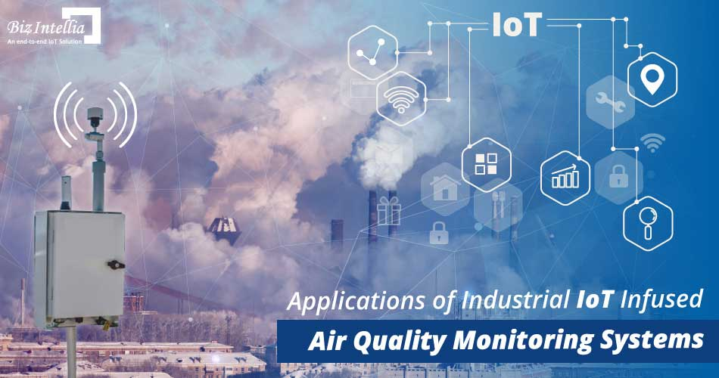

**Collaboration with regulatory bodies, research institutions, and the wider community is key to addressing air quality challenges comprehensively and effectively**