## test_declineEnvelope

signature_tag1

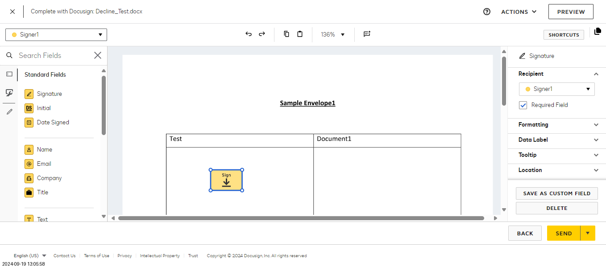

signature_tag2

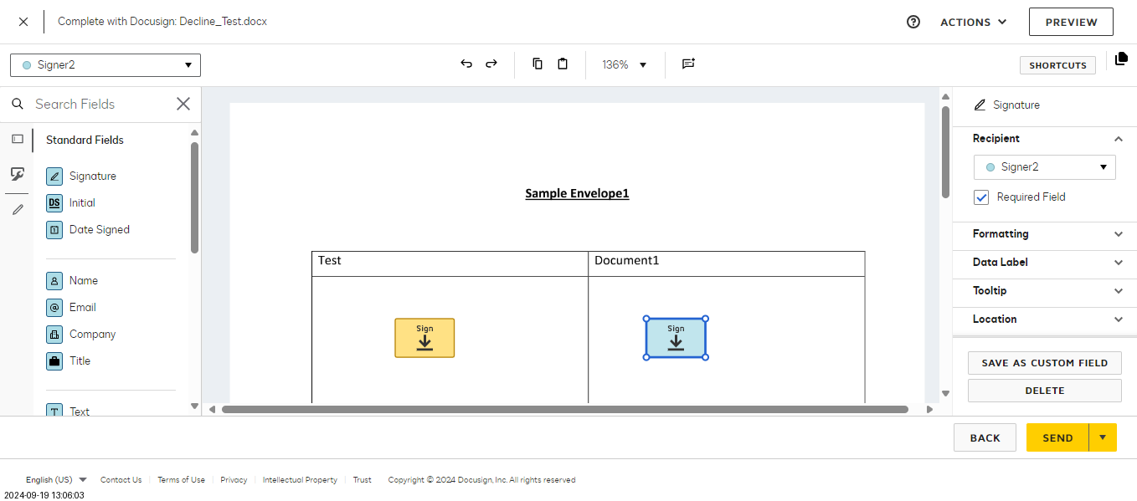

Decline_Envelope

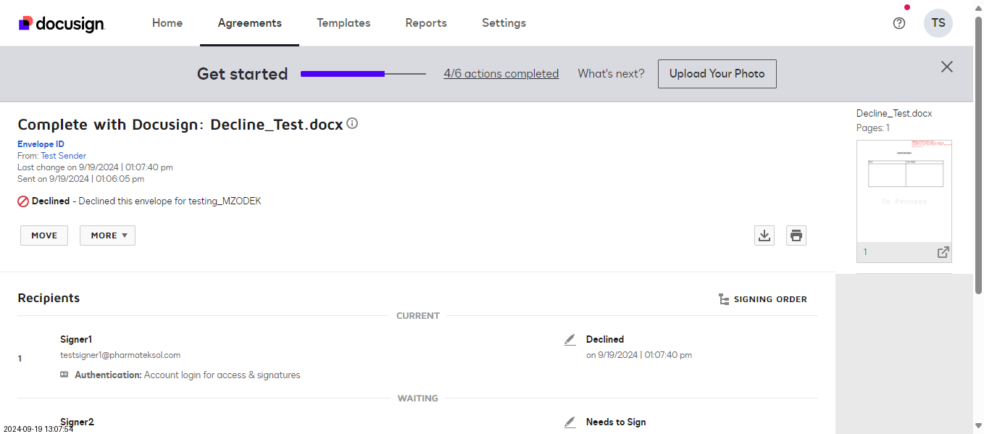

## test_verify_decline_notification

Envelope_declined_notification_to_sender

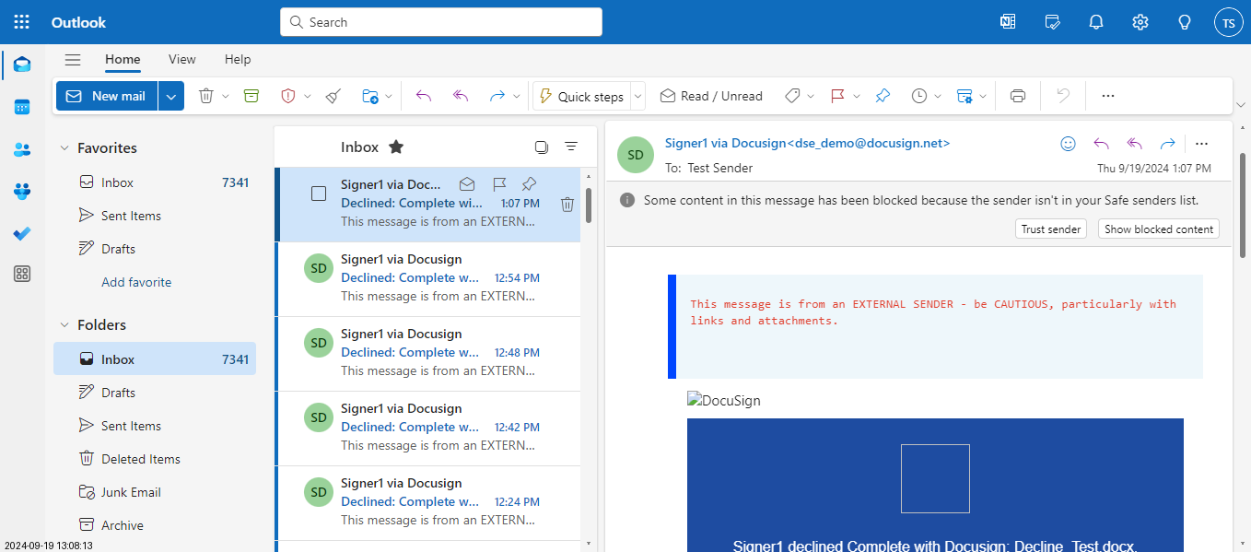

Pytest Test Report

# Passed Tests

test_decline_envelope.py::Test_DeclineEnvelope::test_declineEnvelope

test_decline_envelope.py::Test_DeclineEnvelope::test_verify_decline_notification

# Failed Tests

No tests failed.

# Skipped Tests

No tests were skipped.

# Summary

Total Passed: 2

Total Failed: 0

Total Skipped: 0