DocuSign Automation

Test Summary Report

December 07, 2024

# TestCase1 :test_change_sign_tag_size

1.Login Page

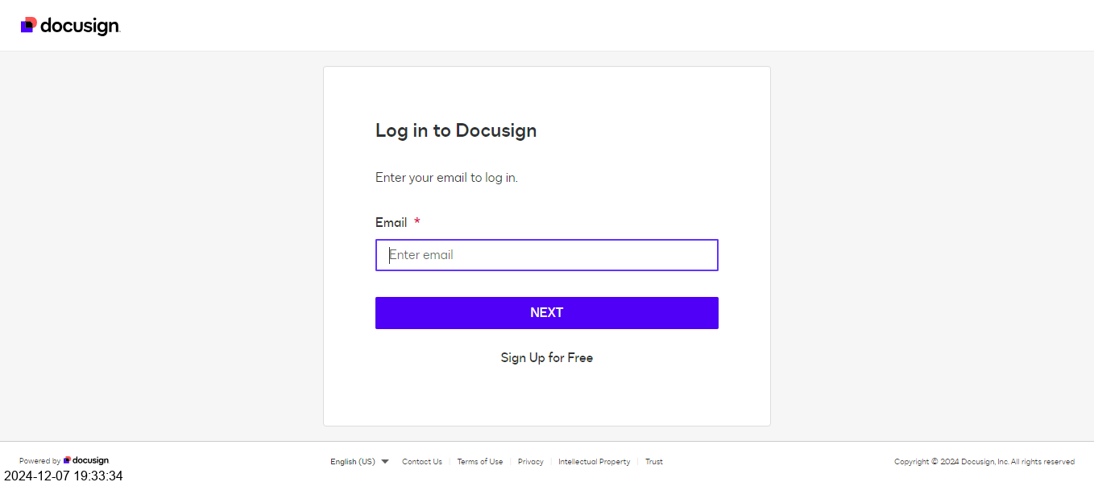

2.Before_changing_Signature_Tag_size_100%_resolution

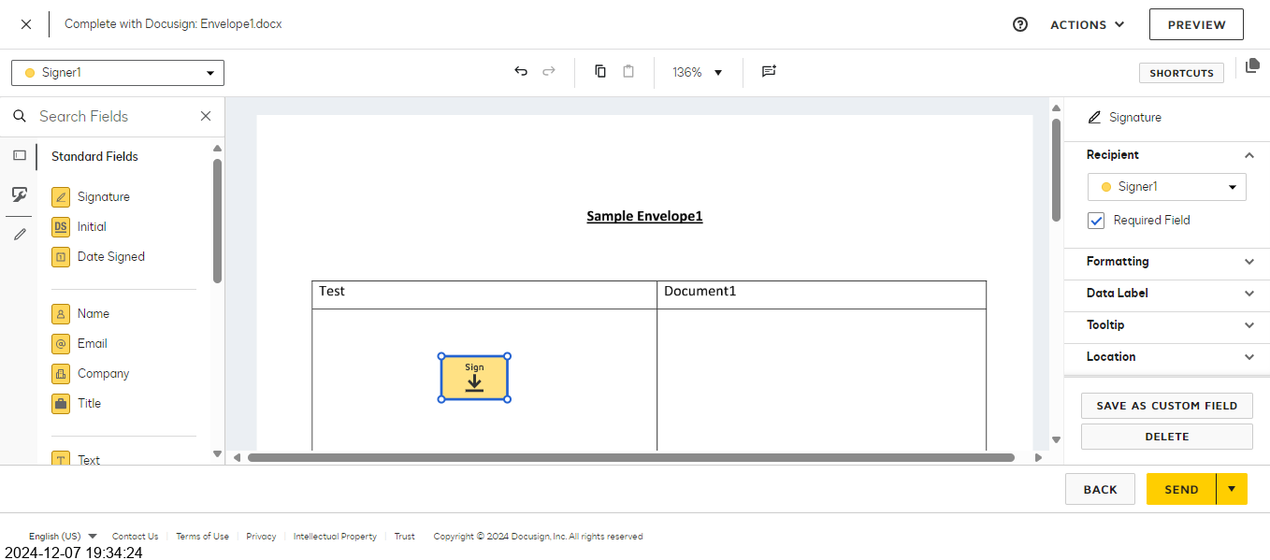

3.After_Changing_signature_Tag_size_200%_resolution

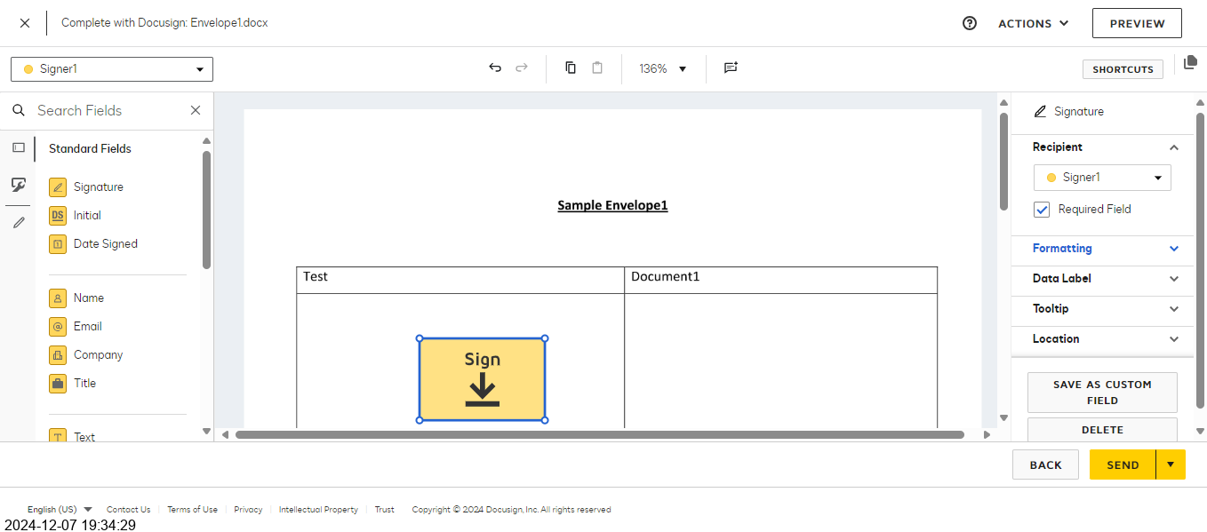

# Passed Tests

Test Script - 1 : test_change_sign_tag_size

# Summary

Total Passed: 1

Total Failed: 0

Total Skipped: 0