1. PROJECT TEAM DETAILS
Roll no | PRN | Name of student | MAILID | MOBILE NO | Signature
11 | 12413071 | Shreyas P. Patil | shreyas.patil24@vit.edu | 9422996733
14 | 12414973 | Yugandhar G. Paulbudhe | yugandhar.paulbudhe24@vit.edu | 9112650632
23 | 12414725 | Prithviraj V. Tandel | prithviraj.tandel24@vit.edu | 9766842608
24 | 12414159 | Pruthvi J. Chaudhari | pruthvi.chaudhari24@vit.edu | 8766593055

2. PROJECT TITLE
Knowledge Distillation for Efficient Object Detection and Depth Estimation in GOD'S EYE

3. PROJECT DOMAIN
Artificial Intelligence, Computer Vision, Deep Learning, Assistive Technology, Embedded Systems

4. PROJECT ABSTRACT
Modern computer-vision systems often achieve high accuracy using large deep-learning models, but their computational requirements make them difficult to deploy on portable and resource-constrained platforms. This project investigates knowledge distillation for reducing the computational requirements of the GOD'S EYE assistive vision system while maintaining its object detection and depth estimation capabilities. A high-capacity Teacher consisting of YOLO11-L and DPT-Large is compared with a compact Student consisting of YOLO11-S and DPT-Small. Both systems are evaluated as an integrated pair on the same RGB frames using KITTI and NYU Depth V2 datasets. Detection accuracy, depth accuracy, object-level distance estimation and computational efficiency are measured using a common evaluation protocol. The current Teacher-Student baseline demonstrates a substantial reduction in inference latency, GPU memory and model parameters with the compact Student, while also revealing task- and dataset-dependent performance losses. Knowledge distillation will subsequently be applied to transfer useful information from the Teacher to the Student. The final objective is to determine whether the Distilled Student can recover part of the Teacher's performance while retaining the computational advantages required for efficient deployment in GOD'S EYE.

5. LITERATURE REVIEW / EXISTING TECHNOLOGY

5.1 Existing Technologies
Several technologies have been developed to assist visually impaired users with environmental perception and navigation.

Traditional White Cane
The white cane is one of the most widely used mobility aids. It allows users to detect nearby physical obstacles through direct contact and provides information about the immediate ground surface.
Limitation:
It provides little or no semantic information about an obstacle. For example, it can indicate that an obstacle exists but cannot identify whether it is a chair, vehicle, person or staircase.

Ultrasonic Obstacle Detection
Ultrasonic sensors can measure the distance to nearby objects by transmitting ultrasonic waves and measuring their reflected signal.
Limitation:
Ultrasonic sensing provides distance information but generally does not identify the semantic class of an object. It also provides limited spatial information compared with a camera.

Smartphone-Based Assistive Vision
Smartphones can run object detection, OCR, image recognition and navigation applications to provide audio descriptions of the environment.
Limitations:
- The user may need to hold or operate the device.
- Continuous processing can consume significant battery power.
- A single modality may not provide sufficient information about both object identity and distance.

Deep-Learning Object Detection
Modern object detectors such as the YOLO family can identify multiple objects in a scene and provide bounding boxes and confidence scores.
Limitation:
Object detection alone answers "What is present?", but does not directly provide reliable metric distance information.

Monocular Depth Estimation
Models such as MiDaS/DPT estimate scene depth from a single RGB image.
Limitation:
Depth estimation provides spatial information but does not inherently identify what each region of the scene represents. Monocular depth is also fundamentally more challenging than direct depth sensing because the model must infer 3D structure from a 2D image.
5.2 Objectives
- Evaluate the performance of a high-capacity Teacher consisting of YOLO11-L and DPT-Large.
- Evaluate a computationally efficient Student consisting of YOLO11-S and DPT-Small.
- Establish a common integrated evaluation protocol for object detection, depth estimation and object-level distance estimation.
- Apply knowledge distillation to transfer useful information from the Teacher to the Student.
- Compare Teacher, Student and Distilled Student using identical datasets and evaluation conditions.
- Quantify the trade-off between accuracy and computational efficiency.
- Determine whether distillation can recover Student performance while preserving its efficiency advantage.

6. PROJECT OBJECTIVES
The primary objectives of GOD'S EYE are:
- To develop an AI-based assistive vision system capable of identifying objects in the user's surroundings.
- To estimate the distance of detected objects using monocular depth estimation.
- To combine object identity and spatial information into meaningful environmental feedback.
- To provide information to the user through audio rather than requiring visual interaction.
- To develop a computationally efficient vision pipeline suitable for eventual wearable deployment.
- To investigate model optimization using knowledge distillation.
- To evaluate the trade-off between model accuracy, inference speed and computational resource requirements.

7. PROJECT SYNOPSIS
This project investigates knowledge distillation for developing an efficient and accurate perception system for GOD'S EYE. A high-capacity Teacher system consisting of YOLO11-L for object detection and DPT-Large for monocular depth estimation is compared with a compact Student system consisting of YOLO11-S and DPT-Small. Both systems process the same RGB frame so that object detection and depth estimation are evaluated as an integrated task. Detected objects are associated with corresponding regions of the depth map to obtain object-level distance estimates. The Teacher and Student are evaluated on the KITTI and NYU Depth V2 datasets using a unified testing pipeline covering detection accuracy, depth accuracy, object-distance accuracy and computational efficiency. The baseline evaluation establishes the performance and efficiency gap between the Teacher and Student. Knowledge distillation is then applied to transfer useful information from the Teacher to the Student, producing a Distilled Student. The final objective is to determine whether the Distilled Student can recover part of the Teacher's performance while retaining the computational advantages of the smaller models, supporting eventual deployment in the GOD'S EYE wearable assistive vision system.
GOD'S EYE is a wearable assistive vision system intended to provide visually impaired users with information about their surrounding environment.
The proposed system consists of five major components:
- Camera module
- AI perception module
- Depth-estimation module
- ESP32-based ultrasonic sensing module
- Audio feedback module
The camera captures frames from the user's surroundings. The AI perception module processes the same RGB frame using a YOLO-based object detector and a DPT-based monocular depth-estimation model.
The object detector produces:
- Object class
- Bounding box
- Detection confidence
The depth model produces a depth map representing the estimated spatial structure of the scene.
The bounding boxes from the object detector are associated with corresponding regions of the depth map. Depth values within each detected object region are then used to estimate the object's distance.
The resulting information is converted into speech and provided to the user through an audio output device.
The ESP32 subsystem operates as an additional sensing layer and can detect nearby ground-level obstacles and changes such as steps or curbs using ultrasonic sensors.
The current AI implementation uses GPU-accelerated inference, with TensorRT used to optimize model execution.

8. BRIEF DESCRIPTION OF PROPOSED SYSTEM ARCHITECTURE DIAGRAMS / FIGURES

8.1 Model Systems
Table 3.1 Teacher baseline student and distilled student
System | Detector | Depth model | Parameters
Teacher | YOLO11-L | MiDaS DPT-Large | 369.396 M
Student | YOLO11-S | MiDaS v2.1 Small | 30.764 M
Distilled | Trained YOLO11-S | Trained MiDaS Small | 30.764 M

The teacher and baseline student begin with pretrained checkpoints. The distilled detector additionally receives supervised KITTI fine-tuning and teacher-response losses. The distilled depth model is trained using NYU images, teacher outputs and valid raw depth. Distillation changes the student weights, not the student architecture; the baseline and distilled systems therefore have the same parameter count.

8.2 Hardware and Software Requirements
Table 3.2 Recorded research and deployment environments
Component | Recorded configuration
Operating system | Windows 11
Research GPU | NVIDIA GeForce RTX 4050 Laptop GPU, 6 GB
Research Python and PyTorch | Python 3.13.6; PyTorch 2.9.1+cu128
Research CUDA and numerical precision | CUDA 12.8; FP32 inference; batch size 1
Export and live-engine environment | PyTorch 2.7.1+cu128; TensorRT 10.11.0.33
Core libraries | Ultralytics, OpenCV, NumPy, psutil and MiDaS
Live input and output | RGB camera, OpenCV display and offline Windows speech

The research and engine-export environments are separate recorded environments. TensorRT timings are not substituted for the PyTorch integrated comparison. Package and GPU records are retained with each experiment.

8.3 Integrated Architecture

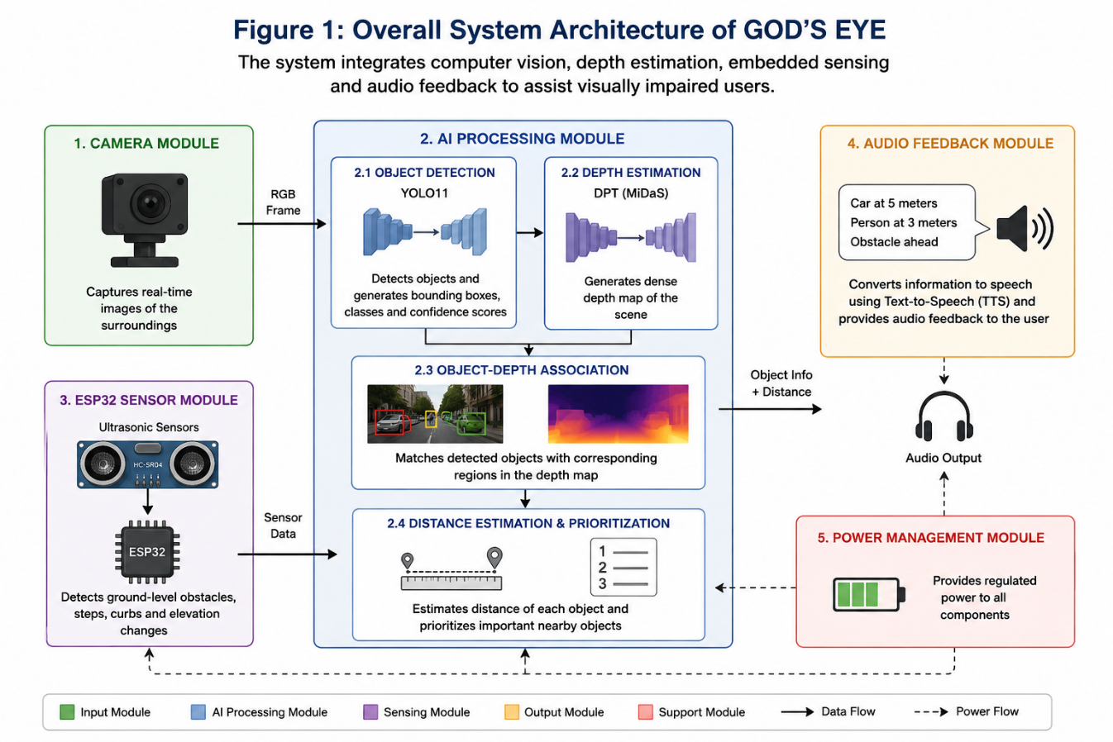

Figure 8.1 overall architecture of the GOD’S EYE assistive system
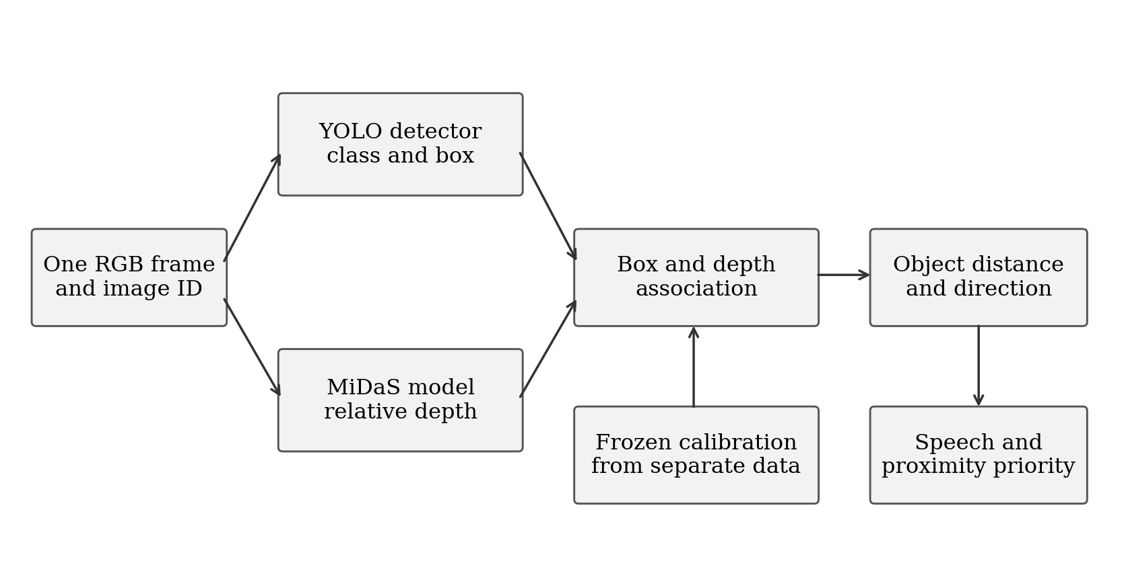
Figure 8.2 Same-frame object detection and depth association
Each evaluated image has a unique identifier. The detector and depth model receive that same image. DPT-Large uses dpt_transform with a nominal 384-pixel aspect-preserving minimal resize, dimensions aligned to multiples of 32, and mean and standard deviation 0.5. MiDaS Small uses small_transform with a nominal 256-pixel upper-bound resize and ImageNet normalisation. These nominal sizes do not guarantee square input tensors. Detection returns class IDs, scores and boxes. Depth is resized to image coordinates and transformed using frozen calibration before object association.
The live application adds tracking, spatial directions and speech. Its camera loop displays detections and a three-by-three grid. Speech operates in a separate worker so that an announcement does not block model inference. The research evaluator instead records predictions, object matches and timing for later analysis; its latency excludes camera capture, display and audio playback.

8.4 Functional Modules and Use Cases
The camera and preprocessing module acquires frames and converts them to the expected model input. The detection module handles inference and non-maximum suppression. The depth module estimates relative depth and performs calibration. The association module combines object boxes with depth regions. Tracking retains a short-lived identity and smooths distance estimates. The audio module announces object names, distances and directions, while the reporting module stores reproducible experimental evidence.
The assistive use case is a user receiving spoken environmental information without relying on the screen. A researcher selects a system, evaluates fixed frames and regenerates comparison tables. A technician-support pilot could use spatial guidance to locate tested tools or instruments at a controlled workstation. Industrial equipment recognition and procedure guidance would require application-specific labels and integration beyond the present dataset study.

8.5 Nine Section Guidance and Speech Priority
The frame is divided by two vertical and two horizontal lines. An object's bounding-box centre determines its grid cell: top-left, top-middle, top-right, middle-left, centre, middle-right, bottom-left, bottom-middle or bottom-right. Overlapping detections of the same class can share a broader row or column direction. Objects from different classes retain their individual names and announcements.
Confirmed nearby tracks receive priority. The application preserves the object name, estimated distance and direction in each phrase, without the earlier caution prefix. A one-item speech queue and busy rejection prevent stale announcements from accumulating. Visible tracks may be announced again after the configured repeat interval, and expired tracks are removed. The default live distance heuristic is 6.63 divided by the relative depth response; this approximate conversion is distinct from the affine research calibration.

8.6 Experimental Data and Reproducibility
The experiment record links image IDs, model checkpoints, class mappings, calibration parameters and configuration to the raw predictions. Each repeat stores frame timing, detection confidence, matches, IoU, predicted object depth, target depth and object errors. These records permit tables to be regenerated without another inference pass. A reporting matrix is useful for navigation, but the original repeat summaries remain the authoritative source when derived summaries disagree.

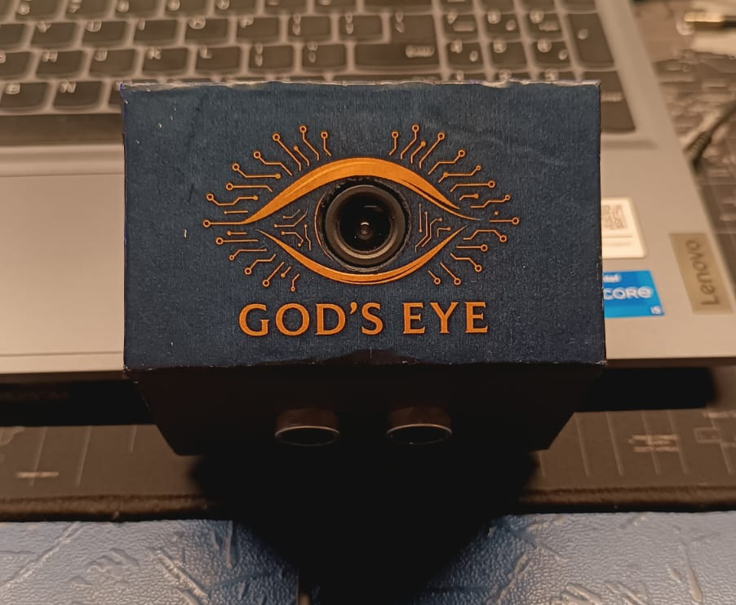
Figure 8.3: Physical Prototype

9. DETAILED PROJECT DESCRIPTION

9.1 Overall Architecture
The system consists of two complementary perception paths.

Vision path
Camera
↓
Image preprocessing
↓
┌───────────────┬─────────────────┐
↓ ↓
YOLO DPT
↓ ↓
Objects Depth map
└───────────────┴─────────────────┘
↓
Object-depth association
↓
Distance estimation
↓
Audio feedback

Sensor path
Ultrasonic Sensors
↓
ESP32
↓
Ground-level obstacle information
↓
Feedback
The two paths complement each other. The camera provides rich semantic information, while ultrasonic sensing provides an additional mechanism for detecting nearby physical obstacles and ground-level changes.

9.2 Object Detection
The project currently uses the YOLO11 family for object detection.
The detector receives an RGB frame and produces bounding boxes corresponding to detected objects.
For each detection, the system obtains:
- Class identifier
- Bounding-box coordinates
- Confidence score
Non-Maximum Suppression is applied to eliminate redundant overlapping detections.
The resulting bounding boxes are then mapped to the corresponding regions of the depth map.

9.3 Monocular Depth Estimation
The project uses DPT-based monocular depth estimation.
The model receives a single RGB image and predicts a dense depth representation.
Unlike a stereo camera or LiDAR system, monocular depth estimation does not directly measure distance using an additional physical sensor. Instead, the neural network estimates scene depth based on visual features learned from training data.
For GOD'S EYE, the predicted depth map is particularly useful because it can be combined with semantic object detections.

9.4 Object-Level Distance Estimation
This is one of the central components of the project.
Instead of evaluating depth independently from object detection, the system combines the outputs.
For example:
YOLO:
Bounding box = Car
Coordinates = (x1,y1,x2,y2)

DPT:
Depth map

↓

Extract depth values
inside the car bounding box

↓

Estimate representative depth

↓

Car ≈ X metres away
This allows the system to produce information that is directly useful to the user.

9.5 Experimental Work

9.5.1 Dataset Preparation and Held Out Partitions
KITTI provides outdoor images with object labels, calibration files and Velodyne point clouds [6]. The project uses labelled object-training assets to construct development partitions. NYU Depth V2 provides indoor RGB images, raw and filled depth, semantic names and instance annotations [7]. The rawDepths variable is used for depth evaluation, excluding invalid measurements rather than treating missing values as real distances.
Table 9.5.1 Project defined training calibration and evaluation partitions
Dataset | Training | Validation | Calibration | Evaluation
KITTI | 6,193 | 688 | 100 | 500
NYU Depth V2 | 764 | 85 | 100 | 500

The partitions use deterministic selection with seed 42. The 600 calibration and evaluation frames per dataset are excluded from the student-training manifests. These are project-defined held-out partitions, not the official KITTI test set or an official NYU test split. Frame-level separation does not by itself establish separation of related sequences or indoor scenes. The three evaluation repetitions reuse the same 500 images and therefore do not increase the number of unique test samples.

9.5.2 Detector Distillation and Training
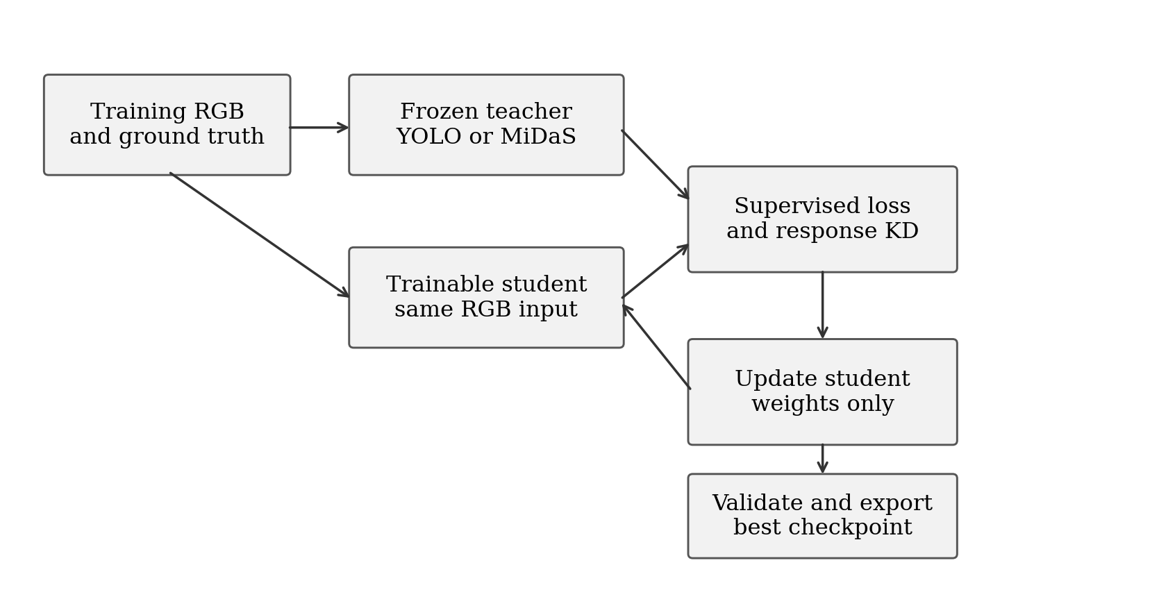
Figure 9.5.1 Frozen teacher and trainable student distillation workflow
The detector student starts from YOLO11-S pretrained weights and trains on KITTI labels. YOLO11-L supplies frozen responses for the same training batch. The objective combines native YOLO supervision for boxes, classes and distribution-focal regression with teacher-student response losses. Temperature-scaled KL divergence is applied to class responses and to the four 16-bin box distributions. The temperature is 2 and the response-loss weight is 1.
The detector completed 100 epochs with AdamW, an initial learning rate of 0.0001, weight decay of 0.0005, batch size 8 and a 640-pixel training image size. Mixed precision was enabled. The Ultralytics training record uses seed 0, while dataset selection uses seed 42. The best checkpoint was selected at epoch 86. Its internal validation mAP50-95 was 0.73724; this training-validation result is separate from the final integrated evaluation.

9.5.3 Depth Distillation and Checkpoint Selection
The depth student starts from MiDaS Small. Its loss combines an L1 difference from the teacher's relative depth output and a valid-ground-truth L1 term after per-image scale-and-shift alignment during training. Both terms have weight 1. Intermediate feature distillation is disabled, with feature weight 0. This training alignment is not a fit to the ground truth of deployment test frames.
Depth training completed 30 epochs. The exported best checkpoint is from epoch 8, with validation loss 2.40328. Training used AdamW, learning rate 0.0001, weight decay 0.0001 and mixed precision. The exported checkpoint records batch size 4; the final epoch checkpoint records batch size 2 with thermal safeguards, reflecting a resumed run. Thirty epochs were the configured training budget, not evidence that a larger budget could not improve convergence.
Table 9.5.2 Recorded distillation training settings
Setting | Detector | Depth
Completed epochs | 100 | 30
Selected checkpoint epoch | 86 | 8
Optimizer | AdamW | AdamW
Initial learning rate | 0.0001 | 0.0001
Weight decay | 0.0005 | 0.0001
Batch size | 8 | 4 at selected checkpoint; 2 at final epoch
Mixed precision | Enabled | Enabled
Teacher contribution | Class and box responses | Relative depth output
Additional supervision | KITTI detection labels | Valid NYU raw depth

9.5.4 Integrated Evaluation Procedure
Load the fixed evaluation manifest, frozen calibration and selected model pair. Retain available model paths, manifest hashes and recorded Python, PyTorch, CUDA and GPU environment metadata.
Read one RGB frame with its image ID and aligned ground truth. Send this exact frame to both models, retaining the model-specific preprocessing used throughout the experiment.
Filter detections at confidence 0.25. Apply the installed detector's non-maximum suppression and retain class, box and confidence. The research adapter does not explicitly record an NMS threshold; the live application's 0.45 threshold is a separate setting.
Resize the depth prediction to image coordinates. Apply the model/dataset calibration learned from the separate calibration subset, then evaluate only finite positive ground-truth depth pixels.
Match detections to ground-truth objects in descending confidence order, requiring equal mapped class and IoU at least 0.50. Each prediction and each ground-truth object can be matched only once.
Extract median calibrated depth inside the predicted bounding box. Compare it with the median valid ground-truth depth inside the target box or a valid instance mask. Record failures and unavailable depth explicitly.
Calculate frame-level depth errors, detection scores, matched-object distance errors and the instrumented timings. Save raw CSV/JSON records and repeat the procedure for each model system.

9.5.5 KITTI Validity and Detection Mapping
Table 9.5.3 KITTI object labels mapped to detector classes
KITTI annotation | Detector class | Rule
Car and Van | car | Accepted under common difficulty filter
Truck | truck | Accepted under common difficulty filter
Pedestrian and Person_sitting | person | Accepted under common difficulty filter
Cyclist | bicycle | Mapped as the bicycle category
Tram | train | Mapped as the train category
Other labels and DontCare | Ignored as targets | No DontCare suppression in custom AP

Accepted boxes have height at least 25 pixels, truncation no greater than 0.3 and occlusion no greater than 1. Sparse depth is produced by projecting positive camera-z Velodyne points using the frame's P2, rectification and extrinsic calibration. Where projected samples share a pixel, the nearest valid depth is retained. Empty pixels are excluded from depth errors.
KITTI object distance is median camera-axis depth inside the annotated box, not reconstructed Euclidean range. Precision and F1 count all retained COCO predictions, including classes outside the accepted KITTI mapping. Excluded difficult objects and DontCare regions receive no suppression. AP averages only classes present in ground truth, so these precision and AP conventions differ from official KITTI scoring. Region medians may include background, especially with sparse LiDAR, and are not independent object-centre or nearest-surface measurements.
The implemented depth mask covers the complete aligned image and requires finite ground-truth depth greater than zero. No Eigen crop or explicit 80-metre KITTI or 10-metre NYU cap is implemented. This same rule is used for all three systems, but the resulting scores should not be compared directly with published cropped or depth-capped benchmarks. Detection AP is a custom 101-point interpolation on confidence-filtered predictions, averaged over classes represented in ground truth; mAP50-95 averages thresholds from 0.50 to 0.95 in steps of 0.05.

9.5.6 Relative Depth and Frozen Distance Calibration
Two evaluation modes are distinguished. Relative-depth evaluation fits scale and shift to valid ground truth on each test frame to study depth-map shape. Deployment-distance evaluation fits one calibration per system and dataset on the 100 separate calibration frames, freezes it and applies it to all evaluation images. The saved complete results in this report are from the fixed-calibration mode. A complete six-system relative-mode result set is not available.
Table 9.5.4 Frozen affine calibration coefficients
Dataset | System | Scale | Shift
KITTI | Teacher | -0.87468499 | 33.89318848
KITTI | Student | -0.04131996 | 26.21384811
KITTI | Distilled | -2.04370070 | 45.63300323
NYU | Teacher | -0.12999575 | 4.49832439
NYU | Student | -0.00433248 | 4.15691996
NYU | Distilled | -0.15567836 | 4.83193827

The implementation applies a direct affine mapping from the relative output to metric depth and clamps nonpositive predictions to 0.000001 metres. Because MiDaS produces relative inverse-depth information, a direct affine mapping to metres is an empirical approximation. Clamping extreme extrapolations can create very large inverse-depth errors. The present calibration therefore does not establish dependable industrial ranging, and improved calibration is part of the future work.

9.5.7 NYU Annotation Audit and Validity
The saved NYU detection preparation contains two confirmed annotation defects. First, the archive has 894 raw semantic names, but the conversion applies a mapping resembling NYU40 class IDs directly to the raw labels. Second, instance numbers are reused across semantic categories, while the conversion groups pixels by instance number alone. This can merge unrelated objects into one bounding box. Correct extraction must use both semantic label and instance number, with an explicit mapping derived from the archive's names.
Table 9.5.5 Examples of incorrect archived NYU class assignments
Raw ID | Actual archive name | Assigned detector class
4 | ceiling | bed
6 | cone | couch
7 | counter | dining table
24 | sink | refrigerator
25 | air vent | tv
31 | telephone cord | person

Consequently, the archived NYU detection and object-distance outputs are diagnostic records, not validated indoor object-performance measurements. The results section labels them accordingly. Whole-image depth errors use rawDepths and a depth-validity mask independently of semantic/instance conversion, so they remain interpretable under the recorded depth protocol. Cross-environment detection recovery cannot be concluded until the annotations are corrected and the object evaluation is repeated.

9.5.8 Metric Definitions and Timing Boundaries
Table 9.5.6 Accuracy and distance metric definitions
Metric | Definition and interpretation
Precision, recall and F1 | Correct detections relative to predictions, targets, and their harmonic mean.
IoU and mAP | Box overlap; average precision at the stated overlap thresholds.
Depth RMSE | Square root of mean squared metric-depth error, in metres.
AbsRel and SqRel | Absolute or squared depth error divided by target depth.
Delta 1, 2 and 3 | Fraction of valid pixels with depth ratio below 1.25, 1.25 squared and 1.25 cubed.
Object MAE and RMSE | Absolute and squared distance errors over correctly matched objects with valid depth.
Median and relative object error | Median absolute error, and absolute error divided by target object depth.
Within 0.5 m or 1.0 m | Success fraction among matched objects with valid depth.
Integrated distance success | Successful detection-and-distance cases divided by all annotated target objects.

Depth metrics are calculated per frame, then averaged across frames and repetitions. Object errors use matched objects with valid target depth. Matched-object tolerance rates differ from all-target integrated success, which includes missed detections. Unavailable object-depth results are not recorded as zero.
Timing uses batch size 1 and three repetitions, after image and ground-truth loading. It includes preprocessing, both models, calibration, matching and metric computation, but excludes file loading, camera capture, display and speech. Integrated runs have no explicit warmup. Separate distilled runtime-only results (20 warmup frames; 600 prepared frames) are not mixed into this comparison.
GPU memory denotes peak PyTorch allocation, not total device usage; RAM denotes peak process resident memory. CPU utilisation can exceed 100% across cores; GPU utilisation comes from sampled resource records. Reported memory is the mean of three repeat peaks. Median, P95 and latency standard deviation likewise average per-repeat summaries, not pooled frame statistics. Aggregation is identical across systems.

9.6 Experimental Results

5.1 Evaluation Coverage and Main Findings
The completed evidence contains teacher, baseline student and distilled evaluations on 500 unique KITTI frames and 500 unique NYU frames, each repeated three times. Distilled KITTI detection improves substantially over the pretrained student, while KITTI depth-map errors improve modestly. Object-distance MAE and RMSE worsen, although tolerance success fractions improve. NYU whole-image depth errors improve slightly, while its object-level conclusions remain unresolved because of the annotation defects described in Section 4.7.
Table 5.1 Integrated comparison from consistent deployment runs
Dataset | System | mAP50 | Depth RMSE m | Object MAE m | FPS | P95 ms
KITTI | Teacher | 0.3360 | 8.485 | 6.250 | 2.20 | 464.96
KITTI | Student | 0.2900 | 10.712 | 8.080 | 17.87 | 72.51
KITTI | Distilled | 0.7407 | 10.466 | 8.806 | 20.48 | 66.18
NYU | Teacher | Invalid* | 0.872 | Invalid* | 6.24 | 166.10
NYU | Student | Invalid* | 0.873 | Invalid* | 14.47 | 77.77
NYU | Distilled | Invalid* | 0.860 | Invalid* | 14.75 | 74.66

* NYU detection and object-distance measurements are invalidated by the annotation conversion. Depth-map and timing entries use the stated independent depth and timing protocols. FPS is 1000 divided by mean integrated latency.

5.2 KITTI Detection Performance
Table 5.2 KITTI detection metrics
Metric | Teacher | Student | Distilled
Precision | 0.3487 | 0.3774 | 0.5463
Recall | 0.8366 | 0.8191 | 0.9757
F1 score | 0.4922 | 0.5167 | 0.7004
mAP50 | 0.3360 | 0.2900 | 0.7407
mAP50-95 | 0.1974 | 0.1671 | 0.5940
Mean matched IoU | 0.8178 | 0.8081 | 0.9111
Matched objects | 1,341 | 1,313 | 1,564
Missed objects | 262 | 290 | 39
False detections | 2,505 | 2,166 | 1,299

KITTI mAP50 rises from 0.2900 for the baseline student to 0.7407 for the distilled detector, compared with 0.3360 for the teacher. The distilled detector matches 1,564 of 1,603 accepted targets and misses 39; the teacher matches 1,341 and the baseline student 1,313. These results demonstrate strong adaptation of the trained detector to the project KITTI subset under the custom class and matching protocol. They do not isolate the effect of KD because the baseline is not an equally fine-tuned supervised control.
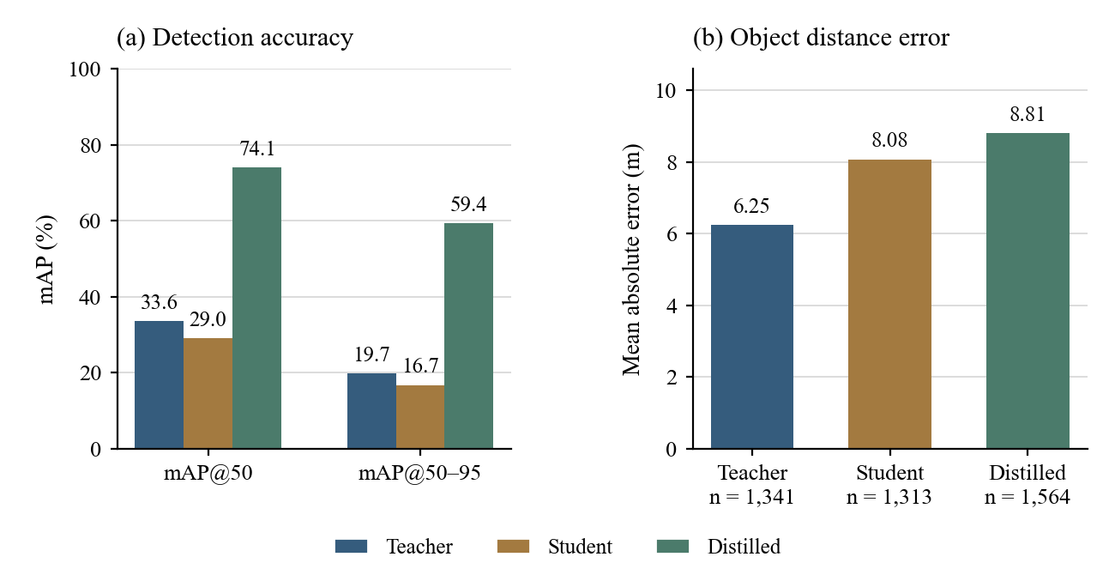
Figure 5.1 KITTI detection gains and object distance error

5.3 Depth Map Quality Under Fixed Calibration
Table 5.3 KITTI fixed calibration depth metrics
Metric | Teacher | Student | Distilled
RMSE in metres | 8.4850 | 10.7121 | 10.4662
AbsRel | 0.4492 | 0.6111 | 0.5847
SqRel | 3.7731 | 6.0305 | 6.0427
Delta 1 | 0.3339 | 0.2354 | 0.2630
Delta 2 | 0.6377 | 0.4834 | 0.5272
Delta 3 | 0.8184 | 0.7035 | 0.7464
SILog as implemented | 271.2299 | 101.8240 | 97.0684

Table 5.4 NYU fixed calibration depth metrics
Metric | Teacher | Student | Distilled
RMSE in metres | 0.8723 | 0.8726 | 0.8603
AbsRel | 0.3043 | 0.3020 | 0.2979
SqRel | 0.3379 | 0.3398 | 0.3286
Delta 1 | 0.5052 | 0.5244 | 0.5233
Delta 2 | 0.8023 | 0.8004 | 0.8051
Delta 3 | 0.9223 | 0.9204 | 0.9246
SILog as implemented | 55.3441 | 54.4695 | 51.5619

On KITTI, the baseline depth RMSE is 10.7121 m and the distilled RMSE is 10.4662 m, while the teacher reaches 8.4850 m. The trained distilled depth model reduces baseline error by approximately 2.30% and recovers 11.04% of the teacher-student RMSE gap. AbsRel improves from 0.6111 to 0.5847, and Delta 1 improves from 0.2354 to 0.2630. The student remains below the teacher on these depth measures.
On NYU, depth RMSE decreases from 0.8726 m to 0.8603 m. Teacher RMSE is 0.8723 m, leaving an extremely small initial teacher-student gap. A recovery percentage based on that tiny denominator would be unstable and misleading, so the report uses the absolute change and the 1.40% error reduction instead. NYU depth quality alone does not demonstrate successful indoor detection-and-distance guidance.
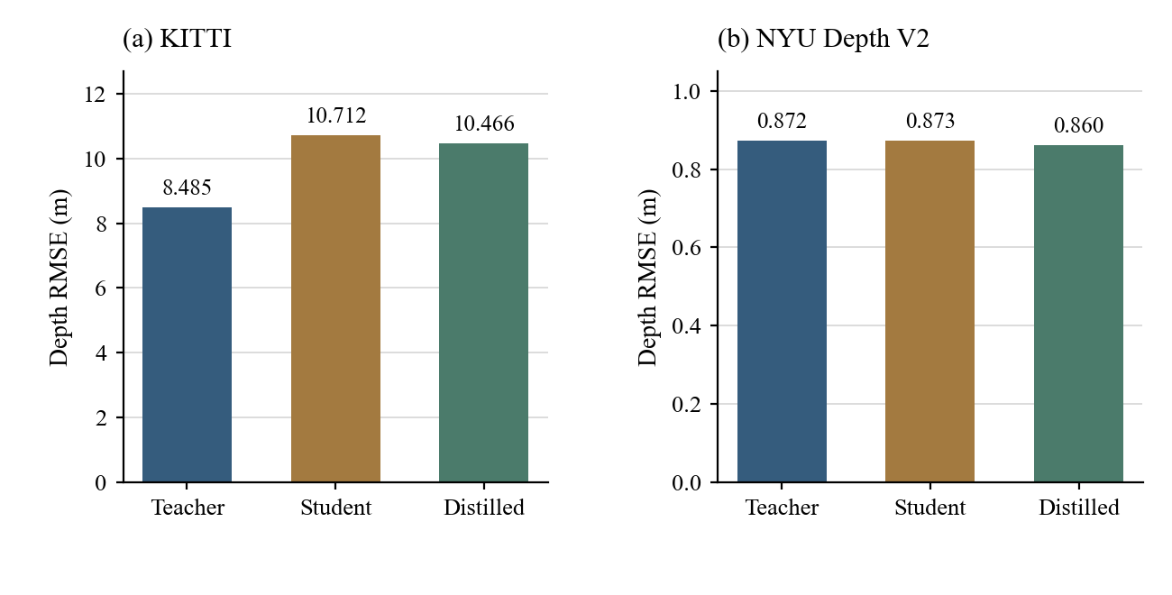
Figure 5.2 Depth RMSE under frozen calibration on both datasets

5.4 KITTI Object Distance Estimation
Table 5.5 KITTI matched object distance metrics
Metric | Teacher | Student | Distilled
Objects with valid target depth | 1,341 | 1,313 | 1,564
Mean absolute error in metres | 6.2502 | 8.0799 | 8.8059
RMSE in metres | 7.8890 | 10.6276 | 11.6910
Median absolute error in metres | 5.4861 | 6.1765 | 7.1783
Mean relative error | 0.3339 | 0.3818 | 0.4216
Median relative error | 0.2640 | 0.3311 | 0.3443
Matched objects within 0.5 m | 4.70% | 3.81% | 4.22%
Matched objects within 1.0 m | 9.17% | 7.39% | 8.31%
All-target success within 0.5 m | 3.93% | 3.12% | 4.12%
All-target success within 1.0 m | 7.67% | 6.05% | 8.11%

The teacher object MAE is 6.2502 m, the student MAE is 8.0799 m and the distilled MAE is 8.8059 m. The distilled error is approximately 8.99% higher than the baseline student. Object RMSE likewise rises from 10.6276 m to 11.6910 m. The three systems match different sets of objects; conditional errors therefore include changes in detection coverage as well as depth quality. A common-object analysis would be required to separate those effects.
The distilled system improves all-target success within 1.0 m from 6.05% to 8.11%, partly because fewer objects are missed. Among matched objects, however, the 1.0-m success fraction is 8.31%, compared with 7.39% for the student and 9.17% for the teacher. This illustrates why both conditional distance quality and complete detection-and-distance success must be reported. The existing results do not establish accurate ranging for an assistive deployment.
Table 5.6 KITTI object distance error by target range
Target range | Teacher MAE m | Student MAE m | Distilled MAE m
2 to 5 m | 1.4543 | 7.3418 | 8.8178
5 to 10 m | 4.7703 | 6.6670 | 8.1175
10 m and above | 6.4823 | 8.2940 | 8.8979

Only three matched objects fall in the 2-to-5-m band for each system, and none in the below-2-m band. The near-field evidence is insufficient for validating the live proximity threshold.

5.5 NYU Archived Detection Diagnostics
The following table preserves the archived detection outputs for traceability only. Incorrect semantic assignments and merged instance masks invalidate their interpretation as model accuracy. In particular, zero matched detections for the distilled system cannot distinguish domain-transfer failure from annotation conversion failure. Its object-distance MAE, RMSE and tolerance fractions are unavailable, not zero.
Table 5.7 Invalidated NYU detection outputs for audit only
Metric | Teacher | Student | Distilled
Archived precision | 0.0569 | 0.0552 | 0.0000
Archived recall | 0.4606 | 0.3939 | 0.0000
Archived F1 | 0.1013 | 0.0969 | 0.0000
Archived mAP50 | 0.0237 | 0.0195 | 0.0000
Archived mAP50-95 | 0.0147 | 0.0108 | 0.0000
Archived matched objects | 152 | 130 | 0
Archived missed objects | 178 | 200 | 330
Archived false detections | 2,518 | 2,224 | 55

No indoor detection improvement, degradation or teacher-accuracy recovery is claimed from Table 5.7. Correct semantic mapping and per-category instance extraction are required before a valid comparison.

5.6 Integrated Runtime and Resource Use
Table 5.8 KITTI integrated timing and resources
Metric | Teacher | Student | Distilled
Mean latency in ms | 454.36 | 55.97 | 48.84
Median latency in ms | 451.90 | 51.80 | 45.14
P95 latency in ms | 464.96 | 72.51 | 66.18
Latency standard deviation in ms | 20.86 | 16.60 | 14.72
FPS from mean latency | 2.20 | 17.87 | 20.48
Peak GPU allocated MiB | 2893.19 | 203.52 | 203.48
GPU utilisation percent | 78.73 | 28.31 | 28.35
Process CPU utilisation percent | 99.06 | 94.82 | 97.09
Peak process RAM MiB | 3387.65 | 1463.24 | 1500.06
Parameters | 369,396,457 | 30,764,305 | 30,764,305
Saved checkpoint MiB | 1361.62 | 100.21 | 226.89

Table 5.9 NYU integrated timing and resources
Metric | Teacher | Student | Distilled
Mean latency in ms | 160.28 | 69.10 | 67.79
Median latency in ms | 159.29 | 68.49 | 67.63
P95 latency in ms | 166.10 | 77.77 | 74.66
Latency standard deviation in ms | 17.77 | 15.30 | 12.42
FPS from mean latency | 6.24 | 14.47 | 14.75
Peak GPU allocated MiB | 2524.18 | 220.29 | 220.29
GPU utilisation percent | 54.82 | 31.20 | 31.23
Process CPU utilisation percent | 99.57 | 98.30 | 97.37
Peak process RAM MiB | 1457.50 | 1477.73 | 1511.93
Parameters | 369,396,457 | 30,764,305 | 30,764,305
Saved checkpoint MiB | 1361.62 | 100.21 | 226.89

For KITTI, mean integrated latency falls from 454.36 ms for the teacher to 55.97 ms for the student and 48.84 ms for the distilled pair. Consistent throughput is 2.20, 17.87 and 20.48 FPS, respectively. On NYU, the corresponding mean latencies are 160.28, 69.10 and 67.79 ms, giving 6.24, 14.47 and 14.75 FPS. These are instrumented research timings and not camera-to-speech response times.
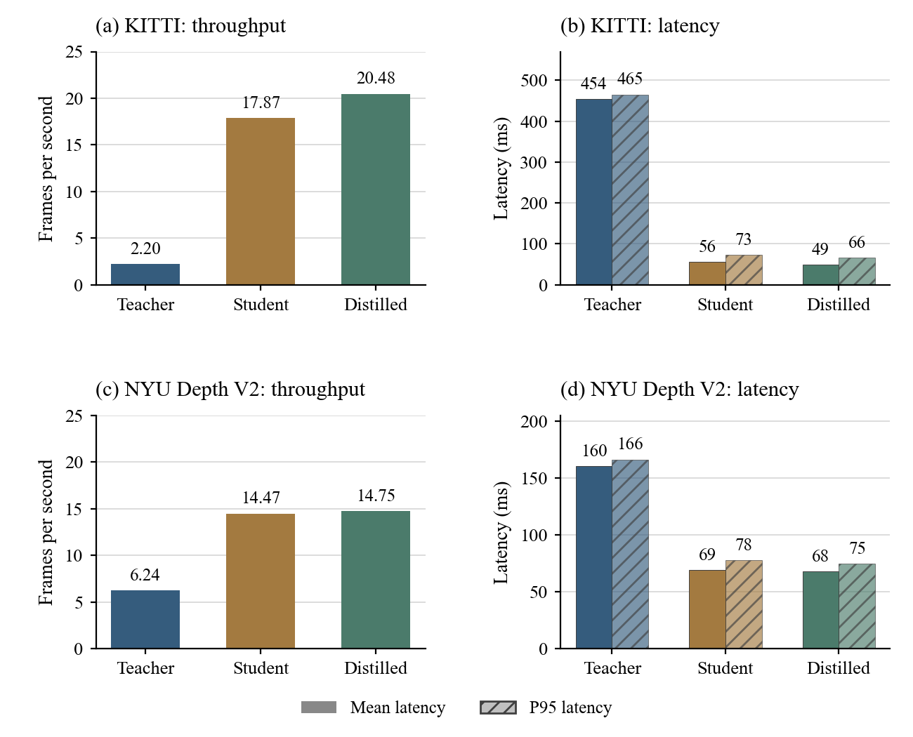
Figure 5.3 Like for like integrated throughput and latency
Table 5.10 KITTI mean timed pipeline components in ms
Metric | Teacher | Student | Distilled
YOLO preprocessing | 0.99 | 2.01 | 1.75
YOLO inference | 14.08 | 16.79 | 15.84
YOLO postprocessing | 1.30 | 1.89 | 1.48
MiDaS preprocessing | 23.67 | 5.43 | 4.34
MiDaS inference | 406.69 | 20.94 | 18.34
Object matching and depth metrics | 5.66 | 6.63 | 5.41

Table 5.11 NYU mean timed pipeline components in ms
Metric | Teacher | Student | Distilled
YOLO preprocessing | 0.98 | 1.91 | 1.89
YOLO inference | 13.22 | 20.40 | 20.82
YOLO postprocessing | 1.18 | 1.44 | 0.71
MiDaS preprocessing | 10.16 | 5.19 | 5.13
MiDaS inference | 114.45 | 19.34 | 19.55
Object matching and depth metrics | 18.74 | 19.32 | 18.76

The large teacher depth model accounts for most of the KITTI processing time. The lightweight depth model reduces that contribution substantially. The sum of component means may differ slightly from the total because timers include different overhead boundaries. The fixed order of runs, laptop power and temperature state, and absence of explicit warmup in the integrated evaluator also limit the strength of precise speedup claims.
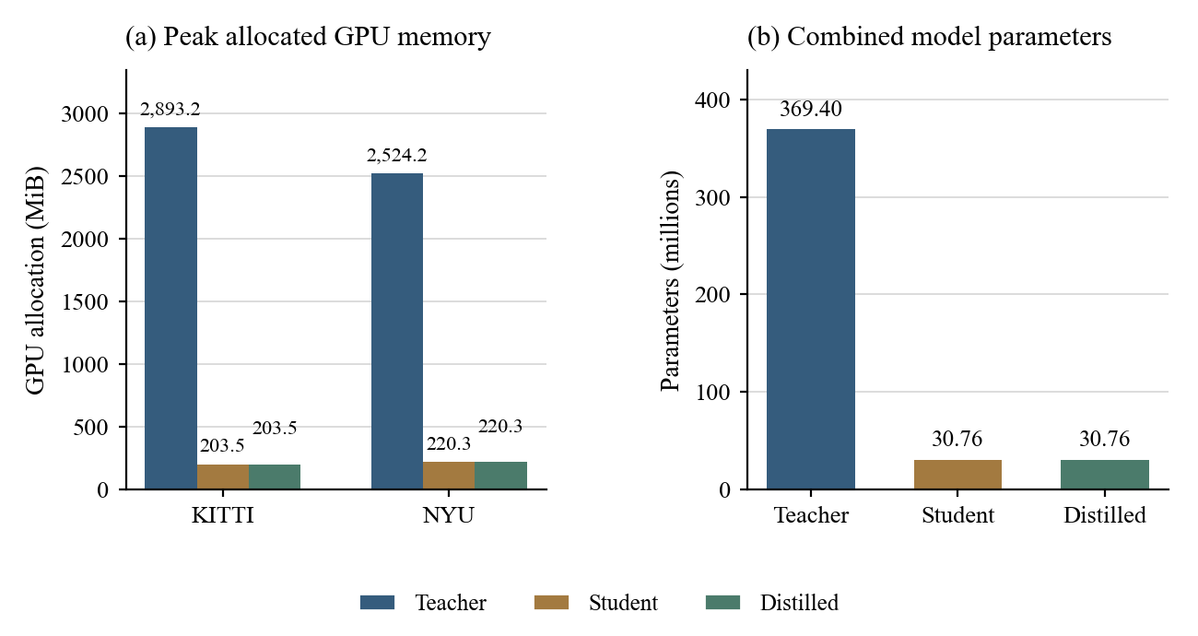
Figure 5.4 Peak PyTorch GPU allocation and model parameter count
Parameter count decreases by 91.67% from 369.396 million to 30.764 million. Distillation retains the compact architecture. The saved distilled checkpoint is larger than the baseline checkpoint because the depth export contains training/optimizer state. Its 226.89-MiB checkpoint size is therefore not a clean measure of inference-only storage. Peak allocated GPU memory should likewise not be interpreted as total physical GPU memory usage.

5.7 Performance Recovery and Efficiency Trade Off
Table 5.12 Efficiency changes relative to the teacher
Dataset | Student speedup | Distilled speedup | Distilled latency reduction | Distilled GPU allocation reduction
KITTI | 8.12x | 9.30x | 89.25% | 92.97%
NYU | 2.32x | 2.36x | 57.70% | 91.27%

For a higher-is-better quality measure, recovery is the distilled-minus-student improvement divided by the teacher-minus-student gap. For a lower-is-better error measure, recovery is the student-minus-distilled error reduction divided by the student-minus-teacher error gap. A positive recovery means movement towards the teacher; a negative recovery means deterioration. If the baseline is already better than the teacher or the gap is near zero, this percentage should not be used as an ordinary recovery claim.
Table 5.13 KITTI quality changes and valid teacher gap recovery
Metric | Student to distilled change | Teacher gap recovery
mAP50 | +0.4507 | Beyond teacher; KD effect not isolated
Depth RMSE | -0.2459 m | 11.04%
Depth AbsRel | -0.0264 | 16.27%
Depth Delta 1 | +0.0276 | 28.01%
Object MAE | +0.7260 m | -39.68%
Object RMSE | +1.0635 m | -38.83%

5.8 Qualitative Same Frame Comparison
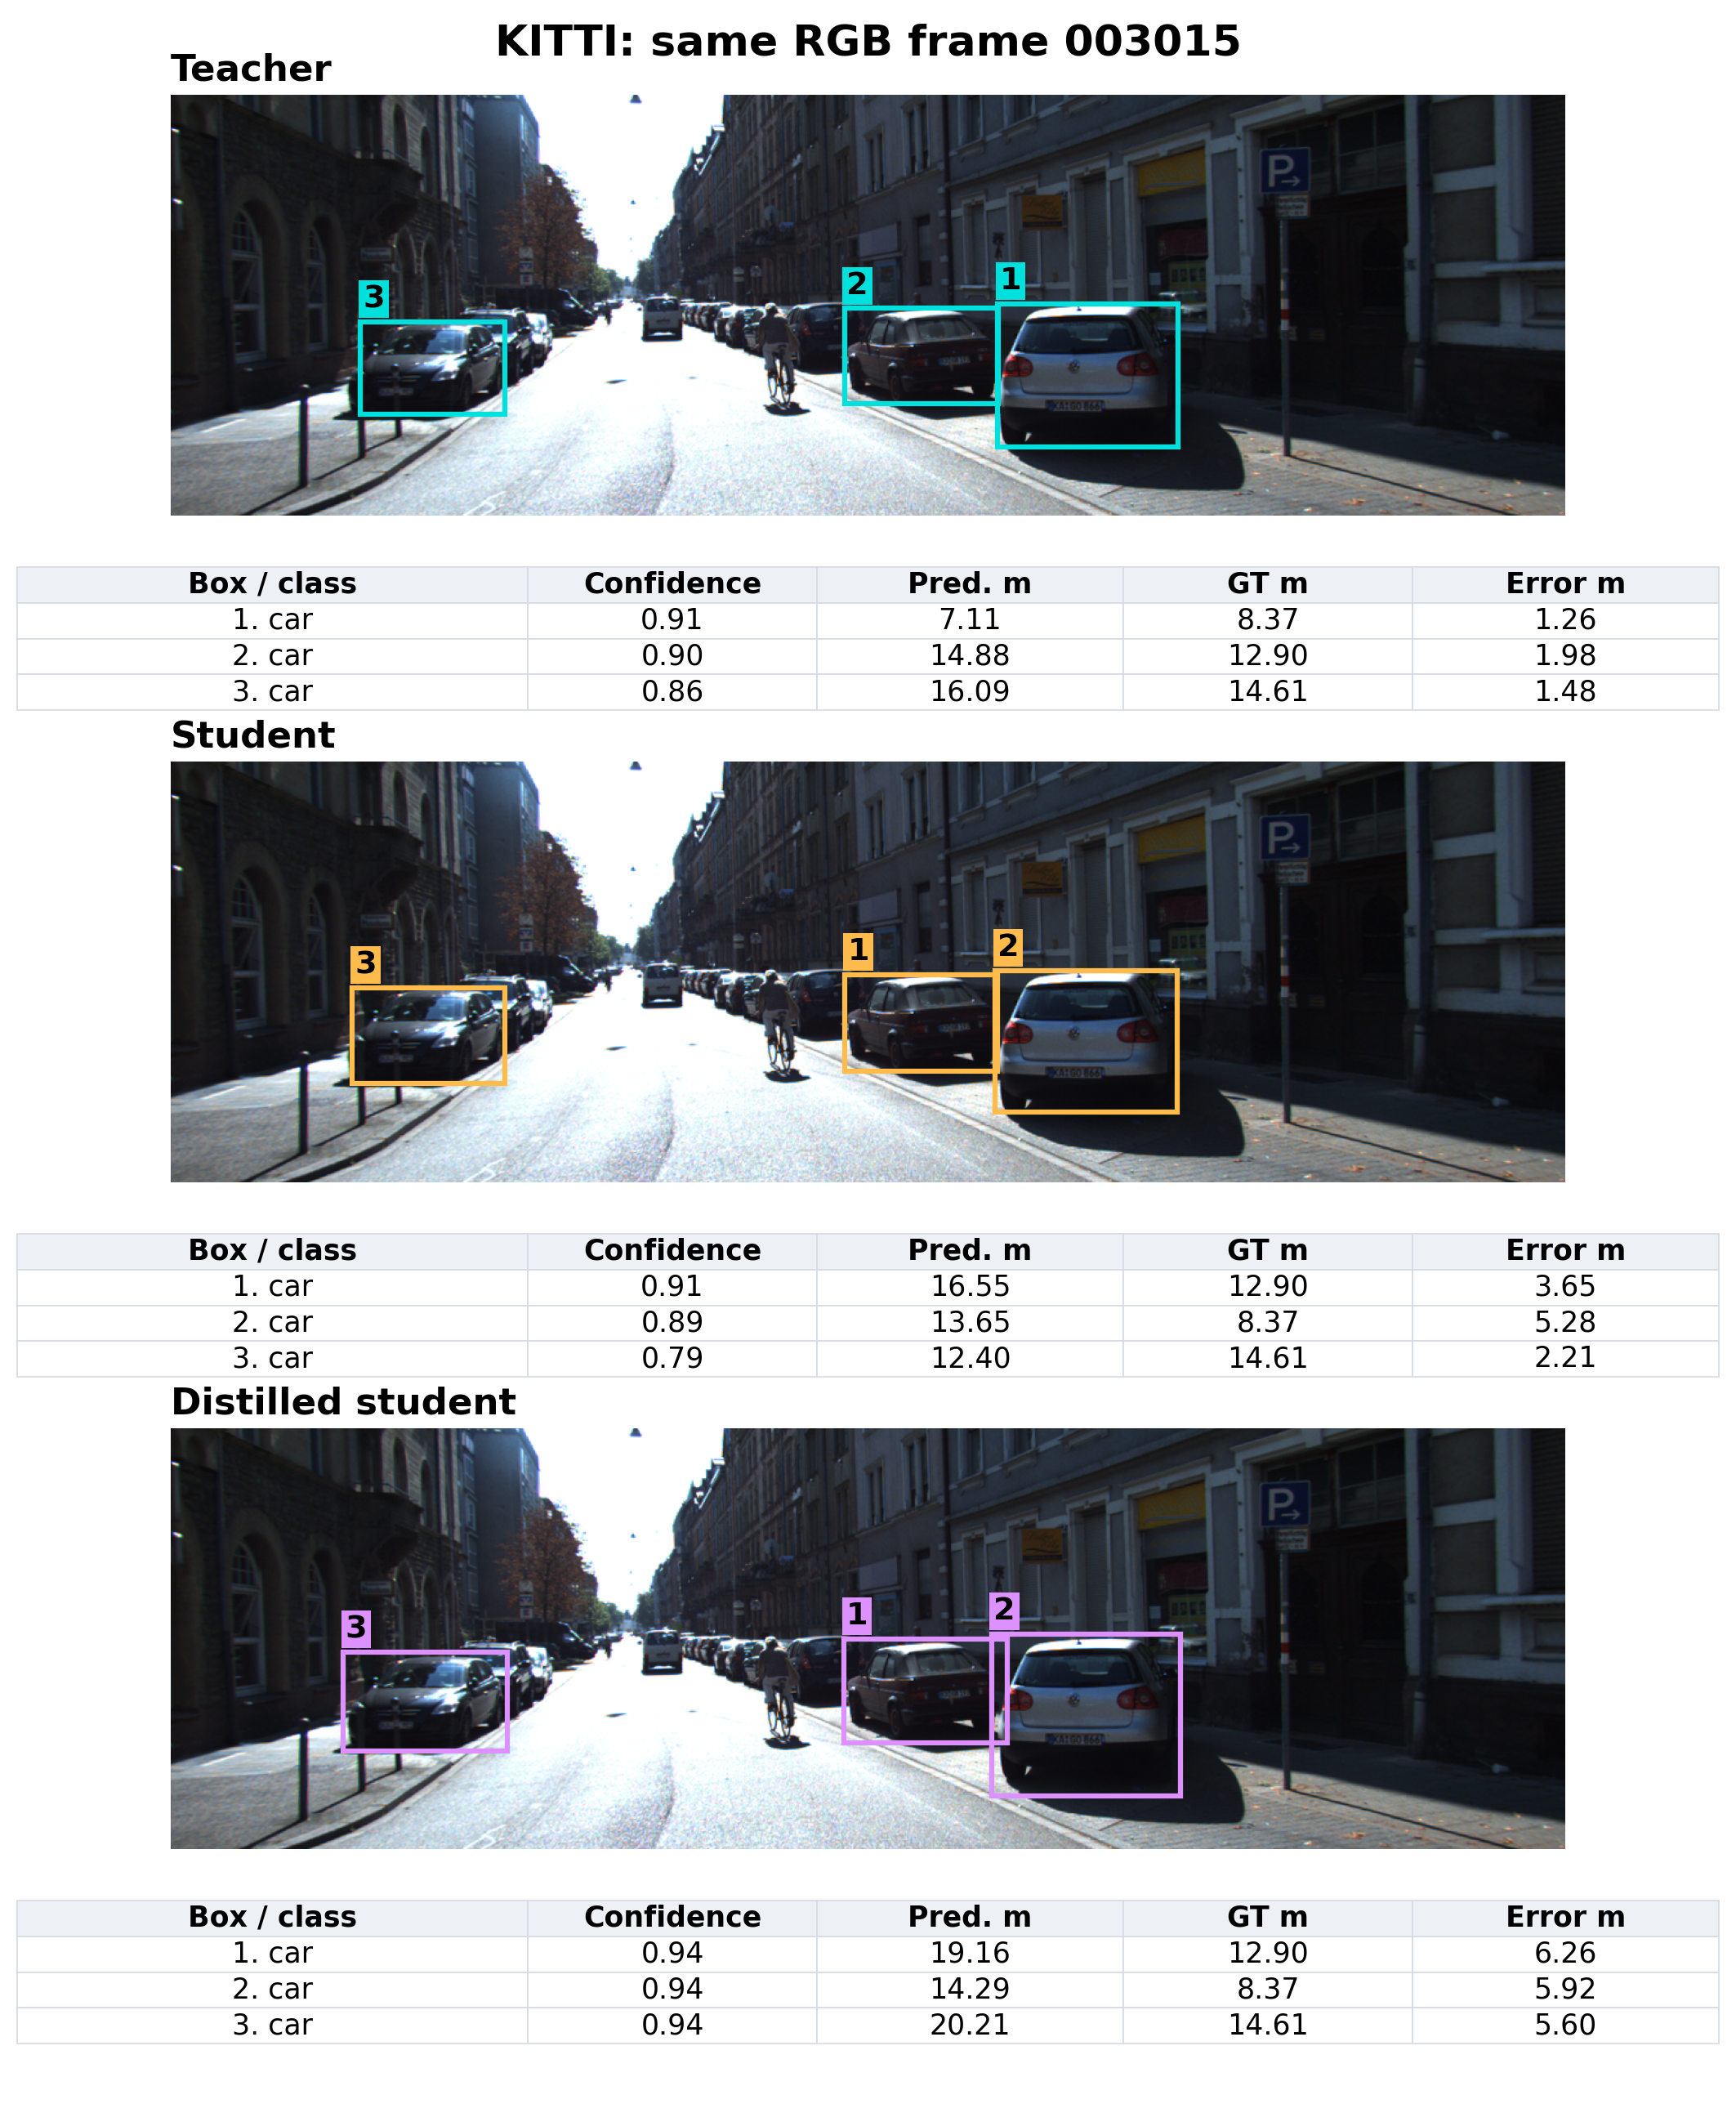
Figure 5.5 Stored KITTI predictions for the same RGB frame
Frame 003015 is selected deterministically from the evaluation manifest. Each panel shows the three highest-confidence saved predictions, with depth and errors from repeat-01 records and frozen calibration. Aggregate tables provide the quantitative comparison; no new inference was performed.

5.9 Limitations and Research Interpretation
The main findings are dataset- and task-dependent. The compact pair preserves computational advantages, and the trained detector adapts strongly to the project KITTI subset. Depth distillation reduces some depth-map errors but does not recover KITTI object-distance accuracy. Indoor object performance is unresolved because of annotation conversion errors. These observations support continuing development rather than declaring the integrated assistive capability fully preserved.
Several limits constrain attribution and generalisation: project-specific frame partitions, no matched supervised-only detector control, custom AP after confidence filtering, no standard depth crop/range caps, approximate affine distance conversion, and runtime that includes evaluation overhead. The near-distance KITTI sample is small, and the raw NYU object protocol requires repair. Repeated inference on the same images also does not constitute independent retraining or a statistical confidence interval for model generalisation.
10. IMPLEMENTATION / WORKING PROCEDURE

4.1 Dataset Preparation and Held Out Partitions
KITTI provides outdoor images with object labels, calibration files and Velodyne point clouds [6]. The project uses labelled object-training assets to construct development partitions. NYU Depth V2 provides indoor RGB images, raw and filled depth, semantic names and instance annotations [7]. The rawDepths variable is used for depth evaluation, excluding invalid measurements rather than treating missing values as real distances.
Table 4.1 Project defined training calibration and evaluation partitions
Dataset | Training | Validation | Calibration | Evaluation
KITTI | 6,193 | 688 | 100 | 500
NYU Depth V2 | 764 | 85 | 100 | 500

The partitions use deterministic selection with seed 42. The 600 calibration and evaluation frames per dataset are excluded from the student-training manifests. These are project-defined held-out partitions, not the official KITTI test set or an official NYU test split. Frame-level separation does not by itself establish separation of related sequences or indoor scenes. The three evaluation repetitions reuse the same 500 images and therefore do not increase the number of unique test samples.

4.2 Detector Distillation and Training
Figure 4.1 Frozen teacher and trainable student distillation workflow
The detector student starts from YOLO11-S pretrained weights and trains on KITTI labels. YOLO11-L supplies frozen responses for the same training batch. The objective combines native YOLO supervision for boxes, classes and distribution-focal regression with teacher-student response losses. Temperature-scaled KL divergence is applied to class responses and to the four 16-bin box distributions. The temperature is 2 and the response-loss weight is 1.
The detector completed 100 epochs with AdamW, an initial learning rate of 0.0001, weight decay of 0.0005, batch size 8 and a 640-pixel training image size. Mixed precision was enabled. The Ultralytics training record uses seed 0, while dataset selection uses seed 42. The best checkpoint was selected at epoch 86. Its internal validation mAP50-95 was 0.73724; this training-validation result is separate from the final integrated evaluation.

4.3 Depth Distillation and Checkpoint Selection
The depth student starts from MiDaS Small. Its loss combines an L1 difference from the teacher's relative depth output and a valid-ground-truth L1 term after per-image scale-and-shift alignment during training. Both terms have weight 1. Intermediate feature distillation is disabled, with feature weight 0. This training alignment is not a fit to the ground truth of deployment test frames.
Depth training completed 30 epochs. The exported best checkpoint is from epoch 8, with validation loss 2.40328. Training used AdamW, learning rate 0.0001, weight decay 0.0001 and mixed precision. The exported checkpoint records batch size 4; the final epoch checkpoint records batch size 2 with thermal safeguards, reflecting a resumed run. Thirty epochs were the configured training budget, not evidence that a larger budget could not improve convergence.
Table 4.2 Recorded distillation training settings
Setting | Detector | Depth
Completed epochs | 100 | 30
Selected checkpoint epoch | 86 | 8
Optimizer | AdamW | AdamW
Initial learning rate | 0.0001 | 0.0001
Weight decay | 0.0005 | 0.0001
Batch size | 8 | 4 at selected checkpoint; 2 at final epoch
Mixed precision | Enabled | Enabled
Teacher contribution | Class and box responses | Relative depth output
Additional supervision | KITTI detection labels | Valid NYU raw depth

4.4 Integrated Evaluation Procedure
Load the fixed evaluation manifest, frozen calibration and selected model pair. Retain available model paths, manifest hashes and recorded Python, PyTorch, CUDA and GPU environment metadata.
Read one RGB frame with its image ID and aligned ground truth. Send this exact frame to both models, retaining the model-specific preprocessing used throughout the experiment.
Filter detections at confidence 0.25. Apply the installed detector's non-maximum suppression and retain class, box and confidence. The research adapter does not explicitly record an NMS threshold; the live application's 0.45 threshold is a separate setting.
Resize the depth prediction to image coordinates. Apply the model/dataset calibration learned from the separate calibration subset, then evaluate only finite positive ground-truth depth pixels.
Match detections to ground-truth objects in descending confidence order, requiring equal mapped class and IoU at least 0.50. Each prediction and each ground-truth object can be matched only once.
Extract median calibrated depth inside the predicted bounding box. Compare it with the median valid ground-truth depth inside the target box or a valid instance mask. Record failures and unavailable depth explicitly.
Calculate frame-level depth errors, detection scores, matched-object distance errors and the instrumented timings. Save raw CSV/JSON records and repeat the procedure for each model system.

4.5 KITTI Validity and Detection Mapping
Table 4.3 KITTI object labels mapped to detector classes
KITTI annotation | Detector class | Rule
Car and Van | car | Accepted under common difficulty filter
Truck | truck | Accepted under common difficulty filter
Pedestrian and Person_sitting | person | Accepted under common difficulty filter
Cyclist | bicycle | Mapped as the bicycle category
Tram | train | Mapped as the train category
Other labels and DontCare | Ignored as targets | No DontCare suppression in custom AP

Accepted boxes have height at least 25 pixels, truncation no greater than 0.3 and occlusion no greater than 1. Sparse depth is produced by projecting positive camera-z Velodyne points using the frame's P2, rectification and extrinsic calibration. Where projected samples share a pixel, the nearest valid depth is retained. Empty pixels are excluded from depth errors.
KITTI object distance is median camera-axis depth inside the annotated box, not reconstructed Euclidean range. Precision and F1 count all retained COCO predictions, including classes outside the accepted KITTI mapping. Excluded difficult objects and DontCare regions receive no suppression. AP averages only classes present in ground truth, so these precision and AP conventions differ from official KITTI scoring. Region medians may include background, especially with sparse LiDAR, and are not independent object-centre or nearest-surface measurements.
The implemented depth mask covers the complete aligned image and requires finite ground-truth depth greater than zero. No Eigen crop or explicit 80-metre KITTI or 10-metre NYU cap is implemented. This same rule is used for all three systems, but the resulting scores should not be compared directly with published cropped or depth-capped benchmarks. Detection AP is a custom 101-point interpolation on confidence-filtered predictions, averaged over classes represented in ground truth; mAP50-95 averages thresholds from 0.50 to 0.95 in steps of 0.05.

4.6 Relative Depth and Frozen Distance Calibration
Two evaluation modes are distinguished. Relative-depth evaluation fits scale and shift to valid ground truth on each test frame to study depth-map shape. Deployment-distance evaluation fits one calibration per system and dataset on the 100 separate calibration frames, freezes it and applies it to all evaluation images. The saved complete results in this report are from the fixed-calibration mode. A complete six-system relative-mode result set is not available.
Table 4.4 Frozen affine calibration coefficients
Dataset | System | Scale | Shift
KITTI | Teacher | -0.87468499 | 33.89318848
KITTI | Student | -0.04131996 | 26.21384811
KITTI | Distilled | -2.04370070 | 45.63300323
NYU | Teacher | -0.12999575 | 4.49832439
NYU | Student | -0.00433248 | 4.15691996
NYU | Distilled | -0.15567836 | 4.83193827

The implementation applies a direct affine mapping from the relative output to metric depth and clamps nonpositive predictions to 0.000001 metres. Because MiDaS produces relative inverse-depth information, a direct affine mapping to metres is an empirical approximation. Clamping extreme extrapolations can create very large inverse-depth errors. The present calibration therefore does not establish dependable industrial ranging, and improved calibration is part of the future work.

4.7 NYU Annotation Audit and Validity
The saved NYU detection preparation contains two confirmed annotation defects. First, the archive has 894 raw semantic names, but the conversion applies a mapping resembling NYU40 class IDs directly to the raw labels. Second, instance numbers are reused across semantic categories, while the conversion groups pixels by instance number alone. This can merge unrelated objects into one bounding box. Correct extraction must use both semantic label and instance number, with an explicit mapping derived from the archive's names.
Table 4.5 Examples of incorrect archived NYU class assignments
Raw ID | Actual archive name | Assigned detector class
4 | ceiling | bed
6 | cone | couch
7 | counter | dining table
24 | sink | refrigerator
25 | air vent | tv
31 | telephone cord | person

Consequently, the archived NYU detection and object-distance outputs are diagnostic records, not validated indoor object-performance measurements. The results section labels them accordingly. Whole-image depth errors use rawDepths and a depth-validity mask independently of semantic/instance conversion, so they remain interpretable under the recorded depth protocol. Cross-environment detection recovery cannot be concluded until the annotations are corrected and the object evaluation is repeated.

4.8 Metric Definitions and Timing Boundaries
Table 4.6 Accuracy and distance metric definitions
Metric | Definition and interpretation
Precision, recall and F1 | Correct detections relative to predictions, targets, and their harmonic mean.
IoU and mAP | Box overlap; average precision at the stated overlap thresholds.
Depth RMSE | Square root of mean squared metric-depth error, in metres.
AbsRel and SqRel | Absolute or squared depth error divided by target depth.
Delta 1, 2 and 3 | Fraction of valid pixels with depth ratio below 1.25, 1.25 squared and 1.25 cubed.
Object MAE and RMSE | Absolute and squared distance errors over correctly matched objects with valid depth.
Median and relative object error | Median absolute error, and absolute error divided by target object depth.
Within 0.5 m or 1.0 m | Success fraction among matched objects with valid depth.
Integrated distance success | Successful detection-and-distance cases divided by all annotated target objects.

Depth metrics are calculated per frame, then averaged across frames and repetitions. Object errors use matched objects with valid target depth. Matched-object tolerance rates differ from all-target integrated success, which includes missed detections. Unavailable object-depth results are not recorded as zero.
Timing uses batch size 1 and three repetitions, after image and ground-truth loading. It includes preprocessing, both models, calibration, matching and metric computation, but excludes file loading, camera capture, display and speech. Integrated runs have no explicit warmup. Separate distilled runtime-only results (20 warmup frames; 600 prepared frames) are not mixed into this comparison.
GPU memory denotes peak PyTorch allocation, not total device usage; RAM denotes peak process resident memory. CPU utilisation can exceed 100% across cores; GPU utilisation comes from sampled resource records. Reported memory is the mean of three repeat peaks. Median, P95 and latency standard deviation likewise average per-repeat summaries, not pooled frame statistics. Aggregation is identical across systems.

11. KEY PROJECT FEATURES
- AI-based real-time object detection
- Object-specific distance estimation using monocular depth
- Multimodal perception using computer vision and ESP32 ultrasonic sensing
- Audio-based environmental feedback
- GPU-accelerated deep-learning inference
- Compact-model optimization through knowledge distillation research
If your form strictly wants four features, use the first four.

12. INNOVATION AND TECHNICAL ADVANTAGES
The primary technical innovation of GOD'S EYE is the integration of semantic object detection and spatial depth estimation into a single assistive perception pipeline.
Conventional obstacle-detection systems may provide information about the presence or distance of an obstacle without identifying its semantic class. Conversely, object-detection systems can identify objects without providing sufficiently useful distance information.
GOD'S EYE combines these capabilities so that the system can associate an object with its estimated distance.
Another technical advantage is the use of multiple sensing modalities. The camera provides rich visual and semantic information, while the ESP32 and ultrasonic sensors provide additional ground-level obstacle information.
The project also investigates computational optimization through knowledge distillation. The preliminary Teacher-Student evaluation demonstrates that the smaller Student architecture can substantially reduce computational requirements.
For example, on KITTI:
- FPS increased from 2.20 to 17.87
- GPU memory decreased from 2893 MB to 204 MB
- Parameters decreased from approximately 369.4M to 30.8M
However, the Student also showed lower KITTI mAP and worse depth/object-distance metrics. Therefore, knowledge distillation is being investigated to determine whether some of this performance loss can be recovered while retaining the efficiency advantage.
Important: Do not write that distillation has improved the system yet. It is your next experimental stage.

13. PRACTICAL / INDUSTRIAL APPLICATION
- Assistive technology for visually impaired users
- Wearable navigation assistance
- Indoor environmental awareness
- Smart mobility systems
- Obstacle-awareness systems
- Human-computer interaction
- Computer-vision-based accessibility systems
- Potential integration with smart glasses or wearable computing platforms

14. REFERENCES
- Ranftl, R., Bochkovskiy, A., and Koltun, V. "Vision Transformers for Dense Prediction." ICCV, 2021.
- Ranftl, R., Lasinger, K., Hafner, D., Schindler, K., and Koltun, V. "Towards Robust Monocular Depth Estimation: Mixing Datasets for Zero-shot Cross-dataset Transfer." IEEE TPAMI, 2022.
- Ultralytics. YOLO Documentation and YOLO11 Technical Documentation.
- NVIDIA. TensorRT Developer Documentation.
- OpenCV. Open Source Computer Vision Library Documentation.
- Silberman, N., Hoiem, D., Kohli, P., and Fergus, R. "Indoor Segmentation and Support Inference from RGBD Images." ECCV, 2012.
Used for the NYU Depth V2 dataset.
- Geiger, A., Lenz, P., and Urtasun, R. "Are We Ready for Autonomous Driving? The KITTI Vision Benchmark Suite." CVPR, 2012.
- Hinton, G., Vinyals, O., and Dean, J. "Distilling the Knowledge in a Neural Network." 2015.
- Espressif Systems. ESP32 Series Documentation.
- NYU Depth V2 official dataset documentation.
- KITTI Vision Benchmark Suite official dataset documentation.

