Course Project Report on
“Knowledge Distillation for Efficient Object Detection and Depth Estimation in GOD'S EYE”
SUBMITTED IN PARTIAL FULFILLMENT OF THE REQUIREMENTS FOR THE DEGREE OF

BACHELOR OF TECHNOLOGY IN

“Computer Science & Engineering (Artificial Intelligence)”
OF
VISHWAKARMA INSTITUTE OF TECHNOLOGY

Savitribai Phule Pune University

11) Shreyas P. Patil (12413071)
14) Yugandhar G. Paulbudhe (12414973)
- Prithviraj V. Tandel (12414725)
- Pruthvi J. Chaudhari (12414159)

UNDER THE GUIDANCE OF
“Dr. Anuradha Yenkikar”

DEPARTMENT OF Computer Science & Engineering (Artificial Intelligence)
BANSILAL RAMNATH AGARWAL CHARITABLE TRUST’S
VISHWAKARMA INSTITUTE OF TECHNOLOGY
(An Autonomous Institute affiliated to Savitribai Phule Pune University) Academic Year: 2026 - 2027

BANSILAL RAMNATH AGARWAL CHARITABLE TRUST’S

VISHWAKARMA INSTITUTE OF TECHNOLOGY
(An Autonomous Institute affiliated to Savitribai Phule Pune University)

PUNE – 411037

CERTIFICATE

This is to certify that the Course Project titled “Knowledge Distillation for Efficient Object Detection and Depth Estimation in GOD'S EYE”, submitted by Shreyas P. Patil (12413071), Yugandhar G. Paulbudhe (12414973), Prithviraj V. Tandel (12414725), Pruthvi J. Chaudhari (12414159) is in partial fulfillment of the requirements for the award of the Degree of Bachelor of Technology in Computer Science and Engineering (Artificial Intelligence) for the course Deep Learning, at Vishwakarma Institute of Technology, affiliated to Savitribai Phule Pune University. This project report is a record of the Bonafide work carried out by the above-mentioned students under my guidance during the academic year 2026–27.

Guide
Dr. Anuradha Yenkikar
HOD
Dr. Nilesh P. Sable

Place: VIT, Pune

Date: 3/10/2026

Bansilal Ramnath Agarwal Charitable Trust’s

Vishwakarma Institute of Technology, Pune-37
Department of “Computer Science Engineering (AI)”

PROJECT SYNOPSIS

Group No: 1
Members: 4

Sr. No. | Class & Div. | Roll No. | G.R.No. | Name of Student | Contact No. | Email ID
1 | CSAI-E | 11 | 12413071 | Shreyas P. Patil | 9422996733 | shreyas.patil24@vit.edu
2 | CSAI-E | 14 | 12414973 | Yugandhar G. Paulbudhe | 9112650632 | yugandhar.paulbudhe24@vit.edu
3 | CSAI-E | 23 | 12414725 | Prithviraj V. Tandel | 9766842608 | prithviraj.tandel24@vit.edu
4 | CSAI-E | 24 | 12414159 | Pruthvi J. Chaudhari | 8766593055 | pruthvi.chaudhari24@vit.edu

Academic Year : 2026-2027
Project Title : Knowledge Distillation for Efficient Object Detection and Depth Estimation in GOD'S EYE
Project Area : Research
Internal Guide : Dr. Anuradha Yenkikar

Signature of Internal Guide

ACKNOWLEDGEMENT

We would like to express our sincere gratitude to Dr. Anuradha Yenkikar for her guidance and encouragement throughout our research project, “Knowledge Distillation for Efficient Object Detection and Depth Estimation in GOD'S EYE.” Her feedback helped us refine our research methodology, address technical challenges, and examine the balance between model accuracy and computational efficiency. This project provided us with practical experience in deep learning, computer vision, knowledge distillation, and integrated evaluation. Combining object detection and depth estimation strengthened our understanding of how a vision system can identify objects and estimate their distance from the same image. Evaluating teacher, student, and distilled systems also developed our skills in systematic experimentation, reproducibility, and critical analysis. Working collaboratively helped us improve model training, software integration, performance benchmarking, and technical documentation. We thank everyone who supported us directly or indirectly throughout this work. Their assistance contributed to the completion of the project and established a foundation for further research in efficient artificial intelligence and assistive vision technologies.

ABSTRACT

The research project titled “Knowledge Distillation for Efficient Object Detection and Depth Estimation in GOD’S EYE” investigates the development of a computationally efficient vision system that identifies objects and estimates their distance from the same RGB frame. The study uses YOLO11-L and MiDaS DPT-Large as teacher models and YOLO11-S and DPT-Small as lightweight student models. Knowledge distillation transfers information from the teacher models to the students, aiming to preserve detection accuracy and depth-estimation quality while reducing computational requirements. The teacher, baseline student, and distilled student systems are evaluated using a consistent integrated pipeline on KITTI and NYU Depth V2, representing outdoor and indoor environments. Evaluation includes detection precision, recall, F1 score and mean average precision; depth-estimation errors; object-level distance errors; and computational measures such as inference latency, frame rate and memory usage. Since MiDaS produces relative depth, the evaluation distinguishes ground-truth-aligned depth quality from distance estimation using fixed calibration. GOD’S EYE combines visual predictions with spoken object names, estimated distances and spatial directions to support assistive awareness. The research examines whether knowledge distillation can retain these capabilities within a smaller model system suitable for deployment on resource-constrained hardware. It provides a framework for assessing the trade-off between accuracy and efficiency in integrated object detection and depth estimation, with potential applications in assistive technology and industrial worker support.

TABLE OF CONTENTS
Project Synopsis i
Acknowledgement i
Abstract i
List of Figures i
List of Tables i
1 Introduction 1
1.1 Overview of the Project 1
1.2 Problem Statement 1
1.3 Objectives 1
1.4 Scope of the Project 1
2 Literature Survey 1
2.1 Existing Approaches and Their Limitations 1
2.2 Dense Prediction and Lightweight Depth Models 1
2.3 Knowledge Distillation 1
2.4 Comparative Study and Research Gap 1
3 System Analysis and Design 1
3.1 Model Systems 1
3.2 Hardware and Software Requirements 1
3.3 Integrated Architecture 1
3.4 Functional Modules and Use Cases 1
3.5 Nine Section Guidance and Speech Priority 1
3.6 Experimental Data and Reproducibility 1
4 Implementation and Testing 1
4.1 Dataset Preparation and Held Out Partitions 1
4.2 Detector Distillation and Training 1
4.3 Depth Distillation and Checkpoint Selection 1
4.4 Integrated Evaluation Procedure 1
4.5 KITTI Validity and Detection Mapping 1
4.6 Relative Depth and Frozen Distance Calibration 1
4.7 NYU Annotation Audit and Validity 1
4.8 Metric Definitions and Timing Boundaries 1
5 Results and Discussion 1
5.1 Evaluation Coverage and Main Findings 1
5.2 KITTI Detection Performance 1
5.3 Depth Map Quality Under Fixed Calibration 1
5.4 KITTI Object Distance Estimation 1
5.5 NYU Archived Detection Diagnostics 1
5.6 Integrated Runtime and Resource Use 1
5.7 Performance Recovery and Efficiency Trade Off 1
5.8 Qualitative Same Frame Comparison 1
5.9 Limitations and Research Interpretation 1
6 Conclusion and Future Scope 1
6.1 Conclusion 1
6.2 Future Scope 1
References 1

LIST OF FIGURES
Figure 3.1 overall architecture of the GOD’S EYE assistive system 1
Figure 3.2 Same-frame object detection and depth association 1
Figure 4.1 Frozen teacher and trainable student distillation workflow 1
Figure 5.1 KITTI detection gains and object distance error 1
Figure 5.2 Depth RMSE under frozen calibration on both datasets 1
Figure 5.3 Like for like integrated throughput and latency 1
Figure 5.4 Peak PyTorch GPU allocation and model parameter count 1
Figure 5.5 Stored KITTI predictions for the same RGB frame 1

LIST OF TABLES
Table 2.1 Comparison of perception approaches 1
Table 3.1 Teacher baseline student and distilled student 1
Table 3.2 Recorded research and deployment environments 1
Table 4.1 Project defined training calibration and evaluation partitions 1
Table 4.2 Recorded distillation training settings 1
Table 4.3 KITTI object labels mapped to detector classes 1
Table 4.4 Frozen affine calibration coefficients 1
Table 4.5 Examples of incorrect archived NYU class assignments 1
Table 4.6 Accuracy and distance metric definitions 1
Table 5.1 Integrated comparison from consistent deployment runs 1
Table 5.2 KITTI detection metrics 1
Table 5.3 KITTI fixed calibration depth metrics 1
Table 5.4 NYU fixed calibration depth metrics 1
Table 5.5 KITTI matched object distance metrics 1
Table 5.6 KITTI object distance error by target range 1
Table 5.7 Invalidated NYU detection outputs for audit only 1
Table 5.8 KITTI integrated timing and resources 1
Table 5.9 NYU integrated timing and resources 1
Table 5.10 KITTI mean timed pipeline components in ms 1
Table 5.11 NYU mean timed pipeline components in ms 1
Table 5.12 Efficiency changes relative to the teacher 1
Table 5.13 KITTI quality changes and valid teacher gap recovery 1

Introduction

Overview of the Project
Knowledge Distillation for Efficient Object Detection and Depth Estimation in GOD’S EYE investigates how lightweight deep-learning models can perform integrated visual perception with reduced computational requirements. GOD’S EYE combines object detection and depth estimation to identify objects, determine their spatial location, and estimate their distance from the same RGB frame. It communicates this information through spoken object names, estimated distances, and directions within a nine-section grid, with priority given to nearby objects.
The research uses YOLO11-L and MiDaS DPT-Large as teacher models and YOLO11-S and DPT-Small as student models. Knowledge distillation is applied to transfer information from the larger teacher models to their smaller counterparts. The teacher, baseline student, and distilled student systems are compared using a consistent evaluation pipeline on KITTI and NYU Depth V2. The study examines whether distillation can preserve useful detection and distance-estimation capabilities while improving inference speed and reducing resource consumption.

Problem Statement
Combining object detection and depth estimation creates a substantial computational workload because both models must process each image. Larger models can provide strong visual predictions, but their processing time, memory requirements, and hardware demands can limit deployment on resource-constrained devices. Smaller models reduce these requirements, although this reduction may affect detection accuracy and depth-estimation quality. For GOD’S EYE, evaluating the two tasks independently is insufficient. The system must correctly detect an object and estimate its distance from the same frame. Missed detections, inaccurate bounding boxes, or unreliable depth predictions can reduce the usefulness of spoken guidance. Furthermore, MiDaS produces relative depth rather than inherently metric distance, making calibration and a clearly defined evaluation protocol necessary. The research therefore investigates whether knowledge distillation can improve lightweight models sufficiently to preserve the integrated capabilities of the larger system. This requires a controlled comparison of detection performance, depth quality, object-level distance accuracy, and computational efficiency across indoor and outdoor environments.

Objective

The main objective is to develop and evaluate a lightweight, distilled GOD’S EYE system that balances object-detection accuracy, depth-estimation quality, and computational efficiency.
The specific objectives are:
- To establish an integrated pipeline in which object detection and depth estimation process the same RGB frame.
- To implement teacher and baseline student systems using YOLO11 and MiDaS models.
- To apply knowledge distillation to improve the lightweight detection and depth models.
- To evaluate detection using precision, recall, F1 score, intersection over union, and mean average precision.
- To evaluate depth-map quality and object-level distance errors against valid ground-truth measurements.
- To distinguish relative-depth evaluation from deployment-distance evaluation using fixed calibration.
- To compare inference latency, frame rate, memory usage, model size, and parameter count across all three systems.
- To assess how much teacher performance is recovered through distillation on KITTI and NYU Depth V2.
- To integrate visual predictions with spoken object names, estimated distances, and spatial directions.
- To maintain reproducible configurations, raw results, and documented evaluation procedures.

Scope of the Project
The project covers the development, training, integration, and evaluation of teacher, baseline student, and distilled student systems for object detection and monocular depth estimation. Its experimental scope includes outdoor scenes from KITTI and indoor scenes from NYU Depth V2. All three systems follow the same dataset splits, preprocessing rules, detection-matching criteria, depth-validity rules, and timing procedures to support a fair comparison. The evaluation considers both depth-map quality and distance estimation for correctly matched objects. It also measures the computational cost of the complete detection-and-depth pipeline. Relative-depth benchmarking uses ground-truth alignment, while deployment-distance benchmarking uses calibration learned separately from the test frames. The application component includes live camera input, object tracking, nine-section spatial guidance, and spoken announcements prioritised by proximity. The project explores assistive awareness and potential industrial worker-support applications. Its scope does not include certified safety control, autonomous navigation, or precision measurement; these would require additional sensing, validation, and application-specific development.

2 Literature Survey

2.1 Existing Approaches and Their Limitations
Assistive perception requires information about both object identity and spatial relationships. Contact-based mobility aids and ultrasonic range sensors provide useful obstacle feedback, while camera-based recognition supplies semantic descriptions. Their outputs address different aspects of environmental awareness. GOD'S EYE examines how object detection and monocular depth can be associated within one camera pipeline to provide an object name, direction and estimated distance.
Object detectors in the YOLO family predict bounding boxes and class scores in a single detection pipeline. Ultralytics provides multiple YOLO11 model sizes, allowing an accuracy and computational-cost comparison within one detector family [1]. A bounding box alone does not establish the object's metric distance from the camera. The proposed pipeline therefore combines the detector with a dense depth model rather than inferring range solely from apparent box size.
Monocular depth models infer scene geometry from visual features. MiDaS was developed using mixed training datasets to support transfer across environments [2]. Its relative output still requires a defined conversion before it is interpreted as distance in metres. Camera intrinsics, scene composition, domain shift and calibration errors can affect this conversion even when the relative ordering of near and far regions appears plausible.

2.2 Dense Prediction and Lightweight Depth Models
Dense Prediction Transformers use transformer features in a dense prediction architecture, with representations reassembled and refined into image-aligned outputs [3]. The teacher in this study uses MiDaS DPT-Large. Its spatial predictions are combined with the detected boxes from YOLO11-L on the same RGB frame.
The compact depth implementation loads MiDaS v2.1 Small with an EfficientNet-Lite3 backbone through torch.hub. The earlier synopsis and configuration use the label DPT-Small or DPT_Small for this component. That label is retained in historical filenames, but the implemented student is a lightweight convolutional MiDaS model, not a smaller DPT transformer. Throughout the completed methods and results, it is therefore described as MiDaS Small [4].

2.3 Knowledge Distillation
Knowledge distillation trains a compact student using information produced by a larger teacher. Hinton, Vinyals and Dean describe transferring predictive behaviour through softened output distributions [5]. For GOD'S EYE, the detector learns from class and box-distribution responses, while the depth student learns from the teacher's depth output together with valid ground-truth supervision. The teacher remains frozen during each training process.
A smaller model can reduce parameter count without reproducing every property of the teacher. Distillation must therefore be assessed through independent evaluation, particularly when errors propagate between tasks. Correct detection does not guarantee accurate object distance, and an accurate depth map cannot recover an object that was missed by the detector.

2.4 Comparative Study and Research Gap
Table 2.1 Comparison of perception approaches
Approach | Information supplied | Main limitation
Object detection | Object class and image location | No direct metric range
Monocular depth | Relative scene depth | Scale and shift need calibration
Integrated large models | Object identity with depth association | High computational workload
Lightweight baseline | Lower parameter and memory demand | Task-dependent accuracy loss
Distilled lightweight pair | Teacher-guided compact predictions | Requires evidence of recovery and generalisation

The research gap is the joint evaluation of detection, object-specific depth and computational cost. This study compares three systems using fixed project subsets and the same instrumented evaluation procedure. It also examines whether improved detector accuracy translates into improved object distance. Matched-data supervised-only controls are not available for either task, so observed changes combine additional ground-truth training and teacher guidance rather than isolating the causal benefit of knowledge distillation.

3 System Analysis and Design

3.1 Model Systems
Table 3.1 Teacher baseline student and distilled student
System | Detector | Depth model | Parameters
Teacher | YOLO11-L | MiDaS DPT-Large | 369.396 M
Student | YOLO11-S | MiDaS v2.1 Small | 30.764 M
Distilled | Trained YOLO11-S | Trained MiDaS Small | 30.764 M

The teacher and baseline student begin with pretrained checkpoints. The distilled detector additionally receives supervised KITTI fine-tuning and teacher-response losses. The distilled depth model is trained using NYU images, teacher outputs and valid raw depth. Distillation changes the student weights, not the student architecture; the baseline and distilled systems therefore have the same parameter count.

3.2 Hardware and Software Requirements
Table 3.2 Recorded research and deployment environments
Component | Recorded configuration
Operating system | Windows 11
Research GPU | NVIDIA GeForce RTX 4050 Laptop GPU, 6 GB
Research Python and PyTorch | Python 3.13.6; PyTorch 2.9.1+cu128
Research CUDA and numerical precision | CUDA 12.8; FP32 inference; batch size 1
Export and live-engine environment | PyTorch 2.7.1+cu128; TensorRT 10.11.0.33
Core libraries | Ultralytics, OpenCV, NumPy, psutil and MiDaS
Live input and output | RGB camera, OpenCV display and offline Windows speech

The research and engine-export environments are separate recorded environments. TensorRT timings are not substituted for the PyTorch integrated comparison. Package and GPU records are retained with each experiment.

3.3 Integrated Architecture

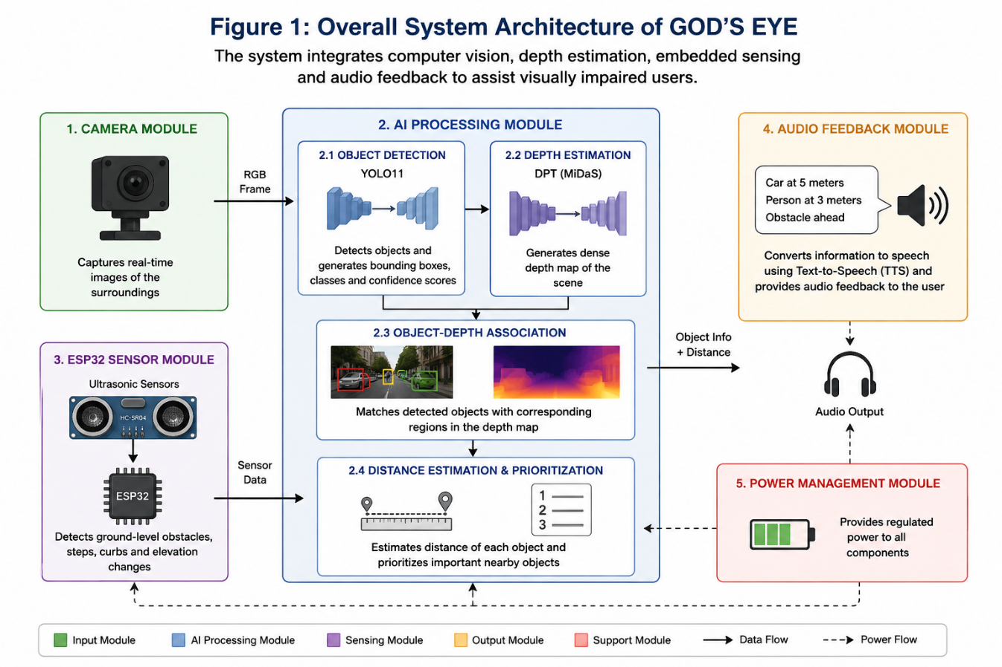

Figure 3.1 overall architecture of the GOD’S EYE assistive system
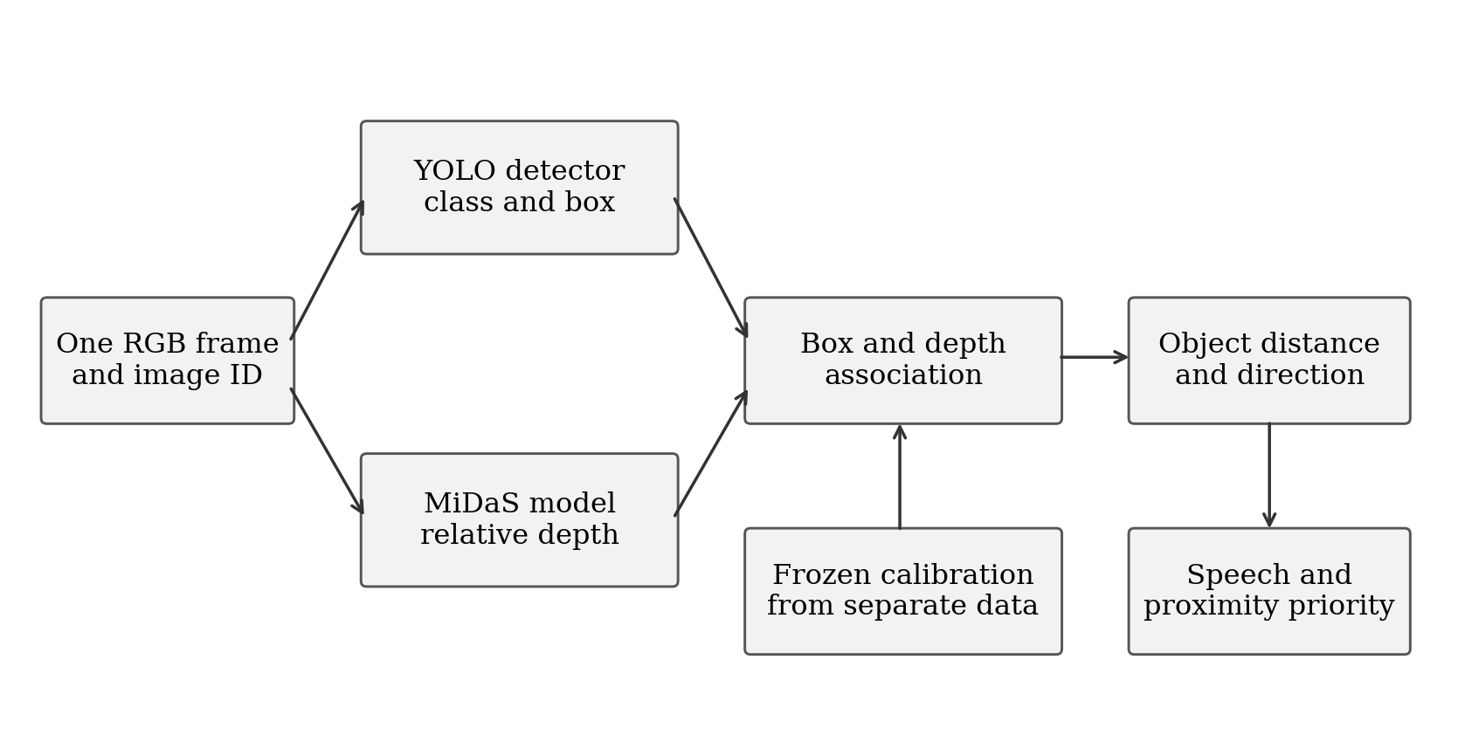
Figure 3.2 Same-frame object detection and depth association
Each evaluated image has a unique identifier. The detector and depth model receive that same image. DPT-Large uses dpt_transform with a nominal 384-pixel aspect-preserving minimal resize, dimensions aligned to multiples of 32, and mean and standard deviation 0.5. MiDaS Small uses small_transform with a nominal 256-pixel upper-bound resize and ImageNet normalisation. These nominal sizes do not guarantee square input tensors. Detection returns class IDs, scores and boxes. Depth is resized to image coordinates and transformed using frozen calibration before object association.
The live application adds tracking, spatial directions and speech. Its camera loop displays detections and a three-by-three grid. Speech operates in a separate worker so that an announcement does not block model inference. The research evaluator instead records predictions, object matches and timing for later analysis; its latency excludes camera capture, display and audio playback.

3.4 Functional Modules and Use Cases
The camera and preprocessing module acquires frames and converts them to the expected model input. The detection module handles inference and non-maximum suppression. The depth module estimates relative depth and performs calibration. The association module combines object boxes with depth regions. Tracking retains a short-lived identity and smooths distance estimates. The audio module announces object names, distances and directions, while the reporting module stores reproducible experimental evidence.
The assistive use case is a user receiving spoken environmental information without relying on the screen. A researcher selects a system, evaluates fixed frames and regenerates comparison tables. A technician-support pilot could use spatial guidance to locate tested tools or instruments at a controlled workstation. Industrial equipment recognition and procedure guidance would require application-specific labels and integration beyond the present dataset study.

3.5 Nine Section Guidance and Speech Priority
The frame is divided by two vertical and two horizontal lines. An object's bounding-box centre determines its grid cell: top-left, top-middle, top-right, middle-left, centre, middle-right, bottom-left, bottom-middle or bottom-right. Overlapping detections of the same class can share a broader row or column direction. Objects from different classes retain their individual names and announcements.
Confirmed nearby tracks receive priority. The application preserves the object name, estimated distance and direction in each phrase, without the earlier caution prefix. A one-item speech queue and busy rejection prevent stale announcements from accumulating. Visible tracks may be announced again after the configured repeat interval, and expired tracks are removed. The default live distance heuristic is 6.63 divided by the relative depth response; this approximate conversion is distinct from the affine research calibration.

3.6 Experimental Data and Reproducibility
The experiment record links image IDs, model checkpoints, class mappings, calibration parameters and configuration to the raw predictions. Each repeat stores frame timing, detection confidence, matches, IoU, predicted object depth, target depth and object errors. These records permit tables to be regenerated without another inference pass. A reporting matrix is useful for navigation, but the original repeat summaries remain the authoritative source when derived summaries disagree.

4 Implementation and Testing

4.1 Dataset Preparation and Held Out Partitions
KITTI provides outdoor images with object labels, calibration files and Velodyne point clouds [6]. The project uses labelled object-training assets to construct development partitions. NYU Depth V2 provides indoor RGB images, raw and filled depth, semantic names and instance annotations [7]. The rawDepths variable is used for depth evaluation, excluding invalid measurements rather than treating missing values as real distances.
Table 4.1 Project defined training calibration and evaluation partitions
Dataset | Training | Validation | Calibration | Evaluation
KITTI | 6,193 | 688 | 100 | 500
NYU Depth V2 | 764 | 85 | 100 | 500

The partitions use deterministic selection with seed 42. The 600 calibration and evaluation frames per dataset are excluded from the student-training manifests. These are project-defined held-out partitions, not the official KITTI test set or an official NYU test split. Frame-level separation does not by itself establish separation of related sequences or indoor scenes. The three evaluation repetitions reuse the same 500 images and therefore do not increase the number of unique test samples.

4.2 Detector Distillation and Training
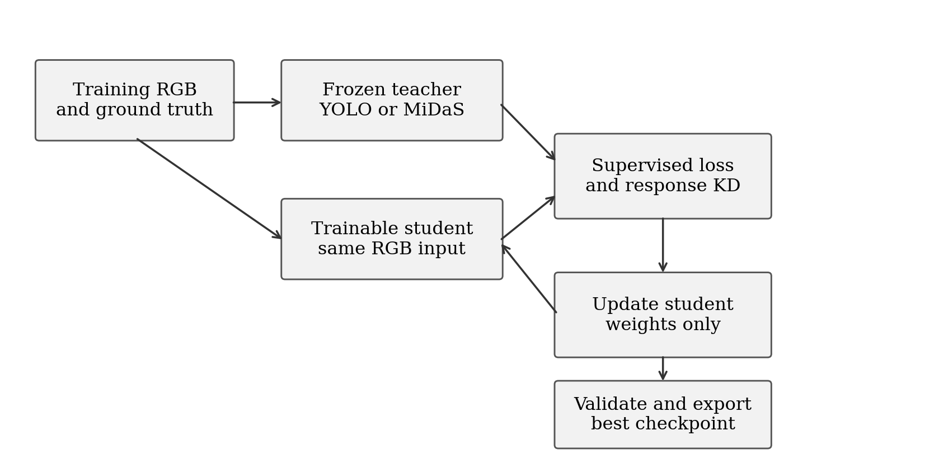
Figure 4.1 Frozen teacher and trainable student distillation workflow
The detector student starts from YOLO11-S pretrained weights and trains on KITTI labels. YOLO11-L supplies frozen responses for the same training batch. The objective combines native YOLO supervision for boxes, classes and distribution-focal regression with teacher-student response losses. Temperature-scaled KL divergence is applied to class responses and to the four 16-bin box distributions. The temperature is 2 and the response-loss weight is 1.
The detector completed 100 epochs with AdamW, an initial learning rate of 0.0001, weight decay of 0.0005, batch size 8 and a 640-pixel training image size. Mixed precision was enabled. The Ultralytics training record uses seed 0, while dataset selection uses seed 42. The best checkpoint was selected at epoch 86. Its internal validation mAP50-95 was 0.73724; this training-validation result is separate from the final integrated evaluation.

4.3 Depth Distillation and Checkpoint Selection
The depth student starts from MiDaS Small. Its loss combines an L1 difference from the teacher's relative depth output and a valid-ground-truth L1 term after per-image scale-and-shift alignment during training. Both terms have weight 1. Intermediate feature distillation is disabled, with feature weight 0. This training alignment is not a fit to the ground truth of deployment test frames.
Depth training completed 30 epochs. The exported best checkpoint is from epoch 8, with validation loss 2.40328. Training used AdamW, learning rate 0.0001, weight decay 0.0001 and mixed precision. The exported checkpoint records batch size 4; the final epoch checkpoint records batch size 2 with thermal safeguards, reflecting a resumed run. Thirty epochs were the configured training budget, not evidence that a larger budget could not improve convergence.
Table 4.2 Recorded distillation training settings
Setting | Detector | Depth
Completed epochs | 100 | 30
Selected checkpoint epoch | 86 | 8
Optimizer | AdamW | AdamW
Initial learning rate | 0.0001 | 0.0001
Weight decay | 0.0005 | 0.0001
Batch size | 8 | 4 at selected checkpoint; 2 at final epoch
Mixed precision | Enabled | Enabled
Teacher contribution | Class and box responses | Relative depth output
Additional supervision | KITTI detection labels | Valid NYU raw depth

4.4 Integrated Evaluation Procedure
Load the fixed evaluation manifest, frozen calibration and selected model pair. Retain available model paths, manifest hashes and recorded Python, PyTorch, CUDA and GPU environment metadata.
Read one RGB frame with its image ID and aligned ground truth. Send this exact frame to both models, retaining the model-specific preprocessing used throughout the experiment.
Filter detections at confidence 0.25. Apply the installed detector's non-maximum suppression and retain class, box and confidence. The research adapter does not explicitly record an NMS threshold; the live application's 0.45 threshold is a separate setting.
Resize the depth prediction to image coordinates. Apply the model/dataset calibration learned from the separate calibration subset, then evaluate only finite positive ground-truth depth pixels.
Match detections to ground-truth objects in descending confidence order, requiring equal mapped class and IoU at least 0.50. Each prediction and each ground-truth object can be matched only once.
Extract median calibrated depth inside the predicted bounding box. Compare it with the median valid ground-truth depth inside the target box or a valid instance mask. Record failures and unavailable depth explicitly.
Calculate frame-level depth errors, detection scores, matched-object distance errors and the instrumented timings. Save raw CSV/JSON records and repeat the procedure for each model system.

4.5 KITTI Validity and Detection Mapping
Table 4.3 KITTI object labels mapped to detector classes
KITTI annotation | Detector class | Rule
Car and Van | car | Accepted under common difficulty filter
Truck | truck | Accepted under common difficulty filter
Pedestrian and Person_sitting | person | Accepted under common difficulty filter
Cyclist | bicycle | Mapped as the bicycle category
Tram | train | Mapped as the train category
Other labels and DontCare | Ignored as targets | No DontCare suppression in custom AP

Accepted boxes have height at least 25 pixels, truncation no greater than 0.3 and occlusion no greater than 1. Sparse depth is produced by projecting positive camera-z Velodyne points using the frame's P2, rectification and extrinsic calibration. Where projected samples share a pixel, the nearest valid depth is retained. Empty pixels are excluded from depth errors.
KITTI object distance is median camera-axis depth inside the annotated box, not reconstructed Euclidean range. Precision and F1 count all retained COCO predictions, including classes outside the accepted KITTI mapping. Excluded difficult objects and DontCare regions receive no suppression. AP averages only classes present in ground truth, so these precision and AP conventions differ from official KITTI scoring. Region medians may include background, especially with sparse LiDAR, and are not independent object-centre or nearest-surface measurements.
The implemented depth mask covers the complete aligned image and requires finite ground-truth depth greater than zero. No Eigen crop or explicit 80-metre KITTI or 10-metre NYU cap is implemented. This same rule is used for all three systems, but the resulting scores should not be compared directly with published cropped or depth-capped benchmarks. Detection AP is a custom 101-point interpolation on confidence-filtered predictions, averaged over classes represented in ground truth; mAP50-95 averages thresholds from 0.50 to 0.95 in steps of 0.05.

4.6 Relative Depth and Frozen Distance Calibration
Two evaluation modes are distinguished. Relative-depth evaluation fits scale and shift to valid ground truth on each test frame to study depth-map shape. Deployment-distance evaluation fits one calibration per system and dataset on the 100 separate calibration frames, freezes it and applies it to all evaluation images. The saved complete results in this report are from the fixed-calibration mode. A complete six-system relative-mode result set is not available.
Table 4.4 Frozen affine calibration coefficients
Dataset | System | Scale | Shift
KITTI | Teacher | -0.87468499 | 33.89318848
KITTI | Student | -0.04131996 | 26.21384811
KITTI | Distilled | -2.04370070 | 45.63300323
NYU | Teacher | -0.12999575 | 4.49832439
NYU | Student | -0.00433248 | 4.15691996
NYU | Distilled | -0.15567836 | 4.83193827

The implementation applies a direct affine mapping from the relative output to metric depth and clamps nonpositive predictions to 0.000001 metres. Because MiDaS produces relative inverse-depth information, a direct affine mapping to metres is an empirical approximation. Clamping extreme extrapolations can create very large inverse-depth errors. The present calibration therefore does not establish dependable industrial ranging, and improved calibration is part of the future work.

4.7 NYU Annotation Audit and Validity
The saved NYU detection preparation contains two confirmed annotation defects. First, the archive has 894 raw semantic names, but the conversion applies a mapping resembling NYU40 class IDs directly to the raw labels. Second, instance numbers are reused across semantic categories, while the conversion groups pixels by instance number alone. This can merge unrelated objects into one bounding box. Correct extraction must use both semantic label and instance number, with an explicit mapping derived from the archive's names.
Table 4.5 Examples of incorrect archived NYU class assignments
Raw ID | Actual archive name | Assigned detector class
4 | ceiling | bed
6 | cone | couch
7 | counter | dining table
24 | sink | refrigerator
25 | air vent | tv
31 | telephone cord | person

Consequently, the archived NYU detection and object-distance outputs are diagnostic records, not validated indoor object-performance measurements. The results section labels them accordingly. Whole-image depth errors use rawDepths and a depth-validity mask independently of semantic/instance conversion, so they remain interpretable under the recorded depth protocol. Cross-environment detection recovery cannot be concluded until the annotations are corrected and the object evaluation is repeated.

4.8 Metric Definitions and Timing Boundaries
Table 4.6 Accuracy and distance metric definitions
Metric | Definition and interpretation
Precision, recall and F1 | Correct detections relative to predictions, targets, and their harmonic mean.
IoU and mAP | Box overlap; average precision at the stated overlap thresholds.
Depth RMSE | Square root of mean squared metric-depth error, in metres.
AbsRel and SqRel | Absolute or squared depth error divided by target depth.
Delta 1, 2 and 3 | Fraction of valid pixels with depth ratio below 1.25, 1.25 squared and 1.25 cubed.
Object MAE and RMSE | Absolute and squared distance errors over correctly matched objects with valid depth.
Median and relative object error | Median absolute error, and absolute error divided by target object depth.
Within 0.5 m or 1.0 m | Success fraction among matched objects with valid depth.
Integrated distance success | Successful detection-and-distance cases divided by all annotated target objects.

Depth metrics are calculated per frame, then averaged across frames and repetitions. Object errors use matched objects with valid target depth. Matched-object tolerance rates differ from all-target integrated success, which includes missed detections. Unavailable object-depth results are not recorded as zero.
Timing uses batch size 1 and three repetitions, after image and ground-truth loading. It includes preprocessing, both models, calibration, matching and metric computation, but excludes file loading, camera capture, display and speech. Integrated runs have no explicit warmup. Separate distilled runtime-only results (20 warmup frames; 600 prepared frames) are not mixed into this comparison.
GPU memory denotes peak PyTorch allocation, not total device usage; RAM denotes peak process resident memory. CPU utilisation can exceed 100% across cores; GPU utilisation comes from sampled resource records. Reported memory is the mean of three repeat peaks. Median, P95 and latency standard deviation likewise average per-repeat summaries, not pooled frame statistics. Aggregation is identical across systems.

5 Results and Discussion

5.1 Evaluation Coverage and Main Findings
The completed evidence contains teacher, baseline student and distilled evaluations on 500 unique KITTI frames and 500 unique NYU frames, each repeated three times. Distilled KITTI detection improves substantially over the pretrained student, while KITTI depth-map errors improve modestly. Object-distance MAE and RMSE worsen, although tolerance success fractions improve. NYU whole-image depth errors improve slightly, while its object-level conclusions remain unresolved because of the annotation defects described in Section 4.7.
Table 5.1 Integrated comparison from consistent deployment runs
Dataset | System | mAP50 | Depth RMSE m | Object MAE m | FPS | P95 ms
KITTI | Teacher | 0.3360 | 8.485 | 6.250 | 2.20 | 464.96
KITTI | Student | 0.2900 | 10.712 | 8.080 | 17.87 | 72.51
KITTI | Distilled | 0.7407 | 10.466 | 8.806 | 20.48 | 66.18
NYU | Teacher | Invalid* | 0.872 | Invalid* | 6.24 | 166.10
NYU | Student | Invalid* | 0.873 | Invalid* | 14.47 | 77.77
NYU | Distilled | Invalid* | 0.860 | Invalid* | 14.75 | 74.66

* NYU detection and object-distance measurements are invalidated by the annotation conversion. Depth-map and timing entries use the stated independent depth and timing protocols. FPS is 1000 divided by mean integrated latency.

5.2 KITTI Detection Performance
Table 5.2 KITTI detection metrics
Metric | Teacher | Student | Distilled
Precision | 0.3487 | 0.3774 | 0.5463
Recall | 0.8366 | 0.8191 | 0.9757
F1 score | 0.4922 | 0.5167 | 0.7004
mAP50 | 0.3360 | 0.2900 | 0.7407
mAP50-95 | 0.1974 | 0.1671 | 0.5940
Mean matched IoU | 0.8178 | 0.8081 | 0.9111
Matched objects | 1,341 | 1,313 | 1,564
Missed objects | 262 | 290 | 39
False detections | 2,505 | 2,166 | 1,299

KITTI mAP50 rises from 0.2900 for the baseline student to 0.7407 for the distilled detector, compared with 0.3360 for the teacher. The distilled detector matches 1,564 of 1,603 accepted targets and misses 39; the teacher matches 1,341 and the baseline student 1,313. These results demonstrate strong adaptation of the trained detector to the project KITTI subset under the custom class and matching protocol. They do not isolate the effect of KD because the baseline is not an equally fine-tuned supervised control.
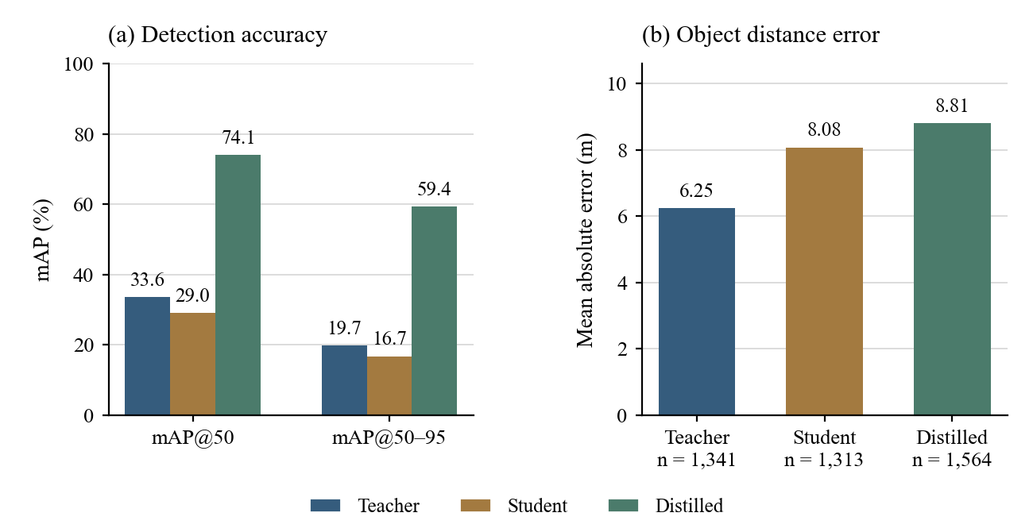
Figure 5.1 KITTI detection gains and object distance error

5.3 Depth Map Quality Under Fixed Calibration
Table 5.3 KITTI fixed calibration depth metrics
Metric | Teacher | Student | Distilled
RMSE in metres | 8.4850 | 10.7121 | 10.4662
AbsRel | 0.4492 | 0.6111 | 0.5847
SqRel | 3.7731 | 6.0305 | 6.0427
Delta 1 | 0.3339 | 0.2354 | 0.2630
Delta 2 | 0.6377 | 0.4834 | 0.5272
Delta 3 | 0.8184 | 0.7035 | 0.7464
SILog as implemented | 271.2299 | 101.8240 | 97.0684

Table 5.4 NYU fixed calibration depth metrics
Metric | Teacher | Student | Distilled
RMSE in metres | 0.8723 | 0.8726 | 0.8603
AbsRel | 0.3043 | 0.3020 | 0.2979
SqRel | 0.3379 | 0.3398 | 0.3286
Delta 1 | 0.5052 | 0.5244 | 0.5233
Delta 2 | 0.8023 | 0.8004 | 0.8051
Delta 3 | 0.9223 | 0.9204 | 0.9246
SILog as implemented | 55.3441 | 54.4695 | 51.5619

On KITTI, the baseline depth RMSE is 10.7121 m and the distilled RMSE is 10.4662 m, while the teacher reaches 8.4850 m. The trained distilled depth model reduces baseline error by approximately 2.30% and recovers 11.04% of the teacher-student RMSE gap. AbsRel improves from 0.6111 to 0.5847, and Delta 1 improves from 0.2354 to 0.2630. The student remains below the teacher on these depth measures.
On NYU, depth RMSE decreases from 0.8726 m to 0.8603 m. Teacher RMSE is 0.8723 m, leaving an extremely small initial teacher-student gap. A recovery percentage based on that tiny denominator would be unstable and misleading, so the report uses the absolute change and the 1.40% error reduction instead. NYU depth quality alone does not demonstrate successful indoor detection-and-distance guidance.
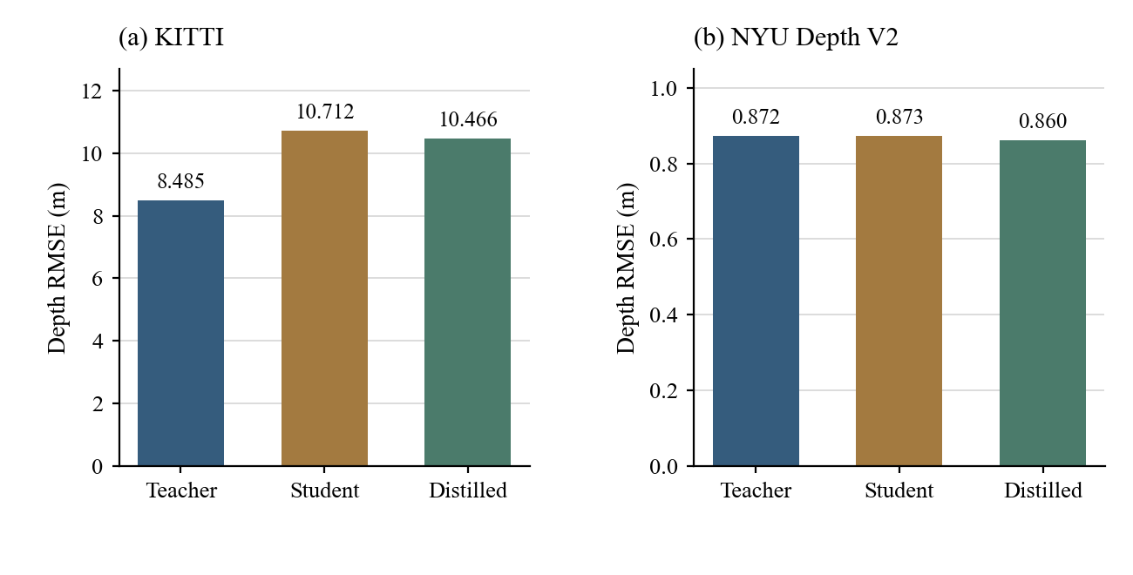
Figure 5.2 Depth RMSE under frozen calibration on both datasets

5.4 KITTI Object Distance Estimation
Table 5.5 KITTI matched object distance metrics
Metric | Teacher | Student | Distilled
Objects with valid target depth | 1,341 | 1,313 | 1,564
Mean absolute error in metres | 6.2502 | 8.0799 | 8.8059
RMSE in metres | 7.8890 | 10.6276 | 11.6910
Median absolute error in metres | 5.4861 | 6.1765 | 7.1783
Mean relative error | 0.3339 | 0.3818 | 0.4216
Median relative error | 0.2640 | 0.3311 | 0.3443
Matched objects within 0.5 m | 4.70% | 3.81% | 4.22%
Matched objects within 1.0 m | 9.17% | 7.39% | 8.31%
All-target success within 0.5 m | 3.93% | 3.12% | 4.12%
All-target success within 1.0 m | 7.67% | 6.05% | 8.11%

The teacher object MAE is 6.2502 m, the student MAE is 8.0799 m and the distilled MAE is 8.8059 m. The distilled error is approximately 8.99% higher than the baseline student. Object RMSE likewise rises from 10.6276 m to 11.6910 m. The three systems match different sets of objects; conditional errors therefore include changes in detection coverage as well as depth quality. A common-object analysis would be required to separate those effects.
The distilled system improves all-target success within 1.0 m from 6.05% to 8.11%, partly because fewer objects are missed. Among matched objects, however, the 1.0-m success fraction is 8.31%, compared with 7.39% for the student and 9.17% for the teacher. This illustrates why both conditional distance quality and complete detection-and-distance success must be reported. The existing results do not establish accurate ranging for an assistive deployment.
Table 5.6 KITTI object distance error by target range
Target range | Teacher MAE m | Student MAE m | Distilled MAE m
2 to 5 m | 1.4543 | 7.3418 | 8.8178
5 to 10 m | 4.7703 | 6.6670 | 8.1175
10 m and above | 6.4823 | 8.2940 | 8.8979

Only three matched objects fall in the 2-to-5-m band for each system, and none in the below-2-m band. The near-field evidence is insufficient for validating the live proximity threshold.

5.5 NYU Archived Detection Diagnostics
The following table preserves the archived detection outputs for traceability only. Incorrect semantic assignments and merged instance masks invalidate their interpretation as model accuracy. In particular, zero matched detections for the distilled system cannot distinguish domain-transfer failure from annotation conversion failure. Its object-distance MAE, RMSE and tolerance fractions are unavailable, not zero.
Table 5.7 Invalidated NYU detection outputs for audit only
Metric | Teacher | Student | Distilled
Archived precision | 0.0569 | 0.0552 | 0.0000
Archived recall | 0.4606 | 0.3939 | 0.0000
Archived F1 | 0.1013 | 0.0969 | 0.0000
Archived mAP50 | 0.0237 | 0.0195 | 0.0000
Archived mAP50-95 | 0.0147 | 0.0108 | 0.0000
Archived matched objects | 152 | 130 | 0
Archived missed objects | 178 | 200 | 330
Archived false detections | 2,518 | 2,224 | 55

No indoor detection improvement, degradation or teacher-accuracy recovery is claimed from Table 5.7. Correct semantic mapping and per-category instance extraction are required before a valid comparison.

5.6 Integrated Runtime and Resource Use
Table 5.8 KITTI integrated timing and resources
Metric | Teacher | Student | Distilled
Mean latency in ms | 454.36 | 55.97 | 48.84
Median latency in ms | 451.90 | 51.80 | 45.14
P95 latency in ms | 464.96 | 72.51 | 66.18
Latency standard deviation in ms | 20.86 | 16.60 | 14.72
FPS from mean latency | 2.20 | 17.87 | 20.48
Peak GPU allocated MiB | 2893.19 | 203.52 | 203.48
GPU utilisation percent | 78.73 | 28.31 | 28.35
Process CPU utilisation percent | 99.06 | 94.82 | 97.09
Peak process RAM MiB | 3387.65 | 1463.24 | 1500.06
Parameters | 369,396,457 | 30,764,305 | 30,764,305
Saved checkpoint MiB | 1361.62 | 100.21 | 226.89

Table 5.9 NYU integrated timing and resources
Metric | Teacher | Student | Distilled
Mean latency in ms | 160.28 | 69.10 | 67.79
Median latency in ms | 159.29 | 68.49 | 67.63
P95 latency in ms | 166.10 | 77.77 | 74.66
Latency standard deviation in ms | 17.77 | 15.30 | 12.42
FPS from mean latency | 6.24 | 14.47 | 14.75
Peak GPU allocated MiB | 2524.18 | 220.29 | 220.29
GPU utilisation percent | 54.82 | 31.20 | 31.23
Process CPU utilisation percent | 99.57 | 98.30 | 97.37
Peak process RAM MiB | 1457.50 | 1477.73 | 1511.93
Parameters | 369,396,457 | 30,764,305 | 30,764,305
Saved checkpoint MiB | 1361.62 | 100.21 | 226.89

For KITTI, mean integrated latency falls from 454.36 ms for the teacher to 55.97 ms for the student and 48.84 ms for the distilled pair. Consistent throughput is 2.20, 17.87 and 20.48 FPS, respectively. On NYU, the corresponding mean latencies are 160.28, 69.10 and 67.79 ms, giving 6.24, 14.47 and 14.75 FPS. These are instrumented research timings and not camera-to-speech response times.
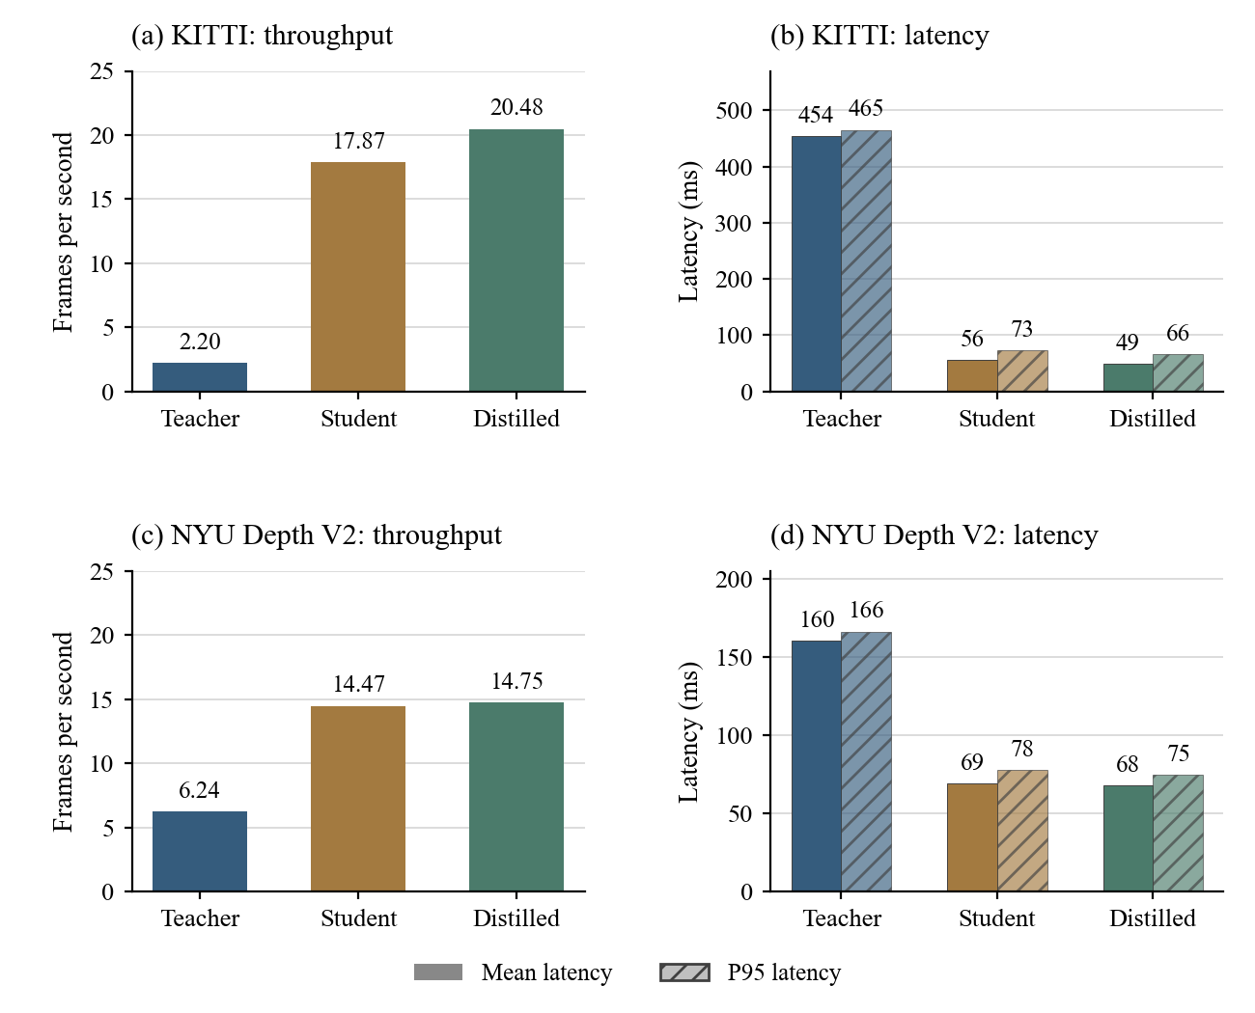
Figure 5.3 Like for like integrated throughput and latency
Table 5.10 KITTI mean timed pipeline components in ms
Metric | Teacher | Student | Distilled
YOLO preprocessing | 0.99 | 2.01 | 1.75
YOLO inference | 14.08 | 16.79 | 15.84
YOLO postprocessing | 1.30 | 1.89 | 1.48
MiDaS preprocessing | 23.67 | 5.43 | 4.34
MiDaS inference | 406.69 | 20.94 | 18.34
Object matching and depth metrics | 5.66 | 6.63 | 5.41

Table 5.11 NYU mean timed pipeline components in ms
Metric | Teacher | Student | Distilled
YOLO preprocessing | 0.98 | 1.91 | 1.89
YOLO inference | 13.22 | 20.40 | 20.82
YOLO postprocessing | 1.18 | 1.44 | 0.71
MiDaS preprocessing | 10.16 | 5.19 | 5.13
MiDaS inference | 114.45 | 19.34 | 19.55
Object matching and depth metrics | 18.74 | 19.32 | 18.76

The large teacher depth model accounts for most of the KITTI processing time. The lightweight depth model reduces that contribution substantially. The sum of component means may differ slightly from the total because timers include different overhead boundaries. The fixed order of runs, laptop power and temperature state, and absence of explicit warmup in the integrated evaluator also limit the strength of precise speedup claims.
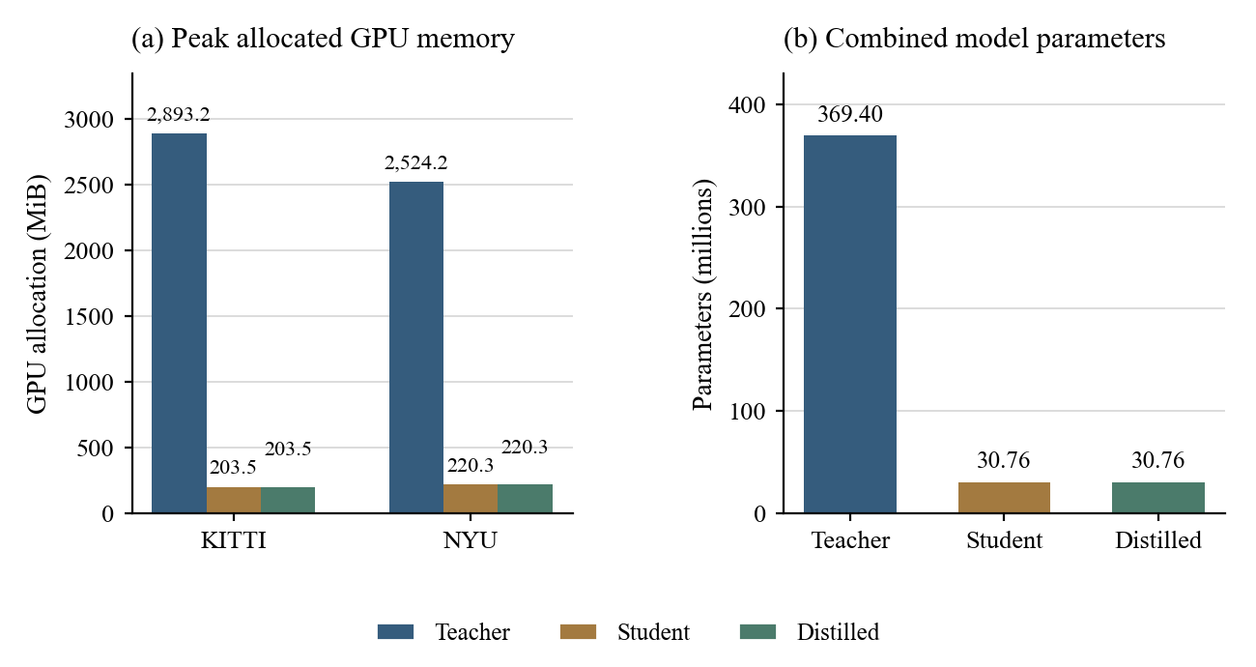
Figure 5.4 Peak PyTorch GPU allocation and model parameter count
Parameter count decreases by 91.67% from 369.396 million to 30.764 million. Distillation retains the compact architecture. The saved distilled checkpoint is larger than the baseline checkpoint because the depth export contains training/optimizer state. Its 226.89-MiB checkpoint size is therefore not a clean measure of inference-only storage. Peak allocated GPU memory should likewise not be interpreted as total physical GPU memory usage.

5.7 Performance Recovery and Efficiency Trade Off
Table 5.12 Efficiency changes relative to the teacher
Dataset | Student speedup | Distilled speedup | Distilled latency reduction | Distilled GPU allocation reduction
KITTI | 8.12x | 9.30x | 89.25% | 92.97%
NYU | 2.32x | 2.36x | 57.70% | 91.27%

For a higher-is-better quality measure, recovery is the distilled-minus-student improvement divided by the teacher-minus-student gap. For a lower-is-better error measure, recovery is the student-minus-distilled error reduction divided by the student-minus-teacher error gap. A positive recovery means movement towards the teacher; a negative recovery means deterioration. If the baseline is already better than the teacher or the gap is near zero, this percentage should not be used as an ordinary recovery claim.
Table 5.13 KITTI quality changes and valid teacher gap recovery
Metric | Student to distilled change | Teacher gap recovery
mAP50 | +0.4507 | Beyond teacher; KD effect not isolated
Depth RMSE | -0.2459 m | 11.04%
Depth AbsRel | -0.0264 | 16.27%
Depth Delta 1 | +0.0276 | 28.01%
Object MAE | +0.7260 m | -39.68%
Object RMSE | +1.0635 m | -38.83%

5.8 Qualitative Same Frame Comparison
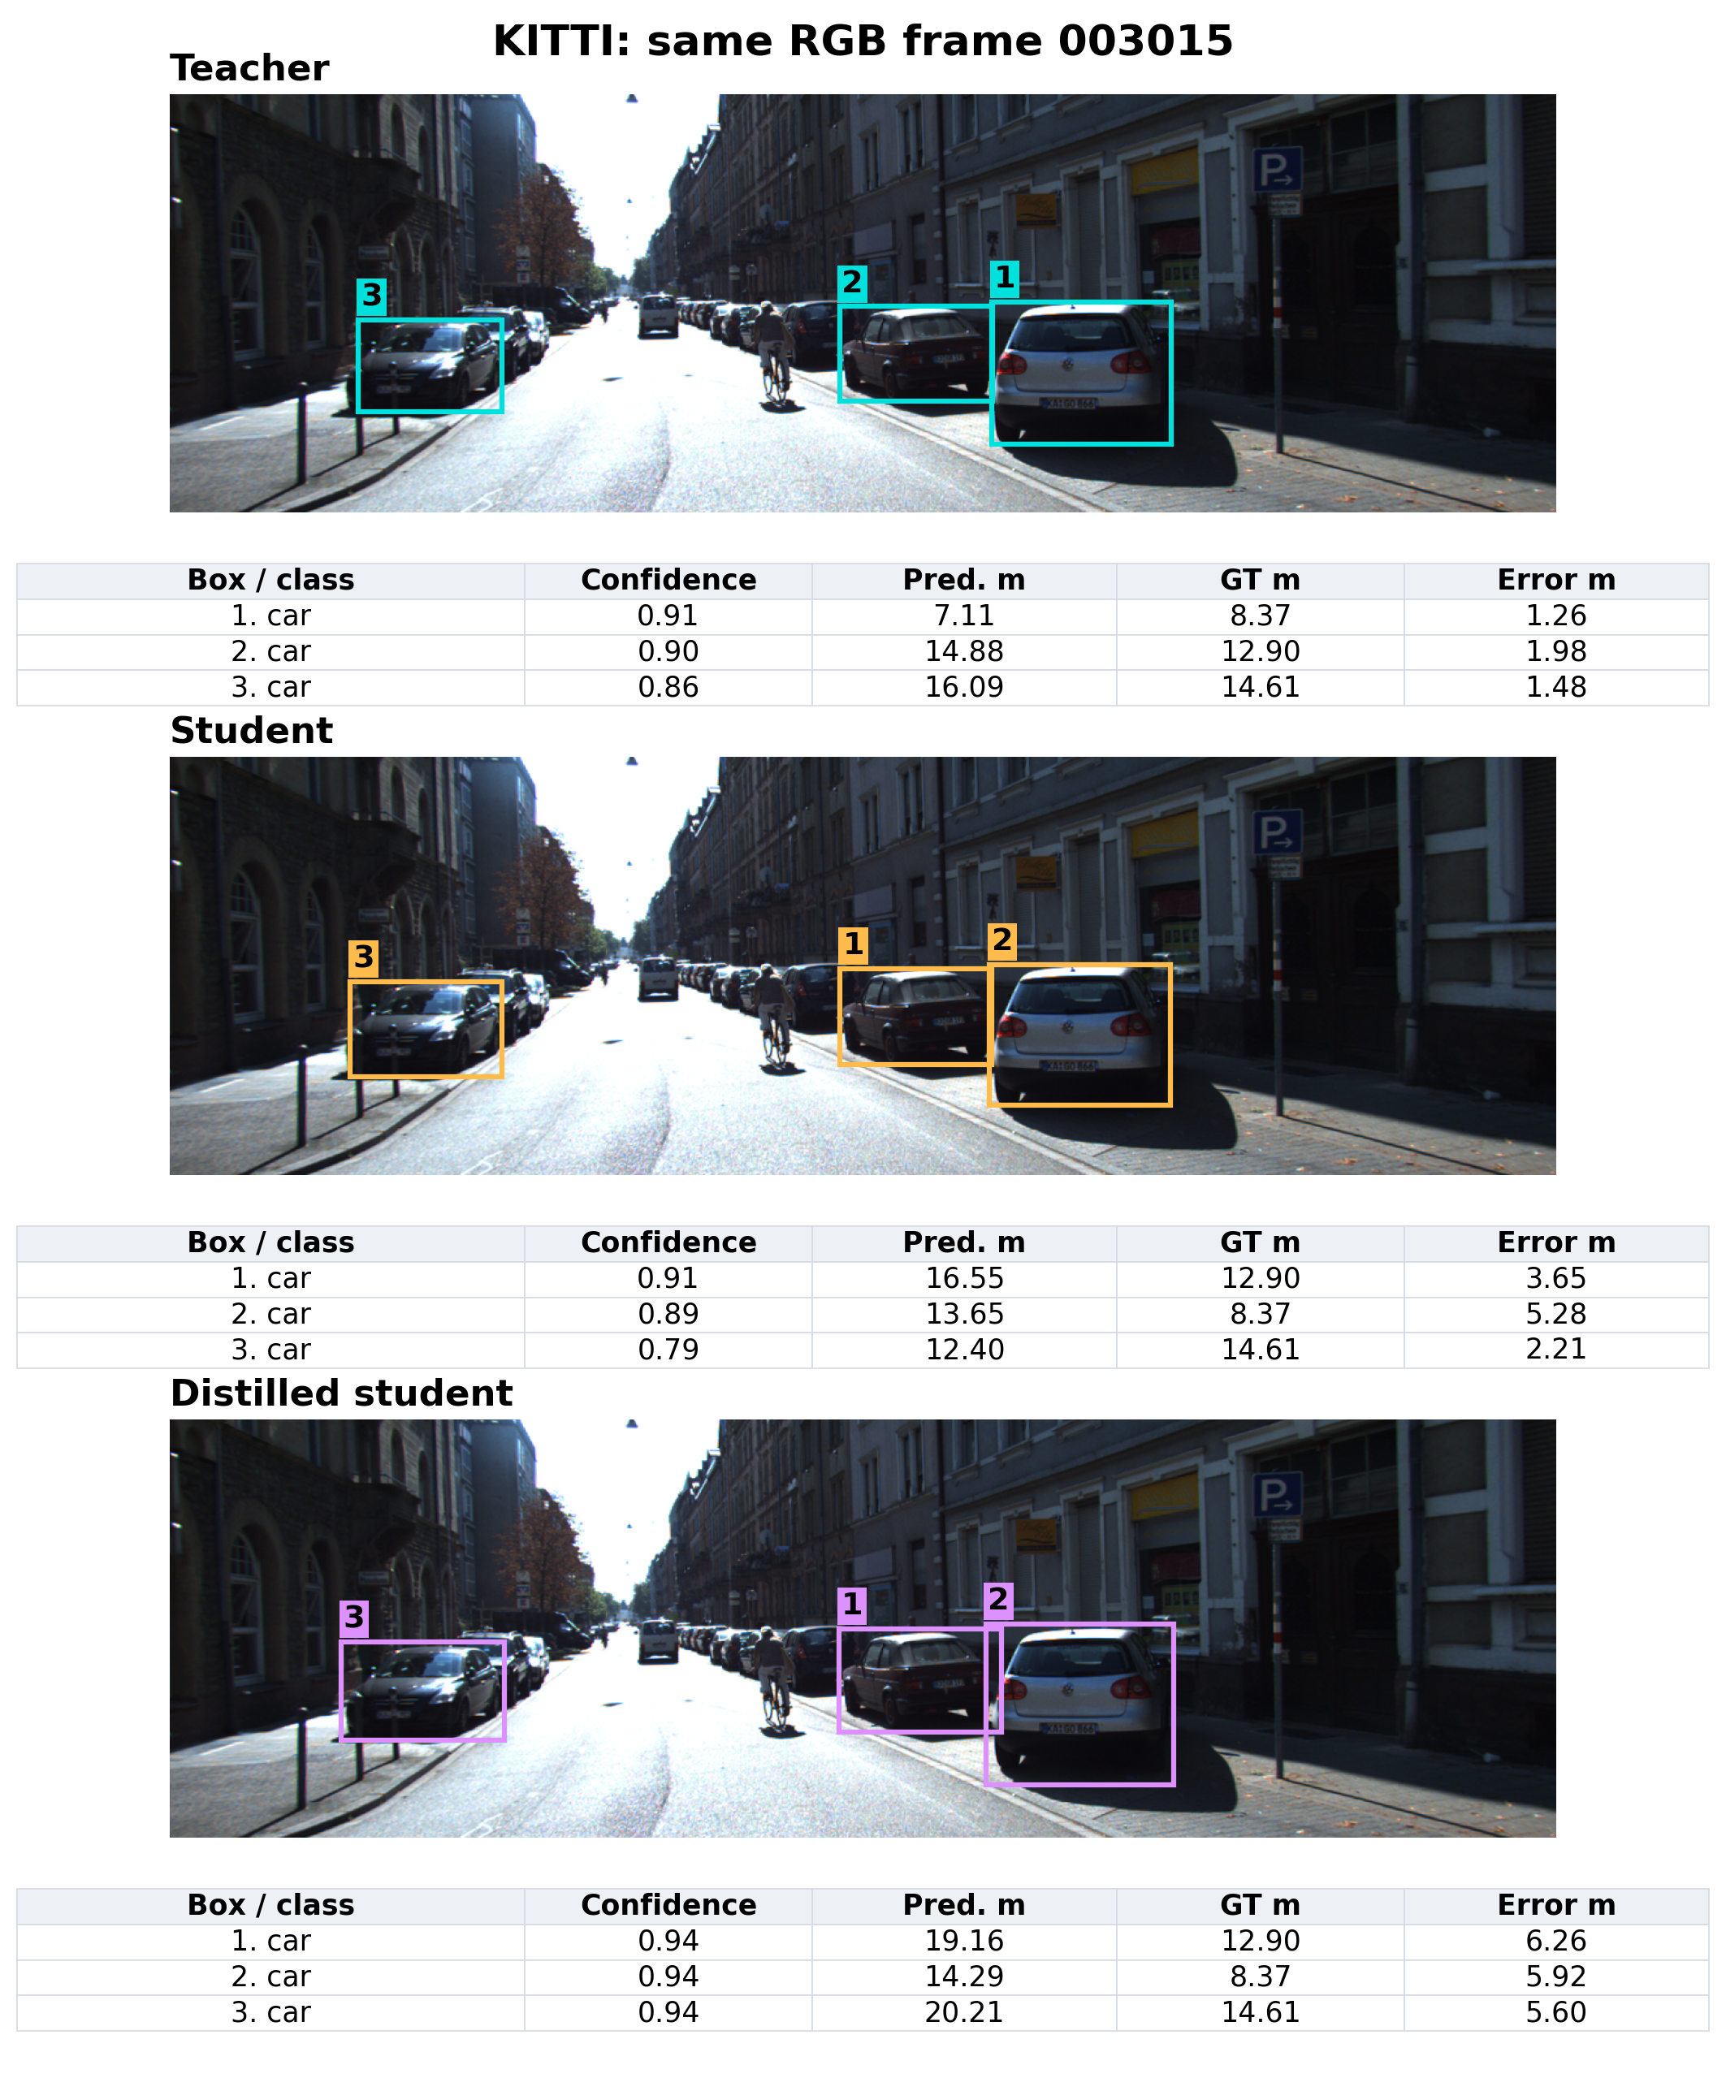
Figure 5.5 Stored KITTI predictions for the same RGB frame
Frame 003015 is selected deterministically from the evaluation manifest. Each panel shows the three highest-confidence saved predictions, with depth and errors from repeat-01 records and frozen calibration. Aggregate tables provide the quantitative comparison; no new inference was performed.

5.9 Limitations and Research Interpretation
The main findings are dataset- and task-dependent. The compact pair preserves computational advantages, and the trained detector adapts strongly to the project KITTI subset. Depth distillation reduces some depth-map errors but does not recover KITTI object-distance accuracy. Indoor object performance is unresolved because of annotation conversion errors. These observations support continuing development rather than declaring the integrated assistive capability fully preserved.
Several limits constrain attribution and generalisation: project-specific frame partitions, no matched supervised-only detector control, custom AP after confidence filtering, no standard depth crop/range caps, approximate affine distance conversion, and runtime that includes evaluation overhead. The near-distance KITTI sample is small, and the raw NYU object protocol requires repair. Repeated inference on the same images also does not constitute independent retraining or a statistical confidence interval for model generalisation.

6 Conclusion and Future Scope

6.1 Conclusion
The project implements an integrated object-detection and depth-estimation pipeline, trains compact student models with teacher guidance, and records a three-system comparison. Teacher, baseline student and distilled weights are evaluated on the same prepared RGB frames. The live application combines object identification, approximate distance, nine-section direction and offline speech with proximity-based priority.
The lightweight architecture substantially reduces parameter count and integrated evaluation latency. KITTI detector mAP50 increases from 0.2900 for the baseline student to 0.7407 after supervised fine-tuning and distillation. KITTI depth RMSE improves from 10.7121 m to 10.4662 m, recovering 11.04% of the teacher-student error gap. However, object-distance MAE increases from 8.0799 m to 8.8059 m. Better detection alone therefore does not establish better distance guidance.
NYU whole-image depth RMSE improves slightly to 0.8603 m. The archived indoor detection and object-distance measurements cannot support a valid cross-environment conclusion because semantic mapping and instance extraction are incorrect. The present evidence establishes a useful efficiency result and a working assistive prototype, while accurate ranging, isolated KD benefit and indoor object generalisation remain open research questions.

6.2 Future Scope
The first priority is to correct NYU labels using the archive's semantic names and extract each instance by its semantic/instance pair. The same corrected annotations should then be frozen for all three systems. A supervised-only YOLO11-S control, trained on the same KITTI data with the same optimisation budget, is needed to isolate the additional benefit of distillation.
Distance calibration should be redesigned around the relative inverse-depth output and validated using independent ground truth at practical near ranges. Predictions outside the supported calibration range should be handled explicitly instead of being interpreted as reliable metre measurements. Common-object evaluation, scene-disjoint partitions, fuller confidence sweeps and standard crop/range protocols would strengthen the accuracy study.
Deployment evaluation should add warmup, repeated timing, power and thermal records, and camera-to-announcement latency. Engine accuracy, controlled workstation assistance and wearable use require hardware-specific testing and user studies.

References
[1] Ultralytics. YOLO11 documentation. https://docs.ultralytics.com/models/yolo11/ (accessed 2 October 2026).
[2] R. Ranftl, K. Lasinger, D. Hafner, K. Schindler and V. Koltun. Towards Robust Monocular Depth Estimation: Mixing Datasets for Zero-shot Cross-dataset Transfer. IEEE Transactions on Pattern Analysis and Machine Intelligence, 2022. https://arxiv.org/abs/1907.01341
[3] R. Ranftl, A. Bochkovskiy and V. Koltun. Vision Transformers for Dense Prediction. ICCV, 2021. https://arxiv.org/abs/2103.13413
[4] MiDaS authors. MiDaS source code, models and input transformations. https://github.com/isl-org/MiDaS (accessed 2 October 2026).
[5] G. Hinton, O. Vinyals and J. Dean. Distilling the Knowledge in a Neural Network. arXiv:1503.02531, 2015. https://arxiv.org/abs/1503.02531
[6] A. Geiger, P. Lenz and R. Urtasun. Are We Ready for Autonomous Driving? The KITTI Vision Benchmark Suite. CVPR, 2012. Dataset: https://www.cvlibs.net/datasets/kitti/
[7] N. Silberman, D. Hoiem, P. Kohli and R. Fergus. Indoor Segmentation and Support Inference from RGBD Images. ECCV, 2012. Dataset: https://cs.nyu.edu/~fergus/datasets/nyu_depth_v2.html
[8] NVIDIA. TensorRT documentation. https://docs.nvidia.com/deeplearning/tensorrt/latest/ (accessed 2 October 2026).
[9] OpenCV. OpenCV documentation. https://docs.opencv.org/4.x/ (accessed 2 October 2026).
[10] GOD'S EYE project team. Saved training logs, experiment configuration, calibration parameters, per-frame predictions and integrated evaluation summaries, August-September 2026. Evidence inventory in Appendix A.

