1. PROJECT TEAM DETAILS
Roll no | PRN | Name of student | MAILID | MOBILE NO | Signature
11 | 12413071 | Shreyas P. Patil | shreyas.patil24@vit.edu | 9422996733
14 | 12414973 | Yugandhar G. Paulbudhe | yugandhar.paulbudhe24@vit.edu | 9112650632
23 | 12414725 | Prithviraj V. Tandel | prithviraj.tandel24@vit.edu | 9766842608
24 | 12414159 | Pruthvi J. Chaudhari | pruthvi.chaudhari24@vit.edu | 8766593055

2. PROJECT TITLE
Knowledge Distillation for Efficient Object Detection and Depth Estimation in GOD'S EYE

3. PROJECT DOMAIN
Artificial Intelligence, Computer Vision, Deep Learning, Assistive Technology, Embedded Systems

4. PROJECT ABSTRACT
Modern computer-vision systems often achieve high accuracy using large deep-learning models, but their computational requirements make them difficult to deploy on portable and resource-constrained platforms. This project investigates knowledge distillation for reducing the computational requirements of the GOD'S EYE assistive vision system while maintaining its object detection and depth estimation capabilities. A high-capacity Teacher consisting of YOLO11-L and DPT-Large is compared with a compact Student consisting of YOLO11-S and DPT-Small. Both systems are evaluated as an integrated pair on the same RGB frames using KITTI and NYU Depth V2 datasets. Detection accuracy, depth accuracy, object-level distance estimation and computational efficiency are measured using a common evaluation protocol. The current Teacher-Student baseline demonstrates a substantial reduction in inference latency, GPU memory and model parameters with the compact Student, while also revealing task- and dataset-dependent performance losses. Knowledge distillation will subsequently be applied to transfer useful information from the Teacher to the Student. The final objective is to determine whether the Distilled Student can recover part of the Teacher's performance while retaining the computational advantages required for efficient deployment in GOD'S EYE.

5. LITERATURE REVIEW / EXISTING TECHNOLOGY

5.1 Existing Technologies
Several technologies have been developed to assist visually impaired users with environmental perception and navigation.

Traditional White Cane
The white cane is one of the most widely used mobility aids. It allows users to detect nearby physical obstacles through direct contact and provides information about the immediate ground surface.
Limitation:
It provides little or no semantic information about an obstacle. For example, it can indicate that an obstacle exists but cannot identify whether it is a chair, vehicle, person or staircase.

Ultrasonic Obstacle Detection
Ultrasonic sensors can measure the distance to nearby objects by transmitting ultrasonic waves and measuring their reflected signal.
Limitation:
Ultrasonic sensing provides distance information but generally does not identify the semantic class of an object. It also provides limited spatial information compared with a camera.

Smartphone-Based Assistive Vision
Smartphones can run object detection, OCR, image recognition and navigation applications to provide audio descriptions of the environment.
Limitations:
- The user may need to hold or operate the device.
- Continuous processing can consume significant battery power.
- A single modality may not provide sufficient information about both object identity and distance.

Deep-Learning Object Detection
Modern object detectors such as the YOLO family can identify multiple objects in a scene and provide bounding boxes and confidence scores.
Limitation:
Object detection alone answers "What is present?", but does not directly provide reliable metric distance information.

Monocular Depth Estimation
Models such as MiDaS/DPT estimate scene depth from a single RGB image.
Limitation:
Depth estimation provides spatial information but does not inherently identify what each region of the scene represents. Monocular depth is also fundamentally more challenging than direct depth sensing because the model must infer 3D structure from a 2D image.
5.2 Objectives
- Evaluate the performance of a high-capacity Teacher consisting of YOLO11-L and DPT-Large.
- Evaluate a computationally efficient Student consisting of YOLO11-S and DPT-Small.
- Establish a common integrated evaluation protocol for object detection, depth estimation and object-level distance estimation.
- Apply knowledge distillation to transfer useful information from the Teacher to the Student.
- Compare Teacher, Student and Distilled Student using identical datasets and evaluation conditions.
- Quantify the trade-off between accuracy and computational efficiency.
- Determine whether distillation can recover Student performance while preserving its efficiency advantage.

6. PROJECT OBJECTIVES
The primary objectives of GOD'S EYE are:
- To develop an AI-based assistive vision system capable of identifying objects in the user's surroundings.
- To estimate the distance of detected objects using monocular depth estimation.
- To combine object identity and spatial information into meaningful environmental feedback.
- To provide information to the user through audio rather than requiring visual interaction.
- To develop a computationally efficient vision pipeline suitable for eventual wearable deployment.
- To investigate model optimization using knowledge distillation.
- To evaluate the trade-off between model accuracy, inference speed and computational resource requirements.

7. PROJECT SYNOPSIS
This project investigates knowledge distillation for developing an efficient and accurate perception system for GOD'S EYE. A high-capacity Teacher system consisting of YOLO11-L for object detection and DPT-Large for monocular depth estimation is compared with a compact Student system consisting of YOLO11-S and DPT-Small. Both systems process the same RGB frame so that object detection and depth estimation are evaluated as an integrated task. Detected objects are associated with corresponding regions of the depth map to obtain object-level distance estimates. The Teacher and Student are evaluated on the KITTI and NYU Depth V2 datasets using a unified testing pipeline covering detection accuracy, depth accuracy, object-distance accuracy and computational efficiency. The baseline evaluation establishes the performance and efficiency gap between the Teacher and Student. Knowledge distillation is then applied to transfer useful information from the Teacher to the Student, producing a Distilled Student. The final objective is to determine whether the Distilled Student can recover part of the Teacher's performance while retaining the computational advantages of the smaller models, supporting eventual deployment in the GOD'S EYE wearable assistive vision system.
GOD'S EYE is a wearable assistive vision system intended to provide visually impaired users with information about their surrounding environment.
The proposed system consists of five major components:
- Camera module
- AI perception module
- Depth-estimation module
- ESP32-based ultrasonic sensing module
- Audio feedback module
The camera captures frames from the user's surroundings. The AI perception module processes the same RGB frame using a YOLO-based object detector and a DPT-based monocular depth-estimation model.
The object detector produces:
- Object class
- Bounding box
- Detection confidence
The depth model produces a depth map representing the estimated spatial structure of the scene.
The bounding boxes from the object detector are associated with corresponding regions of the depth map. Depth values within each detected object region are then used to estimate the object's distance.
The resulting information is converted into speech and provided to the user through an audio output device.
The ESP32 subsystem operates as an additional sensing layer and can detect nearby ground-level obstacles and changes such as steps or curbs using ultrasonic sensors.
The current AI implementation uses GPU-accelerated inference, with TensorRT used to optimize model execution.

8. BRIEF DESCRIPTION OF PROPOSED SYSTEM ARCHITECTURE DIAGRAMS / FIGURES
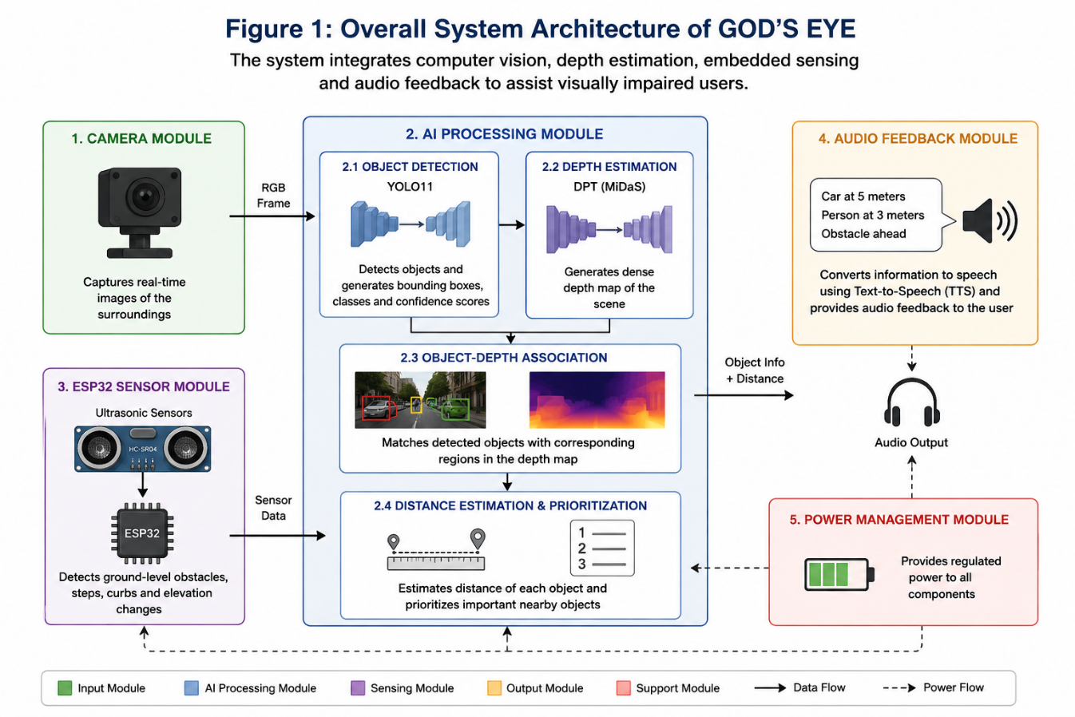
Figure 1: Overall System Architecture
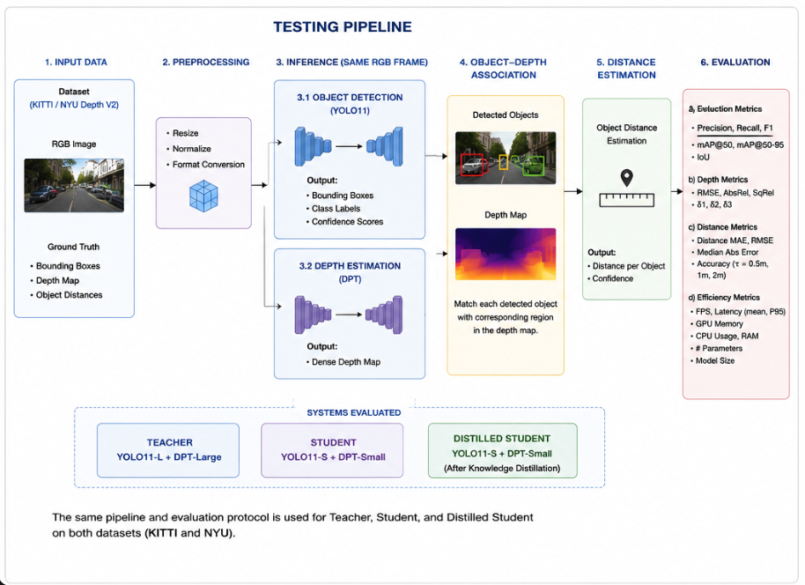
Figure 2: Overall System Architecture for testing
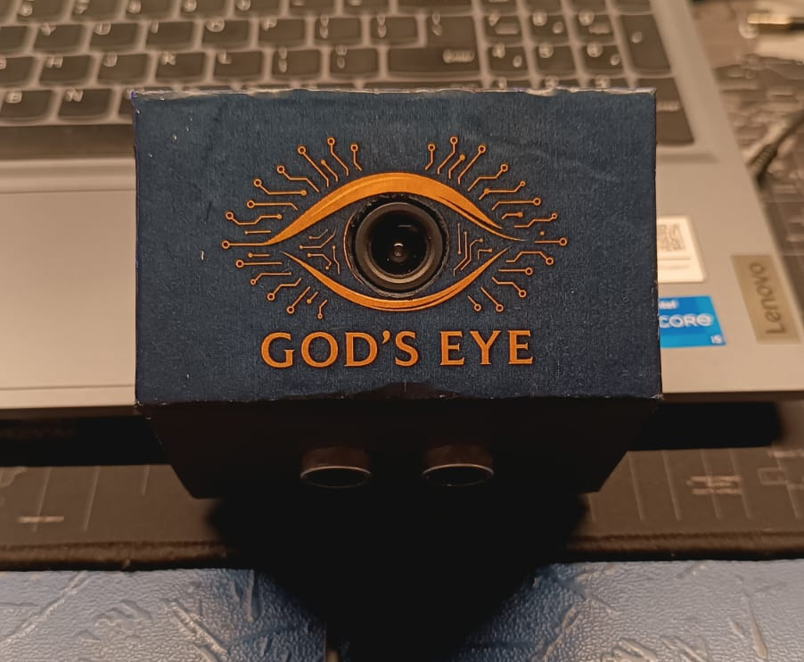
Figure 3: Physical Prototype

9. DETAILED PROJECT DESCRIPTION

9.1 Overall Architecture
The system consists of two complementary perception paths.

Vision path
Camera
↓
Image preprocessing
↓
┌───────────────┬─────────────────┐
↓ ↓
YOLO DPT
↓ ↓
Objects Depth map
└───────────────┴─────────────────┘
↓
Object-depth association
↓
Distance estimation
↓
Audio feedback

Sensor path
Ultrasonic Sensors
↓
ESP32
↓
Ground-level obstacle information
↓
Feedback
The two paths complement each other. The camera provides rich semantic information, while ultrasonic sensing provides an additional mechanism for detecting nearby physical obstacles and ground-level changes.

9.2 Object Detection
The project currently uses the YOLO11 family for object detection.
The detector receives an RGB frame and produces bounding boxes corresponding to detected objects.
For each detection, the system obtains:
- Class identifier
- Bounding-box coordinates
- Confidence score
Non-Maximum Suppression is applied to eliminate redundant overlapping detections.
The resulting bounding boxes are then mapped to the corresponding regions of the depth map.

9.3 Monocular Depth Estimation
The project uses DPT-based monocular depth estimation.
The model receives a single RGB image and predicts a dense depth representation.
Unlike a stereo camera or LiDAR system, monocular depth estimation does not directly measure distance using an additional physical sensor. Instead, the neural network estimates scene depth based on visual features learned from training data.
For GOD'S EYE, the predicted depth map is particularly useful because it can be combined with semantic object detections.

9.4 Object-Level Distance Estimation
This is one of the central components of the project.
Instead of evaluating depth independently from object detection, the system combines the outputs.
For example:
YOLO:
Bounding box = Car
Coordinates = (x1,y1,x2,y2)

DPT:
Depth map

↓

Extract depth values
inside the car bounding box

↓

Estimate representative depth

↓

Car ≈ X metres away
This allows the system to produce information that is directly useful to the user.

9.5 Experimental Work
A separate model-optimization study has been performed to establish the baseline for knowledge distillation.
Two systems were evaluated:

Teacher
YOLO11-L + DPT-Large

Student
YOLO11-S + DPT-Small
Both models were evaluated as a complete pair using the same RGB frames.
Two datasets were used:
- KITTI
- NYU Depth V2
The evaluation included:

Detection metrics
- Precision
- Recall
- F1
- mAP@50
- mAP@50-95
- IoU

Depth metrics
- RMSE
- AbsRel
- SqRel
- δ1
- δ2
- δ3

Object-distance metrics
- Distance MAE
- Distance RMSE
- Median absolute error
- Relative error
- Accuracy within distance tolerances

Computational metrics
- FPS
- Mean latency
- P95 latency
- GPU memory
- CPU usage
- RAM
- Number of parameters
- Model size

9.6 Experimental Results

KITTI
The Teacher achieved:
- 2.20 FPS
- 454 ms average latency
- 2893 MB GPU memory
- 0.336 mAP@50
- 8.49 m depth RMSE
- 6.25 m object-distance MAE
The Student achieved:
- 17.87 FPS
- 56 ms average latency
- 204 MB GPU memory
- 0.290 mAP@50
- 10.71 m depth RMSE
- 8.08 m object-distance MAE
The results demonstrate a major efficiency improvement from the Student architecture, accompanied by a measurable performance loss on the KITTI task.

NYU Depth V2
The Teacher achieved:
- 6.24 FPS
- 160 ms average latency
- 0.872 m depth RMSE
- 0.663 m object-distance MAE
The Student achieved:
- 14.48 FPS
- 69 ms average latency
- 0.873 m depth RMSE
- 0.516 m object-distance MAE
The NYU results show that the Student can retain almost identical depth performance despite being substantially smaller. Its object-distance MAE was also lower than the Teacher's in this evaluation.

Interpretation
The results indicate that the Student is not simply a uniformly inferior model.
The main observation is:
The Student provides a significant computational advantage, but the performance trade-off depends on the dataset and task.
This provides the basis for the subsequent knowledge-distillation experiment.

10. IMPLEMENTATION / WORKING PROCEDURE
Implementation / Working Procedure for the Testing Pipeline
You can put this directly under Section 10: Implementation / Working Procedure:
- Dataset preparation: KITTI and NYU Depth V2 are prepared with RGB images, depth ground truth and object annotations required for the integrated evaluation.
- Evaluation subset creation: Fixed evaluation and calibration subsets are created so that Teacher, Student and Distilled Student are tested on identical frames.
- Model preparation: The appropriate YOLO and DPT models are loaded for the system being evaluated. TensorRT-optimized models can be used for runtime benchmarking.
- Frame preprocessing: Each RGB image is resized, normalized and converted into the input format required by the models.
- Synchronized inference: The same RGB frame is passed through the object detector and depth-estimation model.
- Detection processing: YOLO produces object classes, bounding boxes and confidence scores. Non-Maximum Suppression is applied to remove redundant detections.
- Depth processing: DPT produces a depth map corresponding to the same RGB frame.
- Object-depth association: Each detected object is matched with the corresponding ground-truth object using the defined class-aware IoU protocol. The predicted object's bounding-box region is then associated with the corresponding depth-map region.
- Distance estimation: Depth values belonging to each matched object are aggregated to obtain its representative depth and estimated distance.
- Metric calculation: Predictions are compared with ground truth to calculate detection, depth and object-distance metrics.
- Efficiency measurement: FPS, latency, GPU memory, CPU usage, RAM, parameter count and model size are recorded.
- Result storage: Per-frame predictions, object matches, timing information and aggregate metrics are saved for reproducibility and analysis.
- System comparison: The complete procedure is repeated for the Teacher, Student and, after training, the Distilled Student.
- Final analysis: The three systems are compared to determine whether knowledge distillation improves the Student's accuracy while preserving its computational efficiency.

11. KEY PROJECT FEATURES
- AI-based real-time object detection
- Object-specific distance estimation using monocular depth
- Multimodal perception using computer vision and ESP32 ultrasonic sensing
- Audio-based environmental feedback
- GPU-accelerated deep-learning inference
- Compact-model optimization through knowledge distillation research
If your form strictly wants four features, use the first four.

12. INNOVATION AND TECHNICAL ADVANTAGES
The primary technical innovation of GOD'S EYE is the integration of semantic object detection and spatial depth estimation into a single assistive perception pipeline.
Conventional obstacle-detection systems may provide information about the presence or distance of an obstacle without identifying its semantic class. Conversely, object-detection systems can identify objects without providing sufficiently useful distance information.
GOD'S EYE combines these capabilities so that the system can associate an object with its estimated distance.
Another technical advantage is the use of multiple sensing modalities. The camera provides rich visual and semantic information, while the ESP32 and ultrasonic sensors provide additional ground-level obstacle information.
The project also investigates computational optimization through knowledge distillation. The preliminary Teacher-Student evaluation demonstrates that the smaller Student architecture can substantially reduce computational requirements.
For example, on KITTI:
- FPS increased from 2.20 to 17.87
- GPU memory decreased from 2893 MB to 204 MB
- Parameters decreased from approximately 369.4M to 30.8M
However, the Student also showed lower KITTI mAP and worse depth/object-distance metrics. Therefore, knowledge distillation is being investigated to determine whether some of this performance loss can be recovered while retaining the efficiency advantage.
Important: Do not write that distillation has improved the system yet. It is your next experimental stage.

13. PRACTICAL / INDUSTRIAL APPLICATION
- Assistive technology for visually impaired users
- Wearable navigation assistance
- Indoor environmental awareness
- Smart mobility systems
- Obstacle-awareness systems
- Human-computer interaction
- Computer-vision-based accessibility systems
- Potential integration with smart glasses or wearable computing platforms

14. REFERENCES
- Ranftl, R., Bochkovskiy, A., and Koltun, V. "Vision Transformers for Dense Prediction." ICCV, 2021.
- Ranftl, R., Lasinger, K., Hafner, D., Schindler, K., and Koltun, V. "Towards Robust Monocular Depth Estimation: Mixing Datasets for Zero-shot Cross-dataset Transfer." IEEE TPAMI, 2022.
- Ultralytics. YOLO Documentation and YOLO11 Technical Documentation.
- NVIDIA. TensorRT Developer Documentation.
- OpenCV. Open Source Computer Vision Library Documentation.
- Silberman, N., Hoiem, D., Kohli, P., and Fergus, R. "Indoor Segmentation and Support Inference from RGBD Images." ECCV, 2012.
Used for the NYU Depth V2 dataset.
- Geiger, A., Lenz, P., and Urtasun, R. "Are We Ready for Autonomous Driving? The KITTI Vision Benchmark Suite." CVPR, 2012.
- Hinton, G., Vinyals, O., and Dean, J. "Distilling the Knowledge in a Neural Network." 2015.
- Espressif Systems. ESP32 Series Documentation.
- NYU Depth V2 official dataset documentation.
- KITTI Vision Benchmark Suite official dataset documentation.

