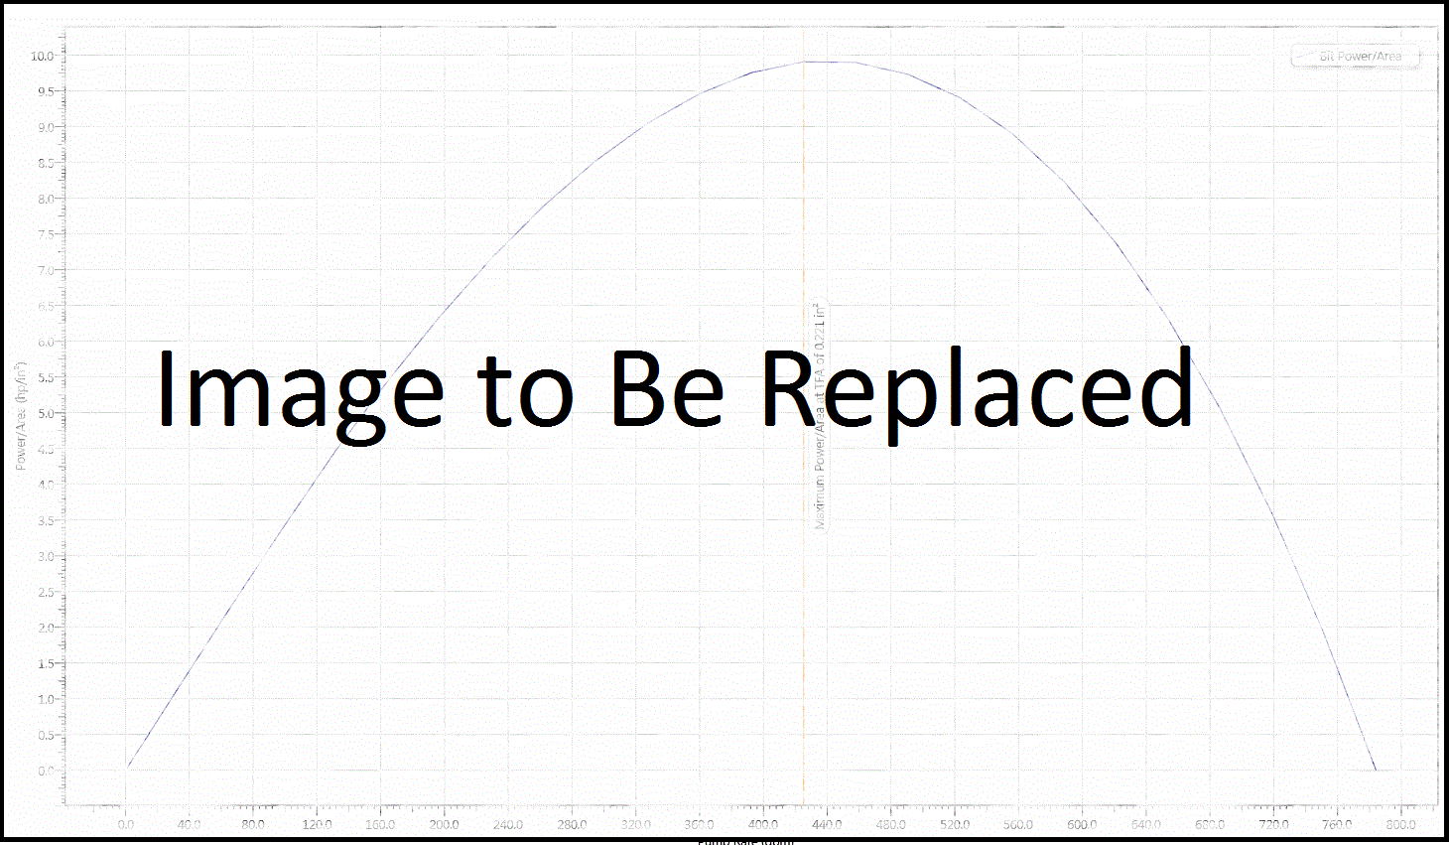

|  |  |  |
| --- | --- | --- |
| **End of Well Report**  for  **PIONEER NATURAL RES. USA.** | | |
| **Rig:** |  |  |
| **Well Name:** |  |  |
| **Field Name:** |  |  |
| **Country:** |  |  |
| **Job Number:** |  |  |
| **API Number:** |  |  |
| **Report Date:** |  |  |

|  |
| --- |
| **Table of Contents** |
| 1. General Information 2. Well Plats 3. Survey Information 4. QC Plots   5. Definitive Surveys |

|  |  |  |  |
| --- | --- | --- | --- |
| **General Information** | | | |
|  | Company: |  |  |
|  | Rig: |  |  |
|  | Well: |  |  |
|  | Field: |  |  |
|  | State: |  |  |
|  | County: |  |  |
|  | Country: |  |  |
|  | API Number: |  |  |
|  | Sperry Job Number: |  |  |
|  | Spud Date: |  |  |
|  | Survey Management Start Date: |  |  |
|  | Survey Management End Date: |  |  |
|  | Survey Management Start Depth: |  |  |
|  | Survey Management End Depth: |  |  |
|  | Well TD Date: |  |  |
|  | Coordinate System: |  |  |
|  | X: |  | «SA:Easting» |
|  | Y: |  | «SA:Northing» |
|  | Well Head Coordinates N: |  |  |
|  | Well Head Coordinates W: |  |  |
|  | Water Depth |  |  |
|  | Directional Company |  |  |
|  | Survey Company |  |  |

|  |
| --- |
| **Plats** |





|  |  |  |  |
| --- | --- | --- | --- |
| **Survey Information** | | | |
|  | Services Preformed: |  |  |
|  | Calculation Method: |  |  |
|  | Magnetic Model: |  |  |
|  | Date of Magnetic Model: |  |  |
|  | North Reference: |  |  |
|  | Grid Convergence: |  | «SA:GridConvergence» |
|  | Surface Magnetic Declination: |  |  |
|  | Surface Total Correction: |  |  |
|  | Surface Dip Angle: |  |  |
|  | Surface Field Strength: |  |  |
|  | Permanent Datum: |  |  |
|  | Survey Depth Reference: |  |  |
|  | Rig Floor Height: |  |  |
|  | Elevation of Depth Reference (RKB): |  |  |
|  | Vertical Section Direction: |  |  |
|  | Sag Corrected: |  |  |
|  | IFR Data: |  |  |

|  |
| --- |
| **Crustal Field Corrected Geomagnetic Waypoint Values (IFR Inputs)** |

|  |  |  |  |  |  |
| --- | --- | --- | --- | --- | --- |
| **Hole Section** | **Total Field (nT)** | **Dip (deg)** | **Declination (deg)** | **Grid Conv. (deg)** | **Total Corr. (deg)** |
| «IFRData» | «IfrMagneticFieldStrength» | «IfrMagneticDipAngle» | «IfrDeclination» | «IfrGridConvergence» | «IfrTotalCorrection» |

|  |
| --- |
| **QC Plots** |

**G Total**



|  |
| --- |
| **QC Plots** |

**B Total**



|  |
| --- |
| **QC Plots** |

**Dip**



|  |
| --- |
| **Definitive Surveys** |

|  |  |  |  |  |
| --- | --- | --- | --- | --- |
| Depth - FT | Inc - Deg | Azim - Deg | Tool Code IPM | Station Type |
|  |  |  |  |  |

