EXPERIMENT I
Online Hotel Room Booking Website
AIM
To design a responsive website for searching hotel rooms, checking dates, creating bookings, viewing booking history, and managing room prices.
ALGORITHM
Display the hotel home page.
Enter destination, check-in date, check-out date, and guest count.
Display four room types with sample prices and amenities.
Validate that required fields are entered and checkout is later than check-in.
Enter guest details and confirm a room booking.
Save the demo booking in localStorage and show a reference number.
Display booking history and provide a demo cancellation option.
Allow the admin demo panel to update room prices and quantities.
Test the responsive layout and displayed messages.
PROGRAM
Save the following code as index.html and open it in a modern browser.

<!DOCTYPE html>
<html lang="en">
<head>
<meta charset="UTF-8">
<meta name="viewport" content="width=device-width, initial-scale=1">
<title>Online Hotel Room Booking Website</title>
<style>
body{font-family:Arial,sans-serif;margin:0;background:#f3f6fa;color:#202b38}
header{background:#234a75;color:white;text-align:center;padding:22px}
main{max-width:1000px;margin:auto;padding:16px}
.panel,.card{background:white;padding:16px;margin:12px 0;border-radius:9px;box-shadow:0 2px 7px #d4dbe4}
input,select,button{padding:10px;margin:5px;border:1px solid #aab4c0;border-radius:5px}
button{background:#1e67a8;color:white;cursor:pointer}
.grid{display:grid;grid-template-columns:repeat(auto-fit,minmax(210px,1fr));gap:12px}
small{color:#586779}
</style>
</head>
<body>
<header><h1>Online Hotel Room Booking Website</h1><p>Responsive Internet Programming Lab Demo</p></header>
<main>
<section class="panel"><h2>Search / Filter</h2>
<input id="query" placeholder="Search or enter route / specialty">
<input id="date" type="date">
<select id="category"><option>All</option><option>Standard Room</option><option>Deluxe Room</option><option>Family Room</option><option>Suite</option></select>
<button onclick="searchItems()">Search</button><p id="message"></p></section>
<h2>Available Options</h2><section id="items" class="grid"></section>
<section class="panel"><h2>Booking / Order Details</h2>
<input id="person" placeholder="Name">
<input id="contact" placeholder="Email or phone">
<input id="extra" placeholder="Additional details: seat, size, slot, or address">
<button onclick="submitRequest()">Confirm Demo Request</button><p id="confirmation"></p></section>
<section class="panel"><h2>My History</h2><button onclick="showHistory()">Refresh History</button><ul id="history"></ul></section>
<section class="panel"><h2>Administrator Panel</h2>
<input id="newItem" placeholder="New listing name"><input id="newPrice" type="number" placeholder="Price / fare">
<button onclick="adminAdd()">Add Listing</button>
<small>Classroom demo only. Real admin access must be protected by server-side authentication.</small></section>
</main>
<script>
const storageKey="hotelRecords";
let items=["Standard Room","Deluxe Room","Family Room","Suite"].map((name,i)=>({name:name,price:[500,800,1100,1500][i],details:"Sample description and availability"}));
let selected=null;
function render(list=items){
document.getElementById("items").innerHTML=list.map((x)=>`<article class="card"><h3>${x.name}</h3><p>Sample price: ₹${x.price}</p><small>${x.details}</small><p><button onclick="selectItem('${x.name.replace(/'/g,"\\'")}')">Select</button></p></article>`).join("");
}
function searchItems(){
let q=document.getElementById("query").value.toLowerCase();
let c=document.getElementById("category").value;
let found=items.filter(x=>(!q||x.name.toLowerCase().includes(q))&&(c==="All"||x.name===c));
render(found);
document.getElementById("message").textContent=found.length+" sample result(s) found. Live availability is not connected.";
}
function selectItem(name){selected=items.find(x=>x.name===name);document.getElementById("message").textContent="Selected: "+name;}
function submitRequest(){
let person=document.getElementById("person").value.trim();
let contact=document.getElementById("contact").value.trim();
if(!selected||!person||!contact){document.getElementById("confirmation").textContent="Select an option and enter your name and contact details.";return;}
let record={id:"REF"+Date.now().toString().slice(-7),person:person,contact:contact,choice:selected.name,date:document.getElementById("date").value,extra:document.getElementById("extra").value,status:"Submitted"};
let records=JSON.parse(localStorage.getItem(storageKey)||"[]");records.push(record);localStorage.setItem(storageKey,JSON.stringify(records));
document.getElementById("confirmation").textContent="Demo request saved. Reference: "+record.id;showHistory();
}
function showHistory(){
let records=JSON.parse(localStorage.getItem(storageKey)||"[]");
document.getElementById("history").innerHTML=records.map(x=>`<li>${x.id} — ${x.person} — ${x.choice} — ${x.status}</li>`).join("")||"<li>No records yet.</li>";
}
function adminAdd(){
let name=document.getElementById("newItem").value.trim();let price=Number(document.getElementById("newPrice").value);
if(!name||price<=0){alert("Enter a listing name and a positive price.");return;}
items.push({name:name,price:price,details:"Added through demo admin panel"});render();alert("Listing added for this browser session.");
}
render();showHistory();
</script>
</body>
</html>

RESULT
Thus, the online hotel room booking website was designed as a responsive web prototype using HTML, CSS, and JavaScript.
OUTPUT / TESTING
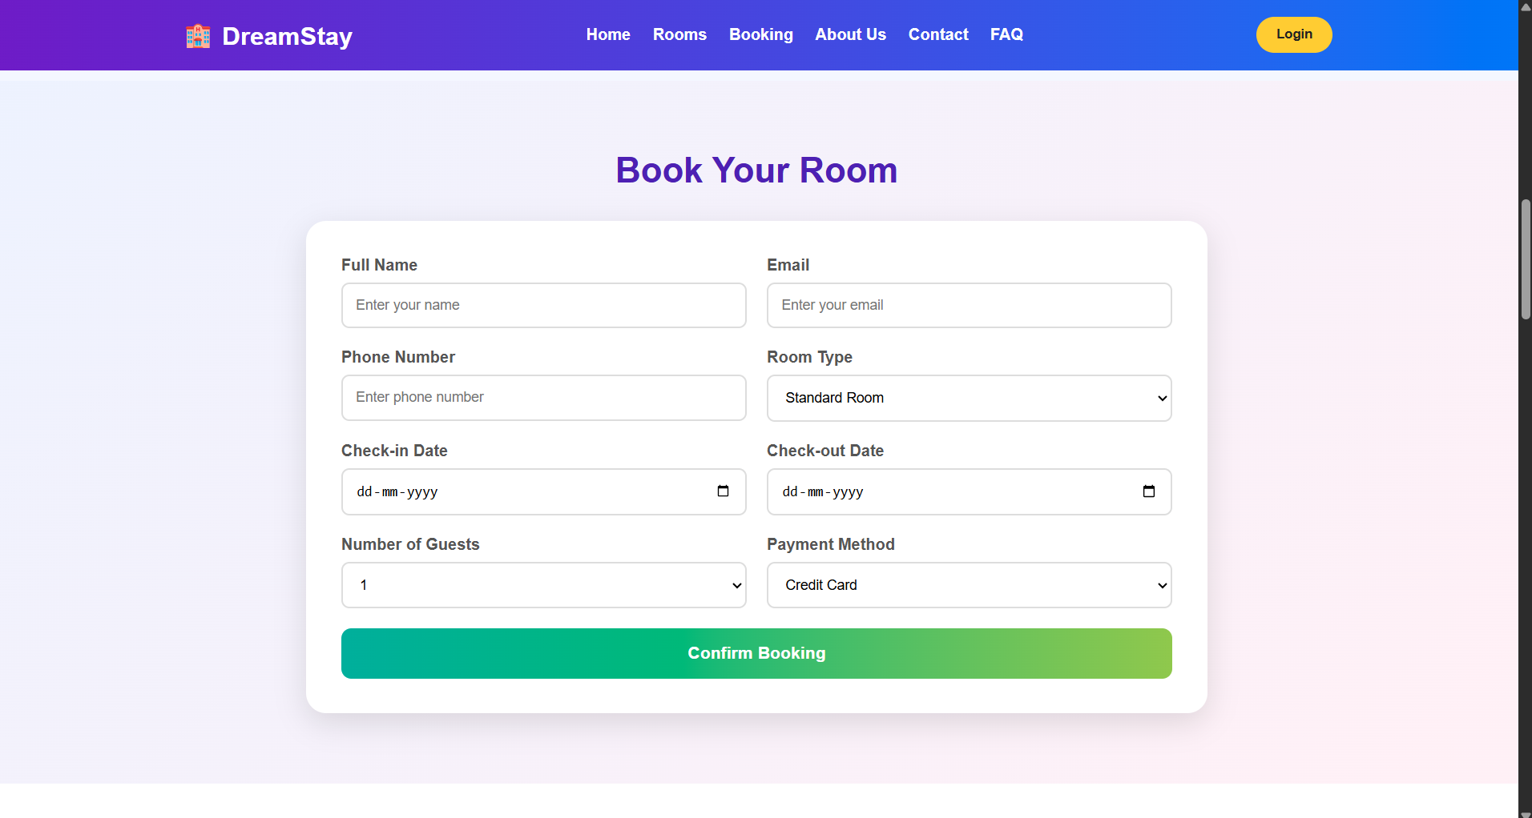
The home page and sample listings are displayed successfully.
The user can search or filter options and select an item.
The form validates required fields and displays a reference number.
Demo records are saved in browser localStorage and appear in history.
The admin demo panel allows a sample listing to be added.
NOTE
This is a classroom prototype. Real user authentication, database storage, payment gateway, live inventory, and email/SMS require secure backend implementation.

