EXPERIMENT III
Online Train Reservation System
AIM
To create a train reservation website for searching trains, checking class availability, entering passenger details, generating a demo PNR, checking status, and cancelling tickets.
ALGORITHM
Display the train search page.
Enter origin, destination, date, and class.
Show sample trains and seat availability.
Enter passenger details after selecting a train.
Calculate a sample fare based on class and passengers.
Confirm booking and generate a demo PNR.
Save reservation details in localStorage.
Allow PNR lookup and demo cancellation/refund estimate.
Display booking status and test input validation.
PROGRAM
Save the following code as index.html and open it in a modern browser.

<!DOCTYPE html>
<html lang="en">
<head>
<meta charset="UTF-8">
<meta name="viewport" content="width=device-width, initial-scale=1">
<title>Online Train Reservation System</title>
<style>
body{font-family:Arial,sans-serif;margin:0;background:#f3f6fa;color:#202b38}
header{background:#234a75;color:white;text-align:center;padding:22px}
main{max-width:1000px;margin:auto;padding:16px}
.panel,.card{background:white;padding:16px;margin:12px 0;border-radius:9px;box-shadow:0 2px 7px #d4dbe4}
input,select,button{padding:10px;margin:5px;border:1px solid #aab4c0;border-radius:5px}
button{background:#1e67a8;color:white;cursor:pointer}
.grid{display:grid;grid-template-columns:repeat(auto-fit,minmax(210px,1fr));gap:12px}
small{color:#586779}
</style>
</head>
<body>
<header><h1>Online Train Reservation System</h1><p>Responsive Internet Programming Lab Demo</p></header>
<main>
<section class="panel"><h2>Search / Filter</h2>
<input id="query" placeholder="Search or enter route / specialty">
<input id="date" type="date">
<select id="category"><option>All</option><option>Sleeper</option><option>AC 3 Tier</option><option>AC 2 Tier</option><option>Chair Car</option></select>
<button onclick="searchItems()">Search</button><p id="message"></p></section>
<h2>Available Options</h2><section id="items" class="grid"></section>
<section class="panel"><h2>Booking / Order Details</h2>
<input id="person" placeholder="Name">
<input id="contact" placeholder="Email or phone">
<input id="extra" placeholder="Additional details: seat, size, slot, or address">
<button onclick="submitRequest()">Confirm Demo Request</button><p id="confirmation"></p></section>
<section class="panel"><h2>My History</h2><button onclick="showHistory()">Refresh History</button><ul id="history"></ul></section>
<section class="panel"><h2>Administrator Panel</h2>
<input id="newItem" placeholder="New listing name"><input id="newPrice" type="number" placeholder="Price / fare">
<button onclick="adminAdd()">Add Listing</button>
<small>Classroom demo only. Real admin access must be protected by server-side authentication.</small></section>
</main>
<script>
const storageKey="trainRecords";
let items=["Sleeper","AC 3 Tier","AC 2 Tier","Chair Car"].map((name,i)=>({name:name,price:[500,800,1100,1500][i],details:"Sample description and availability"}));
let selected=null;
function render(list=items){
document.getElementById("items").innerHTML=list.map((x)=>`<article class="card"><h3>${x.name}</h3><p>Sample price: ₹${x.price}</p><small>${x.details}</small><p><button onclick="selectItem('${x.name.replace(/'/g,"\\'")}')">Select</button></p></article>`).join("");
}
function searchItems(){
let q=document.getElementById("query").value.toLowerCase();
let c=document.getElementById("category").value;
let found=items.filter(x=>(!q||x.name.toLowerCase().includes(q))&&(c==="All"||x.name===c));
render(found);
document.getElementById("message").textContent=found.length+" sample result(s) found. Live availability is not connected.";
}
function selectItem(name){selected=items.find(x=>x.name===name);document.getElementById("message").textContent="Selected: "+name;}
function submitRequest(){
let person=document.getElementById("person").value.trim();
let contact=document.getElementById("contact").value.trim();
if(!selected||!person||!contact){document.getElementById("confirmation").textContent="Select an option and enter your name and contact details.";return;}
let record={id:"REF"+Date.now().toString().slice(-7),person:person,contact:contact,choice:selected.name,date:document.getElementById("date").value,extra:document.getElementById("extra").value,status:"Submitted"};
let records=JSON.parse(localStorage.getItem(storageKey)||"[]");records.push(record);localStorage.setItem(storageKey,JSON.stringify(records));
document.getElementById("confirmation").textContent="Demo request saved. Reference: "+record.id;showHistory();
}
function showHistory(){
let records=JSON.parse(localStorage.getItem(storageKey)||"[]");
document.getElementById("history").innerHTML=records.map(x=>`<li>${x.id} — ${x.person} — ${x.choice} — ${x.status}</li>`).join("")||"<li>No records yet.</li>";
}
function adminAdd(){
let name=document.getElementById("newItem").value.trim();let price=Number(document.getElementById("newPrice").value);
if(!name||price<=0){alert("Enter a listing name and a positive price.");return;}
items.push({name:name,price:price,details:"Added through demo admin panel"});render();alert("Listing added for this browser session.");
}
render();showHistory();
</script>
</body>
</html>

RESULT
Thus, the online train reservation system was designed as a responsive web prototype using HTML, CSS, and JavaScript.
OUTPUT / TESTING
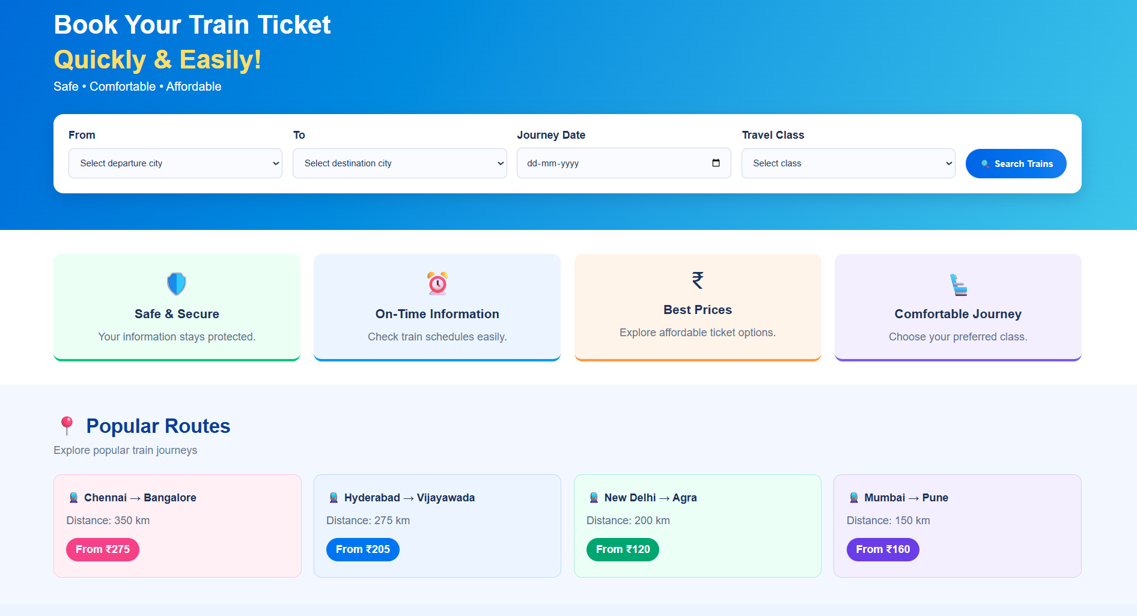
The home page and sample listings are displayed successfully.
The user can search or filter options and select an item.
The form validates required fields and displays a reference number.
Demo records are saved in browser localStorage and appear in history.
The admin demo panel allows a sample listing to be added.
NOTE
This is a classroom prototype. Real user authentication, database storage, payment gateway, live inventory, and email/SMS require secure backend implementation.

