EXPERIMENT IV
Online Flight Reservation System
AIM
To build a flight reservation website for searching flights, selecting class, entering passenger details, booking tickets, viewing itineraries, and managing sample schedules.
ALGORITHM
Display the flight search form.
Enter departure city, destination, date, passenger count, and class.
Show sample flights, fares, and available seats.
Select a flight and enter passenger details.
Validate the required details and calculate sample fare.
Generate a booking reference and save the ticket.
Display My Tickets and itinerary details.
Provide a demo cancellation and admin schedule form.
Test the website on desktop and mobile widths.
PROGRAM
Save the following code as index.html and open it in a modern browser.

<!DOCTYPE html>
<html lang="en">
<head>
<meta charset="UTF-8">
<meta name="viewport" content="width=device-width, initial-scale=1">
<title>Online Flight Reservation System</title>
<style>
body{font-family:Arial,sans-serif;margin:0;background:#f3f6fa;color:#202b38}
header{background:#234a75;color:white;text-align:center;padding:22px}
main{max-width:1000px;margin:auto;padding:16px}
.panel,.card{background:white;padding:16px;margin:12px 0;border-radius:9px;box-shadow:0 2px 7px #d4dbe4}
input,select,button{padding:10px;margin:5px;border:1px solid #aab4c0;border-radius:5px}
button{background:#1e67a8;color:white;cursor:pointer}
.grid{display:grid;grid-template-columns:repeat(auto-fit,minmax(210px,1fr));gap:12px}
small{color:#586779}
</style>
</head>
<body>
<header><h1>Online Flight Reservation System</h1><p>Responsive Internet Programming Lab Demo</p></header>
<main>
<section class="panel"><h2>Search / Filter</h2>
<input id="query" placeholder="Search or enter route / specialty">
<input id="date" type="date">
<select id="category"><option>All</option><option>Economy</option><option>Premium Economy</option><option>Business</option><option>First Class</option></select>
<button onclick="searchItems()">Search</button><p id="message"></p></section>
<h2>Available Options</h2><section id="items" class="grid"></section>
<section class="panel"><h2>Booking / Order Details</h2>
<input id="person" placeholder="Name">
<input id="contact" placeholder="Email or phone">
<input id="extra" placeholder="Additional details: seat, size, slot, or address">
<button onclick="submitRequest()">Confirm Demo Request</button><p id="confirmation"></p></section>
<section class="panel"><h2>My History</h2><button onclick="showHistory()">Refresh History</button><ul id="history"></ul></section>
<section class="panel"><h2>Administrator Panel</h2>
<input id="newItem" placeholder="New listing name"><input id="newPrice" type="number" placeholder="Price / fare">
<button onclick="adminAdd()">Add Listing</button>
<small>Classroom demo only. Real admin access must be protected by server-side authentication.</small></section>
</main>
<script>
const storageKey="flightRecords";
let items=["Economy","Premium Economy","Business","First Class"].map((name,i)=>({name:name,price:[500,800,1100,1500][i],details:"Sample description and availability"}));
let selected=null;
function render(list=items){
document.getElementById("items").innerHTML=list.map((x)=>`<article class="card"><h3>${x.name}</h3><p>Sample price: ₹${x.price}</p><small>${x.details}</small><p><button onclick="selectItem('${x.name.replace(/'/g,"\\'")}')">Select</button></p></article>`).join("");
}
function searchItems(){
let q=document.getElementById("query").value.toLowerCase();
let c=document.getElementById("category").value;
let found=items.filter(x=>(!q||x.name.toLowerCase().includes(q))&&(c==="All"||x.name===c));
render(found);
document.getElementById("message").textContent=found.length+" sample result(s) found. Live availability is not connected.";
}
function selectItem(name){selected=items.find(x=>x.name===name);document.getElementById("message").textContent="Selected: "+name;}
function submitRequest(){
let person=document.getElementById("person").value.trim();
let contact=document.getElementById("contact").value.trim();
if(!selected||!person||!contact){document.getElementById("confirmation").textContent="Select an option and enter your name and contact details.";return;}
let record={id:"REF"+Date.now().toString().slice(-7),person:person,contact:contact,choice:selected.name,date:document.getElementById("date").value,extra:document.getElementById("extra").value,status:"Submitted"};
let records=JSON.parse(localStorage.getItem(storageKey)||"[]");records.push(record);localStorage.setItem(storageKey,JSON.stringify(records));
document.getElementById("confirmation").textContent="Demo request saved. Reference: "+record.id;showHistory();
}
function showHistory(){
let records=JSON.parse(localStorage.getItem(storageKey)||"[]");
document.getElementById("history").innerHTML=records.map(x=>`<li>${x.id} — ${x.person} — ${x.choice} — ${x.status}</li>`).join("")||"<li>No records yet.</li>";
}
function adminAdd(){
let name=document.getElementById("newItem").value.trim();let price=Number(document.getElementById("newPrice").value);
if(!name||price<=0){alert("Enter a listing name and a positive price.");return;}
items.push({name:name,price:price,details:"Added through demo admin panel"});render();alert("Listing added for this browser session.");
}
render();showHistory();
</script>
</body>
</html>

RESULT
Thus, the online flight reservation system was designed as a responsive web prototype using HTML, CSS, and JavaScript.
OUTPUT / TESTING
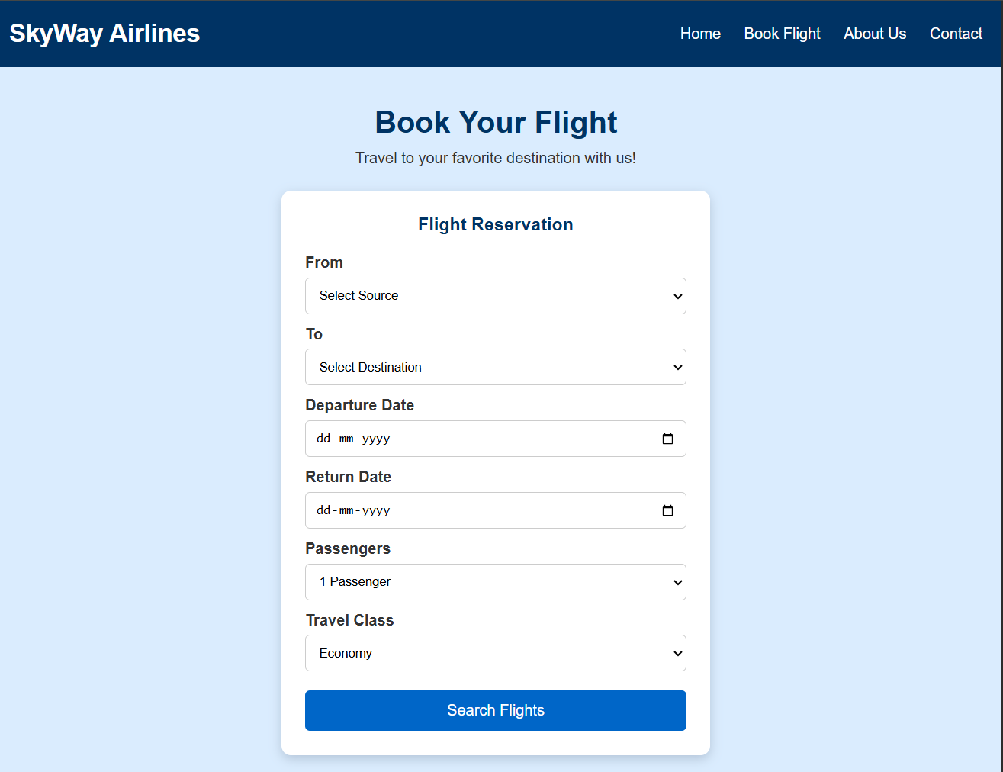
The home page and sample listings are displayed successfully.
The user can search or filter options and select an item.
The form validates required fields and displays a reference number.
Demo records are saved in browser localStorage and appear in history.
The admin demo panel allows a sample listing to be added.
NOTE
This is a classroom prototype. Real user authentication, database storage, payment gateway, live inventory, and email/SMS require secure backend implementation.

