EXPERIMENT VIII
TechSavvy Electronics Shopping Website
AIM
To develop an electronics shopping website with categories, search, product details, cart, checkout, order tracking, reviews, and product administration.
ALGORITHM
Display electronics categories and product cards.
Search by product name and filter by category or price.
Display product specifications and sample reviews.
Add selected products to the cart and update quantities.
Calculate subtotal and sample delivery fee.
Enter checkout details and create an order reference.
Display order history and order status.
Allow admin to add or edit product listings.
Test the cart, checkout, and responsive layout.
PROGRAM
Save the following code as index.html and open it in a modern browser.

<!DOCTYPE html>
<html lang="en">
<head>
<meta charset="UTF-8">
<meta name="viewport" content="width=device-width, initial-scale=1">
<title>TechSavvy Electronics Shopping Website</title>
<style>
body{font-family:Arial,sans-serif;margin:0;background:#f3f6fa;color:#202b38}
header{background:#234a75;color:white;text-align:center;padding:22px}
main{max-width:1000px;margin:auto;padding:16px}
.panel,.card{background:white;padding:16px;margin:12px 0;border-radius:9px;box-shadow:0 2px 7px #d4dbe4}
input,select,button{padding:10px;margin:5px;border:1px solid #aab4c0;border-radius:5px}
button{background:#1e67a8;color:white;cursor:pointer}
.grid{display:grid;grid-template-columns:repeat(auto-fit,minmax(210px,1fr));gap:12px}
small{color:#586779}
</style>
</head>
<body>
<header><h1>TechSavvy Electronics Shopping Website</h1><p>Responsive Internet Programming Lab Demo</p></header>
<main>
<section class="panel"><h2>Search / Filter</h2>
<input id="query" placeholder="Search or enter route / specialty">
<input id="date" type="date">
<select id="category"><option>All</option><option>Smartphone</option><option>Laptop</option><option>Tablet</option><option>Wireless Headphones</option></select>
<button onclick="searchItems()">Search</button><p id="message"></p></section>
<h2>Available Options</h2><section id="items" class="grid"></section>
<section class="panel"><h2>Booking / Order Details</h2>
<input id="person" placeholder="Name">
<input id="contact" placeholder="Email or phone">
<input id="extra" placeholder="Additional details: seat, size, slot, or address">
<button onclick="submitRequest()">Confirm Demo Request</button><p id="confirmation"></p></section>
<section class="panel"><h2>My History</h2><button onclick="showHistory()">Refresh History</button><ul id="history"></ul></section>
<section class="panel"><h2>Administrator Panel</h2>
<input id="newItem" placeholder="New listing name"><input id="newPrice" type="number" placeholder="Price / fare">
<button onclick="adminAdd()">Add Listing</button>
<small>Classroom demo only. Real admin access must be protected by server-side authentication.</small></section>
</main>
<script>
const storageKey="electronicsRecords";
let items=["Smartphone","Laptop","Tablet","Wireless Headphones"].map((name,i)=>({name:name,price:[500,800,1100,1500][i],details:"Sample description and availability"}));
let selected=null;
function render(list=items){
document.getElementById("items").innerHTML=list.map((x)=>`<article class="card"><h3>${x.name}</h3><p>Sample price: ₹${x.price}</p><small>${x.details}</small><p><button onclick="selectItem('${x.name.replace(/'/g,"\\'")}')">Select</button></p></article>`).join("");
}
function searchItems(){
let q=document.getElementById("query").value.toLowerCase();
let c=document.getElementById("category").value;
let found=items.filter(x=>(!q||x.name.toLowerCase().includes(q))&&(c==="All"||x.name===c));
render(found);
document.getElementById("message").textContent=found.length+" sample result(s) found. Live availability is not connected.";
}
function selectItem(name){selected=items.find(x=>x.name===name);document.getElementById("message").textContent="Selected: "+name;}
function submitRequest(){
let person=document.getElementById("person").value.trim();
let contact=document.getElementById("contact").value.trim();
if(!selected||!person||!contact){document.getElementById("confirmation").textContent="Select an option and enter your name and contact details.";return;}
let record={id:"REF"+Date.now().toString().slice(-7),person:person,contact:contact,choice:selected.name,date:document.getElementById("date").value,extra:document.getElementById("extra").value,status:"Submitted"};
let records=JSON.parse(localStorage.getItem(storageKey)||"[]");records.push(record);localStorage.setItem(storageKey,JSON.stringify(records));
document.getElementById("confirmation").textContent="Demo request saved. Reference: "+record.id;showHistory();
}
function showHistory(){
let records=JSON.parse(localStorage.getItem(storageKey)||"[]");
document.getElementById("history").innerHTML=records.map(x=>`<li>${x.id} — ${x.person} — ${x.choice} — ${x.status}</li>`).join("")||"<li>No records yet.</li>";
}
function adminAdd(){
let name=document.getElementById("newItem").value.trim();let price=Number(document.getElementById("newPrice").value);
if(!name||price<=0){alert("Enter a listing name and a positive price.");return;}
items.push({name:name,price:price,details:"Added through demo admin panel"});render();alert("Listing added for this browser session.");
}
render();showHistory();
</script>
</body>
</html>

RESULT
Thus, the techsavvy electronics shopping website was designed as a responsive web prototype using HTML, CSS, and JavaScript.
OUTPUT / TESTING
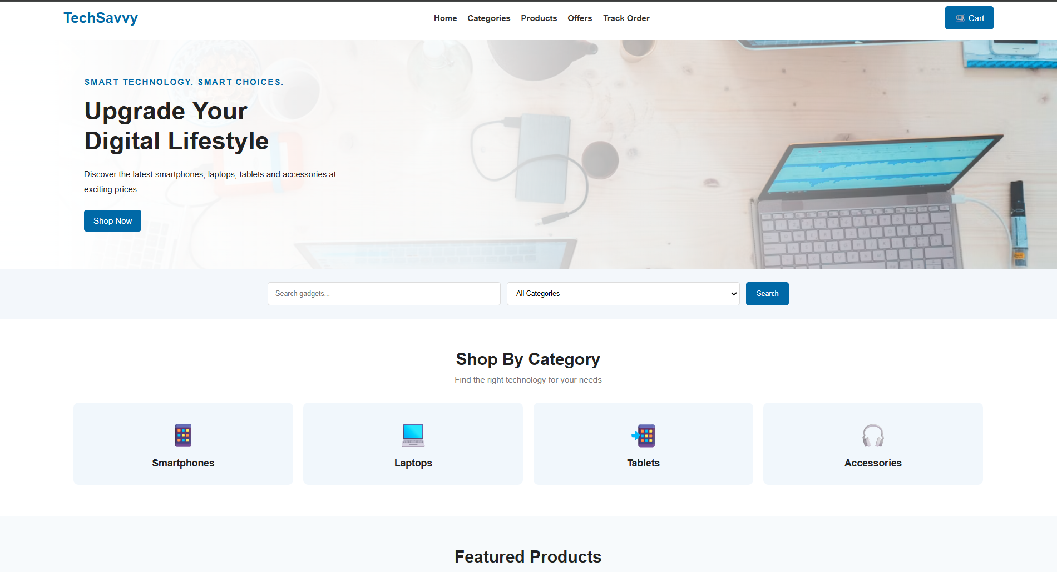
The home page and sample listings are displayed successfully.
The user can search or filter options and select an item.
The form validates required fields and displays a reference number.
Demo records are saved in browser localStorage and appear in history.
The admin demo panel allows a sample listing to be added.
NOTE
This is a classroom prototype. Real user authentication, database storage, payment gateway, live inventory, and email/SMS require secure backend implementation.

