EXPERIMENT IX
StyleHub Online Fashion Shopping Website
AIM
To develop a fashion shopping website with product categories, search and filters, size selection, cart, checkout, order history, and product administration.
ALGORITHM
Display fashion products grouped by category.
Search products and filter by category, size, and price.
Display details, available sizes, colors, and size guide.
Select size and add the product to the cart.
Update quantities and calculate total price.
Enter delivery details and place a demo order.
Display order history and return/exchange status.
Allow admin to manage product details and prices.
Test filtering and checkout validation.
PROGRAM
Save the following code as index.html and open it in a modern browser.

<!DOCTYPE html>
<html lang="en">
<head>
<meta charset="UTF-8">
<meta name="viewport" content="width=device-width, initial-scale=1">
<title>StyleHub Online Fashion Shopping Website</title>
<style>
body{font-family:Arial,sans-serif;margin:0;background:#f3f6fa;color:#202b38}
header{background:#234a75;color:white;text-align:center;padding:22px}
main{max-width:1000px;margin:auto;padding:16px}
.panel,.card{background:white;padding:16px;margin:12px 0;border-radius:9px;box-shadow:0 2px 7px #d4dbe4}
input,select,button{padding:10px;margin:5px;border:1px solid #aab4c0;border-radius:5px}
button{background:#1e67a8;color:white;cursor:pointer}
.grid{display:grid;grid-template-columns:repeat(auto-fit,minmax(210px,1fr));gap:12px}
small{color:#586779}
</style>
</head>
<body>
<header><h1>StyleHub Online Fashion Shopping Website</h1><p>Responsive Internet Programming Lab Demo</p></header>
<main>
<section class="panel"><h2>Search / Filter</h2>
<input id="query" placeholder="Search or enter route / specialty">
<input id="date" type="date">
<select id="category"><option>All</option><option>T-shirt</option><option>Jeans</option><option>Dress</option><option>Sneakers</option></select>
<button onclick="searchItems()">Search</button><p id="message"></p></section>
<h2>Available Options</h2><section id="items" class="grid"></section>
<section class="panel"><h2>Booking / Order Details</h2>
<input id="person" placeholder="Name">
<input id="contact" placeholder="Email or phone">
<input id="extra" placeholder="Additional details: seat, size, slot, or address">
<button onclick="submitRequest()">Confirm Demo Request</button><p id="confirmation"></p></section>
<section class="panel"><h2>My History</h2><button onclick="showHistory()">Refresh History</button><ul id="history"></ul></section>
<section class="panel"><h2>Administrator Panel</h2>
<input id="newItem" placeholder="New listing name"><input id="newPrice" type="number" placeholder="Price / fare">
<button onclick="adminAdd()">Add Listing</button>
<small>Classroom demo only. Real admin access must be protected by server-side authentication.</small></section>
</main>
<script>
const storageKey="fashionRecords";
let items=["T-shirt","Jeans","Dress","Sneakers"].map((name,i)=>({name:name,price:[500,800,1100,1500][i],details:"Sample description and availability"}));
let selected=null;
function render(list=items){
document.getElementById("items").innerHTML=list.map((x)=>`<article class="card"><h3>${x.name}</h3><p>Sample price: ₹${x.price}</p><small>${x.details}</small><p><button onclick="selectItem('${x.name.replace(/'/g,"\\'")}')">Select</button></p></article>`).join("");
}
function searchItems(){
let q=document.getElementById("query").value.toLowerCase();
let c=document.getElementById("category").value;
let found=items.filter(x=>(!q||x.name.toLowerCase().includes(q))&&(c==="All"||x.name===c));
render(found);
document.getElementById("message").textContent=found.length+" sample result(s) found. Live availability is not connected.";
}
function selectItem(name){selected=items.find(x=>x.name===name);document.getElementById("message").textContent="Selected: "+name;}
function submitRequest(){
let person=document.getElementById("person").value.trim();
let contact=document.getElementById("contact").value.trim();
if(!selected||!person||!contact){document.getElementById("confirmation").textContent="Select an option and enter your name and contact details.";return;}
let record={id:"REF"+Date.now().toString().slice(-7),person:person,contact:contact,choice:selected.name,date:document.getElementById("date").value,extra:document.getElementById("extra").value,status:"Submitted"};
let records=JSON.parse(localStorage.getItem(storageKey)||"[]");records.push(record);localStorage.setItem(storageKey,JSON.stringify(records));
document.getElementById("confirmation").textContent="Demo request saved. Reference: "+record.id;showHistory();
}
function showHistory(){
let records=JSON.parse(localStorage.getItem(storageKey)||"[]");
document.getElementById("history").innerHTML=records.map(x=>`<li>${x.id} — ${x.person} — ${x.choice} — ${x.status}</li>`).join("")||"<li>No records yet.</li>";
}
function adminAdd(){
let name=document.getElementById("newItem").value.trim();let price=Number(document.getElementById("newPrice").value);
if(!name||price<=0){alert("Enter a listing name and a positive price.");return;}
items.push({name:name,price:price,details:"Added through demo admin panel"});render();alert("Listing added for this browser session.");
}
render();showHistory();
</script>
</body>
</html>

RESULT
Thus, the stylehub online fashion shopping website was designed as a responsive web prototype using HTML, CSS, and JavaScript.
OUTPUT / TESTING:
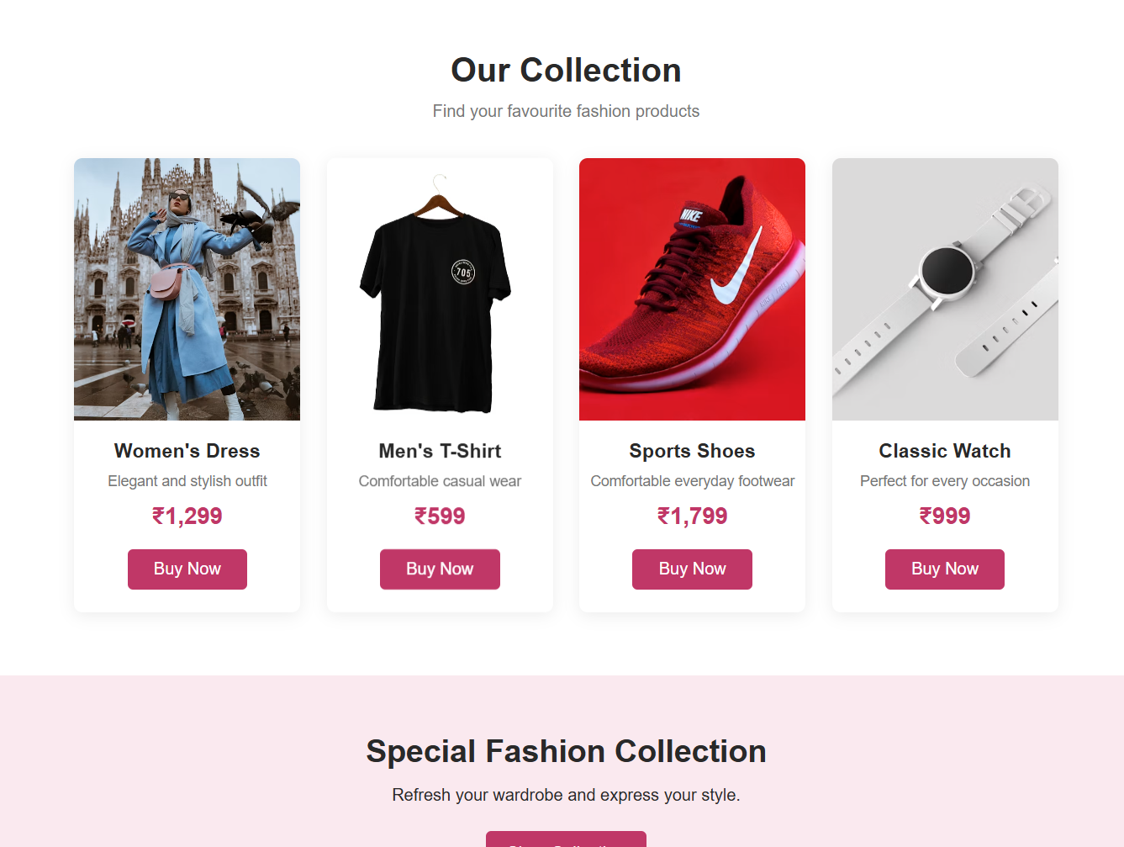
The home page and sample listings are displayed successfully.
The user can search or filter options and select an item.
The form validates required fields and displays a reference number.
Demo records are saved in browser localStorage and appear in history.
The admin demo panel allows a sample listing to be added.
NOTE
This is a classroom prototype. Real user authentication, database storage, payment gateway, live inventory, and email/SMS require secure backend implementation.

