EasyToll – Toll Wallet and Pass

Aim
Demonstrate a wallet, sample toll estimation, pass purchase, and transaction history.

Algorithm
1. Start the EasyToll website in a modern browser.
2. Display the project home page, navigation, and relevant search or service controls.
3. Read the user's selected filters and input values.
4. Display matching sample records and allow the user to select or save an item.
5. Accept the required form details and validate mandatory fields.
6. Create a demo reference or update the browser-stored sample record.
7. Display the operation result and stop.

Code (Complete HTML)
<!DOCTYPE html>
<html lang="en">
<head>
<meta charset="UTF-8">
<meta name="viewport" content="width=device-width, initial-scale=1.0">
<title>EasyToll | Toll Wallet and Pass</title>
<style>
*{box-sizing:border-box}body{margin:0;font-family:Arial,sans-serif;background:#f3f6fb;color:#1d2b40}
header{background:linear-gradient(120deg,#142b50,#2477a8);color:white;padding:24px 5%;display:flex;justify-content:space-between;align-items:center;gap:15px;flex-wrap:wrap}
h1{margin:0;font-size:30px}header p{margin:6px 0;color:#e1edff}nav{display:flex;gap:8px;flex-wrap:wrap}nav a{color:white;text-decoration:none;border:1px solid #ffffff77;padding:8px 12px;border-radius:8px}
main{max-width:1150px;margin:24px auto;padding:0 18px}.hero,.card{background:white;border:1px solid #e1e8f2;border-radius:16px;padding:20px;box-shadow:0 6px 20px #1d2b4010;margin-bottom:18px}
.grid{display:grid;grid-template-columns:repeat(auto-fit,minmax(220px,1fr));gap:15px}.card h3{margin-top:0}.price{font-size:22px;font-weight:bold;color:#14725b}.muted{color:#69778b}
label{display:block;font-weight:600;margin:10px 0 5px}input,select,textarea{font:inherit;width:100%;padding:11px;border:1px solid #cbd6e5;border-radius:8px;background:white}button,.btn{font:inherit;border:0;background:#176cbb;color:white;padding:11px 14px;border-radius:9px;cursor:pointer;display:inline-block;text-decoration:none;margin:5px 4px 5px 0}button:hover,.btn:hover{filter:brightness(.92)}.secondary{background:#e8eef8;color:#18365c}.notice{padding:13px;background:#fff6d8;border:1px solid #f0d77b;border-radius:10px;margin:15px 0}form{display:grid;grid-template-columns:repeat(auto-fit,minmax(210px,1fr));gap:12px}form .wide{grid-column:1/-1}.item{padding:13px;background:#f8faff;border:1px solid #dfe7f1;border-radius:10px;margin:8px 0}footer{text-align:center;padding:25px;color:#6d7b8e}@media(max-width:600px){h1{font-size:24px}}
</style>
</head>
<body>
<header><div><h1>EasyToll</h1><p>Toll Wallet and Pass</p></div><nav><a href="#home">Home</a><a href="#catalog">Browse</a><a href="#manage">Manage</a></nav></header>
<main id="home">
<section class="hero"><h2>Welcome to EasyToll</h2><p>Wallet top-up, route estimate, vehicle type, monthly pass, transaction log.</p>
<div class="grid"><div><label>Start location</label><input id="area" placeholder="Start"><label>Destination</label><input id="type" placeholder="Destination"><label>Vehicle</label><select id="vehicle"><option>Car</option><option>Van</option><option>Truck</option></select><button type="button" onclick="estimate()">Estimate sample toll</button><p id="estimate"></p><label>Add wallet money (₹)</label><input id="budget" type="number" min="1"><button type="button" onclick="topUp()">Add demo funds</button><p id="wallet"></p></div><div><h3>Quick information</h3><p>Toll prices are illustrative only; no live toll API, FASTag, or payment gateway is connected.</p><p id="status" class="muted">Ready. Browse the sample records below.</p><button class="secondary" onclick="clearDemo()">Reset demo data</button></div></div>
</section>
<section id="catalog"><h2>Browse records</h2><div class="grid" id="cards"></div></section>
<section id="manage" class="hero"><h2>Buy a monthly pass</h2><form id="mainForm"><label>Account holder</label><input id="person" required><label>Vehicle number</label><input id="detail" required><label>Pass</label><select id="contact"><option>Monthly demo pass — ₹1500</option></select><button class="wide" type="submit">Submit</button></form><p id="message"></p><div id="history"></div></section>
</main>
<footer>© 2026 EasyToll · Student project · Standalone responsive HTML</footer>
<script>
const seed=[{"name": "Car Toll Estimate", "category": "Car", "description": "Illustrative route fee", "price": 180}, {"name": "Van Toll Estimate", "category": "Van", "description": "Illustrative route fee", "price": 260}, {"name": "Truck Toll Estimate", "category": "Truck", "description": "Illustrative route fee", "price": 480}];
const project="EasyToll";
function getExtra(){return JSON.parse(localStorage[project+'_extra']||'[]')}
function getCart(){return JSON.parse(localStorage[project+'_cart']||'[]')}
function draw(){let data=seed.concat(getExtra());let typeEl=document.getElementById('type');let qEl=document.getElementById('area');let budgetEl=document.getElementById('budget');let type=typeEl?typeEl.value:'All';let q=qEl?qEl.value.toLowerCase():'';let budget=budgetEl&&budgetEl.value?Number(budgetEl.value):Infinity;
let root=document.getElementById('cards');root.innerHTML='';data.filter(x=>(type==='All'||x.category===type)&&(!q||x.name.toLowerCase().includes(q)||x.description.toLowerCase().includes(q)||x.category.toLowerCase().includes(q))&&(x.price===0||x.price<=budget)).forEach((x,i)=>{let d=document.createElement('article');d.className='card';d.innerHTML='<h3>'+x.name+'</h3><p>'+x.category+' · '+x.description+'</p><p class="price">'+(x.price?'₹'+x.price.toLocaleString('en-IN'):'Request details')+'</p><button onclick="choose(\''+x.name.replace(/'/g,"\\'")+'\')">Select</button><button class="secondary" onclick="saveItem(\''+x.name.replace(/'/g,"\\'")+'\')">Save</button>'+(project==='Home Finder'?'<a class="btn secondary" target="_blank" href="https://www.google.com/maps/search/?api=1&query='+encodeURIComponent(x.name)+'">Map</a>':'');root.appendChild(d)});showHistory()}
function choose(name){let d=document.getElementById('detail');if(d&&d.tagName==='INPUT')d.value=name;else if(d&&d.tagName==='TEXTAREA')d.value='Selected: '+name;let s=document.getElementById('status');if(s)s.textContent='Selected: '+name}
function saveItem(name){let a=getCart();if(!a.includes(name))a.push(name);localStorage[project+'_cart']=JSON.stringify(a);showHistory();document.getElementById('status').textContent='Saved: '+name}
function showHistory(){let a=getCart();let extra=getExtra();document.getElementById('history').innerHTML='<h3>Saved items / recent records</h3><div class="item">'+(a.length?a.join(', '):'No saved items yet.')+'</div>'+(extra.length?'<p class="muted">Custom records: '+extra.map(x=>x.name).join(', ')+'</p>':'')}
function clearDemo(){localStorage.removeItem(project+'_cart');localStorage.removeItem(project+'_extra');localStorage.removeItem(project+'_history');document.getElementById('message').textContent='Demo data cleared from this browser.';draw()}
function estimate(){let a=document.getElementById('area').value,b=document.getElementById('type').value;if(!a||!b){document.getElementById('estimate').textContent='Enter a start and destination.';return}let v=document.getElementById('vehicle').value,fee=v==='Truck'?480:v==='Van'?260:180;document.getElementById('estimate').textContent='Illustrative estimate: 3 sample toll points; total ₹'+fee+'.';document.getElementById('status').textContent='Sample estimate only.'}
function topUp(){let el=document.getElementById('budget'),n=Number(el.value);if(n<=0){alert('Enter a positive amount');return}let b=Number(localStorage[project+'_wallet']||500)+n;localStorage[project+'_wallet']=b;document.getElementById('wallet').textContent='Demo wallet balance: ₹'+b;document.getElementById('status').textContent='Wallet updated in this browser demo.'}
function verify(){let ok=document.getElementById('type').value==='123456';document.getElementById('verifymsg').textContent=ok?'Demo verification successful.':'Use sample OTP 123456.';localStorage[project+'_verified']=ok?'yes':'no'}
document.getElementById('mainForm').addEventListener('submit',function(e){e.preventDefault();let person=document.getElementById('person').value;let detail=document.getElementById('detail').value;let contact=document.getElementById('contact').value;let id='REF-'+Date.now().toString().slice(-7);let record={id:id,name:person,detail:detail,contact:contact,status:'Submitted'};let a=JSON.parse(localStorage[project+'_history']||'[]');a.unshift(record);localStorage[project+'_history']=JSON.stringify(a);
if(project==='ReNewMarket'&&detail&&Number(detail)>0){let extra=getExtra();extra.push({name:person,category:contact,description:'Seller listing',price:Number(detail)});localStorage[project+'_extra']=JSON.stringify(extra)}
document.getElementById('message').textContent="Demo pass request recorded."+' Reference: '+id;document.getElementById('status').textContent='Last request: '+id;this.reset();showHistory() });
draw();
</script>
</body>
</html>
Output:
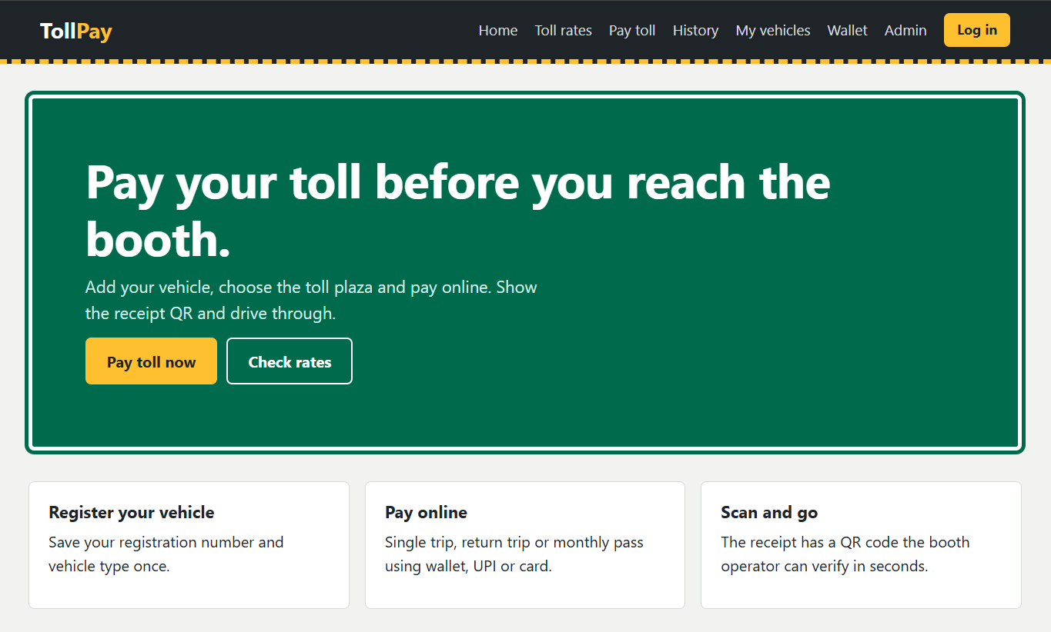

Results
Toll-payment prototype; prices are illustrative, not live toll data. Wallet top-up, route estimate, vehicle type, monthly pass, transaction log. The interface is a front-end demonstration; real authentication, database storage, and external integrations must be added for production use.

