ComplainEase – Complaint Management

Aim
Register complaints, receive reference IDs, track status, and let a demo officer update progress.

Algorithm
1. Start the ComplainEase website in a modern browser.
2. Display the project home page, navigation, and relevant search or service controls.
3. Read the user's selected filters and input values.
4. Display matching sample records and allow the user to select or save an item.
5. Accept the required form details and validate mandatory fields.
6. Create a demo reference or update the browser-stored sample record.
7. Display the operation result and stop.

Code (Complete HTML)
<!DOCTYPE html>
<html lang="en">
<head>
<meta charset="UTF-8">
<meta name="viewport" content="width=device-width, initial-scale=1.0">
<title>ComplainEase | Complaint Management</title>
<style>
*{box-sizing:border-box}body{margin:0;font-family:Arial,sans-serif;background:#f3f6fb;color:#1d2b40}
header{background:linear-gradient(120deg,#142b50,#2477a8);color:white;padding:24px 5%;display:flex;justify-content:space-between;align-items:center;gap:15px;flex-wrap:wrap}
h1{margin:0;font-size:30px}header p{margin:6px 0;color:#e1edff}nav{display:flex;gap:8px;flex-wrap:wrap}nav a{color:white;text-decoration:none;border:1px solid #ffffff77;padding:8px 12px;border-radius:8px}
main{max-width:1150px;margin:24px auto;padding:0 18px}.hero,.card{background:white;border:1px solid #e1e8f2;border-radius:16px;padding:20px;box-shadow:0 6px 20px #1d2b4010;margin-bottom:18px}
.grid{display:grid;grid-template-columns:repeat(auto-fit,minmax(220px,1fr));gap:15px}.card h3{margin-top:0}.price{font-size:22px;font-weight:bold;color:#14725b}.muted{color:#69778b}
label{display:block;font-weight:600;margin:10px 0 5px}input,select,textarea{font:inherit;width:100%;padding:11px;border:1px solid #cbd6e5;border-radius:8px;background:white}button,.btn{font:inherit;border:0;background:#176cbb;color:white;padding:11px 14px;border-radius:9px;cursor:pointer;display:inline-block;text-decoration:none;margin:5px 4px 5px 0}button:hover,.btn:hover{filter:brightness(.92)}.secondary{background:#e8eef8;color:#18365c}.notice{padding:13px;background:#fff6d8;border:1px solid #f0d77b;border-radius:10px;margin:15px 0}form{display:grid;grid-template-columns:repeat(auto-fit,minmax(210px,1fr));gap:12px}form .wide{grid-column:1/-1}.item{padding:13px;background:#f8faff;border:1px solid #dfe7f1;border-radius:10px;margin:8px 0}footer{text-align:center;padding:25px;color:#6d7b8e}@media(max-width:600px){h1{font-size:24px}}
</style>
</head>
<body>
<header><div><h1>ComplainEase</h1><p>Complaint Management</p></div><nav><a href="#home">Home</a><a href="#catalog">Browse</a><a href="#manage">Manage</a></nav></header>
<main id="home">
<section class="hero"><h2>Welcome to ComplainEase</h2><p>Complaint category, location, proof filename, status tracker, officer updates, feedback.</p>
<div class="grid"><div><label>Complaint category</label><select id="type"><option>Roads</option><option>Water</option><option>Electricity</option><option>Sanitation</option><option>Other</option></select><label>Location / area</label><input id="area" placeholder="Street or locality"></div><div><h3>Quick information</h3><p>This is a demo complaint portal. Do not submit sensitive personal information.</p><p id="status" class="muted">Ready. Browse the sample records below.</p><button class="secondary" onclick="clearDemo()">Reset demo data</button></div></div>
</section>
<section id="catalog"><h2>Browse records</h2><div class="grid" id="cards"></div></section>
<section id="manage" class="hero"><h2>Post a complaint</h2><form id="mainForm"><label>Your name</label><input id="person" required><label>Complaint description</label><textarea id="detail" required></textarea><label>Proof filename (optional)</label><input id="contact"><button class="wide" type="submit">Submit</button></form><p id="message"></p><div id="history"></div></section>
</main>
<footer>© 2026 ComplainEase · Student project · Standalone responsive HTML</footer>
<script>
const seed=[{"name": "Road maintenance", "category": "Roads", "description": "Demo service", "price": 0}, {"name": "Water supply", "category": "Water", "description": "Demo service", "price": 0}, {"name": "Street lighting", "category": "Electricity", "description": "Demo service", "price": 0}];
const project="ComplainEase";
function getExtra(){return JSON.parse(localStorage[project+'_extra']||'[]')}
function getCart(){return JSON.parse(localStorage[project+'_cart']||'[]')}
function draw(){let data=seed.concat(getExtra());let typeEl=document.getElementById('type');let qEl=document.getElementById('area');let budgetEl=document.getElementById('budget');let type=typeEl?typeEl.value:'All';let q=qEl?qEl.value.toLowerCase():'';let budget=budgetEl&&budgetEl.value?Number(budgetEl.value):Infinity;
let root=document.getElementById('cards');root.innerHTML='';data.filter(x=>(type==='All'||x.category===type)&&(!q||x.name.toLowerCase().includes(q)||x.description.toLowerCase().includes(q)||x.category.toLowerCase().includes(q))&&(x.price===0||x.price<=budget)).forEach((x,i)=>{let d=document.createElement('article');d.className='card';d.innerHTML='<h3>'+x.name+'</h3><p>'+x.category+' · '+x.description+'</p><p class="price">'+(x.price?'₹'+x.price.toLocaleString('en-IN'):'Request details')+'</p><button onclick="choose(\''+x.name.replace(/'/g,"\\'")+'\')">Select</button><button class="secondary" onclick="saveItem(\''+x.name.replace(/'/g,"\\'")+'\')">Save</button>'+(project==='Home Finder'?'<a class="btn secondary" target="_blank" href="https://www.google.com/maps/search/?api=1&query='+encodeURIComponent(x.name)+'">Map</a>':'');root.appendChild(d)});showHistory()}
function choose(name){let d=document.getElementById('detail');if(d&&d.tagName==='INPUT')d.value=name;else if(d&&d.tagName==='TEXTAREA')d.value='Selected: '+name;let s=document.getElementById('status');if(s)s.textContent='Selected: '+name}
function saveItem(name){let a=getCart();if(!a.includes(name))a.push(name);localStorage[project+'_cart']=JSON.stringify(a);showHistory();document.getElementById('status').textContent='Saved: '+name}
function showHistory(){let a=getCart();let extra=getExtra();document.getElementById('history').innerHTML='<h3>Saved items / recent records</h3><div class="item">'+(a.length?a.join(', '):'No saved items yet.')+'</div>'+(extra.length?'<p class="muted">Custom records: '+extra.map(x=>x.name).join(', ')+'</p>':'')}
function clearDemo(){localStorage.removeItem(project+'_cart');localStorage.removeItem(project+'_extra');localStorage.removeItem(project+'_history');document.getElementById('message').textContent='Demo data cleared from this browser.';draw()}
function estimate(){let a=document.getElementById('area').value,b=document.getElementById('type').value;if(!a||!b){document.getElementById('estimate').textContent='Enter a start and destination.';return}let v=document.getElementById('vehicle').value,fee=v==='Truck'?480:v==='Van'?260:180;document.getElementById('estimate').textContent='Illustrative estimate: 3 sample toll points; total ₹'+fee+'.';document.getElementById('status').textContent='Sample estimate only.'}
function topUp(){let el=document.getElementById('budget'),n=Number(el.value);if(n<=0){alert('Enter a positive amount');return}let b=Number(localStorage[project+'_wallet']||500)+n;localStorage[project+'_wallet']=b;document.getElementById('wallet').textContent='Demo wallet balance: ₹'+b;document.getElementById('status').textContent='Wallet updated in this browser demo.'}
function verify(){let ok=document.getElementById('type').value==='123456';document.getElementById('verifymsg').textContent=ok?'Demo verification successful.':'Use sample OTP 123456.';localStorage[project+'_verified']=ok?'yes':'no'}
document.getElementById('mainForm').addEventListener('submit',function(e){e.preventDefault();let person=document.getElementById('person').value;let detail=document.getElementById('detail').value;let contact=document.getElementById('contact').value;let id='REF-'+Date.now().toString().slice(-7);let record={id:id,name:person,detail:detail,contact:contact,status:'Submitted'};let a=JSON.parse(localStorage[project+'_history']||'[]');a.unshift(record);localStorage[project+'_history']=JSON.stringify(a);
if(project==='ReNewMarket'&&detail&&Number(detail)>0){let extra=getExtra();extra.push({name:person,category:contact,description:'Seller listing',price:Number(detail)});localStorage[project+'_extra']=JSON.stringify(extra)}
document.getElementById('message').textContent="Complaint submitted. Keep the reference ID displayed below."+' Reference: '+id;document.getElementById('status').textContent='Last request: '+id;this.reset();showHistory() });
draw();
</script>
</body>
</html>
Out Put:
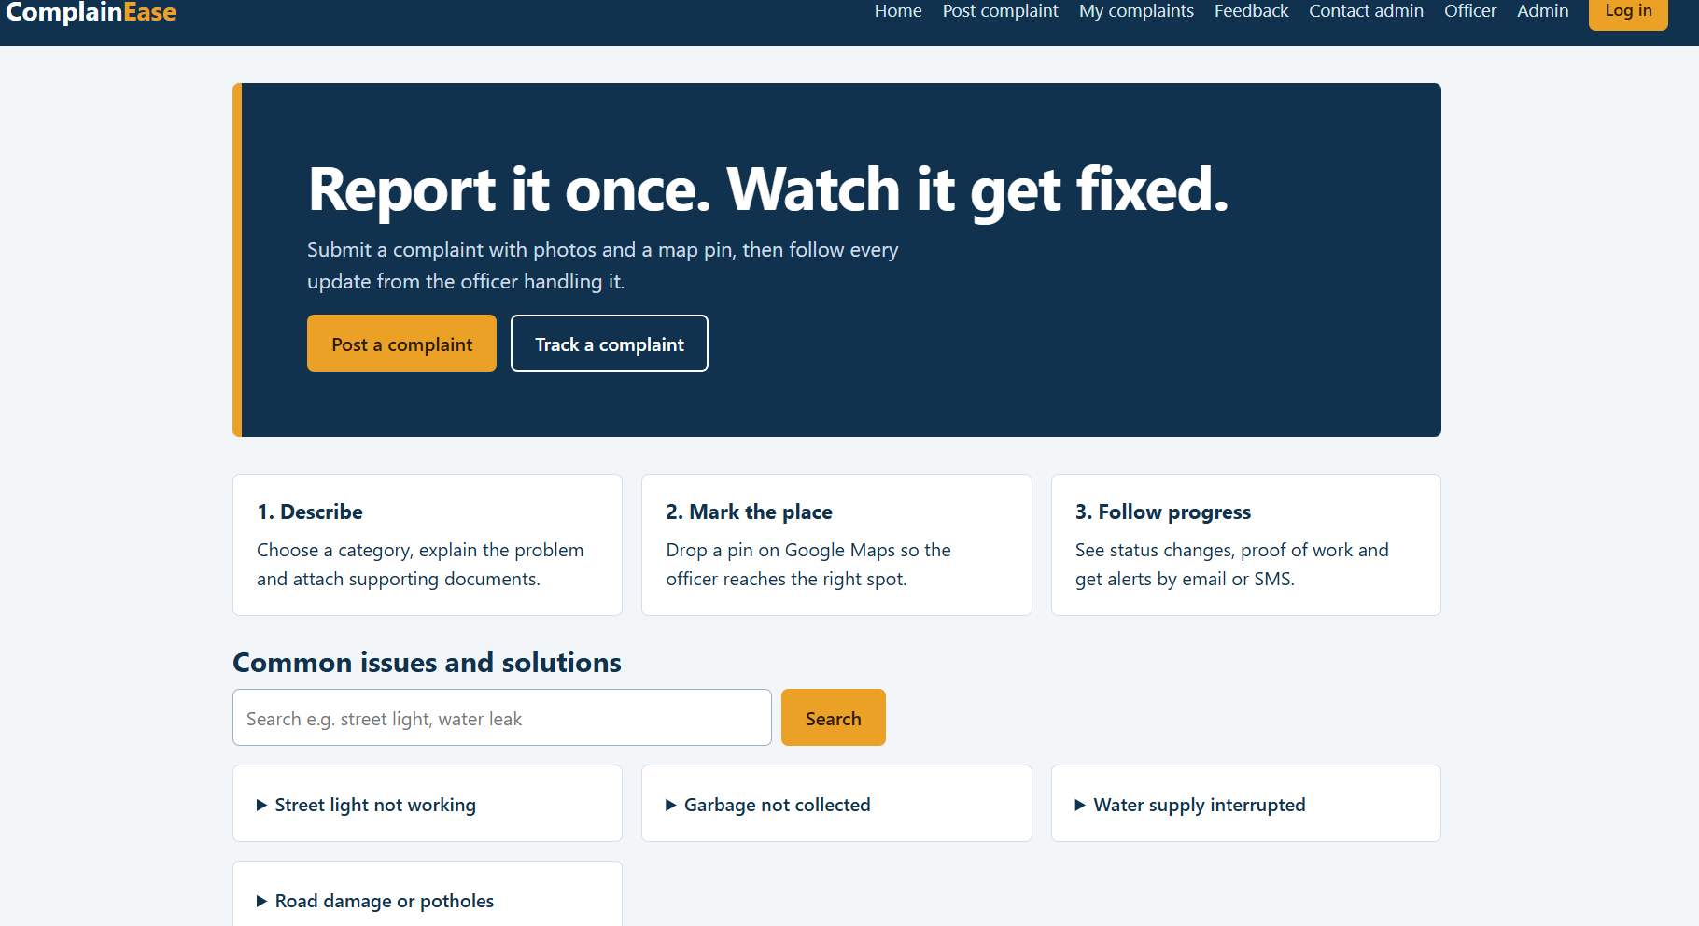

Results
Complaint tracking and officer-workflow prototype. Complaint category, location, proof filename, status tracker, officer updates, feedback. The interface is a front-end demonstration; real authentication, database storage, and external integrations must be added for production use.

