VoteOnline – E-Voting Interface Prototype

Aim
Demonstrate candidate selection with a mock verification code and a browser-only vote receipt.

Algorithm
1. Start the VoteOnline website in a modern browser.
2. Display the project home page, navigation, and relevant search or service controls.
3. Read the user's selected filters and input values.
4. Display matching sample records and allow the user to select or save an item.
5. Accept the required form details and validate mandatory fields.
6. Create a demo reference or update the browser-stored sample record.
7. Display the operation result and stop.

Code (Complete HTML)
<!DOCTYPE html>
<html lang="en">
<head>
<meta charset="UTF-8">
<meta name="viewport" content="width=device-width, initial-scale=1.0">
<title>VoteOnline | E-Voting Interface Prototype</title>
<style>
*{box-sizing:border-box}body{margin:0;font-family:Arial,sans-serif;background:#f3f6fb;color:#1d2b40}
header{background:linear-gradient(120deg,#142b50,#2477a8);color:white;padding:24px 5%;display:flex;justify-content:space-between;align-items:center;gap:15px;flex-wrap:wrap}
h1{margin:0;font-size:30px}header p{margin:6px 0;color:#e1edff}nav{display:flex;gap:8px;flex-wrap:wrap}nav a{color:white;text-decoration:none;border:1px solid #ffffff77;padding:8px 12px;border-radius:8px}
main{max-width:1150px;margin:24px auto;padding:0 18px}.hero,.card{background:white;border:1px solid #e1e8f2;border-radius:16px;padding:20px;box-shadow:0 6px 20px #1d2b4010;margin-bottom:18px}
.grid{display:grid;grid-template-columns:repeat(auto-fit,minmax(220px,1fr));gap:15px}.card h3{margin-top:0}.price{font-size:22px;font-weight:bold;color:#14725b}.muted{color:#69778b}
label{display:block;font-weight:600;margin:10px 0 5px}input,select,textarea{font:inherit;width:100%;padding:11px;border:1px solid #cbd6e5;border-radius:8px;background:white}button,.btn{font:inherit;border:0;background:#176cbb;color:white;padding:11px 14px;border-radius:9px;cursor:pointer;display:inline-block;text-decoration:none;margin:5px 4px 5px 0}button:hover,.btn:hover{filter:brightness(.92)}.secondary{background:#e8eef8;color:#18365c}.notice{padding:13px;background:#fff6d8;border:1px solid #f0d77b;border-radius:10px;margin:15px 0}form{display:grid;grid-template-columns:repeat(auto-fit,minmax(210px,1fr));gap:12px}form .wide{grid-column:1/-1}.item{padding:13px;background:#f8faff;border:1px solid #dfe7f1;border-radius:10px;margin:8px 0}footer{text-align:center;padding:25px;color:#6d7b8e}@media(max-width:600px){h1{font-size:24px}}
</style>
</head>
<body>
<header><div><h1>VoteOnline</h1><p>E-Voting Interface Prototype</p></div><nav><a href="#home">Home</a><a href="#catalog">Browse</a><a href="#manage">Manage</a></nav></header>
<main id="home">
<section class="hero"><h2>Welcome to VoteOnline</h2><p>Sample election, demo voter ID, mock OTP, candidate cards, confirmation receipt.</p>
<div class="grid"><div><label>Demo voter ID</label><input id="area" placeholder="DEMO-1001"><label>Demo OTP (use 123456)</label><input id="type" maxlength="6" placeholder="123456"><button type="button" onclick="verify()">Verify demo voter</button><p id="verifymsg"></p></div><div><h3>Quick information</h3><p>Not a real election system. Never use real voter credentials. This prototype is not secure or legally valid for actual voting.</p><p id="status" class="muted">Ready. Browse the sample records below.</p><button class="secondary" onclick="clearDemo()">Reset demo data</button></div></div>
</section>
<section id="catalog"><h2>Browse records</h2><div class="grid" id="cards"></div></section>
<section id="manage" class="hero"><h2>Demo vote receipt</h2><form id="mainForm"><label>Voter name (demo)</label><input id="person" required><label>Selected candidate</label><input id="detail" required><label>Confirmation note</label><input id="contact" value="Educational mock-up"><button class="wide" type="submit">Submit</button></form><p id="message"></p><div id="history"></div></section>
</main>
<footer>© 2026 VoteOnline · Student project · Standalone responsive HTML</footer>
<script>
const seed=[{"name": "Candidate A", "category": "Student welfare", "description": "Sample candidate", "price": 1}, {"name": "Candidate B", "category": "Sustainability", "description": "Sample candidate", "price": 1}, {"name": "Candidate C", "category": "Technology", "description": "Sample candidate", "price": 1}];
const project="VoteOnline";
function getExtra(){return JSON.parse(localStorage[project+'_extra']||'[]')}
function getCart(){return JSON.parse(localStorage[project+'_cart']||'[]')}
function draw(){let data=seed.concat(getExtra());let typeEl=document.getElementById('type');let qEl=document.getElementById('area');let budgetEl=document.getElementById('budget');let type=typeEl?typeEl.value:'All';let q=qEl?qEl.value.toLowerCase():'';let budget=budgetEl&&budgetEl.value?Number(budgetEl.value):Infinity;
let root=document.getElementById('cards');root.innerHTML='';data.filter(x=>(type==='All'||x.category===type)&&(!q||x.name.toLowerCase().includes(q)||x.description.toLowerCase().includes(q)||x.category.toLowerCase().includes(q))&&(x.price===0||x.price<=budget)).forEach((x,i)=>{let d=document.createElement('article');d.className='card';d.innerHTML='<h3>'+x.name+'</h3><p>'+x.category+' · '+x.description+'</p><p class="price">'+(x.price?'₹'+x.price.toLocaleString('en-IN'):'Request details')+'</p><button onclick="choose(\''+x.name.replace(/'/g,"\\'")+'\')">Select</button><button class="secondary" onclick="saveItem(\''+x.name.replace(/'/g,"\\'")+'\')">Save</button>'+(project==='Home Finder'?'<a class="btn secondary" target="_blank" href="https://www.google.com/maps/search/?api=1&query='+encodeURIComponent(x.name)+'">Map</a>':'');root.appendChild(d)});showHistory()}
function choose(name){let d=document.getElementById('detail');if(d&&d.tagName==='INPUT')d.value=name;else if(d&&d.tagName==='TEXTAREA')d.value='Selected: '+name;let s=document.getElementById('status');if(s)s.textContent='Selected: '+name}
function saveItem(name){let a=getCart();if(!a.includes(name))a.push(name);localStorage[project+'_cart']=JSON.stringify(a);showHistory();document.getElementById('status').textContent='Saved: '+name}
function showHistory(){let a=getCart();let extra=getExtra();document.getElementById('history').innerHTML='<h3>Saved items / recent records</h3><div class="item">'+(a.length?a.join(', '):'No saved items yet.')+'</div>'+(extra.length?'<p class="muted">Custom records: '+extra.map(x=>x.name).join(', ')+'</p>':'')}
function clearDemo(){localStorage.removeItem(project+'_cart');localStorage.removeItem(project+'_extra');localStorage.removeItem(project+'_history');document.getElementById('message').textContent='Demo data cleared from this browser.';draw()}
function estimate(){let a=document.getElementById('area').value,b=document.getElementById('type').value;if(!a||!b){document.getElementById('estimate').textContent='Enter a start and destination.';return}let v=document.getElementById('vehicle').value,fee=v==='Truck'?480:v==='Van'?260:180;document.getElementById('estimate').textContent='Illustrative estimate: 3 sample toll points; total ₹'+fee+'.';document.getElementById('status').textContent='Sample estimate only.'}
function topUp(){let el=document.getElementById('budget'),n=Number(el.value);if(n<=0){alert('Enter a positive amount');return}let b=Number(localStorage[project+'_wallet']||500)+n;localStorage[project+'_wallet']=b;document.getElementById('wallet').textContent='Demo wallet balance: ₹'+b;document.getElementById('status').textContent='Wallet updated in this browser demo.'}
function verify(){let ok=document.getElementById('type').value==='123456';document.getElementById('verifymsg').textContent=ok?'Demo verification successful.':'Use sample OTP 123456.';localStorage[project+'_verified']=ok?'yes':'no'}
document.getElementById('mainForm').addEventListener('submit',function(e){e.preventDefault();let person=document.getElementById('person').value;let detail=document.getElementById('detail').value;let contact=document.getElementById('contact').value;let id='REF-'+Date.now().toString().slice(-7);let record={id:id,name:person,detail:detail,contact:contact,status:'Submitted'};let a=JSON.parse(localStorage[project+'_history']||'[]');a.unshift(record);localStorage[project+'_history']=JSON.stringify(a);
if(project==='ReNewMarket'&&detail&&Number(detail)>0){let extra=getExtra();extra.push({name:person,category:contact,description:'Seller listing',price:Number(detail)});localStorage[project+'_extra']=JSON.stringify(extra)}
document.getElementById('message').textContent="Demo vote recorded only in this browser."+' Reference: '+id;document.getElementById('status').textContent='Last request: '+id;this.reset();showHistory() });
draw();
</script>
</body>
</html>
Output:
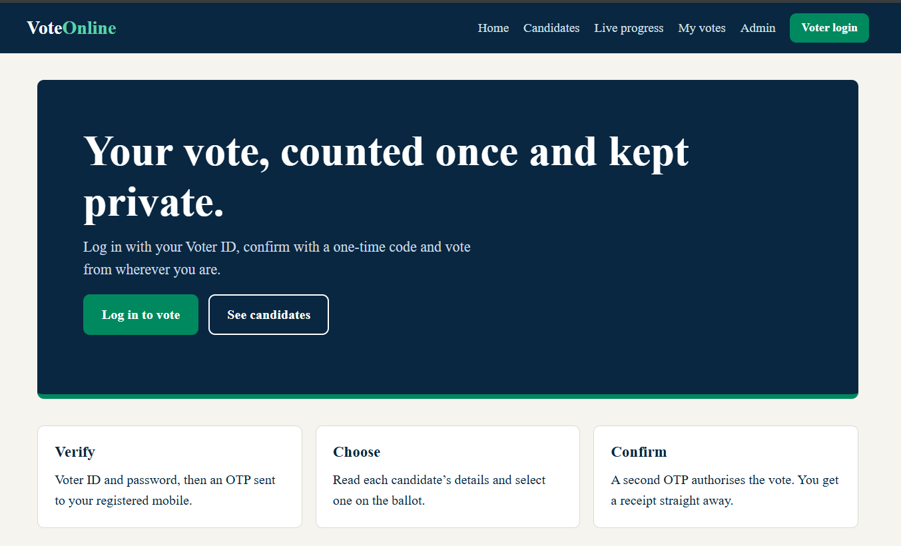

Results
Educational mock-up only; not suitable for real elections. Sample election, demo voter ID, mock OTP, candidate cards, confirmation receipt. The interface is a front-end demonstration; real authentication, database storage, and external integrations must be added for production use.

