AgriMart – Agricultural Products Marketplace

Aim
Browse farm supplies, add items to a cart, enter shipping details, and track demo orders.

Algorithm
1. Start the AgriMart website in a modern browser.
2. Display the project home page, navigation, and relevant search or service controls.
3. Read the user's selected filters and input values.
4. Display matching sample records and allow the user to select or save an item.
5. Accept the required form details and validate mandatory fields.
6. Create a demo reference or update the browser-stored sample record.
7. Display the operation result and stop.

Code (Complete HTML)
<!DOCTYPE html>
<html lang="en">
<head>
<meta charset="UTF-8">
<meta name="viewport" content="width=device-width, initial-scale=1.0">
<title>AgriMart | Agricultural Products Marketplace</title>
<style>
*{box-sizing:border-box}body{margin:0;font-family:Arial,sans-serif;background:#f3f6fb;color:#1d2b40}
header{background:linear-gradient(120deg,#142b50,#2477a8);color:white;padding:24px 5%;display:flex;justify-content:space-between;align-items:center;gap:15px;flex-wrap:wrap}
h1{margin:0;font-size:30px}header p{margin:6px 0;color:#e1edff}nav{display:flex;gap:8px;flex-wrap:wrap}nav a{color:white;text-decoration:none;border:1px solid #ffffff77;padding:8px 12px;border-radius:8px}
main{max-width:1150px;margin:24px auto;padding:0 18px}.hero,.card{background:white;border:1px solid #e1e8f2;border-radius:16px;padding:20px;box-shadow:0 6px 20px #1d2b4010;margin-bottom:18px}
.grid{display:grid;grid-template-columns:repeat(auto-fit,minmax(220px,1fr));gap:15px}.card h3{margin-top:0}.price{font-size:22px;font-weight:bold;color:#14725b}.muted{color:#69778b}
label{display:block;font-weight:600;margin:10px 0 5px}input,select,textarea{font:inherit;width:100%;padding:11px;border:1px solid #cbd6e5;border-radius:8px;background:white}button,.btn{font:inherit;border:0;background:#176cbb;color:white;padding:11px 14px;border-radius:9px;cursor:pointer;display:inline-block;text-decoration:none;margin:5px 4px 5px 0}button:hover,.btn:hover{filter:brightness(.92)}.secondary{background:#e8eef8;color:#18365c}.notice{padding:13px;background:#fff6d8;border:1px solid #f0d77b;border-radius:10px;margin:15px 0}form{display:grid;grid-template-columns:repeat(auto-fit,minmax(210px,1fr));gap:12px}form .wide{grid-column:1/-1}.item{padding:13px;background:#f8faff;border:1px solid #dfe7f1;border-radius:10px;margin:8px 0}footer{text-align:center;padding:25px;color:#6d7b8e}@media(max-width:600px){h1{font-size:24px}}
</style>
</head>
<body>
<header><div><h1>AgriMart</h1><p>Agricultural Products Marketplace</p></div><nav><a href="#home">Home</a><a href="#catalog">Browse</a><a href="#manage">Manage</a></nav></header>
<main id="home">
<section class="hero"><h2>Welcome to AgriMart</h2><p>Seeds, fertilizers, tools, equipment, cart, shipping address, order status.</p>
<div class="grid"><div><label>Category</label><select id="type"><option>All</option><option>Seeds</option><option>Fertilizers</option><option>Tools</option><option>Equipment</option></select><label>Search product</label><input id="area" placeholder="Seeds, tools..."></div><div><h3>Quick information</h3><p>No actual payment, OTP, or shipping provider is connected.</p><p id="status" class="muted">Ready. Browse the sample records below.</p><button class="secondary" onclick="clearDemo()">Reset demo data</button></div></div>
</section>
<section id="catalog"><h2>Browse records</h2><div class="grid" id="cards"></div></section>
<section id="manage" class="hero"><h2>Shipping and checkout</h2><form id="mainForm"><label>Customer name</label><input id="person" required><label>Shipping address</label><textarea id="detail" required></textarea><label>Payment demo</label><select id="contact"><option>Demo wallet</option><option>Cash on delivery (demo)</option></select><button class="wide" type="submit">Submit</button></form><p id="message"></p><div id="history"></div></section>
</main>
<footer>© 2026 AgriMart · Student project · Standalone responsive HTML</footer>
<script>
const seed=[{"name": "Tomato Seeds", "category": "Seeds", "description": "Farm supplies", "price": 180}, {"name": "Organic Compost", "category": "Fertilizers", "description": "Farm supplies", "price": 350}, {"name": "Hand Sprayer", "category": "Tools", "description": "Farm supplies", "price": 650}];
const project="AgriMart";
function getExtra(){return JSON.parse(localStorage[project+'_extra']||'[]')}
function getCart(){return JSON.parse(localStorage[project+'_cart']||'[]')}
function draw(){let data=seed.concat(getExtra());let typeEl=document.getElementById('type');let qEl=document.getElementById('area');let budgetEl=document.getElementById('budget');let type=typeEl?typeEl.value:'All';let q=qEl?qEl.value.toLowerCase():'';let budget=budgetEl&&budgetEl.value?Number(budgetEl.value):Infinity;
let root=document.getElementById('cards');root.innerHTML='';data.filter(x=>(type==='All'||x.category===type)&&(!q||x.name.toLowerCase().includes(q)||x.description.toLowerCase().includes(q)||x.category.toLowerCase().includes(q))&&(x.price===0||x.price<=budget)).forEach((x,i)=>{let d=document.createElement('article');d.className='card';d.innerHTML='<h3>'+x.name+'</h3><p>'+x.category+' · '+x.description+'</p><p class="price">'+(x.price?'₹'+x.price.toLocaleString('en-IN'):'Request details')+'</p><button onclick="choose(\''+x.name.replace(/'/g,"\\'")+'\')">Select</button><button class="secondary" onclick="saveItem(\''+x.name.replace(/'/g,"\\'")+'\')">Save</button>'+(project==='Home Finder'?'<a class="btn secondary" target="_blank" href="https://www.google.com/maps/search/?api=1&query='+encodeURIComponent(x.name)+'">Map</a>':'');root.appendChild(d)});showHistory()}
function choose(name){let d=document.getElementById('detail');if(d&&d.tagName==='INPUT')d.value=name;else if(d&&d.tagName==='TEXTAREA')d.value='Selected: '+name;let s=document.getElementById('status');if(s)s.textContent='Selected: '+name}
function saveItem(name){let a=getCart();if(!a.includes(name))a.push(name);localStorage[project+'_cart']=JSON.stringify(a);showHistory();document.getElementById('status').textContent='Saved: '+name}
function showHistory(){let a=getCart();let extra=getExtra();document.getElementById('history').innerHTML='<h3>Saved items / recent records</h3><div class="item">'+(a.length?a.join(', '):'No saved items yet.')+'</div>'+(extra.length?'<p class="muted">Custom records: '+extra.map(x=>x.name).join(', ')+'</p>':'')}
function clearDemo(){localStorage.removeItem(project+'_cart');localStorage.removeItem(project+'_extra');localStorage.removeItem(project+'_history');document.getElementById('message').textContent='Demo data cleared from this browser.';draw()}
function estimate(){let a=document.getElementById('area').value,b=document.getElementById('type').value;if(!a||!b){document.getElementById('estimate').textContent='Enter a start and destination.';return}let v=document.getElementById('vehicle').value,fee=v==='Truck'?480:v==='Van'?260:180;document.getElementById('estimate').textContent='Illustrative estimate: 3 sample toll points; total ₹'+fee+'.';document.getElementById('status').textContent='Sample estimate only.'}
function topUp(){let el=document.getElementById('budget'),n=Number(el.value);if(n<=0){alert('Enter a positive amount');return}let b=Number(localStorage[project+'_wallet']||500)+n;localStorage[project+'_wallet']=b;document.getElementById('wallet').textContent='Demo wallet balance: ₹'+b;document.getElementById('status').textContent='Wallet updated in this browser demo.'}
function verify(){let ok=document.getElementById('type').value==='123456';document.getElementById('verifymsg').textContent=ok?'Demo verification successful.':'Use sample OTP 123456.';localStorage[project+'_verified']=ok?'yes':'no'}
document.getElementById('mainForm').addEventListener('submit',function(e){e.preventDefault();let person=document.getElementById('person').value;let detail=document.getElementById('detail').value;let contact=document.getElementById('contact').value;let id='REF-'+Date.now().toString().slice(-7);let record={id:id,name:person,detail:detail,contact:contact,status:'Submitted'};let a=JSON.parse(localStorage[project+'_history']||'[]');a.unshift(record);localStorage[project+'_history']=JSON.stringify(a);
if(project==='ReNewMarket'&&detail&&Number(detail)>0){let extra=getExtra();extra.push({name:person,category:contact,description:'Seller listing',price:Number(detail)});localStorage[project+'_extra']=JSON.stringify(extra)}
document.getElementById('message').textContent="Demo agricultural order placed."+' Reference: '+id;document.getElementById('status').textContent='Last request: '+id;this.reset();showHistory() });
draw();
</script>
</body>
</html>
Output:
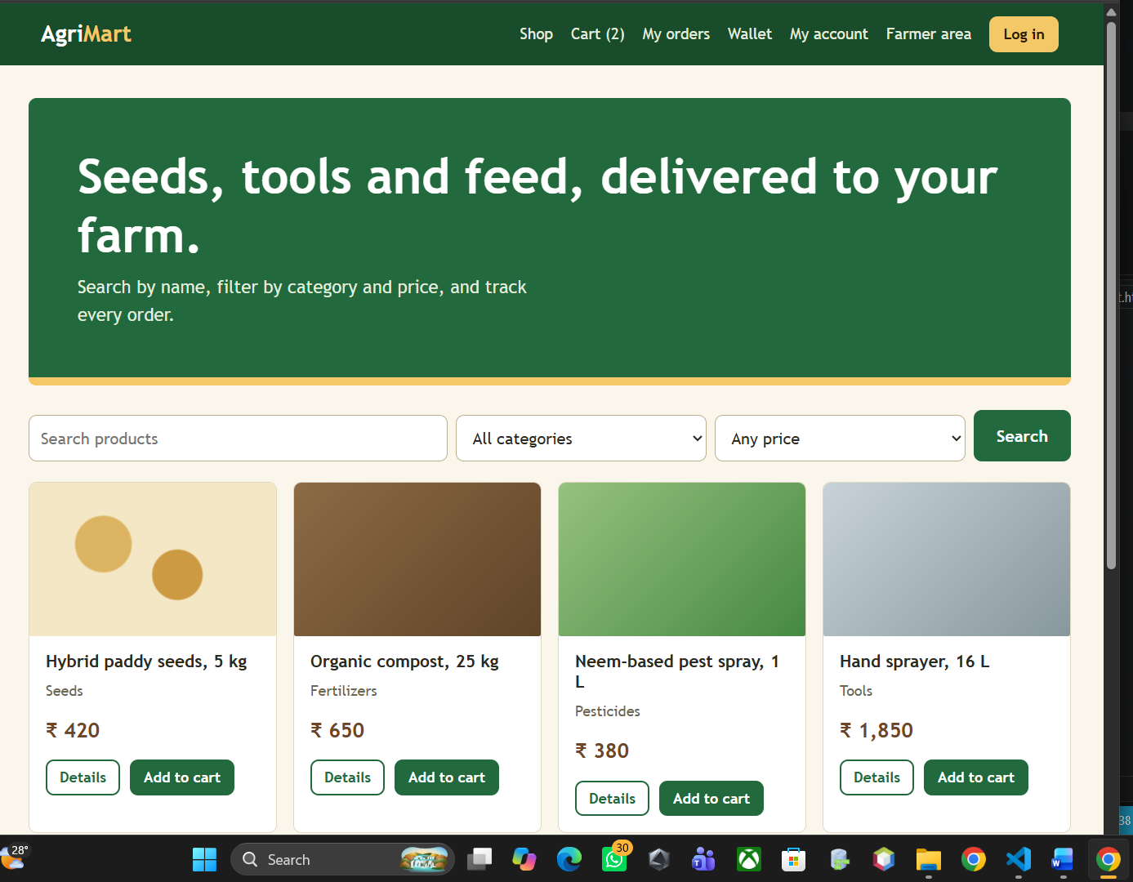

Results
Agricultural e-commerce prototype. Seeds, fertilizers, tools, equipment, cart, shipping address, order status. The interface is a front-end demonstration; real authentication, database storage, and external integrations must be added for production use.

