EMPLOYEE MANAGEMENT SYSTEM WEB APPLICATION
LOG IN PAGE:
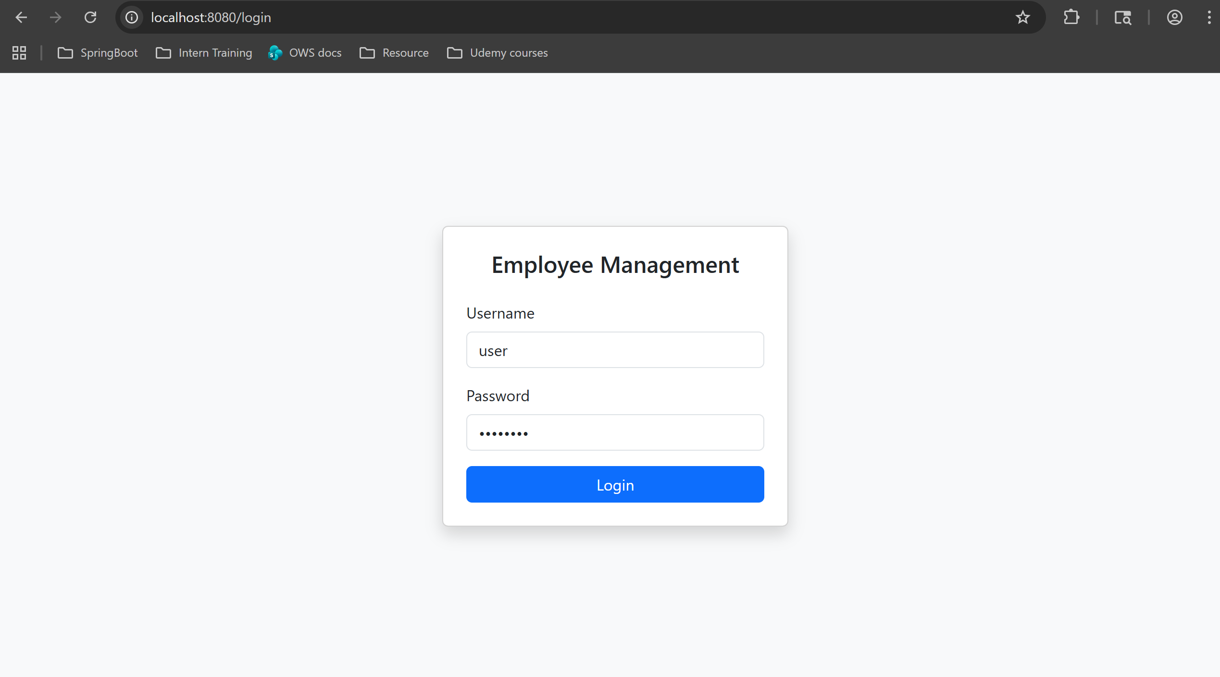
HOME PAGE:
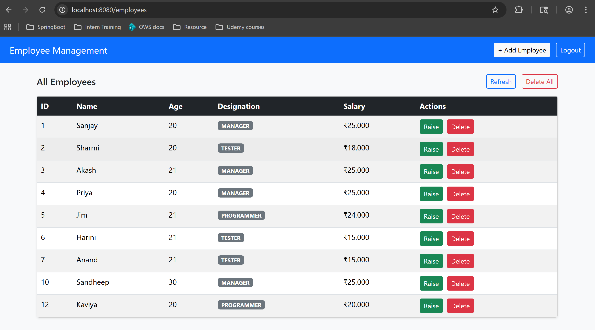

RAISE SALARY POP UP:
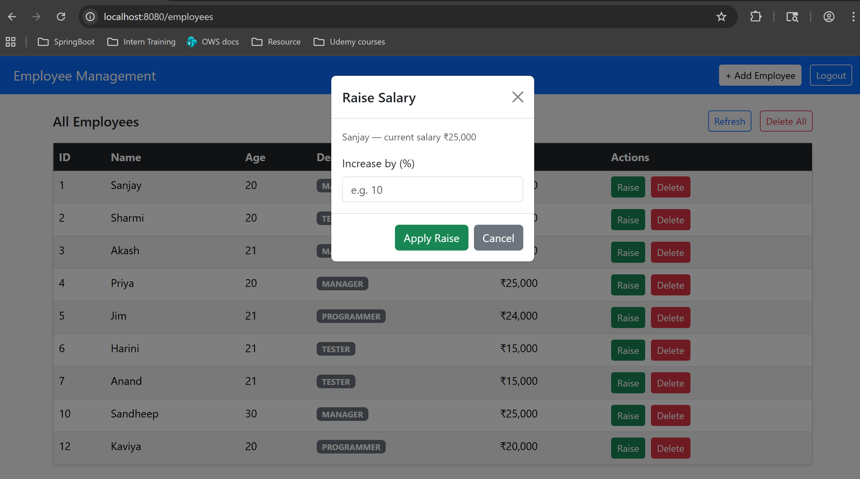
We can see that salary of the employee ID 1 is increased by 10%.
[25,000 > 27,500]
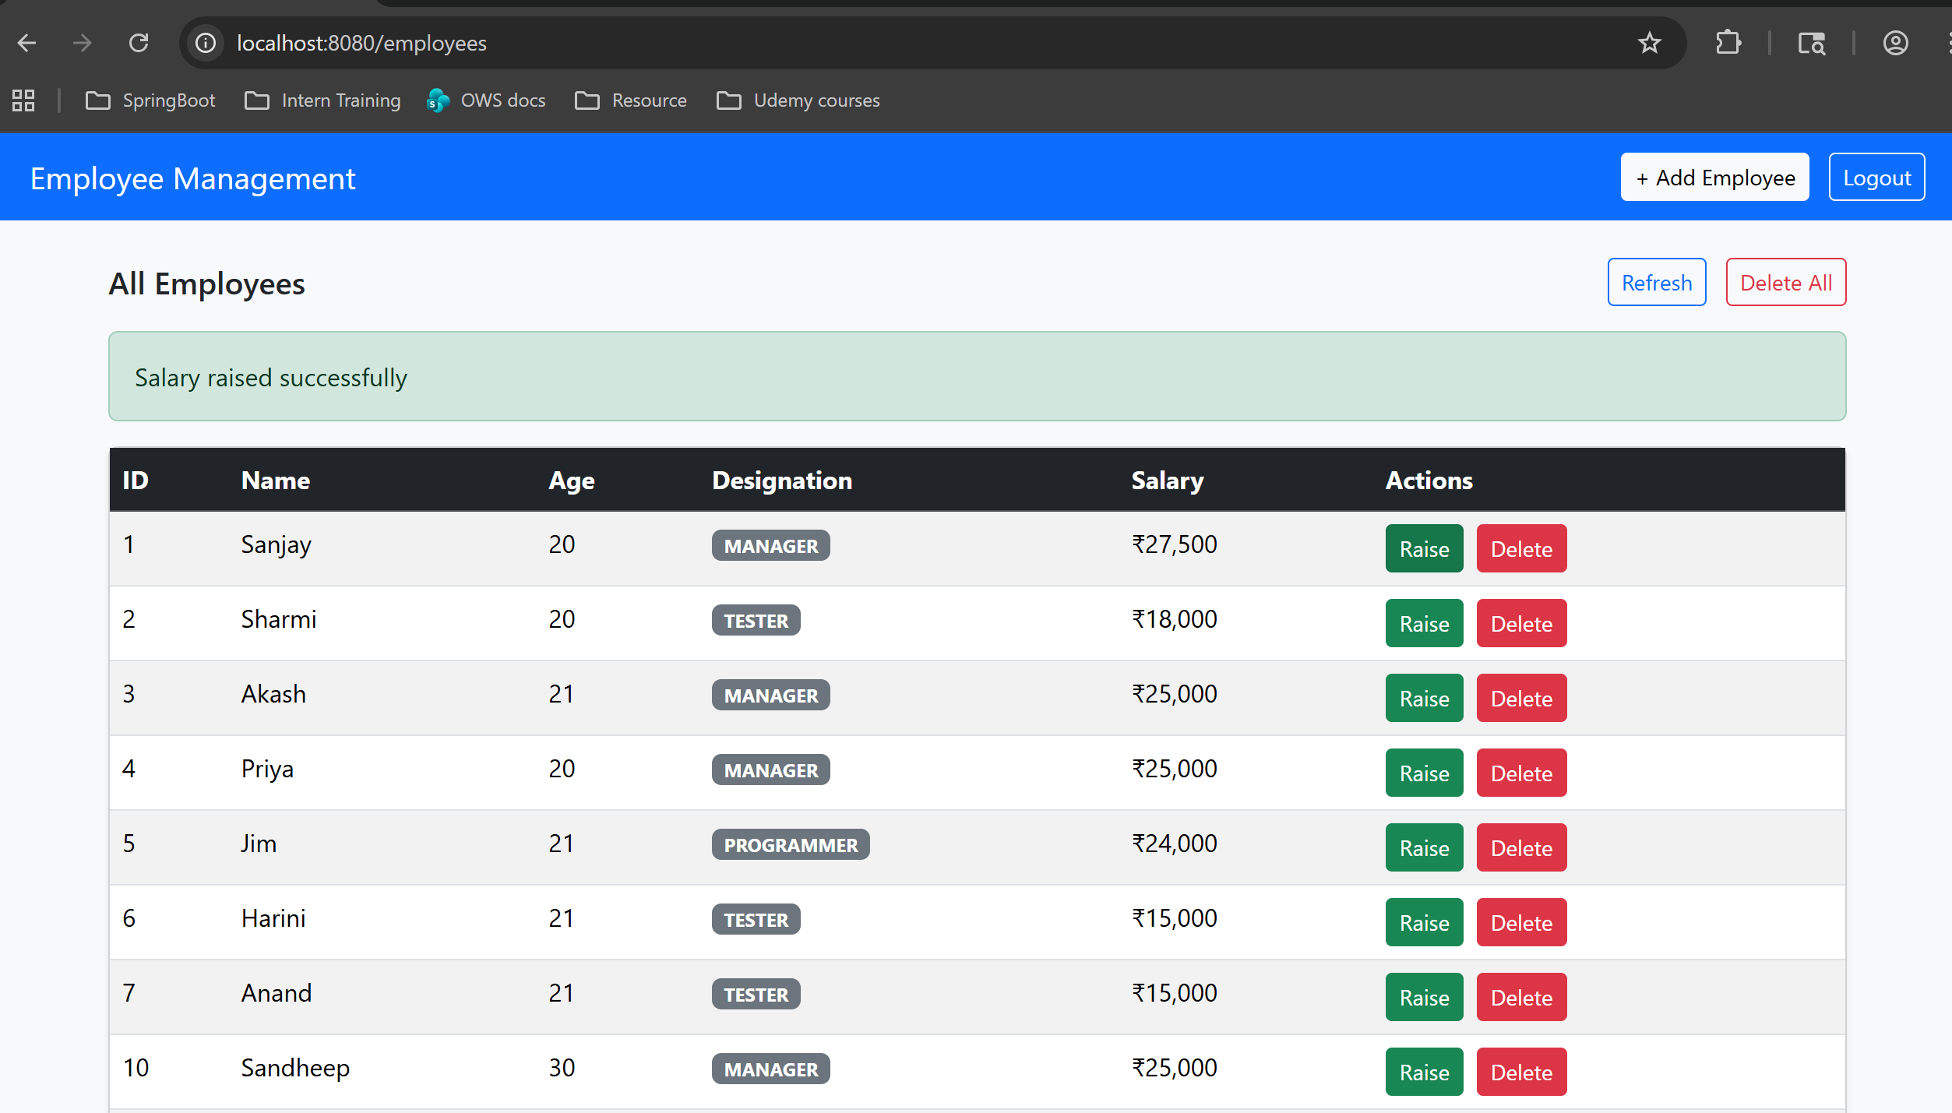

DELETE EMPLOYEE CONFIRMATION POP UP:
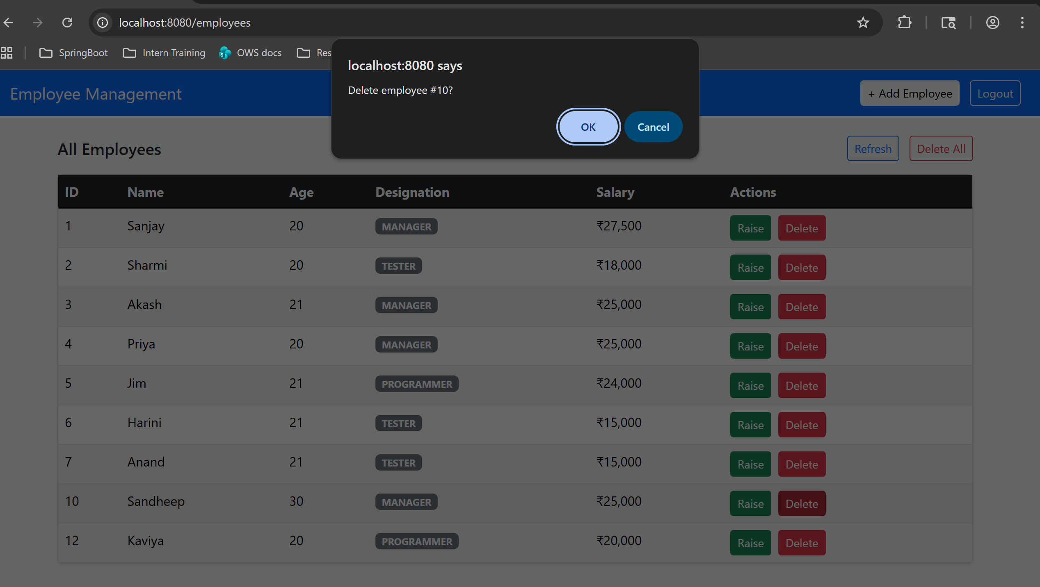
We can see the employee ID 10 has been deleted.
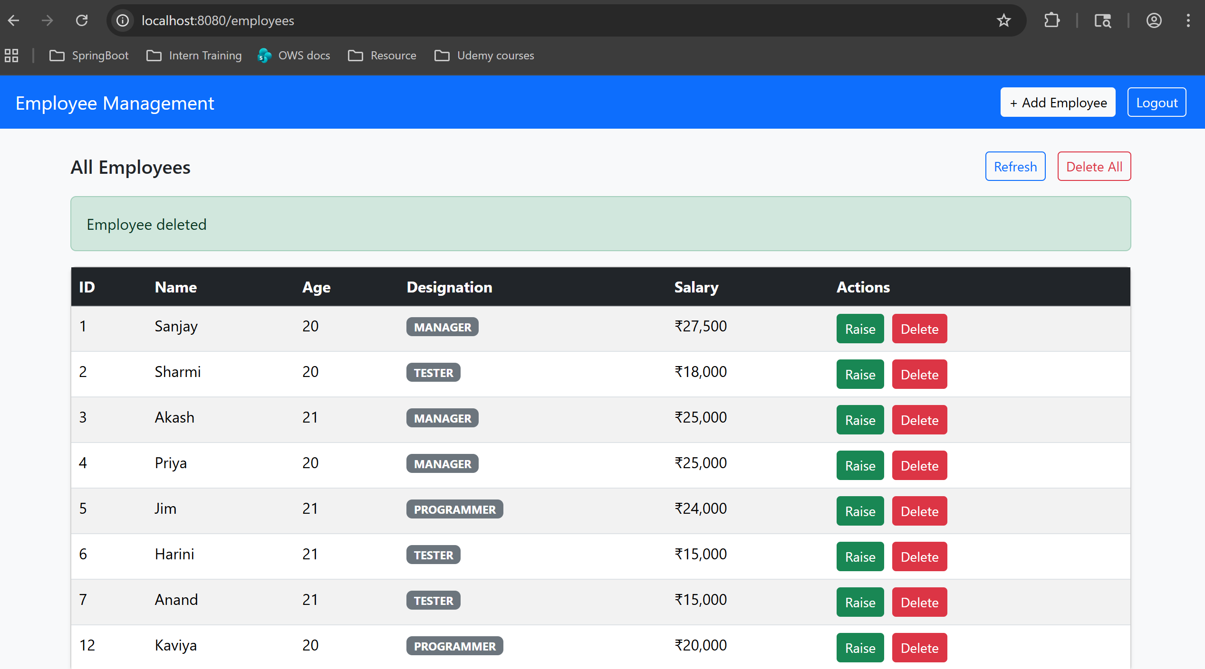

ADD EMPLOYEE PAGE:
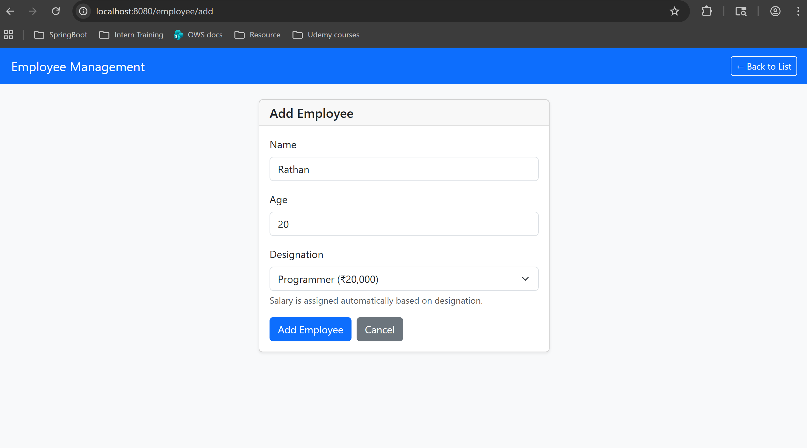
We can see the new employee ID 13 has been created.
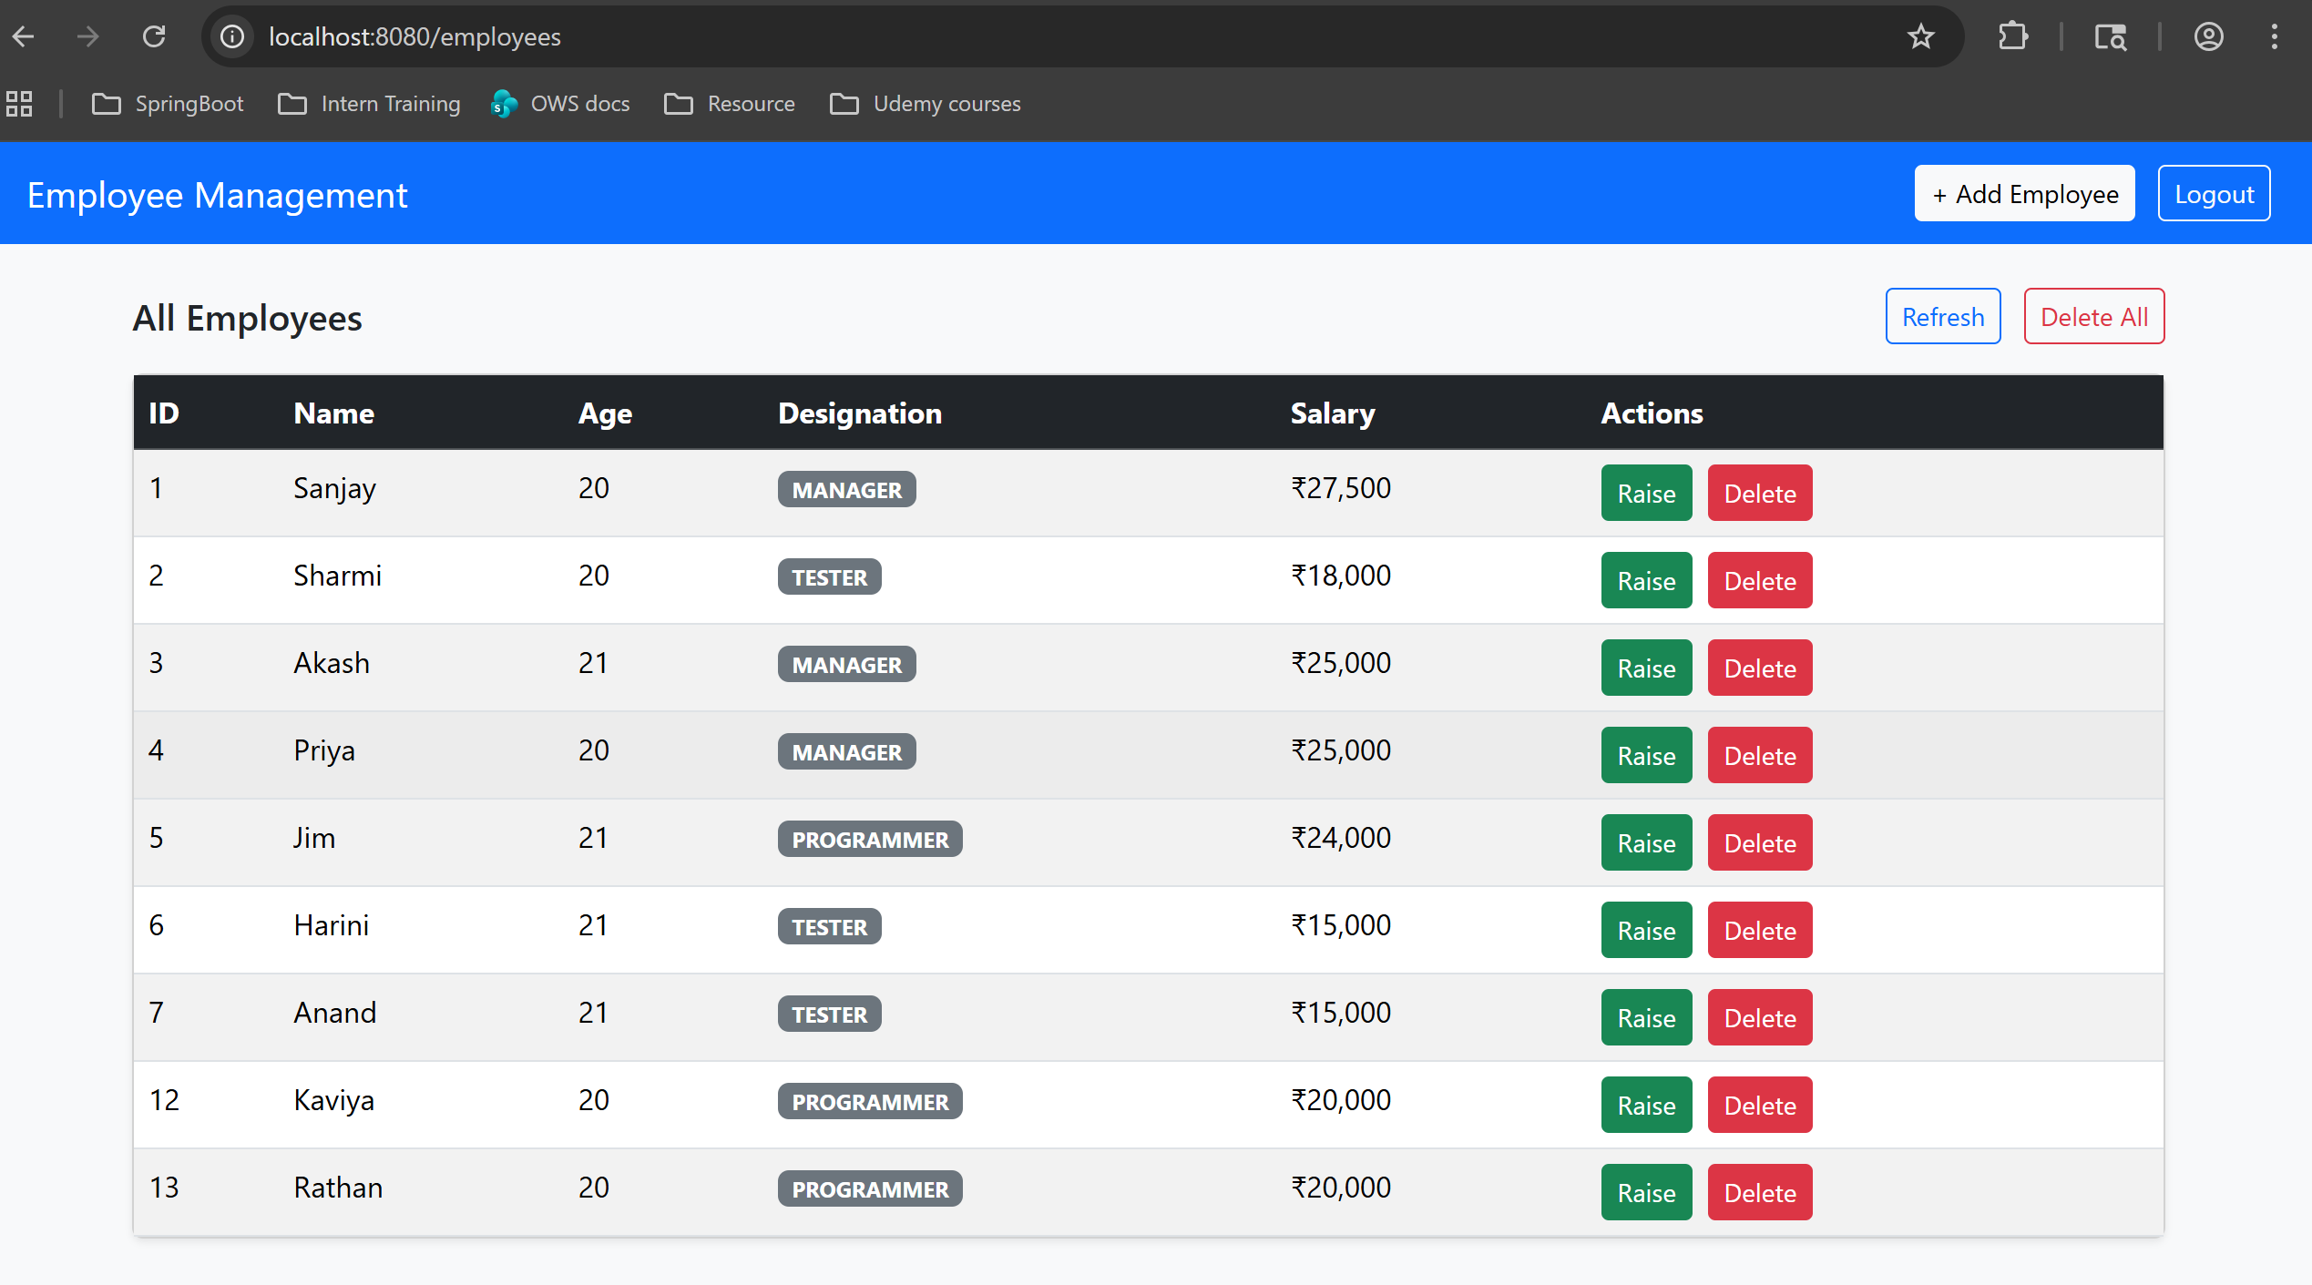

On successful log out, Log in page appears
