Practical 1: Introduction to React and Component Architecture

Problem Statement
- Create a React application using Vite for a student portfolio page.
- The application must include at least 4 reusable components: Header, About, Skills, and Footer.
- Each component must be independently structured and composed into a single-page layout.
- No logic or JSX should be duplicated across components.
- Props must be used to pass at least one piece of data into a minimum of 2 components.

Folder Structure
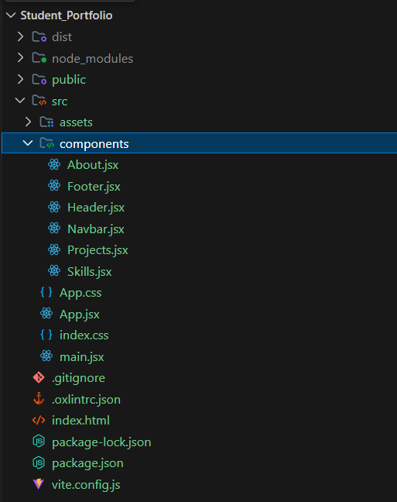
Fig 1: Project folder structure in VS Code

Output

Fig 2: Verifying Node.js and npm versions

Fig 3: Vite development server running successfully

Key Questions / Analysis
1. What is the role of each component in the overall UI structure?
Each component represents a specific part of the UI, manages its own logic, and combines with other components to build the complete application. This makes the UI modular and easier to maintain.
2. How does React re-render when props change?
When a parent passes new props to a child component, React compares the changes using the Virtual DOM. If the props have changed, React re-renders the affected component and updates only the necessary parts of the real DOM.
3. Why is component reusability important in large-scale applications?
Component reusability reduces code duplication, improves consistency, simplifies maintenance, and speeds up development by allowing the same component to be used in multiple places.

Supplementary Problems
- Add a NavBar component that highlights the active section.
- Pass an array of skills as a prop to the Skills component and render them dynamically.
- Add a theme color prop to the Header and apply it as an inline style.

Code Implementation
App.jsx
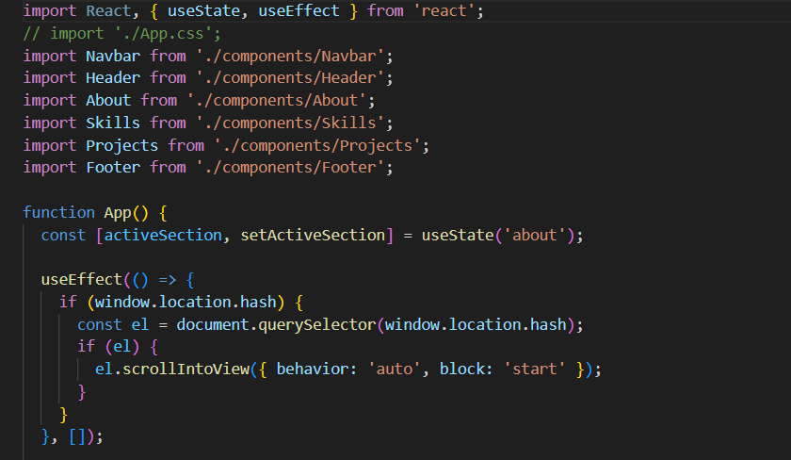
Fig 4: App.jsx composing all components
Skills.jsx
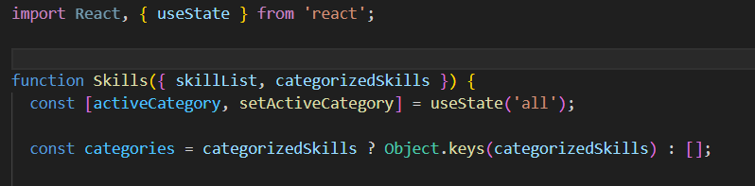
Fig 5: Skills.jsx receiving props (skillList, categorizedSkills)

