Practical 2: State Management and Routing in React
Problem Definition
- Extend the portfolio application from Practical 1 by adding React Router.
- Implement a navigation bar with at least 3 routes: Home, Projects, and Contact.
- Each route must render a distinct component without a full page reload.
- Add at least 2 useState variables used meaningfully — one for toggling UI visibility and one for managing a form input on the Contact page.
- The Contact page must include a controlled input that captures and displays user input in real time.
Output
Figure 1: Project Folder Structure
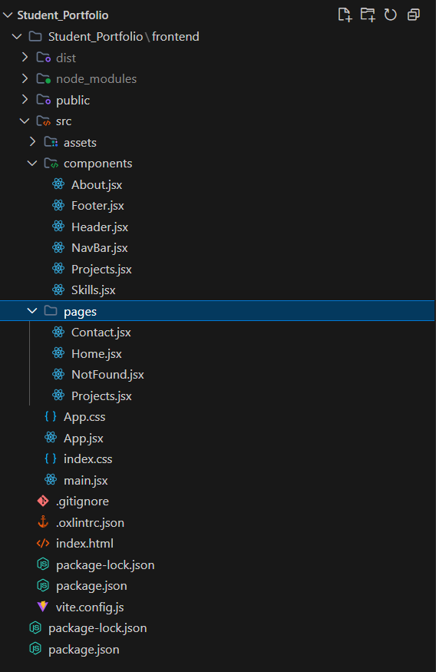
Explanation: Updated project folder structure showing the new pages directory containing Home, Projects, Contact, and NotFound components.
Figure 2: main.jsx – Router Setup
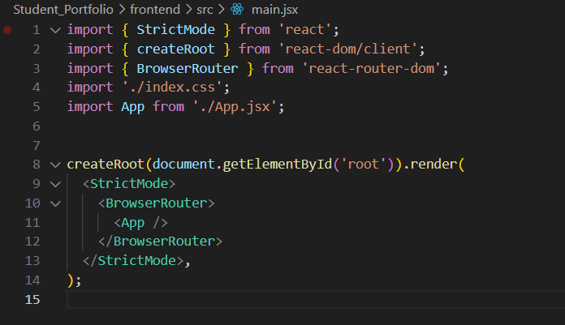
Explanation: main.jsx wrapping the App component with BrowserRouter to enable client-side routing.
Figure 3: App.jsx – Route Definitions
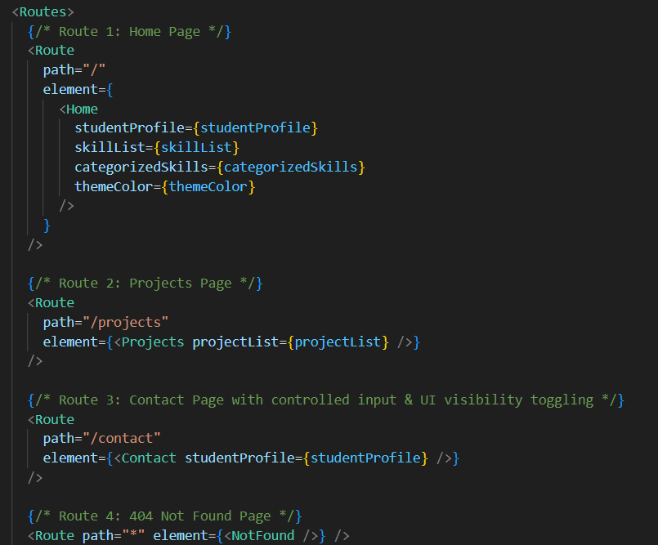
Explanation: Route definitions in App.jsx mapping paths to the Home, Projects, and Contact components, along with a 404 Not Found route.
Figure 4: Output – Home Page
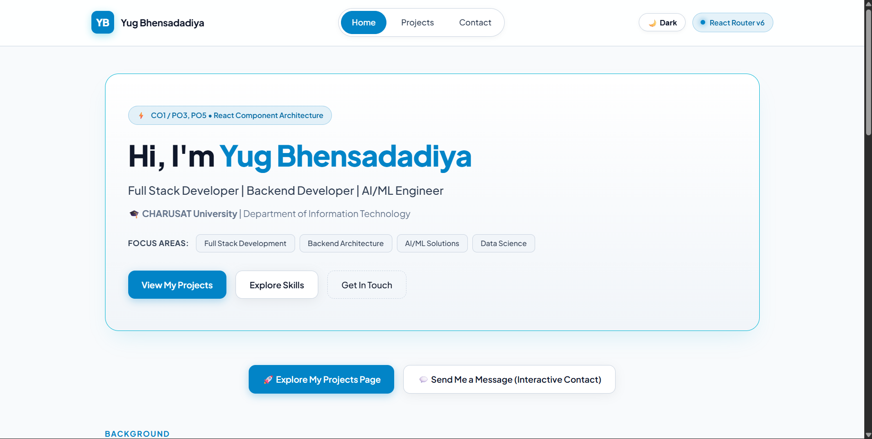
Explanation: Rendered Home page showing the navigation bar with the active route highlighted and a dark/light mode toggle.
Key Questions and Answers
Q1. What is the role of each component in the overall UI structure?
Each component is responsible for a specific part of the user interface. Components such as Home, Projects, Contact, and NavBar organize the application into reusable sections. This improves code structure, readability, and maintenance.
Q2. How does React re-render when props change?
When a component receives new props, React automatically updates and re-renders that component. React compares the updated data with the previous data and refreshes the UI accordingly. This ensures the displayed information remains up to date.
Q3. Why is component reusability important in large-scale applications?
Reusable components reduce code duplication and development effort. They make applications easier to maintain, update, and scale. Reusability also improves consistency across the user interface.

