Practical 3: API Integration and Data Rendering in React
Problem Definition
- Integrate a public REST API (e.g., GitHub API) into the portfolio application to fetch and display a list of repositories dynamically.
- Use the Projects page built in Practical 2 as the integration point.
- Implement a loading spinner component shown while the request is in progress.
- Implement an error message component shown if the API call fails.
- Render at least the repository name and URL for each item returned.
Output
Figure 1: Project Folder Structure
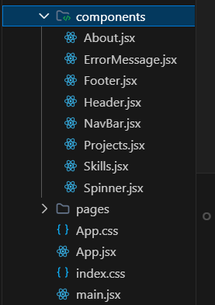
Explanation: Updated components folder showing the newly added ErrorMessage.jsx and Spinner.jsx used for handling API loading and error states.
Figure 2: Development Server Running
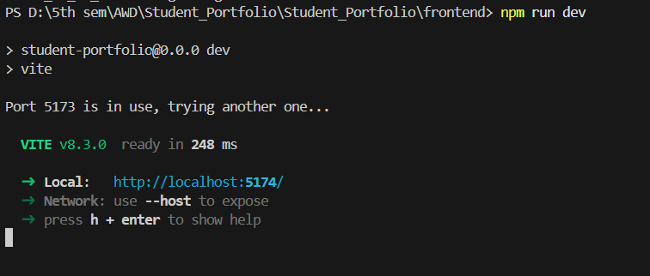
Explanation: Vite development server started successfully using npm run dev.
Figure 3: Projects.jsx – Rendering Logic
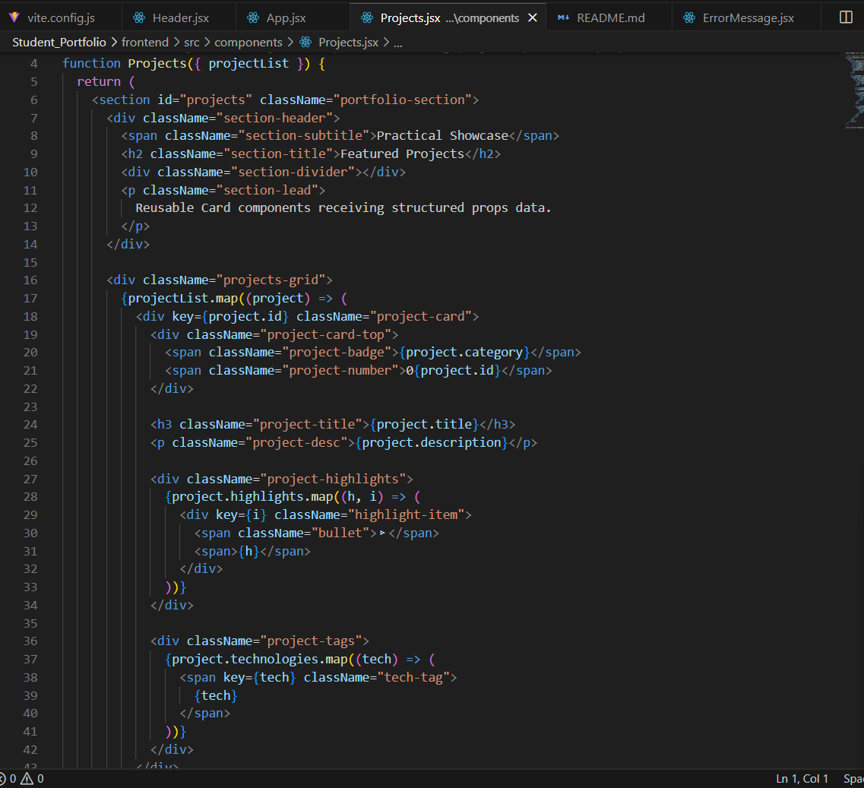
Explanation: Projects.jsx component mapping over the received data and rendering a card for each repository.
Figure 4: Output – GitHub Repositories (Success State)
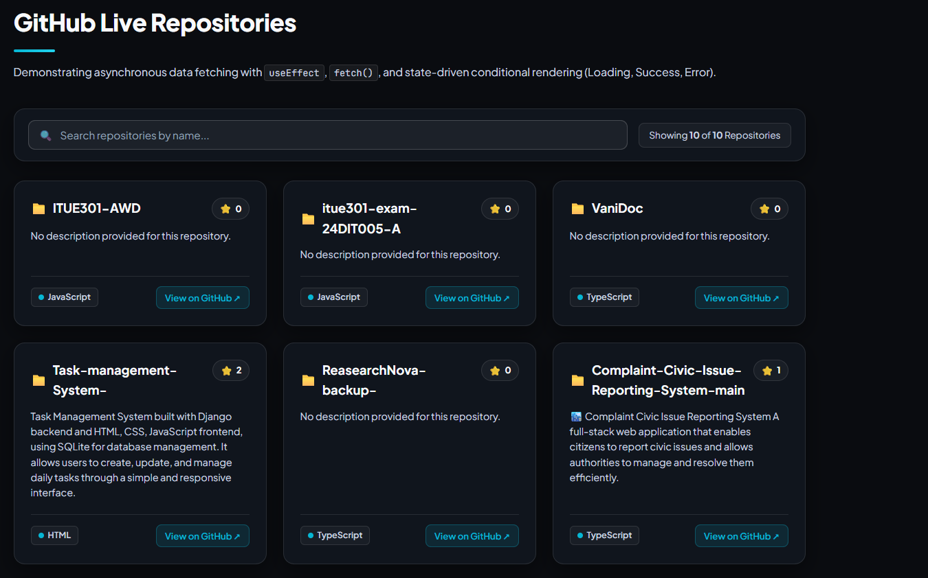
Explanation: Repository list successfully fetched from the GitHub API and rendered on the Projects page.
Figure 5: Output – Filtered Search Results
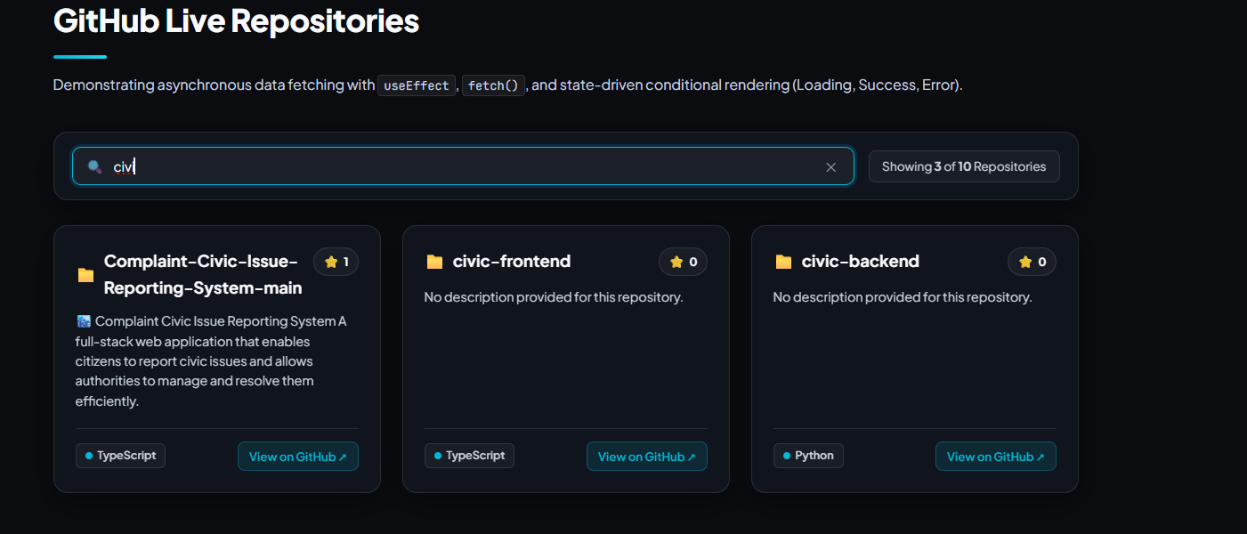
Explanation: Repository list filtered in real time using the search input, displaying only matching repositories.
Figure 6: GitHub Repository – Live Data Source
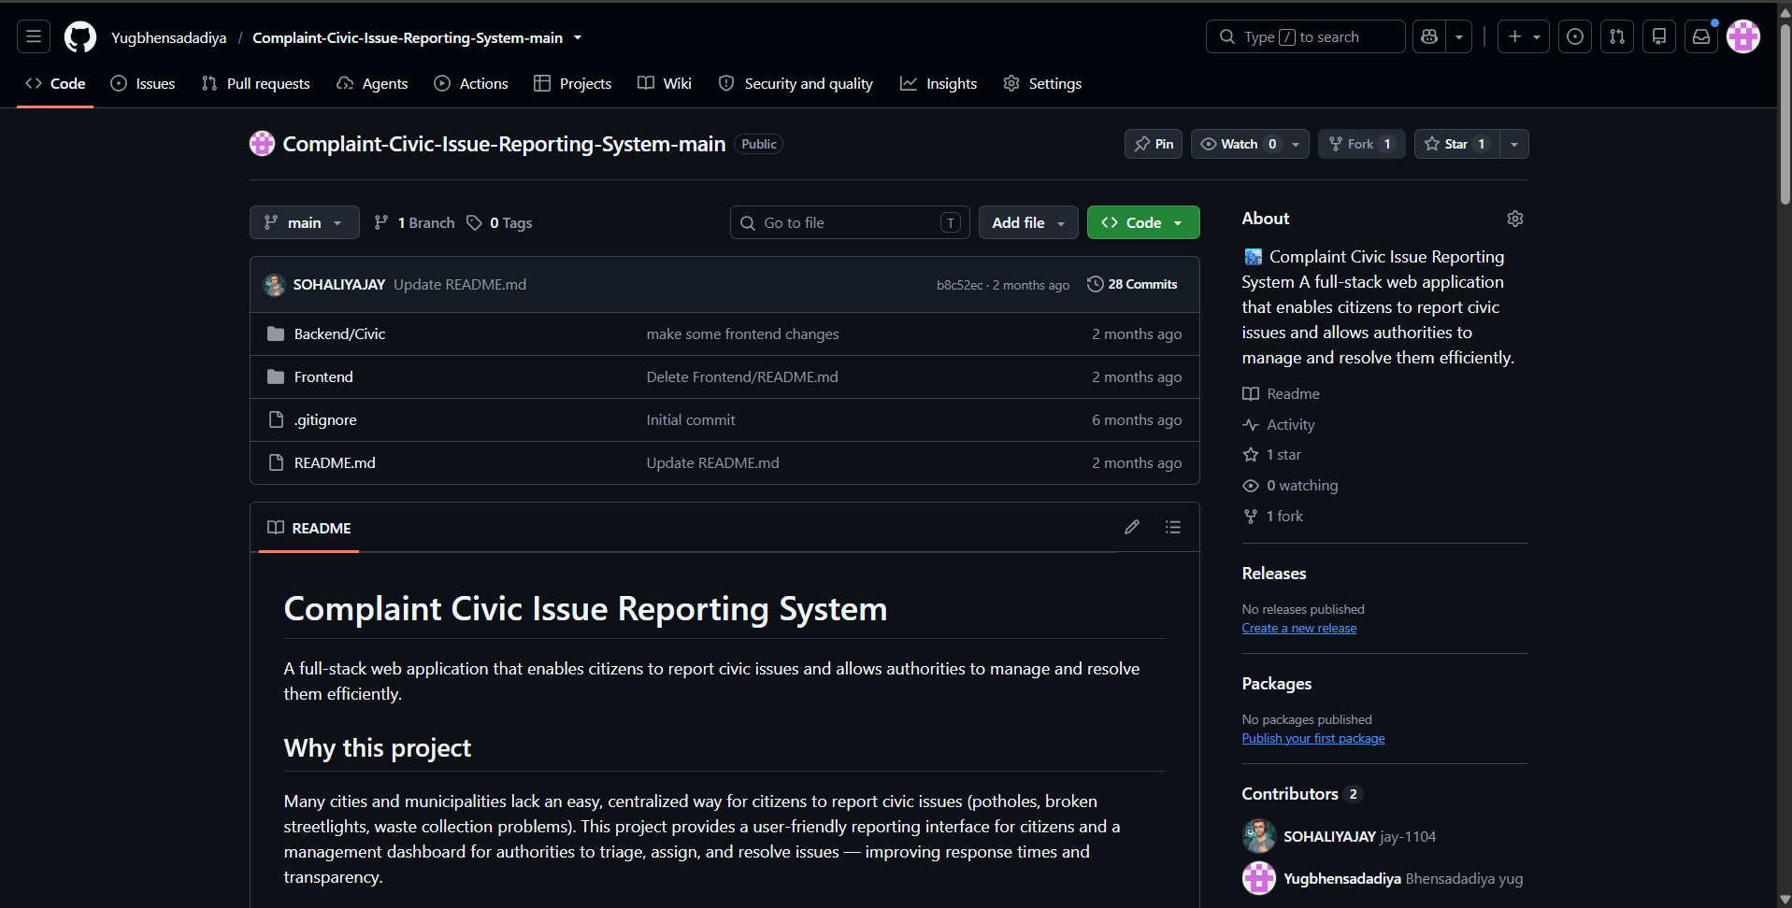
Explanation: Actual GitHub repository page confirming that the data rendered on the Projects page is fetched from a live repository.
Key Questions and Answers
Q1. Why is useEffect required to trigger a fetch on component mount instead of calling fetch directly in the component body?
useEffect runs after the component is rendered and allows the API call to execute only once on component mount. Calling fetch() directly inside the component body would trigger the request on every re-render, causing unnecessary or infinite API calls. It improves performance and prevents repeated network requests.
Q2. What is the difference between a loading state and an error state, and why must both be handled separately?
A loading state indicates that data is currently being fetched, while an error state indicates that the request has failed. They represent different stages of an API request and require different UI feedback. Handling both separately provides clear information about the application's status.
Q3. How would the user experience change if loading and error states were not implemented?
Without a loading state, users may think the application is frozen while waiting for data. Without an error state, users would not know why data failed to load. Implementing both states improves usability, transparency, and overall user experience.

