Practical 4: Building a RESTful API with Node.js and Express
Problem Definition
- Build a Node/Express backend for a Task Management system.
- Implement REST endpoints for creating, reading, updating, and deleting tasks (in-memory array, no database yet).
- Apply a request logging middleware that logs method, URL, and timestamp for every incoming request.
- Apply a global error handling middleware as the last middleware in the pipeline.
- Use correct HTTP status codes (200, 201, 404, 500) for each response.
Output
Figure 1: Project Folder Structure
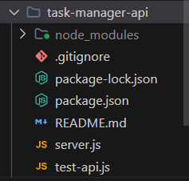
Explanation: Folder structure of the task-manager-api project showing server.js, test-api.js, and configuration files.
Figure 2: server.js – Express Server Setup, Logging and Content-Type Middleware
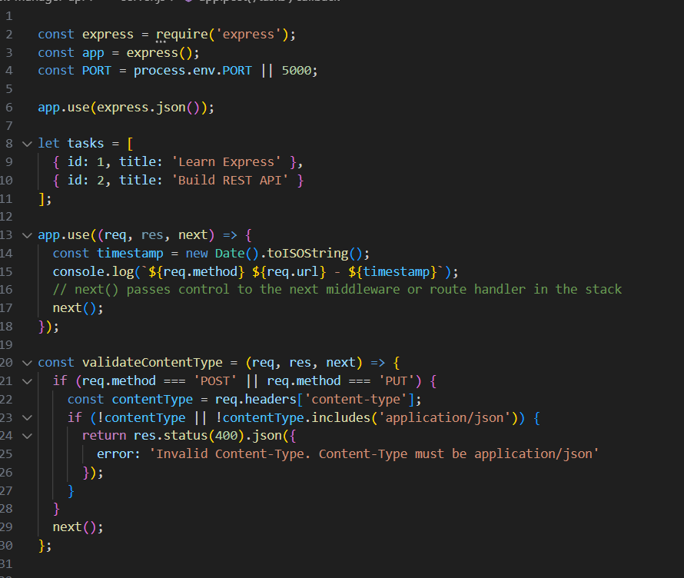
Explanation: Basic Express server setup with the in-memory tasks array, the global request logging middleware, and the content-type validation middleware.
Figure 3: CRUD Routes – GET, POST, and PUT /tasks
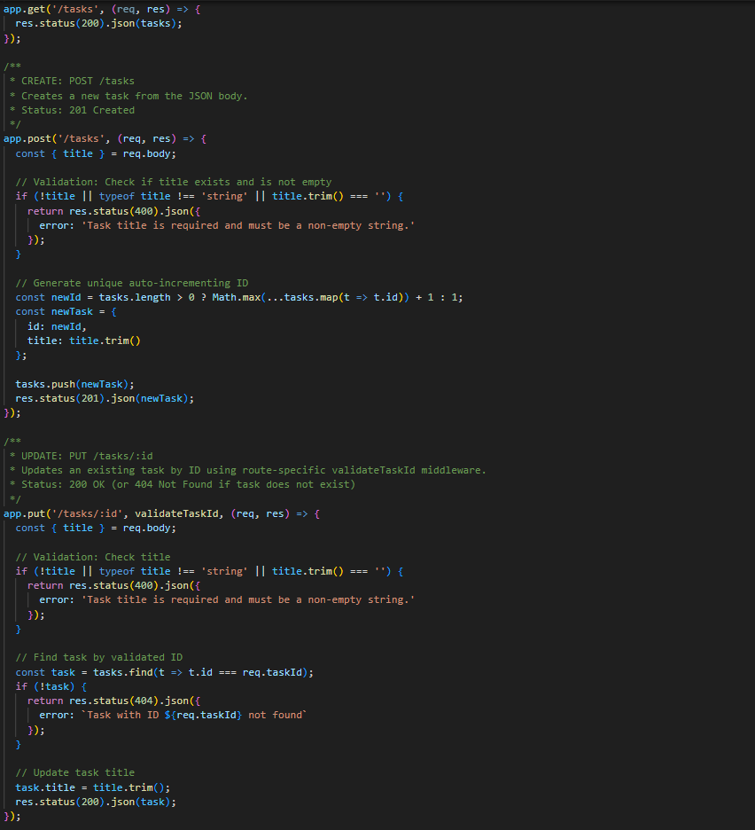
Explanation: Implementation of the GET, POST, and PUT routes with title validation and appropriate HTTP status codes.
Figure 4: Route-Specific Middleware – validateTaskId
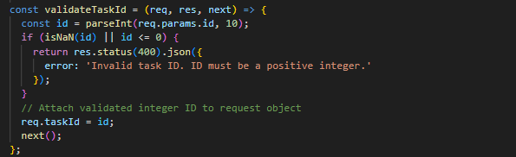
Explanation: Route-specific middleware that validates the task ID format before the request reaches the route handler.
Figure 5: Logging and Content-Type Validation Middleware (Documented View)
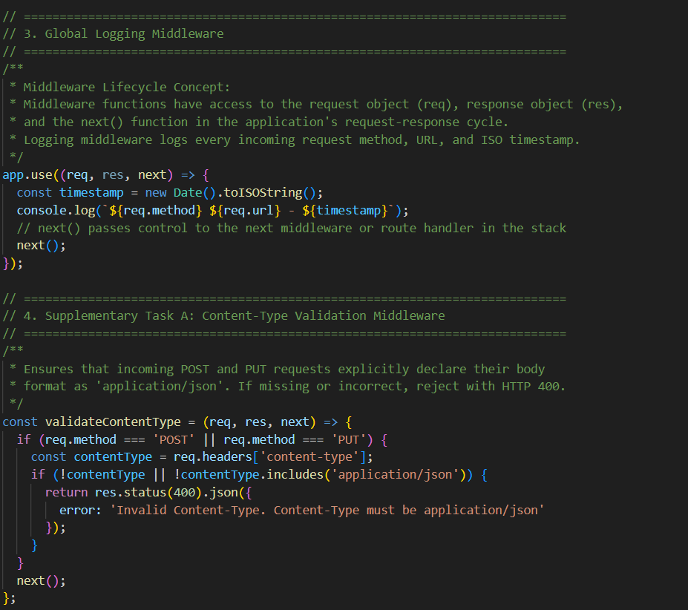
Explanation: Same logging and content-type validation middleware shown with descriptive inline comments explaining the middleware lifecycle.
Figure 6: 404 Handler, Global Error Handler, and Server Start
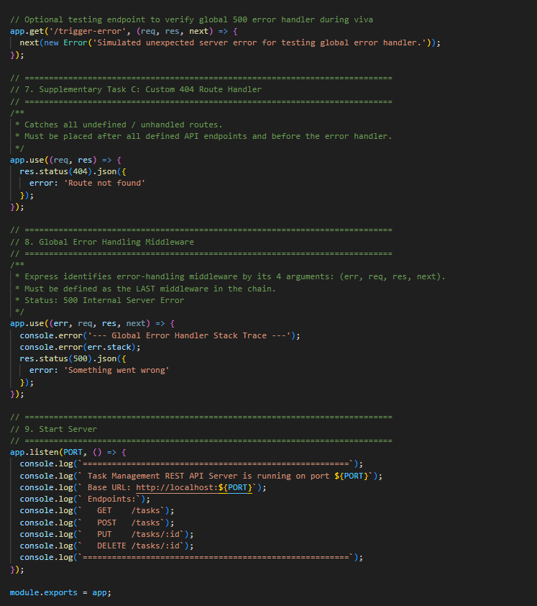
Explanation: Custom 404 route handler and the global error handling middleware defined as the last middleware, followed by the server start code.
Figure 7: Terminal – Server Running
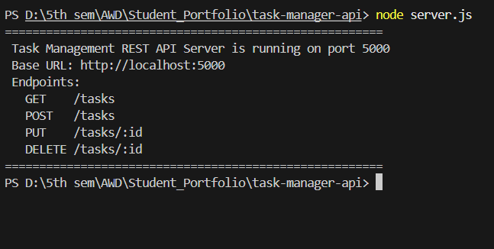
Explanation: Express server started successfully on port 5000, listing all available endpoints.
Figure 8: Output – GET /tasks (200 OK)
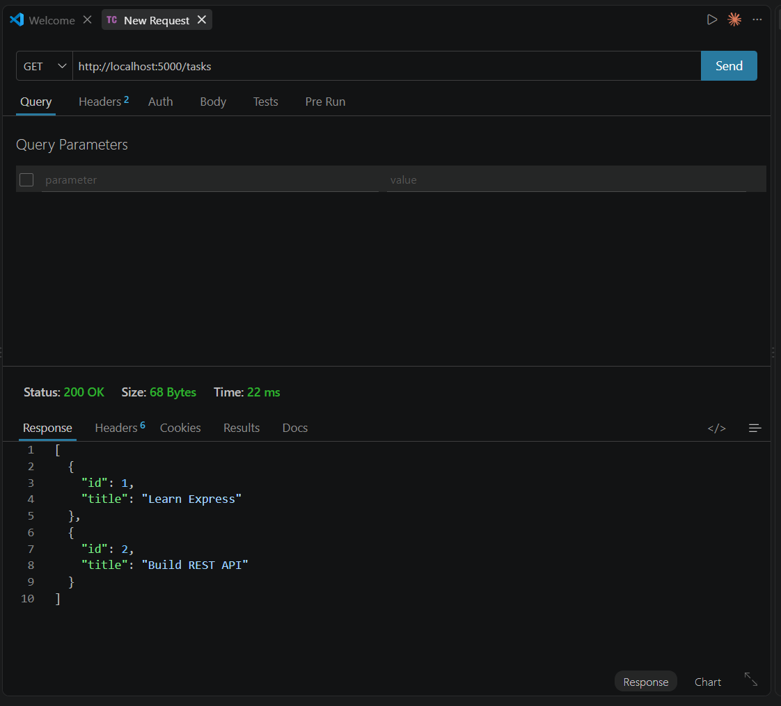
Explanation: GET request to /tasks returning the list of existing tasks with a 200 OK status.
Figure 9: Output – GET /tasks (200 OK) Verification
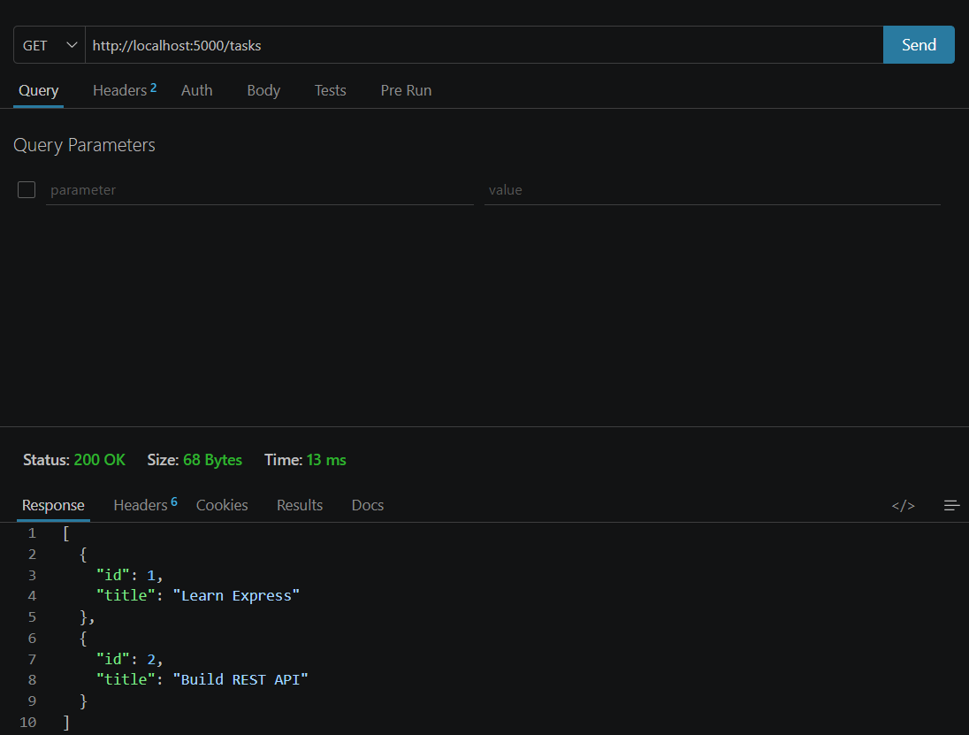
Explanation: Repeated GET request to /tasks confirming a consistent 200 OK response.
Figure 10: Output – GET /tasks/1 (404 Not Found)
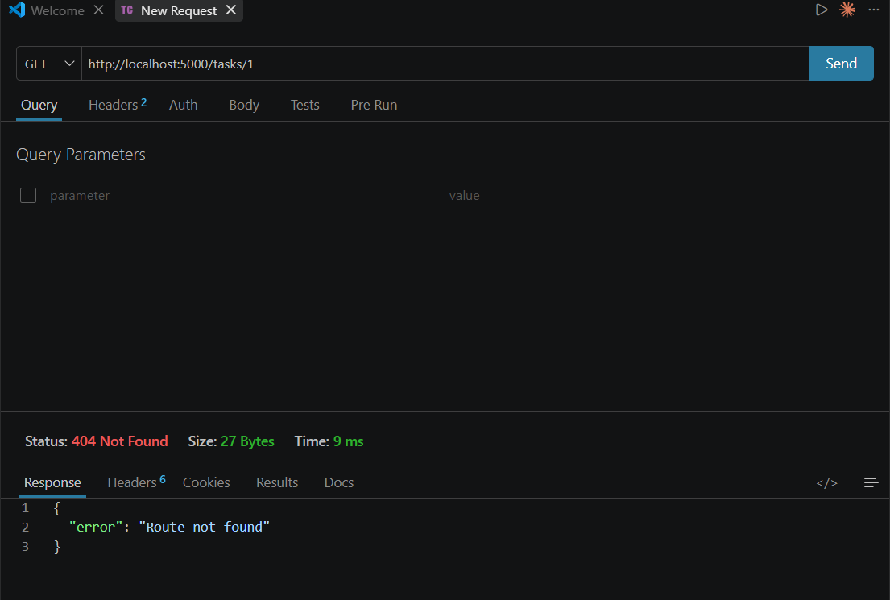
Explanation: GET request to an undefined route /tasks/1 returning a 404 Not Found response handled by the custom 404 middleware.
Figure 11: Output – GET /tasks/1 (404 Not Found) Verification
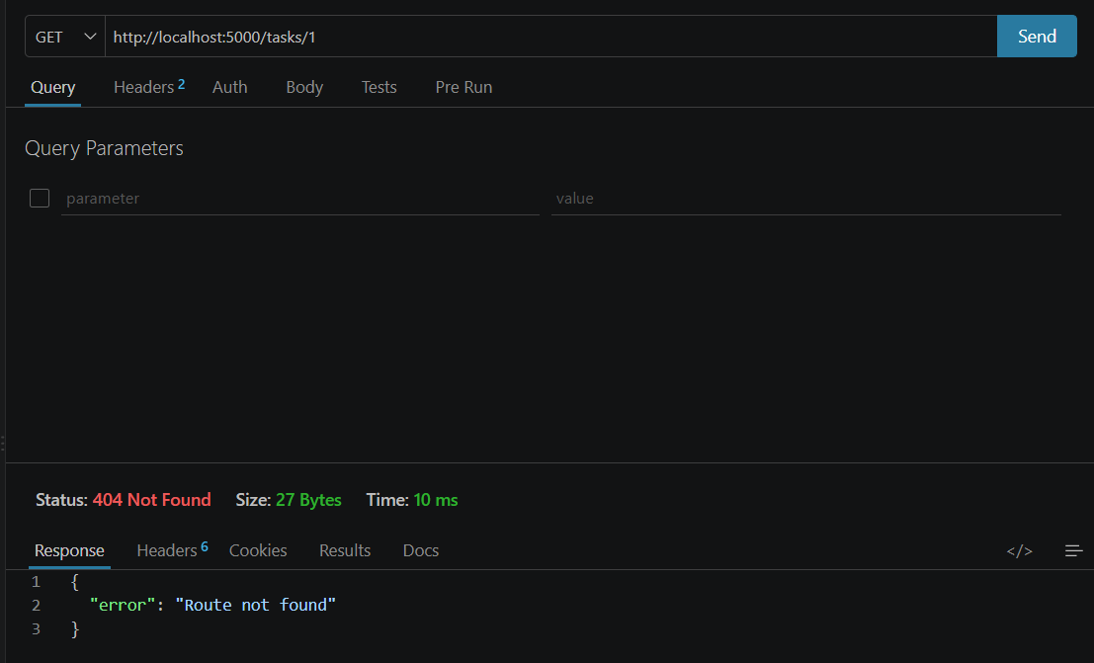
Explanation: Repeated request confirming the 404 Not Found response is returned consistently for undefined routes.
Key Questions and Answers
Q1. Why must the error handling middleware be defined last in the middleware chain?
Error handling middleware should be placed last so it can catch errors generated by routes and previous middleware. If it is placed earlier, later errors will not reach it. This ensures centralized and consistent error handling throughout the application.
Q2. What is the difference between app.use() and a route-specific middleware?
app.use() applies middleware globally to all matching requests, while route-specific middleware runs only for a particular route or endpoint. Route-specific middleware provides more control over where validation or processing occurs. This helps apply logic only where needed.
Q3. Why is it considered bad practice to send raw error stack traces to the client?
Raw error stack traces may expose sensitive information about the server, code structure, or application internals. This can create security risks and help attackers identify vulnerabilities. Instead, clients should receive simple and user-friendly error messages.

