**Tutorial- Retrieving Twitter Data using Twitter4j**

Yugendhar Reddy Sarabudla (N23880634)

**Project Set Up:**

* Visit website Twitter4j website <http://twitter4j.org/>
* Download latest stable version of twitter4j zip file.

As of writing this tutorial it is 4.0.4 as shown below

<http://twitter4j.org/archive/twitter4j-4.0.4.zip>

* Extract all contents of this Archive
* Make sure you have Java IDE such as Eclipse to start a project and write code to retrieve twitter data. In case you don’t have IDE, please download the latest version online.
* Open Eclipse application from your Desktop
* From “File” menu create new project and name it.
* Add Java File in the source folder of your project
* Now add external archive to your project as shown in below screen shot

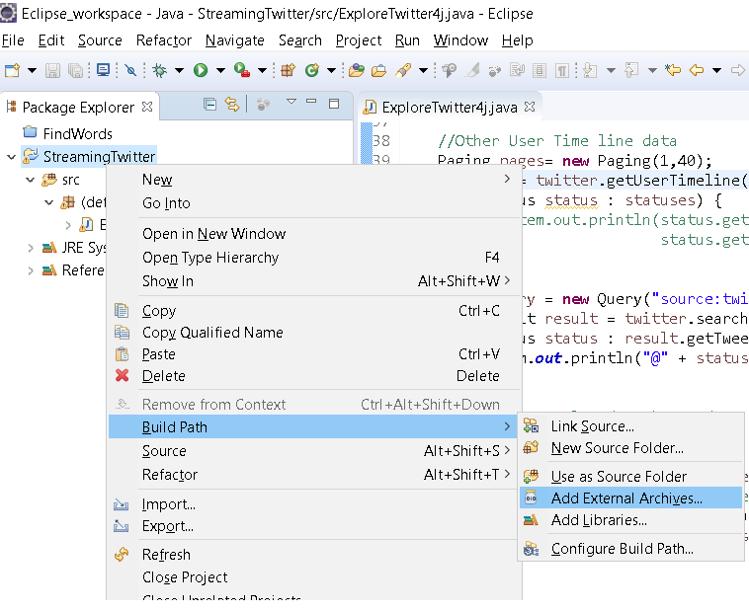

* This will show up file chooser to select archive files. Move to the extracted folder of twitter4j and choose twitter4j core jar file to add it to your project. It will be available in twitter4j\lib folder

**Twitter API Authentication Keys Set up:**

* Login to <https://apps.twitter.com/>
* Click on Create New App
* By filling the appropriate form data, you will create a new app and you see consumer key, consumer secret key being generated for your user id. Note those key values.
* Click on generate authentication access tokens option.
* You will get Access token and Access Secret token for your user id. Note these key values.
* Now you have all 4 key values to be used for configuration in your project.

**Configuring Authentication Keys:**

* Use those key values to configure them in your project. You can configure them in various ways. One of them is using ConfigurationBuilder class
* In your main method, write the below code snippet and add those keys in their respective argument places.

ConfigurationBuilder cb = new ConfigurationBuilder();

cb.setDebugEnabled(true)

.setOAuthConsumerKey("*********************")

.setOAuthConsumerSecret("******************************************")

.setOAuthAccessToken("**************************************************")

.setOAuthAccessTokenSecret("******************************************");

TwitterFactory tf = new TwitterFactory(cb.build());

Twitter twitter = tf.getInstance();

* You are now read to use this twitter instance to make API call to twitter service and retrieve tweets data of any user.

**Code to call TwitterAPI and print tweet data:**

Retrieves and Prints your own Timeline tweets:

Below snippet retrieves your own timeline data and prints it to console with user name and text.

List<Status> statuses = twitter.getHomeTimeline();

System.***out***.println("Showing Your home timeline.");

**for** (Status status : statuses) {

System.***out***.println(status.getUser().getName() + ":" +

status.getText());

}

Retrieves and Prints Other user timeline tweets:

If you would like to get another user timeline and print them to console, below code snippet can be used.

//Other User Time line data

Paging pages= **new** Paging(1,40);

statuses = twitter.getUserTimeline("realdonaldtrump",pages);

**for** (Status status : statuses) {

System.***out***.println(status.getUser().getName() + ":" +

status.getText());

}

This prints statuses of

Retrieves and Prints tweets with specific keyword:

If you would like to search for tweets with specific keyword, you can use below code snippet

//Get tweets related to keyword

query = **new** Query("trump");

QueryResult qr = twitter.search(query);

//List<Tweet> qrTweets = qr.getTweets();

**for** (Status status : qr.getTweets()) {

System.***out***.println("@" + status.getUser().getScreenName() + ":" + status.getText());

}

This prints tweets having keyword “trump”