A Mini Project Report on
FINMENTOR AI
Submitted By
YUGESH A
(Reg. No: 242237)
In Partial Fulfillment of the Requirements for the Award of the Degree of
B.Sc., COMPUTER SCIENCE
(DATA SCIENCE AND ANALYTICS)
Under the Guidance of
Mr. Prajith Vishwa R M.Sc. AI and DS


DEPARTMENT OF COMPUTER SCIENCE
SUBBALAKSHMI LAKSHMIPATHY COLLEGE OF SCIENCE
(An Autonomous and ISO 9001:2015 Certified Institution)
Affiliated to Madurai Kamaraj University
Re-accredited with 'A+' Status by NAAC
TVR Nagar, Aruppukottai Road, Madurai – 625 022
2026-2027



SUBBALAKSHMI LAKSHMIPATHY COLLEGE OF SCIENCE
TVR NAGAR, ARUPPUKOTTAI ROAD, MADURAI-625 022
DEPARTMENT OF COMPUTER SCIENCE
BONAFIDE CERTIFICATE
This is to certify that the project report entitled FINMENTOR AI is a Bonafide record of the project work done by

Name : YUGESH A
Reg No : 242237
Course & Year : B.Sc., Computer Science (DSA) & III year

In partial fulfilment of the requirements for the award of the degree of B.Sc., Computer Science (Data Science and Analytics) and to certify that the project work carried out is an independent work under my supervision and guidance, and this project has not formed the basis for the award of any Degree / Diploma / Associateship / Fellowship or similar nature to any University / Institution earlier.
Submitted for the viva-voce held on:
Place: Madurai

INTERNAL GUIDE HEAD OF THE DEPARTMENT

INTERNAL EXAMINER EXTERNAL EXAMINER

DECLARATION

I hereby declare that the Mini Project titled "FINMENTOR AI" was submitted to SUBBALAKSHMI LAKSHMIPATHY COLLEGE OF SCIENCE. I affirm that all information, data, and analysis presented in this report are authentic and have been collected and analysed by me. I have referred to and acknowledged all the sources, references, and materials used in preparing this project. It is a record of original work done by me and this project has not formed the basis for the award of any degree / associateship / fellowship or similar to any candidate in any university.

B.Sc. Computer Science YUGESH A
(Data Science and Analytics) 242237

ACKNOWLEDGEMENT

Firstly, I am willing to express my heartfelt thanks to the Almighty for providing an excellent Opportunity and I also thank him for his blessings to be a successful human being in all walks of my life.

I would like to express my grateful thanks to our President Padma Shri Awardee Dr. R. LAKSHMIPATHY Sir, our Respected Secretary Dr. L. RAMASUBBU Sir, our Respected Management Executive Mr. R. RAMKUMAR Sir and our beloved Principal Dr. R. SUJATHA M.Sc., M.Phil., M.Tech., Ph.D., Madam for permitting me to do this project and for their encouragement in my academic career.

I take this opportunity to convey thanks to my Head of the Department
Mrs. N. ANURADHA M.Sc., M.Phil., NET., SET., for her support to complete the project successfully and her guidance and moral support during the project period, because her keen interest and valuable suggestions have helped me throughout the project.

I sincerely thank my project guide, Mr. PRAJITH VISHWA R M.Sc. AI and DS, for the invaluable guidance provided during the development of the FinMentor AI platform. The knowledge and support received have been instrumental in completing this project successfully.
I also thank all the faculty members of the Department of Computer Science for their academic support and motivation.

B.Sc. Computer Science YUGESH A
(Data Science and Analytics) 242237

TABLE OF CONTENTS
S.No. | Content | Page No.
1 | Introduction | 1
2 | System Analysis  2.1 Existing System  2.2 Limitations of the Existing System  2.3 Proposed System  2.4 Advantages of the Proposed System | 3
3 | System Requirements  3.1 Hardware Requirements  3.2 Software Requirements  3.3 Functional Requirements  3.4 Non-Functional Requirements | 6
4 | Software Description | 9
5 | System Description  5.1 Module 1 – Authentication  5.2 Module 2 – Financial Analysis Engine  5.3 Module 3 – Personalized Lesson & AI Insight  5.4 Module 4 – AI Mentor Chat  5.5 Module 5 – Progress & Achievement Tracking | 12
6 | System Design | 15
7 | Source Code | 18
8 | Screenshots | 37
9 | Conclusion | 43
10 | Future Enhancements | 45
11 | Bibliography | 47

1. INTRODUCTION

INTRODUCTION
FinMentor AI is a web-based financial literacy platform that transforms a user's uploaded bank transactions into a personalized learning journey. The platform accepts transaction data in CSV or Excel formats, or through a manual-entry form, and applies a fully rule-based financial analysis engine to compute a financial health score and identify the user's most critical learning gaps.
Based on this analysis, a recommendation engine ranks ten curated financial literacy lessons in order of relevance and urgency, building a personalized learning roadmap unique to each user's financial situation. As users read each lesson, an AI model running server-side through the Groq API generates a personalized insight connecting the lesson content to the user's actual financial data, together with a concrete action to take during the week. A two-question quiz follows each lesson, and passing it unlocks the next lesson on the roadmap.
An AI Mentor Chat module allows users to ask contextual questions about their finances and learning progress. The AI assistant is given the user's derived financial profile and lesson history as context, enabling relevant and encouraging responses while maintaining the boundary of an educational tool rather than a financial advisor.
The platform is built using React 19 with TanStack Start for SSR capability, TypeScript, Tailwind CSS, Firebase Authentication, Cloud Firestore, and the Groq API with the llama-3.3-70b-versatile model. All AI calls are performed server-side, ensuring that the API key never reaches the browser. The application targets individuals seeking to improve their financial literacy through their own real transaction data, reducing the gap between abstract financial education and a user's actual financial behaviour.

2. SYSTEM ANALYSIS

2. SYSTEM ANALYSIS

2.1 Existing System
The traditional approach to personal financial literacy relies on generic educational content such as books, articles, videos, and online courses. While these resources provide useful general knowledge, they are not connected to a learner’s actual financial behaviour. A user reading about budgeting does not receive any guidance on how the concepts relate to their own spending patterns or financial gaps.
Existing budgeting and personal finance applications such as expense trackers and bank statement analytics tools focus on presenting data visualisations — charts of spending by category, income versus expense comparisons, and trend graphs. Although these tools help users see where their money goes, they typically do not provide structured educational content, prioritised learning paths, or actionable guidance that is specific to the user’s observed financial weaknesses.

2.2 Limitations of the Existing System
- Generic Content: Financial education resources are one-size-fits-all and not tailored to individual financial data.
- No Prioritization: Users are not guided on which topics to learn first based on their most pressing financial gaps.
- Data-Education Disconnect: Analytics apps show data but do not teach financial concepts in response to that data.
- Low Engagement: Without personalization, users find it difficult to relate educational material to their own situations.
- No Progress Validation: There is no mechanism to verify whether a user has understood a concept before moving to the next.
- Manual Assessment: Evaluating a user’s financial understanding requires manual effort by a financial counsellor.

2.3 Proposed System
FinMentor AI is proposed as an AI-assisted financial literacy platform that bridges the gap between financial data and personalized education. The system accepts a user’s bank transaction history and uses a rule-based analysis engine to compute a Financial Health Score and derive a set of financial observations. A recommendation engine then scores ten financial literacy topics against the user’s financial profile and builds a ranked learning roadmap that prioritizes lessons addressing the user’s weakest areas.
Each lesson consists of structured educational content, a personalized AI-generated insight connecting the lesson to the user’s own financial data, and a two-question quiz to validate understanding. An AI Mentor Chat provides conversational support throughout the learning journey. Progress is tracked per lesson and aggregated into a Financial Literacy Score.

2.4 Advantages of the Proposed System
- Personalized Learning Roadmap: Lesson order is driven by the user’s financial weaknesses, not a fixed curriculum.
- Rule-Based Analysis: A transparent, deterministic financial analysis engine (zero AI) scores five financial dimensions.
- AI-Personalized Insights: Every lesson includes a two-part AI panel (insight + action) tailored to the user’s profile.
- Server-Side AI: The Groq API key is never exposed to the browser; all AI calls happen inside server functions.
- Multiple Import Formats: Accepts CSV, Excel (.xlsx/.xls), and manual entry with intelligent category normalization.
- Progress and Quiz Tracking: Lesson completion and quiz results are persisted in Cloud Firestore.
- Responsive Dashboard: A centralized dashboard displays financial health, literacy score, lessons, and observations.

3. SYSTEM REQUIREMENTS

3.1 Hardware Requirements
Component | Minimum Specification
Processor | Intel Core i5 (7th Gen) or equivalent
RAM | 8 GB (16 GB recommended for smooth development)
Storage | 20 GB free disk space
Display | 1366 × 768 pixels or higher
Internet | Stable broadband connection (Firebase, Groq API access)
Browser | Google Chrome 120+, Microsoft Edge 120+, or Firefox 120+

3.2 Software Requirements
Category | Technology / Tool | Version / Detail
Language | TypeScript | 5.8 (strict mode)
Runtime | Node.js | 20 LTS or higher
Framework | React | 19.x
Meta-framework | TanStack Start | 1.x (SSR via Nitro 3)
Build Tool | Vite | 8.x
Routing | TanStack Router | 1.x (file-based)
Styling | Tailwind CSS | v4 + shadcn/ui (Radix UI)
Authentication | Firebase Auth | Client SDK v12
Database | Cloud Firestore | Client SDK v12
AI / LLM | Groq API (llama-3.3-70b-versatile) | groq-sdk v1.5
CSV Parsing | PapaParse | 5.x
Excel Parsing | SheetJS (xlsx) | 0.18.5
Package Manager | npm | 10.x
Code Quality | ESLint 9 + Prettier | typescript-eslint
IDE | Visual Studio Code | Latest
Version Control | Git + GitHub | Latest
Operating System | Windows 10/11, Ubuntu 22.04 LTS, macOS | Any

3.3 Functional Requirements
- The system shall allow users to sign up and log in using email and password via Firebase Authentication.
- The system shall accept transaction data through CSV file upload, Excel file upload (.xlsx / .xls), and manual entry.
- The system shall normalize uploaded transaction categories using a mapping of over 50 common category names.
- The system shall compute a Financial Profile including monthly income, expenses, savings rate, cash flow, emergency fund estimate, investment rate, and a Financial Health Score (0–100).
- The system shall rank ten financial literacy lessons based on the user's financial profile and display a personalized learning roadmap.
- The system shall render static lesson content and call the Groq API server-side to generate a personalized insight and action for each lesson.
- The system shall present a two-question multiple-choice quiz after each lesson and persist the result in Firestore.
- Passing a quiz shall unlock the next lesson on the user's personalized roadmap.
- The system shall provide an AI Mentor Chat that sends the user's financial profile and last ten messages to the Groq API as context.
- The system shall display a progress page showing lesson completion, skill progress bars, and a Financial Literacy Score (0–100).

3.4 Non-Functional Requirements
- Performance: Financial analysis computations are pure client-side JavaScript and complete in milliseconds for typical statement sizes.
- Security: The Groq API key is accessed only on the server via process.env.GROQ_API_KEY and is never included in the browser bundle.
- Availability: The application relies on Firebase (SLA 99.95%) and Groq API uptime for its cloud-dependent features.
- Usability: Responsive design via Tailwind CSS ensures the interface works on desktop and mobile browsers.
- Maintainability: Clean separation of engines, data-access helpers, hooks, and route components; strict TypeScript throughout.
- Privacy: Raw transaction descriptions are stored in the user's own Firestore collection; only derived aggregate metrics are sent to the AI provider.

4. SOFTWARE DESCRIPTION

FinMentor AI is built on a modern web technology stack designed for type safety, server-side rendering capability, and maintainable code architecture. The key technologies and their roles in the project are described below.

TypeScript
TypeScript 5.8 with strict mode enabled is used throughout the project. Strict type checking ensures that domain models — including Transaction, FinancialProfile, Lesson, UserProgress, and QuizResult — are consistently typed across all components, hooks, engines, and data-access functions.

React 19 and TanStack Start
React 19 provides the component model and rendering layer. TanStack Start is a meta-framework built on top of React and Vite that adds server-side rendering capability and server functions. Server functions allow selected code to run exclusively on the server, which is used to call the Groq API without exposing the API key to the browser. TanStack Router provides type-safe, file-based routing.

Vite 8 and Nitro 3
Vite 8 serves as the build tool, providing fast hot-module replacement during development and optimized production bundles. Nitro 3 is the server engine used by TanStack Start for SSR and server function execution, targeting Cloudflare Workers as its default deployment platform.

Tailwind CSS v4 and shadcn/ui
Tailwind CSS v4 provides the utility-first styling system. Shadcn/ui contributes accessible, composable UI primitives built on Radix UI, including buttons, forms, cards, tabs, progress bars, and tooltips. Motion (the Framer Motion successor) provides declarative animations for page transitions and interactive elements.

Firebase Authentication and Cloud Firestore
Firebase Authentication handles email/password account creation, login, logout, and session management entirely through its client SDK. The application persists all user-specific data — transactions, progress, quiz results, and achievements — in Cloud Firestore using the client SDK. All documents are keyed by the authenticated user’s UID to ensure data isolation at the application layer.

Groq API and llama-3.3-70b-versatile
The Groq API is used for two AI features: lesson personalization and mentor chat. The llama-3.3-70b-versatile model provides fast inference at low latency. Both calls are implemented as TanStack Start server functions in src/lib/groq.ts, meaning the API key (GROQ_API_KEY) is read only from the server environment and never exposed to the client bundle.

PapaParse and SheetJS
PapaParse handles CSV file parsing with header normalization and empty-line skipping. SheetJS (xlsx) parses Excel workbooks and converts the first sheet to row objects using the same column schema as the CSV template. Both parsers feed into a shared normalizeRows function that applies category mapping, amount validation, and date parsing.

5. SYSTEM DESCRIPTION

5. SYSTEM DESCRIPTION
FinMentor AI comprises seven core modules that together implement the end-to-end flow from transaction upload to personalized learning. Each module is described below with its purpose, user flow, and key implementation components.

5.1 Module 1 — Authentication Module
The Authentication Module controls access to the application. Users register with a display name, email address, and a password of at least eight characters. Upon successful registration, Firebase Authentication creates a user account and the application bootstraps a corresponding document in the Firestore users collection with the user's display name, email, creation timestamp, and initial values of zero for literacy score and streak.
Returning users authenticate through the login form. On success, Firebase persists the session to browser localStorage, and the AuthContext provider subscribes to onAuthStateChanged to keep the application's auth state synchronized. All routes under the /app path are wrapped by a ProtectedRoute component that redirects unauthenticated users to the login page.
Key files: src/lib/auth.ts, src/contexts/AuthContext.tsx, src/routes/auth/login.tsx, src/routes/auth/signup.tsx.

5.2 Module 2 — Financial Analysis and Recommendation Engine
This module is the analytical core of the platform. The analysis engine (analysisEngine.ts) takes the user's full transaction list as input and computes a FinancialProfile containing monthly income, monthly expenses, savings rate, cash flow, per-category spending breakdown with percentages, emergency fund estimate, investment rate, subscription load, and a Financial Health Score from 0 to 100.
The Financial Health Score is computed by a rule-based rubric across five dimensions: savings rate (0–30 pts), debt/EMI ratio (0–20 pts), emergency fund coverage (0–20 pts), investment rate (0–15 pts), and subscription load (0–15 pts). The engine generates plain-language financial observations categorized as warnings, informational notes, or positives.
The recommendation engine (recommendationEngine.ts) receives the FinancialProfile and assigns a priority score (0–200) to each of the ten lesson topics using an additive-penalty model. Topics addressing the user's weakest areas receive the highest scores. Advanced topics such as investing and financial independence are gated behind readiness conditions derived from savings rate and emergency fund coverage. The topics are sorted by score to produce a personalized learning roadmap.
Key files: src/engine/analysisEngine.ts, src/engine/recommendationEngine.ts.

5.3 Module 3 — Lesson Content and AI Personalization Module
This module delivers the educational content of the platform. Ten static lessons are defined in src/data/lessons.ts, covering budgeting, smart saving, emergency fund, debt management, investing, goal planning, insurance, digital safety, spending psychology, and financial independence. Each lesson contains a title, educational markdown content, key takeaways, and two quiz questions.
When a user opens a lesson, the LessonPage component fires a server function call to getPersonalization in src/lib/groq.ts. The server function constructs a prompt containing the lesson title, content summary, key takeaways, and the user's derived financial profile (savings rate, top expense category, income, expenses, and observations). The Groq API returns a JSON response containing a personalized insight (two to three sentences connecting the lesson to the user's data) and a personalized action (one concrete step for the week). AI text is rendered as escaped text nodes and never injected as raw HTML.
Key files: src/routes/app/lessons_.$lessonId.tsx, src/lib/groq.ts, src/data/lessons.ts.

5.4 Module 4 — AI Mentor Chat Module
The AI Mentor Chat provides conversational financial literacy support. The system prompt sent to the Groq API embeds the user's derived financial profile (savings rate, top expense, income, expenses, and observation strings), the list of completed lessons, and the current lesson. The last ten messages of the conversation are included for context. The AI assistant is instructed to answer questions about personal finance and the user's learning journey, to be warm and encouraging, and to redirect questions outside financial education politely. The conversation is held in local React state and resets on page reload.
Key files: src/routes/app/mentor.tsx, src/lib/groq.ts (chatWithMentor server function).

5.5 Module 5 — Progress and Achievement Tracking Module
The Progress Module tracks the user's journey through the learning roadmap. Each lesson carries a status of locked, unlocked, in_progress, or completed. A Financial Literacy Score (0–100) is computed by the recommendationEngine's computeLiteracyScore function across four components: lesson completion (up to 60), quiz accuracy (up to 20), streak (up to 10), and achievement count (up to 10). The progress page displays per-topic skill progress bars, lesson history, and achievement badges.
Key files: src/routes/app/progress.tsx, src/hooks/useProgress.ts, src/engine/recommendationEngine.ts (computeLiteracyScore).

6. SYSTEM DESIGN

6. SYSTEM DESIGN

6.1 High-Level System Architecture

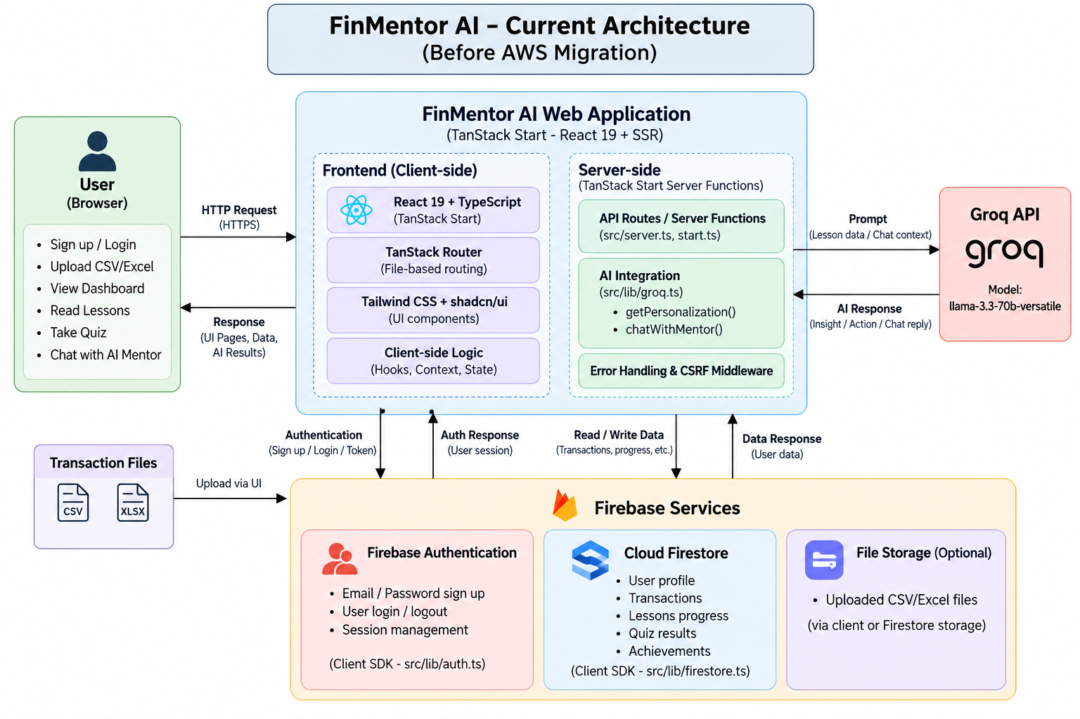

6.2 Data Flow
The following describes the primary data flows in the application:
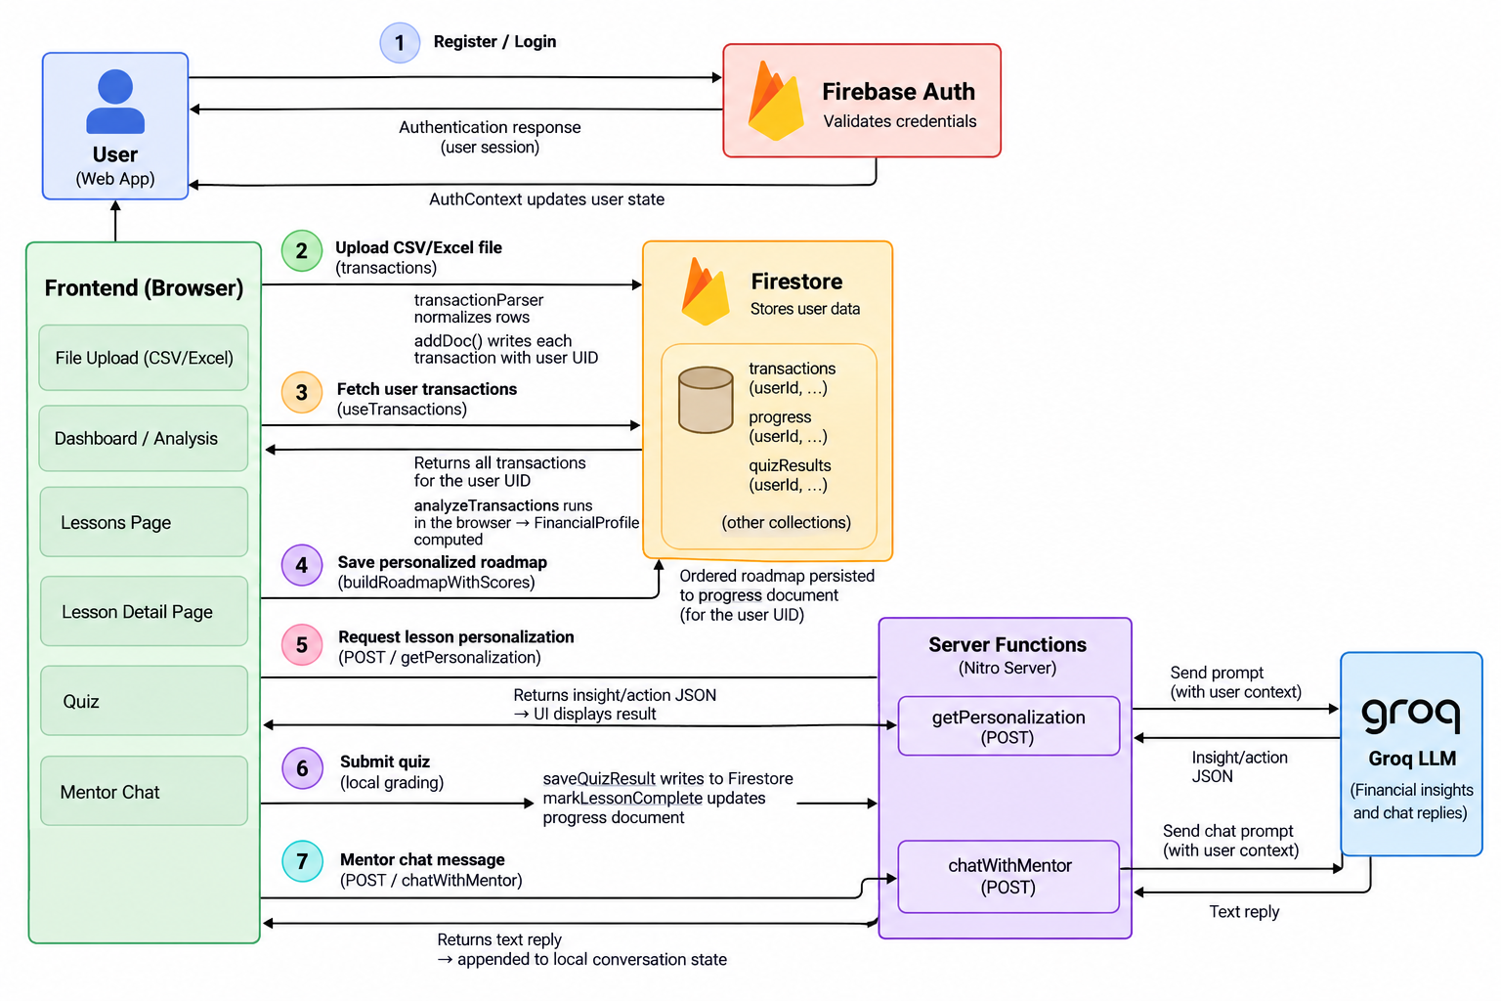

6.3 Firestore Data Model
The application uses the following Firestore collections:
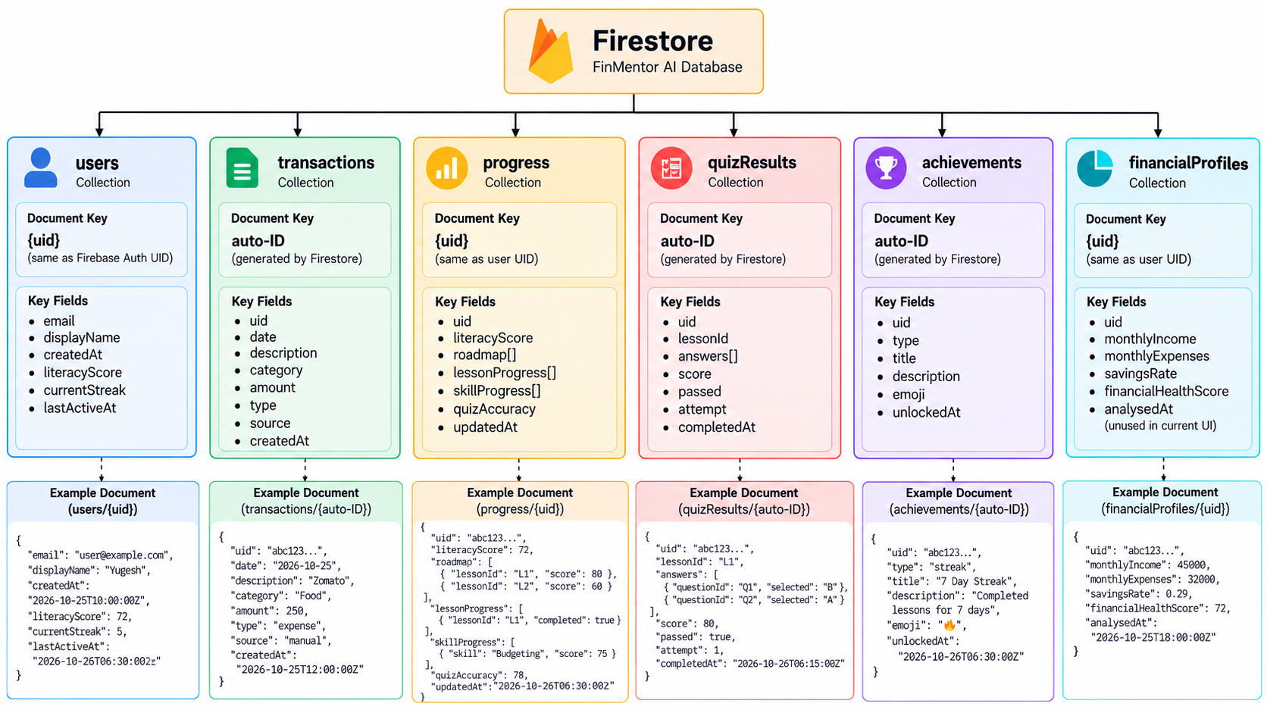

7. SOURCE CODE

7. SOURCE CODE

7.1 Authentication Bootstrap (src/lib/auth.ts)

import {

createUserWithEmailAndPassword,

signInWithEmailAndPassword,

signOut as firebaseSignOut,

onAuthStateChanged,

updateProfile,

type User,

} from "firebase/auth";

import { doc, setDoc, serverTimestamp } from "firebase/firestore";

import { auth, db } from "./firebase";

// ── Sign Up ────────────────────────────

export async function signUp(

email: string,

password: string,

displayName: string,

): Promise<User> {

const credential = await createUserWithEmailAndPassword(

auth,

email,

password,

);

await updateProfile(credential.user, { displayName });

// Bootstrap user document in Firestore

await setDoc(doc(db, "users", credential.user.uid), {

email,

displayName,

photoURL: null,

createdAt: serverTimestamp(),

literacyScore: 0,

currentStreak: 0,

lastActiveAt: serverTimestamp(),

});

return credential.user;

}

// ── Sign In ─────────────────────────────

export async function signIn(email: string, password: string): Promise<User> {

const credential = await signInWithEmailAndPassword(auth, email, password);

return credential.user;

}

// ── Sign Out ───────────────────────────

export async function signOut(): Promise<void> {

await firebaseSignOut(auth);

}

// ── Auth State Observer ──────────────────────

export function subscribeToAuthState(callback: (user: User | null) => void) {

return onAuthStateChanged(auth, callback);

}

7.2 Financial Health Score Computation (src/engine/analysisEngine.ts)
import type {
Transaction,
TransactionCategory,
FinancialProfile,
CategoryBreakdown,
FinancialObservation,
} from "@/types";
import { CATEGORY_LABELS } from "@/types";

// ── Internal helpers ───────────

const INCOME_CATEGORIES: TransactionCategory[] = ["salary"];
const SAVINGS_CATEGORIES: TransactionCategory[] = ["savings", "investment"];
const TRANSFER_CATEGORIES: TransactionCategory[] = ["transfer"];

function sum(txns: Transaction[]): number {
return txns.reduce((acc, t) => acc + t.amount, 0);
}

function clamp(value: number, min: number, max: number): number {
return Math.max(min, Math.min(max, value));
}

// ── Main export

export function analyzeTransactions(
uid: string,
transactions: Transaction[],
): FinancialProfile {
if (transactions.length === 0) {
return emptyProfile(uid);
}

// Exclude internal transfers from spending analysis
const nonTransfer = transactions.filter(
(t) => !TRANSFER_CATEGORIES.includes(t.category),
);

const credits = nonTransfer.filter((t) => t.type === "credit");
const debits = nonTransfer.filter((t) => t.type === "debit");

// ── Income & Expenses ──────────
// Salary credits = income; other credits (savings inflows, etc.) excluded
const incomeTransactions = credits.filter((t) =>
INCOME_CATEGORIES.includes(t.category),
);
const monthlyIncome = sum(incomeTransactions) || sum(credits); // fallback to all credits

const monthlyExpenses = sum(
debits.filter((t) => !SAVINGS_CATEGORIES.includes(t.category)),
);

const savingsAndInvestments = sum(
debits.filter((t) => SAVINGS_CATEGORIES.includes(t.category)),
);

const savingsRate =
monthlyIncome > 0
? clamp(
((monthlyIncome - monthlyExpenses) / monthlyIncome) * 100,
0,
100,
)
: 0;

const investmentRate =
monthlyIncome > 0
? clamp((savingsAndInvestments / monthlyIncome) * 100, 0, 100)
: 0;

const cashFlow = monthlyIncome - monthlyExpenses;

// ── Category Breakdown ───────────────────────────────────────────────────

const categoryMap = new Map<
TransactionCategory,
{ amount: number; count: number }
>();

for (const t of debits) {
if (SAVINGS_CATEGORIES.includes(t.category)) continue;
const existing = categoryMap.get(t.category) ?? { amount: 0, count: 0 };
categoryMap.set(t.category, {
amount: existing.amount + t.amount,
count: existing.count + 1,
});
}

const totalExpenses = monthlyExpenses || 1; // avoid divide-by-zero

const categoryBreakdown: CategoryBreakdown[] = Array.from(
categoryMap.entries(),
)
.map(([category, { amount, count }]) => ({
category,
label: CATEGORY_LABELS[category],
amount,
percentage: parseFloat(((amount / totalExpenses) * 100).toFixed(1)),
count,
}))
.sort((a, b) => b.amount - a.amount);

const highestExpenseCategory =
categoryBreakdown[0]?.category ?? "other";

// ── Specific spend buckets

const subscriptionSpend =
categoryMap.get("subscriptions")?.amount ?? 0;
const debtEmiSpend = categoryMap.get("debt_emi")?.amount ?? 0;

// ── Emergency Fund Estimate ────────────

const emergencyFundMonths =
monthlyExpenses > 0
? clamp(savingsAndInvestments / (monthlyExpenses / 12), 0, 12)
: 0;

// ── Observations

const observations: FinancialObservation[] = [];

if (savingsRate < 10) {
observations.push({
type: "warning",
message: "Your savings rate is below 10%. Financial experts recommend saving at least 20% of income.",
});
} else if (savingsRate >= 20) {
observations.push({
type: "positive",
message: `Great savings rate of ${savingsRate.toFixed(0)}%. You're building a strong financial foundation.`,
});
}

const foodDiningAmount = categoryMap.get("food_dining")?.amount ?? 0;
if (foodDiningAmount / totalExpenses > 0.25) {
observations.push({
type: "warning",
message: "Food & dining accounts for over 25% of your expenses. Small changes here can free up significant savings.",
category: "food_dining",
});
}

if (subscriptionSpend / totalExpenses > 0.1) {
observations.push({
type: "info",
message: "Subscription spending exceeds 10% of expenses. Review which subscriptions you're actively using.",
category: "subscriptions",
});
}

if (debtEmiSpend / monthlyIncome > 0.4) {
observations.push({
type: "warning",
message: "Debt & EMI payments exceed 40% of income. High debt burden limits your financial flexibility.",
category: "debt_emi",
});
}

if (investmentRate < 5 && monthlyIncome > 0) {
observations.push({
type: "info",
message: "No significant investments detected. Starting early, even with small amounts, creates long-term wealth.",
});
}

if (emergencyFundMonths < 3) {
observations.push({
type: "warning",
message: "Emergency fund appears insufficient. Aim for 3–6 months of expenses as a financial safety net.",
});
}

// ── Financial Health Score────────────────
let score = 0;

// Savings rate (0–30 pts)
if (savingsRate >= 30) score += 30;
else if (savingsRate >= 20) score += 24;
else if (savingsRate >= 10) score += 16;
else if (savingsRate >= 5) score += 8;

// Debt/EMI ratio (0–20 pts; lower is better)
const debtRatio = monthlyIncome > 0 ? debtEmiSpend / monthlyIncome : 1;
if (debtRatio < 0.1) score += 20;
else if (debtRatio < 0.2) score += 16;
else if (debtRatio < 0.3) score += 10;
else if (debtRatio < 0.4) score += 5;

// Emergency fund (0–20 pts)
if (emergencyFundMonths >= 6) score += 20;
else if (emergencyFundMonths >= 3) score += 14;
else if (emergencyFundMonths >= 1) score += 7;

// Investment rate (0–15 pts)
if (investmentRate >= 15) score += 15;
else if (investmentRate >= 10) score += 12;
else if (investmentRate >= 5) score += 7;
else if (investmentRate >= 2) score += 3;

// Subscription load (0–15 pts; lower is better)
const subRatio = totalExpenses > 0 ? subscriptionSpend / totalExpenses : 0;
if (subRatio < 0.05) score += 15;
else if (subRatio < 0.1) score += 10;
else if (subRatio < 0.15) score += 5;

return {
uid,
monthlyIncome,
monthlyExpenses,
savingsRate,
cashFlow,
categoryBreakdown,
highestExpenseCategory,
subscriptionSpend,
debtEmiSpend,
emergencyFundMonths,
investmentRate,
observations,
financialHealthScore: clamp(Math.round(score), 0, 100),
analysedAt: new Date(),
};
}

function emptyProfile(uid: string): FinancialProfile {
return {
uid,
monthlyIncome: 0,
monthlyExpenses: 0,
savingsRate: 0,
cashFlow: 0,
categoryBreakdown: [],
highestExpenseCategory: "other",
subscriptionSpend: 0,
debtEmiSpend: 0,
emergencyFundMonths: 0,
investmentRate: 0,
observations: [],
financialHealthScore: 0,
analysedAt: new Date(),
};
}

7.3 Lesson Recommendation Engine (src/engine/recommendationEngine.ts)

import type { FinancialProfile, LessonTopic } from "@/types";

import { LESSONS } from "@/data/lessons";

// ── Types ─────────────

export interface TopicScore {

topic: LessonTopic;

priority: number;

/** Human-readable reasons why this topic was prioritized */

reasons: string[];

}

export interface RoadmapResult {

/** Ordered lesson IDs — highest priority first */

lessonIds: string[];

/** Detailed scores for explainability / AI mentor context */

topicScores: TopicScore[];

}

// ── Helpers ─────────────────────────

function clamp(v: number, min: number, max: number) {

return Math.max(min, Math.min(max, v));

}

function discretionaryPct(profile: FinancialProfile): number {

const cats = ["food_dining", "shopping", "entertainment", "subscriptions"];

return profile.categoryBreakdown

.filter((c) => cats.includes(c.category))

.reduce((s, c) => s + c.percentage, 0);

}

// ── Core Scoring Logic ────────────────────

export function scoreLessonTopics(profile: FinancialProfile): TopicScore[] {

const debtRatio = clamp(

profile.monthlyIncome > 0 ? profile.debtEmiSpend / profile.monthlyIncome : 0,

0, 1,

);

const subRatio = clamp(

profile.monthlyExpenses > 0 ? profile.subscriptionSpend / profile.monthlyExpenses : 0,

0, 1,

);

const discPct = discretionaryPct(profile);

const savings = clamp(profile.savingsRate, 0, 100);

const emergency = clamp(profile.emergencyFundMonths, 0, 12);

const investment = clamp(profile.investmentRate, 0, 100);

// Readiness tiers used to gate advanced topics

const hasBasicStability = savings >= 10 && emergency >= 1;

const hasGoodStability = savings >= 20 && emergency >= 3;

const isFinanciallyMature = savings >= 25 && emergency >= 6 && investment >= 10 && debtRatio < 0.15;

// ── 1. Budgeting ─────────────────────────────────────────────────────────

const budgetingReasons: string[] = [];

let budgetingScore = 5;

if (savings < 5) { budgetingScore += 80; budgetingReasons.push("Very low savings rate — budgeting is urgently needed"); }

else if (savings < 15) { budgetingScore += 50; budgetingReasons.push("Below-average savings rate"); }

else if (savings < 20) { budgetingScore += 20; budgetingReasons.push("Savings rate slightly below 20% target"); }

if (["food_dining","shopping","entertainment"].includes(profile.highestExpenseCategory)) {

budgetingScore += 30; budgetingReasons.push("Discretionary spending is the biggest expense category");

}

if (discPct > 50) { budgetingScore += 25; budgetingReasons.push("Discretionary spending exceeds 50% of expenses"); }

else if (discPct > 35) { budgetingScore += 12; budgetingReasons.push("High proportion of discretionary spending"); }

if (profile.cashFlow < 0) { budgetingScore += 40; budgetingReasons.push("Negative cash flow — spending exceeds income"); }

if (savings >= 30 && discPct <= 30) {

budgetingScore = Math.max(budgetingScore - 30, 5);

budgetingReasons.push("Strong savings rate reduces urgency");

}

// ── 2. Smart Saving ───────────────────────────────────────────────────────

const savingReasons: string[] = [];

let savingScore = 5;

if (savings < 5) { savingScore += 65; savingReasons.push("Critically low savings — smart saving is essential"); }

else if (savings < 10) { savingScore += 45; savingReasons.push("Low savings rate — key growth area"); }

else if (savings < 20) { savingScore += 25; savingReasons.push("Below recommended 20% savings target"); }

else if (savings < 30) { savingScore += 10; savingReasons.push("Good savings, room for further optimization"); }

if (savings >= 30) {

savingScore = Math.max(savingScore - 20, 5);

savingReasons.push("Strong savings rate already established");

}

// ── 3. Emergency Fund ─────────────────────────────────────────────────────

const emergencyReasons: string[] = [];

let emergencyScore = 5;

if (emergency === 0) { emergencyScore += 70; emergencyReasons.push("No emergency fund detected — critical gap"); }

else if (emergency < 1) { emergencyScore += 55; emergencyReasons.push("Emergency fund covers less than 1 month"); }

else if (emergency < 3) { emergencyScore += 40; emergencyReasons.push("Emergency fund below 3-month minimum"); }

else if (emergency < 6) { emergencyScore += 15; emergencyReasons.push("Emergency fund adequate but not fully optimized"); }

else { emergencyScore += 3; emergencyReasons.push("Emergency fund is healthy (6+ months)"); }

if (emergency >= 6) emergencyScore = Math.max(emergencyScore - 20, 3);

// ── 4. Debt Management ────────────────────────────────────────────────────

// Zero base — only appears prominently when real debt exists.

const debtReasons: string[] = [];

let debtScore = 0;

if (debtRatio > 0.5) { debtScore += 120; debtReasons.push("Debt/EMI exceeds 50% of income — extremely high burden"); }

else if (debtRatio > 0.4) { debtScore += 95; debtReasons.push("Debt/EMI exceeds 40% of income — high burden"); }

else if (debtRatio > 0.3) { debtScore += 65; debtReasons.push("Debt/EMI is 30–40% of income — moderate-high burden"); }

else if (debtRatio > 0.2) { debtScore += 40; debtReasons.push("Debt/EMI is 20–30% of income — worth monitoring"); }

else if (debtRatio > 0.1) { debtScore += 15; debtReasons.push("Some debt/EMI present"); }

else { debtScore += 3; debtReasons.push("Low or no debt detected"); }

if (debtRatio > 0.2 && profile.cashFlow < 0) {

debtScore += 30; debtReasons.push("Debt combined with negative cash flow is critical");

}

// ── 5. Investing Basics ───────────────────────────────────────────────────

// Gated: only high priority when the user has stability but no investments.

const investingReasons: string[] = [];

let investingScore = 0;

if (hasGoodStability && investment < 5) {

investingScore += 85; investingReasons.push("Good savings & emergency fund — ready to start investing");

} else if (hasBasicStability && investment < 5) {

investingScore += 45; investingReasons.push("Basic stability in place — investing is the next step");

} else if (hasGoodStability && investment < 10) {

investingScore += 35; investingReasons.push("Could increase investment rate above 10%");

} else if (!hasBasicStability) {

investingScore += 5; investingReasons.push("Build savings & emergency fund before investing");

} else {

investingScore += investment >= 10 ? 20 : 10;

investingReasons.push(investment >= 10 ? "Decent investment rate — reinforce with structure" : "Some investments — room to grow");

}

if (investment < 5 && savings >= 15) {

investingScore += 20; investingReasons.push("Savings exist but investments are near zero — idle money");

}

// ── 6. Financial Goal Planning ────────────────────────────────────────────

// Useful only after basic financial stability is achieved.

const goalReasons: string[] = [];

let goalScore = 0;

if (hasGoodStability && investment >= 5) {

goalScore += 55; goalReasons.push("Stable finances with investments — time to set concrete goals");

} else if (hasGoodStability) {

goalScore += 30; goalReasons.push("Good financial position — goal planning maximizes impact");

} else if (hasBasicStability) {

goalScore += 15; goalReasons.push("Building stability — goal planning provides direction");

} else {

goalScore += 5; goalReasons.push("Focus on fundamentals before goal planning");

}

// ── 7. Insurance Essentials ───────────────────────────────────────────────

// Universally relevant, but deprioritized when more urgent needs exist.

const insuranceReasons: string[] = [];

let insuranceScore = 10;

if (hasGoodStability) { insuranceScore += 30; insuranceReasons.push("Financially stable — insurance protects accumulated wealth"); }

else if (hasBasicStability) { insuranceScore += 15; insuranceReasons.push("Basic stability achieved — insurance is the next safety layer"); }

else { insuranceScore += 3; insuranceReasons.push("Address savings/debt before focusing on insurance"); }

if (debtRatio > 0.2) { insuranceScore += 10; insuranceReasons.push("Debt burden increases importance of insurance protection"); }

// ── 8. Digital Payments & Financial Safety ────────────────────────────────

const digitalReasons: string[] = [];

let digitalScore = 8;

if (subRatio > 0.15) { digitalScore += 20; digitalReasons.push("High subscription spend — digital literacy is important"); }

else if (subRatio > 0.08) { digitalScore += 10; digitalReasons.push("Moderate subscription spend — digital safety applies"); }

else { digitalScore += 3; digitalReasons.push("General digital financial literacy benefit"); }

// ── 9. Lifestyle & Spending Psychology ────────────────────────────────────

const psychologyReasons: string[] = [];

let psychologyScore = 3;

if (discPct > 55) { psychologyScore += 50; psychologyReasons.push("Very high discretionary spending — psychology is the root cause"); }

else if (discPct > 40) { psychologyScore += 30; psychologyReasons.push("High discretionary spending signals habits to examine"); }

else if (discPct > 30) { psychologyScore += 15; psychologyReasons.push("Moderate discretionary spending — lifestyle reflection helpful"); }

if (savings >= 20 && investment < 5) {

psychologyScore += 20; psychologyReasons.push("Good saver but not investing — mindset barriers likely");

}

// ── 10. Becoming Financially Independent ─────────────────────────────────

// Advanced: only surfaces when all fundamentals are strong.

const independenceReasons: string[] = [];

let independenceScore = 0;

if (isFinanciallyMature) {

independenceScore += 70; independenceReasons.push("Strong across all fundamentals — ready for FI planning");

} else if (savings >= 20 && emergency >= 3 && investment >= 5) {

independenceScore += 30; independenceReasons.push("Good foundation — financial independence is a motivating horizon");

} else if (investment >= 10) {

independenceScore += 15; independenceReasons.push("Active investor — independence planning is relevant");

} else {

independenceScore += 3; independenceReasons.push("Focus on fundamentals first — revisit after building stability");

}

8. SCREEN SHOTS

8. SCREEN SHOTS

8.1 Landing Page (/)
The landing page presents the product value proposition with a marketing layout, navigation bar, and a 'Get Started' call-to-action that routes to the signup page.

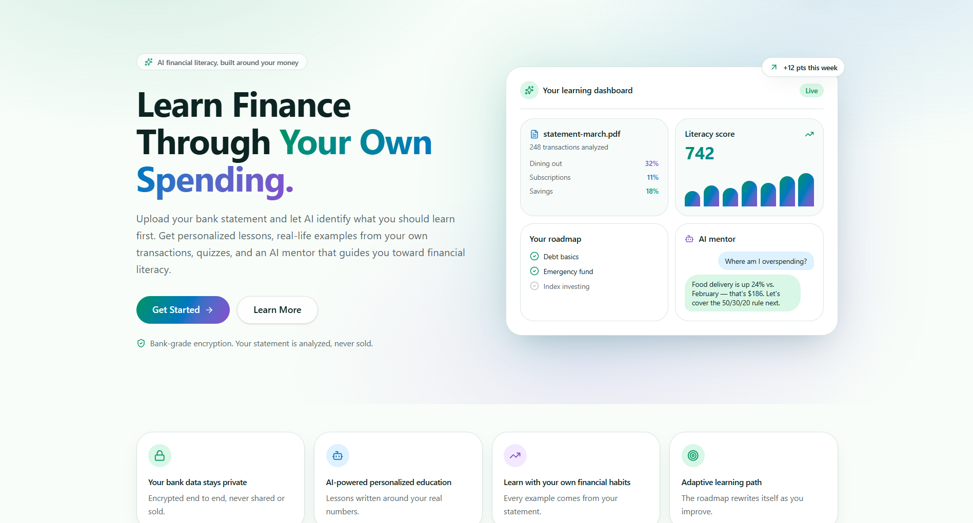

10.2 Sign Up Page (/auth/signup)
The signup form accepts a display name, email address, and password. Client-side validation enforces a minimum password length of eight characters.
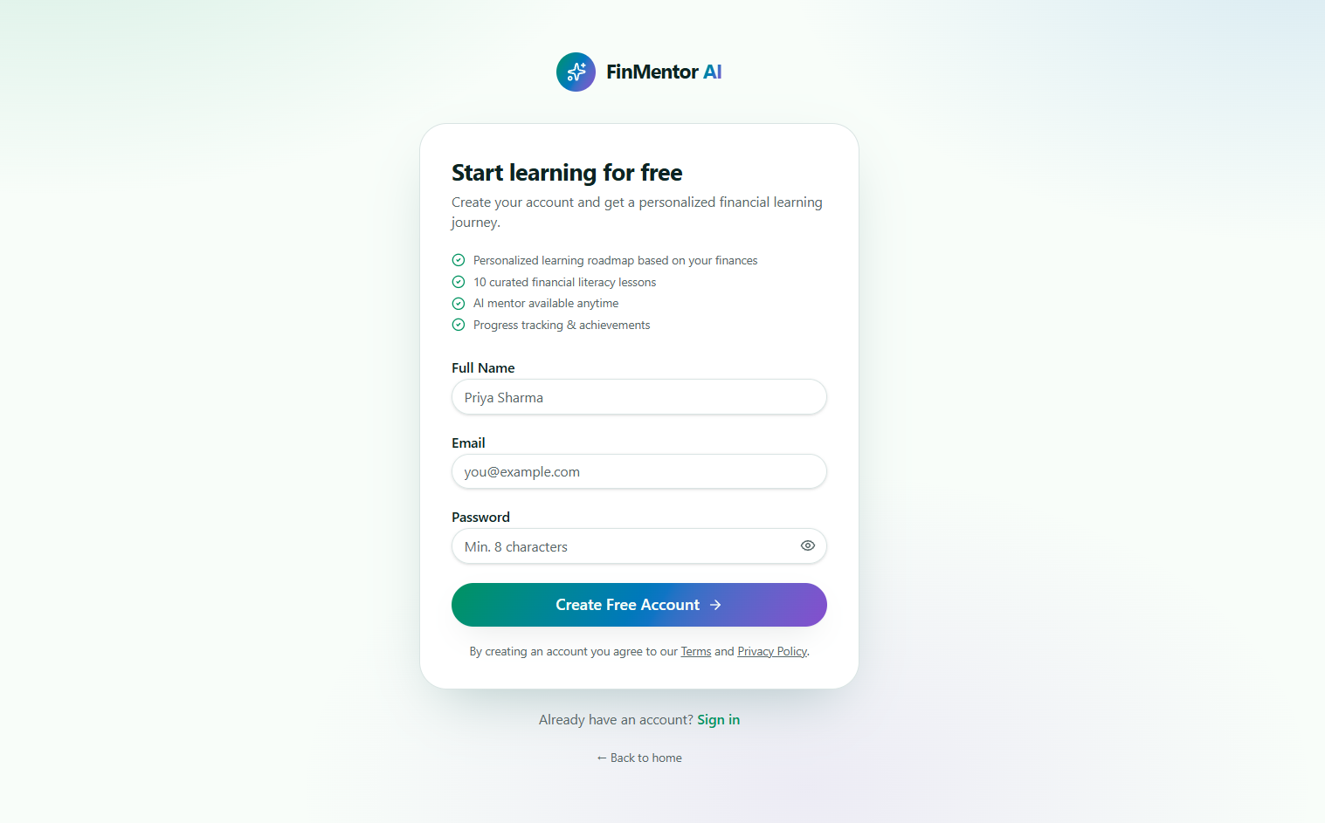

10.3 Login Page (/auth/login)
The login form authenticates users via Firebase Auth. Failed login attempts display a single normalized error message.

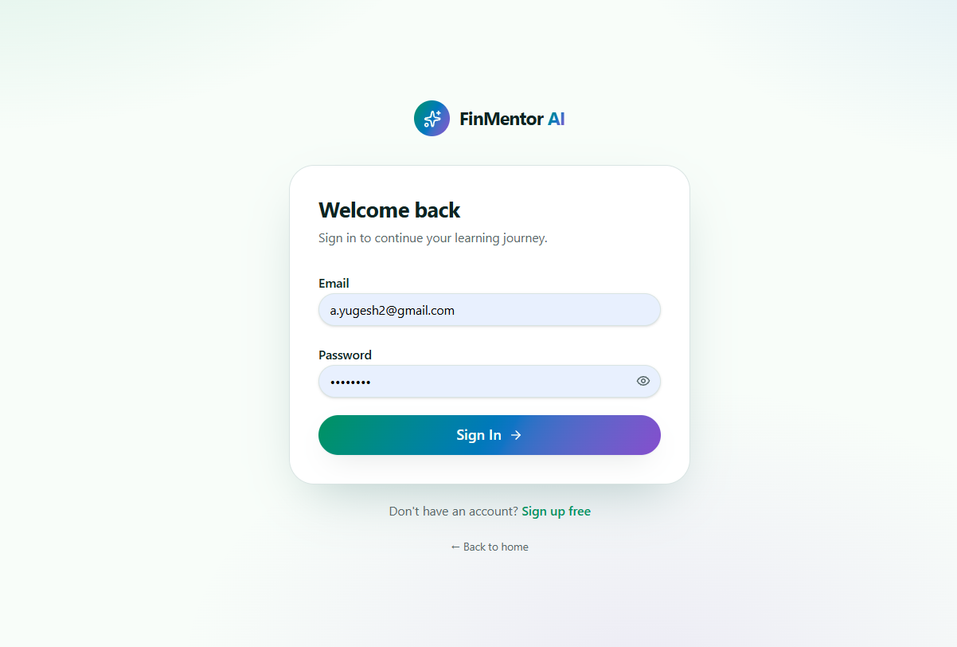

10.4 Dashboard (/app/dashboard)
The dashboard displays the user's financial health score, literacy score, monthly income and expense summary, financial observations, recent transactions, and skill progress bars.
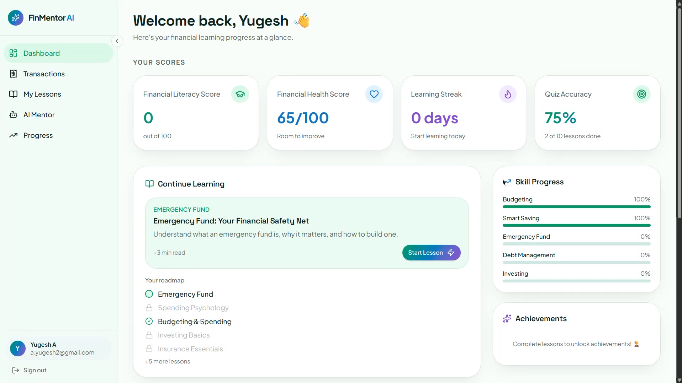

10.5 Transaction Import (/app/transactions)
The transaction page provides three tabs: CSV upload, Excel upload, and manual entry. Uploaded transactions appear in a sortable, paginated list.

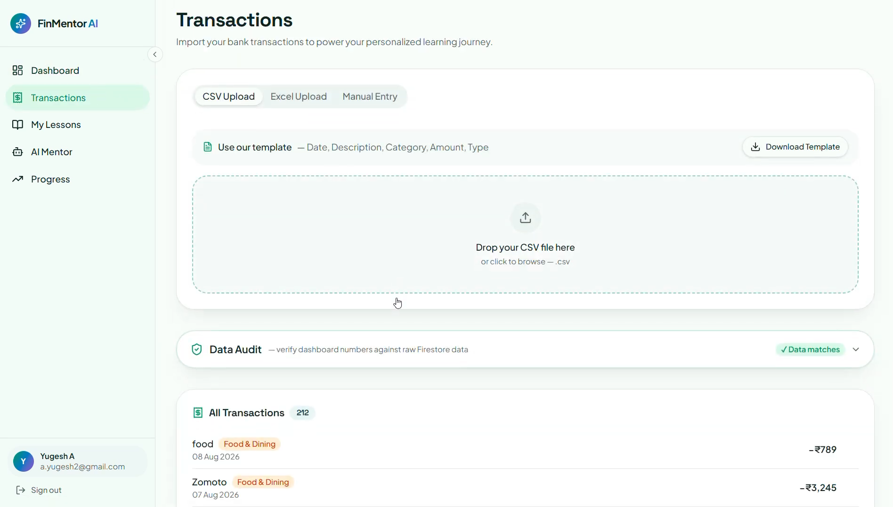

10.6 Lessons Roadmap (/app/lessons)
The lessons page displays the personalized learning roadmap with lesson cards showing topic, estimated reading time, and status (locked/unlocked/completed).

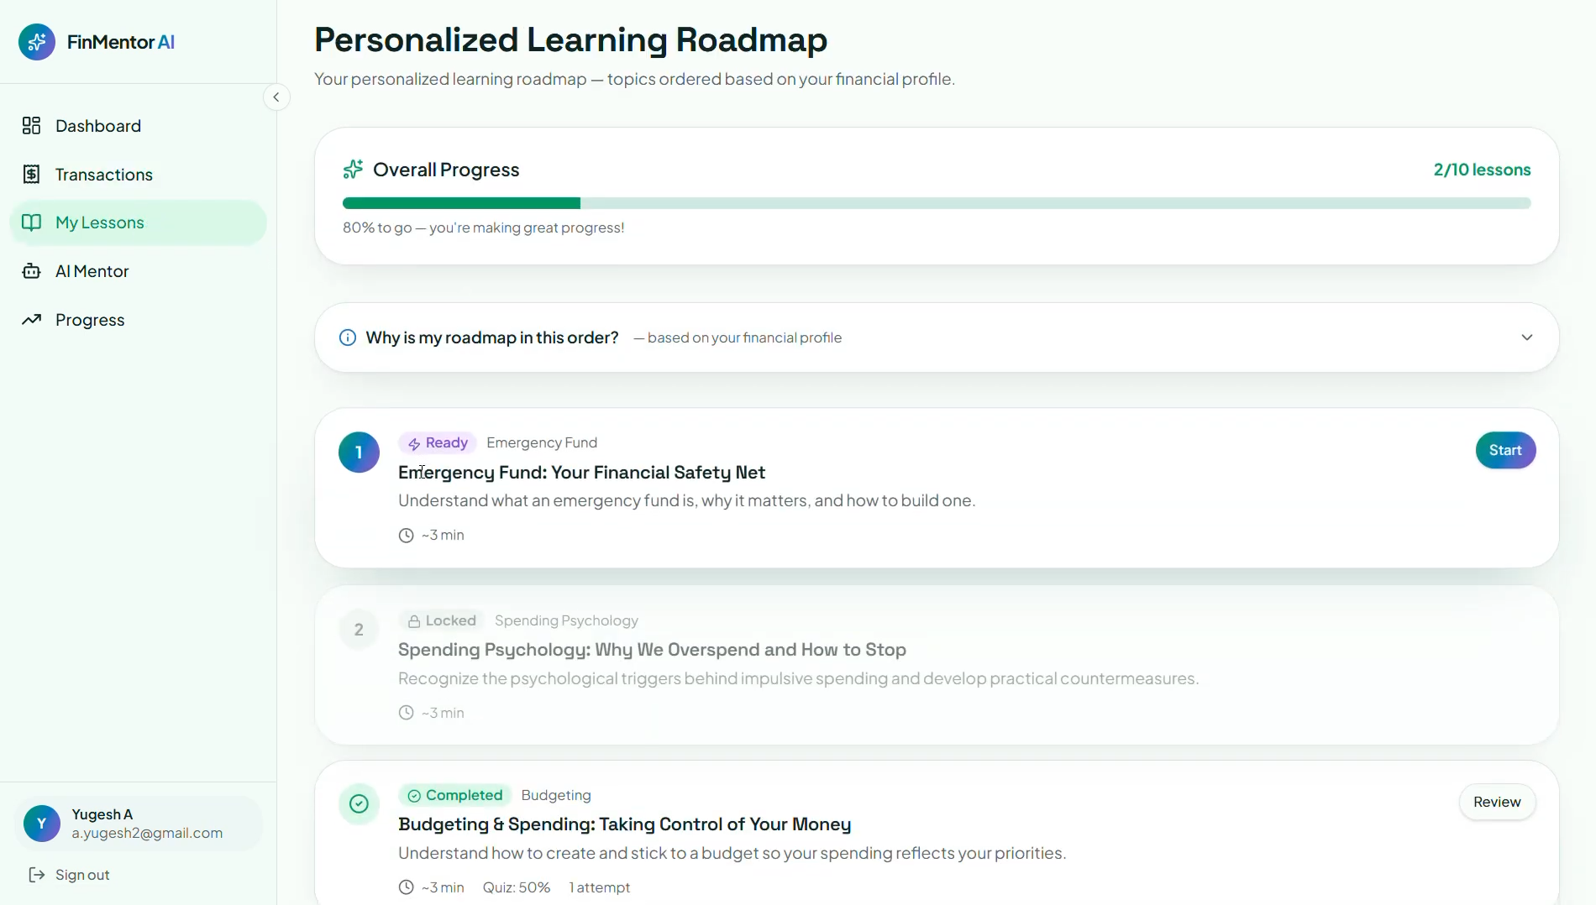

10.7 Lesson Detail (/app/lessons/{id})
A lesson page shows the lesson title, markdown content, key takeaways, and the AI-generated personalization panel (insight and action).

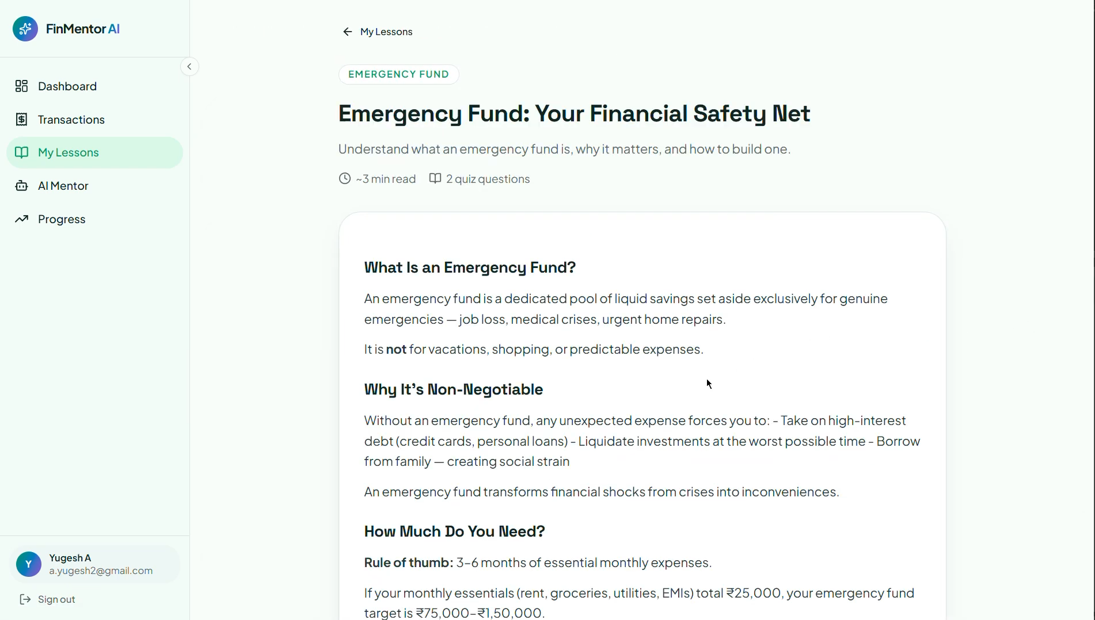

10.8 Quiz Page (/app/quiz/{id})
The quiz page presents two multiple-choice questions with instant feedback and explanations on submission.

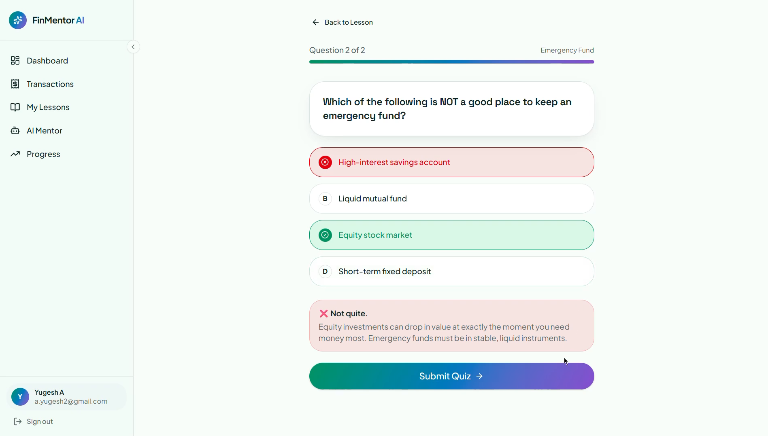

10.9 AI Mentor Chat (/app/mentor)
The mentor chat interface displays the conversation history, a message input field, and starter-question prompts.

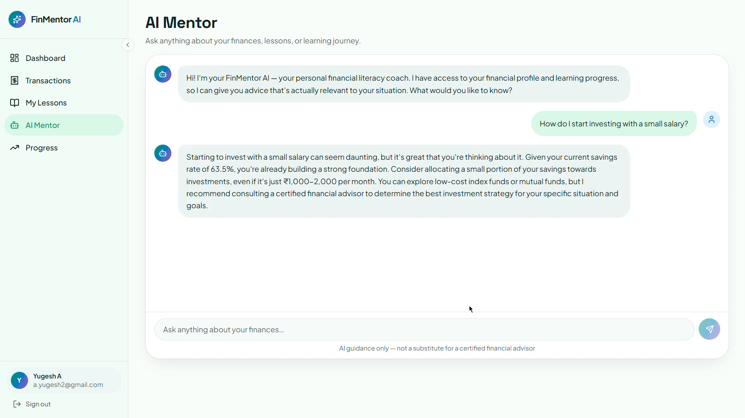

10.10 Progress Page (/app/progress)
The progress page shows the literacy score, per-topic skill progress bars, lesson completion history, and achievement badges.
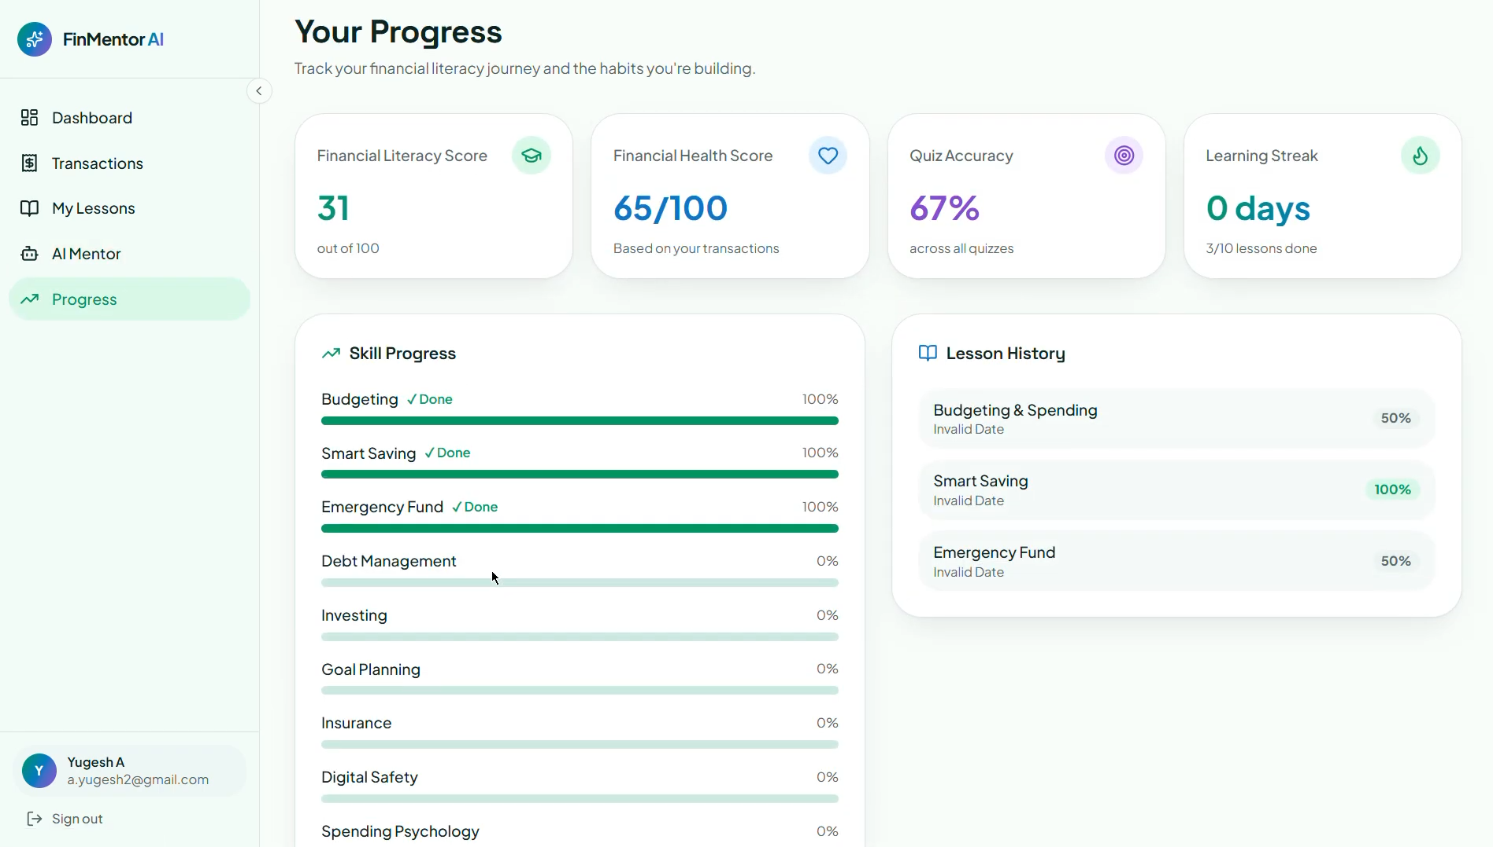

9. CONCLUSION

9. CONCLUSION
FinMentor AI demonstrates how a data-driven personalized learning system can be built by combining a transparent rule-based analysis engine with AI-powered content personalization. The platform addresses a real gap between generic financial education content and the individual's own financial behaviour by using the user's actual bank transactions as the starting point for a customized learning roadmap.
The rule-based financial analysis engine computes a structured financial profile and health score without relying on any AI, ensuring that the analysis is deterministic, explainable, and free from hallucination. The recommendation engine uses an additive-penalty model to prioritize lessons that address the user's most pressing financial gaps, producing meaningfully different roadmaps for different financial profiles.
The integration of the Groq API for lesson personalization and AI mentor chat is implemented using the server function pattern of TanStack Start, which ensures that the API key remains on the server and is never exposed to the browser. CSRF middleware is applied to server function endpoints. These architectural decisions reflect a deliberate commitment to security alongside functionality.
Several areas of the platform are identified for improvement, including the addition of Firestore Security Rules, authentication checks on AI server functions, rate limiting, automated tests, and the completion of the achievement and streak tracking features. The technical audit performed on the codebase provides a detailed roadmap of improvements prioritized by severity and impact.
Overall, FinMentor AI serves as a working prototype of a personalized financial literacy platform and demonstrates the application of modern web technologies — TypeScript, React, TanStack Start, Firebase, and large language models — in a real-world educational context.

10. FUTURE ENCHANCEMENTS

10. FUTURE ENCHANCEMENTS

- Server-Side Security: Firestore Security Rules: Author and commit least-privilege per-UID security rules to the repository and test them with the Firebase Local Emulator Suite.
- AI Endpoint Authentication and Rate Limiting: Authenticate both Groq server functions using Firebase ID token verification and implement per-user daily token budgets stored in Firestore.
- AI Response Caching: Cache the AI-generated personalization insight per (user ID, lesson ID, profile hash) in Firestore so that repeated visits to the same lesson do not incur additional API calls.
- Achievement and Streak Completion: Complete the achievement unlock and streak increment logic by wiring them into the markLessonComplete function, enabling the badge and streak features to function as designed.
- Lesson Renderer Sanitization: Replace dangerouslySetInnerHTML in the lesson renderer with a sanitized markdown component (e.g., react-markdown) to eliminate the risk of XSS if content sources change.
- Automated Testing: Add unit tests for the analysis engine, recommendation engine, and transaction parser; integration tests for Firestore helpers; and end-to-end tests using Playwright.
- Analysis Engine Accuracy: Fix the financial analysis engine to bucket transactions into 30-day windows (instead of summing over the full uploaded range) so that monthly figures are accurate regardless of statement duration.
- Dependency Maintenance: Replace xlsx@0.18.5 with a maintained alternative (exceljs or a vetted SheetJS build), prune unused dependencies, and add npm audit to the CI workflow.
- Persistent Conversation History: Persist the AI Mentor Chat conversation to Firestore so the context is preserved across sessions.

11. BIBLIOGRAPHY

11. BIBLIOGRAPHY

- TanStack. TanStack Start Documentation. https://tanstack.com/start/latest
- TanStack. TanStack Router Documentation. https://tanstack.com/router/latest
- Groq. Groq API Documentation. https://console.groq.com/docs/openai
- Firebase. Firebase Authentication Documentation. https://firebase.google.com/docs/auth
- Firebase. Cloud Firestore Documentation. https://firebase.google.com/docs/firestore
- PapaParse. PapaParse Documentation. https://www.papaparse.com/docs
- SheetJS. SheetJS Community Edition Documentation. https://sheetjs.com/
- Nitro. Nitro Server Engine Documentation. https://nitro.build/
- OWASP Foundation. OWASP Top 10: 2021. https://owasp.org/www-project-top-ten/
- Firebase. Firebase Security Rules Documentation. https://firebase.google.com/docs/rules

