# Configuring Unreal Engine Project for Using AdBox

This document describes about UE project setting configuration for using AdMob plugin AdBox. AdMob is a mobile advertising platform developed by Google, designed to help app developers monetize their mobile applications through in-app advertising.

AdBox is Android plugin for Unreal Engine which provides methods to integrate AdMob easily to UE projects, especially for UE version 4.27.

In fact, Unreal Engine also provides AdMob in it but UE 4.27 is older version and it doesn’t work anymore nowadays because AdMob has changed a lot from the time when UE 4.27 had been released.

You should configure some project settings in UE 4.27 for using AdBox by following steps below.

## Android Minimum SDK Version

You must change the minimum Android SDK version to 26.

This is because AdBox uses high version of AdMob module in it.

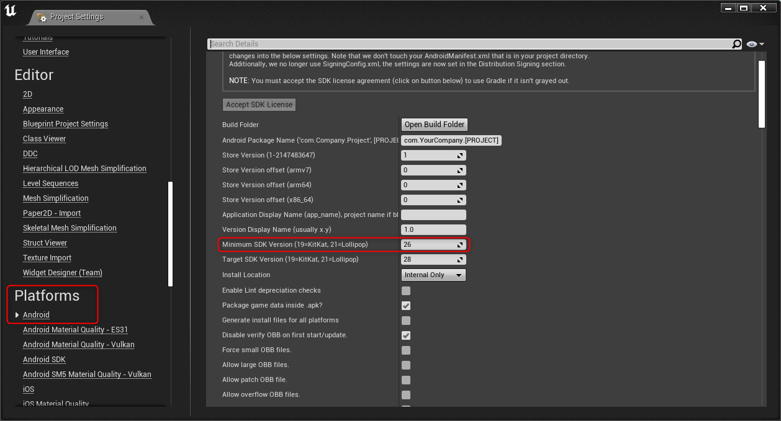

## Add AdMob Advertising Unit IDs

You must add Ad Mob Ad Unit IDs for Banner, Interstitial and Reward Ad.

These IDs are essential for Using AdMob. For more information visit Google AdMob official website. (<https://developers.google.com/admob/android/quick-start>)

You must also disable **Enable Google Play support** and **Include AdMob support for ads** options.

This is because by enabling these items, UE 4.27 generate some deprecated google SDK functions causing crash errors and AdMob module version conflict.

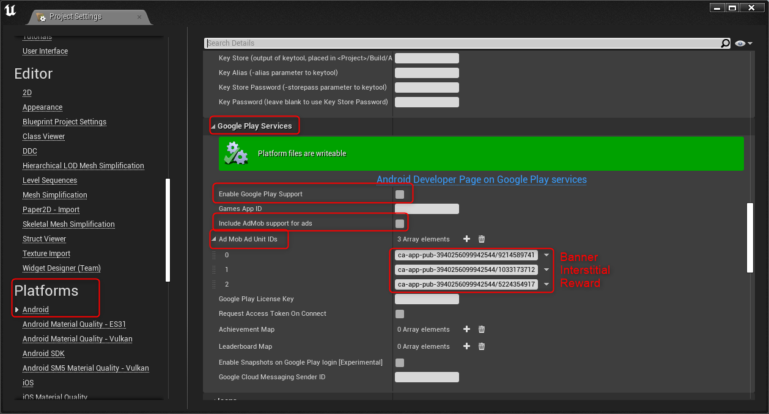

Additionally, you must change the **App ID** defined in **AdMob_APL.xml** (folder path in plugin: AdBox\Source\AdMob).

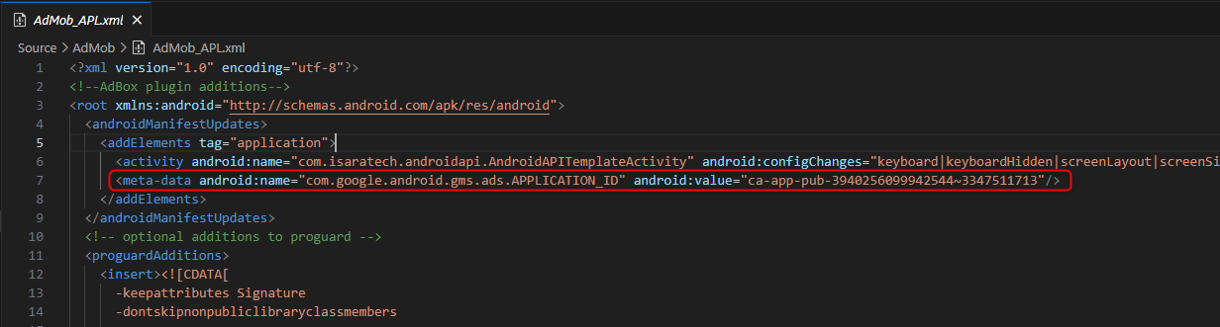

The IDs shown in the above figures are for only **testing**.

## Disabling Google Plugins

You must disable google plugins shown in following figure.

This is because by enabling these plugins, UE 4.27 generate some deprecated google SDK functions causing crash errors.

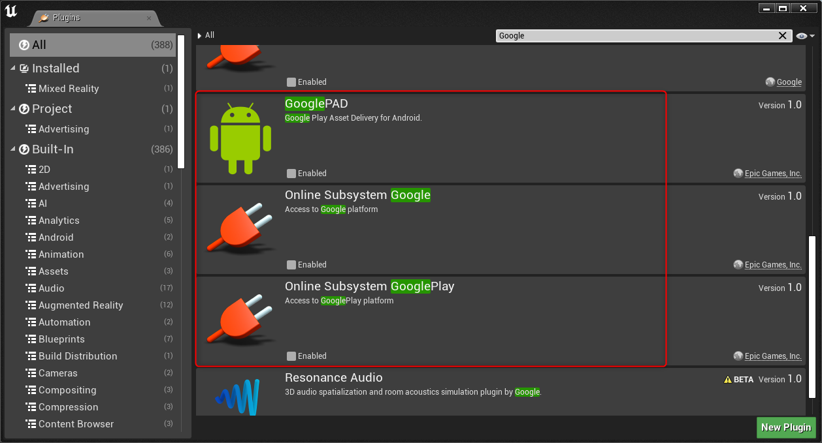

## How to use AdBox in the project

You can use AdBox by simply adding some blueprint functions.

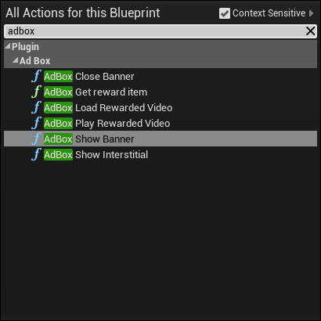

* Banner

Show Banner

Close Banner

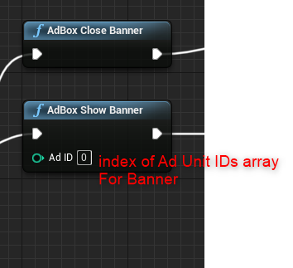

The Ad ID is index value of Ad Mob Ad Unit IDs array described in step 2.

Index value 0 is for Banner.

* Interstitial

Show Interstitial

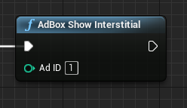

Index value 1 is for Interstitial.

* Reward

Load Rewarded Video

Play Rewarded Video

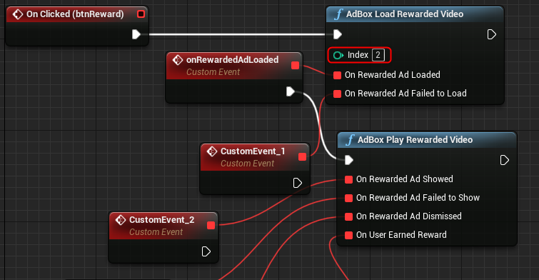

Index value 2 is for Reward.

That’s all and thanks for your careful reading.