Practical - 1
Practical Title: Project Initiation, Requirement Analysis, Sitemap, Wireframe, and GitHub Setup

Problem Definition: Initiate the semester-long StudentHub portal by identifying the problem scope, user roles, key modules, navigation flow, and minimum 10 pages. Create a sitemap, low-fidelity wireframe, project folder structure, README file, and GitHub repository.

Theory

What is URL and parts of URL?
Answer :
A URL (Uniform Resource Locator) is the address of a webpage or resource on the internet. It tells the browser where the webpage is located and how to access it.
Example:
https://www.example.com/about.html
Parts of a URL:
- Protocol: https:// – Defines how data is transferred.
- Domain Name: www.example.com – The website's address.
- Path: /about.html – The specific page or file on the website.

How does HTML file process in web browser?
Answer:
When a user enters a website address or opens an HTML file, the browser loads the HTML document. It reads the HTML code from top to bottom and creates the page structure. Then it loads the CSS for styling and JavaScript for interactivity. Finally, the browser displays the fully rendered webpage on the screen.

3. How will page navigation flow managed among all HTML pages?
Answer:
Page navigation is managed using HTML links (<a> tags). Each page contains links to other pages such as Home, About, Contact, Profile, and Dashboard. When a user clicks a link, the browser opens the corresponding HTML page. This creates a smooth and organized navigation flow throughout the website.

4. How will GitHub commits be maintained after each practical?
Answer:
After completing each practical, the updated files are saved and uploaded to the GitHub repository using a new commit. Every commit includes a clear message describing the changes, such as "Added Login Page" or "Updated Contact Form". This helps keep track of progress, maintain version history, and makes it easy to review or restore previous work if needed.

Implementation/ Output/Result

Required Analysis:

create new account page
login page
dashboard
profile
course
assignment detail
attendance
result detail page
contact

Sitemap:
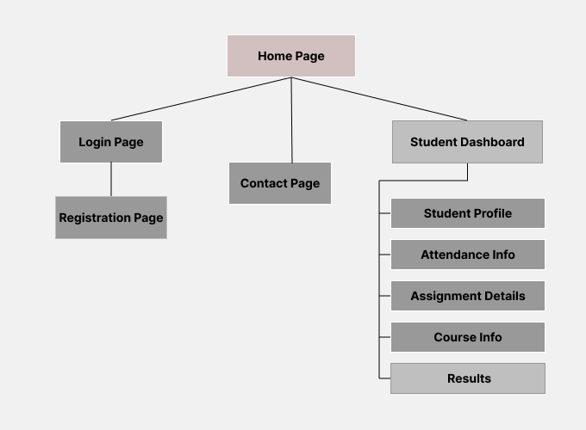


Evidence of Work (Screenshots)

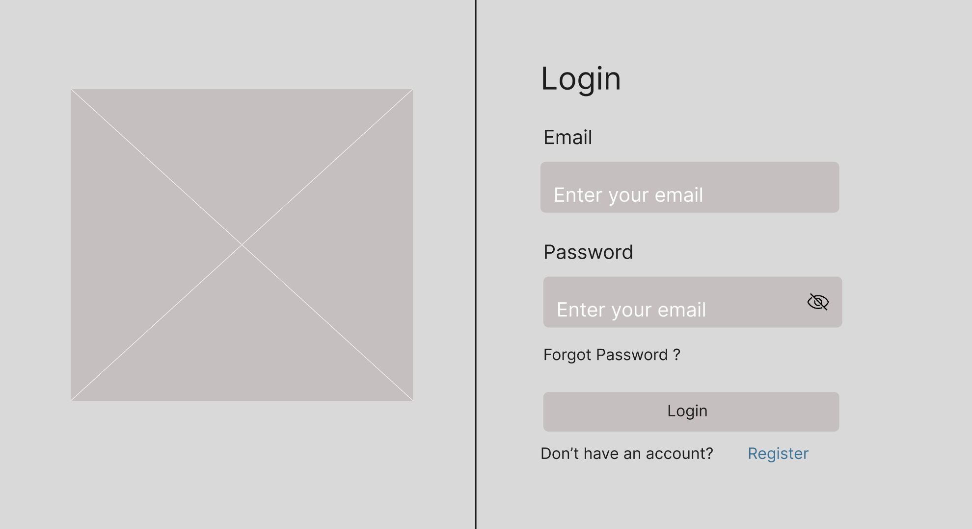





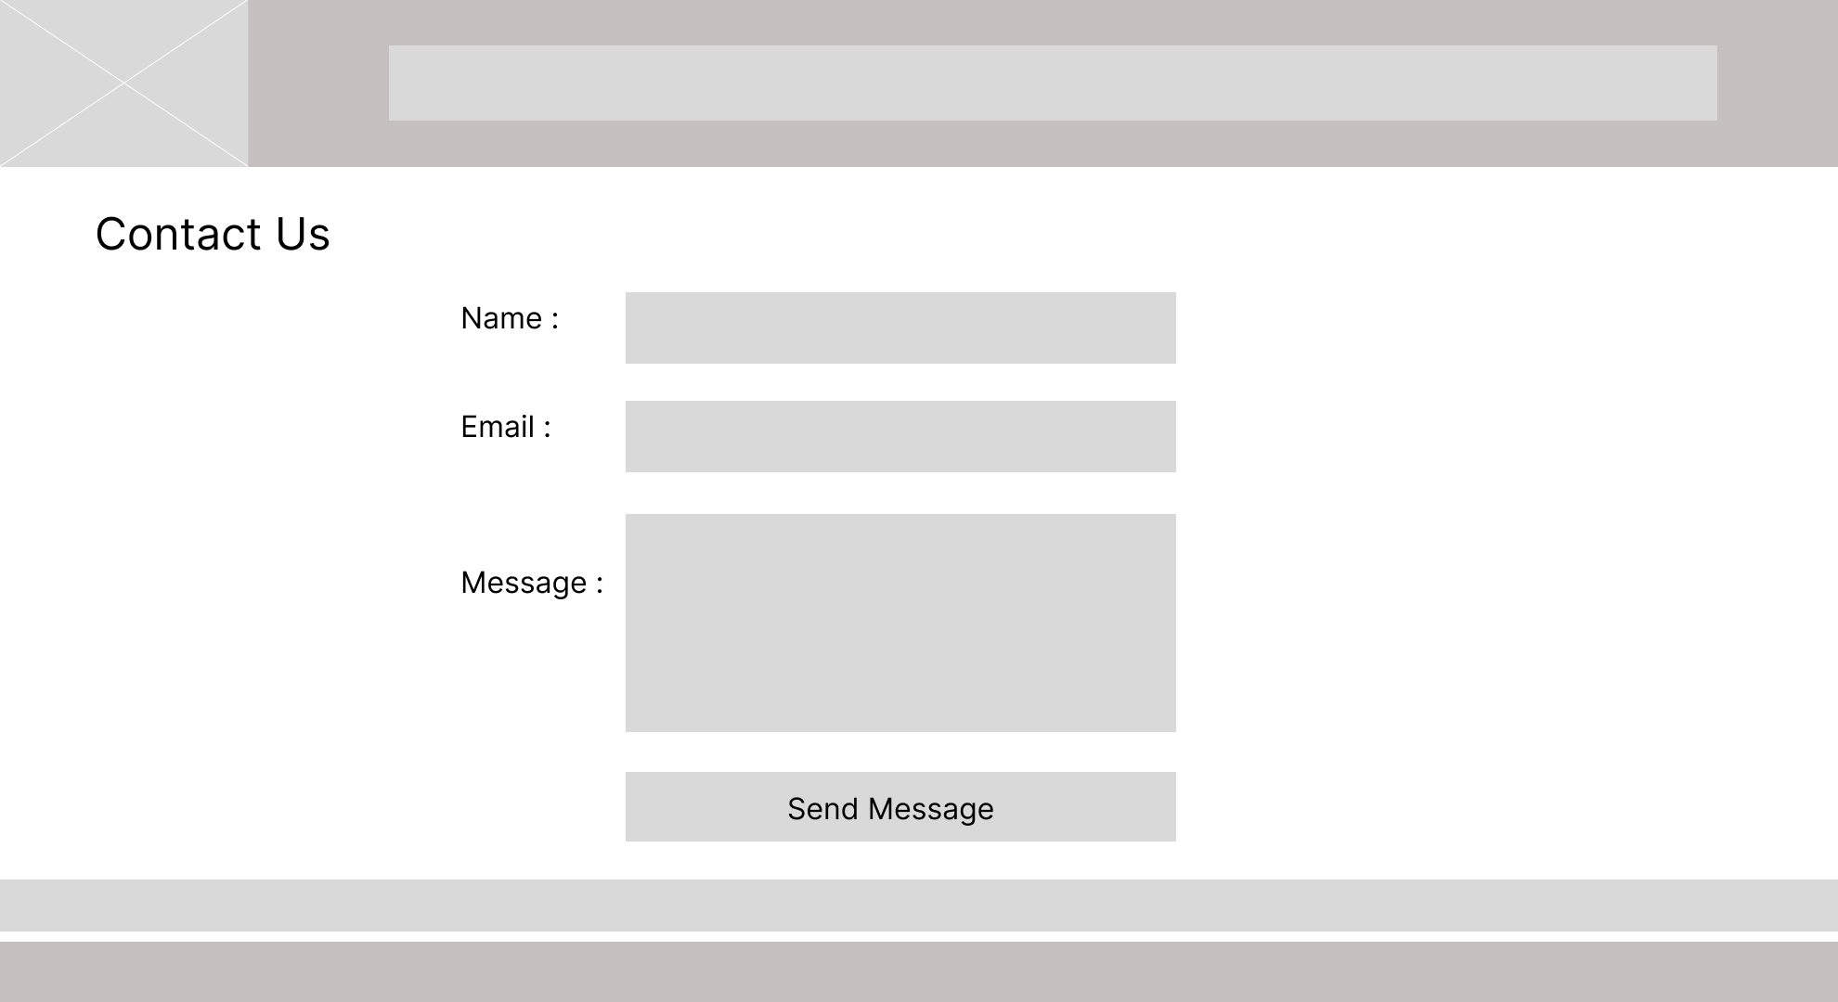




GitHub Repository Link:
https://github.com/Yugpatel009/STUDENTHUB.git

Challenges Faced:
- Understanding the requirements of the Student Hub Portal.
- Organizing all pages correctly in the sitemap.
- Designing a simple and user-friendly wireframe.
- Deciding the proper navigation between pages.
- Creating the report in Microsoft Word because I was not familiar with formatting.
- Managing time while completing all the tasks.

Learning Outcomes:

- Learned how to analyze project requirements.
- Understood how to create a sitemap for website navigation.
- Gained experience in designing wireframes.
- Improved planning and website design skills.
- Learned basic Microsoft Word formatting for documentation.

Practical - 2
Practical Title: Semantic HTML5 Pages with Accessibility-Ready Structure

Problem Definition: Develop static HTML5 skeletons for at least 10 StudentHub pages such as Home, About, Register, Login, Dashboard, Events, Profile, Contact, Admin, FAQ, and Feedback. Use semantic tags and accessibility-friendly structure.

Theory

1. Are semantic tags such as header, nav, main, section, article, aside, and footer used properly?
Answer:
Yes. The website uses semantic HTML5 tags appropriately to organize the page structure and improve readability, accessibility, and SEO.

2. Are form labels, headings, image alt text, and navigation links accessible?
Answer:
Yes. All form fields have associated labels, headings follow a logical hierarchy, images include descriptive alt text, and navigation links are clear and keyboard accessible.

3. Is the page structure consistent across all pages?
Answer:
Yes. All pages follow a consistent layout with the same header, navigation menu, main content area, and footer, providing a uniform user experience.

Implementation

<html> – Root element that contains the entire HTML document.

<head> – Contains metadata, title, links to CSS, and other resources.

<title> – Defines the title of the web page displayed in the browser tab.

<body> – Contains all visible content of the web page.

<header> – Represents the introductory section or page header.

<nav> – Defines the navigation menu with links.

<main> – Contains the primary content of the page.

<footer> – Represents the footer section of the page.

<h1> to <h6> – Defines headings from highest to lowest level.

<p> – Defines a paragraph of text.

<a> – Creates hyperlinks to other pages or resources.

<img> – Displays an image with an alt attribute for accessibility.

<form> – Creates a form to collect user input.

<label> – Provides a label for form controls.

<input> – Accepts user input such as text, email, or password.

<button> – Creates a clickable button.

<ul> – Creates an unordered (bulleted) list.

• Evidence of Work (Screenshots)

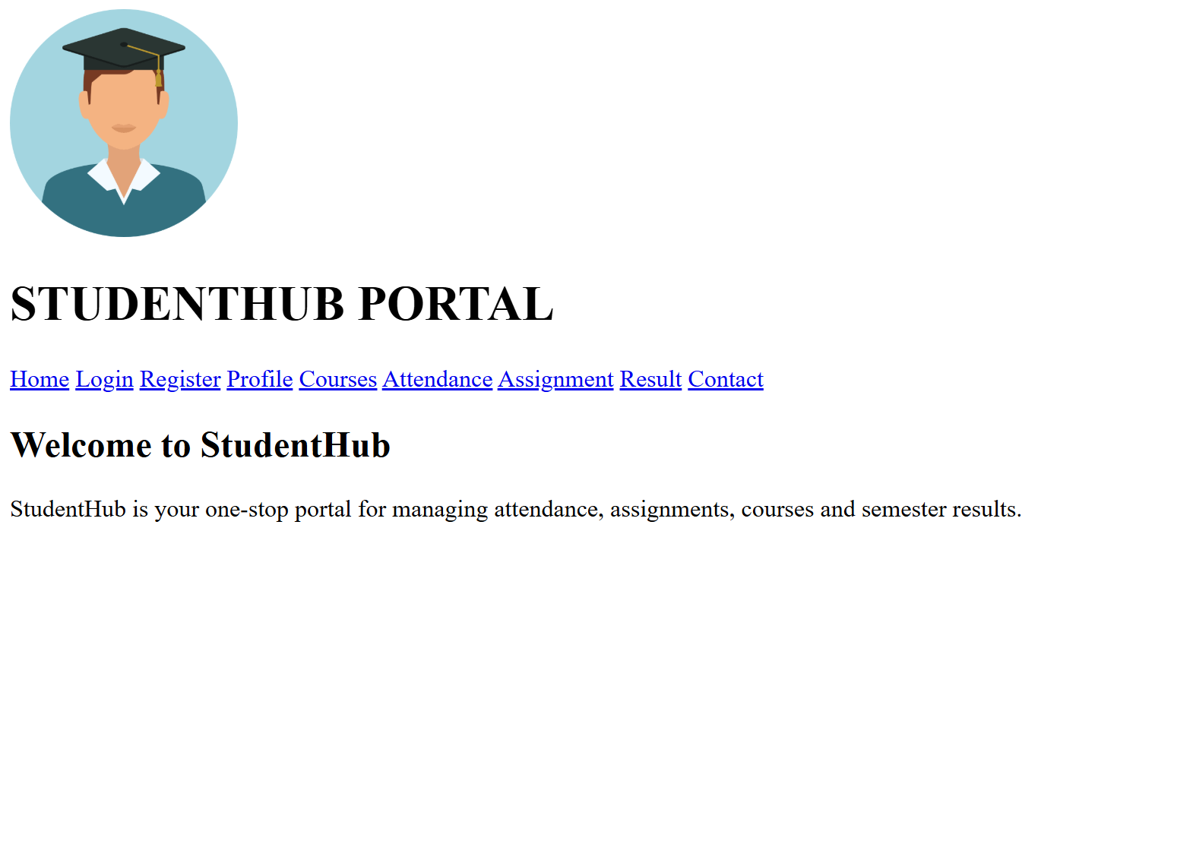
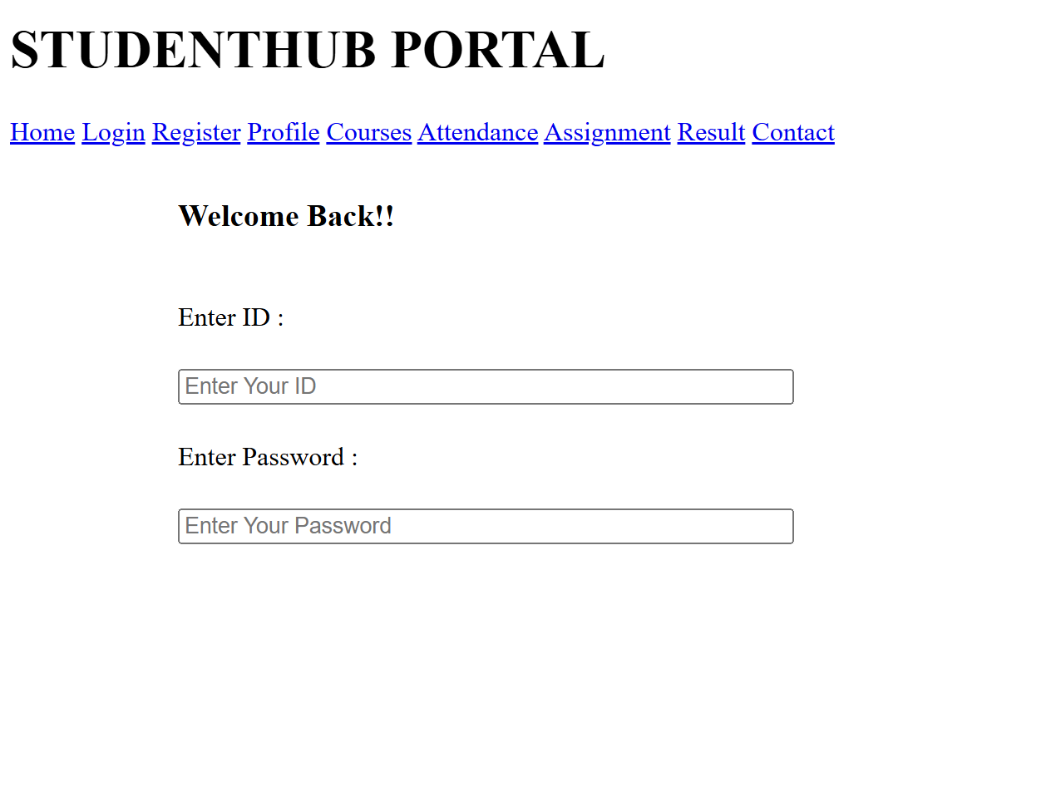
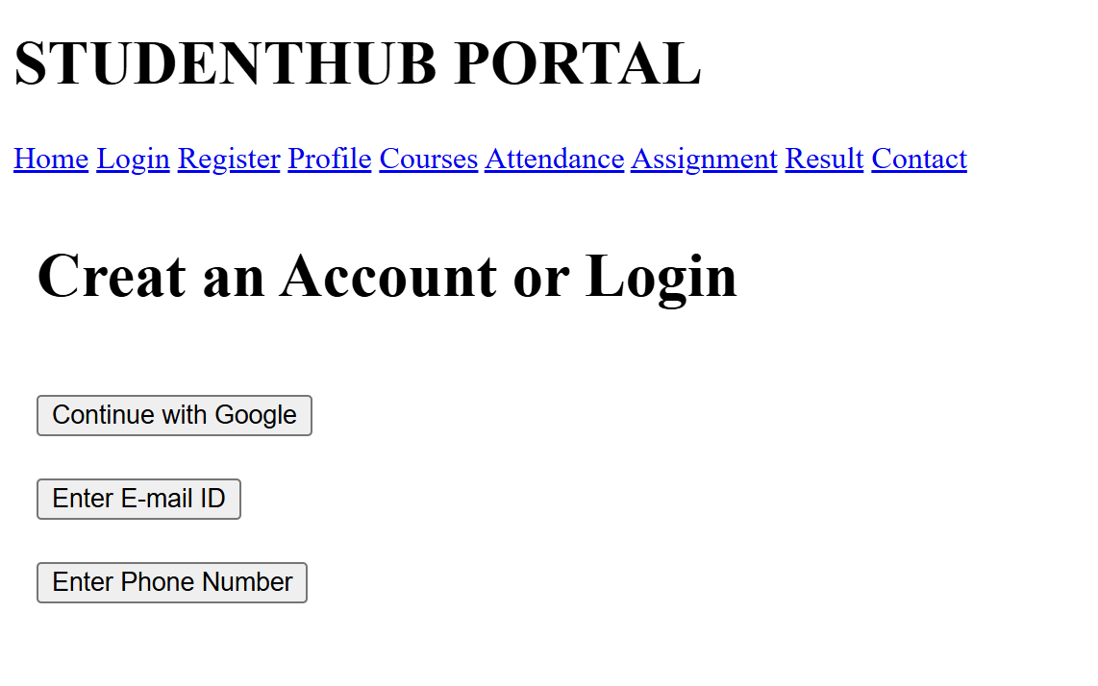
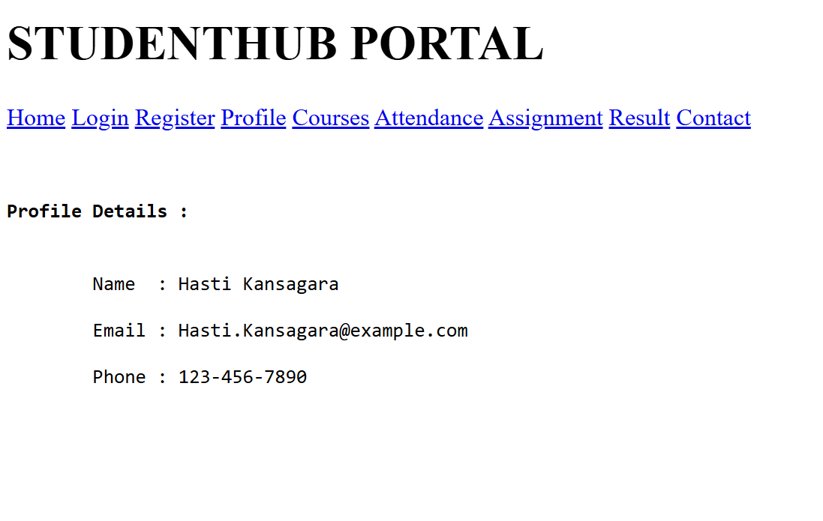
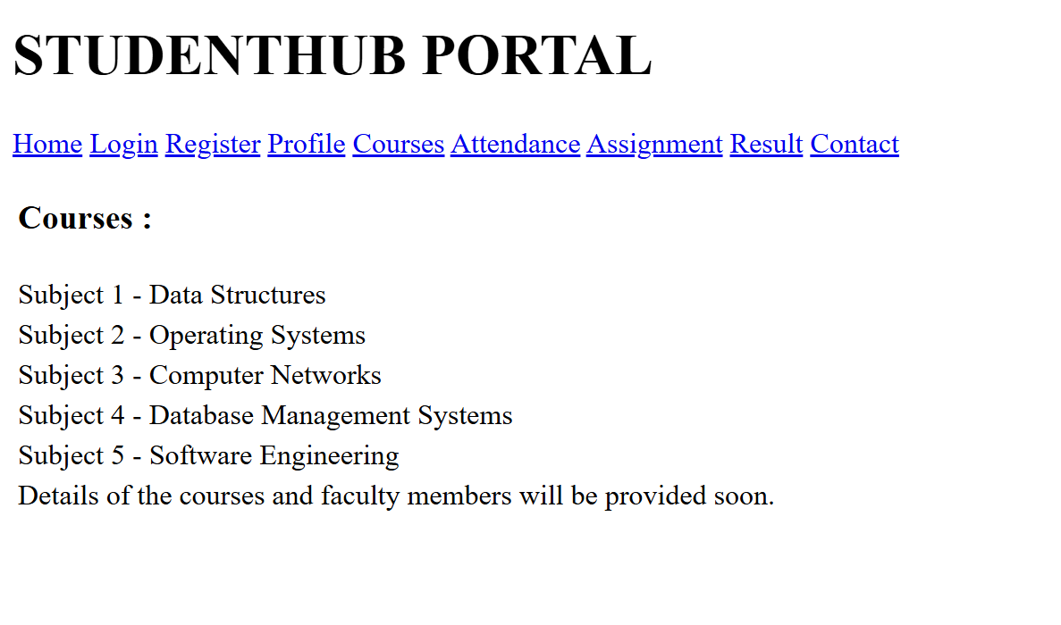
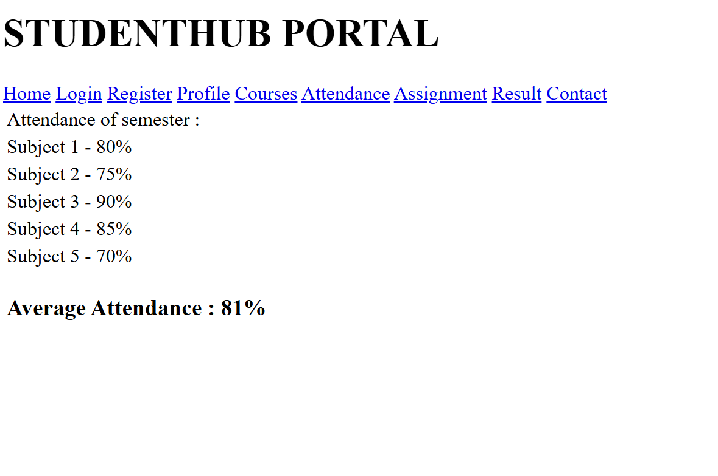
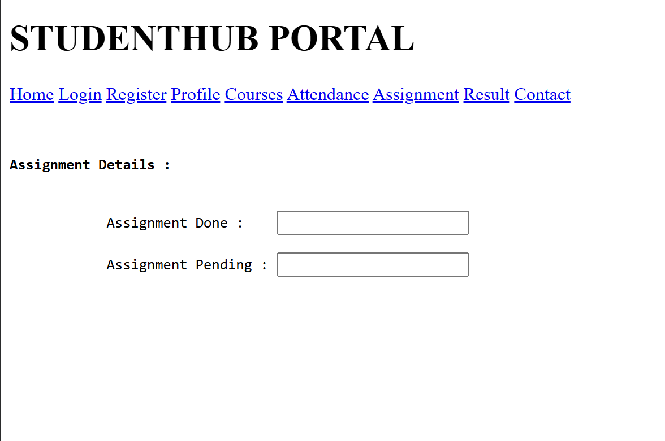
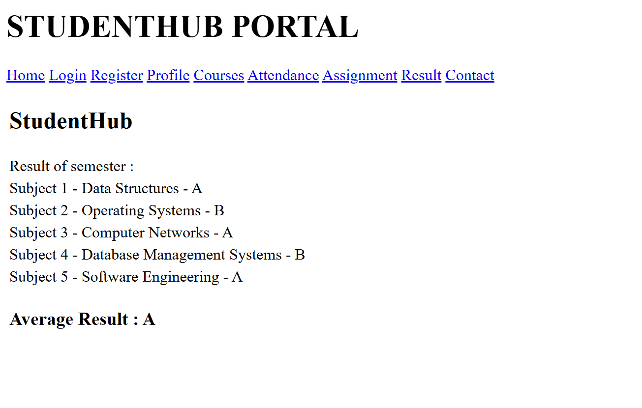
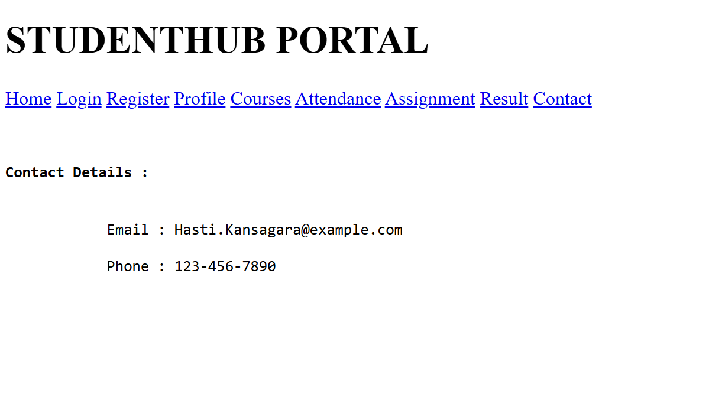

GitHub Repository Link:
https://github.com/Yugpatel009/STUDENTHUB.git

Challenges Faced:

- Using HTML5 semantic tags correctly.
- Maintaining a consistent page structure.
- Creating accessible forms and navigation.
- Organizing content logically.
- Ensuring proper heading hierarchy.
- Avoiding HTML syntax errors.
- Keeping layouts uniform across pages.
- Following HTML5 and accessibility standards.

Learning Outcomes:
- Learned to create HTML5 page structures using semantic tags.
- Understood the importance of accessibility-friendly web design.
- Developed skills in organizing content with a proper layout.
- Learned to create consistent structures for multiple web pages.
- Built a strong foundation for future CSS styling and JavaScript development.

Practical - 3
Practical Title: Responsive UI Design using CSS Grid, Flexbox, and Bootstrap/Tailwind
Problem Definition: Design responsive layouts for Home, About, Registration, Dashboard, and Events pages using CSS Grid and Flexbox. Optional to use CSS framework such as Bootstrap or Tailwind. Ensure mobile-first responsiveness.

Theory

How does the layout adapt for mobile, tablet, and desktop screens?
Answer:
The layout uses responsive design with breakpoints to adjust content, navigation and grids for mobile, tablet, and desktop screens.

Which layout technique is used and why?
Answer:
Bootstrap Grid (Flexbox) is used because it provides a responsive, flexible, and easy-to-manage layout.

Are typography, spacing, colors, and contrast readable?
Answer:
Yes, readable typography, proper spacing, suitable colors, and sufficient contrast improve accessibility and user experience.

Is the framework used consistently without unnecessary inline CSS?
Answer:
Yes, the framework classes are used consistently, and unnecessary inline CSS is avoided to keep the code clean and maintainable.

Implementation
• Used CSS Grid to create responsive page layouts.
• Applied Flexbox for navigation bars, forms, and content alignment.
• Followed a mobile-first approach using CSS media queries.
• Designed responsive layouts for Home, About, Registration, Dashboard, and Events pages.
• Used consistent typography, colors, spacing, and button styles.
• Added responsive navigation that adjusts for different screen sizes.
• Created flexible cards and sections that resize automatically.
• Ensured images and content scale properly on all devices.
• Maintained a clean and consistent design across all pages.

Evidence of Work (Screenshots)
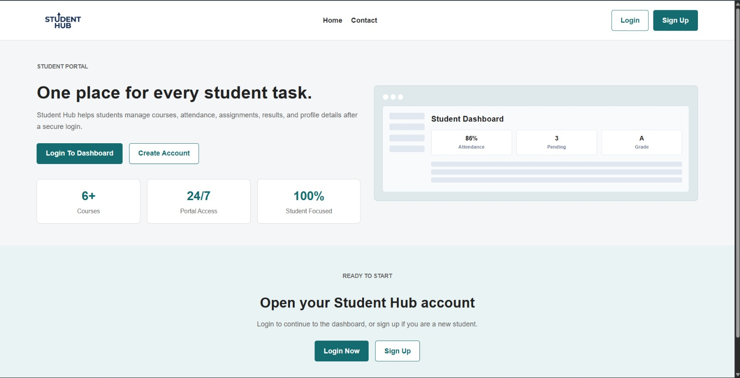

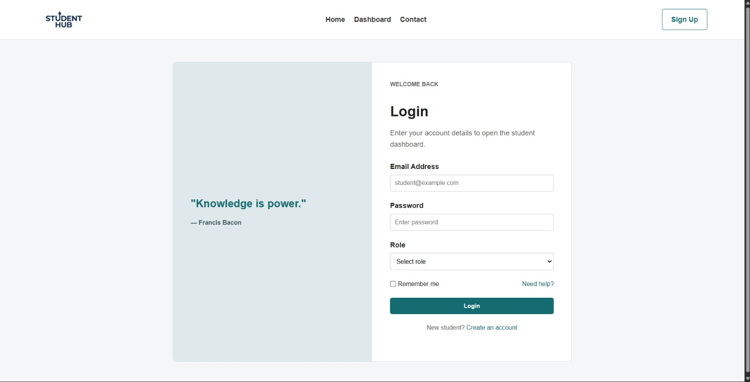

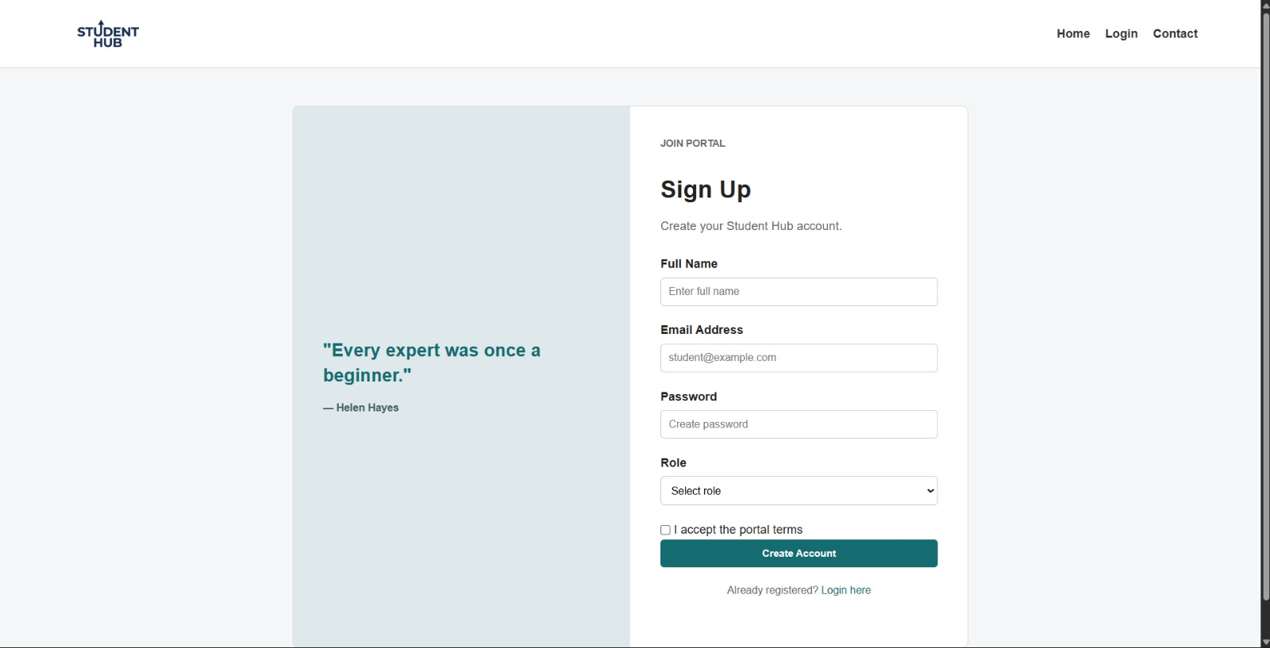
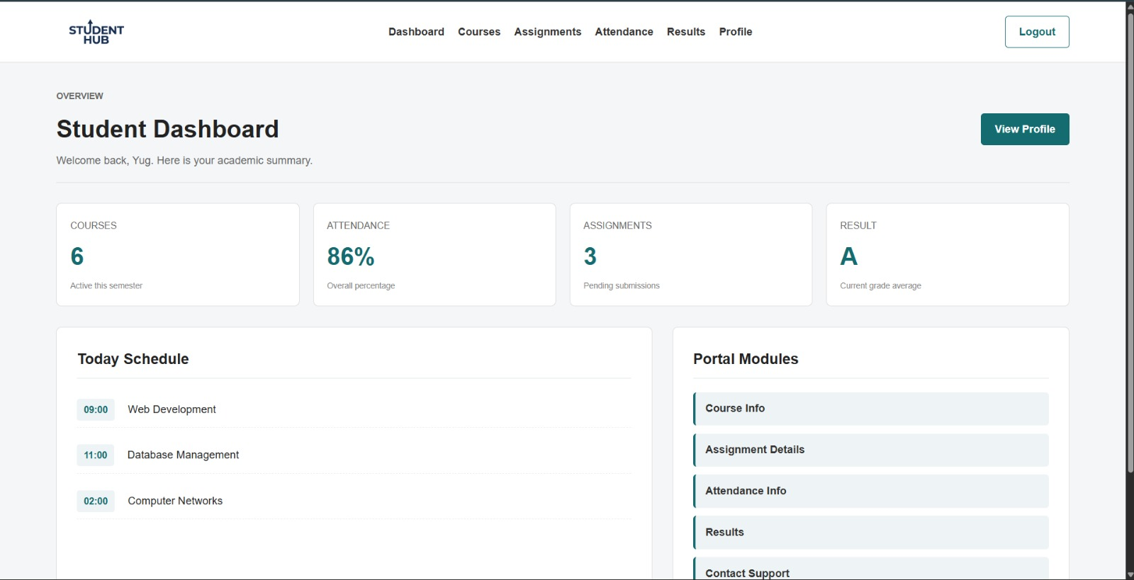

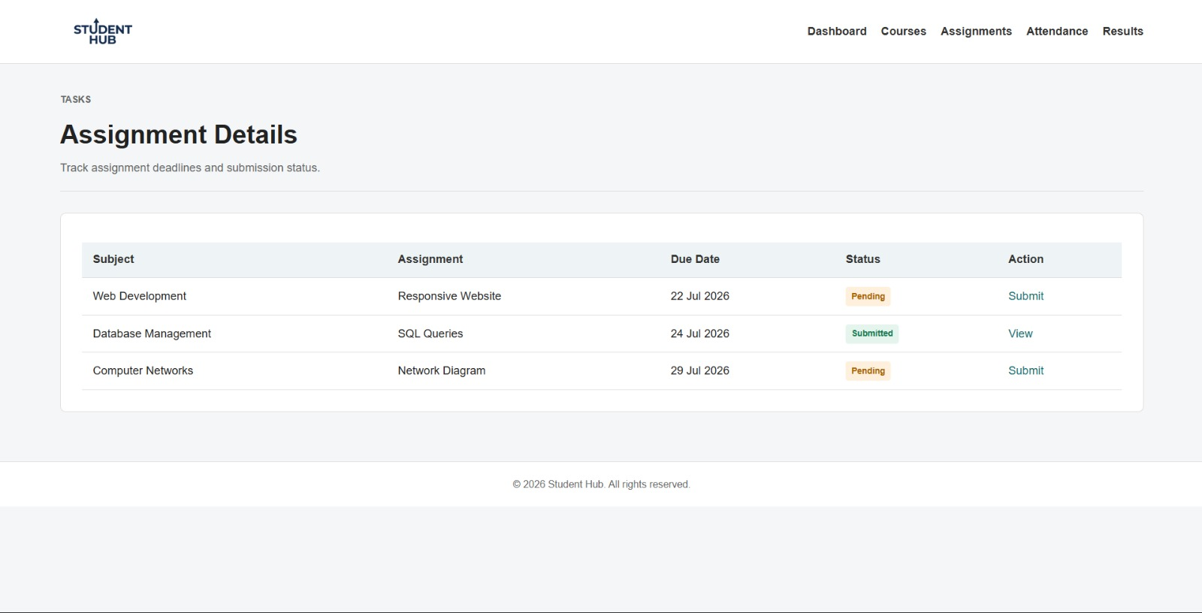
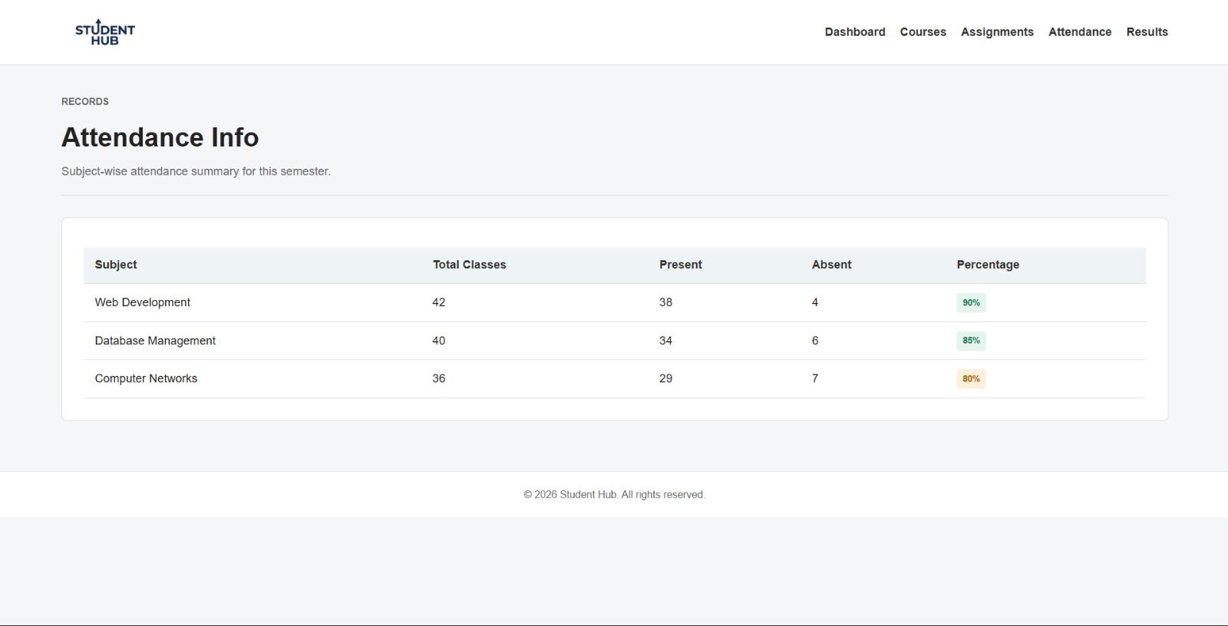

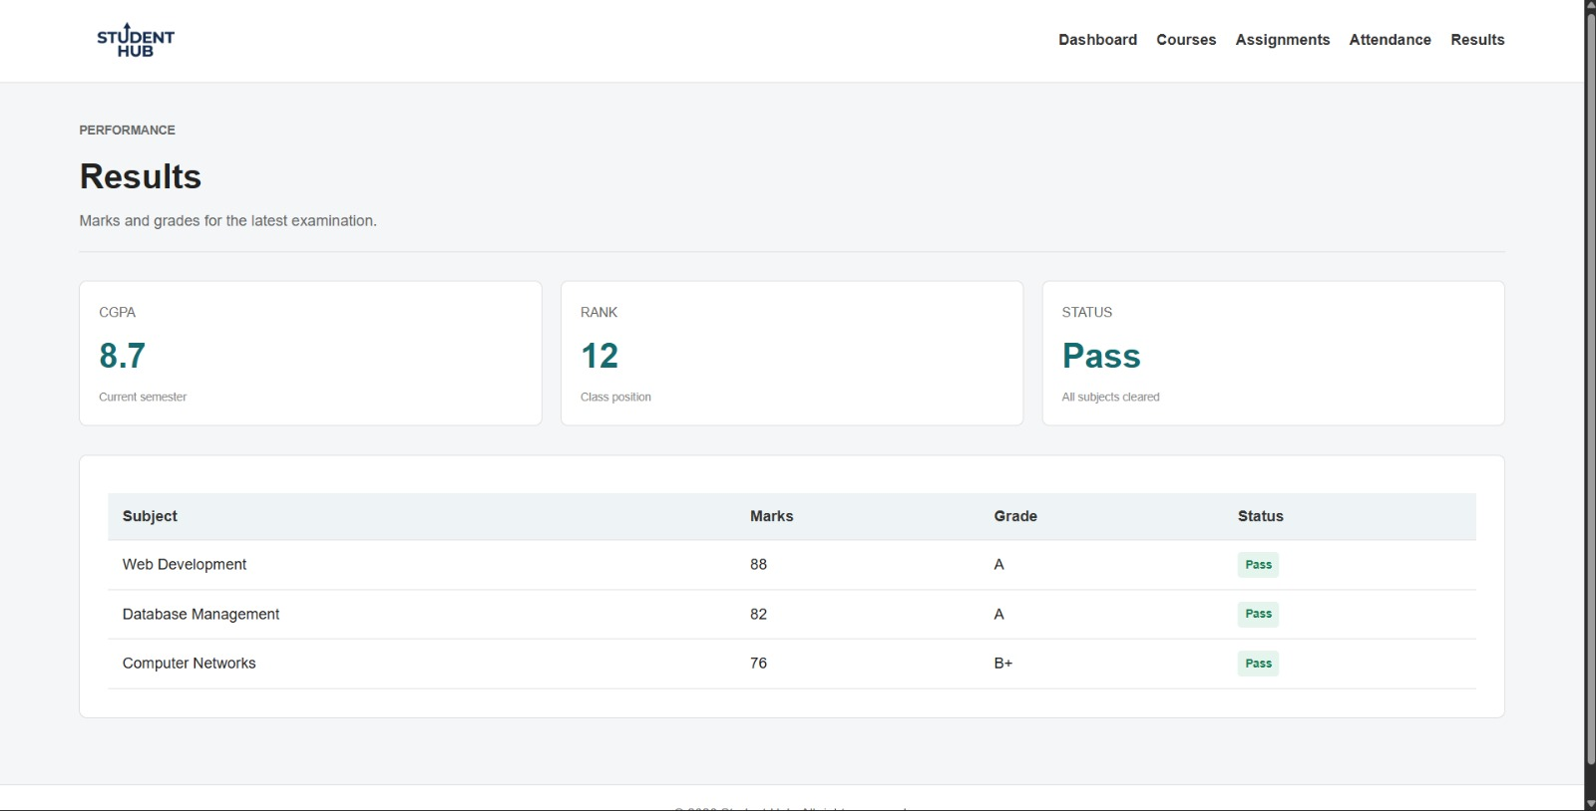

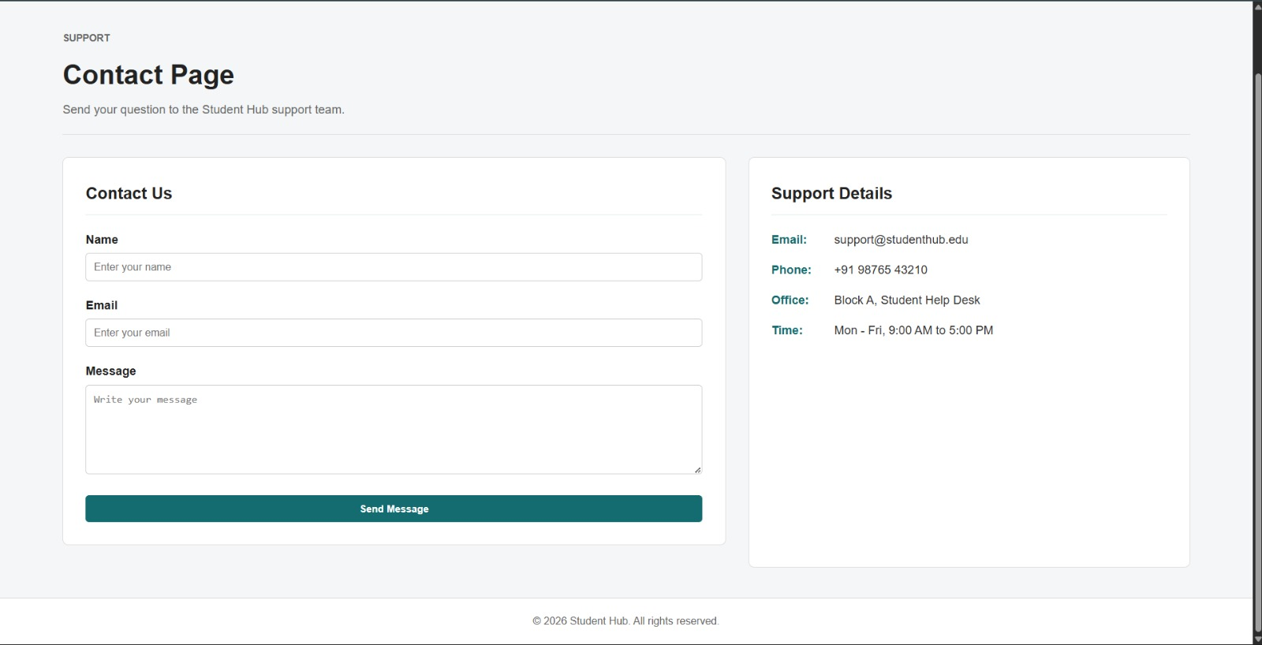

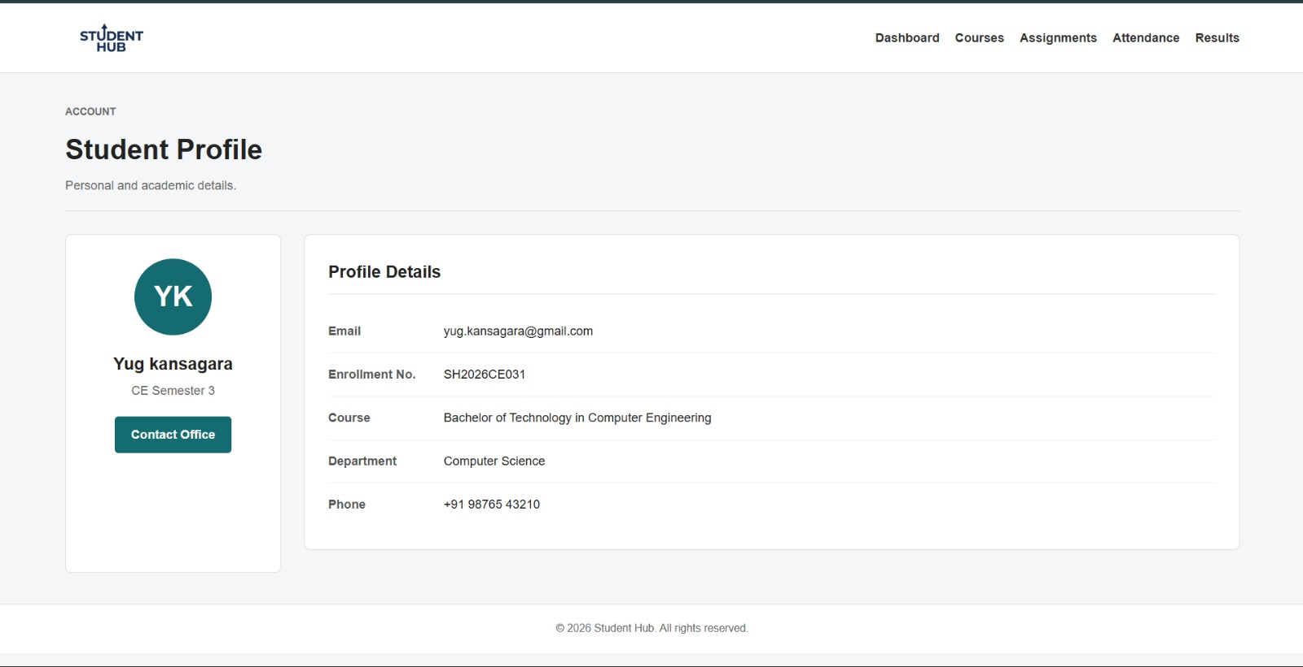

GitHub Repository Link:

https://github.com/Yugpatel009/STUDENTHUB.git

Challenges Faced:
- Designing a mobile-first responsive layout.
- Using CSS Grid and Flexbox together effectively.
- Maintaining consistent alignment and spacing across pages.
- Ensuring compatibility with different screen sizes and devices.
- Keeping the design uniform and easy to maintain.

Learning Outcomes:
- Learned to create responsive web layouts using CSS Grid and Flexbox.
- Understood the mobile-first approach for web design.
- Improved skills in designing layouts for different screen sizes.
- Learned to maintain consistent styling and responsive navigation.
- Gained practical experience in building modern, user-friendly web pages.

Practical 4
Problem Definition: Add dynamic UI components such as collapsible FAQ, modal popup, image/content slider, notification banner, hamburger menu, and light/dark theme switcher using JavaScript.
The StudentHub website developed in the previous practical contains static HTML and CSS pages. In this practical, JavaScript is used to make the website interactive and user-friendly.
The following dynamic components are implemented:
- Collapsible FAQ
- Modal popup
- Content slider
- Notification banner
- Hamburger menu
- ++Light/Dark theme switcher

DARK/LIGHT THEME:

Landing Page Drak Mode:
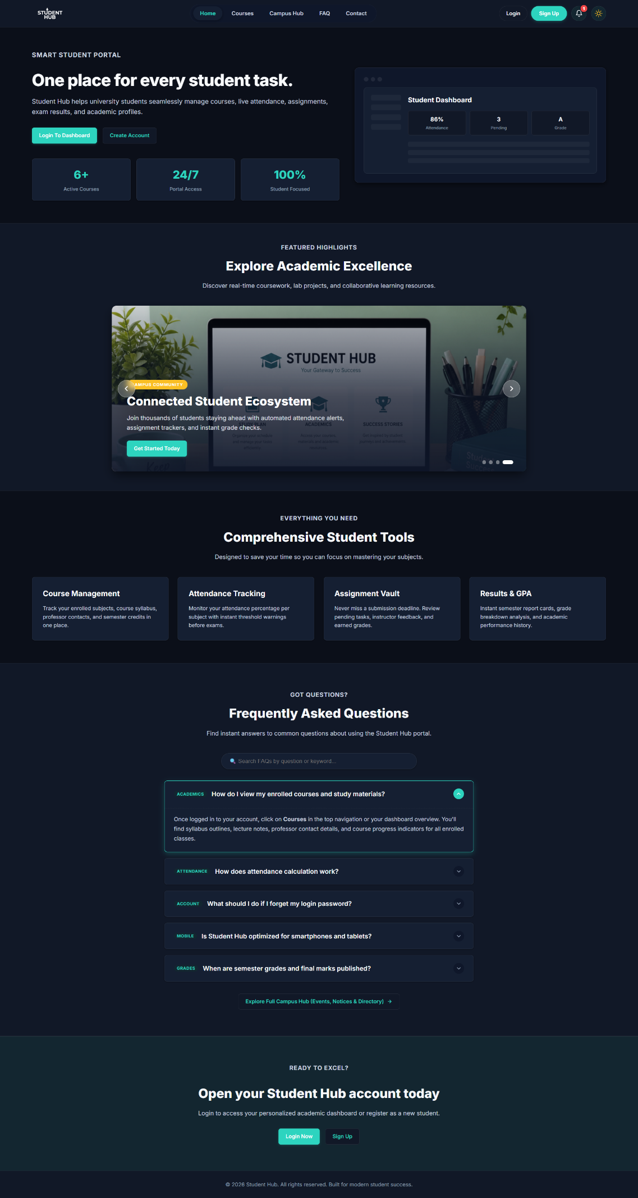
LIGHT MODE:
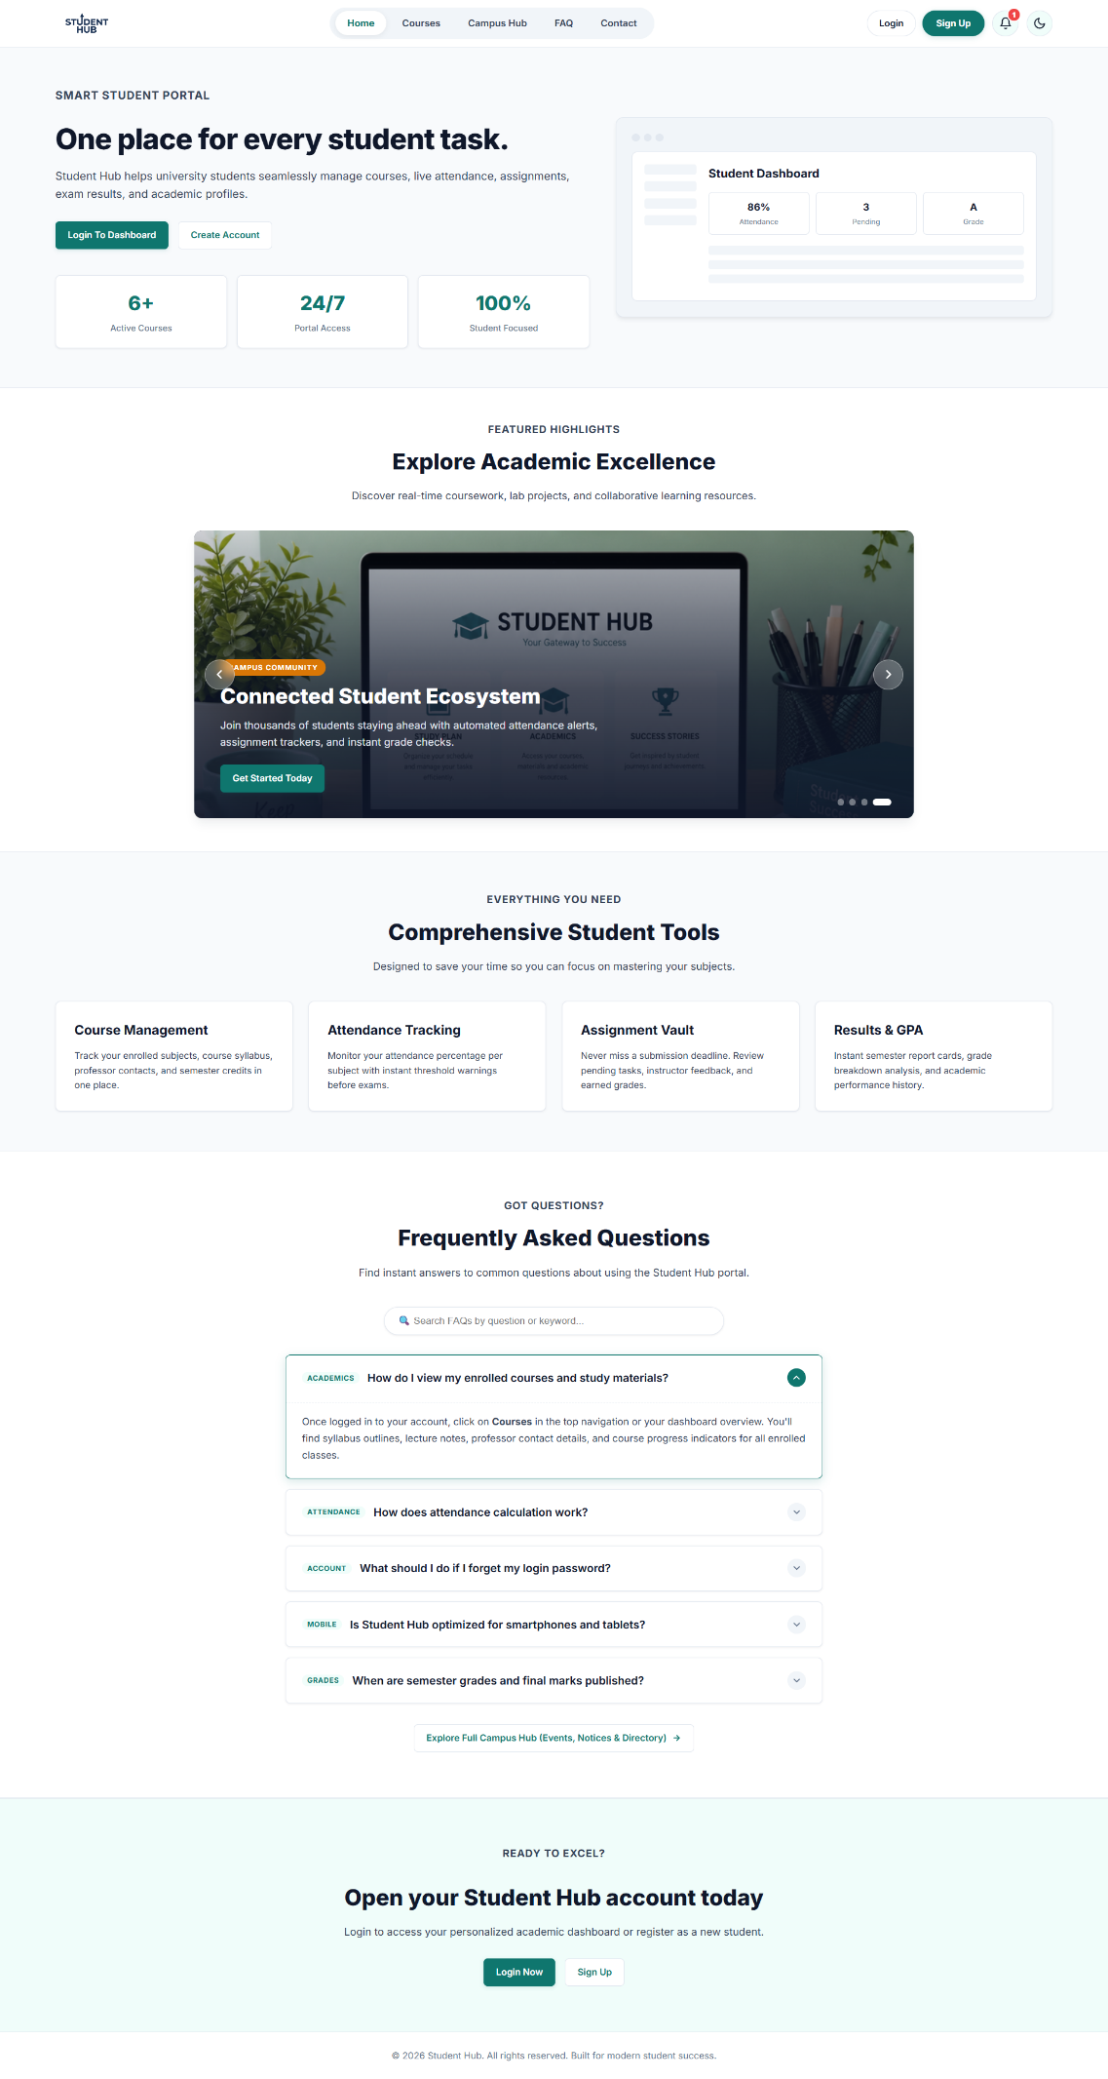

REGISTAR PAGE :DARK MODE
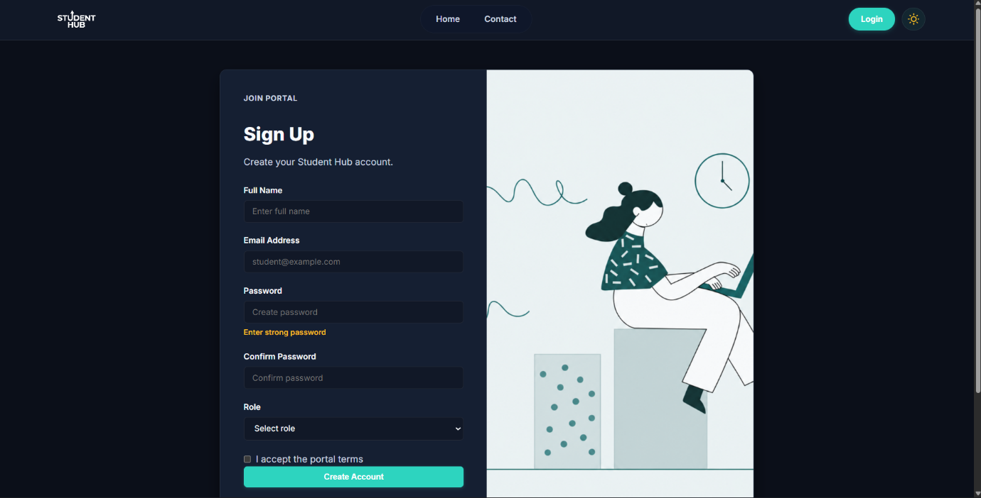
LIGHT MODE:
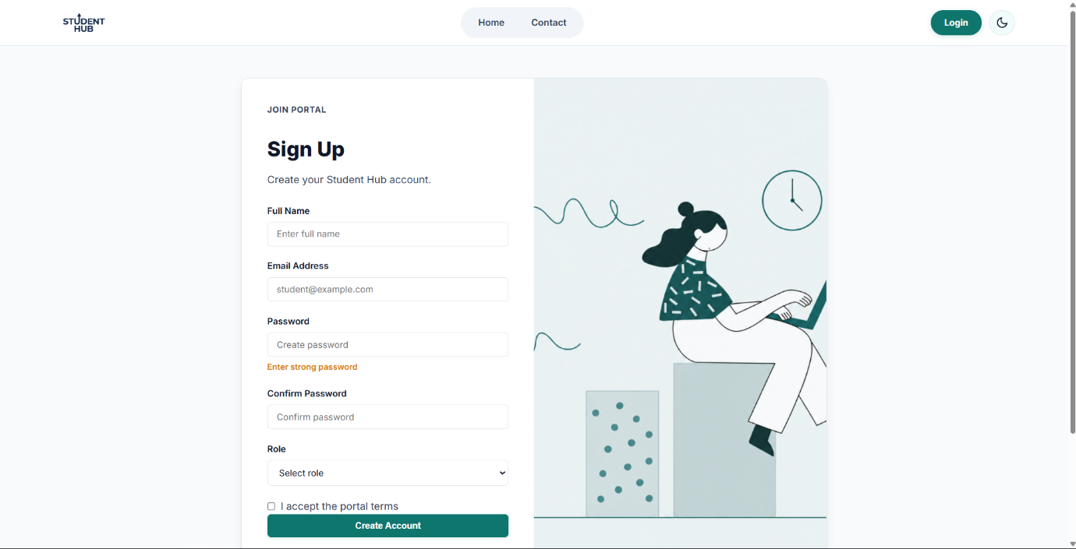
Login pages dark mode
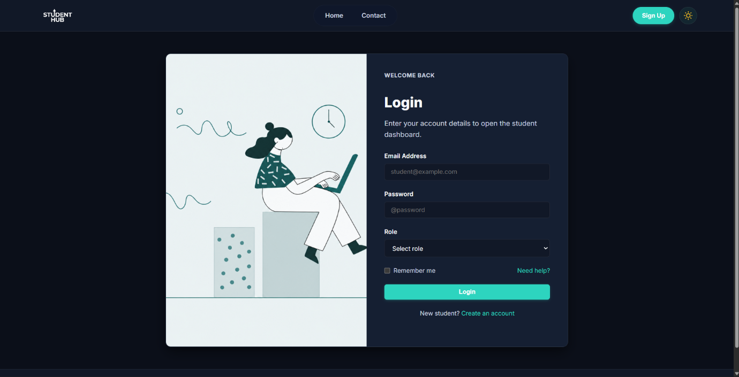

Light mode
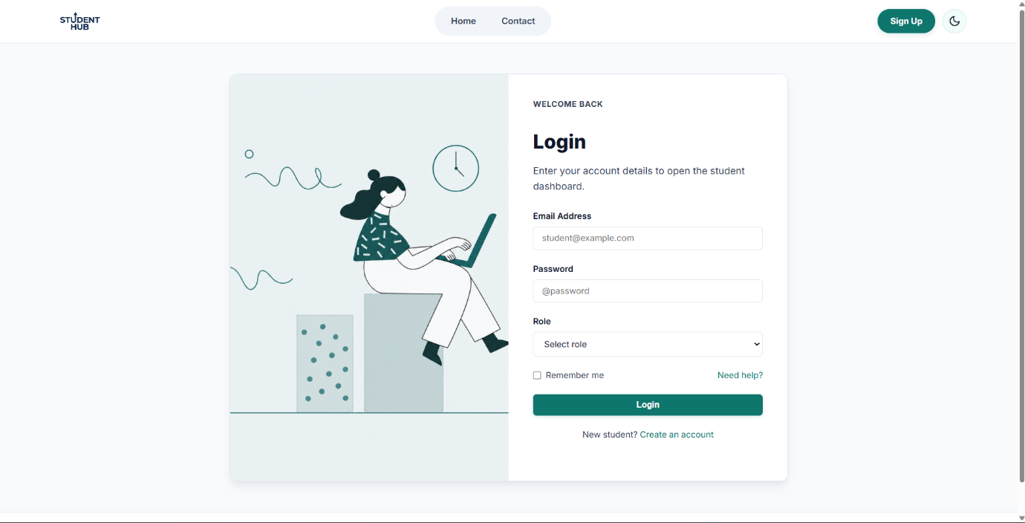

DASHBOARD DARK MODE
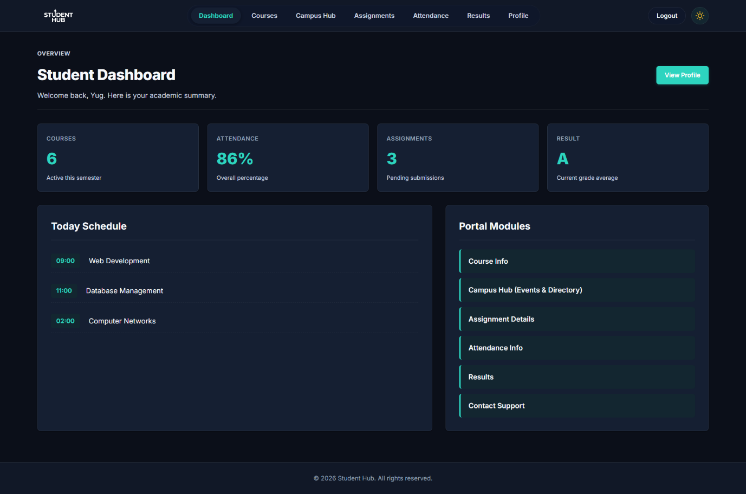
LIGHT MODE
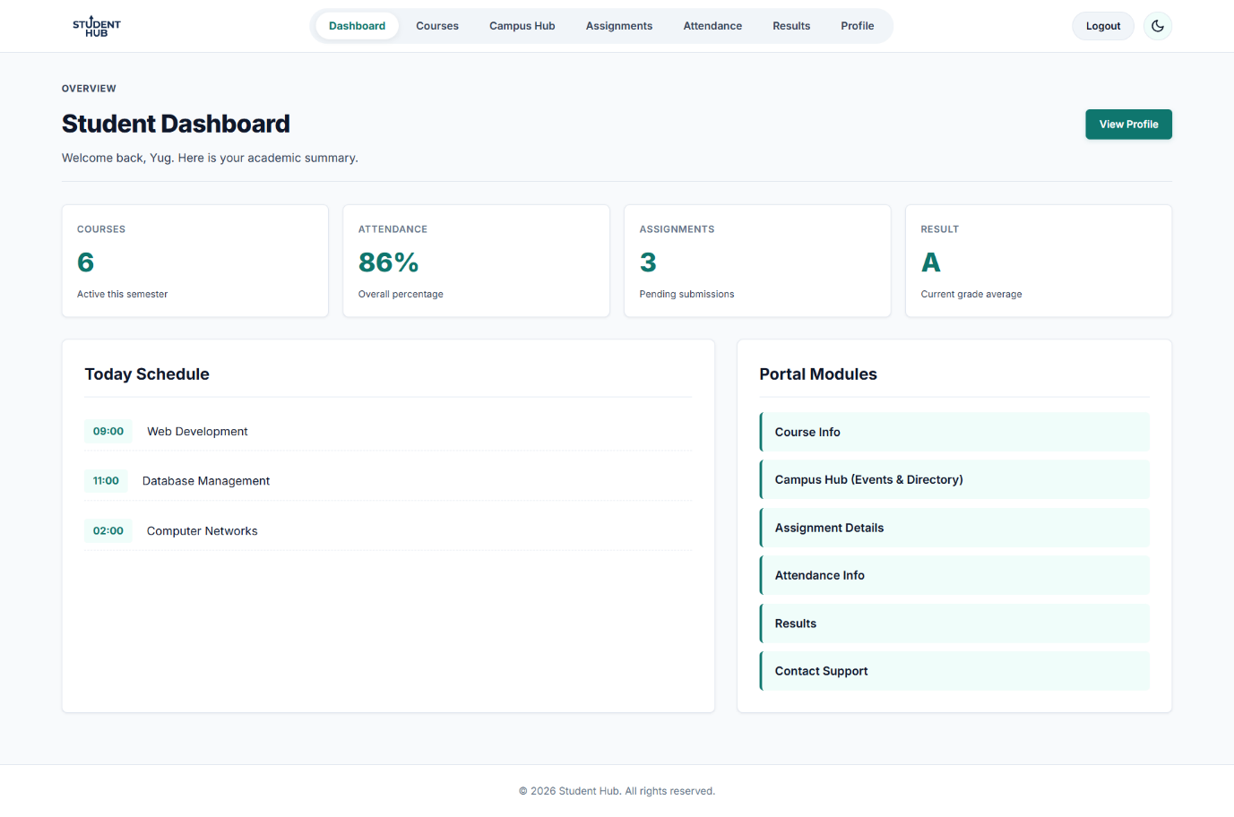
EVENTS DARK MODE
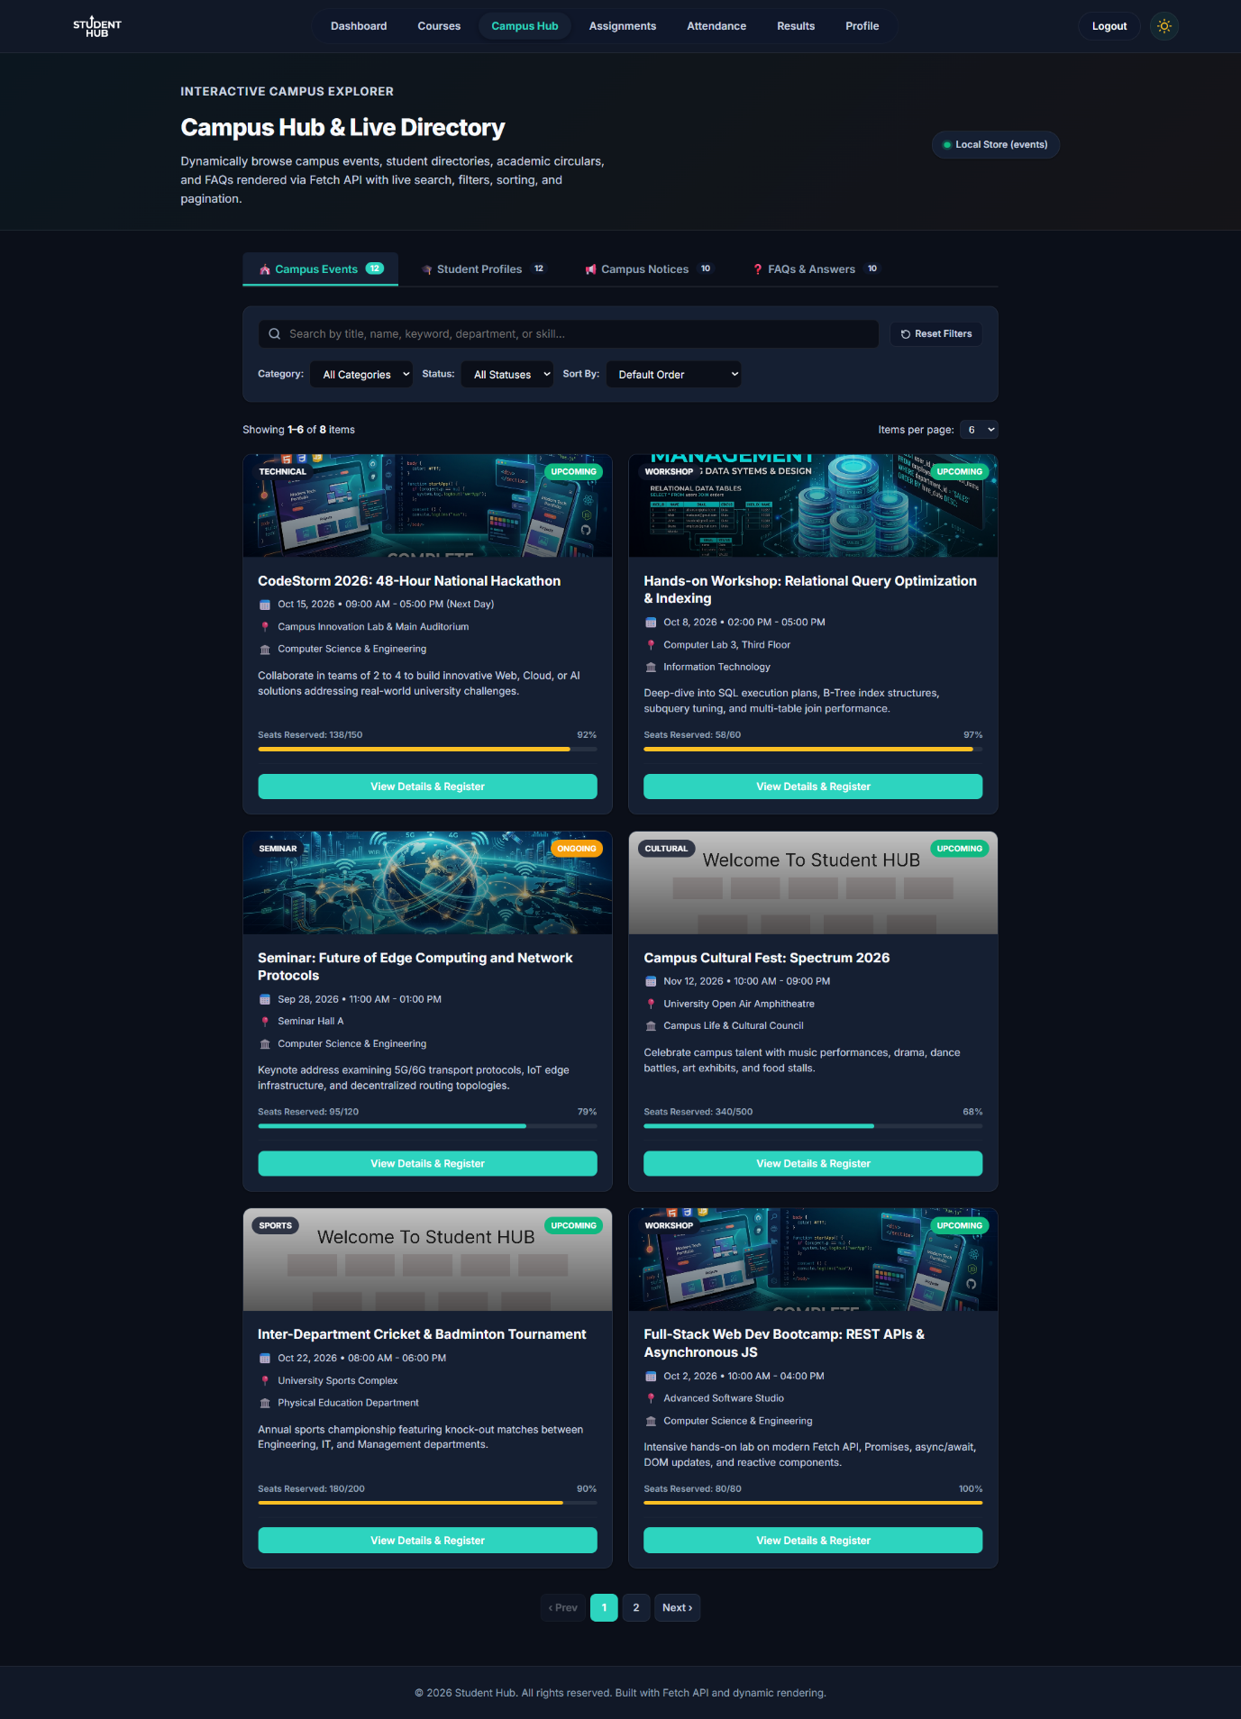

LIGHT MODE
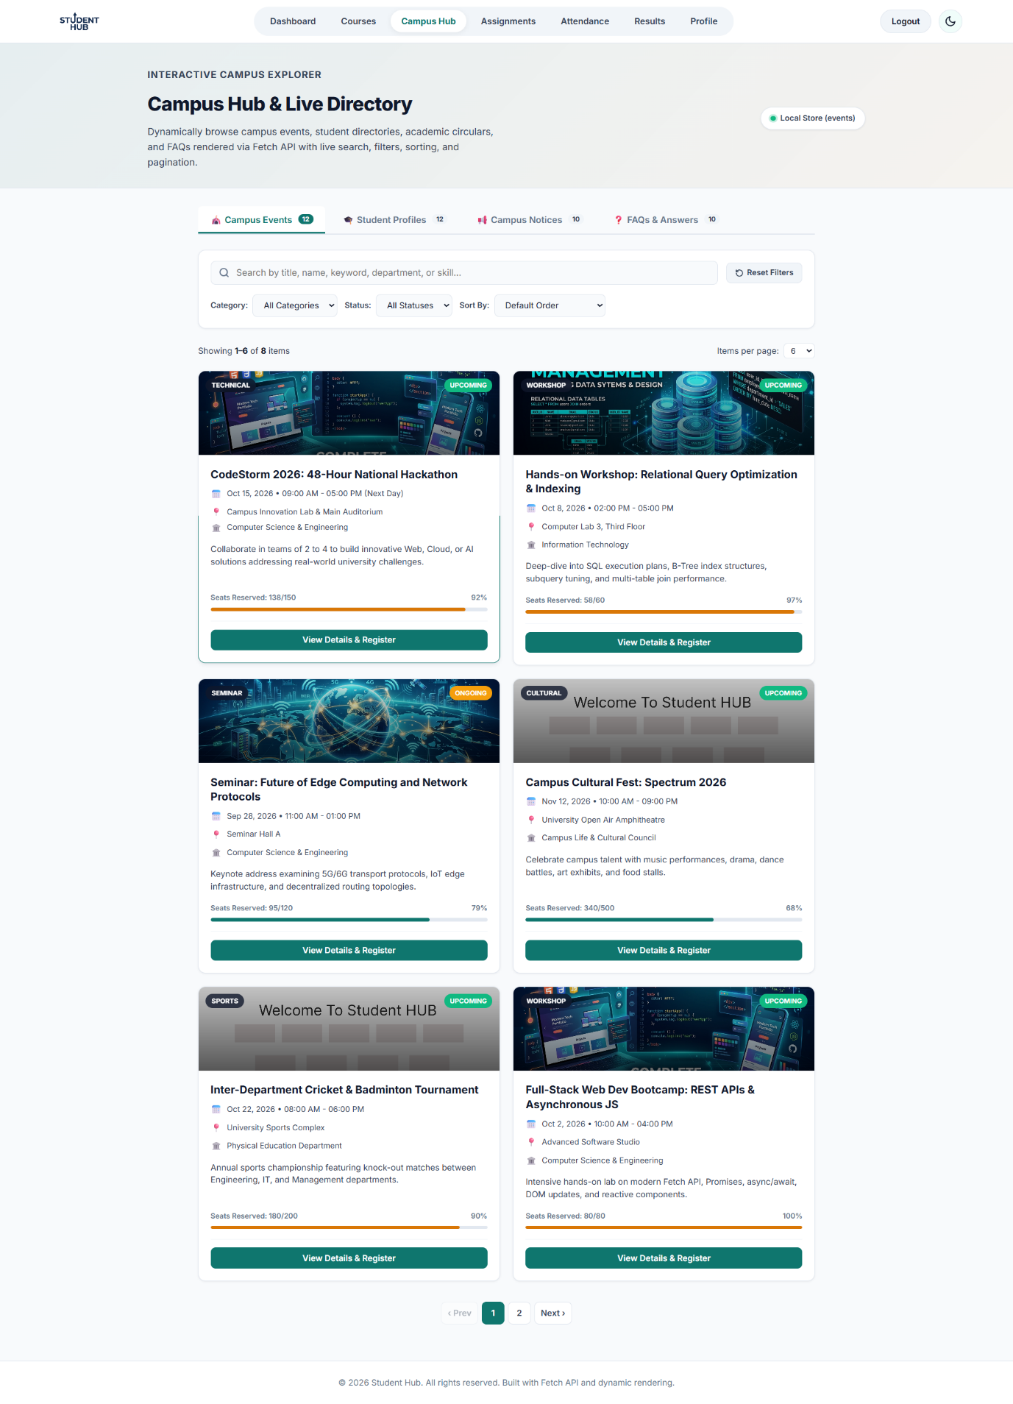
PROFILE PAGE DARK MODE
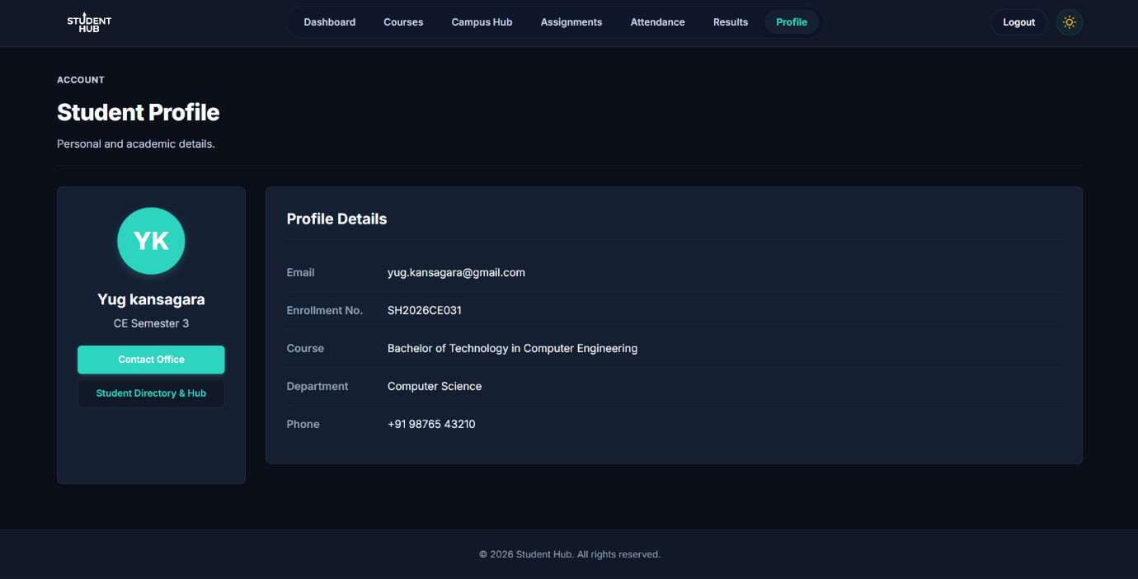

LIGHT MODE
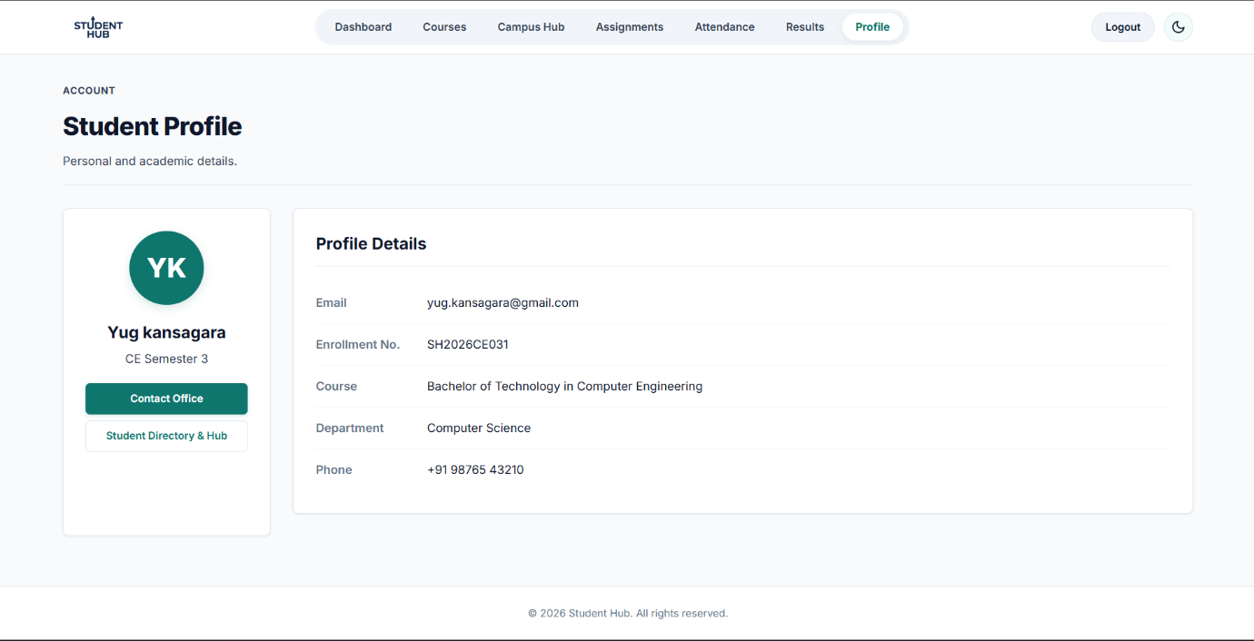
CONTACT DARK MODE
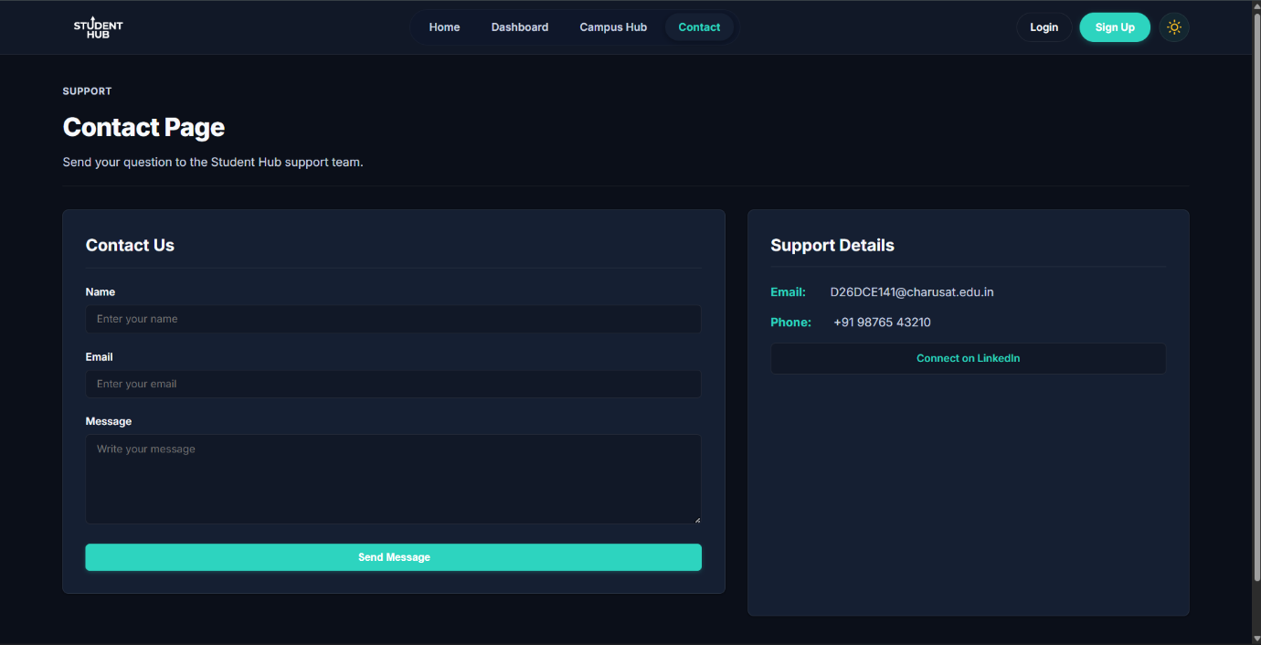
LIGHT MODE

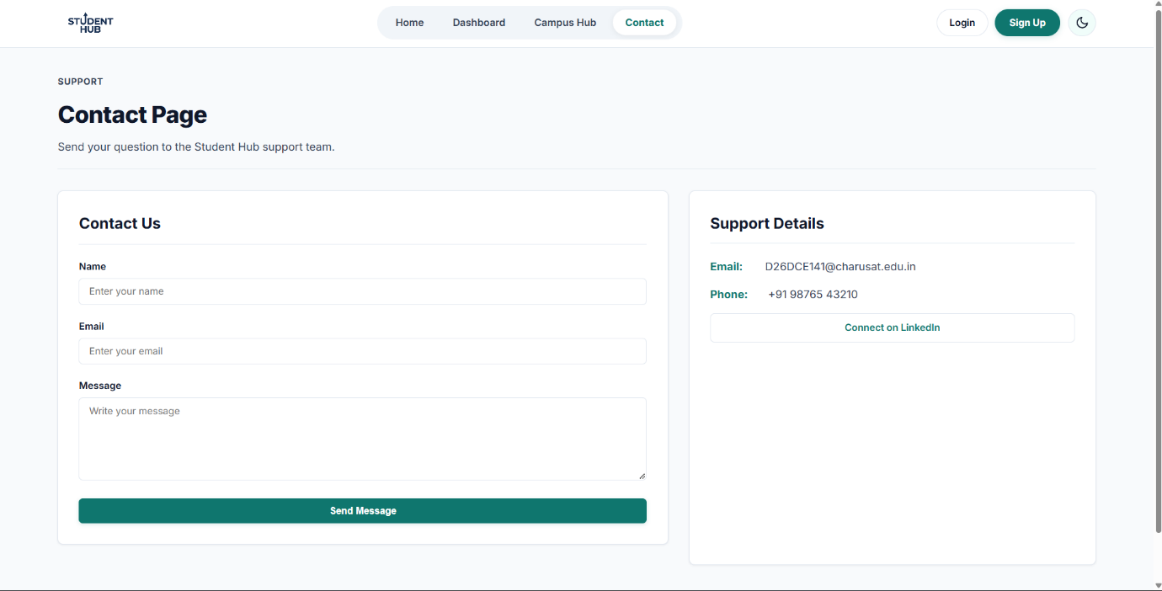

FAQ PAGE DARK MODE
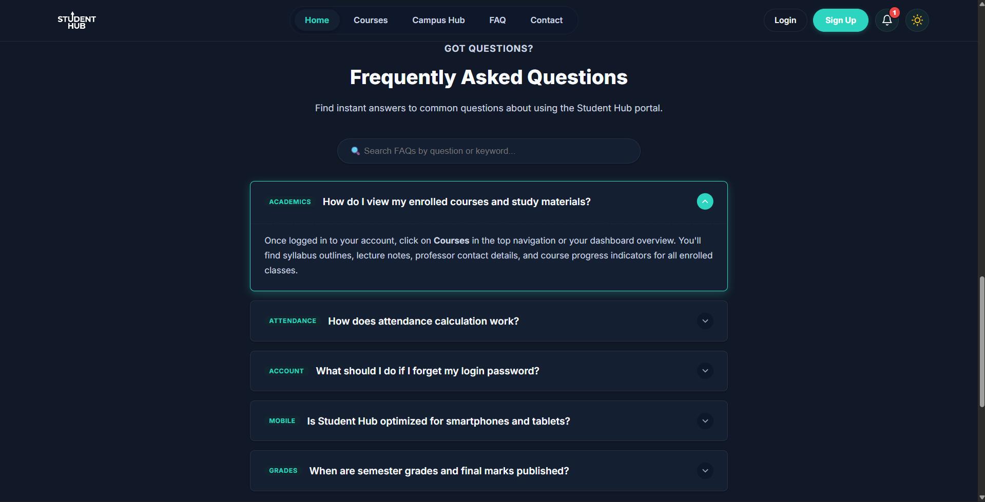
LIGHT MODE
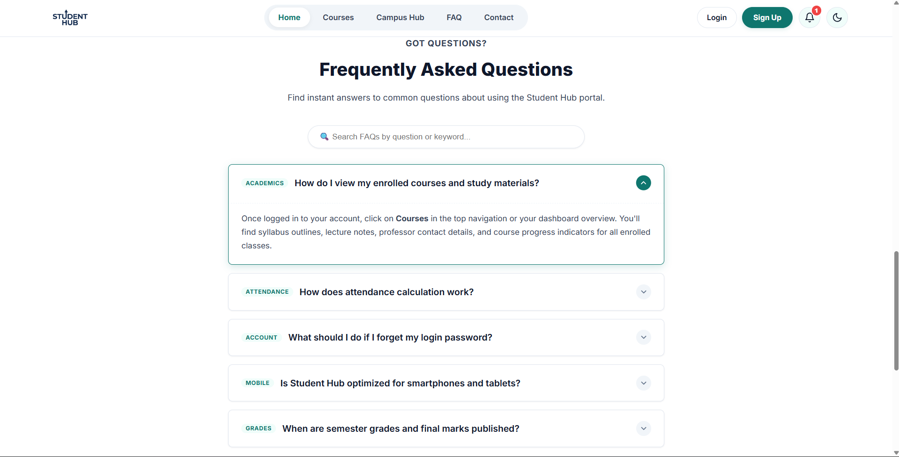

Key Questions / Analysis / Interpretation

1. Are correct input types and attributes used?
2. Are validation errors displayed near the relevant fields?
3. Is password strength checked?
4. Is the form accessible using keyboard and screen-reader-friendly
labels?
GIT HUB LINK: https://github.com/Yugpatel009/STUDENTHUB.git

Practical – 5

Create a student registration form with HTML5 input types and JavaScript
validation for name, email, mobile number, password, confirm password,
course, year, gender, and terms acceptance. Use Regular Expression for
validations.

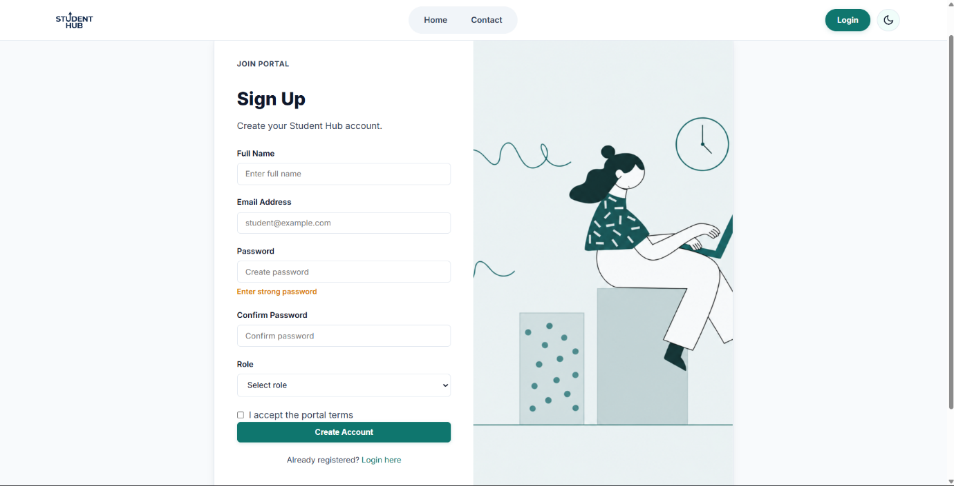

1.Are correct input types and attributes used?

Ans.) Using the correct semantic input types is the first line of defense for data validation and user experience.
- Semantic Input Types: Modern HTML offers specialized types like <input type="email">, <input type="tel">, <input type="url">, and <input type="number">. These types automatically trigger native browser validation (e.g., rejecting an email missing an @ symbol) and surface specialized mobile keyboards (like a numeric keypad for phone numbers).
- Validation Attributes: Attributes like required, minlength, maxlength, and pattern (which accepts a Regular Expression) enforce rules directly in the browser's native engine. This prevents form submission prior to basic frontend verification, saving server bandwidth.

2. Are validation errors displayed near the relevant fields?

Ans.) Error messages must be highly contextual and immediately clear. Placing errors in a single lump sum at the top or bottom of a form causes cognitive fatigue, especially on longer forms.
- Proximity and Visual Links: Error text should appear directly beneath or beside the problematic input box. To link them technically for assistive devices, use the aria-describedby attribute. This attribute points to the unique id of the error message container, forcing screen readers to read the error as soon as the user focuses on the invalid field.
- Dynamic States: When an input fails validation, its styling should change cleanly (e.g., a distinct border color, though not red alone, to assist colorblind users). Crucially, the invalid input should dynamically receive the aria-invalid="true" attribute so assistive technologies announce the error state instantly.

3. Is password strength checked?

Ans.) Password security requires moving away from rigid, arbitrary rules (like requiring exactly one capital letter and one symbol) and moving toward evaluating true entropy (unpredictability).
- Strength Estimation (Entropy): The modern industry standard is to use algorithmic libraries like zxcvbn (developed by Dropbox). These analyze inputs against common dictionaries, keyboard patterns, dates, and sequential characters to give a realistic strength score (e.g., from 0 to 4).
- Visual Feedback and UX: As the user types, a live visual gauge (like a color-changing progress bar or text indicator) should reflect the password's strength. Additionally, a "Show/Hide Password" toggle button must be included. This drastically reduces typing mistakes, which is a major usability barrier for mobile users and people with motor or cognitive impairments.

4. Is the form accessible using keyboard and screen-reader-friendly labels?

Ans.) An accessible form ensures that any user can perceive, navigate, and successfully submit their information, regardless of how they interact with the web.
- Explicit, Screen-Reader-Friendly Labels: Every input must have a programmatically linked label using the <label for="input-id"> syntax. Placeholder text (placeholder="Enter text") must never be used as a replacement for a label. Placeholders disappear when a user types, disrupting short-term memory, and many screen readers ignore them entirely.
- Keyboard Navigation and Focus Focus: A user must be able to navigate through every form field, checkbox, and button using only the Tab key (forward) and Shift + Tab (backward), and submit the form by hitting Enter. Focus indicators (the ring or outline that appears around an element when selected) must be clearly visible and never hidden with CSS like outline: none.

GIT HUB LINK: https://github.com/Yugpatel009/STUDENTHUB.git

Practical – 6

Problem Statement:

Display event lists, student profiles, notices, or FAQs from external JSON
files using Fetch API. Implement dynamic rendering, search, filter,
sorting, and pagination.
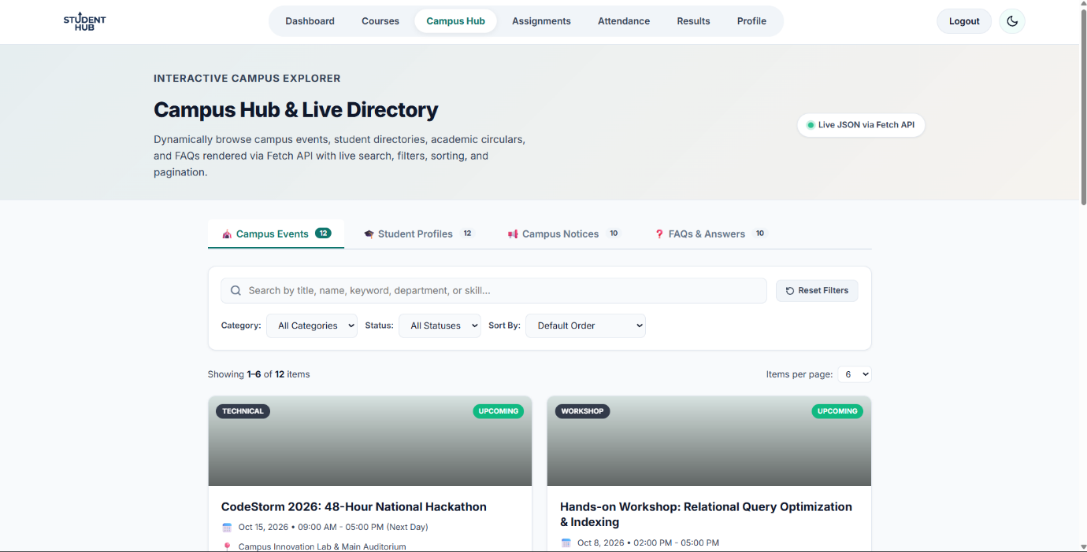

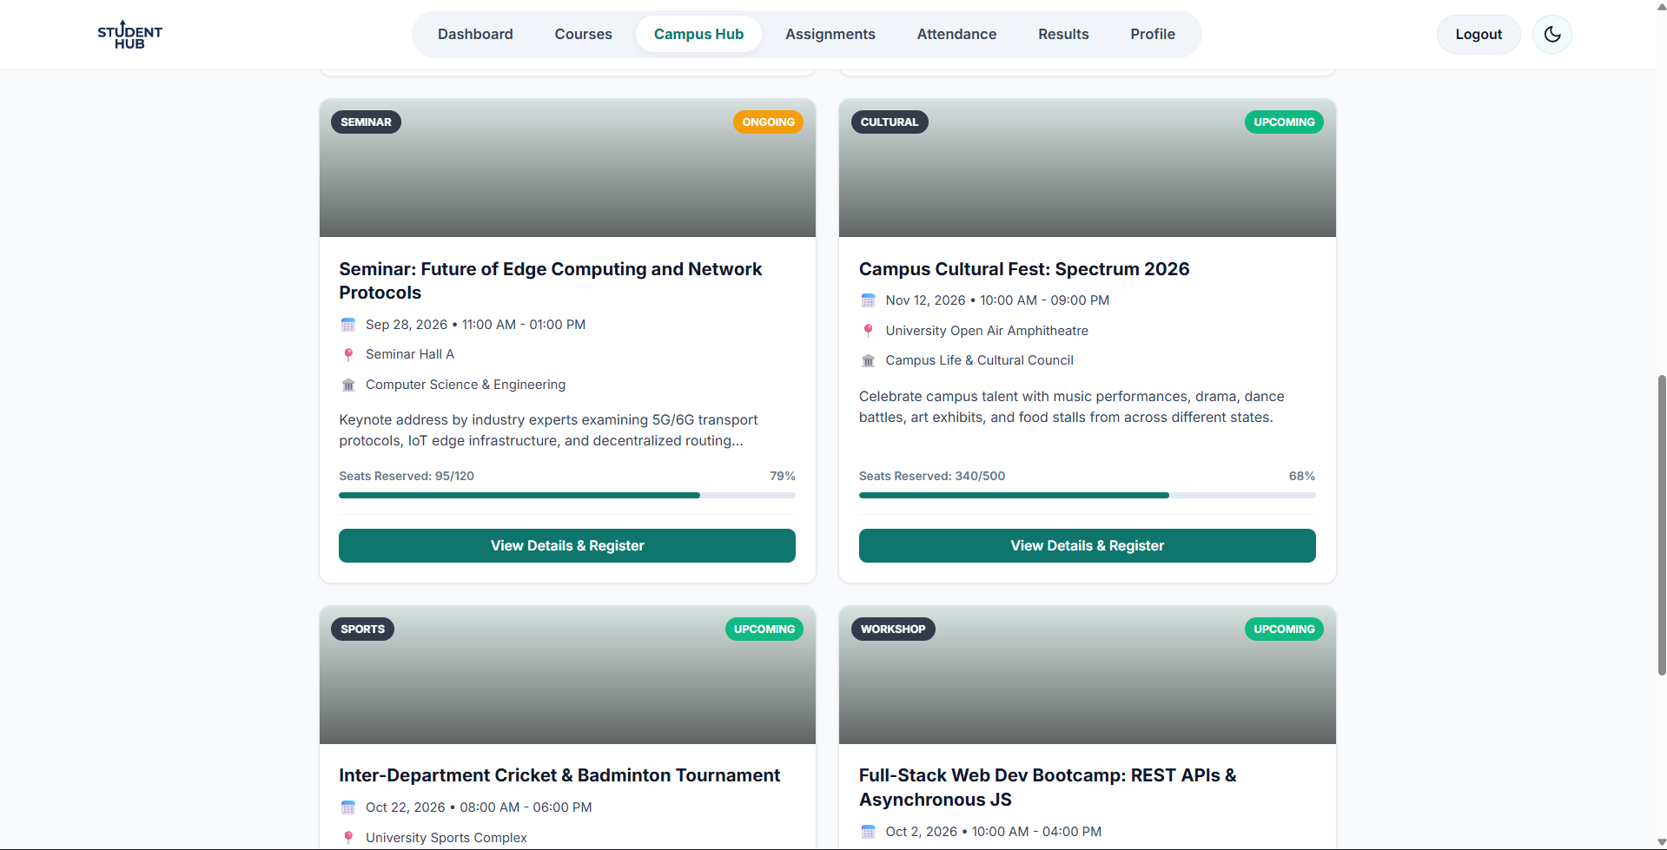

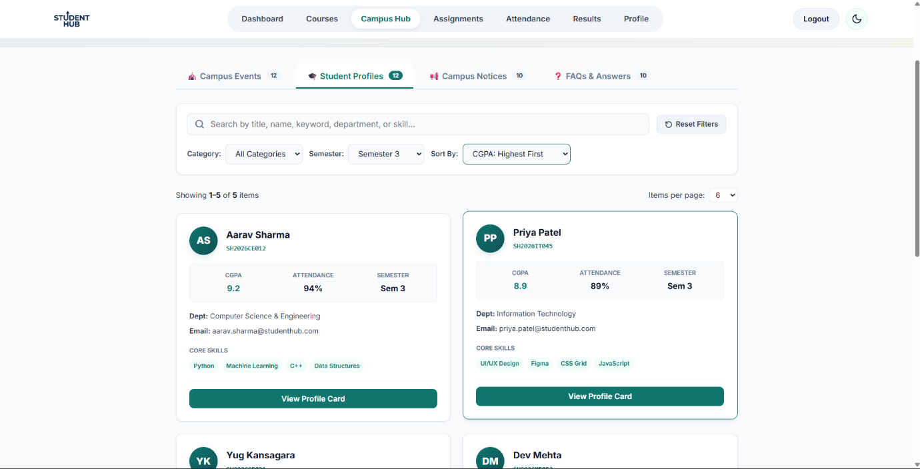

Key question:

- How is JSON fetched, parsed, and rendered?

Ans.) JSON is fetched via network requests, parsed from a raw string into a JavaScript object, and rendered by inserting that data into the Document Object Model (DOM). This asynchronous lifecycle allows modern web applications to load data dynamically without refreshing the page.
The Three-Step Lifecycle
- Fetching: The browser uses the fetch() API to send an asynchronous HTTP request to a server or API endpoint. The server responds with raw text formatted as a JSON string.
- Parsing: The browser cannot use a raw string directly. The .json() method reads the stream and converts the JSON string into a native JavaScript object or array.
- Rendering: The parsed JavaScript data is passed to DOM manipulation functions. The browser updates the HTML structure (using methods like textContent or innerHTML) to display the data to the user.

- Which array methods are used for search, filter, sort, and pagination?

Ans.) JavaScript provides distinct array methods to search, filter, sort, and paginate data, which are often chained together to process raw data lists.
Here is the breakdown of the exact methods used for each operation:
- Search: find() and findIndex() locate a single item or its position based on a condition, while includes() checks if a specific value exists.
- Filter: filter() extracts all items that match a specific criteria and returns them in a brand new list.
- Sort: sort() reorganizes the order of the list permanently based on a custom comparison rule (like alphabetical or lowest-to-highest score).
- Pagination: slice() extracts a small, precise section of the list for a specific page using mathematical calculations for the start and end positions.

- How are loading and error states handled?

Ans.) Loading and error states are managed by tracking a request's operational status and updating the interface dynamically.
- State Tracking: Applications use dedicated status flags to monitor if a network request is pending, completed, or failed.
- Triggering Loading: Right before fetching data, the status is set to loading, which hides the main content.
- Visual Indicators: While loading, the UI displays a placeholder, like a spinner, progress bar, or skeleton layout.
- Catching Failures: The network request is wrapped in a protective mechanism to catch issues like broken links or offline connections.
- Status Validation: Code must explicitly check if the server response is successful, manually triggering an error for bad status codes.
- Displaying Errors: If a failure occurs, the loading graphic is removed, and a user-friendly error message is displayed.
- Recovery Options: Good error interfaces include a manual "Retry" button to let users attempt the data fetch again.

- How is modularity maintained in JavaScript files?

Ans.) Modularity is maintained in JavaScript files by breaking code into isolated, single-purpose files and sharing functionality using import and export syntax.
- Private File Scopes: Each module operates in its own strict, isolated scope, meaning internal variables cannot accidentally leak out.
- Preventing Name Clashes: This strict isolation prevents global namespace pollution, allowing different files to safely use identical variable names.
- Explicit Exporting: A module chooses exactly what functions, objects, or classes to make public using the export keyword.
- Explicit Importing: Other files request access to those specific public elements by using the import keyword at the top of the file.
- Clear Dependencies: Explicit imports make relationships transparent, showing exactly what code a file relies on to function properly.
- Named vs Default: Developers use default exports for a file's main feature and named exports for collections of utility functions.
- Browser Execution: Modern web browsers natively support modular files when the script tag is explicitly marked with a module type attribute.
- Production Bundling: For deployment, specialized build tools analyze these file linkages to compile the entire codebase into optimized browser assets.

GIT HUB LINK: https://github.com/Yugpatel009/STUDENTHUB.git

Practical – 7

Promblem: Process submitted registration/contact form data using PHP. Validate and sanitize inputs on the server side and store records in CSV or JSON file format. Display success/error messages.

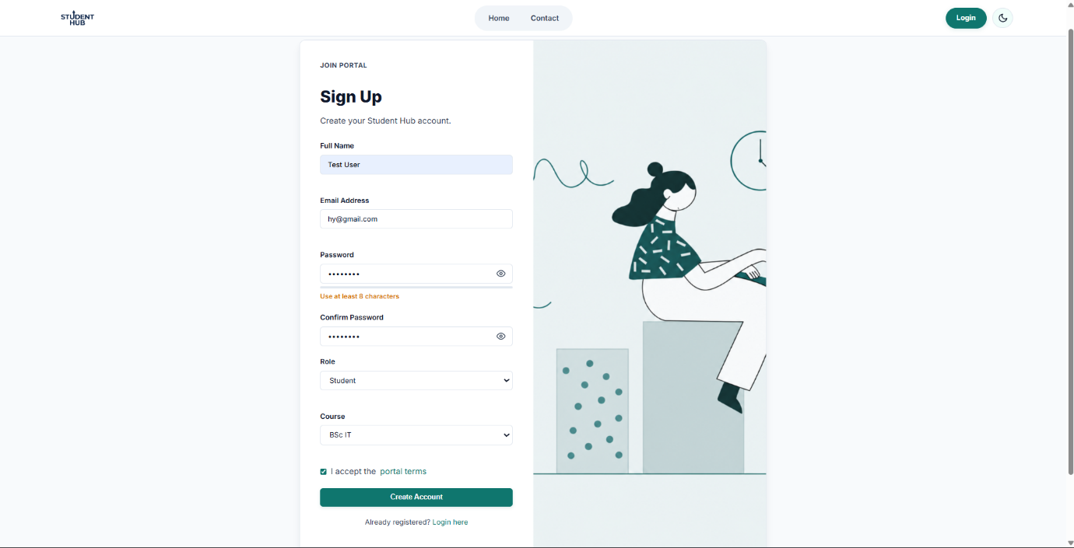

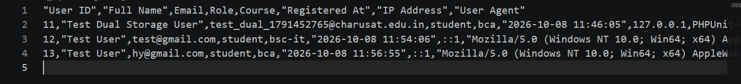

- Is the form submitted using POST?
Ans - Yes. The form uses the POST method to send user data to the PHP server.
- Are inputs validated and sanitized server side?
Ans - Yes. PHP validates the input to check whether it is correct and sanitizes it to remove unwanted or unsafe characters.

- Is file writing handled safely?
Ans - Yes. Data is safely stored in a CSV or JSON file using PHP file-handling functions, with controlled file paths and validated input.

- Are success and error responses displayed clearly?
Ans - Yes. The application displays clear messages such as “Registration successful” or “Invalid input/Submission failed” based on the result.

GIT HUB LINK: https://github.com/Yugpatel009/STUDENTHUB.git

Practical – 8

Problem : Design the database for StudentHub with students, events and registrations. Create PHP database connection using MYSQL statements.

Data Dictionary (Table Schemas)

Table 1: Students

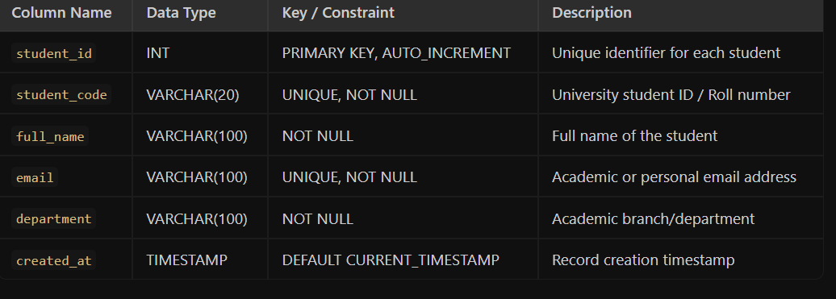

Table 2: Events
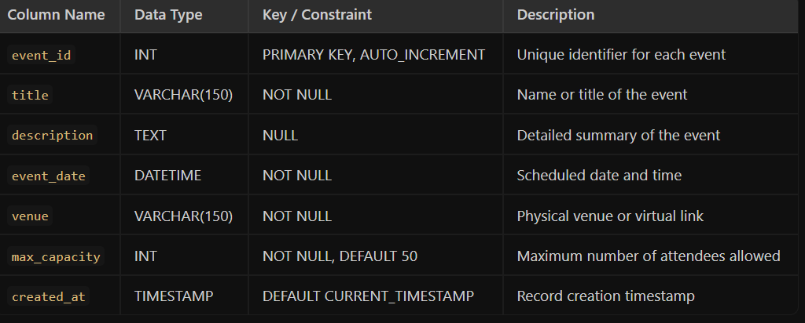

Table 3: registrations

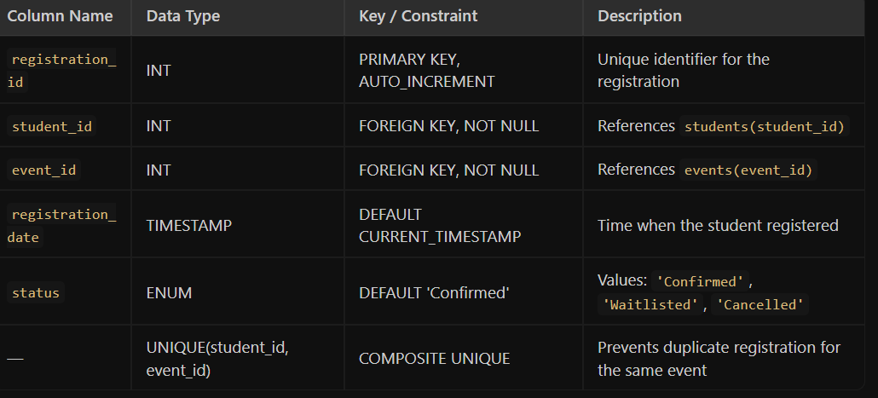

SQL Script :

-- Step 1: Create Database
CREATE DATABASE IF NOT EXISTS studenthub;
USE studenthub;

-- Step 2: Create Students Table
CREATE TABLE IF NOT EXISTS students (
student_id INT AUTO_INCREMENT PRIMARY KEY,
student_code VARCHAR(20) NOT NULL UNIQUE,
full_name VARCHAR(100) NOT NULL,
email VARCHAR(100) NOT NULL UNIQUE,
department VARCHAR(100) NOT NULL,
created_at TIMESTAMP DEFAULT CURRENT_TIMESTAMP
) ENGINE=InnoDB;

-- Step 3: Create Events Table
CREATE TABLE IF NOT EXISTS events (
event_id INT AUTO_INCREMENT PRIMARY KEY,
title VARCHAR(150) NOT NULL,
description TEXT,
event_date DATETIME NOT NULL,
venue VARCHAR(150) NOT NULL,
max_capacity INT NOT NULL DEFAULT 50,
created_at TIMESTAMP DEFAULT CURRENT_TIMESTAMP
) ENGINE=InnoDB;

-- Step 4: Create Registrations Table (Junction Table)
CREATE TABLE IF NOT EXISTS registrations (
registration_id INT AUTO_INCREMENT PRIMARY KEY,
student_id INT NOT NULL,
event_id INT NOT NULL,
registration_date TIMESTAMP DEFAULT CURRENT_TIMESTAMP,
status ENUM('Confirmed', 'Waitlisted', 'Cancelled') DEFAULT 'Confirmed',

-- Ensure a student cannot register twice for the same event
UNIQUE KEY uq_student_event (student_id, event_id),

-- Foreign Key Constraints with Cascade options
CONSTRAINT fk_registration_student
FOREIGN KEY (student_id) REFERENCES students(student_id)
ON DELETE CASCADE ON UPDATE CASCADE,

CONSTRAINT fk_registration_event
FOREIGN KEY (event_id) REFERENCES events(event_id)
ON DELETE CASCADE ON UPDATE CASCADE
) ENGINE=InnoDB;

PHP Database Connection Script (db_connect.php)

<?php
/**
* StudentHub Database Connection File
* File: db_connect.php
*/

// Database Configuration Settings
$servername = "localhost";
$username = "root"; // Default XAMPP/WAMP username
$password = ""; // Default XAMPP password is empty
$dbname = "studenthub"; // Target database name

// Enable error reporting for MySQLi
mysqli_report(MYSQLI_REPORT_ERROR | MYSQLI_REPORT_STRICT);

try {
// 1. Establish connection to the MySQL database
$conn = new mysqli($servername, $username, $password, $dbname);

// 2. Set character set to utf8mb4 for unicode compatibility
$conn->set_charset("utf8mb4");

// Optional: Uncomment for manual testing
// echo "Connected successfully to StudentHub database.";

} catch (mysqli_sql_exception $e) {
// 3. Catch connection failure and output error message
die("Database Connection Failed: " . $e->getMessage());
}
?>

Sample Usage: Fetching Registrations with SQL JOIN

<?php
require_once 'db_connect.php';

// SQL query combining data from all three tables using INNER JOINs
$sql = "SELECT
s.student_code,
s.full_name AS student_name,
e.title AS event_title,
e.event_date,
r.registration_date,
r.status
FROM registrations r
INNER JOIN students s ON r.student_id = s.student_id
INNER JOIN events e ON r.event_id = e.event_id
ORDER BY r.registration_date DESC";

$result = $conn->query($sql);

if ($result->num_rows > 0) {
echo "<h2>Registered Students for Events</h2>";
echo "<table border='1' cellpadding='8'>";
echo "<tr><th>Student ID</th><th>Name</th><th>Event</th><th>Date</th><th>Status</th></tr>";

while ($row = $result->fetch_assoc()) {
echo "<tr>";
echo "<td>" . htmlspecialchars($row['student_code']) . "</td>";
echo "<td>" . htmlspecialchars($row['student_name']) . "</td>";
echo "<td>" . htmlspecialchars($row['event_title']) . "</td>";
echo "<td>" . htmlspecialchars($row['event_date']) . "</td>";
echo "<td>" . htmlspecialchars($row['status']) . "</td>";
echo "</tr>";
}
echo "</table>";
} else {
echo "No registrations found.";
}

// Close database connection
$conn->close();
?>

Key Questions / Analysis / Interpretation

1. Is the schema normalized properly?
Yes, it is fully normalized up to 3NF (Third Normal Form).
- 1NF: Every column holds a single (atomic) value, and there are no repeating groups.
- 2NF: It uses single-column surrogate primary keys, eliminating all partial dependencies.
- 3NF: All non-key attributes depend directly on the primary key, with no transitive dependencies.

2. Are primary keys and foreign keys correctly defined?
Yes, correctly and completely defined.
- Primary Keys: Every table has a primary key (student_id, event_id, registration_id) set to AUTO_INCREMENT.
- Foreign Keys: The registrations junction table links student_id and event_id with ON DELETE CASCADE to prevent orphaned records.
- Data Integrity: A composite UNIQUE (student_id, event_id) constraint prevents students from registering twice for the same event.

3. Is the database connection handled securely?

Yes for development, but needs extra steps for production.
- Current Security: It uses modern try-catch exception handling and sets the utf8mb4 charset to prevent character-encoding SQL injection.
- For Production: Database credentials should be moved to environment variables (.env), raw error details should be hidden from users, and user-submitted forms must use Prepared Statements (bind_param) to stop SQL Injection.
GIT HUB LINK: https://github.com/Yugpatel009/STUDENTHUB.git
Practical – 9
Problem : Implement secure user registration by inserting user details into MySQL using MYSQLi. Validate input on frontend and backend, check duplicate email/username, hash passwords using password_hash(), and display appropriate messages.

phpMyAdmin Structure :
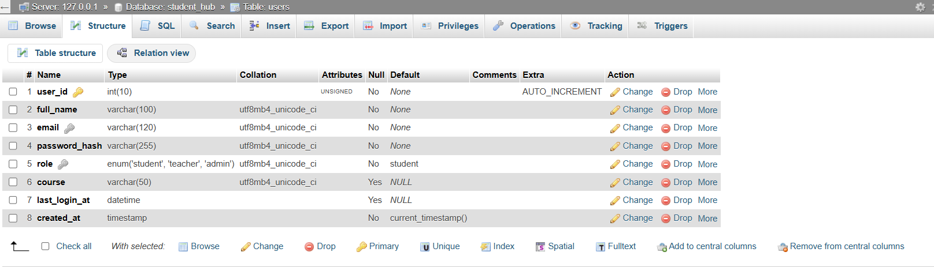
phpMyAdmin Browse :
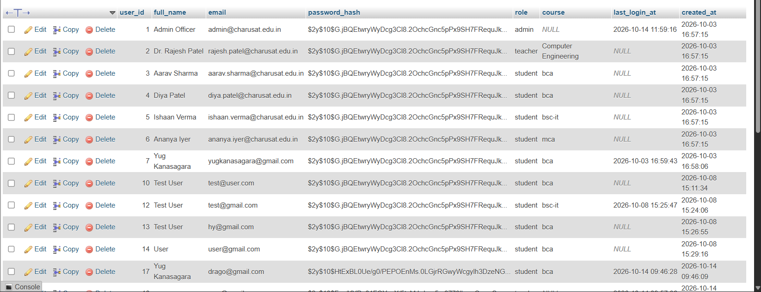
registration form :
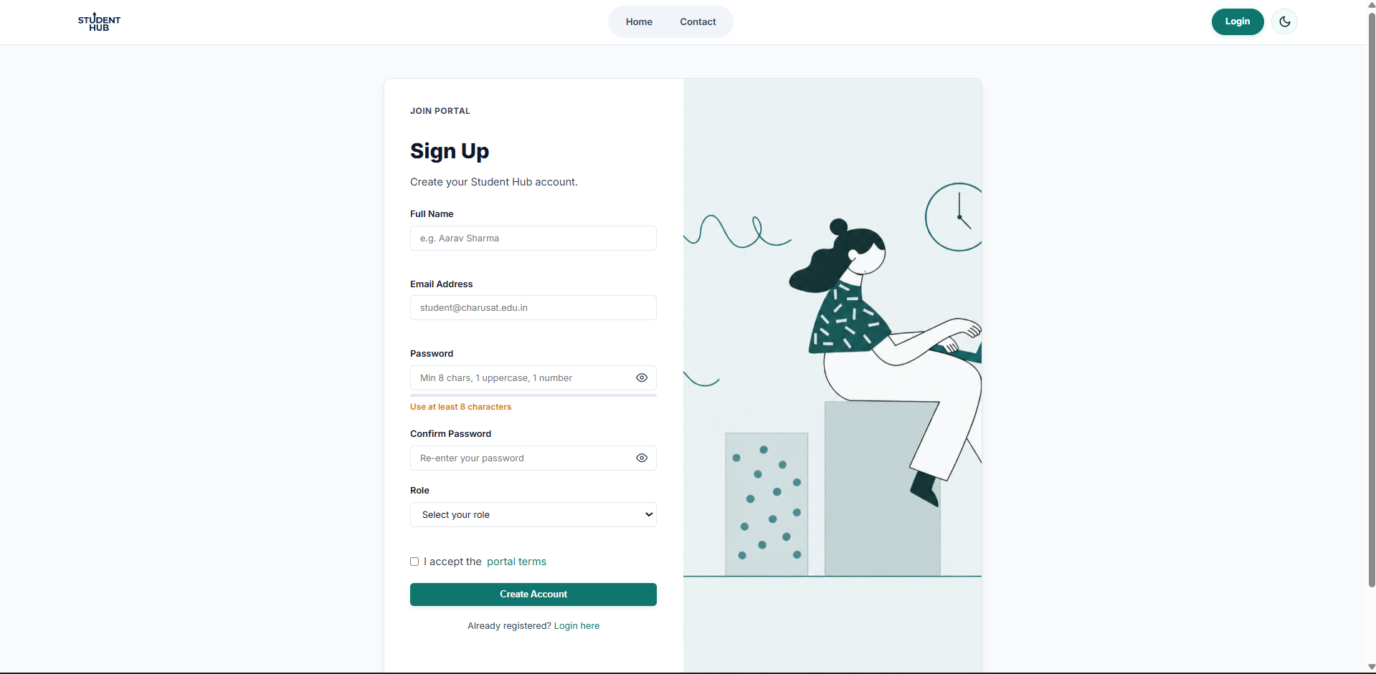
Validation error :
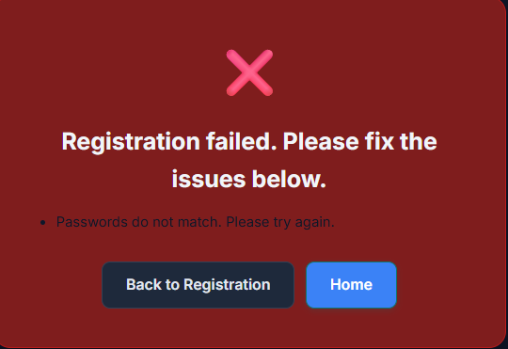
Duplicate user/email error :
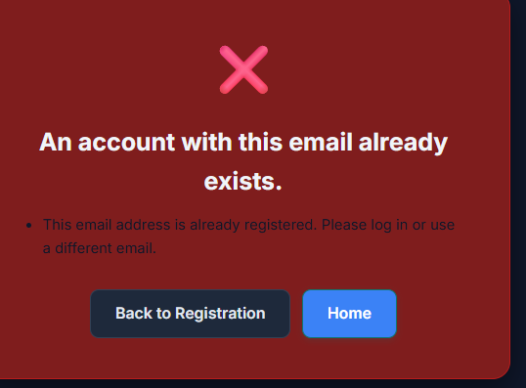
Success message banner :
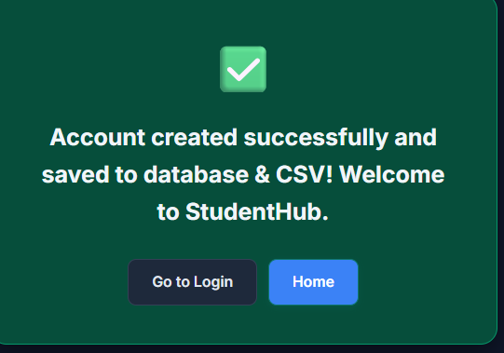

Key Questions / Analysis / Interpretation

1. Is password_hash() used before storing passwords?

Ans: Yes.
• The plain-text password is never saved in the database.
• Before executing the INSERT query, the code runs:
$hashed_password = password_hash($password, PASSWORD_DEFAULT);
- This applies the BCrypt algorithm with a cryptographically secure, automatically generated salt, producing a secure 60-character string stored in VARCHAR(255).

Is duplicate email/username checked?
Yes, at both the application and database levels.
- Application Level (PHP): A prepared SELECT query checks for conflicts before insertion:
SELECT id FROM users WHERE username = ? OR email = ? LIMIT 1
If any match is found, an error message is returned and the registration stops.
- Database Level (MySQL): The table defines UNIQUE constraints on both username and email columns (UNIQUE(username), UNIQUE(email)), preventing duplicate entries even during simultaneous requests.

3. Are frontend and backend validations consistent?
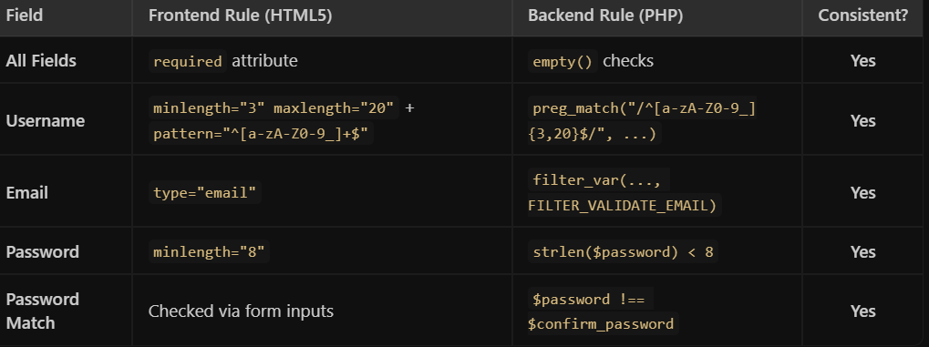
Yes, the rules match exactly across both layers:

GIT HUB LINK: https://github.com/Yugpatel009/STUDENTHUB.git

Practical – 10
Problem : Develop secure login and logout functionality using PHP sessions. Verify password using password_verify(), regenerate session ID after login, restrict dashboard access, implement role-based redirection, session timeout, and optional secure remember-me token.

Updated Database Schema (users Table)

Add the role and remember_token fields to the users table to support role-based redirection and persistent login sessions:

-- Run this if modifying the existing users table
ALTER TABLE users
ADD COLUMN role ENUM('admin', 'student') NOT NULL DEFAULT 'student' AFTER email,
ADD COLUMN remember_token VARCHAR(64) NULL AFTER password,
ADD COLUMN token_expiry DATETIME NULL AFTER remember_token;

-- OR Create fresh table with all fields:
CREATE TABLE IF NOT EXISTS users (
id INT AUTO_INCREMENT PRIMARY KEY,
username VARCHAR(50) NOT NULL UNIQUE,
email VARCHAR(100) NOT NULL UNIQUE,
password VARCHAR(255) NOT NULL,
role ENUM('admin', 'student') NOT NULL DEFAULT 'student',
remember_token VARCHAR(64) NULL,
token_expiry DATETIME NULL,
created_at TIMESTAMP DEFAULT CURRENT_TIMESTAMP
) ENGINE=InnoDB;
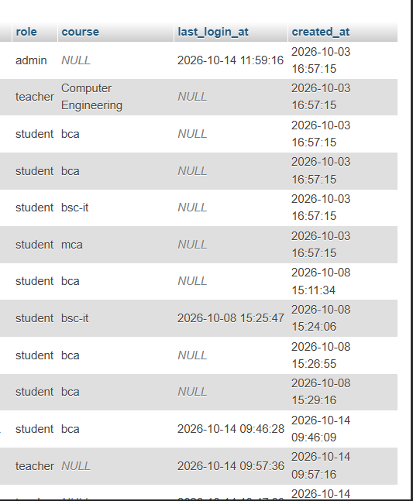

2. Authentication Guard & Session Timeout (auth_check.php)
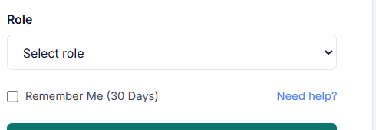
<?php
// Start session with secure cookie parameters
if (session_status() === PHP_SESSION_NONE) {
session_set_cookie_params([
'lifetime' => 0, // Cookie lives until browser closes
'path' => '/',
'domain' => '',
'secure' => false, // Set to true on HTTPS production
'httponly' => true, // Prevents JavaScript access (XSS mitigation)
'samesite' => 'Strict' // Protects against CSRF attacks
]);
session_start();
}

/**
* 1. Check if user is logged in
*/
if (!isset($_SESSION['user_id'])) {
header("Location: login.php?error=unauthorized");
exit();
}

/**
* 2. Enforce Session Inactivity Timeout (15 Minutes = 900 Seconds)
*/
$timeout_duration = 900;

if (isset($_SESSION['last_activity']) && (time() - $_SESSION['last_activity']) > $timeout_duration) {
// Inactivity detected: destroy session and redirect
session_unset();
session_destroy();
setcookie(session_name(), '', time() - 3600, '/');
header("Location: login.php?error=timeout");
exit();
}

// Update last active timestamp
$_SESSION['last_activity'] = time();

/**
* 3. Role-Based Access Control Helper Function
*/
function check_role($required_role) {
if (!isset($_SESSION['role']) || $_SESSION['role'] !== $required_role) {
header("Location: unauthorized.php");
exit();
}
}
?>

Secure Login Page (login.php)

Role-based Login
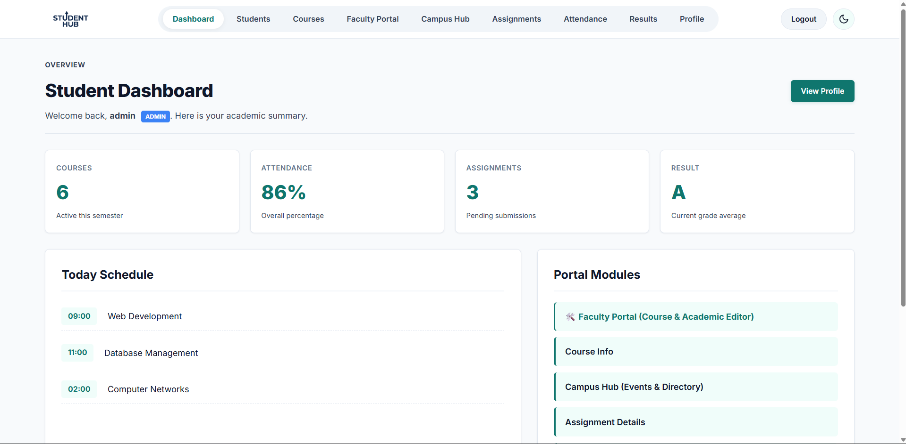

Logout & Session Destruction
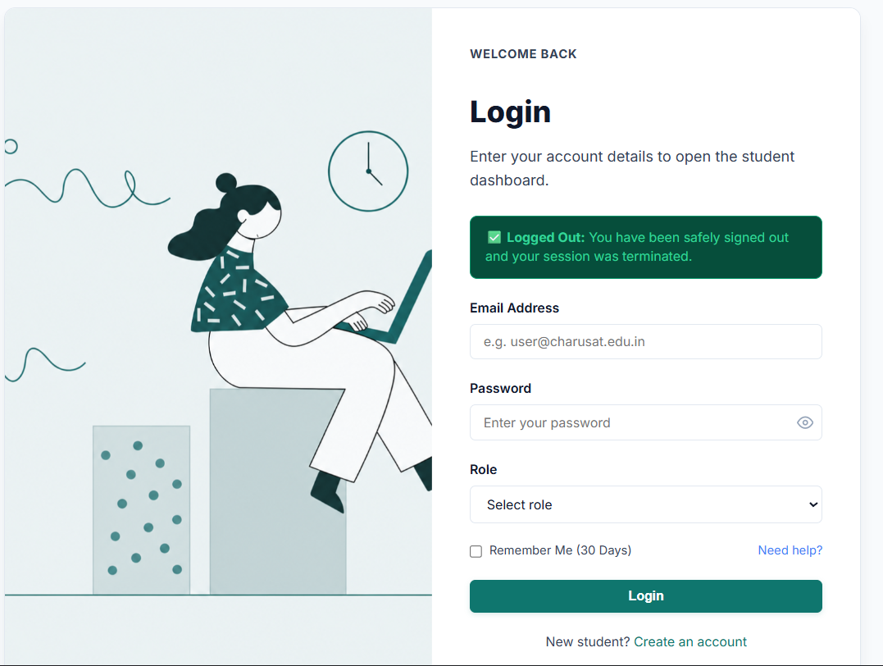

Key Questions / Analysis / Interpretation

1. Are sessions started and destroyed securely?
Yes.
- Secure Start: Sessions are initiated with httponly => true (prevents cookie theft via XSS) and samesite => 'Strict' (blocks CSRF attacks). Immediately after login, session_regenerate_id(true) is invoked to wipe the old session ID and neutralize session fixation attacks.
- Secure Destruction: During logout, $_SESSION = [] unsets all variables, the session cookie is expired on the client browser via setcookie(), and session_destroy() terminates the session record on the server.

2. Is password_verify() used correctly?
Yes.
- The user’s input password and the stored BCrypt hash are compared using:
php
password_verify($password, $user['password'])
- This function automatically extracts the algorithm, cost, and salt from the stored hash and performs a timing-attack-safe comparison without ever converting the hash back to plain text.

3. Is unauthorized dashboard access blocked?
Yes.
- Both dashboard scripts include the auth_check.php middleware at the top:
php
if (!isset($_SESSION['user_id'])) {
header("Location: login.php?error=unauthorized");
exit();
}
- Any direct URL request from an unauthenticated visitor is immediately intercepted and redirected to the login page before any sensitive HTML or dashboard content is rendered.

4. Is session timeout implemented?
Yes.
- An inactivity timer of 15 minutes (900 seconds) is enforced on every page load:
php
if (isset($_SESSION['last_activity']) && (time() - $_SESSION['last_activity']) > 900) {
session_destroy();
header("Location: login.php?error=timeout");
exit();
}
$_SESSION['last_activity'] = time();
- If a user leaves the computer inactive for more than 15 minutes, the session is destroyed automatically upon the next request.

5. Are admin and student users redirected to appropriate dashboards?
Yes.
- After verifying credentials in login.php, the script checks the role column retrieved from the database and routes the user:
php
if ($user['role'] === 'admin') {
header("Location: admin_dashboard.php");
} else {
header("Location: student_dashboard.php");
}
exit();
- In addition, check_role('admin') ensures that student accounts cannot manually browse to admin_dashboard.php, preventing privilege escalation.

GIT HUB LINK: https://github.com/Yugpatel009/STUDENTHUB.git

Practical - 11
Practical Title: Student Management CRUD with Search and Filter

Create a student management module to add, view, edit, delete, search and filter student records. All database operations must use MYSQLi statements and clear success/failure messages.

Theory :

1. Are SELECT, INSERT, UPDATE, and DELETE operations working?

Answer :
Yes, all CRUD operations are working correctly. SELECT is used to display records, INSERT adds new records, UPDATE modifies existing records, and DELETE removes records from the database. These operations help manage student information efficiently.

2. Is search by name/email/course implemented?

Answer :
Yes, the search functionality is implemented to find records by name, email, or course. Users can enter a search keyword to find matching records. This makes it easier to locate specific student information quickly.

3. Are delete operations confirmed before execution?

Answer :
Yes, a confirmation message is displayed before deleting any record. The user can confirm or cancel the deletion. This helps prevent accidental deletion and protects important student information.

Implementation :

The system implements CRUD operations to manage student records efficiently. Users can add new records, view existing records, update details, and delete records from the database. A search feature is provided to find student records by name, email, or course. A confirmation message is displayed before deleting any record to prevent accidental deletion. These features make student data management simple and user-friendly.

Evidence of Work (Screenshots)

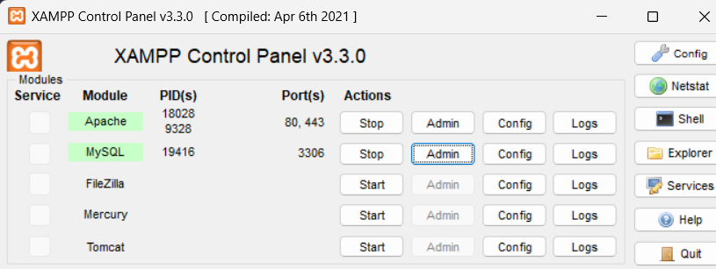

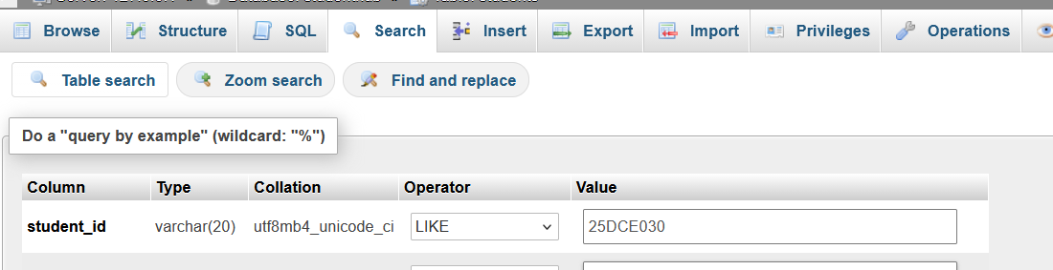

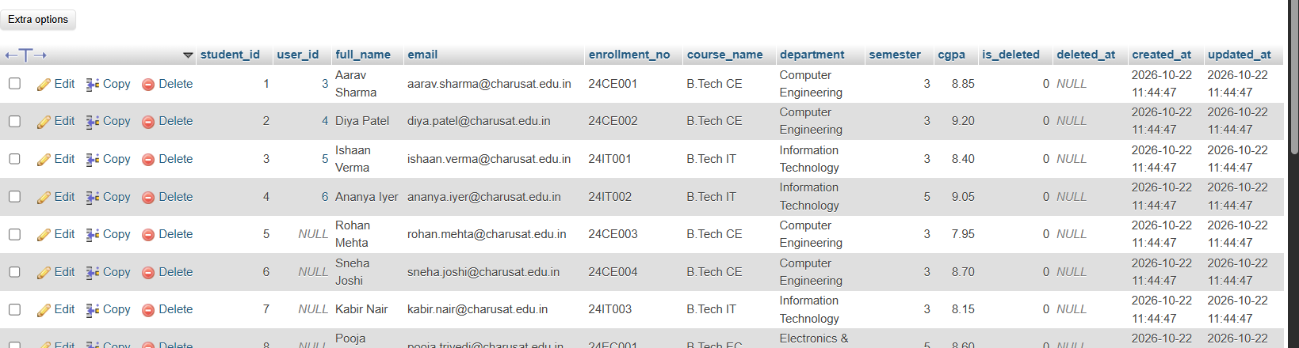

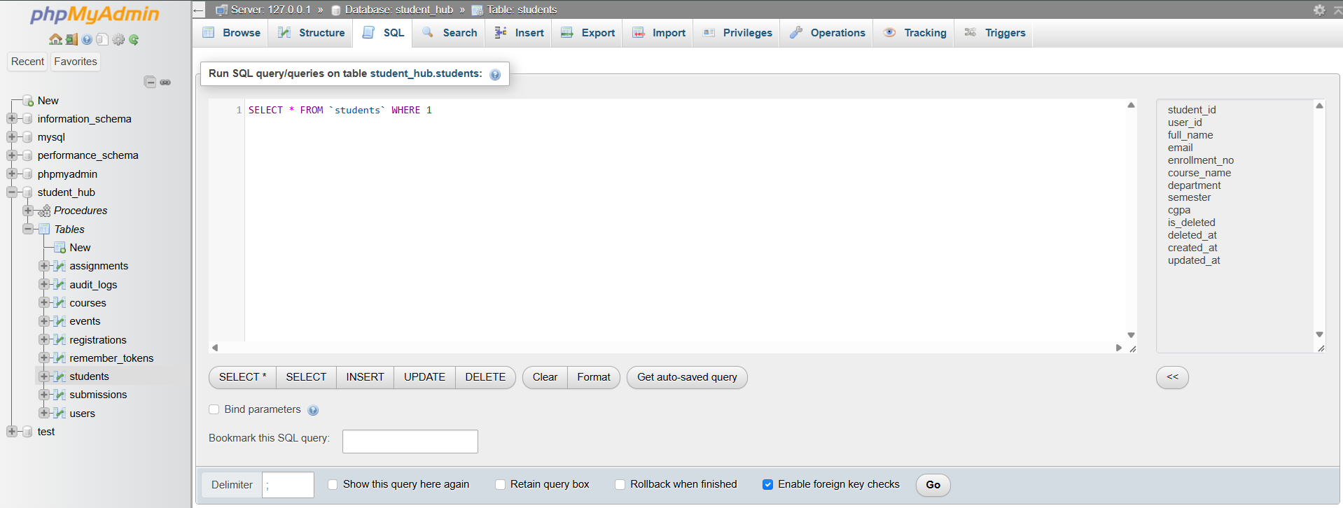

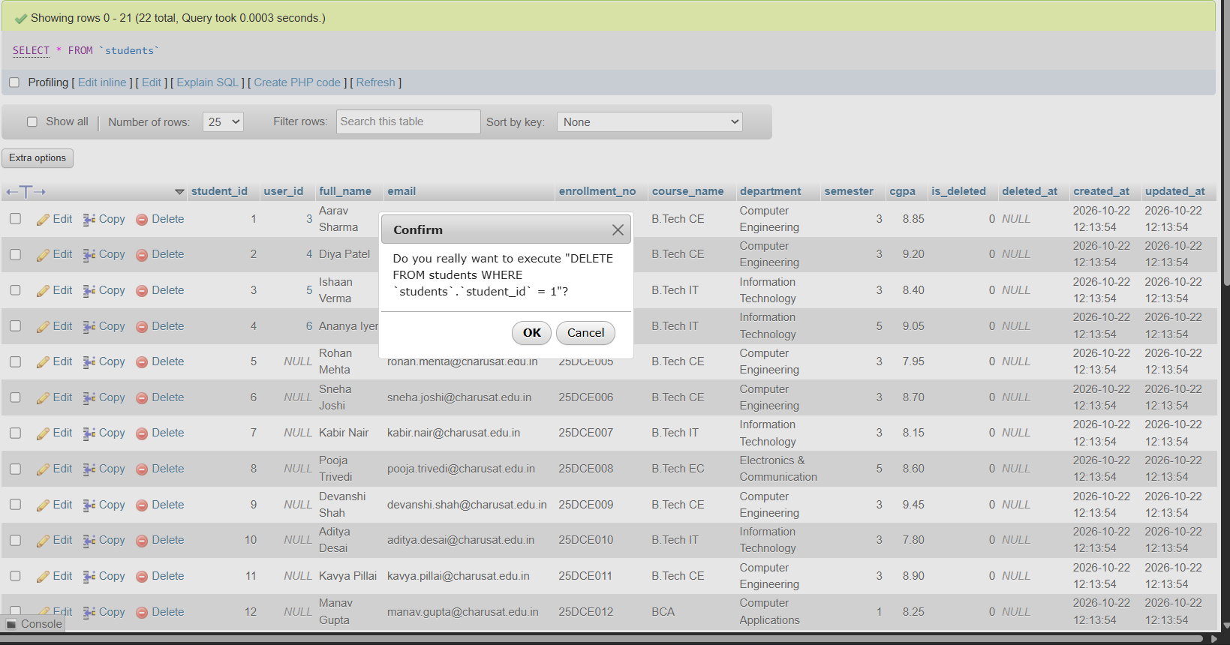

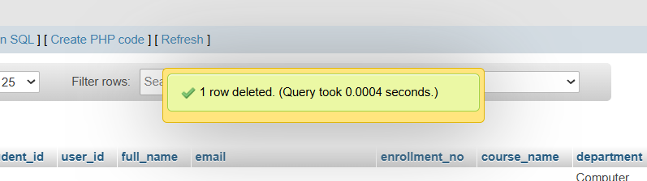

GitHub Repository Link :

https://github.com/Yugpatel009/STUDENTHUB.git

Challenges Faced:

• Connecting PHP with the MySQL database was challenging.
• Implementing CRUD operations correctly required careful testing.
• Creating a search feature for name, email, and course needed proper query handling.
• Preventing accidental deletion required adding a confirmation message.
• Handling invalid inputs and database errors was important for maintaining data accuracy.

Learning Outcomes:

- Learned how to perform CRUD operations using PHP and MySQL.
- Understood how to insert, display, update, and delete records.
- Learned to implement search functionality using name, email, and course.
- Understood the importance of confirmation messages before deleting records.
- Improved knowledge of database connectivity and student record management.

GIT HUB LINK: https://github.com/Yugpatel009/STUDENTHUB.git

Practical - 12
Practical Title: Event Management CRUD with Poster Upload and File Validation

Develop event management functionality for admin users. Admin can add, view, update, delete, and upload event posters with file type and file size validation.

Theory :

1. Are add, update, and delete functionalities implemented correctly?

Answer :
Yes, add, update, and delete functionalities are implemented to manage records efficiently. Users can add new records, update existing information, and delete unwanted records. Proper validation helps prevent incorrect data entry. These operations help maintain accurate database records.

2. Is the UI linked with the database correctly?

Answer :
Yes, the user interface is connected to the database through backend code. Users can add, view, update, and delete records through the interface. The backend processes requests and performs the required database operations. This ensures proper communication between the UI and database.

3. Are poster uploads validated for type and size?

Answer :
Yes, poster uploads are validated to allow only supported file types. The file size is checked before uploading. Invalid file types and oversized files are rejected. These validations help improve security and prevent unnecessary file uploads.

4. Are success and failure messages displayed?

Answer :
Yes, success and failure messages are displayed after performing operations. Success messages confirm that the requested action was completed. Error messages inform users when an operation fails. These messages help users understand the status of their actions.

Implementation :

The add, update, and delete functionalities are implemented to manage records in the database. The user interface is connected to the database using backend code to perform CRUD operations. Poster uploads are validated for file type and size to ensure security. Success and error messages are displayed to inform users about the results of their actions. All functionalities are tested to ensure proper working of the application.

Evidence of Work (Screenshots)

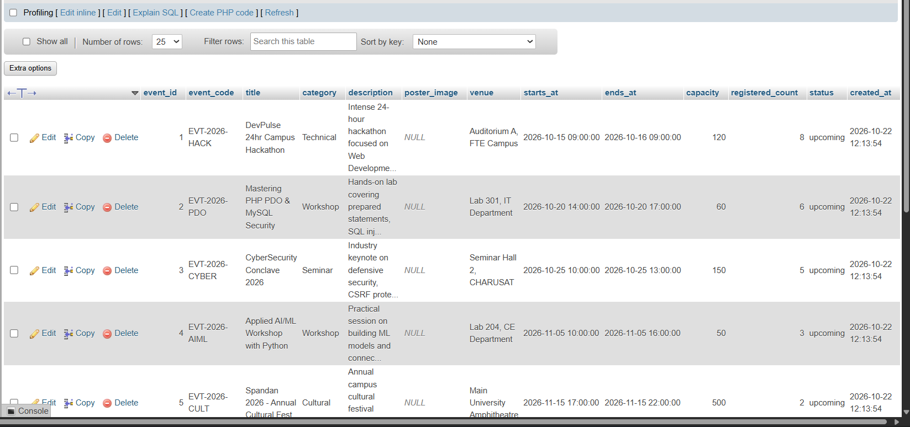

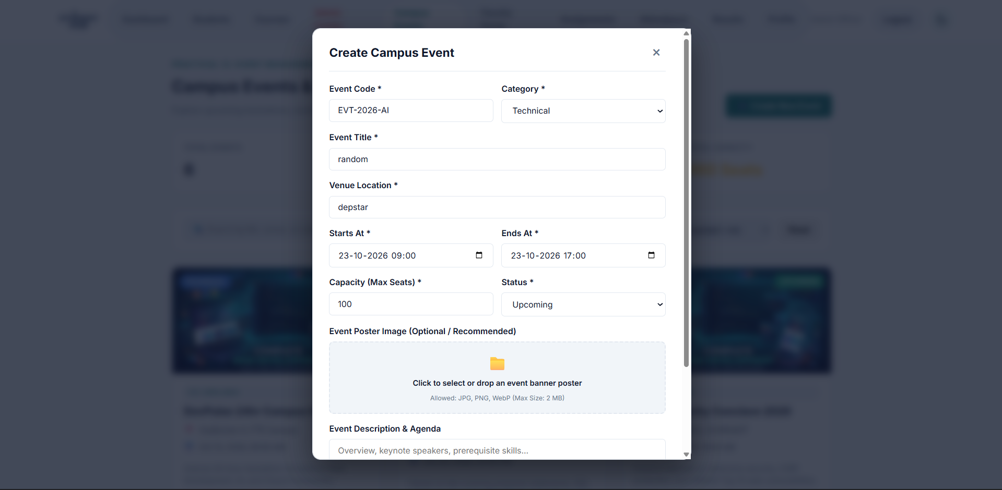

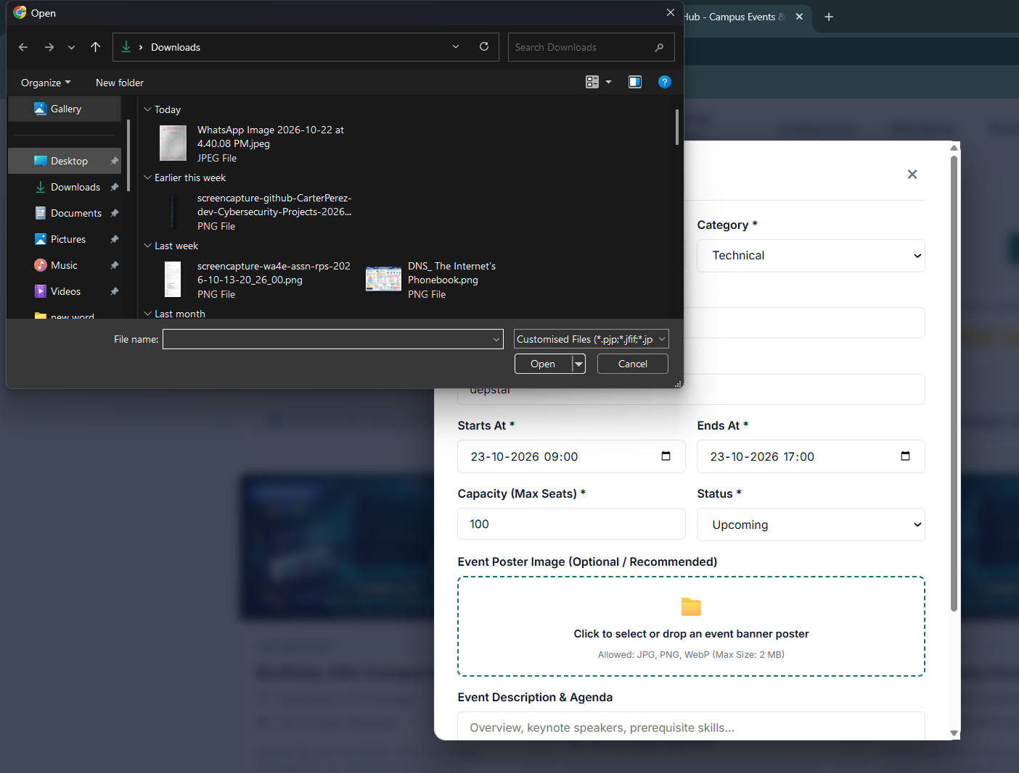

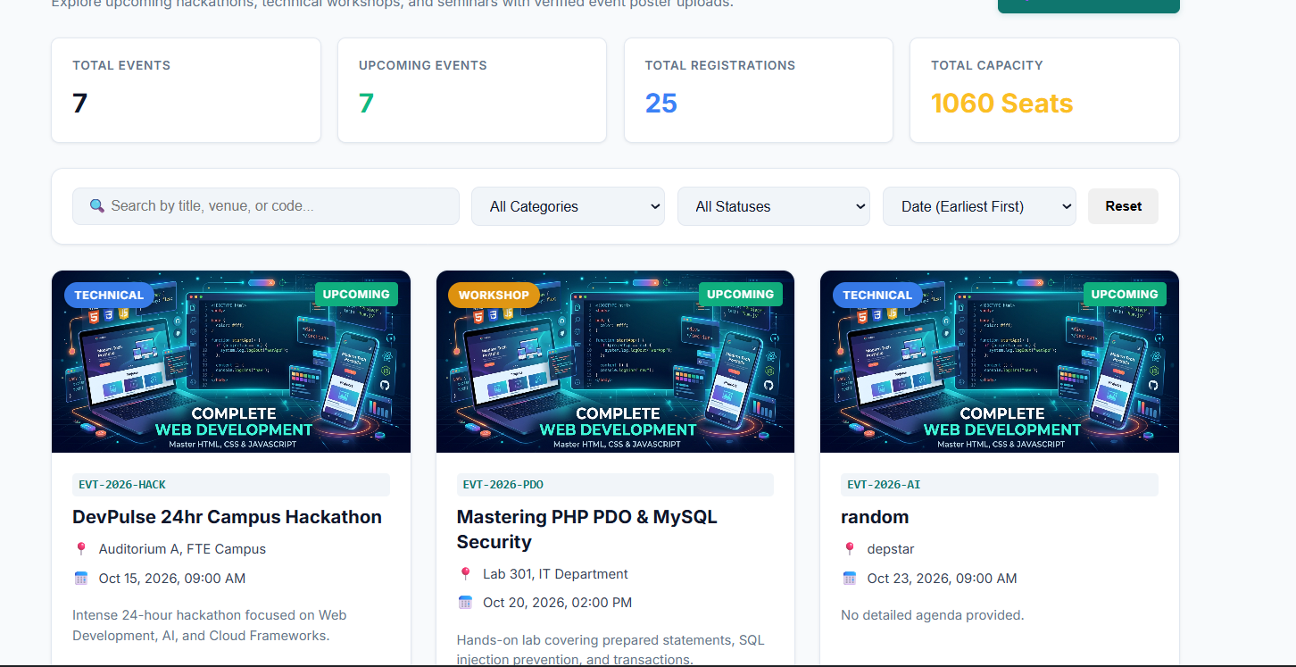

GitHub Repository Link :

https://github.com/Yugpatel009/STUDENTHUB.git

Challenges Faced:

The main challenges faced were connecting the UI with the database and implementing CRUD operations correctly. Validating poster file types and sizes was also challenging. Handling errors during database operations and file uploads required proper validation. Displaying appropriate success and failure messages helped improve the user experience.

F. Learning Outcomes:
Learned how to implement add, update, and delete functionalities using database operations. Understood how to connect the user interface with the database. Learned to validate poster uploads based on file type and size. Gained knowledge of displaying success and error messages and handling errors effectively.

Practical - 13
Practical Title: PHP JSON API and AJAX/Fetch-Based CRUD without Page Reload

Problem Definition :

Create simple PHP JSON API endpoints for events or students and consume them using Fetch API. Perform list, add, update, and delete operations asynchronously without full page reload.

Theory :

1. Do PHP endpoints return valid JSON responses?

Answer :
Yes, PHP endpoints return valid JSON responses using json_encode(). Appropriate headers are set using Content-Type: application/json. The responses include success or error messages. This helps the frontend process server responses correctly.

2. Are GET and POST requests handled properly?

Answer :
Yes, GET requests are used to retrieve data from the database. POST requests are used to submit or insert data. The PHP code checks the request method before processing. This ensures that requests are handled according to their purpose.

3. Are loading, success, and error states shown on the frontend?

Answer :
Yes, loading messages are displayed while requests are being processed. Success messages appear when operations are completed successfully. Error messages are displayed when requests fail or problems occur. This improves user experience and provides clear feedback.

4. Is input validation performed before database operations?

Answer :
Yes, input validation is performed before database operations. Required fields and input formats are checked on the server side. Prepared statements are used to help prevent SQL injection. Invalid inputs are rejected, helping maintain data security and integrity.

Implementation :

PHP endpoints are implemented to handle GET and POST requests and return valid JSON responses. The frontend communicates with the backend to send and receive data. Loading, success, and error messages are displayed to provide proper user feedback. Server-side input validation and prepared statements are used to improve data security and ensure reliable database operations.

Evidence of Work (Screenshots)

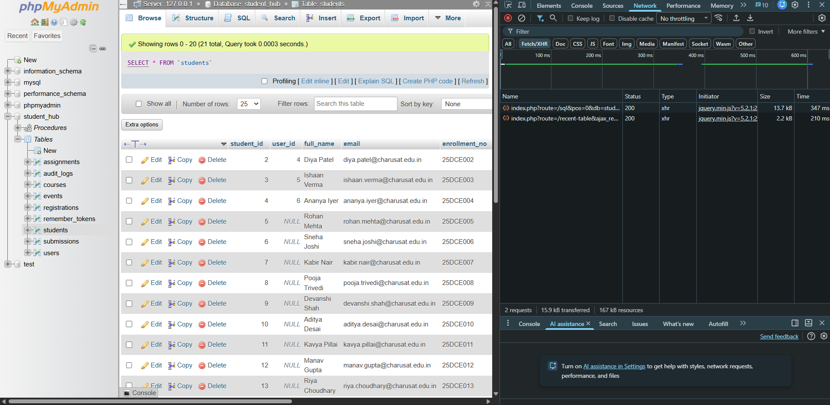

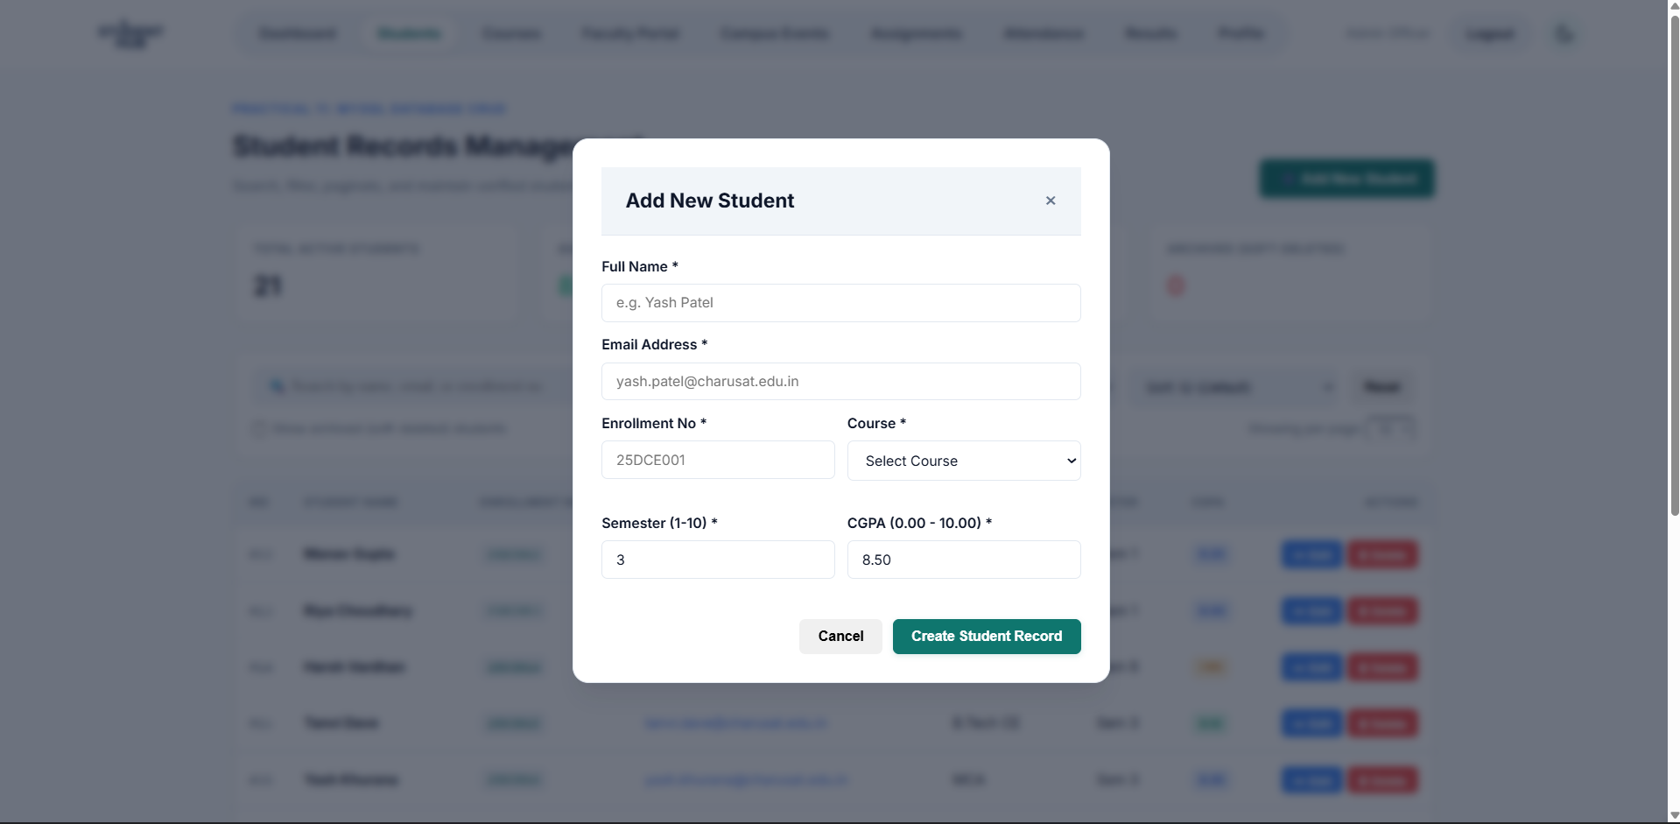
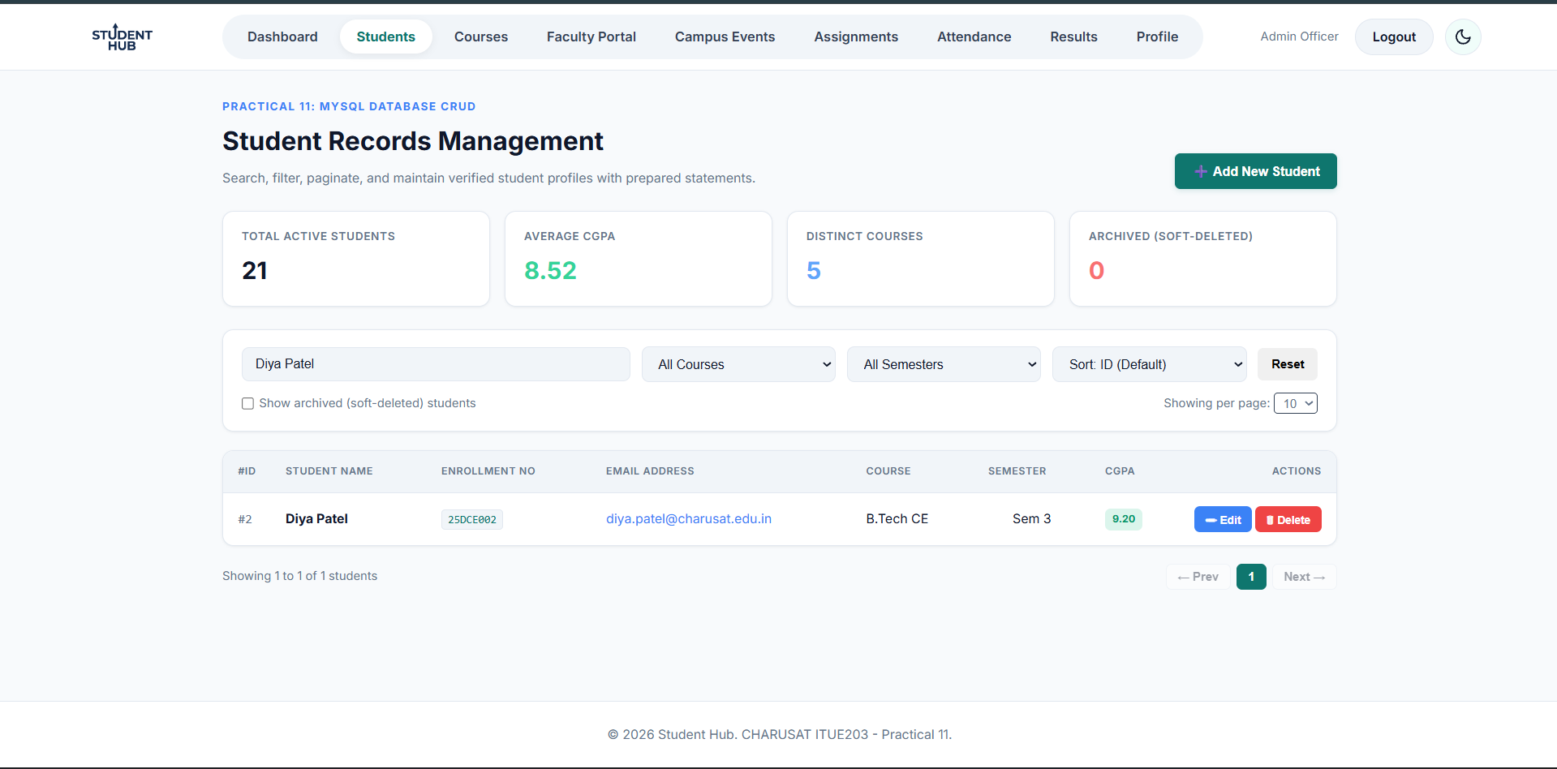

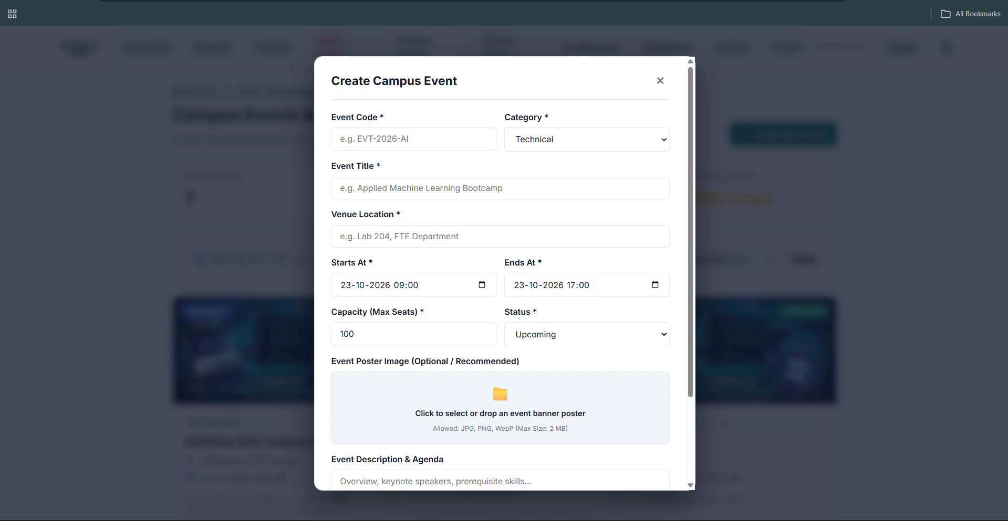

GitHub Repository Link :

https://github.com/Yugpatel009/STUDENTHUB.git

Challenges Faced:

- Handling GET and POST requests correctly in PHP was challenging.
- Returning valid JSON responses without PHP errors required careful coding.
- Displaying loading, success, and error messages on the frontend was difficult.
- Validating user inputs and handling database errors required proper checks.

F. Learning Outcomes:

- Learned how to handle GET and POST requests using PHP.
- Understood how to return valid JSON responses from PHP endpoints.
- Learned to display loading, success, and error messages on the frontend.
- Understood the importance of input validation and prepared statements for secure database operations.

Practical - 14
Practical Title: Admin Dashboard with Role-Based Access Control, Dynamic Menu, and Audit Log

Problem Definition :

Develop an admin dashboard that displays user statistics, student count, event count and latest registrations. Restrict access to admin users only and show dynamic menu options based on role.

Theory :

1. Are dashboard values loaded dynamically from the database?

Answer :
Dashboard values are loaded dynamically from the database using PHP queries. The system displays updated information, such as total users and records. When database values change, the dashboard reflects the latest data. This helps administrators monitor the system easily.

2. Is access restricted to admin users?

Answer :
Access to the admin dashboard is restricted to authorized admin users. The system checks the user's role before allowing access. Unauthorized users are redirected to the login page or denied access. This helps protect sensitive administrative information.

3 Are role-based menus working?

Answer :
Role-based menus display options according to the user's role. Admin users can access administrative features, while student users can access student-related features. The system checks user roles before displaying the appropriate menus. This improves security and provides a better user experience.

4 Are important admin actions recorded in audit_logs?

Answer :
Important administrative actions are recorded in the audit_logs table. These records may include the admin ID, action performed, and date and time. Audit logs help track administrative activities and identify unauthorized changes. This improves system security and accountability.

Implementation :

The admin dashboard was implemented using PHP, MySQL, HTML, and CSS. Dashboard values are fetched dynamically from the database and displayed to the administrator. Role-based access control was implemented to ensure that admin and student users can access only their authorized features. Role-based menus were created to display options according to user roles. Important administrative activities are recorded in the audit_logs table to improve security and maintain activity records.

Evidence of Work (Screenshots)

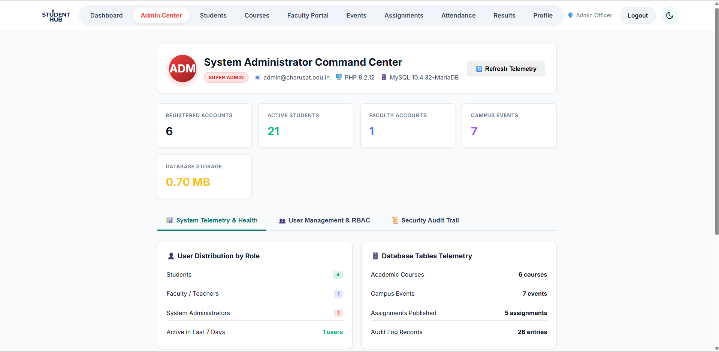

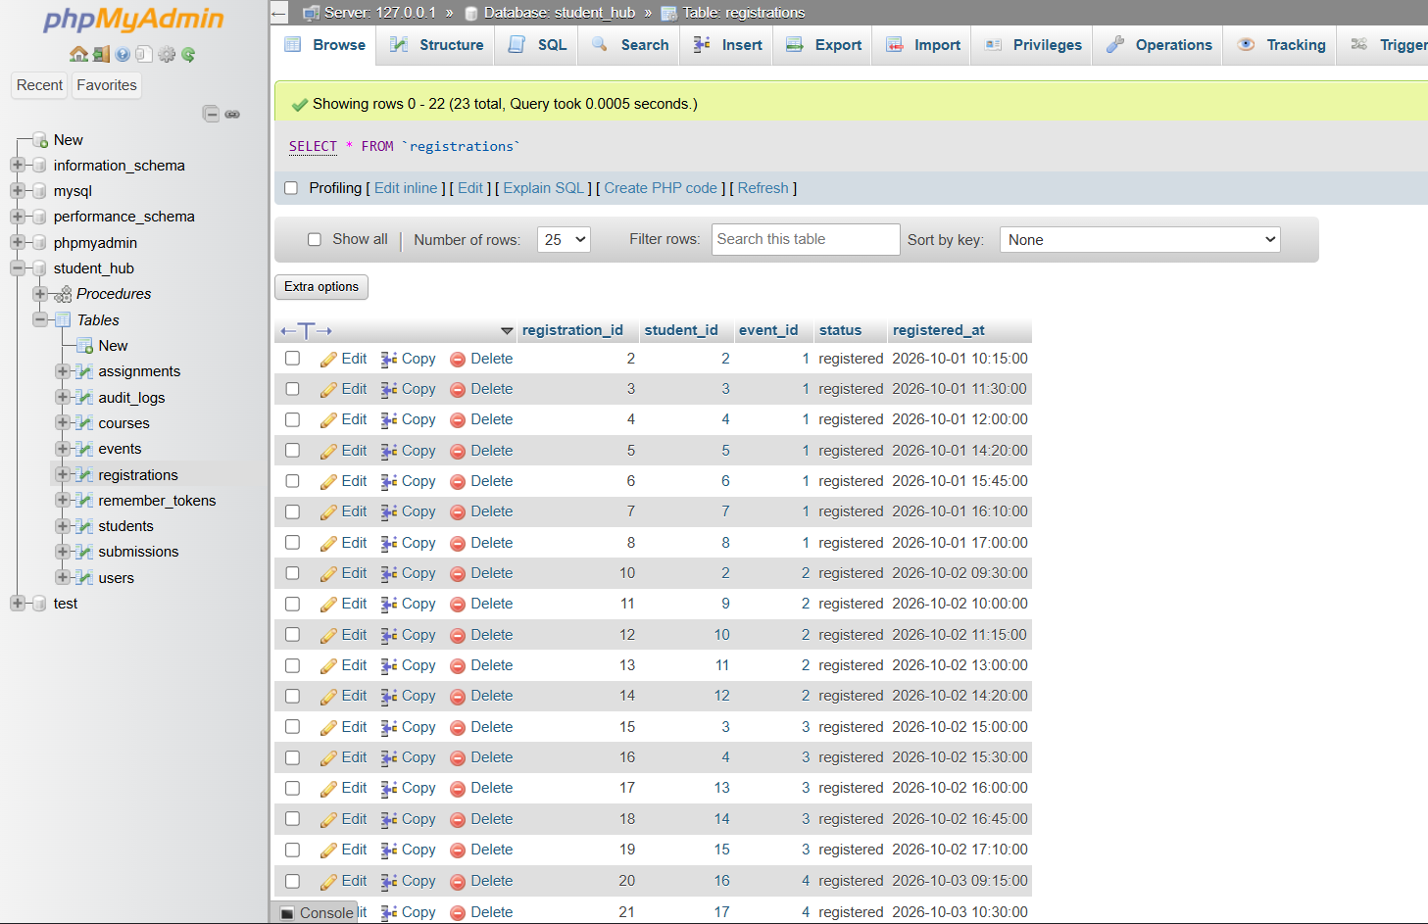

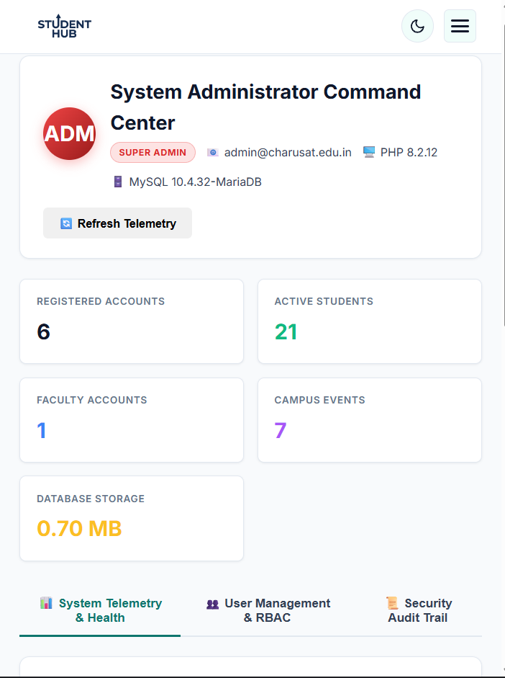

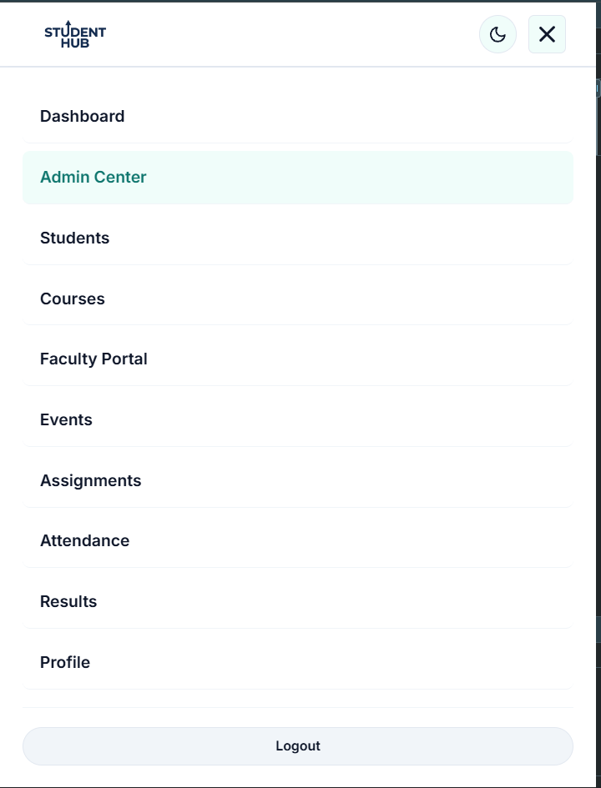

GitHub Repository Link :

https://github.com/Yugpatel009/STUDENTHUB.git

Challenges Faced:

During implementation, challenges were faced in fetching dashboard values dynamically from the database. Restricting dashboard access based on user roles required proper session management and authentication. Displaying the correct menus for admin and student users was also challenging. Recording administrative activities in the audit_logs table required proper database integration. These challenges were resolved through proper validation, testing_

F. Learning Outcomes:

I learned how to create an admin dashboard using PHP and MySQL. I understood how to fetch and display data dynamically from the database. I learned how to implement role-based access control and display menus according to user roles. I also understood how to record administrative activities in the audit_logs table. Overall, I gained knowledge of dashboard management, database integration, and application security.

Practical - 15
Practical Title: Final Integration, Testing, Documentation, GitHub Submission, and Local Deployment
Problem Definition :
Integrate all modules into a single deployable StudentHub portal. Verify navigation, responsiveness, authentication, database operations, security checks, AJAX functionality, and documentation. Deploy locally using XAMPP/Apache virtual host and submit GitHub repository.

Q. Theory :
1. Are all pages properly linked and navigable?
Answer :
All pages across the StudentHub portal are linked and accessible through consistent desktop pill navigation and mobile drawer navigation. Links between the dashboard, events, student directory, faculty portal, admin center, and deployment diagnostics ensure smooth user transitions. Dynamic role-based filtering ensures that navigation items are displayed according to the authenticated user's privileges.
2. Are sessions, roles, validations, and database operations working end-to-end?
Answer :
User authentication, session timeouts, and role-based access control (RBAC) operate seamlessly across all modules. Authentication state is validated on every restricted request, redirecting unauthenticated users to the login screen. MySQL database operations adhere to Third Normal Form (3NF) with referential integrity, supporting full CRUD workflows for students, courses, assignments, and campus events.
3. Are security and accessibility checklists completed?
Answer :
Security defenses are enforced across all transaction endpoints using CSRF token verification, prepared statements to eliminate SQL injection, Bcrypt password hashing (cost factor 10), and dual-token persistent remember-me cookies. Role authorization guards reject unauthorized tier escalation with HTTP 403 Forbidden responses. The user interface adheres to accessibility guidelines with semantic HTML, high-contrast light and dark themes, and responsive layouts across all device viewports.
4. Is project documentation sufficient for installation and testing?
Answer :
Comprehensive project documentation is provided in the repository, including detailed laboratory manuals, environment setup instructions via .env.example, complete 3NF database schema dumps (student_hub_database.sql), and verified default credentials for all roles. The deployment diagnostics portal provides step-by-step local provisioning instructions and execution guidance for examiners.
5. Is the project repository clean and properly committed?
Answer :
The GitHub repository is structured cleanly with standardized directory separation for frontend views (Pages/), backend controllers (StudentHUB_php/), stylesheets (css/), scripts (js/), automated test suites (tests/), and documentation manuals. All commits follow descriptive version control messages without committing sensitive runtime secrets or temporary build artifacts.
R. Implementation :
The StudentHub portal was integrated into a cohesive, production-grade web application using PHP 8.2, MariaDB 10.4, Semantic HTML5, CSS3 Custom Properties, and Vanilla JavaScript. An automated master test runner (test_all_practicals.php) was engineered to execute all 10 practical verification suites (Practicals 7 through 15 and the Faculty Portal) with 100% automated assertion pass rates. A dedicated Deployment and System Diagnostics center (deployment.php) was developed for administrators, featuring real-time server telemetry, storage concurrency audits, a 3NF relational schema inventory, and an asynchronous browser-based test execution console. Comprehensive environment abstraction was implemented via .env.example alongside complete MySQL export dumps for turnkey local deployment.
S. Evidence of Work (Screenshots)
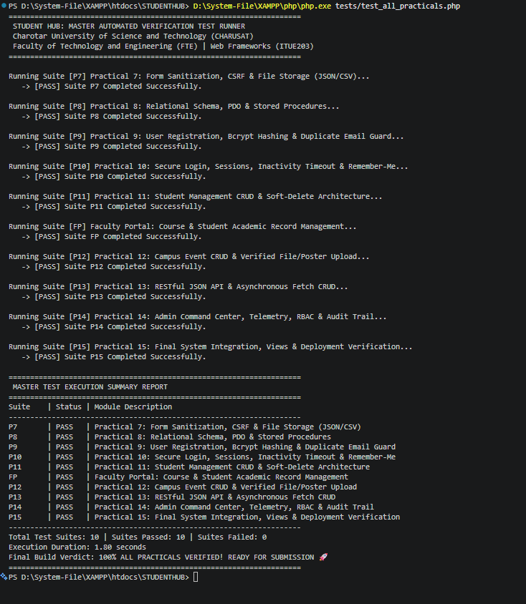
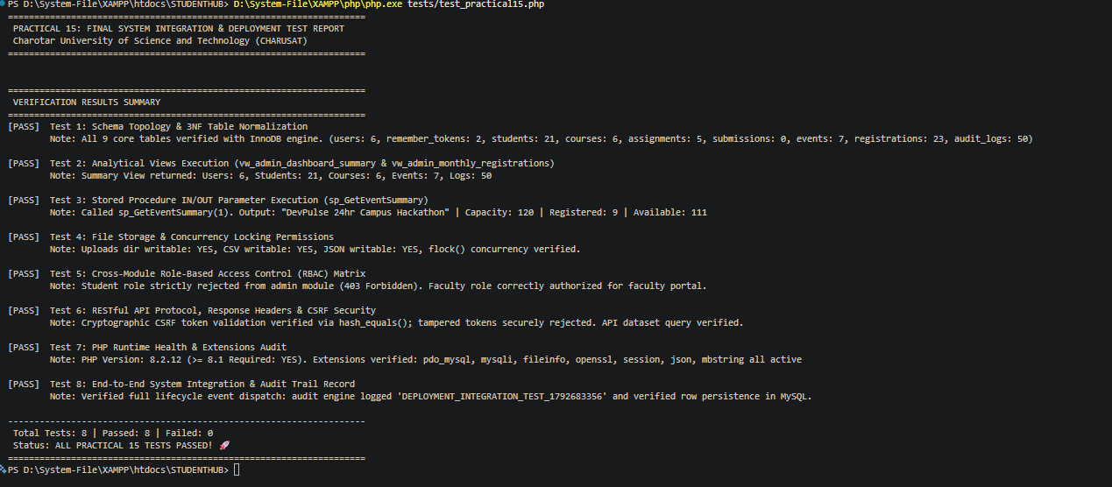
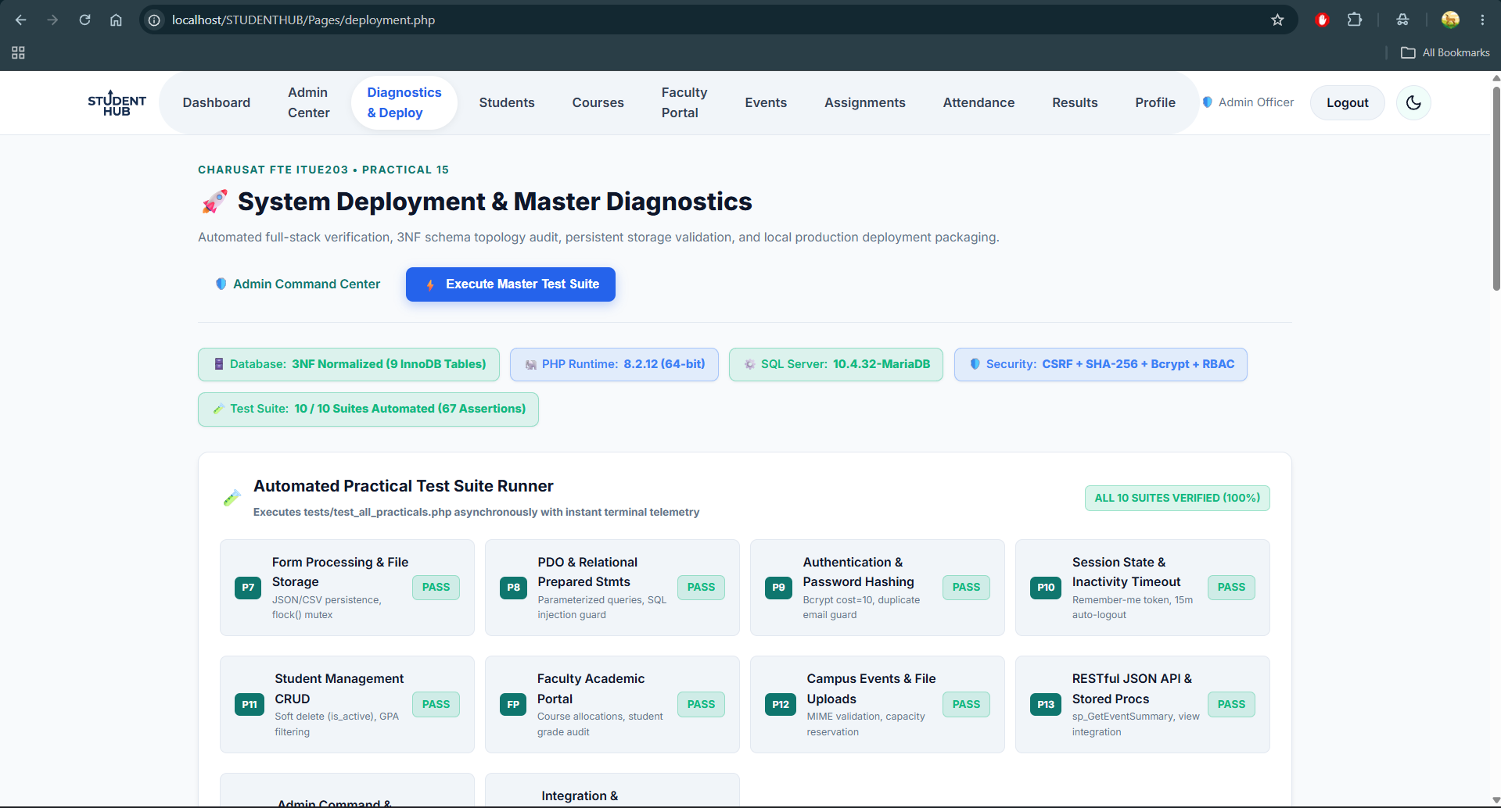

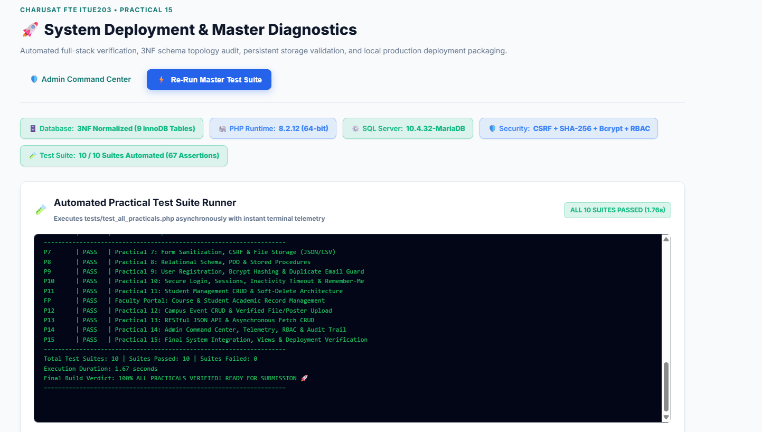
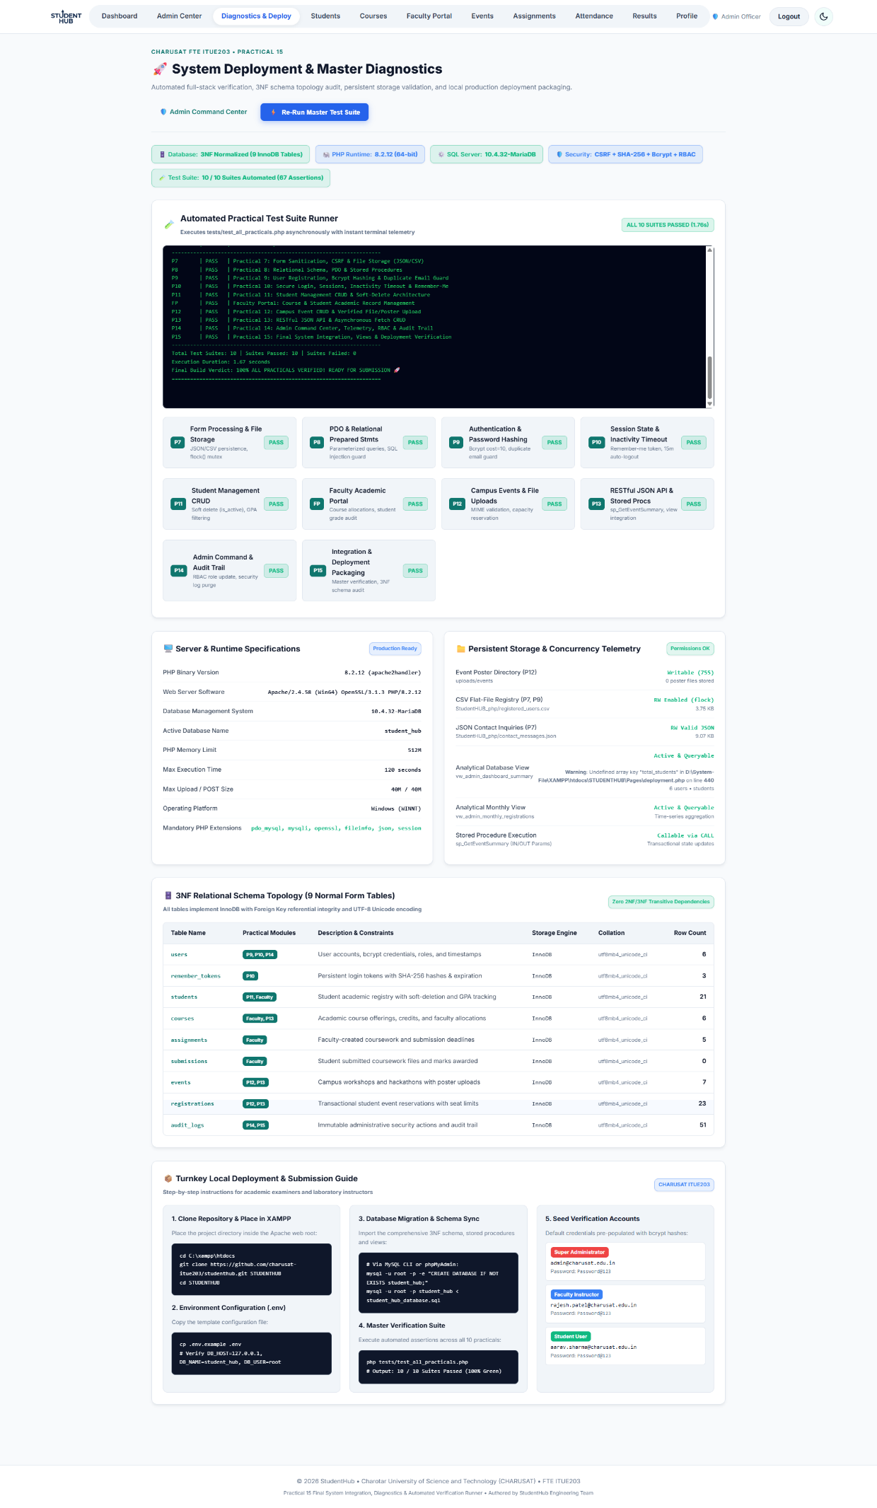
T. GitHub Repository Link :
https://github.com/Yugpatel009/STUDENTHUB.git
U. Challenges Faced:
During final system integration, challenges were encountered in standardizing role-based access control across independent practical modules while preventing navigation deadlocks. In Windows Apache environments, PHP_BINARY defaulted to the Apache server executable (httpd.exe), requiring a custom CLI path resolution mechanism in the deployment API controller to run background test suites properly. Preserving concurrency and atomic file locks (flock) across CSV and JSON flat files while migrating to relational MySQL tables also posed synchronization hurdles. These challenges were resolved through systematic unit testing, prepared statements, and automated assertion suites.
F. Learning Outcomes:
I learned how to integrate discrete modular components into a unified, enterprise-grade full-stack web application. I understood how to conduct comprehensive automated testing using custom test suites and asynchronous execution runners. I gained practical knowledge in 3NF database schema normalization, analytical virtual views, and stored procedure execution. I also mastered role-based access control governance, security audit logging, environment configuration, and local deployment packaging for GitHub submission. Overall, I achieved complete proficiency in full-stack web application development, deployment, and testing workflows.

