Agrocast Analytics
Internship Project Documentation
This is about the project I worked on during my internship, a live drone streaming and AI object-detection system. I've written it in four parts: how to start the setup, how this would be set up for a client, what every feature on the website does, and how the whole system is structured.
1. How to Start the Setup
There are two servers on AWS that need to be started before we can fly, and stopped after we're done, so we don't keep paying for them while they're idle.
Starting up
- Log in to AWS. Go to the AWS Console and sign in, the sign in credentials are in the csv file of harsh admin. Make sure the region in the top right is set to Asia Pacific (Mumbai) ap-south-1, since that's where the servers are.
- Go to EC2 → Instances. There's a list of servers here. The two that matter are:
- agrocast-main-streaming: handles the live video and the website's connection to it.
- agrocast-main-detection: the GPU server, it runs the AI detection and the auto-follow logic.
- Start both of them. Select each one and click Instance State → Start.
- Sometimes the GPU server fails to start and says something like “insufficient capacity.” That just means AWS is temporarily out of that server type. Wait a few minutes and try again.
- Wait about a minute, then note down both new IP addresses. Every time these servers are started they get a new public IP, since I haven't set up a fixed IP for them. The new IP shows up in the EC2 console under “Public IPv4 address.”
- Run the update command. On the PC, open PowerShell and run:
powershell -ExecutionPolicy Bypass -File "D:\Live Stream\update-servers.ps1" -StreamIP <new streaming IP> -GpuIP <new GPU IP>
This one command does everything updates both servers with the correct IP, restarts the background services, re-hosts the gimbal script so the RC picks it up on its own within about 10 seconds, and pushes the latest version of the website.
At the end it prints either a green “ALL DONE” or a red list of anything that failed. If something shows up in red, it means that step didn't actually happen, so it's worth checking before flying.
- Two things I always do manually (these are on separate devices, so they can't be part of the script):
- On the laptop: open OBS → Settings → Stream → set Server to rtmp://<new streaming IP>:1935 (the key stays drone) → Start Streaming.
- On the website: open livestreamxk.com, enter the new Streaming IP in the Server IP box, and click Connect All Cameras.
- The RC and gimbal side needs nothing from me, it checks for updates every 10 seconds on its own and picks up whatever was just deployed.
Once this is done, everything is live video, detection, gimbal control, and auto-follow.
Shutting down
- Go back to EC2 → Instances.
- Select both agrocast-main-streaming and agrocast-main-detection.
- Click Instance State → Stop.
The website itself runs on a separate server that's always on that one is cheap to run and needs to stay reachable, so it's never stopped. Only the streaming and GPU servers get stopped after use.
2. How This Would Be Set Up for a Client
Setting up a new client now takes just a few clicks in AWS plus one script — I built onboard-client.ps1 specifically so this doesn't take a long manual walkthrough every time.
Setting up the client's servers
- Launch the streaming server. Go to EC2 → Instances → Launch Instances, then:
- Name: something clear, like “clientname-streaming”.
- Application and OS Image: Ubuntu Server (the same one our own streaming server uses).
- 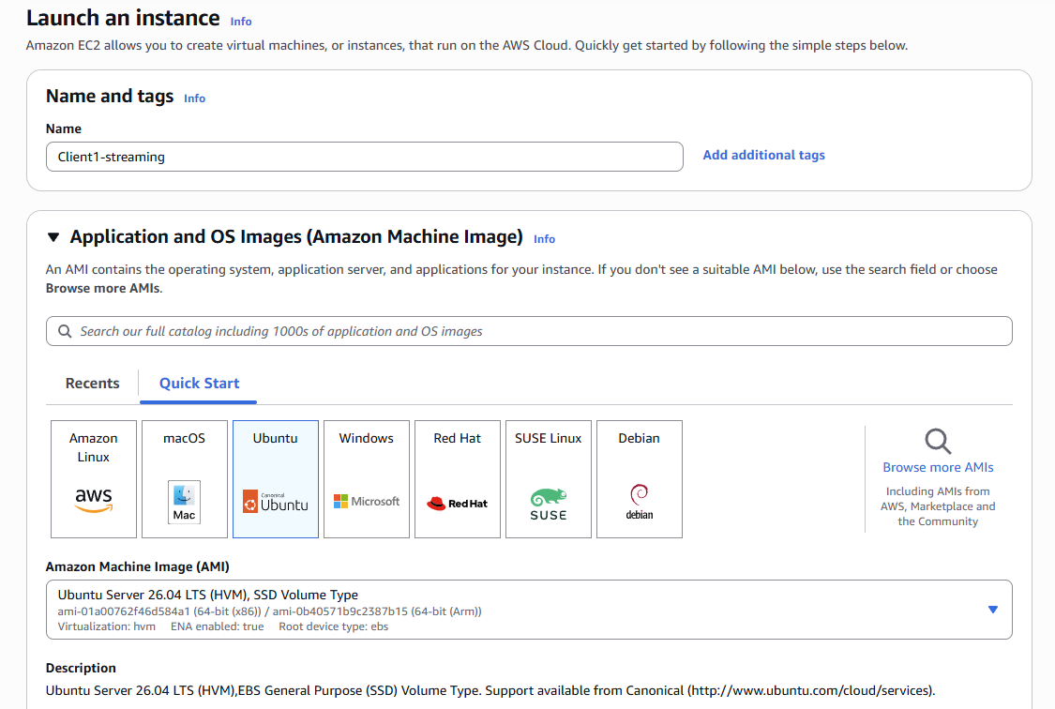
- Instance type: t3.medium.
- Key pair: choose our existing one, agrocast-main-key.pem. This is a small file, already saved in our project folder, that works like a very secure password for logging in to any of our AWS servers over SSH we reuse this exact same file for every client's servers instead of creating a new one each time, since it's already set up and safe to reuse.
- Security group (the firewall rules): create or reuse one that allows these ports in: 22 (so we can log in over SSH to set it up), 1935 (so OBS can push video into it), and 5000, 8554, 8889 (used by our backend program and the video relay).
- 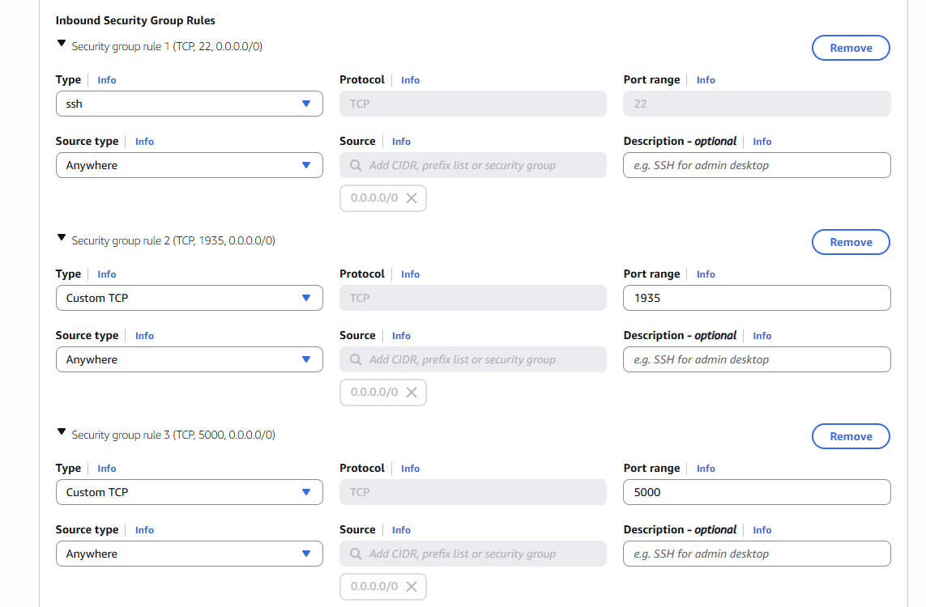
- 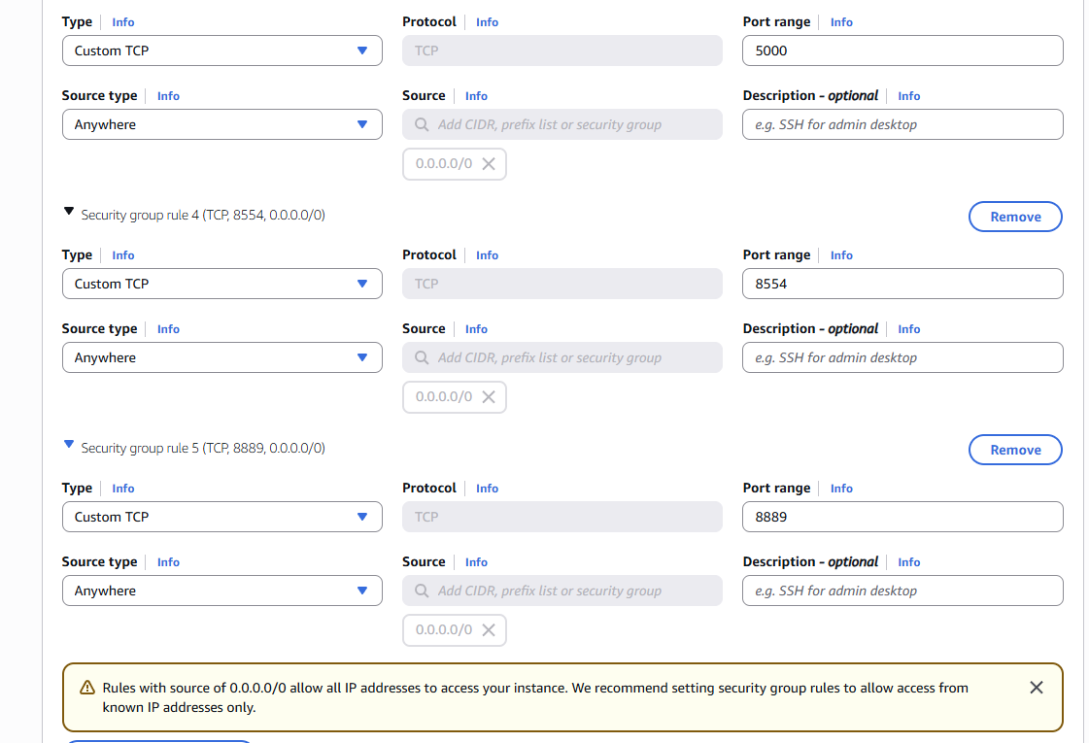
- Click Launch Instance.
- Once it shows as Running, copy its Public IPv4 address — that's the Streaming IP we'll use below.
- Launch the GPU server. Same process, but:
- Name: “clientname-detection”.
- Application and OS Image: search for and pick a Deep Learning AMI that already has PyTorch installed — this saves a lot of setup time, since the AI libraries come preloaded.
- 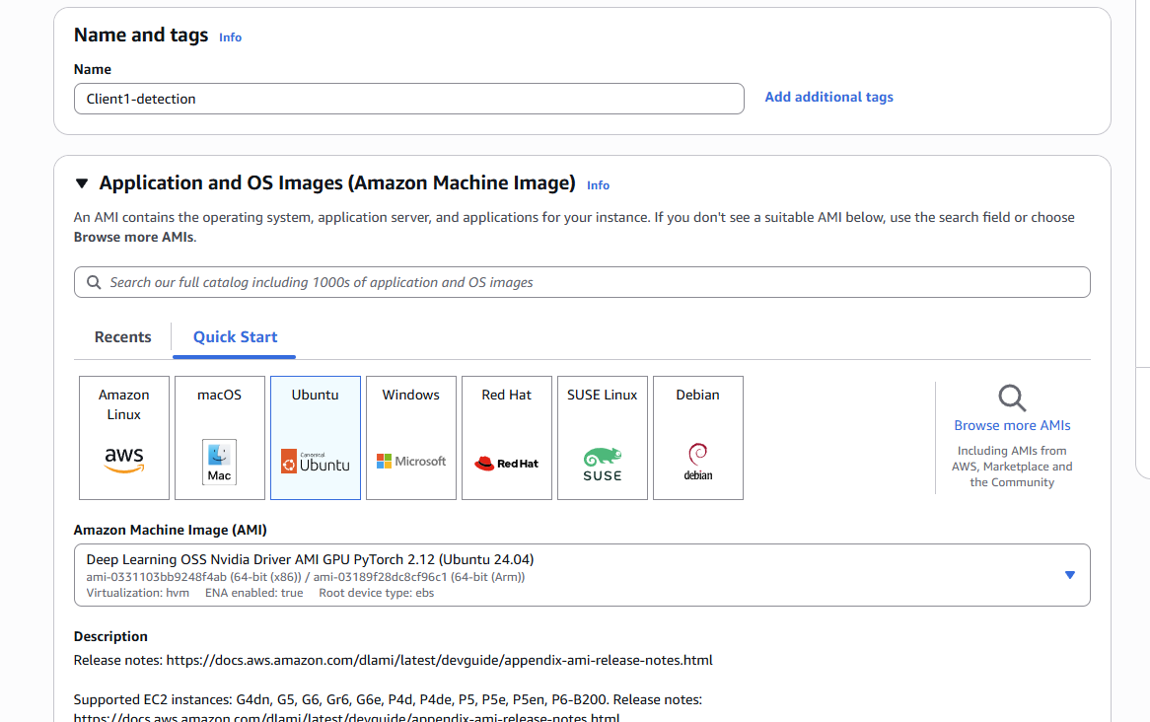
- Instance type: g4dn.xlarge.
- Key pair: the same agrocast-main-key.pem.
- Security group: only port 22 needs to be open here, since this server only ever reaches OUT to the streaming server — nothing connects in to it directly.
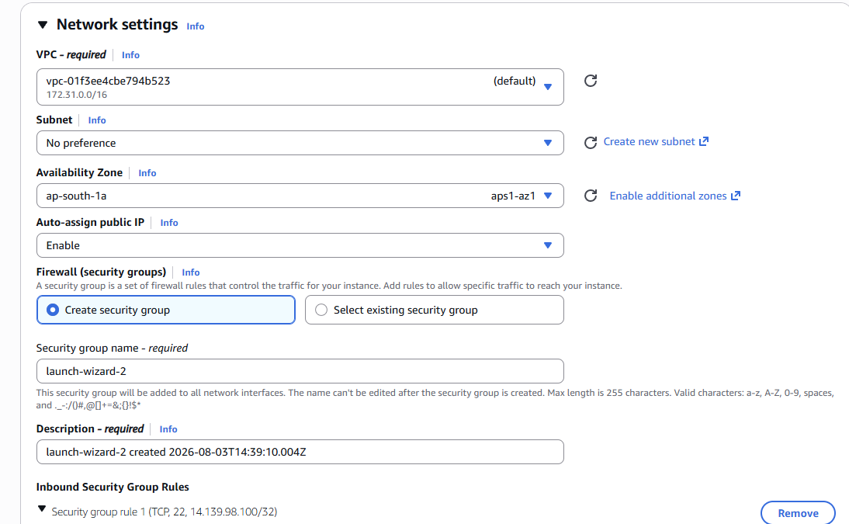
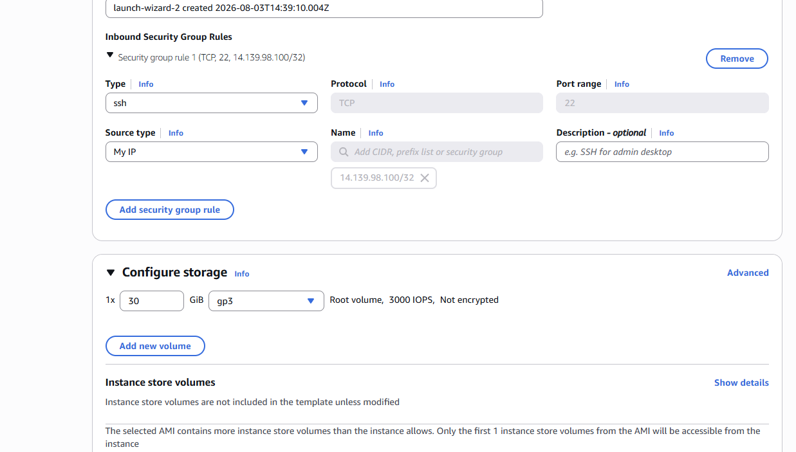
- Click Launch Instance, and once it's running, copy its Public IPv4 address — that's the GPU IP.
- (Recommended) Give both servers a fixed IP. Go to EC2 → Network & Security → Elastic IPs → Allocate Elastic IP address, then Actions → Associate Elastic IP address and pick the new server. Do this once for each of the two servers, so their IPs never change again.
- Run one command. This does everything else automatically:
powershell -ExecutionPolicy Bypass -File "D:\Live Stream\onboard-client.ps1" -ClientName <name> -StreamIP <their streaming IP> -GpuIP <their GPU IP>
If the client has more than one drone from day one, add -NumDrones 3 (or however many) to that same command, and it sets all of them up at once - each gets its own detection process and its own camera on the website automatically. If they start with one and buy more later, use add-drone.ps1 instead (see “Adding More Drones” below) rather than re-running this.
In one run, this installs everything needed on both servers, sets both up to auto-start, generates that client's own API Key by itself, hosts their own private gimbal script, adds a first camera automatically, and prints exactly what to hand the client at the end.
- Set up their laptop with OBS, HDMI cable from their RC into a capture card into the laptop, then OBS streaming to their fixed streaming IP. This part is still manual, it's a different device.
- Set up their RC. If this is a brand-new radio controller that has never run our software before, first install Termux and Termux:Boot on it — this part is only ever needed once for that device:
- Sideload both apps directly from their official GitHub release pages — not the Play Store version of Termux, since it doesn't work correctly together with Termux:Boot from F-Droid.
- Open Termux once, just to let it finish its first-time setup.
- Then, in Termux, run these commands. This also only ever needs to be done once per RC:
mkdir -p ~/.termux/boot
curl -sf -o ~/.termux/boot/start-gimbal.sh https://livestreamxk.com/clients/<their name>/start-gimbal.sh
chmod +x ~/.termux/boot/start-gimbal.sh
~/.termux/boot/start-gimbal.sh
The first three lines save their gimbal script into the one folder Android automatically runs scripts from every time the RC powers on. The last line starts it running right now too, so we don't have to wait for a reboot just to test it.
From this point on, the RC looks after itself: it starts automatically every time it's powered on, and it checks every 10 seconds for a newer version of the script, swapping over on its own if we ever push out an update. Nothing further ever needs to be done on the RC itself for this client again.
- Test everything end to end: video, detection, gimbal, auto-follow before handing it over.
Worth deciding with the client upfront: running a GPU server all month, all the time, costs a real amount of money. That's worth factoring into what's charged, versus only running it during scheduled flight windows.
Adding More Cameras
Adding a camera works the same way whether it's for our own testing or for a client, and it's done from the website itself, not from AWS:
- Go to the Link tab and click + Add Camera.
- Fill in three fields: a Camera Name (whatever we want to call it, like “Drone 2”), a Stream Path (a short name with no spaces, like drone2) for the raw video, and an AI Path (another short name, like drone2_ai) for the AI-processed version.
- The Stream Path and AI Path must be different for every camera on the same server — this is what keeps two cameras from overwriting each other.
- Click Add Camera, then Connect All Cameras. Whatever video source (OBS, or another RC's video feed) pushes to that Stream Path on the server will now show up on the website automatically.
A client can now have more than one drone with full AI detection and auto-follow on all of them at the same time - each drone runs as its own independent process on the GPU server, so one drone's detection never interferes with another's.
Adding More Drones
A camera added the plain way above (through the website) only gives a raw video feed - no AI boxes, no auto-follow, since there's nothing running to process that particular stream. To add a properly working extra drone - its own detection process, its own camera, its own gimbal script for its own RC - I use a separate one-line command instead:
powershell -ExecutionPolicy Bypass -File "D:\Live Stream\add-drone.ps1" -ClientName <name> -StreamIP <ip> -GpuIP <ip> -ApiKey <their key>
- It figures out the drone number itself, by checking how many cameras that client already has - I never have to track or pass a number.
- It sets up that drone's own detection process on the GPU server, as its own auto-starting service, separate from every other drone's.
- It hosts that drone's own gimbal script at its own private address, since each drone is a separate aircraft with its own RC.
- It adds the camera on the website automatically.
- It prints that drone's OBS Stream Key and the Termux setup commands for its RC, the same as the main onboarding command does.
Proven working end to end on a real test client (2026-08-04) - it now genuinely runs two drones side by side, each with its own working AI feed.
Giving a Client Their API Key
This is now fully automatic, in the minimum possible steps:
- Run onboard-client.ps1 (above). It picks a brand-new random key by itself, no typing one up by hand.
- It writes that same key into that client's own copies of our three programs, so everything already agrees on it before the script even finishes.
- It prints the key at the end. Copy that straight to the client to type into the website's API Key box — that's the whole handoff.
Every client automatically gets a different key, since the script generates a brand-new one every time it runs and never reuses a previous client's. And since every client is on their own separate server anyway, one client's key could never work against another client's system even by accident.
3. Every Feature on the Website, and What It Does
The website has a header at the top, four tabs on the left (Link, Detect, Gimbal, Data), and the video area in the middle.
Header
- Shows how many cameras are added and how many are connected, plus a live clock.
- A Live/Offline indicator green when connected, red when not.
- Sign Out, Password for sign in on website is Agrocast
- A light/dark mode toggle, under the Link tab's Appearance section.
Link tab: connecting to the servers and cameras
- Server IP and API Key fields tells the website which server to talk to. This changes every time the servers are restarted.
- Connect All Cameras connects every added camera in one click.
- Cameras list: add a new camera, rename one, or remove one.
Detect tab: how the AI looks for things
- Model choice: Fast, Balanced, Accurate, or Best. Fast is best for a moving drone covering a wide area. Balanced is the usual default. Accurate and Best are for closer, steadier shots where fewer mistakes matter more than speed.
- Confidence slider: how sure the AI needs to be before drawing a box around something. Lower catches more but with more false alarms.
- Class checklist: pick exactly which kinds of things to detect and count, with Select All / Clear All shortcuts, then Apply.
Gimbal tab: controlling the camera
- D-pad (up/down/left/right): manually pans and tilts the camera.
- Center button: points the camera straight ahead again.
- Zoom slider: jump straight to any zoom level. This is the reliable way to zoom right now.
- Zoom in/out buttons: meant for continuous zoom, but these currently don't work. Still being looked into.
- Auto Focus button: tries to refocus the camera.
- Dragging directly on the video: click and drag on the picture itself to pan/tilt, like a joystick on the footage.
- Save Current Position: saves wherever the gimbal is currently pointing as a named preset.
- Preset list: jump back to a saved position any time, or delete ones no longer needed.
- Follow Speed slider: how aggressively the camera reacts while auto-follow is tracking something. Gentle is steadier but slower to catch up with movement; fast catches a moving target quicker but can overshoot.
- Auto-Follow on/off switch: a hard master switch. When it's off, clicking a detected box does nothing at all, so follow can never turn on by accident.
Main video area
- One tile per connected camera.
- Live/AI toggle: switch between the raw camera feed and the AI-processed feed with detection boxes drawn on it.
- OSD toggle: show or hide those detection boxes.
- Click a detected box to auto-follow it, the camera tries to keep it centered. A “Following” banner appears with a Stop button.
- Snapshot All: takes a still photo from every connected camera.
- Reconnect All: useful if a camera's feed drops and needs reconnecting.
Data tab: counts and recorded sessions
- Live Counts: for each class being detected: how many are in frame right now, the running total seen, and a “unique” count that avoids counting the same object twice if it leaves and re-enters frame.
- Start Session / Stop & Save: starts a recording window that tracks counts over time, then saves it when finished.
- Download CSV: exports all saved sessions as a spreadsheet.
- Clear All: wipes all saved session history.
On mobile
The website also works on a phone the sidebar tucks away behind a menu button, buttons are sized for fingers, and pinch-zoom/scrolling work properly.
4. How the Whole System Is Structured
Here's the full chain, from the drone's camera to what shows up on the website.
DRONE CAMERA (SIYI ZR10)
| (radio link)
v
RC (MK15 controller)
| HDMI out
v
CAPTURE CARD --USB--> LAPTOP --OBS--> STREAMING SERVER --> WEBSITE
| ^ (always on,
v | never restarted)
GPU SERVER (AI)
|
v
gimbal commands and counts
go back through the
streaming server
|
v
RC (Termux app)
|
v
physical gimbal
In plain words:
- The drone's camera sends video down to the RC over the radio link, the same as any FPV setup.
- The RC outputs that video over an HDMI cable.
- A capture card plugs into that cable and turns it into something the laptop can use, like a webcam.
- OBS, running on the laptop, streams that video out to the streaming server.
- The streaming server relays the raw video, and it's also where the website's backend program lives — this is what the website actually talks to.
- The GPU server does the heavy work. It pulls the video from the streaming server, runs the AI model on every frame to detect and track objects, and sends back a version of the video with boxes drawn on it, plus live counts. It's also where the auto-follow logic lives when someone clicks an object on the website, this server works out how the camera needs to move to keep tracking it.
- The website is a separate, always-on server. It's just the front end it shows both video feeds, lets you control the gimbal, pick AI settings, and see the counts. It doesn't run anything itself, it just talks to the other two servers.
- Getting a command back to the camera works like this: the website sends a command to the streaming server. The RC runs a small program inside an Android terminal app called Termux, which keeps checking the streaming server for new commands and sends them straight to the gimbal using the manufacturer's own control protocol. That same program reports back the gimbal's position and zoom level, so the website always shows where the camera is actually pointing.
- This RC-side program updates itself. Whenever the gimbal code changes, the RC checks every 10 seconds and swaps over automatically, without needing to be touched by hand.
Where everything lives:
- The PC holds all the actual code the AI detection program, the backend, the gimbal-control program, and the website plus the one script that deploys everything to the servers in one go.
- The laptop at the RC only runs OBS. It doesn't need any of the project's code, it's just the video bridge.
- The two AWS servers run the code that gets deployed to them.
- The website server is separate again, and it's the only one of the four that's always switched on.
5. The Project Files
Everything the project actually needs to run - not the test recordings, old abandoned experiments, or one-off notes lying around the folder - is collected together in one place: a folder called “Project Files”, sitting right next to this document. Here's what each file in it actually does, in plain terms.
detection.py — the AI brain
Runs on the GPU server, one copy per drone. This is the program that actually watches the video, runs the YOLO object-detection model on every frame, tracks the same object across frames so it doesn't lose or double-count it, and does the auto-follow logic that keeps a clicked object centered in frame. I built it so one single file can serve any number of drones for a client, just by telling it which stream to watch when it starts, instead of needing a separate copy of the file per drone.
detection_api.py — the go-between
Runs on the streaming server. It's a small Flask web server that everything else talks to — think of it as a shared noticeboard. The website posts settings to it (which classes to detect, gimbal commands, a follow target), and the GPU server and the gimbal script both read from it and write back to it (detections, counts, gimbal status). Nothing talks to anything else directly — it all goes through this one program, which is what lets the website, the AI, and the gimbal work together without needing to know about each other.
gimbal_control.py — controls the camera on the drone
Runs on the RC (the MK15 controller) itself, inside Termux — not on AWS. It reads gimbal commands (pan, tilt, zoom, focus, presets, auto-follow) from detection_api.py and sends them on to the SIYI ZR10 camera over its own protocol. Every client gets their own private copy of this file hosted on our website, with their own server address and API key already filled in, so their RC only ever talks to their own servers.
start-gimbal.sh — keeps gimbal_control.py running and up to date
The wrapper script that runs on the RC through Termux:Boot. It starts automatically every time the RC powers on, and in a loop it re-downloads the latest gimbal_control.py before running it — so whenever I update the gimbal code, every RC out there picks it up on its own within about 10 seconds, without me touching the device. If the program ever crashes, this same loop just restarts it.
drone_stream_portal.html — the website itself
The entire website in one file (it gets uploaded to the server as index.html). Every tab, button, video tile, and the click-to-follow behaviour described in Part 3 of this document is built here — plain HTML, CSS and JavaScript, with no separate build step needed.
proxy.php — lets the website reach any client's server
The website itself is served over HTTPS, but our AWS servers only speak plain HTTP — browsers block a secure page from directly calling an insecure address. This small file sits on the website's own server and just forwards whatever request the website makes (with a target server's IP, port and API key) to the right place, then hands the response back. It's what makes typing a different Server IP into the website actually work for every client, without needing HTTPS set up on every single client server.
onboard-client.ps1 — sets up a brand-new client
Covered in full in Part 2. Run once per new client, after their two servers exist — it does everything else by itself: installs both servers, generates their API key, hosts their gimbal script(s), adds their first camera(s), and prints exactly what to hand them at the end.
add-drone.ps1 — adds one more drone to an existing client
Used when a client who's already set up buys another drone later on. It works out the next drone number by itself, then sets up that one drone's detection service, gimbal script and camera — without touching anything already working for their other drone(s).
drone-helpers.ps1 — shared building blocks
Not something I run directly — both onboard-client.ps1 and add-drone.ps1 load this file and reuse its functions. That way, the actual steps for setting up one drone (installing its service, hosting its gimbal script, adding its camera) only exist in one place, instead of being copied into both scripts separately.
update-servers.ps1 — re-points everything at fresh IPs
Covered in Part 1. Since our own two servers get a brand-new IP address every time they're restarted, this is the one command that updates both of them and re-hosts the gimbal script with the new address, every time we start up for a flight.

