The assumptions I did:
Assumptions on “Information to record”:
1. The names of the Venues are unique.
2. The names of the Sections are unique within the Venues.
3. Segments and Genres are unique.
4. A Ticket can only be resold to a Customer once – Assume there is no person who bought a Ticket and sold it and bought again.
Assumptions on “Queries to support”:
1. The default distance for searching by latitude and longitude is 4. Use Euclidean distance as an aproximation.
2. Adjacent postal codes are postal codes that have the same first 3 characters.
3. Outputing a selected Performance to the user means providing the pid, Event name, Performance datetime, and Venue name.

ER diagram:
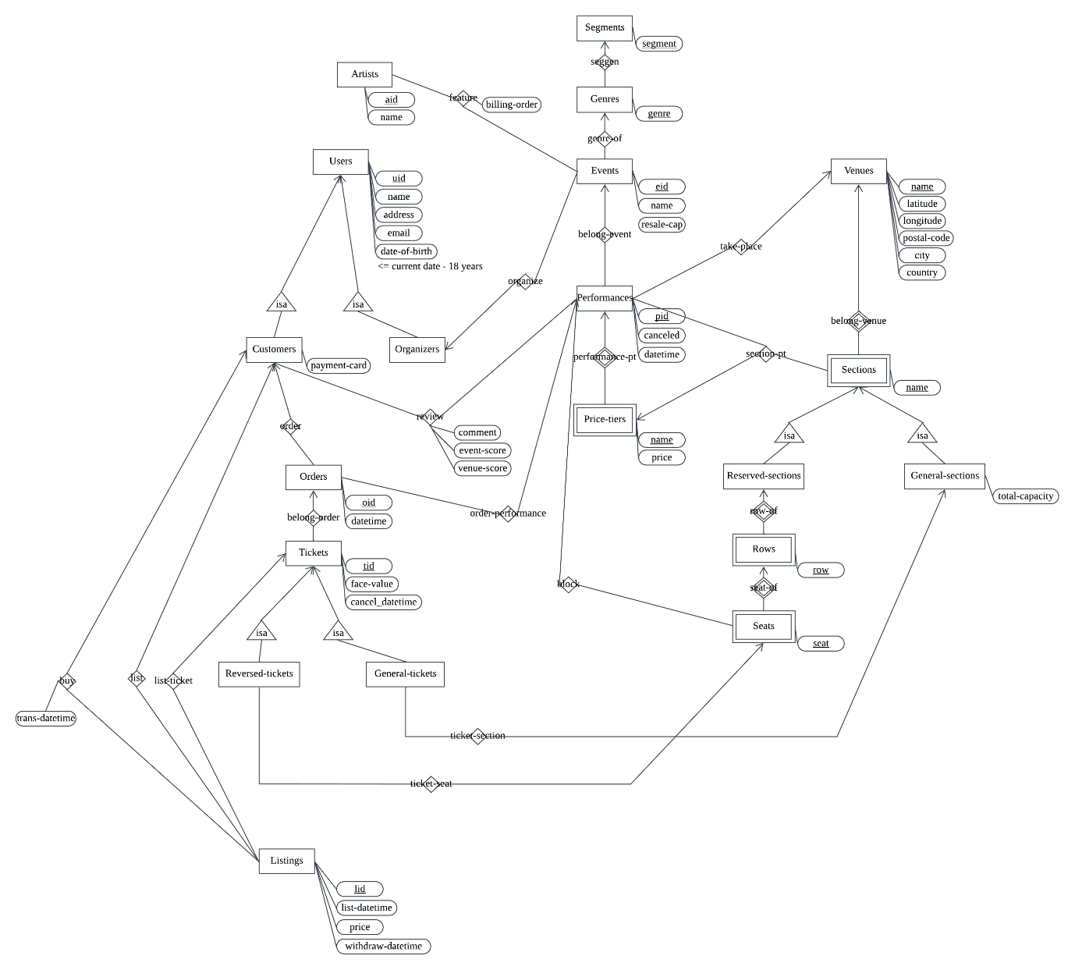
Restrictions that cannot be expressed in ER diagram:
1. The Customer can only review a Performance if they have an Order with a Ticket not canceled, and the datetime of the Performance has passed.
2. The Organizer can only block Seats in a Performance that are not in a Ticket that is not canceled.
3. A canceled Ticket cannot be resold. A resold Ticket cannot be canceled.
4. A Listing can only be one of the states:
 | sold | seller withdrawn | selling
withdrawn-datetime | NULL | √ | NULL
buyer-id | √ | NULL | NULL
trans-datetime | √ | NULL | NULL

Relation schema: (Note: All the “-” are actually “_”, but “_” confuses reader with underlining, so I write “-” instead.)
Artists (aid, name)
FDs: aid -> name
LHS aid is primary key, thus superkey, so Artists is in BCNF.
Users (uid, name, address, email, date-of-birth)
FDs: uid -> name, address, email, date-of-birth
LHS uid is primary key, thus superkey, so Users is in BCNF.
Customers (uid, payment-card)
FDs: uid -> payment-card
LHS uid is primary key, thus superkey, so Customers is in BCNF.
Organizers (uid)
FDs:
Orders (oid, uid, pid, datetime)
FDs: oid -> uid, pid, datetime
LHS oid is primary key, thus superkey, so Orders is in BCNF.
Tickets (tid, face-value, cancelled, oid)
FDs: tid -> face-value, canceled, oid
LHS tid is primary key, thus superkey, so Tickets is in BCNF.
Reserved-tickets (tid, seat, row, section-name, venue-name)
FDs: tid -> seat, row, section-name, venue-name
LHS tid is primary key, thus superkey, so Reserved-tickets is in BCNF.
General-tickets (tid, section-name, venue-name)
FDs: tid -> section-name, venue-name
LHS tid is primary key, thus superkey, so General-tickets is in BCNF.
Listings (lid, tid, seller-id, list-datetime, price, withdraw-datetime, buyer-id, trans-datetime)
FDs: lid -> tid, seller-id, list-datetime, price, withdraw-datetime, buyer-id, trans-datetime
LHS lid is primary key, thus superkey, so Listings is in BCNF.
Segments (segment)
FDs:
Genres (segment, genre)
FDs: genre -> segment
LHS genre is primary key, thus superkey, so Genres is in BCNF.
Events (eid, name, resale-cap, uid, genre)
FDs: eid -> name, resale-cap, uid, genre
LHS eid is primary key, thus superkey, so Events is in BCNF.
Performances (pid, cancelled, datetime, eid, venue-name)
FDs: pid -> canceled, datetime, eid, venue-name
LHS pid is primary key, thus superkey, so Performances is in BCNF.
Price-tiers (name, price, pid)
FDs: name, pid -> price
LHS (name, pid) is primary key, thus superkey, so Price-tiers is in BCNF.
Venues (name, latitude, longitude, postal-code, city, country)
FDs: name -> latitude, longitude, postal-code, city, country
LHS name is primary key, thus superkey, so Venues is in BCNF.
Sections (name, venue-name)
FDs:
Reserved-sections(name, venue-name)
FDs:
General-sections (name, venue-name, total-capacity)
FDs: name, venue-name -> total-capacity
LHS (name, venue-name) is primary key, thus superkey, so General-sections is in BCNF.
Rows (row, section-name, venue-name)
FDs:
Seats (seat, row, section-name, venue-name)
FDs:
Feature (aid, eid, billing-order)
FDs: aid, eid -> billing-order
LHS (aid, eid) is primary key, thus superkey, so Feature is in BCNF.
Review (uid, pid, comment, event-score, venue-score)
FDs: uid, pid -> comment, event-score, venue-score
LHS (uid, pid) is primary key, thus superkey, so Review is in BCNF.
Section-pricetier (section-name, pid, pricetier-name)
FDs: section-name, pid -> pricetier-name
LHS (section-name, pid) is primary key, thus superkey
so Section-pricetier is in BCNF.
Block (pid, seat, row, section-name)
FDs:

DDL statements:
CREATE TABLE Artists (
aid INT AUTO_INCREMENT PRIMARY KEY,
name VARCHAR(255) NOT NULL
);

CREATE TABLE Users (
uid INT AUTO_INCREMENT PRIMARY KEY,
name VARCHAR(255) NOT NULL,
address VARCHAR(255) NOT NULL,
email VARCHAR(255) NOT NULL,
date_of_birth DATE NOT NULL
);

CREATE TABLE Segments (
segment VARCHAR(255) PRIMARY KEY
);

CREATE TABLE Customers (
uid INT PRIMARY KEY,
payment_card VARCHAR(16) NOT NULL,
FOREIGN KEY (uid) REFERENCES Users(uid)
ON UPDATE CASCADE
);

CREATE TABLE Organizers (
uid INT PRIMARY KEY,
FOREIGN KEY (uid) REFERENCES Users(uid)
ON UPDATE CASCADE
);

CREATE TABLE Genres (
genre VARCHAR(255) PRIMARY KEY,
segment VARCHAR(255) NOT NULL,
FOREIGN KEY (segment) REFERENCES Segments(segment)
ON UPDATE CASCADE
);

CREATE TABLE Venues (
name VARCHAR(255) PRIMARY KEY,
latitude DECIMAL(9, 6) NOT NULL,
longitude DECIMAL(9, 6) NOT NULL,
postal_code VARCHAR(10) NOT NULL,
city VARCHAR(255) NOT NULL,
country VARCHAR(255) NOT NULL
);

CREATE TABLE Events (
eid INT AUTO_INCREMENT PRIMARY KEY,
name VARCHAR(255) NOT NULL,
resale_cap DECIMAL(5, 2) NOT NULL,
uid INT NOT NULL,
genre VARCHAR(255) NOT NULL,
FOREIGN KEY (uid) REFERENCES Organizers(uid)
ON UPDATE CASCADE,
FOREIGN KEY (genre) REFERENCES Genres(genre)
ON UPDATE CASCADE
);

CREATE TABLE Performances (
pid INT AUTO_INCREMENT PRIMARY KEY,
eid INT NOT NULL,
cancelled BOOLEAN NOT NULL DEFAULT FALSE,
datetime DATETIME NOT NULL,
venue_name VARCHAR(255) NOT NULL,
FOREIGN KEY (eid) REFERENCES Events(eid)
ON UPDATE CASCADE,
FOREIGN KEY (venue_name) REFERENCES Venues(name)
ON UPDATE CASCADE
);

CREATE TABLE Price_tiers (
name VARCHAR(255) NOT NULL,
pid INT NOT NULL,
price DECIMAL(10, 2) NOT NULL,
PRIMARY KEY (name, pid),
FOREIGN KEY (pid) REFERENCES Performances(pid)
ON UPDATE CASCADE
);

CREATE TABLE Sections (
name VARCHAR(255) NOT NULL,
venue_name VARCHAR(255) NOT NULL,
PRIMARY KEY (name, venue_name),
FOREIGN KEY (venue_name) REFERENCES Venues(name)
ON UPDATE CASCADE
);

CREATE TABLE Reserved_sections (
name VARCHAR(255) NOT NULL,
venue_name VARCHAR(255) NOT NULL,
PRIMARY KEY (name, venue_name),
FOREIGN KEY (name, venue_name) REFERENCES Sections(name, venue_name)
ON UPDATE CASCADE
);

CREATE TABLE General_sections (
name VARCHAR(255) NOT NULL,
venue_name VARCHAR(255) NOT NULL,
total_capacity INT NOT NULL,
PRIMARY KEY (name, venue_name),
FOREIGN KEY (name, venue_name) REFERENCES Sections(name, venue_name)
ON UPDATE CASCADE
);

CREATE TABLE Rows (
row INT NOT NULL,
section_name VARCHAR(255) NOT NULL,
venue_name VARCHAR(255) NOT NULL,
PRIMARY KEY (row, section_name, venue_name),
FOREIGN KEY (section_name, venue_name) REFERENCES Reserved_sections(name, venue_name)
ON UPDATE CASCADE
);

CREATE TABLE Seats (
seat INT NOT NULL,
row INT NOT NULL,
section_name VARCHAR(255) NOT NULL,
venue_name VARCHAR(255) NOT NULL,
PRIMARY KEY (seat, row, section_name, venue_name),
FOREIGN KEY (row, section_name, venue_name) REFERENCES Rows(row, section_name, venue_name)
ON UPDATE CASCADE
);

CREATE TABLE Orders (
oid INT PRIMARY KEY,
uid INT NOT NULL,
pid INT NOT NULL,
datetime DATETIME NOT NULL,
FOREIGN KEY (uid) REFERENCES Customers(uid)
ON UPDATE CASCADE,
FOREIGN KEY (pid) REFERENCES Performances(pid)
ON UPDATE CASCADE
);

CREATE TABLE Tickets (
tid INT AUTO_INCREMENT PRIMARY KEY,
face_value DECIMAL(10, 2) NOT NULL,
cancel_datetime DATETIME,
oid INT NOT NULL,
FOREIGN KEY (oid) REFERENCES Orders(oid)
ON UPDATE CASCADE
);

CREATE TABLE Reserved_tickets (
tid INT PRIMARY KEY,
seat INT NOT NULL,
row INT NOT NULL,
section_name VARCHAR(255) NOT NULL,
venue_name VARCHAR(255) NOT NULL,
FOREIGN KEY (tid) REFERENCES Tickets(tid)
ON UPDATE CASCADE,
FOREIGN KEY (seat, row, section_name, venue_name) REFERENCES Seats(seat, row, section_name, venue_name)
ON UPDATE CASCADE
);

CREATE TABLE General_tickets (
tid INT PRIMARY KEY,
section_name VARCHAR(255) NOT NULL,
venue_name VARCHAR(255) NOT NULL,
FOREIGN KEY (tid) REFERENCES Tickets(tid)
ON UPDATE CASCADE,
FOREIGN KEY (section_name, venue_name) REFERENCES General_sections(name, venue_name)
ON UPDATE CASCADE
);

CREATE TABLE Feature (
aid INT NOT NULL,
eid INT NOT NULL,
billing_order VARCHAR(255) NOT NULL,
PRIMARY KEY (aid, eid),
FOREIGN KEY (aid) REFERENCES Artists(aid)
ON UPDATE CASCADE,
FOREIGN KEY (eid) REFERENCES Events(eid)
ON UPDATE CASCADE
);

CREATE TABLE Review (
uid INT NOT NULL,
pid INT NOT NULL,
comment TEXT NOT NULL,
event_score INT NOT NULL,
venue_score INT NOT NULL,
PRIMARY KEY (uid, pid),
FOREIGN KEY (uid) REFERENCES Customers(uid)
ON UPDATE CASCADE,
FOREIGN KEY (pid) REFERENCES Performances(pid)
ON UPDATE CASCADE,
CHECK (event_score >= 1 AND event_score <= 5),
CHECK (venue_score >= 1 AND venue_score <= 5)
);

CREATE TABLE Section_pricetier (
section_name VARCHAR(255) NOT NULL,
pid INT NOT NULL,
pricetier_name VARCHAR(255) NOT NULL,
PRIMARY KEY (section_name, pid),
FOREIGN KEY (pricetier_name, pid) REFERENCES Price_tiers(name, pid)
ON UPDATE CASCADE
);

CREATE TABLE Block (
pid INT NOT NULL,
seat INT NOT NULL,
row INT NOT NULL,
section_name VARCHAR(255) NOT NULL,
PRIMARY KEY (pid, seat, row, section_name),
FOREIGN KEY (pid) REFERENCES Performances(pid)
ON UPDATE CASCADE
);

CREATE TABLE Listings (
lid INT AUTO_INCREMENT PRIMARY KEY,
tid INT NOT NULL,
seller_id INT NOT NULL,
list_datetime DATETIME NOT NULL,
price DECIMAL(10, 2) NOT NULL,
withdraw_datetime DATETIME,
buyer_id INT,
trans_datetime DATETIME,
FOREIGN KEY (tid) REFERENCES Tickets(tid)
ON UPDATE CASCADE,
FOREIGN KEY (seller_id) REFERENCES Customers(uid)
ON UPDATE CASCADE,
FOREIGN KEY (buyer_id) REFERENCES Customers(uid)
ON UPDATE CASCADE,
CHECK (
(buyer_id IS NOT NULL AND trans_datetime IS NOT NULL AND withdraw_datetime IS NULL)
OR (buyer_id IS NULL AND trans_datetime IS NULL)
)
);

