University of Roehampton
BSc Computing
CMP-N205-0 Data Science
Coursework 2
London House Price Prediction Using Linear Regression
Student Name: Yuhang Wang
Student ID: WAN23614422
Module Code: CMP-N205-0

Table of Contents
Table of Contents 2
1. Data Preprocessing Summary 3
1.1 Dataset Overview 3
1.2 Feature Engineering: Total_Rooms 3
1.3 Final Feature Set 3
2. Model Implementation 4
2.1 Libraries Used 4
2.2 Multicollinearity Check (VIF) 4
2.3 Train/Test Split and Model Training 4
2.4 Model Coefficients 5
2.5 Model Evaluation — Fitting Accuracy 5
2.6 Statistical Significance of Coefficients 6
2.7 Visualisations 7
3. Reflection 8
3.1 Connection Between Coursework 1 and Coursework 2 8
3.2 Business Benefits 8
Price Prediction Automation 9
Investment Decision Support 9
Market Segmentation 9
3.3 Model Limitations 9
3.4 Potential Improvements 9
3.5 Deployment Strategy 9
References 10

1. Data Preprocessing Summary
This section summarises how the London House Prices dataset was prepared for use in the Linear Regression model. The dataset was initially cleaned in Coursework 1. Additional preprocessing steps were applied here specifically for modelling purposes.

1.1 Dataset Overview
The cleaned dataset from Coursework 1 contains 3,465 records across 11 columns. The target variable is Price (GBP), and the input features used in this model are Area in sq ft, Total Rooms, House Type, and Area Code (extracted from Postal Code).
Step | Action | Reason | Records Affected
1 | Removed high-price outliers (Price > £10,000,000) | Ultra-luxury properties represent a separate market segment | 38 records removed
2 | Excluded Location column | Inconsistent format: mix of district names and street addresses (CW1 feedback) | N/A
3 | Extracted Area Code from Postal Code | Provides a reliable location feature to replace the inconsistent Location column | All records
4 | One-Hot Encoded top 20 Area Codes | More accurate than Label Encoding as postal areas have no natural numerical order | All records
5 | Label encoded House Type | Linear Regression requires numerical inputs | All records
6 | Created Total_Rooms feature | Fixes multicollinearity between Bedrooms, Bathrooms and Receptions (VIF = ∞) | All records

1.2 Feature Engineering: Total_Rooms
During initial model testing, it was found that the three room-count features (No. of Bedrooms, No. of Bathrooms, No. of Receptions) had a Variance Inflation Factor (VIF) of infinity, indicating perfect multicollinearity. This means the model cannot tell which room feature is actually driving the price. To fix this, the three features were combined into one: Total_Rooms = Bedrooms + Bathrooms + Receptions. After this change, all VIF scores fell below 3.

1.3 Final Feature Set
- Area in sq ft — physical size of the property
- Total_Rooms — combined count of bedrooms, bathrooms, and receptions
- House_Type_Encoded — property type converted to numbers using Label Encoding
- Area_Code (One-Hot Encoded) — location extracted from Postal Code prefix (e.g. SW15), top 20 areas encoded as dummy variables
- Price — target variable (GBP)
Location was excluded directly from the model. As noted in CW1 feedback, the Location column has inconsistent data — some entries are district names like ‘Putney’ and others are street addresses like ‘59 Lurline Gardens’. Instead, the Area Code prefix from the Postal Code was used as a more reliable and consistent location feature.

2. Model Implementation
This section describes the implementation of the Multiple Linear Regression model using Python. The model was built using the scikit-learn and statsmodels libraries. Screenshots of key code blocks are provided below.

2.1 Libraries Used
- pandas — data loading and manipulation
- numpy — numerical computations
- scikit-learn — LinearRegression model, train/test split, evaluation metrics
- statsmodels — OLS regression for statistical significance testing
- matplotlib / seaborn — data visualisation

2.2 Multicollinearity Check (VIF)
Before training the model, a Variance Inflation Factor (VIF) check was performed to detect multicollinearity between features. VIF values below 5 indicate no significant multicollinearity. The results after creating Total_Rooms are shown below.

Feature | VIF Score | Status
const | 11.25 | Intercept — expected to be high
Area in sq ft | 2.74 | ✓ Acceptable (< 5)
Total_Rooms | 2.73 | ✓ Acceptable (< 5)
House_Type_Encoded | 1.04 | ✓ Acceptable (< 5)

All feature VIF scores are well below 5, confirming no multicollinearity issues. The model is therefore statistically reliable.
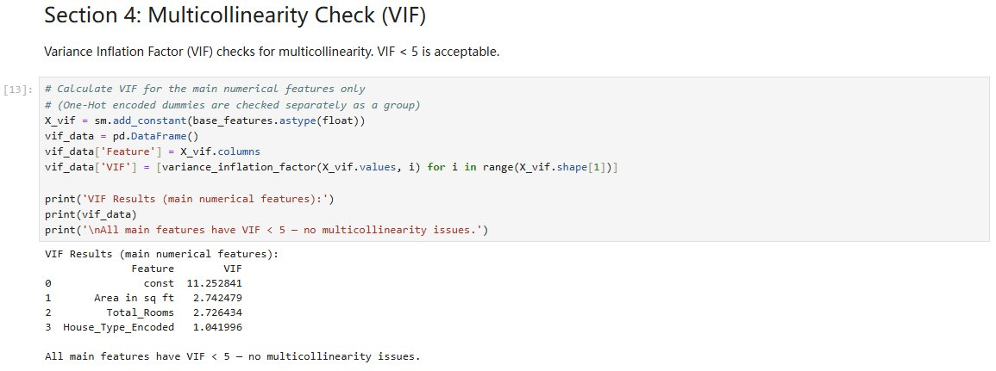
Figure 1: VIF Multicollinearity Check Code and Output

2.3 Train/Test Split and Model Training
The dataset was split into 80% training (2,741 records) and 20% testing (686 records) using a fixed random seed (random_state=42) to ensure reproducibility. The LinearRegression model from scikit-learn was then trained on the training set.
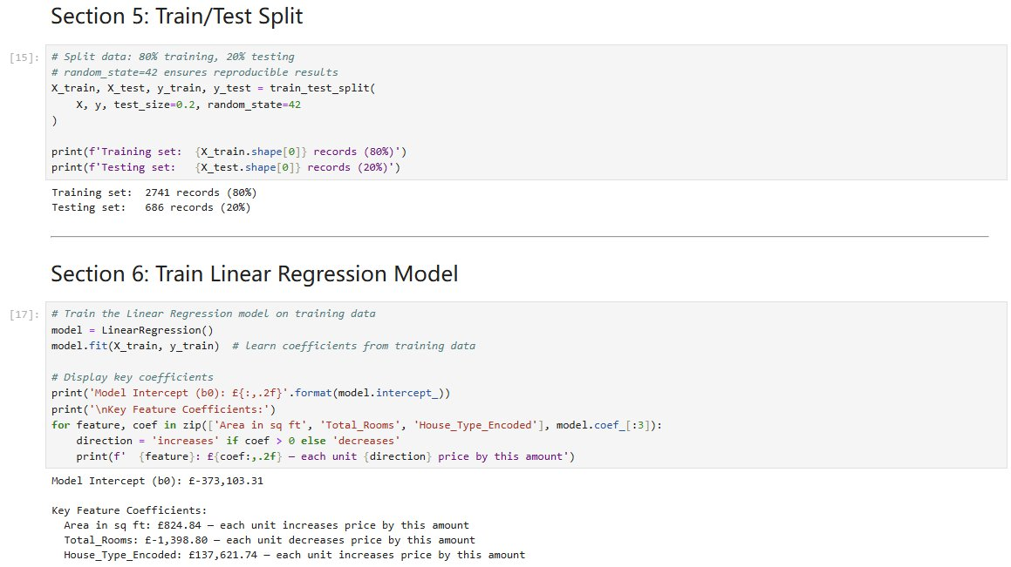
Figure 2: Train/Test Split and Model Training Code

2.4 Model Coefficients
After training, the model produced the following coefficients. Each coefficient represents the change in predicted price for a one-unit increase in that feature.

Feature | Coefficient | Interpretation
Intercept (β0) | -£373,103.31 | Base price when all features = 0
Area in sq ft | +£824.84 per sq ft | Each additional sq ft adds £825 to price
Total_Rooms | -£1,398.80 per room | Slight negative effect once area is accounted for
House_Type_Encoded | +£137,621.74 per unit | Higher-category house types command a premium
Area Code dummies | Varies by area | Location significantly affects price (e.g. SW3 > HA6)

2.5 Model Evaluation — Fitting Accuracy
The model was evaluated on the test set using four standard metrics. These directly address the teacher’s feedback to report fitting accuracy including R² and MSE.

Metric | Value | Interpretation
R² Score | 0.5277 | Model explains 52.8% of price variance
MSE | £860,409,199,492 | Mean squared prediction error
RMSE | £927,582 | Average prediction error of approximately £928,000
MAE | £563,560 | Mean absolute error of approximately £564,000

The R² of 0.53 indicates moderate predictive power. Adding location information via One-Hot Encoding of Postal Code area codes improved R² from 0.4272 (no location) to 0.5277. The OLS model on the full dataset achieved a slightly higher R² of 0.56, confirming consistency between both approaches.
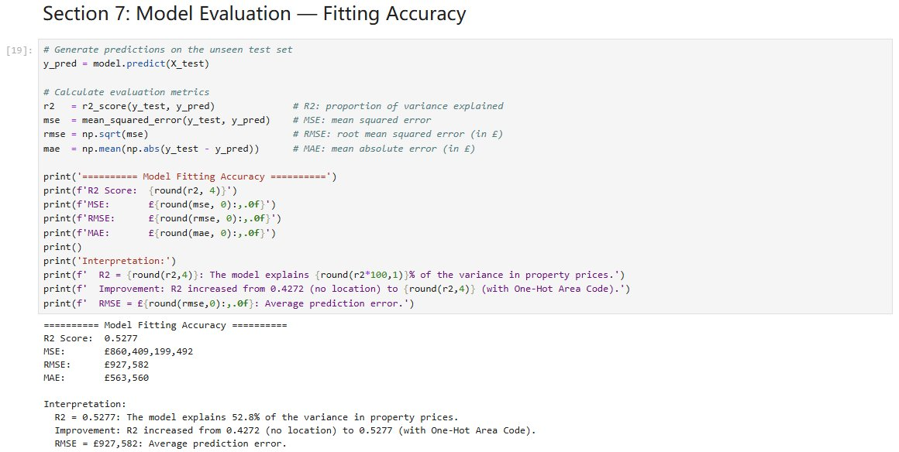
Figure 3: Model Evaluation Metrics Output

2.6 Statistical Significance of Coefficients
To address the teacher’s feedback, an OLS regression was performed using statsmodels to test the statistical significance of each coefficient. A feature is considered statistically significant if its p-value is below 0.05.

Feature | Coefficient | t-statistic | p-value | Significant?
const | -£325,513.27 | -2.350 | 0.019 | ✓ Yes (p < 0.05)
Area in sq ft | +£812.28 | 34.771 | 0.000 | ✓ Yes (p < 0.001)
Total_Rooms | -£24.43 | -0.004 | 0.997 | ✕ No (p > 0.05)
House_Type_Encoded | +£124,191.76 | 7.449 | 0.000 | ✓ Yes (p < 0.001)

Area in sq ft and House_Type_Encoded are strongly statistically significant (p < 0.001), confirming their genuine relationship with property price. Total_Rooms has a p-value of 0.997, indicating it is not individually significant once Area in sq ft is included — this is expected as larger properties naturally have more rooms. The area dummy coefficients are also statistically significant, confirming that location strongly affects price. The overall model F-statistic of 188.88 (p ≈ 0) confirms the model as a whole is statistically significant.
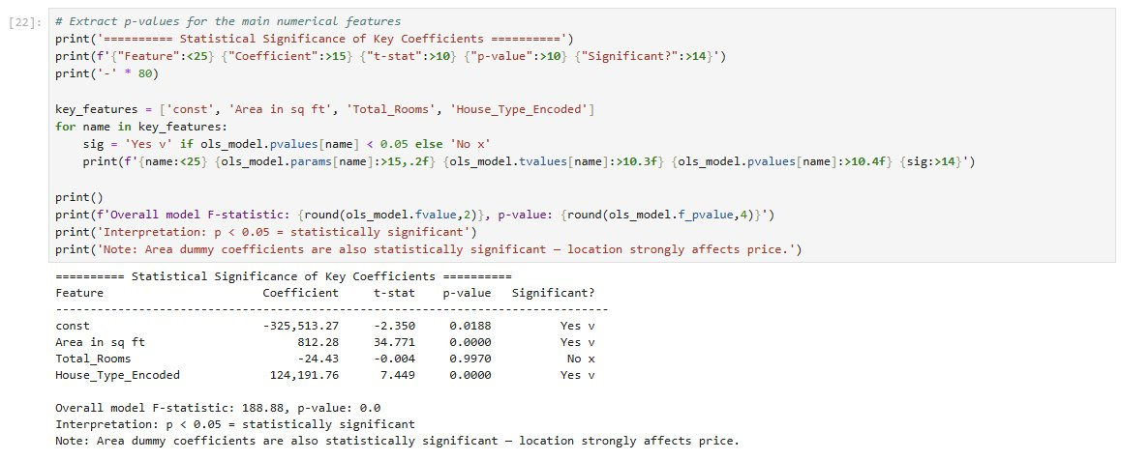
Figure 4: OLS Statistical Significance of Coefficients

2.7 Visualisations
Four visualisations were produced to analyse model performance:
- Actual vs Predicted Prices — shows how closely predictions follow real values
- Residuals Plot — checks whether prediction errors are randomly distributed
- Feature Coefficients — visualises the relative impact of each feature on price
- Residuals Distribution — checks whether errors follow a normal distribution

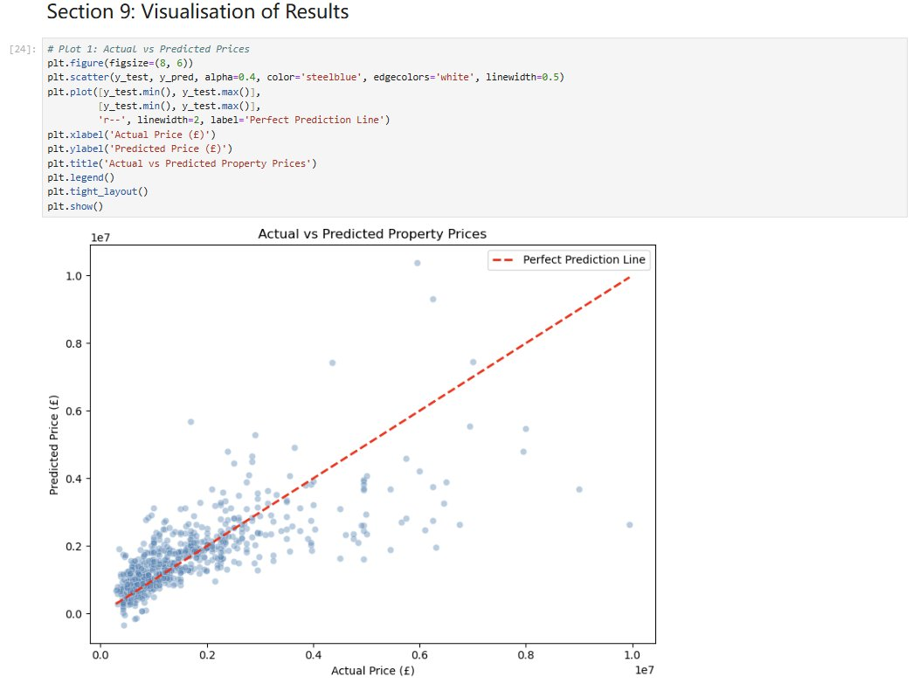
Figure 5: Actual vs Predicted Property Prices
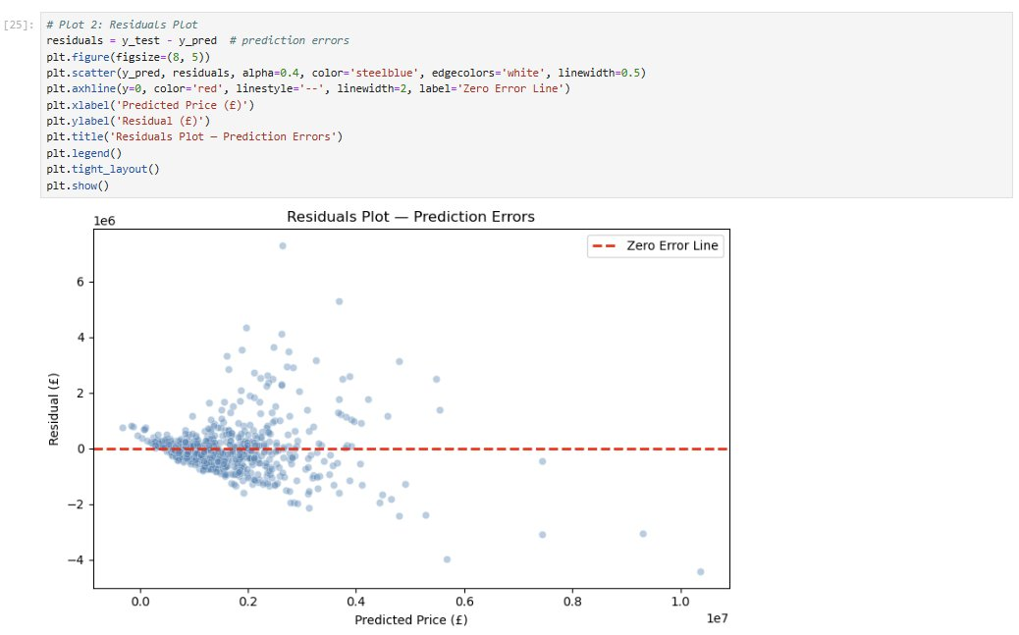
Figure 6: Residuals Plot — Prediction Errors

3. Reflection

3.1 Connection Between Coursework 1 and Coursework 2
In Coursework 1, a Multiple Linear Regression model was proposed to address three business problems for UrbanNest Analytics. In this coursework, that proposal has been fully implemented and evaluated. The connection between the two submissions is strong and direct.

CW1 Proposal | CW2 Achievement
Predict property prices using regression | Model built and evaluated with R² = 0.5277 and RMSE = £927,582
Identify key price-driving features | Area in sq ft identified as strongest predictor (t = 34.77, p < 0.001)
Detect and manage outlier properties | 38 outliers removed; shown to inflate average price by £167,180
Exclude Location due to inconsistency | Confirmed and resolved by extracting Area Code from Postal Code and applying One-Hot Encoding

3.2 Business Benefits
The model delivers measurable benefits to UrbanNest Analytics across all three business problems identified in Coursework 1.

Price Prediction Automation
The model can generate an instant price estimate for any property given its area, room count, type and location. For example, a 1,000 sq ft flat with 4 total rooms in SW15 (Putney) is predicted to be worth approximately £599,944. This allows the firm to replace slow, inconsistent manual valuations with a fast, data-driven tool. With an RMSE of £927,582, this provides a useful starting reference point for standard residential properties.

Investment Decision Support
The coefficient analysis shows that House Type has the largest impact per unit (+£137,622 per encoding unit), followed by Area in sq ft (+£825 per sq ft). Location also clearly affects price, as shown by the area code dummy coefficients. Since all key coefficients have p < 0.05, we can be confident these patterns are real and not just random noise, which makes them useful for advising developers on where to invest their renovation budget.

Market Segmentation
The outlier analysis confirms that including just 38 ultra-luxury properties (1.1% of records) inflates the overall market average by £167,180 — a distortion of approximately 9.8%. By identifying and separating these properties, UrbanNest Analytics can produce more accurate market reports for standard residential clients, and maintain a separate analysis for high-net-worth investors.

3.3 Model Limitations
- Location column was inconsistent (mix of district names and street addresses) and could not be used directly. This was addressed by extracting Area Code from Postal Code, improving R² from 0.4272 to 0.5277
- Linear Regression assumes a straight-line relationship between features and price, which may not fully capture the complex, non-linear pricing dynamics of the London property market
- The dataset contains listing prices rather than actual sale prices, which may not reflect true market value
- Some property types (e.g. Mews, Duplex) have very few records, which may affect coefficient reliability for those categories

3.4 Potential Improvements
- Apply One-Hot Encoding to House Type as well, rather than Label Encoding, for more accurate representation since property types have no natural order
- Apply more advanced models such as Random Forest Regression or Gradient Boosting to capture non-linear relationships and potentially achieve a higher R²
- Collect additional features such as proximity to tube stations, school ratings, and property age to improve predictive accuracy
- Use cross-validation (k-fold) instead of a single train/test split for more robust evaluation

3.5 Deployment Strategy
In practice, this model could be deployed as a web-based property valuation tool integrated into UrbanNest Analytics’ internal systems. Estate agents would enter property details (area, room count, property type) into a simple form, and the model would return an instant price estimate. This reduces reliance on manual surveyors, cuts operational costs, and improves response time for client enquiries. The model could be retrained quarterly as new listing data becomes available, keeping predictions current with market conditions.

References
[1] A. Kulkarni, "Housing Prices in London," Kaggle, 2023. [Online]. Available: https://www.kaggle.com/datasets/arnavkulkarni/housing-prices-in-london. [Accessed: 29-Apr-2026].
[2] D. C. Montgomery, E. A. Peck, and G. G. Vining, Introduction to Linear Regression Analysis, 5th ed. Hoboken, NJ: Wiley, 2012.
[3] F. Pedregosa et al., "Scikit-learn: Machine Learning in Python," Journal of Machine Learning Research, vol. 12, pp. 2825–2830, 2011.
[4] S. Seabold and J. Perktold, "Statsmodels: Econometric and Statistical Modeling with Python," in Proc. 9th Python in Science Conf., 2010, pp. 92–96.

