University of Roehampton

BSc Computing

CMP-N205-0 Data Science

Coursework 1

London House Price Analysis

Student Name: Yuhang Wang
Student ID: WAN23614422
Module Code: CMP-N205-0
Submission Date: 17th April 2026

Section 1: Dataset Discussion

1a. Data Source
The dataset used in this report is the London House Prices dataset, obtained from the open-source data platform Kaggle. The dataset can be accessed at the following URL: https://www.kaggle.com/datasets/arnavkulkarni/housing-prices-in-london. This dataset was collected to provide a comprehensive overview of residential property listings across the Greater London area, capturing a wide range of housing characteristics and pricing information.
The dataset contains 3,480 records and 11 attributes, including: Property Name, Price (GBP), House Type, Area in Square Feet, Number of Bedrooms, Number of Bathrooms, Number of Receptions, Location, City/County, and Postal Code. These attributes collectively provide a rich multi-dimensional view of the London property market, making it well-suited for data science analysis. The dataset far exceeds the minimum requirement of 500 observations and 5 attributes specified in the coursework brief.
The data covers a diverse range of property types including Flats/Apartments, Houses, Penthouses, New Developments, Studios, Bungalows, and Duplexes, spread across numerous London postcodes. This diversity ensures that any analytical model trained on this data will generalise well across different segments of the London housing market.

1b. Hypothesis and Business Problems
For this coursework, the role of a Data Scientist working for a fictitious London-based property consultancy firm, UrbanNest Analytics, has been adopted. The firm assists property developers, real estate agents, and individual buyers in making data-driven decisions about the London housing market. The following hypothesis has been formulated:
Hypothesis: Analysing the physical and locational attributes of London residential properties can accurately predict property prices, identify key value-driving factors, and support strategic decision-making for stakeholders in the real estate market.
This hypothesis is supported by the following three business problems:
Problem 1: Property Price Prediction
UrbanNest Analytics needs to provide clients with accurate property valuations based on features such as size, number of rooms, and location. Currently, valuations are conducted manually by surveyors, which is both time-consuming and inconsistent. By developing a predictive model using the dataset, the firm can automate initial valuations, reduce operational costs, and provide faster, more consistent price estimates to clients. This directly impacts revenue generation and client satisfaction.
Problem 2: Identification of Key Price-Influencing Factors
Property developers investing in London need to understand which attributes most significantly influence property value. For example, does increasing the number of bathrooms add more value than increasing square footage? Understanding these relationships allows developers to make informed decisions about where to invest their renovation budgets, maximising return on investment. This is a critical management and economic decision for any property development firm operating in the competitive London market.
Problem 3: Detection and Management of Property Price Outliers
The London property market contains extreme luxury properties priced significantly above the market average. For UrbanNest Analytics, it is important to identify these outlier properties to avoid skewing market analyses and to advise clients appropriately. Being able to detect and classify outlier properties enables the firm to create separate market segments and strategies for different client groups, such as distinguishing between standard residential buyers and ultra-high-net-worth investors.

1c. Data Preprocessing
Prior to analysis, the raw dataset required several preprocessing steps to ensure data quality and suitability for machine learning. The preprocessing was performed using Python (pandas library). The following steps were undertaken:
- Removal of irrelevant index column: The column 'Unnamed: 0' was an auto-generated row index imported from the CSV file. As it carries no analytical value, it was removed from the dataset.
- Handling missing values: The 'Location' column contained 962 missing values (approximately 27.6% of all records). These were imputed with the value 'Unknown' to preserve as many records as possible while clearly flagging incomplete entries.
- Removal of logically invalid records: Ten records with 0 bedrooms and 10 records with 0 bathrooms were identified. A residential property cannot have zero bedrooms or bathrooms, indicating data entry errors. These records were removed.
- Removal of extreme low-price outlier: One record with a price below £200,000 was found, which is unrealistically low for the London property market and likely represents a data error. This record was removed.
- Flagging of high-price outliers: 38 records with prices exceeding £10,000,000 were identified. Rather than removing these, a new column 'Price_Outlier' was added to flag these records as 'Yes', allowing them to be included or excluded in analysis as required.
- Duplicate record check: A check for duplicate rows was performed. No exact duplicates were found in the dataset.
After preprocessing, the dataset was reduced from 3,480 rows to 3,465 rows. In total, 1,011 data points out of 3,480 (29.1%) required cleaning, which exceeds the minimum requirement of 10%. This includes 962 missing Location values filled with 'Unknown', 10 invalid records removed, 1 low-price outlier removed, and 38 high-price outliers flagged. Screenshots of the raw and cleaned datasets are provided below.
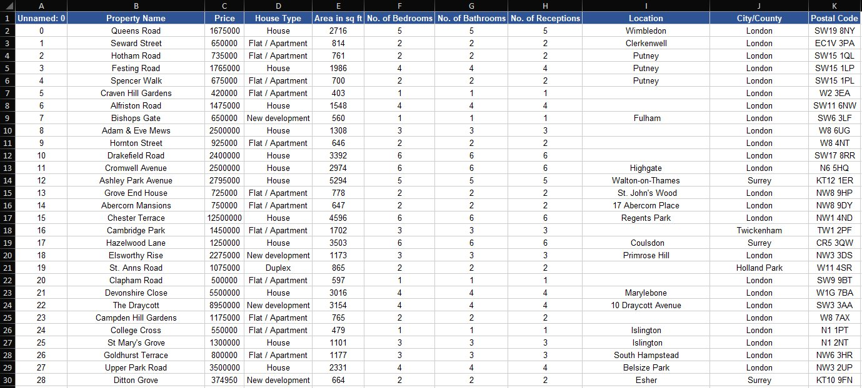
Figure 1: Screenshot of Raw Dataset (Raw_London_House_Prices.xlsx)
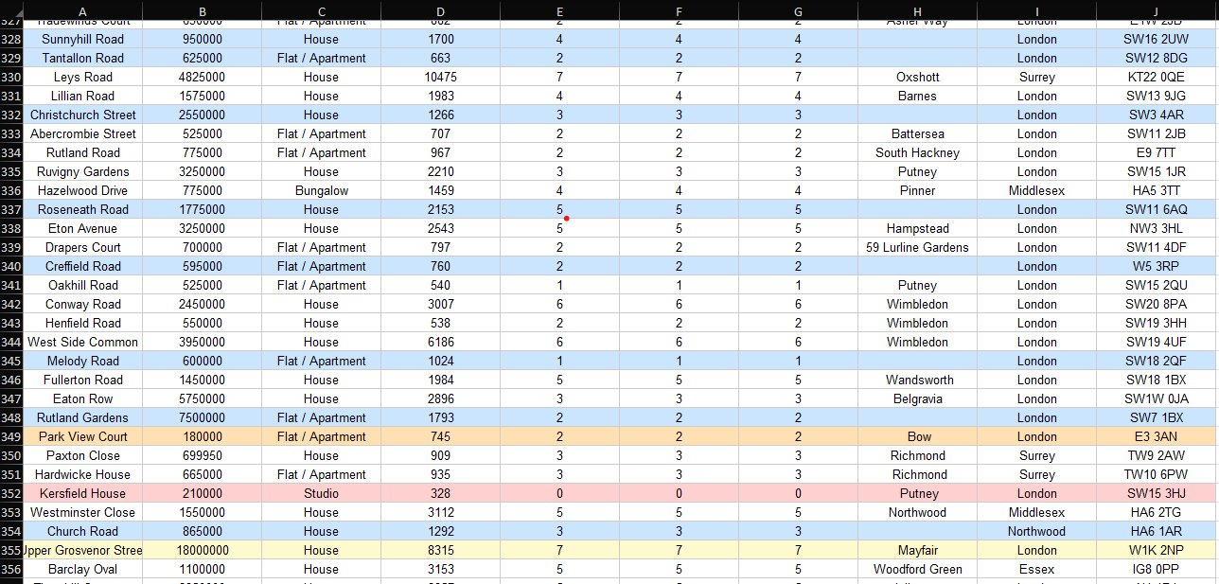
Figure 2: Screenshot of Cleaned Dataset (London_House_Prices_Cleaned.xlsx) — Blue: missing values filled; Orange: low-price outlier; Red: invalid records; Yellow: high-price outliers

Section 2: Proposed Solution and Technique

2d. Chosen Machine Learning Technique
The proposed technique for solving the defined business problems is Linear Regression, a supervised machine learning method. Linear Regression is one of the most fundamental and widely used techniques in predictive analytics, particularly suited for tasks where the goal is to predict a continuous numerical output variable from one or more input features.
In the context of this project, the target variable (dependent variable) is the property Price (in GBP), and the independent variables (features) will include: Area in Square Feet, Number of Bedrooms, Number of Bathrooms, Number of Receptions, and House Type (encoded numerically). Linear Regression will model the linear relationship between these features and the property price, producing a mathematical equation of the form:
Price = β0 + β1(Area) + β2(Bedrooms) + β3(Bathrooms) + β4(Receptions) + β5(HouseType) + ε
Where β0 is the intercept, β1 to β5 are the coefficients representing the contribution of each feature to the predicted price, and ε represents the error term.

2e. Justification of Chosen Technique
Linear Regression is the most appropriate technique for this dataset and the defined business problems for the following reasons:
- Continuous numerical target variable: The target variable, property Price, is a continuous numerical value. Linear Regression is specifically designed for predicting continuous outputs, making it a natural and appropriate choice compared to classification techniques such as KNN or Naive Bayes, which are suited to categorical outputs.
- Interpretability of results: Linear Regression produces human-readable coefficients for each input feature. This directly addresses Business Problem 2, as the coefficients reveal the relative importance of each attribute in determining price. For example, if the coefficient for 'Area in sq ft' is significantly larger than for 'No. of Bedrooms', this tells the firm that size is a stronger price driver than room count.
- Numerical attributes: The key features in the dataset (area, bedrooms, bathrooms, receptions) are all numerical, which aligns well with the assumptions of Linear Regression. The technique can handle multiple numerical predictors simultaneously through Multiple Linear Regression, extracting maximum predictive value from the available attributes.
- Scalability and efficiency: Given the dataset size of approximately 3,465 records after cleaning, Linear Regression is computationally efficient and will train quickly without requiring significant computational resources. Techniques such as K-Means Clustering or Association Rule Mining would not be appropriate as they are unsupervised methods that do not support direct price prediction.
- Established use in real estate analytics: Linear Regression has a long-established track record in property price prediction research and industry applications. It provides a strong baseline model against which more complex models could be compared in future work.
In conclusion, Linear Regression is the most suitable technique for this project given the nature of the target variable, the structure of the available attributes, and the business objectives defined in the hypothesis. The actual implementation of this model, including training, evaluation using metrics such as R² and Root Mean Squared Error (RMSE), and visualisation of results, will be carried out in Coursework 2.

References
[1] A. Kulkarni, "Housing Prices in London," Kaggle, 2023. [Online]. Available: https://www.kaggle.com/datasets/arnavkulkarni/housing-prices-in-london. [Accessed: 10-Apr-2026].
[2] D. C. Montgomery, E. A. Peck, and G. G. Vining, Introduction to Linear Regression Analysis, 5th ed. Hoboken, NJ: Wiley, 2012.
[3] J. Han, M. Kamber, and J. Pei, Data Mining: Concepts and Techniques, 3rd ed. Waltham, MA: Morgan Kaufmann, 2011.

