CS 590 Cortical thickness challenge

Full names: Yuhao Zhang

Students id: 002313313

1. Abstract

The goal of this experiment is to develop an algorithm to estimate cortical thickness map from a raw T1-weighted image. In this experiment I will combine diffeomorphic registration based cortical thickness (DiReCT) measure with Advanced Normalization Tools (ANTS) and DL+DiReCT, a tool combines a deep learning-based neuroanatomy segmentation and cortex parcellation with a diffeomorphic registration technique to measure cortical thickness from T1w MRI.

1. Enviroment

System: Linux 4.4.0 Ubuntu 20.04.4 LTS

package used: DL+DiReCT, HD-BET, ANTsPy, nilearn

Usage

Run dl+direct on a T1-weighted MRI including skull-stripping (--bet) using HD-BET with:

source activate DL_DiReCT

dl+direct --subject <your_subj_id> --bet <path_to_t1_input.nii.gz> <output_dir>

1. Document each step.

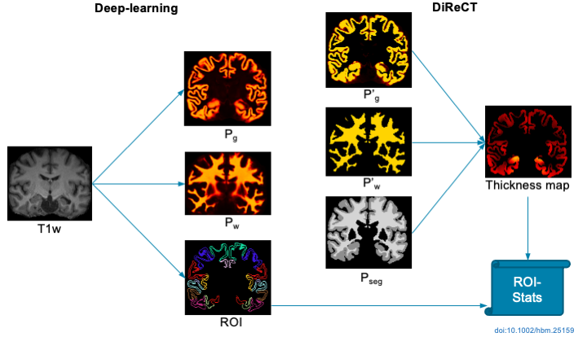

Figure Deep learning-based neuroanatomy segmentation followed by a diffeomorphic registration to estimate cortical thickness from MRI [3]

Figure 1 illustrates the procedure for obtaining the thickness map based on the study article. DiReCT is used after deep learning-based segmentation of the anatomy, which includes parcellation of the cortex, to get measurements of cortical thickness directly from T1-weighted (T1w) MRI.

Step 1. Segment the gray and white matter

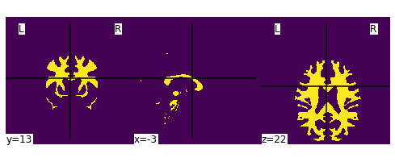

Figure white matter

To demonstrate the process, I use compute_brain_mask function from nilearn to extract the mask of white matter.

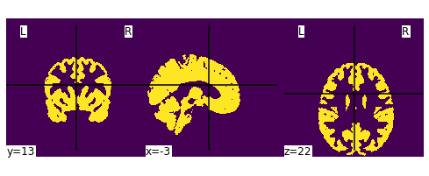

Figure gray matter

To demonstrate the process, I use compute_brain_mask function from nilearn to extract the mask of gray matter.

Step 2. find the cortical thickness at each point in the gray matter

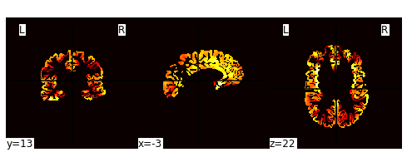

Figure cortical thickness map

Dl+direct use ants.kelly_kapowski (s, g, w, its=50, r=0.025, m=1.5, **kwargs) function to compute cortical thickness using the DiReCT algorithm, Diffeomorphic registration-based cortical thickness based on probabilistic segmentation of an image.

Step 3. Label all gray matter voxels with the cortical thickness value at that point

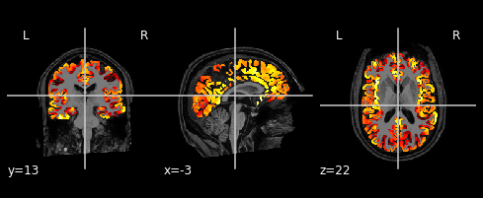

Figure thickness map overlay for object T2

1. Conclusion

In this experiment I study the previous research about cortical thickness and how researchers using principled approach to find correspondence between WM and GM surfaces using shape-constrained Diffeomorphic mapping. Due to limitations of this study of brain study and working on MRI image, this experiment is based on tools created by previous researchers. In the future study, I would like to expand the current work to increase the efficiency and accuracy base on the current algorithm.

REFERENCES

[1] Das, Sandhitsu R., et al. "Registration based cortical thickness measurement." *Neuroimage* 45.3 (2009): 867-879.

[2] Avants, Brian B., Nick Tustison, and Gang Song. "Advanced normalization tools (ANTS)." *Insight j* 2.365 (2009): 1-35.

[3] Rebsamen, M, Rummel, C, Reyes, M, Wiest, R, McKinley, R.

Direct cortical thickness estimation using deep learning‐based anatomy segmentation and cortex parcellation.

Human brain mapping. 2020; 41: 4804-4814. https://doi.org/10.1002/hbm.25159

[4] Sharaff, Aakanksha, and Harshil Gupta. "Extra-tree classifier with metaheuristics approach for email classification." *Advances in computer communication and computational sciences*. Springer, Singapore, 2019. 189-197.