Yuriko Hashimoto

990853225

Penn State MGIS Capstone

GEOG 596B

**Evaluating environmental predictors of breeding waterfowl population distribution and abundance in the Central Interior of British Columbia (2007-2017)**

ABSTRACT

Conservation biology has seen an explosion of species distribution models (SDMs) in the recent published literature and growing numbers of governments and organizations responsible for small-scale regional to global conservation activities are actively utilizing them or have embarked on their own predictive studies (Franklin and Miller 2009; Guisan, Wilfried, and Zimmermann 2017). Waterfowl conservation planning in British Columbia (BC) however currently does not have the benefit of breeding waterfowl SDMs. To address this gap I have developed methods to generate SDMs using 11 years of survey data from BC’s annual Breeding Waterfowl Survey between 2007 and 2017. Models utilizing a random forest-based approach were used to produce predictive maps for ten species and five species groups within the boundaries of the central interior representing core provincial breeding waterfowl habitat. The models can be used as a template for future studies and act as guides in conservation planning.

Keywords: waterfowl, machine learning, random forest, species distribution model.

INTRODUCTION

While the uses and practical applications of species distribution models in conservation decision-making are diverse (Guillera-Arroita et al. 2015; Guisan et al. 2013; Guisan and Thuiller 2005) the overarching aim is to conserve biodiversity and support better land use planning and environmentally sustainable management practices. The breadth of practical applications include predicting climate change adaptation, invasive species management, critical habitat identification, reserve selection, impact assessment and ecological restoration (Elith and Graham 2009; Franklin and Miller 2009).

Recognizing the lack of waterfowl species distribution models (SDMs) to support conservation actions in response to the urgency of conservation challenges in Canada’s boreal forests, Barker et al (2014) published the first national-scale waterfowl SDMs in 2014 based on the traditional Waterfowl Breeding Population and Habitat Survey (WBPHS) database. The WBPHS has been described as “arguably the largest and best-designed population survey in the world” (Murray, Anderson, and Steury 2010), continental in scale and running on a continuous annual basis since 1955, the survey captures what is recognized to be “core waterfowl breeding habitat” in North America. Designed primarily to provide annual breeding population estimates and inform hunting regulations in the U.S. and Canada, these data additionally provide a long-term population monitoring dataset that has since informed countless studies on species-habitat relationships in support of waterfowl conservation. While the models performed well over all, the results of extrapolation to out-of-sample areas were variable for a number of reasons as outlined by the authors. British Columbia (BC) is not within the traditional survey and no survey data from BC informed the models which predicted low total densities for the Western Cordillera between the Pacific coast and Rocky Mountains—a result that conflicts with anecdotal expert opinion (A. Breault, personal communication 2018). As such there are currently no adopted waterfowl breeding population distribution models in use for the province. This study aims to fill the this gap and help support the mandate of the Canadian Wildlife Service (CWS) to conserve biodiversity (Environment and Climate Change Canada 2019; Environment Canada - Biodiversity Convention Office 1995).In the early 2000s after exploratory pilot surveys in BC’s central and sub-boreal highlands determined waterfowl population abundances to be significant enough to justify a regional breeding survey program, the British Columbia Breeding Waterfowl Survey began in earnest in 2006. BC’s May surveys, run jointly by the CWS and the U.S. Fish and Wildlife Service and conducted in partnership with Ducks Unlimited Canada, inform the annual population status of migratory game birds in the Central Interior Plateau of BC and contributes to adaptive harvest strategies for mallards in the Pacific Flyway (Zimpfer, Breault, and Sanders 2019).

I developed methods to create SDMs for the top ten most abundant species as well as five groups based on nesting and feeding guilds (Baldassarre 2014) (Tables 1 and 2). Guisan et al (2013) have observed that despite the oft-cited assumption of the utility of SDMs in conservation decision-making there is little evidence demonstrating their application in real-world conservation management. Following their recommendation that modellers make explicit the objectives of the framework within which models were developed, I provide guidance on how the models may be improved and implemented as a decision-making platform for conservation planning by the Canadian Wildlife Service and partners in conservation.

MATERIALS AND METHODS

Survey Methods

The study area was designed to capture BC’s prime waterfowl breeding habitat of the humid, continental plateaus of the central and sub-boreal Interior between the Coast mountains to the west and Rocky Mountains to the east. The region of interlocking highlands and valleys are mainly forested and sparsely populated. The main industries include forestry, cereal crop agriculture within lowland valleys, ranching and mining (Demarchi 2011).

The survey design consists of latitudinal strip transects 400 metres wide, spaced ten miles apart (16.09 km) and delineated by the boundaries of eight ecosections which represent the finest scale, sub-regional stratum within the Ecoregion Classification System of British Columbia—a small-scale ecosystem management framework stratifying nested regions of “similar climate, physiography, oceanography, hydrology, vegetation and wildlife potential” (Demarchi 2011) (Figure 1). The classification levels ordered from high to low include Ecodomains for global mapping applications, ecodivisions for national-scale, ecoprovinces for provincial scale, ecoregions for regional and ecosections for sub-regional planning. While designed for small-scale mapping ecosection boundaries are drawn at large scale (1:20,000).

The southern two-thirds of the study area falls within the Fraser Plateau Ecoregion. The flat and rolling hills of the region contain numerous meandering streams and low-lying depressions that create an abundance of wetland habitat (Demarchi 2011) while the Central Interior Ecoprovince in which it nests supports 65% of all species known to occur and 61% of all bird species known to breed in BC. with the greatest total abundances of waterfowl occurring in the Cariboo Basin ecosection within the Riske Creek area (Demarchi 2011; Savard, Sean Boyd, and John Smith 1994). The remaining northernmost third of the study area stretches into the Sub-boreal Interior Ecoprovince which supports 57% of all bird species known to occur and 45% known to breed in the province (Demarchi 2011). Table # provides general descriptions of study area ecosections.

The surveys are conducted by helicopter and surveyed by a consistent survey crew of two to three experienced observers (Zimpfer, Breault, and Sanders 2019). The transects when originally conceived were designed within the NAD 1983 geographic coordinate system and were based on the mapped Ecoregion Classification System version 2.0 circa 1995. The annual surveys continue to follow the extent of the original design however the ecosection boundaries have since been updated with finer scale vegetation zonation data in version 2.1 (2006). All analyses were based on the areal overlap between the two versions with the boundaries redefined and updated to version 2.1 .

|  |
| --- |
| image  **Figure 1**. The survey area divided into the ecosections of the Ecoregions of British Columbia Classification system (Demarchi, 2011). Latitudinal strip transects (horizontal lines) are spaced ten miles (~16 km) apart within the Central and Sub-boreal plateaus of BC. |

**Table 1.** General descriptions of ecosections within study area.

|  |  |  |  |  |  |  |
| --- | --- | --- | --- | --- | --- | --- |
| Ecoregion | Ecosection | | Topography | Climate | Vegetation | Development |
| Fraser Basin | |  | | --- | |  | | Babine Upland | Rolling upland with low ridges; many small streams and lakes and several large lakes | Sub-continental--extreme winter cold and snow events, humid and rainy | Sub-boreal spruce dominated forests | No communities but summer homes and fishing lodges occur; many protected areas |
| Fraser Plateau | |  | | --- | |  | | Bulkley Basin | Broad, lowland valleys with many lakes | Rainshadow effect of Coast mountains | Dominated by lodgepole pine; trembling aspen in lower south-facing valleys | Extensive development and agriculture within Yellowhead corridor between Vanderhoof and Williams Lake and surrounding Francois Lake; protected areas include Francois lake Park |
| Fraser Plateau | |  | | --- | |  | | Cariboo Basin | Rolling uplands; many streams, wetlands and lakes | Warmest temperatures within ecoregion; relatively high summer precipitation | Vegetation zonation changes | Small farms, ranches and logging are main industries. Williams Lake is largest city |
| Fraser Plateau | |  | | --- | |  | | Chilcotin Plateau | Rolling uplands with many small lakes and wetlands; higher relief in south and northwest abutting Chilcotin Ranges and west Chilcotin; many small streams and rivers | Pronounced rain shadow effect | Douglas fir near rivers and lodgepole pine at higher elevations | Ranching and logging are main industries; Big Creek Park is largest park |
| Fraser Plateau | |  | | --- | |  | | Nazko Upland | Rolling uplands with high relief within north-central region; slow moving streams and wetlands | Sub-continental climate--cold winters, warm summers, maximum precipitation in late spring/early summer; subject to cold balasts of Arctic air | Lodgepole pine in south and white spruce/lodgepole pine/subalpine fir in north | Ranching and First Nations reserves but no large communities |
| Fraser Basin | |  | | --- | |  | | Nechako Lowland | Flat or gently rolling lowlands | Sub-boreal climate-humid summers and harsh winters | Sub-boreal spruce forests and lodgepole pine | Largest city is Prince George; cereal crop farming and ranching in southern lowlying areas |
| Fraser Plateau | |  | | --- | |  | | Quesnel Lowland | Lowland trench bissected by the Fraser River; small lakes and wetlands but no large lakes | Subject to cold Arctic air; increased precipitation as air moves east over Columbia Mountains and in summer due to upland wetlands | Douglas-fir on dry south-facing slopes and trembling aspen, lodegpole pine, white spruce to subalpine fir with increasing elevation | Quesnel is the largest and only city but many communities; farming ranching and forestry (with extensive logging) |
| Fraser Plateau | |  | | --- | |  | | Western Chilcotin Upland | Rounded uplanded with a large lowland area containing many lakes | Sub-continental climate subject to blasts of Arctic winter air | Mainly lodgepole pine and white spruce in higher elevations | Anahim Lake is largest community |

The survey does not follow the design methodology of the traditional WBPHS, however the survey techniques are consistent with the methods outlined in Smith (1995) and the Standard Operating Procedures (US Fish and Wildlife Service (USFWS) and Canadian Wildlife Service (CWS) 1987). Prior to 2010, the survey technologies employed consisted of paper maps, field notes and GPS units with navigation determined by piloting along bearings to GPS waypoints. In 2010, the mobile GIS software PC-Mapper with Airborne Inspection (version 4.0, Corvallis Microtechnology Inc, 2015) was adopted for both survey navigation and data collection. The software is run on Panasonic Toughbooks (CF-19 and CF-31) with the screen in view of both the pilot and observer. Real-time navigation is guided by the GIS with reference base data containing strip transect boundaries, freshwater polygons and stream segments, ecosection boundaries and fuel waypoints. Digital data collection via georeferenced voice recordings transcribed by the observer post-survey collection have replaced paper analogue methods.

The survey is designed to capture the primary breeding period beginning in early May but is weather and climate dependent and has taken place as early as late April (April 28, 2015) and as late as mid-May (May 13, 2011). Heavy snowpack and/or cold spring temperatures can delay accessibility to open water and wetlands. The study area extent is almost 11 million hectares and takes an average 23 days (~105 flying hours) to survey.

The species recorded in the survey assessment are listed in Table 2.

|  |  |  |  |  |  |
| --- | --- | --- | --- | --- | --- |
| **Table 2.** Species included in the study and their nesting and feeding guilds based on Baldasarre (2014) and Cornell (2015). Species-specific models for only the top ten most common species were created however less common species were accounted for in the groups outlined in Table 2. | | | | | |
| Species  Code | Common Name | Scientific Name | Species Group | Foraging Guild | Nesting Guild |
| AMWI | American Wigeon\* | *Mareca americana* | Dabblers | Dabbler - Plants | Ground |
| BAGO | Barrow's Goldeneye\* | *Bucephala islandica* | Divers | Surface - Dive - Insects | Cavity |
| BUFF | Bufflehead\* | *Bucephala albeola* | Divers | Aerial Dive - Insects | Floating |
| BWTE | Blue-winged Teal\* | *Spatula discors* | Dabblers | Dabbler - Seeds | Ground |
| CAGO | Canada Goose\* | *Branta canadensis* | Geese | Ground Forager - Seeds | Ground |
| CANV | Canvasback | *Aythya valisineria* | Divers | Surface - Dive - Plants | Floating |
| CITE | Cinnamon Teal | *Spatula cyanoptera* | Dabblers | Dabbler - Seeds | Ground |
| COGO | Common Goldeneye | *Bucephala clangula* | Divers | Surface - Dive - Insects | Cavity |
| COME | Common Merganser | *Mergus merganser* | Mergansers | Surface - Dive - Fish | Cavity |
| GADW | Gadwall | *Mareca strepera* | Dabblers | Dabbler - Plants | Ground |
| GWTE | Green-winged Teal\* | *Anas crecca* | Dabblers | Dabbler - Seeds | Ground |
| HADU | Harlequin Duck | *Histrionicus histrionicus* | Divers | Surface - Dive - Insects | Ground |
| HOME | Hooded Merganser | *Lophodytes cucullatus* | Mergansers | Surface - Dive - Fish | Cavity |
| LTDU | Long-tailed Duck | *Clangula hyemalis* | Divers | Surface - Dive - Insects | Ground |
| MALL | Mallard\* | *Anas platyrhynchos* | Dabblers | Dabbler - Seeds | Ground |
| NOPI | Northern Pintail | *Anas acuta* | Dabblers | Dabbler - Seeds | Ground |
| NSHO | Northern Shoveler\* | *Spatula clypeata* | Dabblers | Dabbler - Plants | Ground |
| RBME | Red-breasted Merganser | *Mergus serrator* | Mergansers | Surface - Dive - Fish | Ground |
| REDH | Redhead | *Aythya americana* | Divers | Surface - Dive - Plants | Floating |
| RNDU | Ring-necked Duck\* | *Aythya collaris* | Divers | Surface - Dive - Plants | Floating |
| RUDU | Ruddy Duck | *Oxyura jamaicensis* | Divers | Surface - Dive - Insects | Ground |
| SCAU\*\* | Lesser Scaup\* | *Aythya affinis* | Divers | Surface - Dive - Insects | Ground |
| SNGO | Snow Goose | *Anser caerulescens* | Geese | Ground Forager - Plants | Ground |
| TRUS | Trumpeter Swan | *Cygnus buccinator* | Swans | Dabbler - Plants | Ground |
| WFGO | White-fronted Goose | *Anser albifrons* | Geese | Dabbler - Plants | Ground |
| WODU | Wood Duck | *Aix sponsa* | Dabblers | Dabbler - Plants | Ground |
| \* Species within the top ten most commonly observed for which a species-specific model was created. | | | | | |
| \*\* The waterfowl population survey does not distinguish scaup species however only lesser scaup are observed in the area. | | | | | |

|  |  |
| --- | --- |
| **Table 3.** Species groups for which group-specific species distribution models were generated (refer to Table 1 for specific species included within the groups). | |
| Abbreviation | Explanation |
| sp\_div | Count of total indicated breeding population of distinct species |
| sp\_tot | Count of total indicated breeding population of all waterfowl |
| dabblers | Count of total indicated breeding population of dabbling ducks |
| divers | Count of total indicated breeding population of diving ducks |
| cavity | Count of total indicated breeding population of cavity nesting species |

**Population estimates**

The surveys are conducted by helicopter along meandering paths at altitudes and speeds lower than fixed-wing aircraft (30-50 m and 40-80 km/h, respectively) therefore no complementary ground surveys are conducted and no visibility correction factor is applied as visibility is assumed to be complete. The total indicated breeding population estimates were derived from raw counts based on species, sex and grouping as outlined in Smith (1995). The temporal subset of the analysis was from 2007 to 2017 inclusive (data from 2006 was excluded due to data inconsistencies and 2018 was excluded due to the absence of interpreted climate data). Survey observation points record the location of the observer within the helicopter and not the bird on the ground. Efforts to correct locations guided by reference data and field observation notes were discontinued from 2012 onward due to resource constraints and inconsistent observational record-keeping. In order to account for this spatial uncertainty, observation location points were collated to the nearest 400m interval along the center line of the strip transect.

|  |  |  |  |  |  |  |  |  |  |  |  |  |
| --- | --- | --- | --- | --- | --- | --- | --- | --- | --- | --- | --- | --- |
| C:\Users\hashimotoy\AppData\Local\Microsoft\Windows\INetCache\Content.MSO\6711D398.tmp   |  |  |  |  |  |  |  |  | | --- | --- | --- | --- | --- | --- | --- | --- | | C:\Users\hashimotoy\AppData\Local\Microsoft\Windows\INetCache\Content.MSO\6711D398.tmp | Babine Upland | C:\Users\hashimotoy\AppData\Local\Microsoft\Windows\INetCache\Content.MSO\6711D398.tmp | Cariboo Basin | C:\Users\hashimotoy\AppData\Local\Microsoft\Windows\INetCache\Content.MSO\6711D398.tmp | Nazko Upland | C:\Users\hashimotoy\AppData\Local\Microsoft\Windows\INetCache\Content.MSO\6711D398.tmp | Quesnel Lowland | | Bulkley Basin | Chilcotin Plateau | Nechako Lowland | Western Chilotin Upland | |
| **Figure 2.** Total indicated breeding population of the top ten most common species observed within the transect (2007-2017). |

The Cariboo Basin is by far the most populous ecosection with the greatest total count (Figure 2) and population density (Figure 3) followed by the Chilcotin Plateau, Nechako Lowland and Nazko Upland. The remaining ecosections—Bulkley Basin, Quesnel Lowland, Western Chilcotin Upland and Babine Upland—have similar population densities with the lattermost consistently the least populous. These ecosections share similarly stable year-to-year trends while the densities in the two most populous ecosections, Cariboo Basin and Chilcotin Plateau, display concordant fluctuations and appear to be increasing.

|  |  |  |  |  |  |  |  |  |  |  |  |  |
| --- | --- | --- | --- | --- | --- | --- | --- | --- | --- | --- | --- | --- |
| **C:\Users\hashimotoy\Documents\MGIS\Documentation\Reports\Jupyter\rel_pop_sp_eco.png**C:\Users\hashimotoy\AppData\Local\Microsoft\Windows\INetCache\Content.MSO\4081B9.tmp   |  |  |  |  |  |  |  |  | | --- | --- | --- | --- | --- | --- | --- | --- | | C:\Users\hashimotoy\AppData\Local\Microsoft\Windows\INetCache\Content.MSO\6711D398.tmp | Babine Upland | C:\Users\hashimotoy\AppData\Local\Microsoft\Windows\INetCache\Content.MSO\6711D398.tmp | Cariboo Basin | C:\Users\hashimotoy\AppData\Local\Microsoft\Windows\INetCache\Content.MSO\6711D398.tmp | Nazko Upland | C:\Users\hashimotoy\AppData\Local\Microsoft\Windows\INetCache\Content.MSO\6711D398.tmp | Quesnel Lowland | | Bulkley Basin | Chilcotin Plateau | Nechako Lowland | Western Chilotin Upland | |
| **Figure 3.** Total annual indicated breeding population density per square kilometre of the top ten most common species by ecosection observed within the transect. |
| **C:\Users\hashimotoy\Documents\MGIS\Documentation\Reports\Jupyter\rel_pop_sp_eco.png**   |  |  |  |  |  |  |  |  | | --- | --- | --- | --- | --- | --- | --- | --- | | C:\Users\hashimotoy\AppData\Local\Microsoft\Windows\INetCache\Content.MSO\6711D398.tmp | Babine Upland | C:\Users\hashimotoy\AppData\Local\Microsoft\Windows\INetCache\Content.MSO\6711D398.tmp | Cariboo Basin | C:\Users\hashimotoy\AppData\Local\Microsoft\Windows\INetCache\Content.MSO\6711D398.tmp | Nazko Upland | C:\Users\hashimotoy\AppData\Local\Microsoft\Windows\INetCache\Content.MSO\6711D398.tmp | Quesnel Lowland | | Bulkley Basin | Chilcotin Plateau | Nechako Lowland | Western Chilotin Upland | |
| **Figure 4.** Boxplots of total annual indicated breeding population density per square kilometre of the top ten most common species by ecosection observed within the transect. |

|  |  |  |  |  |  |  |  |  |  |  |  |  |
| --- | --- | --- | --- | --- | --- | --- | --- | --- | --- | --- | --- | --- |
| C:\Users\hashimotoy\AppData\Local\Microsoft\Windows\INetCache\Content.MSO\3797D33C.tmp   |  |  |  |  |  |  |  |  | | --- | --- | --- | --- | --- | --- | --- | --- | | C:\Users\hashimotoy\AppData\Local\Microsoft\Windows\INetCache\Content.MSO\6711D398.tmp | Babine Upland | C:\Users\hashimotoy\AppData\Local\Microsoft\Windows\INetCache\Content.MSO\6711D398.tmp | Cariboo Basin | C:\Users\hashimotoy\AppData\Local\Microsoft\Windows\INetCache\Content.MSO\6711D398.tmp | Nazko Upland | C:\Users\hashimotoy\AppData\Local\Microsoft\Windows\INetCache\Content.MSO\6711D398.tmp | Quesnel Lowland | | Bulkley Basin | Chilcotin Plateau | Nechako Lowland | Western Chilotin Upland | |
| **Figure 5.** Total indicated breeding population of the top ten most common species observed within the transect (2007-2017). |

Of the top ten most commonly observed species, the species demonstrating the greatest year-to-year variability in abundance include Lesser Scaup\* (LESC), Ring-necked Duck (RNDU), Canada Goose (CAGO), and Mallard (MALL) (Figure 5). The distributions suggest it is LESC and RNDU species driving the increasing population trends in the Cariboo Basin and the Chilcotin Plateau. Mallard (MALL), Canada Goose (CAGO), Green-Winged Teal (GWTE), Blue-Winged Teal (BWTE), and Northern Shoveler (NOSH) reflect concordant annual fluctuations—decreasing from 2007 to 2010, increasing between 2010 and 2015, and decreasing again to 2017. American Wigeon (AMWI) to a lesser degree follows the main trend but appears to be slightly increasing in the Cariboo Basin. Barrow's Goldeneye (BAGO) distributions remained steady throughout their distributions in all ecosections during the study period.

**Environmental** **data**

Environmental predictor variables were pre-selected based on ecological theory of life history traits and physiological processes: hydrological features associated with wetlands, and land use practices and disturbances that can potentially influence waterfowl habitat (Table 2). Where possible direct measures of predictor variables rather than proxy data was selected. For example, measures of temperature and precipitation rather than the indirect measure of elevation were included in the analyses. A number of datasets were collated and evaluated but the final data inputs were constrained by availability, resolution, coverage, and currency, and complicated by interpretation and relevance (Appendix 1).

Annual, seasonal, monthly and 30-year normal climatic variables were extracted from ClimateBC software (version 6.10, Wang, Hamann, Spittlehouse, & Carroll, 2016) based on the coordinates and elevation at 400m interval points along the transect center line. Growing degree days and average April temperature were included to capture primary productivity. To represent and characterize hydrological regimes which are driven mainly by snowpack accumation in winter within the study area (Demarchi 2011; Islam et al. 2017; R. Pike et al. 2010) precipitation as snow and the climatic moisture deficit (precipitation minus potential evapotranspiration) were selected. The Biogeoclimatic Zones of British Columbia (BEC) is a standardized provincial dataset that classifies ecosystems within nested classes of regional, site and chronological levels of apex vegetaion (Ministry of Forests, Lands, Natural Resource Operations and Rural Development (FLNRO), 2018) and was included to represent the combined influence of soil chemistry, vegetation, topography and climate. Additionally, the BEC Zone classifications provide an alternative regional classification system to the Ecoregions of BC ecosections for supplemental model development. Moreover, predicted changes to BEC Zone boundaries due to predicted climate change scenarios can be extracted from ClimateBC for future climate impact studies.

Land cover variables to characterize habitat were derived from 2010 Landsat imagery published by the North American Land Change Monitoring Sytem (CCRS/CCMEO/NRCan 2017). Cover classes were aggregated and reclassified to account for imbalanced classes (Appendix #). Topographic data included slope and aspect derived from 1:20,000 DEM (FLNRO, 2014).

Hydrological variables were derived from the provincial reference dataset for standardized hydrological features, and included polygons of lakes, rivers, man-made waterbodies and wetlands as well as stream lines (FLRNO, 2011). Lakes were classified by size class and streams were aggregated by stream order values (Appendix 2). To account for shoreline complexity and avoid correlation a lake perimeter to area index was derived.

The line network of unpaved roads was included to represent anthropogenic disturbance of resource extraction activities (Ministry of Forests, Lands, Natural Resource Operations and Rural Development, 2013).

Land management practices were represented by the Agricultural Land Reserve (Agricultural Land Commission, 2018)—provincial designation designed to identify and conserve agricultural productivity, and by the Protected Areas Database of lands under federal, provincial and municipal protection and land conservancy trusts (CWS, 2018).

**Table 4.** Environmental predictor variables selected for model inputs.

|  |  |  |  |  |  |
| --- | --- | --- | --- | --- | --- |
| Predictor - abbreviation | Predictor - description | Resolution | Time Period | Source | Calculation |
| fwa\_1 | Freshwater Atlas - Lakes < 1 ha | 1:20,000 | Static (Variable) | Data BC | Total area within 1.2 km circular radius of centroid point along 400m interval of transect |
| fwa\_2 | Freshwater Atlas - Lakes 1-2 ha | 1:20,000 | Static (variable) | Data BC | Total area within 1.2 km circular radius of centroid point along 400m interval of transect |
| fwa\_3 | Freshwater Atlas - Lakes 3-5 ha | 1:20,000 | Static (variable) | Data BC | Total area within 1.2 km circular radius of centroid point along 400m interval of transect |
| fwa\_4 | Freshwater Atlas - Lakes 5-10 ha | 1:20,000 | Static (variable) | Data BC | Total area within 1.2 km circular radius of centroid point along 400m interval of transect |
| fwa\_5 | Freshwater Atlas - Lakes 10-20 ha | 1:20,000 | Static (variable) | Data BC | Total area within 1.2 km circular radius of centroid point along 400m interval of transect |
| fwa\_6 | Freshwater Atlas - Lakes 20-50 ha | 1:20,000 | Static (variable) | Data BC | Total area within 1.2 km circular radius of centroid point along 400m interval of transect |
| fwa\_7 | Freshwater Atlas - Lakes 50-100 ha | 1:20,000 | Static (variable) | Data BC | Total area within 1.2 km circular radius of centroid point along 400m interval of transect |
| fwa\_8 | Freshwater Atlas - Lakes > 100 ha | 1:20,000 | Static (variable) | Data BC | Total area within 1.2 km circular radius of centroid point along 400m interval of transect |
| fwa\_10ha\_plus | Freshwater Atlas - Lakes > 10 ha | 1:20,000 | Static (variable) | Data BC | Total area within 1.2 km circular radius of centroid point along 400m interval of transect |
| shorecx\_10plus | Freshwater Atlas - Shoreline index of lakes < 10 ha | 1:20,000 | Static (variable) | Data BC | Ratio of total perimeter to area of lakes, multiplied by 100,000 |
| shorecx\_10plus | Freshwater Atlas - Shoreline index of lakes > 10 ha | 1:20,000 | Static (variable) | Data BC | Ratio of total perimeter to area of lakes, multiplied by 100,000 |
| str\_s | Freshwater Atlas - Stream order 1-3 | 1:20,000 | Static (variable) | Data BC | Total length of streams of stream orders 1 to 3 |
| str\_m | Freshwater Atlas - Stream orders 4-6 | 1:20,000 | Static (variable) | Data BC | Total length of streams of stream orders 4 to 6 |
| fwa\_w | Freshwater Atlas - Wetlands | 1:20,000 | Static (variable) | Data BC | Total area of wetlands within 1.2 km circular radius of centroid point along 400m interval of transect |
| fwa\_r | Freshwater Atlas - River | 1:20,000 | Static (variable) | Data BC | Total area of rivers within 1.2 km circular radius of centroid point along 400m interval of transect |
| aspect | Compass direction | 1:20,000 | Static (2011) | Data BC | Average aspect within 400 x 400 m areal interval of strip transect |
| slope | Topographic slope | 1:20,000 | Static (2011) | Data BC | Average slope within 400 x 400 m areal interval of strip transect |
| alr | Agricultural Land Reserve | 1:20,000 | Static (2014) | Data BC | Total area within 1.2 km circular radius of centroid point along 400m interval of transect |
| pa | Protected Areas | 1:20,000 | Static (2018) | CWS Conservation Areas DB | Total area within 1.2 km circular radius of centroid point along 400m interval of transect |
| dra\_u | Digital Road Atlas, Unpaved Roads | 1:20,000 | Static (2014) | Data BC | Total density within 1.2 km circular radius of centroid point along 400m interval of transect |
| cec\_urban | Land cover - urban | 30 m | Static (2010) | Commission for Environmental Cooperation | Total area within 1.2 km circular radius of centroid point along 400m interval of transect |
| cec\_shrubland | Land cover - shrubland | 30 m | Static (2010) | Commission for Environmental Cooperation | Total area within 1.2 km circular radius of centroid point along 400m interval of transect |
| cec\_mixed\_forest | Land cover - mixed forest | 30 m | Static (2010) | Commission for Environmental Cooperation | Total area within 1.2 km circular radius of centroid point along 400m interval of transect |
| cec\_broadleaf | Land cover - broadleaf (deciduous) | 30 m | Static (2010) | Commission for Environmental Cooperation | Total area within 1.2 km circular radius of centroid point along 400m interval of transect |
| cec\_needleleaf | Land cover - needleleaf (coniferous) | 30 m | Static (2010) | Commission for Environmental Cooperation | Total area within 1.2 km circular radius of centroid point along 400m interval of transect |
| bec\_zn | Biogeoclimatic Zone | 1:20,000 | Static (2018) | Data BC | Majority area within 400 x 400 m areal interval of strip transect |
| norm\_dd5 | 30 yr normal Growing Degree Days > 5°C | Scale-free 400 m | 1980-2010 | ClimateBC | Climatic measure at coordinate position and elevation along 400m interval of transect |
| norm\_cmd | 30 yr normal Cumulative Moisture Deficit | Scale-free 400 m | 1980-2010 | ClimateBC | Climatic measure at coordinate position and elevation along 400m interval of transect |
| pas\_wt | Mean Precipitation as Snow in winter | Scale-free 400 m | Annual | ClimateBC | Climatic measure at coordinate position and elevation along 400m interval of transect averaged over survey period |
| tave04 | Average April Temperature | Scale-free 400 m | Annual | ClimateBC | Climatic measure at coordinate position and elevation along 400m interval of transect averaged over survey period |

**Geoprocessing Methods**

Spatial analyses were performed and mapping products were produced in ArcGIS Pro (versions 2.2 to 2.4, ESRI, 2019) and Python (version 3.6.5, Python Software Foundation, 2018). Predictor variables were extracted, projected, rasterized and generalized as required in BC Albers equal area coordinate system within a 1 km buffer of the study area to eliminate edge effects. The location uncertainty of point observations determined the finest scale of the analysis was a resolution of 400m. Topographic values of slope and aspect were generalized to the mean average within 16 ha (400m x 400m) cells determined by the boundaries of the strip transect and 400m interval breaks. BEC zone classifications were generalized by majority area within the cell and remained categorical. All remaining predictors were represented by continuous values and generalized to a 1.2 km radius of the interval centroid to capture landscape level effects (Figure 6). Predicted response values were projected to a fishnet grid of 400m cell centroid points with attributed predictor values and rasterized for display. Many of the steps required in the pre-processing of spatial data were automated in a Python Script Toolbox (Appendix 3).

|  |
| --- |
| C:\Users\hashimotoy\Documents\MGIS\Documentation\Reports\Jupyter\zoom_landscape.png  **Figure 6.** Representative schematic of the survey methods incorporating survey data from 2017. Observation points (yellow dots) are collected along the meandering flight tracklog (dashed pink line) within the transect. The strip transect was spliced into 400m wide intervals (red squares) with a circular focal neighbourhood of 1.2 km (pale circle) of the 400x400m grid cell centroid (black dot) used to characterize landscape level effects of environmental variables. |

**Statistical Methods**

Random forest is an ensemble machine learning algorithm that creates a series of decision trees based on the principles of bagging (or bootstrapped aggregation—the drawing of a large number of data samples by random sampling with replacement ) and random permutation. Each individual decision tree is based on a random subset of the data and at each node of the tree the data is partitioned into two branches based on a randomly selected but predetermined number of predictor variables evaluated by the algorithm to produce the best split. As individual trees are highly susceptible to noise in the data and sensitive to local optima, each tree is considered a ‘weak learner’ (Guisan, Wilfried, and Zimmermann 2017). But by combining and averaging the results of several regression trees, a ‘strong learner’ is created in the final ensembled prediction.

A random forest-based approach was selected for its predictive accuracy, resistance to overfitting, ability to account for imbalanced classes, ability to handle both continuous and categorical variables, and its independence from requirements of feature scaling and centering as well as assumptions of normality (Cutler, Cutler, and Stevens 2012; Guisan, Wilfried, and Zimmermann 2017). The observation frequency distribution of bird counts reflected a zero-inflated negative binomial distribution typical of ecological count data (Qian 2010) but not amenable to standard regression-based approaches. Preliminary explorations of zero-inflated generalized mixed models indicated it is a promising approach for future explanatory model building.

All statistical modeling and data manipulation was performed in R (version 3.5.3, R Core Team, 2018). The R ‘party’ package (version 1.3-3) was selected for its implementation of the random forest and bagging algorithm ‘cforest\_unbiased’ function which utilizes conditional inference trees that account for correlation structures between variables in the permutation scheme of variable selection; additionally, the function implements a permutation importance measure, function ‘varimp’, that is immune to erroneous calculations due to correlated responses and is not biased towards continuous data or categorical variables with many classifications unlike the Gini accuracy of traditional random forest implementations (Strobl et al. 2008; Strobl, Hothorn, and Zeileis 2009). Slight differences in selected predictor variables between ecosection models were due to zero or near-zero variance, correlated data structures and/or mismatched factor variables in ecosection-based data inputs for model training and prediction.

Preliminary trial results of model inputs of annual survey data indicated low variable importance rankings for the dynamic climate variables. As all other environmental data was static the model input values were based on mean averaged counts and climate measures. Due to high zero-inflation (average of 93.6% frequency of zeroes for the top ten most common species) the data was not subset into training, validation, and test sets to evaluate model performance, instead the internal out-of-bag (OOB) error measures were determined. As each tree is based on a random subset of the training data, a collection of datasets which do not contain a particular record can be ensembled for each record. This collection forms the out-of-bag examples which are used as an unbiased test set to assess prediction accuracy by averaging the error rate. The predetermined number of candidate variables for each node split (‘mtry’ parameter of ‘cforest’) was left at the default value of 5 which resulted in better OOB estimates than 8 which was tested using Briemann’s rule of thumb to divide the number of candidate variables by three for regression trees (Guisan, Wilfried, and Zimmermann 2017). The stability of ‘varimp’ ranks helped to inform the number of trees generated for each model which was set to 5,000.

Separate models for each species or species group were developed for each ecosection. Preliminary trials of generalized models on the entire study area indicated significant ecosection differences in predictor variables. Additionally, the computational intensity of the algorithm required for the entire study area was greater than available resources.

The conditional inference trees utilized by ‘party’package are insensitive to highly correlated data structures but in order to reduce processing time, data preparation included addressing correlation and multicollinearity by step-wise elimination of correlated variables with threshold measures of r = 0.8 followed by elimination of variance inflation factors of 5 and greater corresponding to general thresholds recommended by Guisan et al (2017). The ‘varimp’ function to derive variable importance can be parameterized to produced unbiased importance measures of highly correlated data however preliminary trial results in Cariboo Basin reflected exaggerated processing times that restricted the application in this study. Neither correlation nor multicollinearity in predictor variables reduces predictive accuracy of random forests however the candidate predictors removed in the preprocessing step for the generation of ‘varimp’ values were not re-incorporated in the final prediction models. It is recommended these be included in future modeling exercises. The predictive models were re-run setting different seed values in order to confirm the stability of importance measures.

Random forest methods are widely recognized as fast and able to handle large amounts of data and model variables but the unbiased algorithm of the ‘cforest’ implementation is more computationally intensive than standard approaches. For example model training took approximately 10 minutes to process ~3,000 records and 27 variable inputs for mallards in Babine Upland, while model forecasting to the ecosection, an area ~ 40 times greater, took over 18 hours on a 64-bit OS workstation with 48.0 GB RAM and an Intel Xeon(R) CPU 3.60GHz.

The R scripts developed for statistical analyses as well as links to a Github repository of latest project updates and an interactive Jupyter Notebook documenting major processing steps are provided in Appendix 4.

RESULTS AND DISCUSSION

Predictive modelling algorithms like random forest forsake the theoretical hypotheses of explanatory causal models for accurate forecasting (Shmueli 2011). The variable importance measures derived from recursive partitioning methods are unlike regression coefficients in that they do not provide a linear measure of the relationship between the predictor and response variables, rather the reported measure reflects the drop in prediction accuracy of the model by random permutation of the variable (Guisan, Wilfried, and Zimmermann 2017; Strobl et al. 2008). The most unambiguous application of these values is in variable selection for model building. In summary, variable importance values are not by themselves interpretive however they may reveal causal mechanisms to inform the development of explanatory models (Shmueli, 2011). Predictors were ranked by their variable important measures and summaries are provided in Table # and Table #, respectively (see Appendix # for variable importance plots of each unique species within each ecosection).

Species Abundance and Distribution

<insert discussion of predicted distributions and abundance of mapped outputs>

Model Performance

Model performance was assessed with the out-of-bag (OOB) estimate. The mean absolute error (MAE) and coefficient of determination (R2) are reported in Table #. The MAE is less sensitive to outliers than the root mean square error (RMSE) and provides a measure of the difference between the observed and expected values. R2 represents the measure of variance in response values that is explained by the model and corresponds to the correlation between the observed and expected values.

<insert discussion>

Model Limitations

We know that “[d]ucks like water” (Pimm 1994), but wetlands have yet to be mapped: Canada, unlike most industrialized nations, does not have a national wetland dataset (Canadian Wetland Inventory — Ducks Unlimited Canada, 2019). The delineation of highly productive wetlands, including ephemeral wetlands due to increased nutrient mineralization by aerobic microbes (Schlesinger and Bernhardt 2013) and smaller wetlands due to increased light penetration at shallower depths and greater shoreline emergent vegetation, are difficult to capture with freely available, coarser-scale remote sensing imagery (e.g. Landsat imagery at 30m resolution). Techniques for finer-scale wetland feature extraction based on Landsat have been developed for open wetlands but have not yet been fully developed and tested on forested wetlands (Halabisky et al. 2018).

Relative to other provinces, BC has an abundance of fine-scale (1:20,000) base reference spatial data however the creation of much of these data has been driven by the forestry sector which is a significant component of the BC economy. Consequently, much of the mapping of environmental features has been focused on supporting forestry management practices and the delineation of wetlands (areas unsuited to logging) especially at higher elevations is poor (D. Filatow, personal communication April 28, 2018). Ongoing efforts to develop methodologies for wetland mapping coincident with the May surveys utilizing Radarsat-2 technologies in a collaborative effort between the CWS and the Science and Technology branches of Environment and Climate Change Canada are promising but results are still preliminary and the project is far from complete (K. Moore, personal communication, September 30, 2018). Additionally, the Canadian Wetland Inventory project spearheaded by Ducks Unlimited Canada aims to provide a comprehensive national wetland inventory but BC has yet to be mapped (Canadian Wetland Inventory — Ducks Unlimited Canada, 2019). Model performance and predictive accuracy can be expected to improve with the incorporation of improved wetland cover products, but proactive management measures should not be delayed while waiting for these data.

Hydrological regimes that create and maintain wetland ecosystems are influenced by a host of factors such as the depth of snowpack, the rate of snowmelt, levels of groundwater, precipitation, glacial retreat, land management practices, and anthropogenic and natural disturbance (Adamus 2014; R. G. Pike et al. 2010). Future studies may be improved by incorporating snow basin, drainage and/or watershed data to better model hydrology. BC’s forested ecosystems have been challenged by the mountain pine beetle outbreak from 1999 to 2015 followed by the extreme fire seasons of 2017 and 2018. The impacts of these regional disturbances on forest hydrology are difficult to predict (R. Pike et al. 2010; R. G. Pike et al. 2010) but are worthy of monitoring and future investigation (Bunnell, Fred L, Wells, Ralph 2010; MacKenzie and Moran 2004; Snauffer, Hsieh, and Cannon 2016).

The population estimates reflect sampled observations over a limited period of time and therefore reflect only a snapshot of the species-habitat relationship assumed to be in pseudo-equilibrium (Guisan, Wilfried, and Zimmermann 2017). Moreover, the models did not account for density-dependence, breeding philopatry, site fidelity, territoriality, influence of breeding phenology, species nesting chronologies or lagged response to environmental shifts. A recent study on the breeding phenology of cavity-nesting birds identified impacts on nesting activities with critical temperature periods of local temperature as short as 4 days (Drake and Martin 2018). Daily temperature datasets from Natural Resources Canada at 1 km resolution (McKenney et al. 2011) were collated but not included in the generation of the models. Future efforts are encouraged to explore the incorporation of these and other datasets as identified in Appendix 1.

Model Applications

This modeling study had two main, related objectives: first, develop the methods and techniques required to consolidate and standardize the BC May Surveys for analysis and model generation and second, create SDMs of relative abundance and distribution of breeding waterfowl to support conservation planning and habitat management. The predicted distribution maps can be used to highlight hotspot areas of high abundance and diversity to evaluate and assess protection or mitigation measures, provide finer-scale population estimates for environmental impact assessments, and help guide adaptive management measures to prepare for climate change. Additonally, the results can inform future studies of ecological relationships, and serve as guidance further model development that addresses the models’ limitations.

Changes in BC’s hydrological regimes due to increased warming and drying trends are predicted to lead to wetland losses at low to mid-elevations. As higher elevations are less sensitive to temperature changes that can affect snowpack accumulation, BC’s higher elevation wetlands may buffer the impacts for waterfowl and other wetland species (Bunnell, Fred L, Wells, Ralph 2010; R. Pike et al. 2010; R. G. Pike et al. 2010). The breeding habitat within BC’s Central Interior by no means near as productive as the Prairie Pothole Region (PPR), however the conservation value of our wetlands, especially at elevations greater than 1200 metres (Bunnell, Fred L, Wells, Ralph 2010), may rise with the present and predicted climate-related shifts in wetland productivity of the PPR (N. D. Niemuth, Fleming, and Reynolds 2014; N. Niemuth, Wangler, and Reynolds 2010; Zhao et al. 2016). Future studies of climate impacts should take into account the wide ranges in variability of projected climate between the global models available in ClimateBC and employ ensemble methods that encompass this range of variability for impact assessments and adaptive management (R. G. Pike et al. 2010; Spittlehouse and Wang 2016).

CONCLUSION

“The single story creates stereotypes, and the problem with stereotypes is not that they are untrue,

but that they are incomplete. They make one story become the only story“ (Adichie 2009).

With the quote above, the Nigerian author Chimamanda Ngozi Adichie was referring to the dangers of racial stereotyping. But similarly, a species distribution model is a single story: a simplified human construct of a complex phenomenon shared to help reveal patterns and better our understanding of the conditions around us. Models, like stories, must be developed and communicated in meaningful ways. They rely on experience and expertise to both create and interpret in order for them to be useful for us to assess our conservation efforts and guide conservation action. Future modeling studies are encouraged to validate and build upon these results by integrating expert opinion, employing best available methods and data, addressing uncertainty, and supporting systematic monitoring and ecological research to better our understanding of fundamental biological and ecological theory (Sinclair et al, 2010). This study is only one story but it is a story worth telling in support of waterfowl conservation in British Columbia.

ACKNOWLEDGEMENTS

Throughout this project I have been provided with a great deal of support and assistance. Foremost, I sincerely thank Dr. Julian Avery, Beth King, and Dr. Justine Blanford at Penn State for their invaluable guidance and support. I express gratitude to the Canadian Wildlife Service and Fisheries and Oceans Canada who as my employers provided the time and resources to carry out and complete the study. My CWS colleagues—Andre Breault, Kathleen Moore, Dr. Rhonda Millikin, Dr. Andrea Norris, Jeffrey Thomas and Dr. Caroline Fox—provided indispensable guidance and encouragement and were ever generous with their time and wealth of knowledge. Finally, I thank my partner Brady Ciel Marks for her enduring patience, humour, and awesome dance moves.

REFERENCES

Adamus, Paul. 2014. “Effects of Forest Roads and Tree Removal In or Near Wetlands of the Pacific Northwest: A Literature Synthesis.” (December).

Adichie, Chimamanda Ngozi. 2009. “The Danger of a Single Story.” https://www.ted.com/talks/chimamanda\_adichie\_the\_danger\_of\_a\_single\_story?language=en.

Baldassarre, Guy. 2014. *Ducks, Geese, and Swans of North America*. Revised an. John Hopkins University Press.

Bunnell, Fred L, Wells, Ralph, Moy Arnold. 2010. “Vulnerability of Wetlands to Climate Change in the Southern Interior Ecoprovince : A Preliminary Assessment 1 Final Report.” *Centre for Applied Conservation Research, University of British Columbia* (March).

“Canadian Wetland Inventory — Ducks Unlimited Canada.” https://www.ducks.ca/initiatives/canadian-wetland-inventory/ (July 27, 2019).

CCRS/CCMEO/NRCan. 2017. “2010 Land Cover of North America at 30 Meters.” http://www.cec.org/tools-and-resources/map-files/land-cover-2010-landsat-30m.

Commission, Agricultural Land. 2018. “Agricultural Land Reserve.” https://catalogue.data.gov.bc.ca/dataset/alc-alr-boundary.

Corvallis Microtechnology Inc. 2015. “PC-Mapper with Airborne Inspection.”

Cutler, A, DR Cutler, and JR Stevens. 2012. “Random Forests.” In *Ensemble Machine Learning*, eds. C Zhang and Y Ma.

Demarchi, Dennis Alvin. 2011. *An Introduction to the Ecoregions of British Columbia*. Victoria. http://www.env.gov.bc.ca/wld/documents/techpub/rn324.pdf.

Drake, Anna, and Kathy Martin. 2018. “Local Temperatures Predict Breeding Phenology but Do Not Result in Breeding Synchrony among a Community of Resident Cavity-Nesting Birds.” *Scientific Reports* 8(1): 2756. http://www.nature.com/articles/s41598-018-20977-y (August 1, 2019).

Elith, Jane, and Catherine H. Graham. 2009. “Do They? How Do They? WHY Do They Differ? On Finding Reasons for Differing Performances of Species Distribution Models.” *Ecography* 32(1): 66–77. http://doi.wiley.com/10.1111/j.1600-0587.2008.05505.x (July 19, 2019).

Environment and Climate Change Canada. 2019. *Summary of Canada’s 6th National Report to the Convention on Biological Diversity*. Gatineau, Quebec.

Environment Canada - Biodiversity Convention Office. 1995. *Canadian Biodiversity Strategy--Canada’s Response to the Convention on Biological Diversity*. Hull, Quebec. http://www.biodivcanada.ca/560ED58E-0A7A-43D8-8754-C7DD12761EFA/CBS\_e.pdf.

ESRI. 2019. “ArcGIS Pro.”

Franklin, J, and JA Miller. 2009. *Mapping Species Distributions*. Cambridge: Cambridge University Press.

Guillera-Arroita, Gurutzeta et al. 2015. “Is My Species Distribution Model Fit for Purpose? Matching Data and Models to Applications.” *Global Ecology and Biogeography* 24(3): 276–92. http://doi.wiley.com/10.1111/geb.12268 (July 19, 2019).

Guisan, Antoine et al. 2013. “Predicting Species Distributions for Conservation Decisions” ed. Hector Arita. *Ecology Letters* 16(12): 1424–35. http://doi.wiley.com/10.1111/ele.12189 (April 25, 2018).

Guisan, Antoine, and Wilfried Thuiller. 2005. “Predicting Species Distribution: Offering More than Simple Habitat Models.” *Ecology Letters* 8(9): 993–1009. http://doi.wiley.com/10.1111/j.1461-0248.2005.00792.x (March 4, 2018).

Guisan, Antoine, Thuiller Wilfried, and Niklaus E. Zimmermann. 2017. *Habitat Suitability and Distribution Models with Applications in R*. Cambridge University Press.

Halabisky, Meghan et al. 2018. “Harnessing the Temporal Dimension to Improve Object-Based Image Analysis Classification of Wetlands.” *Remote Sensing* 10(9): 1467. http://www.mdpi.com/2072-4292/10/9/1467 (July 27, 2019).

Islam, Siraj ul et al. 2017. “Future Climate Change Impacts on Snow and Water Resources of the Fraser River Basin, British Columbia.” *Journal of Hydrometeorology* 18(2): 473–96. http://journals.ametsoc.org/doi/10.1175/JHM-D-16-0012.1 (April 1, 2018).

MacKenzie, W.H., and J.R. Moran. 2004. *Wetlands of British Columbia: A Guide to Identification. Land Management Handbook 52*. http://www.for.gov.bc.ca/hfd/pubs/Docs/Lmh/Lmh52.htm.

McKenney, Daniel W. et al. 2011. “Customized Spatial Clinate Models for North America.” *Bulletin of the American Meteorological Society* (December): 1611–22.

Ministry of Forests, Lands, Natural Resource Operations, and Rural Development (Organization/Institution). 2011. “Freshwater Atlas.” ftp://ftp.geobc.gov.bc.ca/sections/outgoing/bmgs/FWA\_Public.

———. 2018. “Biogeoclimatic Zones of British Columbia.” https://catalogue.data.gov.bc.ca/dataset/bec-map.

———. 2013. “Digital Road Atlas - Master Partially Attributed Roads.” https://catalogue.data.gov.bc.ca/dataset/digital-road-atlas-dra-master-partially-attributed-roads/resource/a06a2e11-a0b1-41d4-b857-cb2770e34fb0.

———. 2014. “TRIM Contours.”

———. 2014. "ALC Agricultural Land Reserve." https://catalogue.data.gov.bc.ca/dataset/alc-alr-polygons

Murray, Dennis L., Michael G. Anderson, and Todd D. Steury. 2010. “Temporal Shift in Density Dependence among North American Breeding Duck Populations.” *Ecology* 91(2): 571–81. http://doi.wiley.com/10.1890/MS08-1032.1 (March 22, 2018).

Niemuth, ND, B Wangler, and RE Reynolds. 2010. “Spatial and Temporal Variation in Wet Area of Wetlands in the Prairie Pothole Region of North Dakota and South Dakota.” *Wetlands* 30.

Niemuth, Neal D., Kathleen K. Fleming, and Ronald E. Reynolds. 2014. “Waterfowl Conservation in the US Prairie Pothole Region: Confronting the Complexities of Climate Change” ed. Ben Bond-Lamberty. *PLoS ONE* 9(6): e100034. http://dx.plos.org/10.1371/journal.pone.0100034 (March 9, 2018).

Pike, R et al. 2010. *Compendium of Forest Hydrology and Geomorphology in British Columbia*. https://www.for.gov.bc.ca/hfd/pubs/docs/lmh/Lmh66.htm (March 11, 2018).

Pike, Robin G et al. 2010. “Climate Change Effects on Watershed Processes in British Columbia.” In *Compendium of Forest Hydrology and Geomorphology in British Columbia*,.

Pimm, Stuart L. 1994. “The Importance of Watching Birds from Airplanes.” *Trends in Ecology & Evolution* 9(2): 41–43. https://www.sciencedirect.com/science/article/pii/016953479490264X (July 27, 2019).

Python Software Foundation. 2018. “Python Language Reference.” https://www.python.org/downloads/.

Qian, Song S. 2010. *Environmental and Ecological Statistics with R*. CRC Press.

R Core Team. 2018. “R: A Language and Environment for Statistical Computing.” http://www.r-project.org/.

Savard, Jean-Pierre L., W. Sean Boyd, and G. E. John Smith. 1994. “Waterfowl-Wetland Relationships in the Aspen Parkland of British Columbia: Comparison of Analytical Methods.” *Hydrobiologia* 279–280(1): 309–25. http://link.springer.com/10.1007/BF00027864 (March 31, 2018).

Schlesinger, William H, and Emily S Bernhardt. 2013. *Biogeochemistry*. 3rd ed. Elsevier.

Shmueli, Galit. 2011. “To Explain or to Predict?” *Statistical Science* 25(3): 289–310.

Sinclair, SJ, MD White, and GR Newell. 2010. “How Useful Are Species Distribution Models for Managing Biodiversity under Future Climates?” *Ecology and Society* 15(1). http://www.ecologyandsociety.org/vol15/iss1/art8/.

Smith, GW. 1995. 268 Biological Science Report *A Critical Review of the Aerial and Ground Surveys of Breeding Waterfowl in North America*. http://www.ncbi.nlm.nih.gov/pubmed/11438027.

Snauffer, Andrew M., William W. Hsieh, and Alex J. Cannon. 2016. “Comparison of Gridded Snow Water Equivalent Products with in Situ Measurements in British Columbia, Canada.” *Journal of Hydrology* 541: 714–26. https://www.sciencedirect.com/science/article/pii/S0022169416304577 (June 30, 2018).

Spittlehouse, Dave, and Tongli Wang. 2016. “Comparison of Climate Change Projections in ClimateBC v5 . 30.” : 1–6.

Strobl, Carolin et al. 2008. “Conditional Variable Importance for Random Forests.” *BMC Bioinformatics* 9(1): 307. https://bmcbioinformatics.biomedcentral.com/articles/10.1186/1471-2105-9-307 (May 26, 2019).

Strobl, Carolin, Torsten Hothorn, and Achim Zeileis. 2009. “Party on! A New, Conditional Variable-Importance Measure for Random Forests Available in the Party Package.” *R Journal* 1(2): 14–17.

US Fish and Wildlife Service (USFWS) and Canadian Wildlife Service (CWS). 1987. *Standard Operating Procedures for Aerial Waterfowl Breeding Ground Population and Habitat Surveys in North America*.

Wang, Tongli, Andreas Hamann, Dave Spittlehouse, and Carlos Carroll. 2016. “Locally Downscaled and Spatially Customizable Climate Data for Historical and Future Periods for North America.” : 1–17.

Zhao, Qing, Emily Silverman, Kathy Fleming, and G. Scott Boomer. 2016. “Forecasting Waterfowl Population Dynamics under Climate Change — Does the Spatial Variation of Density Dependence and Environmental Effects Matter?” *Biological Conservation* 194: 80–88. https://www.sciencedirect.com/science/article/pii/S0006320715301853 (March 22, 2018).

Zimpfer, Nathan L, Andre Breault, and Todd Sanders. 2019. *British Colulmbia Breeding Waterfowl Survey Report, 2019*.

APPENDIX 1 – Dataset Sources

Environmental datasets collated and evaluated for the modeling study. The table describes each dataset and provides a brief description of variables and their assessment.

APPENDIX 2—Reclassification

<reclass tables for land cover and FWA>

APPENDIX 3 – Python Script Toolbox

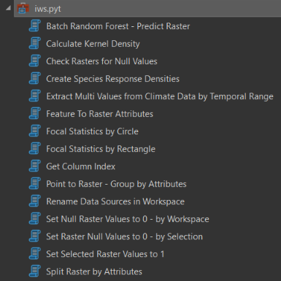

Figure 3. Python Script Toolbox as displayed in ArcGis Pro.

The code for the Python script toolbox is provided below.

# -\*- coding: utf-8 -\*-  
  
import arcpy, os  
from arcpy import env  
arcpy.env.overwriteOutput = True  
from arcpy.sa import \*  
arcpy.CheckOutExtension("Spatial")  
arcpy.env.qualifiedFieldNames = False  
# scratch\_ws = arcpy.CreateScratchName(workspace=arcpy.env.scratchGDB)  
arcpy.env.snapRaster = r"C:\Users\hashimotoy\Desktop\ws\base\_alb.gdb\dem"  
arcpy.env.mask = r"C:\Users\hashimotoy\Desktop\ws\base\_alb.gdb\survey\_mask"  
scratch\_ws = r"C:\Users\hashimotoy\Desktop\ws\_prep\scratch.gdb"  
  
def checkFieldExists(in\_tbl, field\_nm, field\_type):  
 fields = arcpy.ListFields(in\_tbl)  
 x = False  
 for field in fields:  
 if field.name == field\_nm:  
 x = True  
 if x == False:  
 arcpy.AddField\_management(in\_tbl, field\_nm, field\_type)  
  
  
def getBaseName(in\_fc):  
 desc = arcpy.Describe(in\_fc)  
 basename = desc.baseName  
 return basename  
  
def unique\_values(table, field):  
 with arcpy.da.SearchCursor(table, [field]) as cursor:  
 return sorted({row[0] for row in cursor})  
  
  
class Toolbox(object):  
 def \_\_init\_\_(self):  
 *"""Define the toolbox (the name of the toolbox is the name of the  
 .pyt file)."""* self.label = "IWS Data Tools"  
 self.alias = ""  
  
 # List of tool classes associated with this toolbox  
 self.tools = [featureToRasterAttributes,  
 setRasterNullValuesTo0,  
 setRasterNullValuesTo0Workspace,  
 renameDataInWorkspace,  
 kernelDensityCalculations,  
 splitRasterByAttributes,  
 focalStatsByCircle,  
 focalStatsByRectangle,  
 setRasterValuesTo1,  
 pointToRasterGroupByAttributes,  
 getColumnIndex,  
 extractClimateValuesForRange,  
 checkRasterForNullValues,  
 batchRandomForest,  
 createPredictedDensitySurfaces]  
  
class Tool(object):  
 def \_\_init\_\_(self):  
 *"""Define the tool (tool name is the name of the class)."""* self.label = "Tool"  
 self.description = ""  
 self.canRunInBackground = False  
  
 def getParameterInfo(self):  
 *"""Define parameter definitions"""* # First parameter  
 param0 = arcpy.Parameter(  
 displayName="Input Features",  
 name="in\_features",  
 datatype="GPFeatureLayer",  
 parameterType="Required",  
 direction="Input")  
  
 # Second parameter  
 param1 = arcpy.Parameter(  
 displayName="Sinuosity Field",  
 name="sinuosity\_field",  
 datatype="Field",  
 parameterType="Optional",  
 direction="Input")  
  
 param1.value = "sinuosity"  
  
 # Third parameter  
 param2 = arcpy.Parameter(  
 displayName="Output Features",  
 name="out\_features",  
 datatype="GPFeatureLayer",  
 parameterType="Derived",  
 direction="Output")  
  
 param2.parameterDependencies = [param0.name]  
 param2.schema.clone = True  
  
 parameters = [param0, param1, param2]  
  
 return parameters  
  
 def isLicensed(self):  
 *"""Set whether tool is licensed to execute."""* return True  
  
 def updateParameters(self, parameters):  
 *"""Modify the values and properties of parameters before internal  
 validation is performed. This method is called whenever a parameter  
 has been changed."""* return  
  
 def updateMessages(self, parameters):  
 *"""Modify the messages created by internal validation for each tool  
 parameter. This method is called after internal validation."""* return  
  
 def execute(self, parameters, messages):  
 *"""The source code of the tool."""* return  
  
class batchRandomForest(object):  
 def \_\_init\_\_(self):  
 *"""Define the tool (tool name is the name of the class)."""* self.label = "Batch Random Forest - Predict Raster"  
 self.description = "Tool uses explanatory rasters to predict to raster. Specify the output workspace" \  
 "for the four resulting outputs: prediction raster, variable importance table, trained " \  
 "features and validation r2. The outputs will be named according to the name of the input feature class" \  
 "and the species selected for prediction."  
 self.canRunInBackground = True  
  
 def getParameterInfo(self):  
 *"""Define parameter definitions"""* param0 = arcpy.Parameter(  
 displayName="Input Training Features",  
 name="in\_fc",  
 datatype="DEFeatureClass",  
 parameterType="Required",  
 direction="Input")  
  
 param1 = arcpy.Parameter(  
 displayName="Variables to Predict",  
 name="sp\_field",  
 datatype="Field",  
 parameterType="Required",  
 direction="Input",  
 multiValue=True)  
  
 param1.parameterDependencies = [param0.name]  
  
 param2 = arcpy.Parameter(  
 displayName="Output Workspace",  
 name="out\_ws",  
 datatype="DEWorkspace",  
 parameterType="Required",  
 direction="Input")  
  
 param3 = arcpy.Parameter(  
 displayName="Output Files Prefix",  
 name="prefix",  
 datatype="GPString",  
 parameterType="Required",  
 direction="Input")  
  
 param4 = arcpy.Parameter(  
 displayName="Number of Trees",  
 name="n\_tree",  
 datatype="GPLong",  
 parameterType="Required",  
 direction="Input")  
  
 param5 = arcpy.Parameter(  
 displayName="# of Random Variables - mtry",  
 name="m\_try",  
 datatype="GPLong",  
 parameterType="Required",  
 direction="Input")  
  
 param6 = arcpy.Parameter(  
 displayName="Compensate for Sparse Categories",  
 name="sparse",  
 datatype="GPBoolean",  
 parameterType="Required",  
 direction="Input")  
 param6.value = True  
  
 param7 = arcpy.Parameter(  
 displayName="Percent Excluded for Validation",  
 name="pct\_train",  
 datatype="GPLong",  
 parameterType="Required",  
 direction="Input")  
 param7.filter.type = "ValueList"  
 param7.filter.list = [10, 20, 30]  
  
 param8 = arcpy.Parameter(  
 displayName="Number of Validation Runs",  
 name="n\_validation",  
 datatype="GPLong",  
 parameterType="Required",  
 direction="Input")  
  
 # Fifth parameter  
 param9 = arcpy.Parameter(  
 displayName="Select Explanatory Rasters",  
 name="in\_rasters",  
 datatype="DERasterDataset",  
 parameterType="Required",  
 direction="Input",  
 multiValue=True)  
  
  
 parameters = [param0, param1, param2, param3, param4, param5,  
 param6, param7, param8, param9]  
  
 return parameters  
  
 def isLicensed(self):  
 *"""Set whether tool is licensed to execute."""* return True  
  
 def updateParameters(self, parameters):  
 *"""Modify the values and properties of parameters before internal  
 validation is performed. This method is called whenever a parameter  
 has been changed."""* return  
  
 def updateMessages(self, parameters):  
  
 return  
  
 def execute(self, parameters, messages):  
 ws\_fishnet = r"C:\Users\hashimotoy\Desktop\ws\_prep\fishnet.gdb"  
  
 in\_fc = parameters[0].valueAsText  
 lst\_sp = parameters[1].valueAsText  
 out\_ws = parameters[2].valueAsText  
 prefix = parameters[3].valueAsText  
 n\_tree = parameters[4].valueAsText  
 m\_try = parameters[5].valueAsText  
 sparse = parameters[6].valueAsText  
 pct\_train = parameters[7].valueAsText  
 n\_validation = parameters[8].valueAsText  
 in\_rasters = parameters[9].valueAsText  
  
 prediction\_type = "PREDICT\_RASTER"  
 nm = getBaseName(in\_fc)  
 in\_features = in\_fc  
 arcpy.env.mask = r"C:\Users\hashimotoy\Desktop\ws\_prep\raster\_attributes.gdb\\" + "eco\_" + nm  
  
 lst\_rasters = []  
 lst\_matching = [] # Explanatory raster matching  
 for raster in in\_rasters.split(';'):  
 lst\_rasters.append(raster)  
 sub\_lst = [raster, raster]  
 lst\_matching.append(sub\_lst)  
  
  
  
 treat\_variable\_as\_categorical = None  
 explanatory\_variables = None  
 distance\_features = None  
 explanatory\_rasters = lst\_rasters  
 features\_to\_predict = None  
 explanatory\_variable\_matching = None  
 explanatory\_distance\_matching = None  
 explanatory\_rasters\_matching = lst\_matching  
 use\_raster\_values = True  
 number\_of\_trees = n\_tree  
 minimum\_leaf\_size = None  
 maximum\_level = None  
 sample\_size = None  
 random\_sample = m\_try  
 percentage\_for\_training = pct\_train  
 output\_classification\_table = None  
 compensate\_sparse\_categories = True  
 number\_validation\_runs = n\_validation  
  
 for sp in lst\_sp.split(';'):  
 arcpy.AddMessage("Running forest for " + sp)  
 variable\_predict = sp  
 file\_prefix = prefix + "\_" + nm + "\_" + sp + "\_"  
 output\_features = os.path.join(out\_ws, file\_prefix + "\_output\_features")  
 output\_raster = os.path.join(out\_ws, file\_prefix + "\_rtr")  
 output\_trained\_features = os.path.join(out\_ws, file\_prefix + "\_trained")  
 output\_importance\_table = os.path.join(out\_ws, file\_prefix + "\_varimp")  
 output\_validation\_table = os.path.join(out\_ws, file\_prefix + "\_validation")  
  
 arcpy.stats.Forest(prediction\_type,  
 in\_features,  
 variable\_predict,  
 treat\_variable\_as\_categorical,  
 explanatory\_variables,  
 distance\_features,  
 explanatory\_rasters,  
 features\_to\_predict,  
 output\_features, output\_raster,  
 explanatory\_variable\_matching,  
 explanatory\_distance\_matching,  
 explanatory\_rasters\_matching,  
 output\_trained\_features,  
 output\_importance\_table,  
 use\_raster\_values,  
 number\_of\_trees,  
 minimum\_leaf\_size,  
 maximum\_level,  
 sample\_size,  
 random\_sample,  
 percentage\_for\_training,  
 output\_classification\_table,  
 output\_validation\_table,  
 compensate\_sparse\_categories,  
 number\_validation\_runs)  
  
 return  
  
  
  
class checkRasterForNullValues(object):  
 def \_\_init\_\_(self):  
 *"""Define the tool (tool name is the name of the class)."""* self.label = "Check Rasters for Null Values"  
 self.description = "Interrogates selected rasters for NULL values"  
 self.canRunInBackground = True  
  
 def getParameterInfo(self):  
 *"""Define parameter definitions"""* # First parameter  
 param0 = arcpy.Parameter(  
 displayName="Select Rasters",  
 name="in\_rasters",  
 datatype="DERasterDataset",  
 parameterType="Required",  
 direction="Input",  
 multiValue=True)  
  
 # Second parameter  
 param1 = arcpy.Parameter(  
 displayName="Output Workspace",  
 name="out\_ws",  
 datatype="DEWorkspace",  
 parameterType="Required",  
 direction="Input")  
  
 parameters = [param0, param1]  
  
 return parameters  
  
 def isLicensed(self):  
 *"""Set whether tool is licensed to execute."""* return True  
  
 def updateParameters(self, parameters):  
 *"""Modify the values and properties of parameters before internal  
 validation is performed. This method is called whenever a parameter  
 has been changed."""* return  
  
 def updateMessages(self, parameters):  
 *"""Modify the messages created by internal validation for each tool  
 parameter. This method is called after internal validation."""* return  
  
 def execute(self, parameters, messages):  
 lst\_rasters = parameters[0].valueAsText  
 out\_ws = parameters[1].valueAsText  
  
 for raster in lst\_rasters.split(';'):  
 nm = getBaseName(raster)  
 arcpy.AddMessage("Reading {0}".format(raster))  
 outras = IsNull(raster)  
 outras.save("{0}/{1}".format(out\_ws, nm))  
 arcpy.AddMessage("Saving {0}".format(raster))  
 return  
  
  
class setRasterNullValuesTo0Workspace(object):  
 def \_\_init\_\_(self):  
 *"""Define the tool (tool name is the name of the class)."""* self.label = "Set Null Raster Values to 0 - by Workspace"  
 self.description = "Interrogates rasters in a workspace and checks for null values. If present, NA values are set" \  
 "to 0"  
 self.canRunInBackground = True  
  
 def getParameterInfo(self):  
 *"""Define parameter definitions"""* # First parameter  
 param0 = arcpy.Parameter(  
 displayName="Raster Workspace",  
 name="in\_rasters",  
 datatype="DEWorkspace",  
 parameterType="Required",  
 direction="Input")  
  
 # Second parameter  
 param1 = arcpy.Parameter(  
 displayName="Output Workspace",  
 name="out\_ws",  
 datatype="DEWorkspace",  
 parameterType="Required",  
 direction="Input")  
  
 parameters = [param0, param1]  
  
 return parameters  
  
 def isLicensed(self):  
 *"""Set whether tool is licensed to execute."""* return True  
  
 def updateParameters(self, parameters):  
 *"""Modify the values and properties of parameters before internal  
 validation is performed. This method is called whenever a parameter  
 has been changed."""* return  
  
 def updateMessages(self, parameters):  
 *"""Modify the messages created by internal validation for each tool  
 parameter. This method is called after internal validation."""* return  
  
 def execute(self, parameters, messages):  
 in\_ws = parameters[0].valueAsText  
 out\_ws = parameters[1].valueAsText  
 arcpy.env.workspace = in\_ws  
 rasters = arcpy.ListRasters()  
  
 for raster in rasters:  
 nm = getBaseName(raster)  
 arcpy.AddMessage("Reading {0}".format(raster))  
 outras = Con(IsNull(raster), 0, raster)  
 arcpy.AddMessage("Setting null for {0}".format(raster))  
 outras.save("{0}/{1}".format(out\_ws, nm))  
 arcpy.AddMessage("Saving {0}".format(raster))  
 return  
  
class setRasterNullValuesTo0(object):  
 def \_\_init\_\_(self):  
 *"""Define the tool (tool name is the name of the class)."""* self.label = "Set Raster Null Values to 0 - by Selection"  
 self.description = "Sets all null raster values to 0 in new raster"  
 self.canRunInBackground = True  
  
 def getParameterInfo(self):  
 *"""Define parameter definitions"""* # First parameter  
 param0 = arcpy.Parameter(  
 displayName="Input Rasters",  
 name="in\_rasters",  
 datatype="DERasterDataset",  
 parameterType="Required",  
 direction="Input",  
 multiValue=True)  
  
 param1 = arcpy.Parameter(  
 displayName="Target workspace",  
 name="out\_ws",  
 datatype="DEWorkspace",  
 parameterType="Required",  
 direction="Input")  
  
 parameters = [param0, param1]  
  
 return parameters  
  
 def isLicensed(self):  
 *"""Set whether tool is licensed to execute."""* return True  
  
 def updateParameters(self, parameters):  
 *"""Modify the values and properties of parameters before internal  
 validation is performed. This method is called whenever a parameter  
 has been changed."""* return  
  
 def updateMessages(self, parameters):  
 *"""Modify the messages created by internal validation for each tool  
 parameter. This method is called after internal validation."""* return  
  
 def execute(self, parameters, messages):  
 lst\_rasters = parameters[0].valueAsText  
 out\_ws = parameters[1].valueAsText  
  
 for raster in lst\_rasters.split(';'):  
 nm = getBaseName(raster)  
 arcpy.AddMessage("Reading {0}".format(raster))  
 outras = Con(IsNull(raster), 0, raster)  
 arcpy.AddMessage("Setting null for {0}".format(raster))  
 outras.save("{0}/{1}".format(out\_ws, nm))  
 arcpy.AddMessage("Saving {0}".format(raster))  
  
 return  
  
class featureToRasterAttributes(object):  
 def \_\_init\_\_(self):  
 *"""Define the tool (tool name is the name of the class)."""* self.label = "Feature To Raster Attributes"  
 self.description = ""  
 self.canRunInBackground = True  
  
 def getParameterInfo(self):  
 # Define parameter definitions  
  
 # First parameter  
 param0 = arcpy.Parameter(  
 displayName="Input Features",  
 name="in\_features",  
 datatype="DEFeatureClass",  
 parameterType="Required",  
 direction="Input")  
  
 # Second parameter  
 param1 = arcpy.Parameter(  
 displayName="Attribute Field",  
 name="field",  
 datatype="Field",  
 parameterType="Required",  
 direction="Input")  
  
 param1.filter.list = ['TEXT', 'LONG']  
 param1.parameterDependencies = [param0.name]  
  
 param2 = arcpy.Parameter(  
 displayName="Output workspace",  
 name="out\_ws",  
 datatype="DEWorkspace",  
 parameterType="Required",  
 direction="Input"  
 )  
 param2.defaultEnvironmentName = "workspace"  
  
 parameters = [param0, param1, param2]  
 return parameters  
  
 def isLicensed(self):  
 *"""Set whether tool is licensed to execute."""* return True  
  
 def updateParameters(self, parameters):  
  
 return  
  
 def updateMessages(self, parameters):  
 *"""Modify the messages created by internal validation for each tool  
 parameter. This method is called after internal validation."""* return  
  
 def execute(self, parameters, messages):  
 import os  
  
 in\_fc = parameters[0].valueAsText  
 in\_field = parameters[1].valueAsText  
 out\_ws = r"C:\Users\hashimotoy\Desktop\ws\_prep\raster.gdb"  
 attributes\_ws = r"C:\Users\hashimotoy\Desktop\ws\_prep\raster\_attributes.gdb"  
 out\_raster = os.path.join(out\_ws, os.path.basename(in\_fc))  
 # Converting to Raster  
 arcpy.AddMessage("Converting to raster: " + out\_raster + "...")  
 raster = arcpy.FeatureToRaster\_conversion(in\_fc, in\_field, os.path.join(out\_ws, out\_raster))  
 # raster = r"C:\Users\hashimotoy\Desktop\ws\_prep\raster.gdb\vri"  
 values = unique\_values(raster, in\_field)  
 # Extract By Attributes each unique value  
 for value in values:  
 if value == "":  
 pass  
 else:  
 print(" Extracting " + value)  
 where\_clause = in\_field + " = '" + value + "'"  
 arcpy.AddMessage(" " + where\_clause)  
 extract = ExtractByAttributes(raster, where\_clause)  
 out\_nm = (in\_field + "\_" + value).lower()  
 extract.save(os.path.join(attributes\_ws, out\_nm))  
 return  
  
class renameDataInWorkspace(object):  
 def \_\_init\_\_(self):  
 *"""Define the tool (tool name is the name of the class)."""* self.label = "Rename Data Sources in Workspace"  
 self.description = "The tool will batch rename data within a workspace by one of three options: " \  
 "replace, prefix or add suffix. if "  
 self.canRunInBackground = True  
  
 def getParameterInfo(self):  
 *"""Define parameter definitions"""* # First parameter  
 param0 = arcpy.Parameter(  
 displayName="Input Workspace",  
 name="in\_ws",  
 datatype="DEWorkspace",  
 parameterType="Required",  
 direction="Input")  
 #param0.filter.type = "Workspace"  
  
 param1 = arcpy.Parameter(  
 displayName="Select String Parsing Function",  
 name="parse\_function",  
 datatype="GPString",  
 parameterType="Required",  
 direction="Input")  
  
 param1.filter.list = ["REPLACE SUBSTRING", "ADD PREFIX", "ADD SUFFIX"]  
  
 # Second parameter  
 param2 = arcpy.Parameter(  
 displayName="Input string",  
 name="in\_string",  
 datatype="GPString",  
 parameterType="Required",  
 direction="Input")  
  
 # Third parameter  
 param3 = arcpy.Parameter(  
 displayName="Output string",  
 name="out\_string",  
 datatype="GPString",  
 parameterType="Optional",  
 direction="Input")  
  
 parameters = [param0, param1, param2, param3]  
  
 return parameters  
  
 def isLicensed(self):  
 *"""Set whether tool is licensed to execute."""* return True  
  
 def updateParameters(self, parameters):  
 parameters[3].enabled = False  
 if parameters[1].value:  
 if parameters[1].valueAsText == "REPLACE SUBSTRING":  
 parameters[3].enabled = True  
 else:  
 parameters[3].enabled = False  
 return  
  
 def updateMessages(self, parameters):  
 *"""Modify the messages created by internal validation for each tool  
 parameter. This method is called after internal validation."""* return  
  
 def execute(self, parameters, messages):  
 in\_ws = parameters[0].valueAsText  
 parse\_function = parameters[1].valueAsText  
 in\_string = parameters[2].valueAsText  
 out\_string = parameters[3].valueAsText  
  
 env.workspace = in\_ws  
 fcs = arcpy.ListFeatureClasses()  
 rasters = arcpy.ListRasters()  
  
 lst = fcs + rasters  
  
 for data in lst:  
 nm = getBaseName(data)  
 if in\_string in nm:  
 pass  
 elif parse\_function == "ADD PREFIX":  
 out\_string = in\_string + nm  
 elif parse\_function == "ADD SUFFIX":  
 out\_string = nm + out\_string  
 elif parse\_function == "REPLACE SUBSTRING":  
 if in\_string not in nm:  
 arcpy.AddMessage("\nThe substring " + in\_string) + " is not within data source names"  
 pass  
 else:  
 arcpy.Rename\_management(data, nm.replace(in\_string, out\_string))  
 arcpy.AddMessage("\nRenamed " + nm + " to " + nm.replace(in\_string, out\_string))  
 arcpy.Rename\_management(data, out\_string)  
 arcpy.AddMessage("\nRenamed " + nm + " to " + out\_string)  
 return  
  
class kernelDensityCalculations(object):  
 def \_\_init\_\_(self):  
 *"""Define the tool (tool name is the name of the class)."""* self.label = "Calculate Kernel Density"  
 self.description = "Tool to generalize vector point and line inputs (use the Focal Statistics tool for raster inputs)"  
 self.canRunInBackground = True  
  
 def getParameterInfo(self):  
 *"""Define parameter definitions"""* """Define parameter definitions"""  
 # First parameter  
 param0 = arcpy.Parameter(  
 displayName="Input Feature Classes",  
 name="lst\_in\_features",  
 datatype="DEFeatureClass",  
 parameterType="Required",  
 direction="Input",  
 multiValue=True)  
  
 param0.filter.list = ["Point", "Multipoint", "Polyline"]  
  
 param1 = arcpy.Parameter(  
 displayName="Search radius",  
 name="search\_radius",  
 datatype="GPLong",  
 parameterType="Required",  
 direction="Input")  
 param1.value = 564 # pi 'r' squared ~ 1sqkm  
  
 param2 = arcpy.Parameter(  
 displayName="Cell size",  
 name="cell\_size",  
 datatype="GPLong",  
 parameterType="Required",  
 direction="Input")  
  
 param2.value = 20 # Default  
  
 param3 = arcpy.Parameter(  
 displayName="Density unit value",  
 name="area\_unit\_scale\_factor",  
 datatype="GPString",  
 parameterType="Required",  
 direction="Input")  
 param3.filter.list = ["SQUARE\_MAP\_UNITS","SQUARE\_KILOMETERS","HECTARES","SQUARE\_METERS"]  
  
 param3.value = "SQUARE\_METERS"  
  
 param4 = arcpy.Parameter(  
 displayName="Output workspace",  
 name="out\_ws",  
 datatype="DEWorkspace",  
 parameterType="Required",  
 direction="Input")  
  
 parameters = [param0, param1, param2, param3, param4]  
 # parameters = [param0, param1, param2, param3]  
 return parameters  
  
 def isLicensed(self):  
 *"""Set whether tool is licensed to execute."""* return True  
  
 def updateParameters(self, parameters):  
 *"""Modify the values and properties of parameters before internal  
 validation is performed. This method is called whenever a parameter  
 has been changed."""* return  
  
 def updateMessages(self, parameters):  
 *"""Modify the messages created by internal validation for each tool  
 parameter. This method is called after internal validation."""* return  
  
 def execute(self, parameters, messages):  
  
 lst\_inputs = parameters[0].valueAsText  
 search\_radius = parameters[1].valueAsText  
 cell\_size = parameters[2].valueAsText  
 area\_unit\_scale\_factor = parameters[3].valueAsText  
 out\_ws = parameters[4].valueAsText  
  
 for in\_fc in lst\_inputs.split(';'):  
 nm = getBaseName(in\_fc)  
 arcpy.AddMessage("\n\nProcessing " + nm)  
 kd = KernelDensity(in\_features=in\_fc,  
 population\_field="",  
 cell\_size=cell\_size,  
 search\_radius=search\_radius,  
 area\_unit\_scale\_factor=area\_unit\_scale\_factor,  
 out\_cell\_values="DENSITIES",  
 method="PLANAR")  
 kd.save(os.path.join(out\_ws, nm))  
  
 return  
  
class splitRasterByAttributes(object):  
 def \_\_init\_\_(self):  
 *"""Define the tool (tool name is the name of the class)."""* self.label = "Split Raster by Attributes"  
 self.description = "Output rasters are named according to the attribute field and value"  
 self.canRunInBackground = False  
  
 def getParameterInfo(self):  
 *"""Define parameter definitions"""* # First parameter  
 param0 = arcpy.Parameter(  
 displayName="Input Raster",  
 name="in\_raster",  
 datatype=["DERasterDataset","GPRasterLayer"],  
 parameterType="Required",  
 direction="Input")  
  
 # Second parameter  
 param1 = arcpy.Parameter(  
 displayName="Attribute Field",  
 name="field",  
 datatype="Field",  
 parameterType="Required",  
 direction="Input")  
  
 param1.filter.list = ['TEXT', 'LONG']  
 param1.parameterDependencies = [param0.name]  
  
 param2 = arcpy.Parameter(  
 displayName="Output workspace",  
 name="out\_ws",  
 datatype="DEWorkspace",  
 parameterType="Required",  
 direction="Input"  
 )  
 param2.defaultEnvironmentName = "workspace"  
  
 parameters = [param0, param1, param2]  
 return parameters  
  
 def isLicensed(self):  
 *"""Set whether tool is licensed to execute."""* return True  
  
 def updateParameters(self, parameters):  
 *"""Modify the values and properties of parameters before internal  
 validation is performed. This method is called whenever a parameter  
 has been changed."""* return  
  
 def updateMessages(self, parameters):  
 *"""Modify the messages created by internal validation for each tool  
 parameter. This method is called after internal validation."""* return  
  
 def execute(self, parameters, messages):  
 in\_raster = parameters[0].valueAsText  
 in\_field = parameters[1].valueAsText  
 out\_ws = parameters[2].valueAsText  
  
 values = unique\_values(in\_raster, in\_field)  
 # Extract By Attributes each unique value  
 for value in values:  
 if value == "":  
 pass  
 else:  
 print(" Extracting " + value)  
 where\_clause = in\_field + " = '" + value + "'"  
 arcpy.AddMessage(" " + where\_clause)  
 extract = ExtractByAttributes(in\_raster, where\_clause)  
 out\_nm = (in\_field + "\_" + value).lower()  
 extract.save(os.path.join(out\_ws, out\_nm))  
 return  
  
class focalStatsByCircle(object):  
 def \_\_init\_\_(self):  
 self.label = "Focal Statistics by Circle"  
 self.description = "Tool to generalize raster inputs (use the Kernel Density tool for vector points and lines)"  
 self.canRunInBackground = True  
  
 def getParameterInfo(self):  
  
 param0 = arcpy.Parameter(  
 displayName="Input Rasters",  
 name="in\_rasters",  
 datatype="DERasterDataset",  
 parameterType="Required",  
 direction="Input",  
 multiValue=True)  
  
  
 param1 = arcpy.Parameter(  
 displayName="Neighbourhood in map units",  
 name="neighbourhood",  
 datatype="GPLong",  
 parameterType="Required",  
 direction="Input")  
 param1.value = 1200 # Circular neighbourhood of 1.2km to account for center of 400m cell grid  
  
 param2 = arcpy.Parameter(  
 displayName="Statistics type",  
 name="stats\_type",  
 datatype="GPString",  
 parameterType="Required",  
 direction="Input",  
 multiValue=False)  
 param2.filter.list = ["MEAN", "MAJORITY", "MAXIMUM", "MEDIAN",  
 "MINIMUM", "MINORITY", "RANGE", "STD",  
 "SUM", "VARIETY"]  
 param2.value = "SUM"  
  
 param3 = arcpy.Parameter(  
 displayName="Output workspace",  
 name="out\_ws",  
 datatype="DEWorkspace",  
 parameterType="Required",  
 direction="Input")  
  
 parameters = [param0, param1, param2, param3]  
 return parameters  
  
 def isLicensed(self):  
 *"""Set whether tool is licensed to execute."""* return True  
  
 def updateParameters(self, parameters):  
 *"""Modify the values and properties of parameters before internal  
 validation is performed. This method is called whenever a parameter  
 has been changed."""* return  
  
 def updateMessages(self, parameters):  
 *"""Modify the messages created by internal validation for each tool  
 parameter. This method is called after internal validation."""* return  
  
 def execute(self, parameters, messages):  
  
 rasters = parameters[0].valueAsText  
 neighbourhood = parameters[1].valueAsText  
 stats\_type = parameters[2].valueAsText  
 out\_ws = parameters[3].valueAsText  
  
 for in\_raster in rasters.split(';'):  
 arcpy.AddMessage(in\_raster)  
 nm = getBaseName(in\_raster)  
 arcpy.AddMessage("\nProcessing focal statistics for " + nm)  
 fs = FocalStatistics(in\_raster, NbrCircle(neighbourhood, "MAP"),  
 stats\_type,"DATA")  
 fs.save(os.path.join(out\_ws, nm))  
  
 return  
  
class focalStatsByRectangle(object):  
 def \_\_init\_\_(self):  
 self.label = "Focal Statistics by Rectangle"  
 self.description = "Tool to generalize raster inputs (use the Kernel Density tool for vector points and lines)"  
 self.canRunInBackground = True  
  
 def getParameterInfo(self):  
  
 param0 = arcpy.Parameter(  
 displayName="Input Rasters",  
 name="in\_rasters",  
 datatype="DERasterDataset",  
 parameterType="Required",  
 direction="Input",  
 multiValue=True)  
  
  
 param1 = arcpy.Parameter(  
 displayName="Neighbourhood in map units",  
 name="neighbourhood",  
 datatype="GPLong",  
 parameterType="Required",  
 direction="Input")  
 param1.value = 1000 # Rectangular neighbourhood 1km x 1km  
  
 param2 = arcpy.Parameter(  
 displayName="Statistics type",  
 name="stats\_type",  
 datatype="GPString",  
 parameterType="Required",  
 direction="Input",  
 multiValue=True)  
 param2.filter.list = ["MEAN", "MAJORITY", "MAXIMUM", "MEDIAN",  
 "MINIMUM", "MINORITY", "RANGE", "STD",  
 "SUM", "VARIETY"]  
 param2.value = "SUM"  
  
 param3 = arcpy.Parameter(  
 displayName="Output workspace",  
 name="out\_ws",  
 datatype="DEWorkspace",  
 parameterType="Required",  
 direction="Input")  
  
 parameters = [param0, param1, param2, param3]  
 return parameters  
  
 def isLicensed(self):  
 *"""Set whether tool is licensed to execute."""* return True  
  
 def updateParameters(self, parameters):  
 *"""Modify the values and properties of parameters before internal  
 validation is performed. This method is called whenever a parameter  
 has been changed."""* return  
  
 def updateMessages(self, parameters):  
 *"""Modify the messages created by internal validation for each tool  
 parameter. This method is called after internal validation."""* return  
  
 def execute(self, parameters, messages):  
  
 rasters = parameters[0].valueAsText  
 neighbourhood = parameters[1].valueAsText  
 stats\_type = parameters[2].valueAsText  
 out\_ws = parameters[3].valueAsText  
  
 for in\_raster in rasters.split(';'):  
 arcpy.AddMessage(in\_raster)  
 nm = getBaseName(in\_raster)  
 arcpy.AddMessage("\nProcessing focal statistics for " + nm)  
 fs = FocalStatistics(in\_raster, NbrRectangle(neighbourhood, neighbourhood, "MAP"),  
 stats\_type,"DATA") #  
 fs.save(os.path.join(out\_ws, nm))  
  
 return  
  
class setRasterValuesTo1(object):  
 def \_\_init\_\_(self):  
 *"""Define the tool (tool name is the name of the class)."""* self.label = "Set Selected Raster Values to 1"  
 self.description = "Sets all raster values to 1 within a specified workspace. For categorical (factor) variables."  
 self.canRunInBackground = False  
  
 def getParameterInfo(self):  
 *"""Define parameter definitions"""* # First parameter  
 param0 = arcpy.Parameter(  
 displayName="Input Rasters",  
 name="in\_rasters",  
 datatype="DERasterDataset",  
 parameterType="Required",  
 direction="Input",  
 multiValue=False)  
  
 param1 = arcpy.Parameter(  
 displayName="Output workspace",  
 name="out\_ws",  
 datatype="DEWorkspace",  
 parameterType="Required",  
 direction="Input")  
  
 parameters = [param0, param1]  
 return parameters  
  
 def isLicensed(self):  
 *"""Set whether tool is licensed to execute."""* return True  
  
 def updateParameters(self, parameters):  
 *"""Modify the values and properties of parameters before internal  
 validation is performed. This method is called whenever a parameter  
 has been changed."""* return  
  
 def updateMessages(self, parameters):  
 *"""Modify the messages created by internal validation for each tool  
 parameter. This method is called after internal validation."""* return  
  
 def execute(self, parameters, messages):  
 lst\_rasters = parameters[0].valueAsText  
 out\_ws = parameters[1].valueAsText  
  
 for in\_raster in lst\_rasters.split(';'):  
 nm = getBaseName(in\_raster)  
 arcpy.AddMessage("\n" + nm)  
 out\_con = Con(~IsNull(in\_raster), 1, 0)  
 out\_con.save(os.path.join(out\_ws, nm))  
  
 return  
  
  
class pointToRasterGroupByAttributes(object):  
 def \_\_init\_\_(self):  
 *"""Define the tool (tool name is the name of the class)."""* self.label = "Point to Raster - Group by Attributes"  
 self.description = "Create raster surfaces from one or more attributes in an input point feature class." \  
 " Output rasters will be prefixed by user defined string" \  
 "and appended with the field value. The optional 'group by' parameter will output individual rasters" \  
 "based on attribute."  
 self.canRunInBackground = True  
  
 def getParameterInfo(self):  
 *"""Define parameter definitions"""* # First parameter  
 param0 = arcpy.Parameter(  
 displayName="Input Point Feature Class",  
 name="in\_pts",  
 datatype="GPFeatureLayer",  
 parameterType="Required",  
 direction="Input")  
  
 # Second parameter  
 param1 = arcpy.Parameter(  
 displayName="Attribute fields",  
 name="fields",  
 datatype="Field",  
 parameterType="Required",  
 direction="Input",  
 multiValue=True)  
 param1.parameterDependencies = [param0.name]  
  
 # Third parameter  
 param2 = arcpy.Parameter(  
 displayName="Output Workspace",  
 name="out\_ws",  
 datatype="DEWorkspace",  
 parameterType="Required",  
 direction="Input")  
 param2.defaultEnvironmentName = "workspace"  
 # param2.filter.list = ["Local Database"]  
  
 # Fourth parameter  
 param3 = arcpy.Parameter(  
 displayName="Prefix for out raster name",  
 name="prefix",  
 datatype="GPString",  
 parameterType="Required",  
 direction="Input")  
  
 # Fifth parameter  
 param4 = arcpy.Parameter(  
 displayName="Cell Assignment",  
 name="assignment\_type",  
 datatype="GPString",  
 parameterType="Required",  
 direction="Input")  
 param4.filter.type = 'ValueList'  
 param4.filter.list = ["MEAN", "MAXIMUM", "MOST\_FREQUENT",  
 "MINIMUM","RANGE", "STANDARD\_DEVIATION",  
 "SUM", "COUNT"]  
 param4.value = "MEAN"  
  
 # Sixth parameter  
 param5 = arcpy.Parameter(  
 displayName="Cell Size",  
 name="cell\_size",  
 datatype="GPLong",  
 parameterType="Input",  
 direction="Input")  
 param5.value = 400  
  
 # Seventh Optional parameter  
 param6 = arcpy.Parameter(  
 displayName="Optional - Group By attribute",  
 name="groupby",  
 datatype="Field",  
 parameterType="Optional",  
 direction="Input",  
 multiValue = False)  
  
 param6.parameterDependencies = [param0.name]  
  
 parameters = [param0, param1, param2, param3, param4, param5, param6]  
  
 return parameters  
  
 def isLicensed(self):  
 *"""Set whether tool is licensed to execute."""* return True  
  
 def updateParameters(self, parameters):  
 *"""Modify the values and properties of parameters before internal  
 validation is performed. This method is called whenever a parameter  
 has been changed."""* return  
  
 def updateMessages(self, parameters):  
 *"""Modify the messages created by internal validation for each tool  
 parameter. This method is called after internal validation."""* return  
  
 def execute(self, parameters, messages):  
 # Set environment settings  
  
 in\_pts = parameters[0].valueAsText  
 fields = parameters[1].valueAsText  
 out\_ws = parameters[2].valueAsText  
 prefix = parameters[3].valueAsText  
 assignment\_type = parameters[4].valueAsText  
 cell\_size = parameters[5].valueAsText  
 groupby = parameters[6].valueAsText  
  
 env.workspace = out\_ws  
  
 arcpy.AddMessage("Running Point to Raster on: " + in\_pts)  
  
 for field in fields.split(';'):  
 valField = field  
  
 if groupby is None:  
 arcpy.AddMessage("\n Processing " + field)  
 inFeatures = in\_pts  
 outRaster = (prefix + "\_" + field).lower()  
 arcpy.PointToRaster\_conversion(inFeatures, valField, outRaster,  
 assignment\_type, "", cell\_size)  
  
 else:  
 values = unique\_values(in\_pts, groupby)  
 for value in values:  
 arcpy.AddMessage("\n Processing " + field + " for " + str(value))  
 nm = getBaseName(in\_pts)  
 out\_nm = nm + "\_" + str(value)  
 where\_clause = groupby + " = '" + str(value) + "'"  
 inFeatures = arcpy.Select\_analysis(in\_pts, out\_nm, where\_clause)  
 outRaster = (prefix + "\_" + field + "\_" + str(value)).lower()  
 arcpy.PointToRaster\_conversion(inFeatures, valField, outRaster,  
 assignment\_type, "", cell\_size)  
  
  
 return  
  
class getColumnIndex(object):  
 def \_\_init\_\_(self):  
 *"""Define the tool (tool name is the name of the class)."""* self.label = "Get Column Index"  
 self.description = "Using pandas module, read a csv file and get the index of selected columns"  
 self.canRunInBackground = True  
  
 def getParameterInfo(self):  
 *"""Define parameter definitions"""* # First parameter  
 param0 = arcpy.Parameter(  
 displayName="Input CSV",  
 name="csv",  
 datatype="DEFile",  
 parameterType="Required",  
 direction="Input")  
 param0.filter.list = ['txt', 'csv']  
  
 # Second parameter  
 param1 = arcpy.Parameter(  
 displayName="Fields",  
 name="fields",  
 datatype="Field",  
 parameterType="Required",  
 direction="Input",  
 multiValue=True)  
 param1.parameterDependencies = [param0.name]  
  
 parameters = [param0, param1]  
  
 return parameters  
  
 def isLicensed(self):  
 *"""Set whether tool is licensed to execute."""* return True  
  
 def updateParameters(self, parameters):  
 *"""Modify the values and properties of parameters before internal  
 validation is performed. This method is called whenever a parameter  
 has been changed."""* return  
  
 def updateMessages(self, parameters):  
 *"""Modify the messages created by internal validation for each tool  
 parameter. This method is called after internal validation."""* return  
  
 def execute(self, parameters, messages):  
 import pandas as pd  
  
 in\_csv = parameters[0].valueAsText  
 fields = parameters[1].valueAsText  
  
 arcpy.AddMessage("\n\nGetting indices for selected columns...\n\n")  
 csv = pd.read\_csv(in\_csv)  
  
 for field in fields.split(';'):  
 index = csv.columns.get\_loc(field)  
 arcpy.AddMessage("\n " + field + " : " + str(index) + "\n")  
  
 return  
  
class extractClimateValuesForRange(object):  
 def \_\_init\_\_(self):  
 *"""Define the tool (tool name is the name of the class)."""* self.label = "Extract Multi Values from Climate Data by Temporal Range"  
 self.description = "The tool will extract the values of selected climate variables for" \  
 "the input points for each year in the study range 2007-2017. Basename of filename" \  
 "will be appended with \_annual\_clim. Note intermediate files will be output to the 'Output" \  
 "workspace'"  
 self.canRunInBackground = True  
  
 def getParameterInfo(self):  
 *"""Define parameter definitions"""* # First parameter  
 param0 = arcpy.Parameter(  
 displayName="Input Features",  
 name="in\_features",  
 datatype="GPFeatureLayer",  
 parameterType="Required",  
 direction="Input")  
  
 # Second parameter  
 param1 = arcpy.Parameter(  
 displayName="Output Workspace",  
 name="out\_ws",  
 datatype="DEWorkspace",  
 parameterType="Required",  
 direction="Input")  
  
 # Third parameter  
 param2 = arcpy.Parameter(  
 displayName="Select climate variables",  
 name="clim\_var",  
 datatype="GPString",  
 parameterType="Input",  
 direction="Input",  
 multiValue=True)  
 param2.filter.type = 'ValueList'  
 param2.filter.list = ["ahm", "bffp","cmd", "dd5", "dd18", "effp", "mat", "map",  
 "ppt", "pas\_sp", "pas\_wt", "shm", "tave\_sp", "tave\_wt", "tave04"]  
  
 # Fourth parameter  
 param3 = arcpy.Parameter(  
 displayName="Workspace containing climate rasters",  
 name="clim\_ws",  
 datatype="DEWorkspace",  
 parameterType="Input",  
 direction="Input")  
  
 parameters = [param0, param1, param2, param3]  
  
 return parameters  
  
 def isLicensed(self):  
 *"""Set whether tool is licensed to execute."""* return True  
  
 def updateParameters(self, parameters):  
 *"""Modify the values and properties of parameters before internal  
 validation is performed. This method is called whenever a parameter  
 has been changed."""* return  
  
 def updateMessages(self, parameters):  
 *"""Modify the messages created by internal validation for each tool  
 parameter. This method is called after internal validation."""* return  
  
 def execute(self, parameters, messages):  
 pts = parameters[0].valueAsText  
 out\_ws = parameters[1].valueAsText  
 clim\_var = parameters[2].valueAsText  
 ws\_clim = parameters[3].valueAsText  
  
 base\_nm = getBaseName(pts)  
  
 lst\_merge = []  
 for i in range(2007,2018):  
 out\_fc = os.path.join(out\_ws,base\_nm + "clim\_" + str(i))  
 arcpy.AddMessage("\nRunning value extraction for " + out\_fc)  
 in\_pts = arcpy.CopyFeatures\_management(pts, out\_fc)  
 checkFieldExists(in\_pts, "year\_txt", "TEXT")  
 lst\_clim = []  
 for var in clim\_var.split(';'):  
 clim\_raster = os.path.join(ws\_clim,"clim\_" + var + "\_" + str(i))  
 arcpy.AddMessage(" " + clim\_raster)  
 lst\_clim.append([clim\_raster, var])  
 arcpy.CalculateField\_management(out\_fc, "year\_txt", "'" + str(i) + "'")  
 ExtractMultiValuesToPoints(out\_fc, lst\_clim)  
 lst\_merge.append(out\_fc)  
 arcpy.AddMessage("\n\nCompleted extractions by year. \n\nMerging into final dataset...")  
 arcpy.Merge\_management(lst\_merge, os.path.join(out\_ws, base\_nm + "\_annual\_clim"))  
 return  
  
class createPredictedDensitySurfaces(object):  
 def \_\_init\_\_(self):  
 *"""Define the tool (tool name is the name of the class)."""* self.label = "Create Species Response Densities"  
 self.description = "This tool will create density surfaces for predicted SDMs output from 'cforest'"  
 self.canRunInBackground = False  
  
 def getParameterInfo(self):  
 *"""Define parameter definitions"""* # First parameter  
 param0 = arcpy.Parameter(  
 displayName="Input Directory of CSV response files",  
 name="in\_csv",  
 datatype="DEWorkspace",  
 parameterType="Required",  
 direction="Input")  
  
 # Second parameter  
 param1 = arcpy.Parameter(  
 displayName="Geodatabase of fishnets for each ecosection",  
 name="ws\_fishnet",  
 datatype="DEWorkspace",  
 parameterType="Required",  
 direction="Input")  
  
  
 # Third parameter  
 param2 = arcpy.Parameter(  
 displayName="Output Workspace",  
 name="ws\_out",  
 datatype="DEWorkspace",  
 parameterType="Required",  
 direction="Input")  
  
 # Fourth parameter  
 param3 = arcpy.Parameter(  
 displayName="Snap Raster",  
 name="snap\_raster",  
 datatype="DERasterDataset",  
 parameterType="Required",  
 direction="Input")  
  
 parameters = [param0, param1, param2, param3]  
  
 return parameters  
  
 def isLicensed(self):  
 *"""Set whether tool is licensed to execute."""* return True  
  
 def updateParameters(self, parameters):  
 *"""Modify the values and properties of parameters before internal  
 validation is performed. This method is called whenever a parameter  
 has been changed."""* return  
  
 def updateMessages(self, parameters):  
 *"""Modify the messages created by internal validation for each tool  
 parameter. This method is called after internal validation."""* return  
  
 def execute(self, parameters, messages):  
 ws\_response = parameters[0].valueAsText  
 ws\_fishnet = parameters[1].valueAsText  
 ws\_output = parameters[2].valueAsText  
 snap\_raster = parameters[3].valueAsText  
  
 # Loop through the CSV files of predicted densities  
 # For each CSV file, get the basename, join it to the appropriate ecosection fishnet  
 # Output a raster  
 env.workspace = ws\_response  
 arcpy.env.snapRaster = snap\_raster  
 files = arcpy.ListFiles("\*.csv")  
 for f in files:  
 f\_nm = getBaseName(f)  
 arcpy.AddMessage(f\_nm)  
 eco = f\_nm[7:10]  
 sp = f\_nm[11:len(f\_nm)]  
 arcpy.AddMessage("Preparing " + sp.upper() + " for " + eco + "...")  
 fishnet\_lyr = arcpy.MakeFeatureLayer\_management(os.path.join(ws\_fishnet,eco), "fishnet\_lyr")  
 joined = arcpy.AddJoin\_management(fishnet\_lyr, "id\_fishnet", f, "id\_fishnet")  
 arcpy.FeatureToRaster\_conversion(joined, sp, os.path.join(ws\_output, eco + "\_" + sp), cell\_size=400)  
 arcpy.AddMessage("\n\nCompleted rasterized densities. Check results in " + ws\_output)  
 return

APPENDIX 4 – R Scripts – Project Repository

Latest updates to the project will be uploaded to <https://github.com/Yuhash/iws>. The repository contains the base survey data inputs as well as an interactive [Jupyter notebook](https://github.com/Yuhash/iws/blob/master/IWS_Notebook.ipynb) running the R-kernel that documents the major script processes in the workflow. For optimal viewing (without interactive code functionality) in Notebook Viewer go to <https://nbviewer.jupyter.org/github/Yuhash/iws/blob/master/IWS_Notebook.ipynb>.

Workflow Model

# <https://journal.r-project.org/archive/2009/RJ-2009-013/RJ-2009-013.pdf>

#===========================================================================

# cforest model

# mclapply is a parallelizing function available only on MAC OS. On Windows change ‘mclapply’ to ‘lapply’

and set mc.cores to 1

useMaxCoreCount <- 2

nTree <- 5000

mTry <- 5

seed <- 42

PREDICT <- TRUE

gitHubRoot <- "/Volumes/Black/Yuri/iws/inputs/by\_location/"

outputRoot <- "/Users/hashimotoy/Desktop/iws-results/"

fgcRequire <- function(pkg) {

if(pkg %in% rownames(installed.packages()) == FALSE) {

install.packages(pkg)

}

# library(pkg)

}

fgcRequire("ggplot2")

fgcRequire("icesTAF")

fgcRequire("party")

fgcRequire("Hmisc")

fgcRequire("lattice")

fgcRequire("beepr")

#install.packages("parallel") # is base, should not be updated (MacOS / R 3.6.0 / RStudio Version 1.2.1335 )

#install.packages("tools") # is base, should not be updated (MacOS / R 3.6.0 / RStudio Version 1.2.1335 )

library(parallel)

library(lattice)

library(Hmisc)

library(party)

library(tools)

library(icesTAF)

library(beepr)

wd <- gitHubRoot

outwd <- paste0(outputRoot,paste0("results-seed-",seed,"-year-studyarea/"))

set.seed(seed)

mkdir(outwd)

setwd(wd)

getwd()

locList <- c("BAU", "NAU", "NEL", "CHP", "BUB", "CAB", "WCU", "QUL")

spList <- c("amwi","buff","bago","bwte","cago","gwte","mall","nsho","rndu","scau","dabblers","divers","cavity","sp\_div","sp\_tot")

mclapply(spList, function(sp) {

lapply(locList, function(loc) {

setwd(wd)

mydata <- read.csv(paste0(wd,"id1\_years\_",loc,".csv"))

mydata[ 2:ncol(mydata) ] <- lapply(mydata[2:ncol(mydata)], as.numeric)

#sum(is.na(mydata))

fishnet <- read.csv(paste0(gitHubRoot,"fishnet\_",loc,".csv"))

fishnet[ 2:ncol(fishnet) ] <- lapply(fishnet[2:ncol(fishnet)], as.numeric)

setwd(outwd) # DOING OUTPUT NOW

rdsFilename <- paste0("cf\_", sp, "\_", loc, ".rds")

vi\_fn <- paste0("VI-",sp,"\_",loc,".csv")

print(paste("START Processing cforest for:", sp))

cf <- if (

!file.exists(paste0(outwd, rdsFilename))

) {

#colnames(mydata)[colnames(mydata)==sp] <- "sp" RENAME HACK

cf <- cforest(

eval(parse(text = paste0(sp,

"~ aspect + slope + alr + pa + cec\_urban + cec\_shrubland + ",

" cec\_mixed\_forest + cec\_grassland + cec\_broadleaf + cec\_needleleaf + ",

" fwa\_1 + fwa\_2 + fwa\_3 + fwa\_4 + fwa\_10ha\_more + str\_s + str\_m + ",

" fwa\_r + fwa\_w + dra\_u + ",

# bec\_zn + # removed becase: model used for CAB on the eco section basis

#eco + # removed because we have bined by eco

"norm\_dd5 + norm\_cmd + pas\_wt + tave04 +",

"shorecx\_10plus\_100000 + shorecx\_10less\_100000"

)))

,

data = mydata,

controls = cforest\_unbiased(ntree = nTree, mtry = mTry)

)

print(paste("cforest done:", sp))

saveRDS(cf, paste0(outwd, rdsFilename))

cf

} else {

readRDS(paste0(outwd, rdsFilename))

}

if (!file.exists(paste0(outwd, vi\_fn))

) {

vi <- varimp(cf, conditional = FALSE, OOB = TRUE)

# write.csv(vi, paste(fn, ".csv", sep = ""), row.names = FALSE)

df\_vi <- as.data.frame(vi)

write.csv(df\_vi,vi\_fn);

}

#### Not incorporated in batch: deriving OOB, Response, Probability

if (PREDICT) {

ofResp <- paste0(outwd,sp,"-response\_",loc,".csv")

cf\_response <- predict(cf, newdata = fishnet, OOB = TRUE, type = 'response')

df\_result <- data.frame(fishnet$id\_fishnet, cf\_response)

write.csv(df\_result, ofResp)

}

print(paste("COMPLETED Anaylsis of:", sp))

})

}

, mc.cores = min(useMaxCoreCount,detectCores())

)

#=====================================================================================================

# Ranking and Plots for varimp

# Written if RDS has to be loaded

setwd(wd)

rdss <- list.files(wd, pattern ="\*rds$")

lapply(rdss, function(f){

cf <- readRDS(f)

fn <- substr(basename(f), 4, nchar(basename(f)) - 4)

eco <- substr(fn, nchar(fn) - 2, nchar(fn))

sp <- sub(paste0("\_", eco), "", fn)

vi\_fn <- paste0(wd, "vi\_", fn, ".csv")

vi <- varimp(cf, conditional = FALSE, OOB = TRUE)

df\_vi <- as.data.frame(vi)

v <- as.vector(df\_vi$vi)

vi <- varimp(cf, conditional = FALSE, OOB = TRUE)

df\_vi <- as.data.frame(vi)

df\_vi$X <- names(vi)

df\_vi$eco <- eco

df\_vi$sp <- sp

# Add metadata fields

df\_vi <- as.data.frame(vi)

df\_vi$X <- names(vi)

df\_vi$eco <- eco

df\_vi$sp <- sp

# Rank

df\_vi <- df\_vi %>%

mutate(rank = dense\_rank(desc(df\_vi$vi)))

write.csv(df\_vi, vi\_fn, row.names = FALSE)

})

## Create plots

library(tools)

setwd(wd)

varimpFiles <- list.files(wd, pattern = "^vi.\*csv$")

lapply(varimpFiles, function(f) {

fn <- substr(basename(f),4,nchar(basename(f))-4)

print(fn)

eco <- substr(fn,nchar(fn)-2,nchar(fn))

sp <- sub(paste0("\_",eco),"", fn)

print(paste("Starting plot", f))

fn <- file\_path\_sans\_ext(basename(f))

title <- paste(toupper(sp),eco)

print(title)

df\_vi <- read.csv(f)

v <- as.vector(df\_vi$vi)

names(v) <- as.vector(df\_vi$X)

print(names(v))

dotchart(v[order(v)], cex = 0.9, pch = 19,

color = "darkblue",

xlab = "varImp", main = title)

dev.copy(png, paste(wd, paste("varimp\_", title, ".png", sep = ""), sep = "/"))

dev.off()

print(paste("plot done:", fn))

})

print("ALL DONE")

Snippets - Data Manipulation

# Create a data frame from a list of csv files converted to a list of data frames merged by common column values

path <- "C:/Users/hashimotoy/Documents/MGIS/Analysis/Models/grid\_cell/cab/glmm\_2007to2017"

extension = "\*.csv"

batch\_read <- function(path, extension) {

file\_names <- list.files(path, pattern = extension)

data\_list <- lapply(paste(path, file\_names, sep = "/"), read.csv)

data\_frame <- bind\_rows(data\_list)

data\_frame

}

#----------------------------

# From a list of CSV files, select columns and merge

# Helper function

readdata <- function(filename) {

df <- read.csv(filename)

vec <- df[, 4]# Identify the columns

names(vec) <- df[, 1]

return(vec)

}

result <- do.call(rbind, lapply(filenames, readdata))

# ======================

# Merge all files in a folder

wd = "C:/Users/hashimotoy/Documents/MGIS/Data/climateBC/climatebc\_normals1980-2010"

setwd(wd)

files <- list.files(pattern = "\\.csv")

all\_files <- lapply(files, function(x){

read.csv(x, header=TRUE)

})

df <- do.call(rbind.data.frame, all\_files)

write.csv(df, "climatebc\_normals\_1980-2010\_merged.csv", row.names = FALSE)

# Another way

library(dplyr)

library(readr)

df <- do.call(rbind(lapply(files, function(x)read.table(x, header=TRUE, sep = ","))))

#======================================================

# Flat correlation matrix with P and r values

library(tidyr)

library(tibble)

library(Hmisc)

flat\_cor\_mat <- function(cor\_r, cor\_p){

#This function provides a simple formatting of a correlation matrix

#into a table with 4 columns containing :

# Column 1 : row names (variable 1 for the correlation test)

# Column 2 : column names (variable 2 for the correlation test)

# Column 3 : the correlation coefficients

# Column 4 : the p-values of the correlations

library(tidyr)

library(tibble)

cor\_r <- rownames\_to\_column(as.data.frame(cor\_r), var = "row")

cor\_r <- gather(cor\_r, column, cor, -1)

cor\_p <- rownames\_to\_column(as.data.frame(cor\_p), var = "row")

cor\_p <- gather(cor\_p, column, p, -1)

cor\_p\_matrix <- left\_join(cor\_r, cor\_p, by = c("row", "column"))

cor\_p\_matrix

}

library(corrplot)

cor <- rcorr(as.matrix(mtcars[, 1:7]))

my\_cor\_matrix <- flat\_cor\_mat(cor$r, cor$P)

head(my\_cor\_matrix)

corr <- rcorr(as.matrix(df))

corrplot(corr$r, method='number', number.cex= 12/ncol(df\_sub))#To alter font size

#========================================

# Check for NA values

df %>%

select\_if(function(x) any(is.na(x))) %>%

summarise\_each(funs(sum(is.na(.)))) -> extra\_NA

#========================================

# Set NA values to 0

df[is.na(df)] <- 0

#=============================================================================================

# The function complete.cases() returns a logical vector indicating which cases are complete.

# list rows of data that have missing values

df[!complete.cases(df),]

#================================================================

# Check which version of R is running

Sys.getenv("R\_ARCH")

# "/i386" or "/x64"

# ==============================

# UPDATE PACKAGES

update.packages(checkBuilt=TRUE, ask=FALSE)

#=================================

# Find column names with NA values

colnames(df)[colSums(is.na(df)) > 0]

mypath <- path

multmerge = function(mypath){

filenames=list.files(path=mypath, full.names=TRUE)

datalist = lapply(filenames, function(x){read.csv(file=x,header=T)})

Reduce(function(x,y) {merge(x,y)}, datalist)}

mymergeddata = multmerge(path)

#====================================

# UPDATE R Version

# installing/loading the package:

if(!require(installr)) {

install.packages("installr"); require(installr)} #load / install+load installr

library(installr)

# using the package:

updateR()

#=========================

# # Rename a column in R

colnames(data)[colnames(data)=="old\_name"] <- "new\_name

sp\_start <- grep("dabblers", colnames(df))

sp\_end <- grep("tot\_sp", colnames(df))

print(sp\_start)

print(sp\_end)

sp <- colnames(df)[sp\_start:sp\_end]

var\_start <- sp\_end + 1

var\_end <- ncol(df)

print(var\_start)

print(var\_end)

int\_eco <- grep("eco", colnames(df))

int\_trans <- grep("trans\_id", colnames(df))

int\_bec\_zn <- grep("bec\_zone", colnames(df))

int\_bec\_sz <- grep("bec\_sz", colnames(df))

for (i in 1:length(sp)){

nm <- sp[i]

print(nm)

int = grep(nm, colnames(df))

data <- df[c(int,int\_eco,int\_trans,int\_bec\_zn, int\_bec\_sz,var\_start:var\_end)]

colnames(data)[1]<- "sp"

write.csv(data, paste(outwd, paste("rf\_",scale, "\_",nm,".csv", sep = ""), sep = "/"), row.names = FALSE)

}

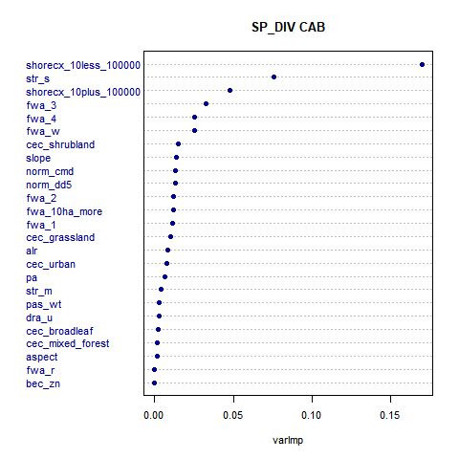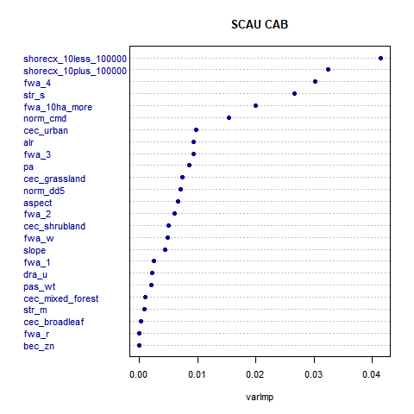APPENDIX 5 – Variable Importance Plots

Babine Upland

Bulkley Basin

Cariboo Basin

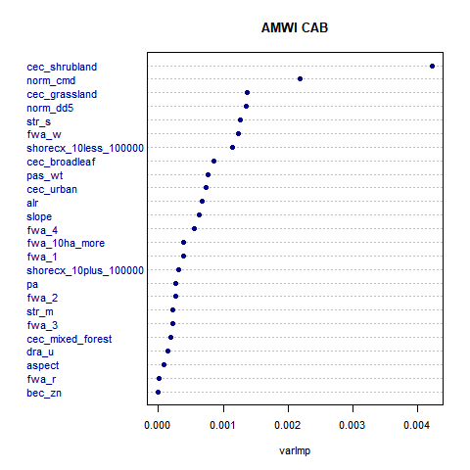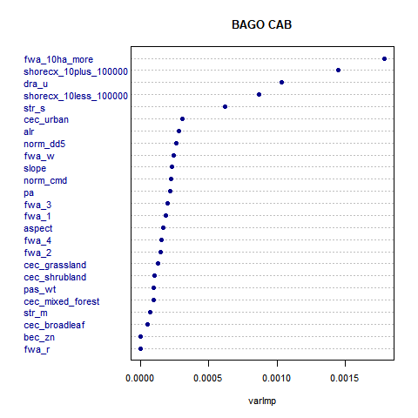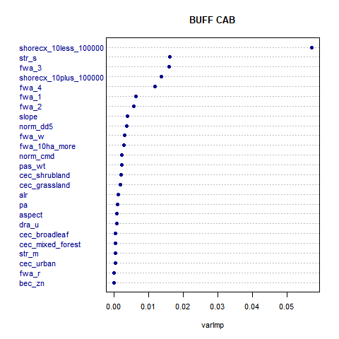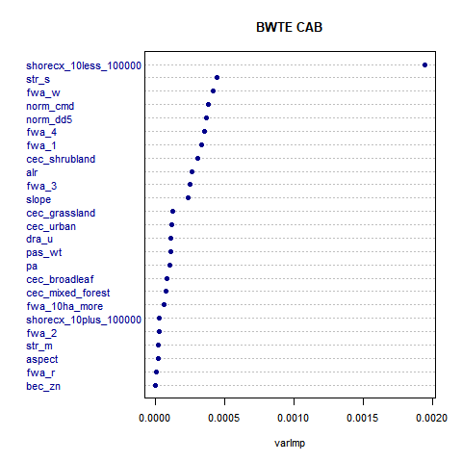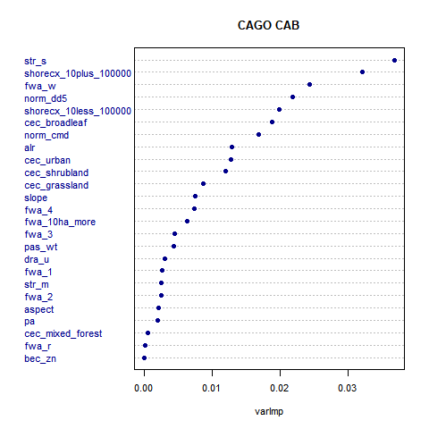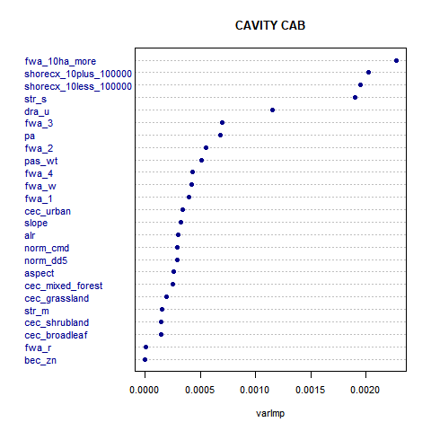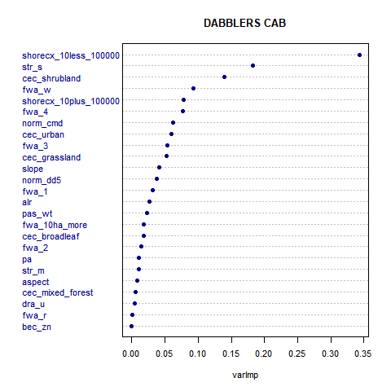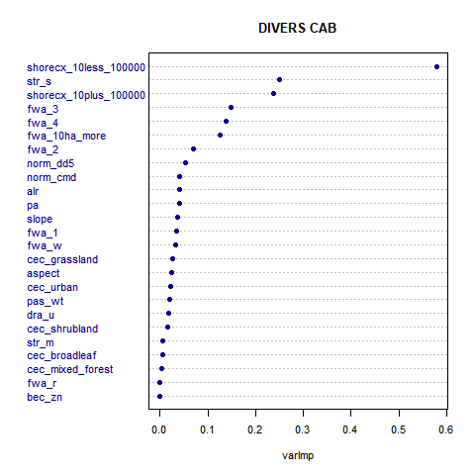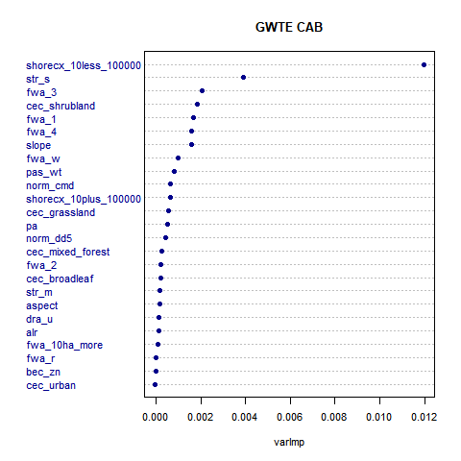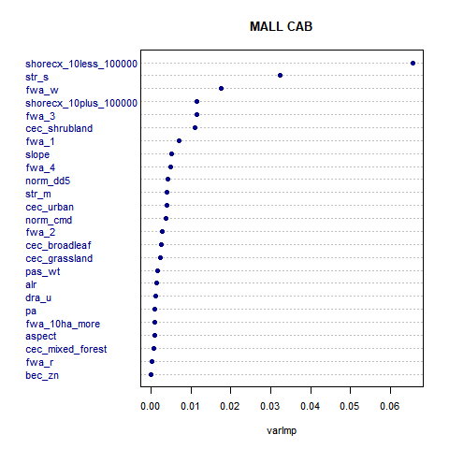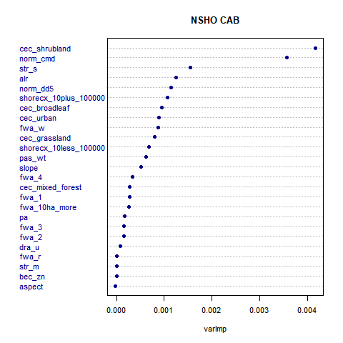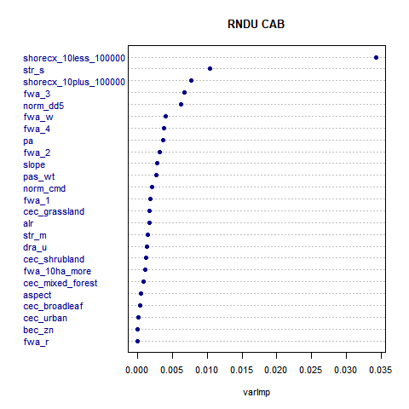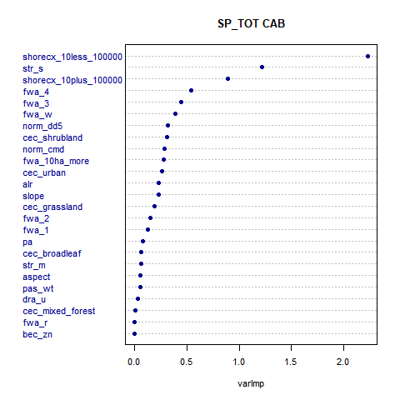

Chilcotin Plateau

Nazko Upland

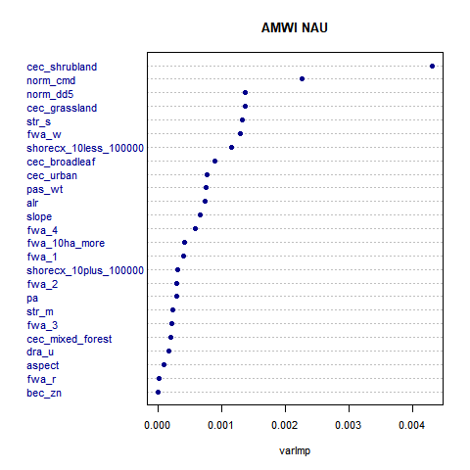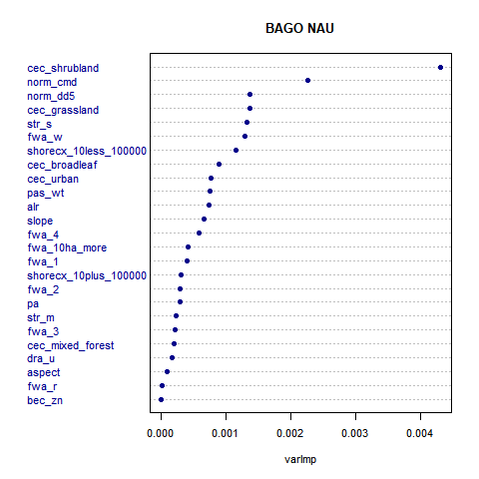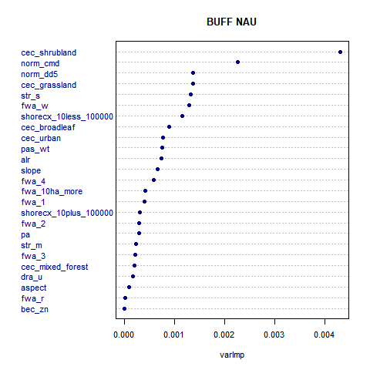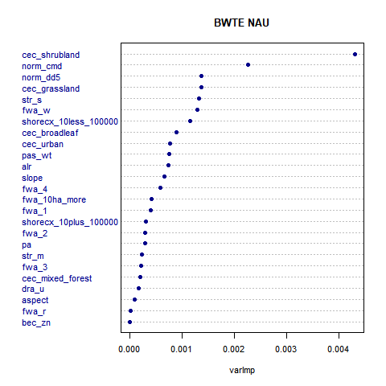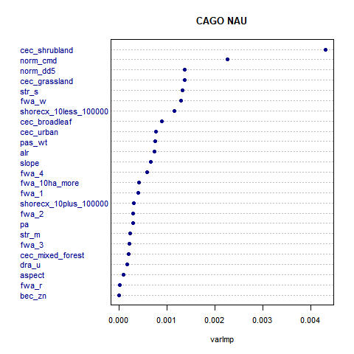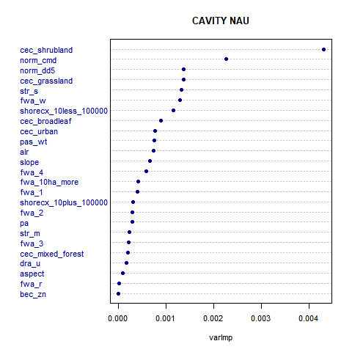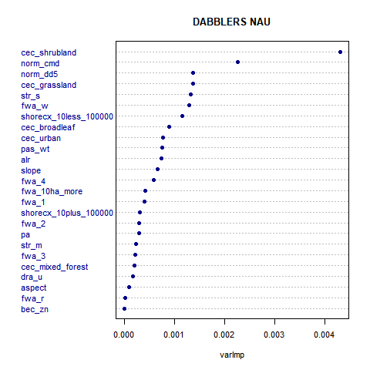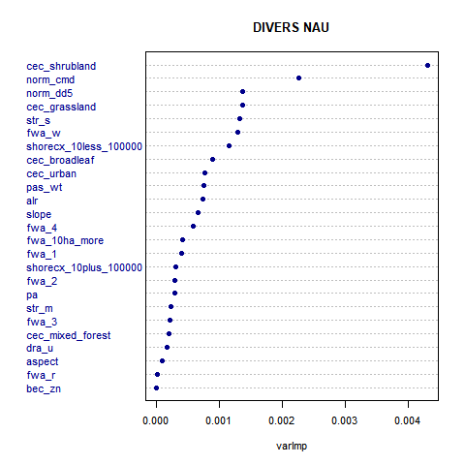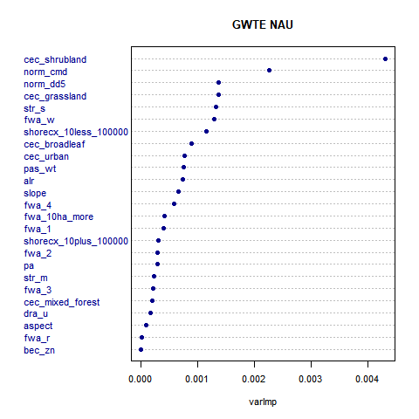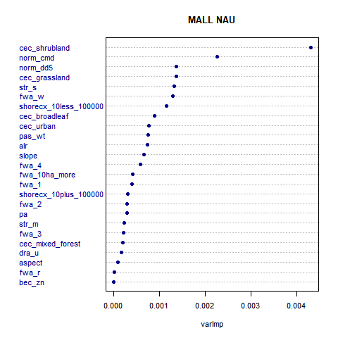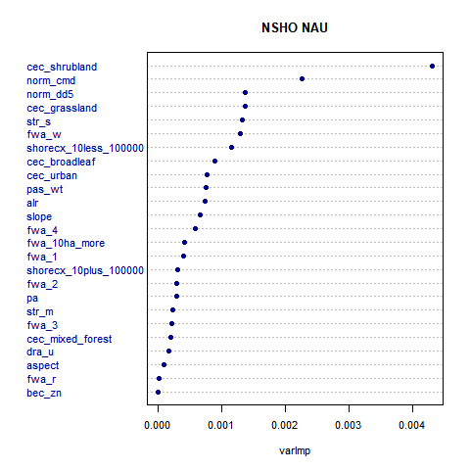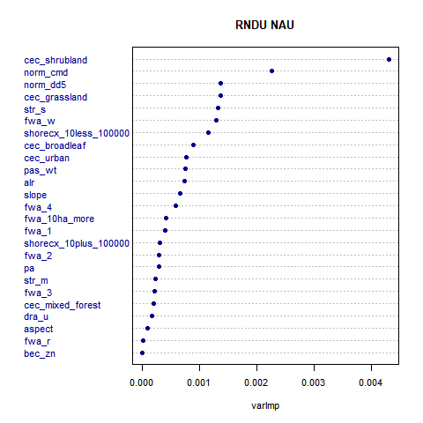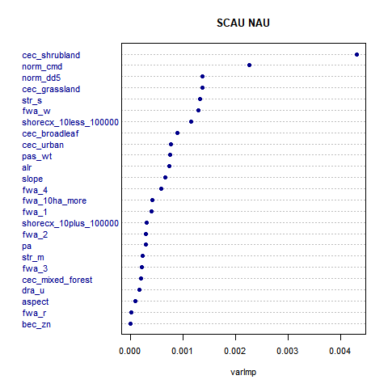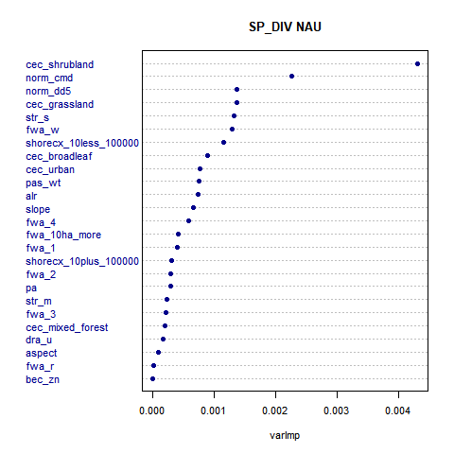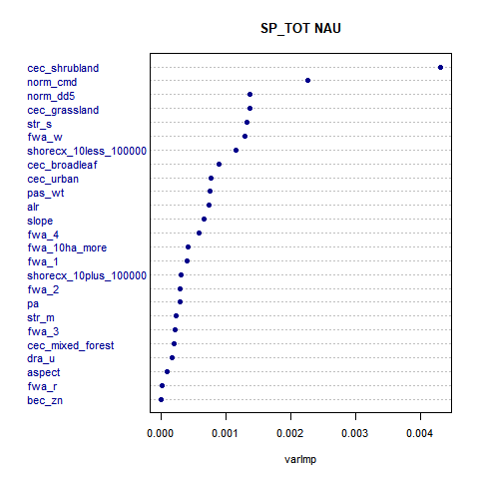

Nechako Lowland

Quesnel Lowland

**Western Chilcotin Uupland**