获取数据字典
export const getDictFetch = parameter => {
return axios({
url: '/admin/api/dictionaries',
method: 'get',
params: parameter
});
};

import { getDictFetch } from '@/api/common';

created() {
this.getFetch();
},

getFetch() {
const param = {
page: 1,
pageSize: 10000
};
getDictFetch(Object.assign({ dictTypeCode: 'OPERATOR_TYPE' }, param)).then(res => {
if (res.data.rows && res.data.rows.length) {
this.operatorType = res.data.rows.map(v => {
return {
value: v.dictCode,
label: v.dictName,
title: v.dictName
};
});
}
});
},

获取数据字典后的插槽使用和数据处理

<span slot="operatorType" slot-scope="text">
<template>
{{ getOperatorType(text) }}
</template>
</span>

getOperatorType(text) {
if (!this.operatorType || !this.operatorType.length) return '-';
let resultList = this.operatorType.filter(v => {
return v.value == text;
});
return resultList.length ? resultList[0].label : '-';
},

表格内容过长省略显示
第一种：
<span slot="state" slot-scope="text, record">
<j-ellipsis :value="text" :length="2" />
</span>

{
title: '状态',
align: 'center',
dataIndex: 'state',
scopedSlots: { customRender: 'state' },
},
第二种：
import { Ellipsis } from '@/components';

{
title: '小图标图片地址',
width: 250,
dataIndex: 'smallIcons',
scopedSlots: { customRender: 'smallIcons' }
},

<span slot="smallIcons" slot-scope="text">
<ellipsis :length="30" tooltip>{{ text }}</ellipsis>
</span>

导出excel
// 导出文件
urlDownloadExcel(data, fileName) {
let currentFileName = fileName || '文档';
let blobObj = new Blob([data], {
type: 'application/vnd.ms-excel'
});
if (window.navigator && window.navigator.msSaveOrOpenBlob) {
window.navigator.msSaveOrOpenBlob(blobObj, currentFileName + '.xls');
} else {
let blobUrl = window.URL.createObjectURL(blobObj);
let a = document.createElement('a');
a.style.display = 'none';
a.download = currentFileName + '.xls';
a.href = blobUrl;
a.click();
window.URL.revokeObjectURL(a.href);
a = null;
}
},
handleExport() {
console.log('!@#$', this.form);
this.getExportDeviceMonitorLogsFetch();
},
getExportDeviceMonitorLogsFetch() {
let params = {
deviceCode: this.queryParam.deviceCode,
startDate: this.queryParam.startDate,
endDate: this.queryParam.endDate
};
exportDeviceMonitorLogsFetch(params)
.then(res => {
if (res.code && res.code == 500) {
this.$message.error(`导出失败！`);
} else {
let name = '导出文件';
this.urlDownloadExcel(res, name);
this.$message.success('导出成功！');
}
})
.catch(() => {
this.$message.error(`导出失败！`);
});
},

/**
* @desc 导出设备历史电量
* @param {Object} params
*/
export const exportDeviceMonitorLogsFetch = parameter => {
return axios({
url: '/hcc-support/api/deviceMonitorLogs/export',
method: 'get',
params: parameter,
responseType: 'blob'
});
};

年月日时分秒字符串转毫秒数
// 年月日时分秒转毫秒数
timechange(str) {
let date = new Date(str).getTime();
return date;
},

停止表格加载
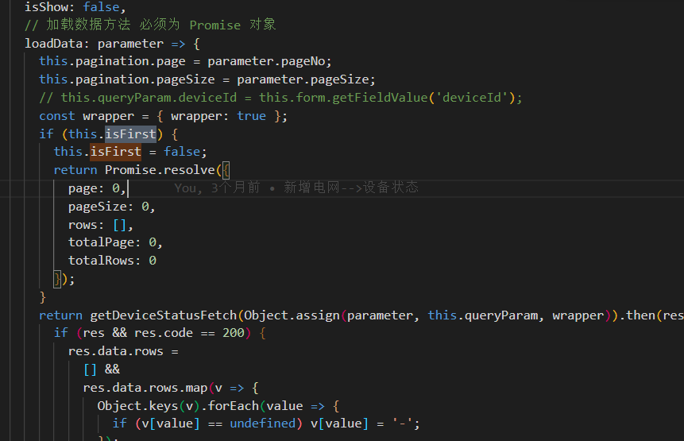
if (this.isFirst) {
this.isFirst = false;
return Promise.resolve({
page: 0,
pageSize: 0,
rows: [],
totalPage: 0,
totalRows: 0
});
}

表单验证
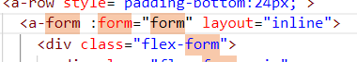
v-decorator="[
'projectName',
{
rules: [
{
required: true,
whitespace: true,
message: '请选择项目'
}
]
}
]"

handleSearch(e) {
e.preventDefault();
this.form.validateFields((err, values) => {
if (!err) {
// console.log(values);
this.$refs.table.refresh(true);
// this.form.resetFields();
// this.queryParam = { status: '' };
} else {
this.$message.warning('请正确填写！');
}
});
},

表单赋值
this.form.setFieldsValue({ projectName: String(obj.projectName) });
表单获值
this.form.getFieldValue('projectId')
表单重置
this.form.resetFields();

echarts大小自适应
mounted() {
this.getMessage()
this.$nextTick(() => {
window.addEventListener(
'resize',
() => {
this.myChart2.resize()
this.myChart3.resize()
},
false
)
})
},
beforeDestroy() {
window.removeEventListener(
'resize',
() => {
this.myChart2.resize()
this.myChart3.resize()
},
false
)
},

时间段组件默认值
import moment from 'moment';
import zhCN from 'ant-design-vue/lib/locale-provider/zh_CN';
import 'moment/locale/zh-cn';
moment.locale('zh-cn');

data() {
return {
locale: zhCN,
moment,
}

<a-form-item label="起止日期">
<a-range-picker
v-decorator="[
'SDtime',
{
initialValue: [moment(), moment()],
rules: [
{
required: false,
message: '请选择起止日期'
}
]
}
]"
@change="onChange"
/>
</a-form-item>

获取当前年月日
let now = new Date();
let nowDay =
now.getFullYear() + '-' + (now.getMonth() + 1) + '-' + now.getDate();

