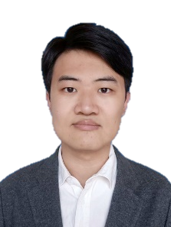

MU YANG

E-mail：yangmufy@163.com

Website：[www.yuhuyang.com](http://www.yuhuyang.com)

**Education Backgrounds**

**Shandong University**, School of Translation Studies, English, Bachelor 2016.9 - 2020.6

**Nankai University**, Collage of Chinese Language and Culture, Linguistics & Applied Linguistics, Master 2016.9 - 2020.6

**Zhejiang University**, School of International Studies, Foreign Linguistics & Applied Linguistics, Doctor

2016.9 - 2020.6

**Awards**

Third Prize in May 4th Essay Competition of Collage of Chinese Language and Culture, Nankai University 2021

Second Prize in Gongneng Scholarship of Nankai University 2022

Special Scholarship for academic of Nankai University 2022

**Skills**

**English**, TEM4 *Good*, TEM8 *Pass*

**Programming languages**, Python, Netlogo, LaTeX, R, SmartDraw, Ai

**Areas of expertise**, data statistics and analysis, corpus, agent-based modeling (ABM)

**Research Projects**

**Quantitative Linguistics**, Piotrovsky-Altmann Law

**Language Networks**, Generative mechanisms for small-world properties of language networks

**Language Evolution**, language diffusion studies based on agents-based modelling

**Publications**

*Review and development of dependency parsing*, AMI included, first author 2022.1

*The role of syntax in the formation of scale-free networks*，SCI/Scopus includes，first author 2022.9

**Thesis**

*A Study on High-frequency* *Verb-noun Heterosemous Words based on Dependency Syntax* 2022.6

* Quantitative research on the grammatical function of verbs, nouns, and Verb-noun Heterosemous Words
* Construction of the verb-noun continuum
* Research on valency acquisition of verbs and nouns