**UNIVERSIDAD TECNOLÓGICA DE PANAMÁ**

**FACULTAD DE INGENIERÍA DE SISTEMAS COMPUTACIONALES**

**DEPARTAMENTO DE PROGRAMACIÓN DE COMPUTADORAS**

**HERRAMIENTAS DE PROGRAMACIÓN APLICADAS III**

**Proyecto #1**

**Tema: MenuStrip y TabControl**

**Prof. Anna Araba de Ruiz**

**Equipo #1**

**Integrantes:**

**Yui Lo, 8-929-854**

**Eric Cedeño, 8-900-1629**

**Luis Delgado, 8-943-12**

**Agustín Alvia, 3-731-1188**

**Grupo: 1IL-131**

**Versión de VB: 16.5.2**

**Fecha de entrega: 01/06/2020**

**Código fuente de la aplicación:**

Public Class frmCV

Public mousevendido As Integer

Public keyboardvendido As Integer

Public headsetvendido As Integer

Public mousecomprado As Integer

Public keyboardcomprado As Integer

Public headsetcomprado As Integer

Public nombre As String

Public stockmouse As Integer = 100

Public stockkeyboard As Integer = 100

Public stockheadset As Integer = 100

Public historial As String = ""

Private Sub IntegrantesToolStripMenuItem_Click(sender As Object, e As EventArgs) Handles IntegrantesToolStripMenuItem.Click

frmInfo.Show()

End Sub

Private Sub ProblemaToolStripMenuItem_Click(sender As Object, e As EventArgs) Handles ProblemaToolStripMenuItem.Click

frmProblema.Show()

End Sub

Private Sub btnSalir_Click(sender As Object, e As EventArgs) Handles btnSalir.Click

End

End Sub

Private Sub CompraToolStripMenuItem_Click(sender As Object, e As EventArgs) Handles CompraToolStripMenuItem.Click

frmHistorial.Show()

End Sub

Private Sub VentaToolStripMenuItem_Click(sender As Object, e As EventArgs) Handles VentaToolStripMenuItem.Click

frmStock.Show()

End Sub

Private Sub btnVenta_Click(sender As Object, e As EventArgs) Handles btnVenta.Click

nombre = txtNombre.Text

Dim texto1 As String = ""

Dim texto2 As String = ""

Dim texto3 As String = ""

If chkMouseV.CheckState = CheckState.Checked Then

mousevendido = InputBox("Cantidad de mouse vendido:", "Venta")

texto1 = CStr(mousevendido) + " mouse,"

stockmouse -= mousevendido

End If

If chkKeyboardV.CheckState = CheckState.Checked Then

keyboardvendido = InputBox("Cantidad de keyboard vendido:", "Venta")

texto2 = CStr(keyboardvendido) + " keyboard,"

stockkeyboard -= keyboardvendido

End If

If chkHeadsetV.CheckState = CheckState.Checked Then

headsetvendido = InputBox("Cantidad de headset vendido:", "Venta")

texto3 = CStr(headsetvendido) + " headset,"

stockheadset -= headsetvendido

End If

historial = "Se ha vendido " & texto1 & texto2 & texto3 & " a " & nombre

frmHistorial.txtHistorial.Text = frmHistorial.txtHistorial.Text & vbNewLine + historial

MsgBox("La venta fue realizada con éxito.", vbOKOnly, "Venta")

txtNombre.Text = ""

chkMouseV.CheckState = CheckState.Unchecked

chkKeyboardV.CheckState = CheckState.Unchecked

chkHeadsetV.CheckState = CheckState.Unchecked

End Sub

Private Sub btnCompra_Click(sender As Object, e As EventArgs) Handles btnCompra.Click

Dim texto1 As String = ""

Dim texto2 As String = ""

Dim texto3 As String = ""

If chkMouseC.CheckState = CheckState.Checked Then

mousecomprado = InputBox("Cantidad de mouse comprado:", "Compra")

texto1 = CStr(mousecomprado) + " mouse,"

stockmouse += mousecomprado

End If

If chkKeyboardC.CheckState = CheckState.Checked Then

keyboardcomprado = InputBox("Cantidad de keyboard comprado:", "Compra")

texto2 = CStr(keyboardcomprado) + " keyboard,"

stockkeyboard += keyboardcomprado

End If

If chkHeadsetC.CheckState = CheckState.Checked Then

headsetcomprado = InputBox("Cantidad de headset comprado:", "Compra")

texto3 = CStr(headsetcomprado) + " headset,"

stockheadset += headsetcomprado

End If

historial = "Se ha comprado " & texto1 & texto2 & texto3 & " y se actualizó la cantidades en existencia "

frmHistorial.txtHistorial.Text = frmHistorial.txtHistorial.Text & vbNewLine + historial

MsgBox("La compra fue realizada con éxito.", vbOKOnly, "Compra")

chkMouseC.CheckState = CheckState.Unchecked

chkKeyboardC.CheckState = CheckState.Unchecked

chkHeadsetC.CheckState = CheckState.Unchecked

End Sub

End Class

Public Class frmInfo

Private Sub btnCerrar_Click(sender As Object, e As EventArgs) Handles btnCerrar.Click

Me.Hide()

End Sub

End Class

Public Class frmProblema

Private Sub btnCerrar_Click(sender As Object, e As EventArgs) Handles btnCerrar.Click

Me.Hide()

End Sub

End Class

Public Class frmHistorial

Private Sub btnCerrar_Click(sender As Object, e As EventArgs) Handles btnCerrar.Click

Me.Hide()

End Sub

End Class

Public Class frmStock

Private Sub frmStock_Load(sender As Object, e As EventArgs) Handles MyBase.Load

txtMouseS.Text = frmCV.stockmouse

txtKeyboardS.Text = frmCV.stockkeyboard

txtHeadsetS.Text = frmCV.stockheadset

End Sub

Private Sub btnCerrar_Click(sender As Object, e As EventArgs) Handles btnCerrar.Click

Me.Close()

End Sub

End Class

**Ejecución y resultados obtenidos:**

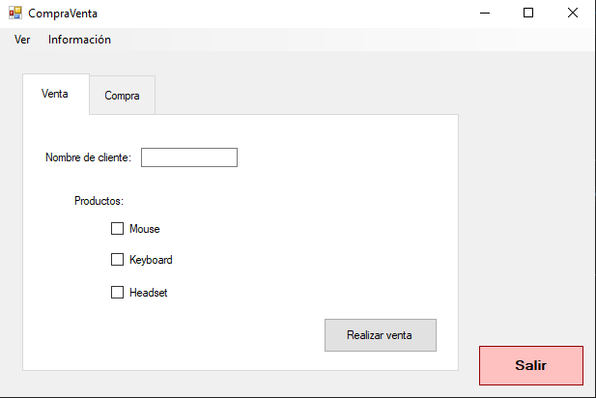

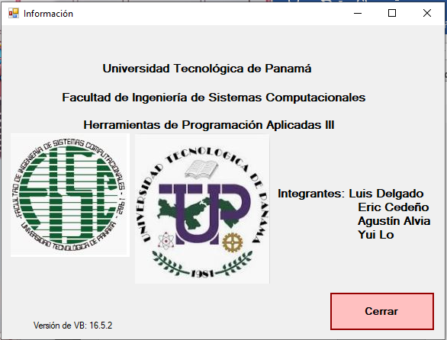

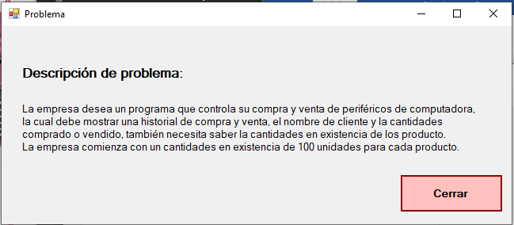

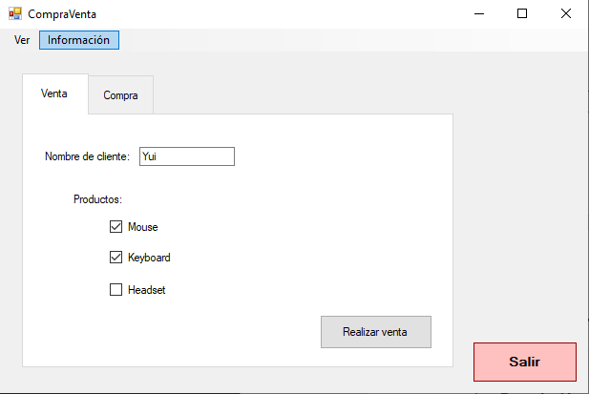 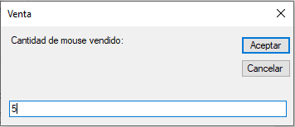 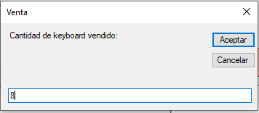 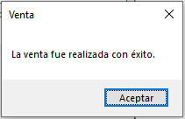 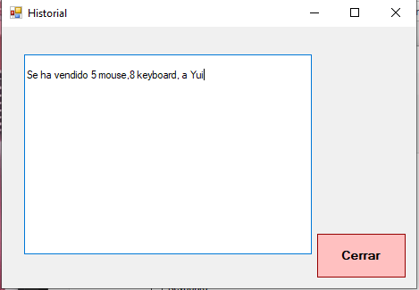 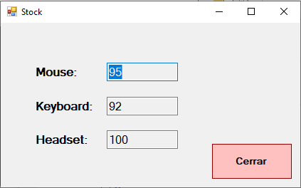 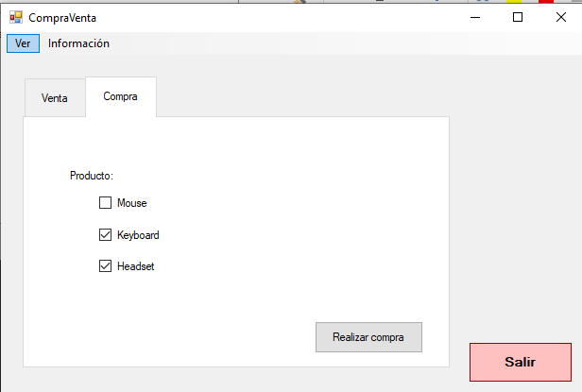 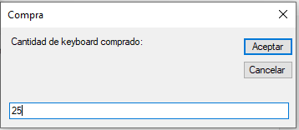 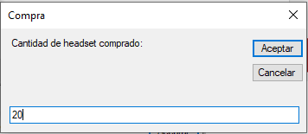 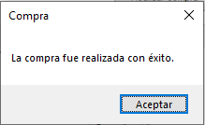 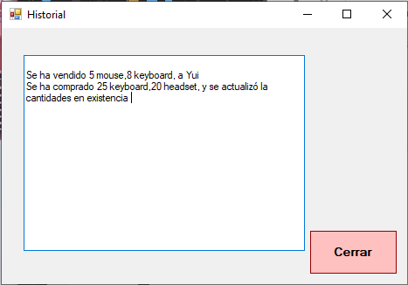 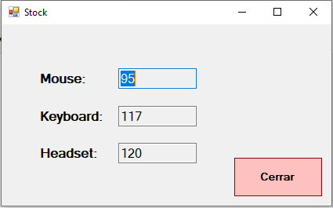

**Aporte de cada uno de los integrantes del equipo:**

**Yui Lo:** Para el form de la historial estuve que usar la función close() en vez de hide(), porque de contrario el función load de form no se ejecuta de nuevo y esto causa que los texto de texbox no se actualiza.

**Conclusión del equipo:**

**Recomendaciones del equipo:**