P(Y=1|X1, … , X1) = P(Y=0|X1, … , X1)

∴ eβ0 +β1 X1 +···+βp Xp = 1

∴ β0 +β1 X1 +···+βp Xp = 0

given β0 + β1X1 + β2X2 =0

When (X1, X2) = (0, 2)

β0 + 2β2 =0 …i

When (X1, X2) = (-2, 0)

β0 - 2β1 =0…ii

∵ i and ii

β1 +β2 = 0 …iii

∵ iii and β12+β22= 2

(β0, β1, β2) = (2, 1, -1), (-2, -1, 1)

When (β0, β1, β2) = (2, 1, -1)

β0 + β1X1 + β2X2 = 2

When (β0, β1, β2) = (-2, -1, 1)

β0 + β1X1 + β2X2 = -2

∴ (β0, β1, β2) = (-2, -1, 1)

guessed line: -1- X1 + X2 = 0

sample 1: -1-0+2 = +1

sample 2: -1-0+0 = -1

sample 3: -1-(-2)+0 = +1

=> all sample has the same magnitude of 1

∴ -1- X1 + X2 = 0

∴ 0 =

=

=

= log16 -3/4X12 -3/4X22



X2

A

B

X1

Colored part is A and un-colored part is B

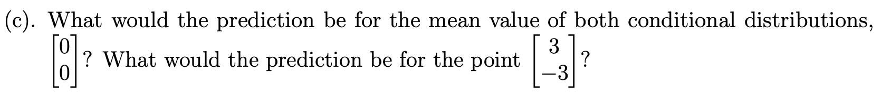

Boundary between B and C:

0 =

=

Boundary between A and C:

∴ 0 =

=

=

= log81 -8/9X12 -8/9X22

X1

X2

C

A

B

