HW7

Yuichi Hamamoto

A.

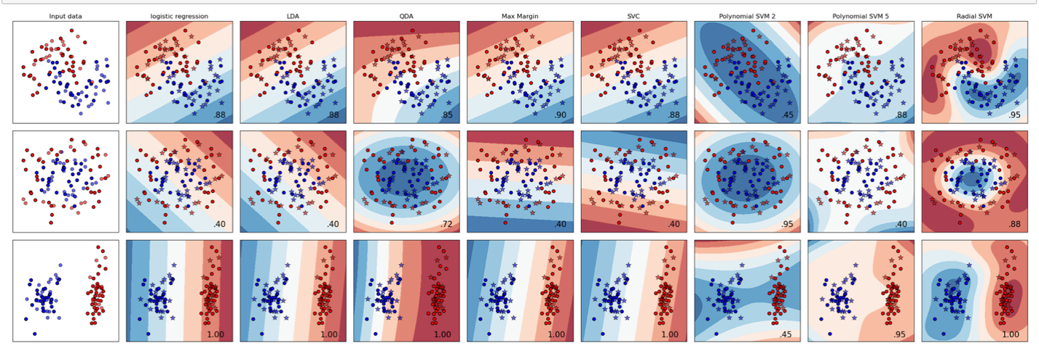

B. Logistic, LDA and Max Margin would result in liner decision boundaries. Yes, it was the case. Logistic regression and LDA result in the similar result. Max Margin and SVC results in similar to those but as we can see in the sample set 2, it can result differently.

C. QDA, SVM with polynomial kernel of degree 2, SVM with polynomial kernel of degree 5, and SVM with radial basis function kernel would result in boundaries defined by quadratic equations. Yes, it was the case. They all look different. Besides SVM with polynomial kernel of degree 2, they look nice but SVM with polynomial kernel of degree 2 seems under fitting.

D. They don’t appear liner but QDA and SVM with polynomial kernel of degree 2 resulted in very close to liner.

E. It seems like both of them fit nicely for make_moon and linearly_saparable but for the make_circle LDA does not fit well. So for the more complex dataset, QDA fit better com

F. SVC works well when they want a liner decision boundary but on the second dataset, it is clearly under fitting. SVM with polynomial kernel of degree 2 seems under fitting for all the datasets. One with degree 5 seems performing better but not as good as SVM with radial basis function kernel. SVM with radial basis function kernel seems fitting the best for any kind of dataset.