317 lab1

Yuichi Hamamoto

(a)

1. Graphical user interface, text, website

   Description automatically generatedBecause of if (x[i] >= 0) in line18, it counts 0 as a positive number. The cause the test to fail
2. test:
3. A screenshot of a computer

   Description automatically generatedGood test:

Bad test:

(b)

1. The loop doesn’t reach the index 0.
2. test:

1. good test:

bad test:

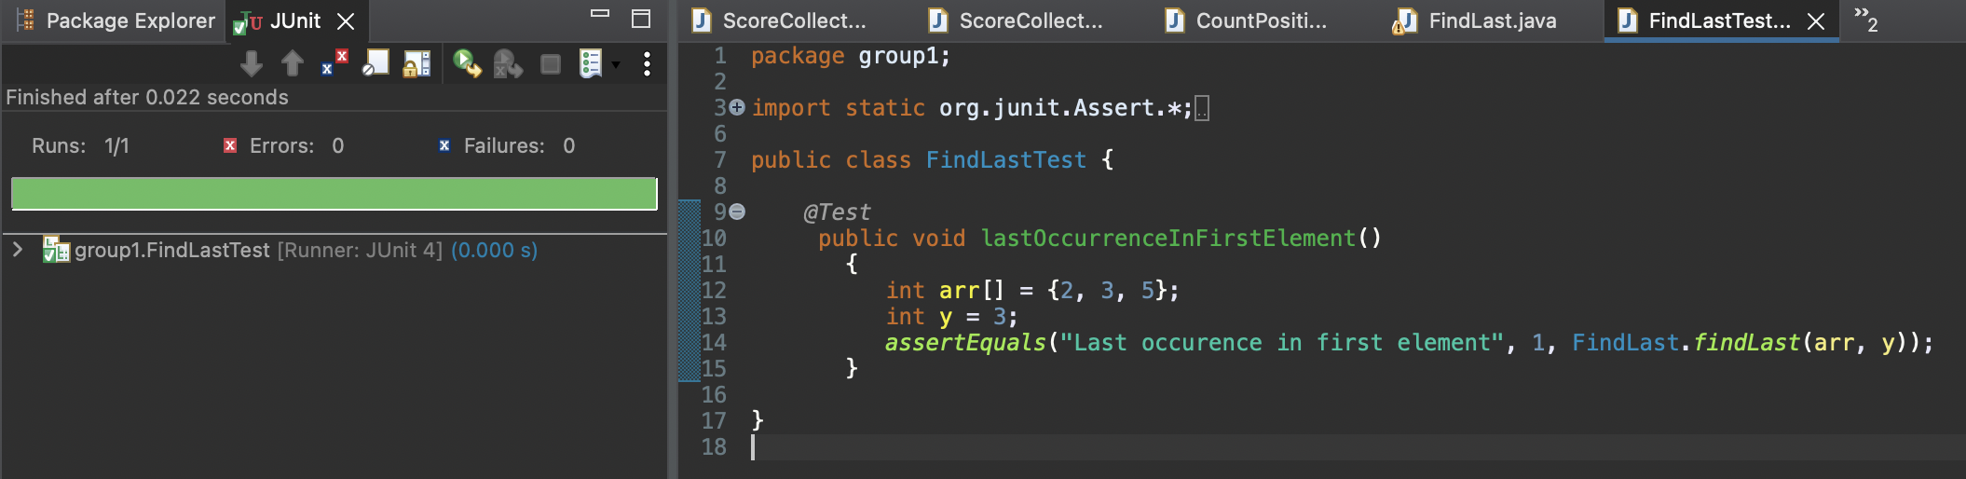

(c)

1)It will return the index as soon as it finds zero. Therefore, if there are more than one zero in the array, it will cause the error.

2)test:

3)good test:

bad test:

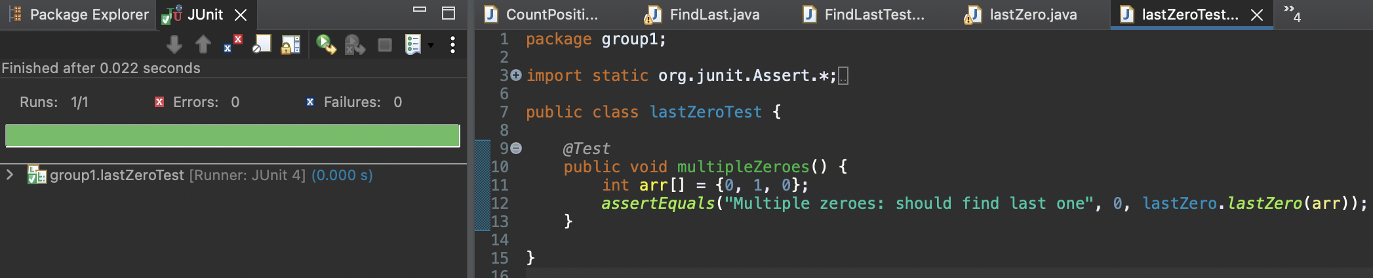

(d)

1. Because Java returns mod with sign when the number is negative odd number, it return -1 which cause the error in the code.
2. test:

1. good test:

bad test:

