**Does Decision Authority at a Workplace Matter to the Intention to Quit a Job?**

Yuichiro Tomitsuka

1009767398

yui.tomitsuka@mail.utoronto.ca

ECO375: Applied Econometrics

University of Toronto

Department of Economics

March 2023

**Abstract**

Human resources are one of the essential elements of a company’s performance. Therefore, preventing talented people from leaving the company is essential for the company to grow and is the biggest challenge that companies must address. According to Hom et al. (2012), the intention to quit a job is the most appropriate predictor of actual turnover. Therefore, this research examined whether decision authority affects the intention to quit a job. This paper did not provide evidence that decision authority affects the desire to quit a job but found a relation that intention to quit a job decreases when job satisfaction is high, corroborating the results of previous studies.

**Introduction**

While existing studies have examined various factors that affect job turnover rate, few studies have examined the effect of job discretion. For example, Cotto and Tuttle (1986) found that age, annual income, job content, and job satisfaction were related to turnover. Interrole conflict caused by family-work balance also increases the desire to leave a job (Jeong & Lee, 2022). Furthermore, Ro and Lee (2017) focused on job engagement. They found that psychological security and the sense of being able to play an active role at work motivate people to continue working.

Moreover, psychological stress is caused by a variety of factors. For example, it has been noted that discretion at work causes psychological distress (Liss-Levinson et al., 2015). The decision authority in the job leads to a sense of control over things oneself and is thought to increase motivation to do the job. Therefore, we hypothesized that decision authority reduces the intention to quit a job.

H1: High levels of decision authority decrease the intention to quit a job.

In addition, no matter how high the level of satisfaction with the job, motivation may drop if one cannot do the job in one’s way. Therefore, we hypothesized that the decision authority would affect the effect of liking a job on the desire to quit it.[1]

H2: Low levels of decision authority reduce the effect of liking a job on the intention to quit.

**The Context and Data**

This research used the Work, Family & Health Network data that follows panel data (Work, Family, and Health Study, 2018). In order to collect the data, surveys were conducted in the form of group-randomized field experiments. The subjects were employees and managers of Fortune 500 companies in the information technology industry and extended-care companies. Follow-up surveys were administered to all subjects who had still been in the company and in the area where the survey was conducted. Data were collected four times: 6, 12, and 18 months after the initial baseline survey, and the number of observations that participated in at least a survey amounts to 9193.

The dependent variable in this research is the degree to which workers want to quit their current job. Table 1 shows that this variable takes values from 1 to 5. This variable is a categorical variable, where 5 indicates strongly agree and 1 indicates strongly disagree with the question: You are seriously considering quitting your for another employer. In other words, the higher the value of this variable, the stronger the intention to quit the job.

This research’s independent variable of primary interest is decision authority at work. This variable is also a categorical variable ranging from 1 to 5, with 5 indicating strongly agree and 1 strongly disagree with the question: On your job, you have very little freedom to decide how you do your work. In other words, the higher this value is, the less decision authority they have. In addition, we used the variable of how much they like their current job as the independent variable for Hypotheses 2. The higher the value, the more they like the job.

In addition, the following variables are added to the present analysis to control for other factors that may affect the relationship between the above two variables. First, we fixed individual and time, controlling for factors that vary across individuals but are constant over time and factors that vary over time but do not vary across individuals. The factors that vary both across individuals and over time were interrole conflict, which is the problem of balancing family and work, psychological distress, which is the feeling of not being helpful at work, and perceived stress, the extent to which people feel that their work is not going the way they want it to.[2]

As Table 1 shows, the standard deviation of each variable is around 1, indicating that there is not much variation in the variables. As this means that the information is limited, the estimates of the result may be inaccurate.

**Regression Analysis**

**Baseline Models**

Model 1 in Table 2 contains only the variables representing the degree of decision authority at a workplace, which is the primary dependent variable. The model is as follows:

$${IntentionQuit}_{it}=β_{0}+{β_{1}NoDecAgree}_{it}+{β_{2}NoDecNeither}_{it}+{β_{3}NoDecDisagree}_{it}+{β_{4}NoDecStrDisagree}_{it}+u_{it} For individual i in time t$$

The variable was converted to dummy variables to show the relationship with the intention to quit the job on each scale. Its intercept is 2.274 on an average scale of 1 to 5 for the desire to quit a job when strongly agreeing with having no discretion at work, which is statistically significant at the 0.1% significance level. In addition, the intention to quit a job for those who think they have freedom at work is 0.255 less than for those who strongly agree with having no discretion. This means that the mean of the desire to quit for those who disagree with the question about no discretion at the workplace is 2.019, which is significant at the 1% level. On the one hand, the mean of the intention to quit a job for those who strongly disagree with the question is 1.614, significant at the 0.1% significance level. This result indicates a negative relationship between the presence of decision authority at work and the desire to quit a job.

However, the mean difference in the intention to quit a job among those who strongly agree and those who strongly disagree with having discretionary authority is 0.660. Meanwhile, the standard deviation of the variable of willingness to quit a job is 1.053; thus, the difference is associated with only 62.68% of one standard deviation of intention to quit a job (see Table 1). This means that the difference between having and not having freedom in the workplace is only slightly related to the difference in the willingness to quit a job.

In Model 2, we controlled for individual characteristics and used clustered standard errors, valid when an error could be correlated within an entity (this standard error was used in all the following models). Individuals differ in their sensitivity to wanting to quit their jobs. For example, some individuals want to quit their job immediately when their boss harasses them, while others have a high tolerance for harassment and do not want to quit immediately. Controlling for personal characteristics that influence this measure of intention to quit a job yields more robust results as a causal relationship. The intercept is almost the same as in Model 1, at 2.210 and significant at the 0.1% significance level. However, the coefficient for those who disagreed with the question about having little freedom in their job is no longer significant. The coefficient for those who strongly believe they have freedom was -0.196, significant at the 5% level. The R-squared is 0.677, which is much higher than that of Model 1. The high R-squared indicates that the individual fixed effects account for a large amount of variation in the dependent variable.

The average score for those who answered they had no freedom at all in their job was 2.210, which is not much different from Model 1. The average degree to which they are willing to quit a job for those who strongly feel they have freedom in the workplace is 0.196 lower than those who do not think at all that they have freedom in their job. This difference is more negligible than in Model 1, and this slope is not economically significant either.

Model 3 controlled for the time effects in addition to Model 2, which can mitigate the omitted variable bias from variables that do not change across survey subjects but change over time. An example of such variables is the economic recession that makes people less inclined to quit their jobs. Its equation is as follows:

$${IntentionQuit}_{it}=β_{0}+{β_{1}NoDecAgree}_{it}+{β_{2}NoDecNeither}_{it}+{β_{3}NoDecDisagree}_{it}+{β_{4}NoDecStrDisagree}_{it}+{Individual Fixed Effects+Time Fixed Effects+ u}_{it} For individual i in time t$$

The mean score for the intention to quit a job for those who strongly agree that they have no freedom in their job is 2.122, which is significant at the 0.1% level. The coefficient for those who strongly agree that they have freedom in their job is -0.199, which is statistically significant at the 5% level. This suggests that the mean score of intention to quit is 1.923, while the mean score for those who think there is little freedom is 2.122. Figure 1 shows this negative relationship between the two variables.

The results of Model 3 are slightly different from those of Model 2. The little difference between the results of the two models means that there is no economic significance in the relationship between decision authority at work and the intention to quit one’s job from this model. The intercept that indicates the mean score of desire to quit a job for those who think their jobs have no discretion at all is 2.122, which is close to the score for disagreeing with the question about wanting to quit their job. This implies that the lack of discretion does not lead to the intention to quit one’s job. The fact that the scores are almost unchanged from Model 2 suggests that the effect of variables that is constant across individuals but vary across time on the desire to quit a job is small. This slight change can be because of the short period over which the survey was conducted (18 months). Few changes might have affected the desire to quit a job during that time.

**Multiple Linear Regression**

Model 4 includes variables that are determinant of the intention to quit a job in addition to the variables controlled by the time effects and the individual effects. Compared to Model 3, the coefficient for those who strongly believe they have more freedom at work is not statistically significant. This suggests that greater job discretion is not associated with the intention to quit. However, the intercept significantly increased from 2.122 to 3.376 at the 0.1% level, suggesting that the mean score for the desire to quit a job is higher for those who strongly feel they have no freedom than the previous model. However, 3.376 is almost identical to 3, the response of neither wanting nor not wanting to quit a job. Thus, when they cannot decide how to do their job at all, they do not want to leave their current company.

We estimated a small effect of how much they like their job on the intention to quit. The coefficient is -0.365, which is significant at the 0.1% level. The standard deviation for this variable is 0.758, and one standard deviation change would be 0.277 change in the intention to quit a job. Since the standard deviation of the intention to quit a job is 1.053 (see Table 1), one standard deviation change in how much they like their work is only 26% of the standard deviation change in willingness to quit a job. Moreover, the difference in the effects on the desire to quit a job between those who like it very much and do not like it at all is only 1.46. This result shows a relationship that one would not want to quit a job when they like it, but it is not economically significant.

Model 5 is a regression that checks the sensitivity of the result to a change in Model 4. As can be seen from the results, the intercept has dropped from 3.376 to 1.774. This decrease in the intercept means that the estimate is negatively biased if one believes there is no discretion at all in the job when the model does not control the effect of how much they like their work. As shown in Table 3, this variable negatively correlates with how much the workers like their job (its correlation coefficient is -0.020). Furthermore, the coefficient on how much one likes the job is positive from Model 4; hence, the bias should be negative, which is consistent with the result of Model 5. Aside from the decision authority, there is no significant difference in the coefficients of the other variables. This suggests that the estimated coefficient on having no job discretion at all is sensitive to including a variable for how much workers like their job. The coefficient on liking one’s job is statistically significant so that variable should remain in the model.

Model 6 is a regression with an interaction term of the decision authority and how much workers like their work, and its equation is shown below.

$${IntentionQuit}_{it}=β_{0}+{β_{1}NoDec}_{it}+{β_{2}LikeWork}_{it}+{β_{3}NoDec×LikeWork}_{it}+{β_{4}InterConfl}_{it}{{+β}_{5}PsychDist}_{it}+{β_{6}PercStrfl}_{it}+{Individual Fixed Effects+Time Fixed Effects+ u}_{it} For individual i in time t$$

The coefficient of job decision authority represents the marginal effect when the value for how much they like it is 0, but it is not statistically significant: thus, Hypothesis 1 was rejected. Also, the coefficient on the variable of how one likes one’s job represents the marginal effect when the value of the variable of job discretion is 0. Its estimated scope was -0.316, rejecting that its coefficient is 0 at the 0.1% level. It suggests that the more one likes one’s job, the less one wants to quit, but as in Model 4, the effect is unlikely to be economically significant. Furthermore, the coefficient on the interaction term is a differential effect of how much they like their job on the effect of the decision authority on the intention to quit their job. However, this was not statistically significant, meaning Hypothesis 2 was not supported.

Model 7 is a regression to check the sensitivity of these conclusions to changes in Model 6. Dropping the control variables that are determinant of the willingness to quit a job causes slight changes in variables, so these variables should remain in the regression model.

Model 8 is a regression with the demeaning approach to make the coefficients interpretable in Model 6. In Model 6, the coefficients indicate marginal effects when the values of how much they like their job and job discretion are zero, which is out of the range of possible values that those variables can take. Therefore, the job discretion and job liking variables were demeaned to make the model easier to interpret, with the coefficients showing the effect on the average of those variables. The results of statistical significance are the same as in Model 6. That is, we did not obtain evidence that job discretion affects the intention to quit a job and that the absence of freedom at workplaces did not reduce the effect of liking a job on the intention to quit it. The marginal effect of the degree to which workers like their job when the degree of job discretion is average is -0.369, which suggests that the intention to quit a job decreases when one likes one’s job. We also found that conflicts between home and work, the psychological stress that comes from the feeling of not contributing at work, and perceived stress that things are not going the way one wants to have positive effects on the desire to quit one’s job. However, these coefficients are very small, and given that the possible values of these variables range from 1 to 5, we can conclude that their effects on the desire to quit a job are minor.

**Limitations of Results**

Since this analysis fixes the individual and time effects, it mitigates the threat of omitted variable bias. Therefore, the results of this analysis provide more substantial evidence for causality than simple linear regression.

However, some variables that the model does not capture in this analysis may affect the intention to quit a job and could also be correlated with decision authority, leading this analysis to suffer from omitted variable bias. An example is the change in wages. Changes in wages are thought to impact the willingness to quit a job significantly. In addition, individuals with more job discretion may be more likely to be in more critical positions and tend to have higher wages. Since wages can vary across individuals and over time, we could not control for this variable by the fixed effects regression, which might cause bias in the estimates.

The second threat is sampling bias. The analysis is based on employees and managers and does not include part-time workers. In addition, looking at the time-fixed and non-fixed models, we found a difference in the number of samples. This suggests that some people may have quit during the 18 months. Therefore, the people included in this analysis may be those who did not quit, which could bias the results. Thus, the OLS assumption that the sample is i.i.d. is unmet.

Furthermore, we believe there is a limitation to the extent to which the results of this analysis cannot be generalized to other situations. This is because the target audience for this sample is Fortune 500 technology firms and those working in the extended care industry. In other industries, other factors may influence quitting a job. Also, while the sample is likely in the U.S., the results cannot be applied to other countries with different cultures. It is unlikely that similar results can be generalized to other countries, especially in a country like Japan, where human resource mobility is low. Moreover, the period covered by the survey is short, from 2009 to 2012. This analysis does not control for the case of a significant economic change like Covid-19, which could influence the intention to quit a job. Thus, it is unlikely that the results of this analysis can be applied to other situations when the economic condition differs.

**Conclusion**

　This research examined the effect of decision authority on the intention to quit a job and found no statistical support for this effect. It also did not support the hypothesis that people would want to quit when they did not have freedom in their jobs, even if they liked their jobs. On the contrary, we found that liking their job has a small but negative effect on the intention to quit, corroborating previous research that investigated the effect of job satisfaction on the desire to quit one’s job (Cotton & Tuttle, 1986). However, this analysis suffers from omitted variable bias, and further research is needed to conclude these hypotheses. Prior research suggests that the significant effect of satisfaction with annual income has a significant effect on the desire to quit a job (Liss-Levinson et al., 2015). Therefore, controlling for satisfaction with compensation would yield more substantial results as a causal relationship.

**References**

Cotton, J. L., & Tuttle, J. M. (1986). Employee turnover: A meta-analysis and review with implications for research. *Academy of Management Review*, 11(1), 55-70.

Hom, P. W., Mitchell, T. R., Lee, T. W., & Griffeth, R. W. (2012). Reviewing employee turnover: Focusing on proximal withdrawal states and an expanded criterion. *Psychological Bulletin*, 138(5), 831–858.https://doi.org/10.1037/a0027983

Jeong, S., & Lee, Y. (2022). Is turnover intention static or dynamic? The impacts of inter-role conflicts and psychological workplace strain on turnover intention trajectories. Human Resource Development Quarterly, 1-20, DOI: https://doi.org/10.1002/hrdq.21484

Liss-Levinson, R., Bharthapudi, K., Leider, JP., Sellers, K. (2015). Loving and Leaving Public Health: Predictors of Intentions to Quit Among State Health Agency Workers. *J Public Health Manag Pract*. 6(6):91-101. DOI: 10.1097/PHH.0000000000000317.

Ro, H. & Lee, J. (2017). Call Center Employees’ Intent to Quit: Examination of Job Engagement and Role Clarity, *Journal of Quality Assurance in Hospitality & Tourism*, 18(4), 531-543, DOI: 10.1080/1528008X.2017.1292163

Work, Family, and Health Study (WFHS). (2018). Inter-university Consortium for Political and Social Research, DOI: https://doi.org/10.3886/ICPSR36158.v2

**Table 1**

*Descriptive Statistics*

**Table 2**

*Regression Analysis*

**Table 3**

*****Correlation Matrix of No Decision Authority at Work and Intention to Quit a Job*

**Figure 1**

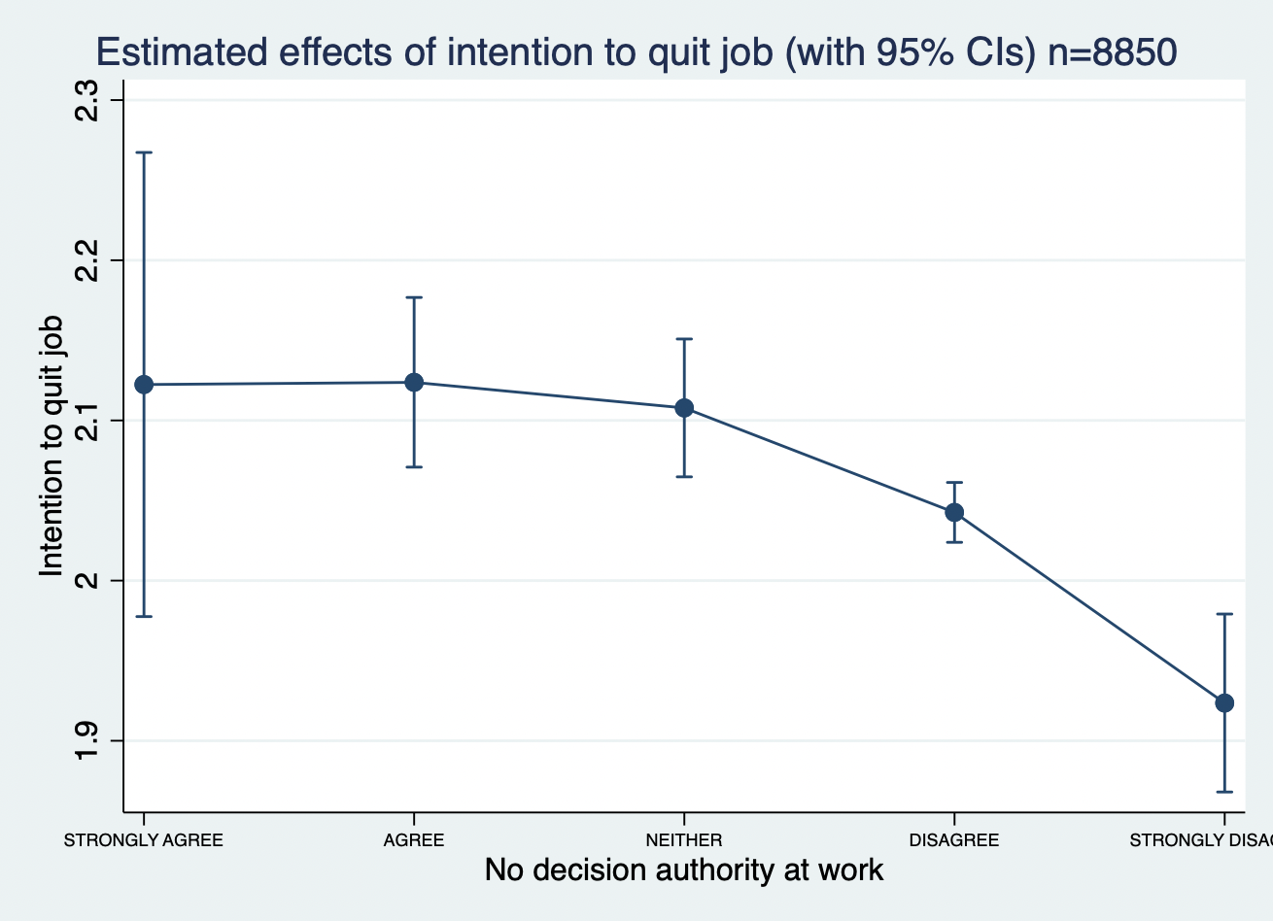

1. We believe that not liking the job is not synonymous with being willing to quit because it is possible to have a situation in which one does not want to quit a job, even if one does not like it. For example, if a worker earns a good salary and has to support her/his family, she/he may not want to quit her/his job even if she/he dislikes it. Hence, we treated how much the workers like their job as a variable of job satisfaction in this analysis.
2. Based on previous research, we added those variables that influences the intention to quit a job. Interrole conflict was defined as 5 for strongly agree and 1 for strongly disagree to the question: The demands of your family or personal relationships interfere with work-related activities. Psychological distress is defined as 5 for all of the time and 1 for "none of the time" to the question: During the past 30 days, how much of the time did you feel worthless? Perceived stress is defined as 5 when answering Never and 1 when very often to the question: During the past 30 days, how often have you felt that things were going your way?